STEP 1 : Type STRSDA command

SDA stands for Screen Designing Aid – utility that helps us to create screens

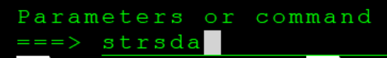

STEP 2 : Select option 1

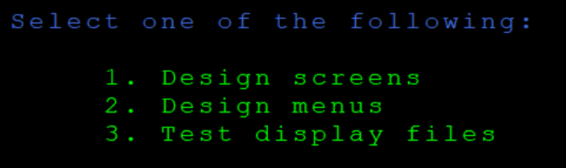

STEP 3 : Give member name

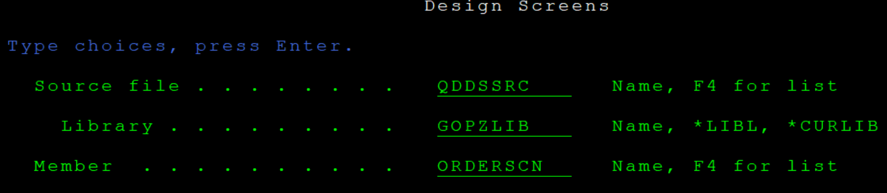

STEP 4 : Give option 1 to add records.

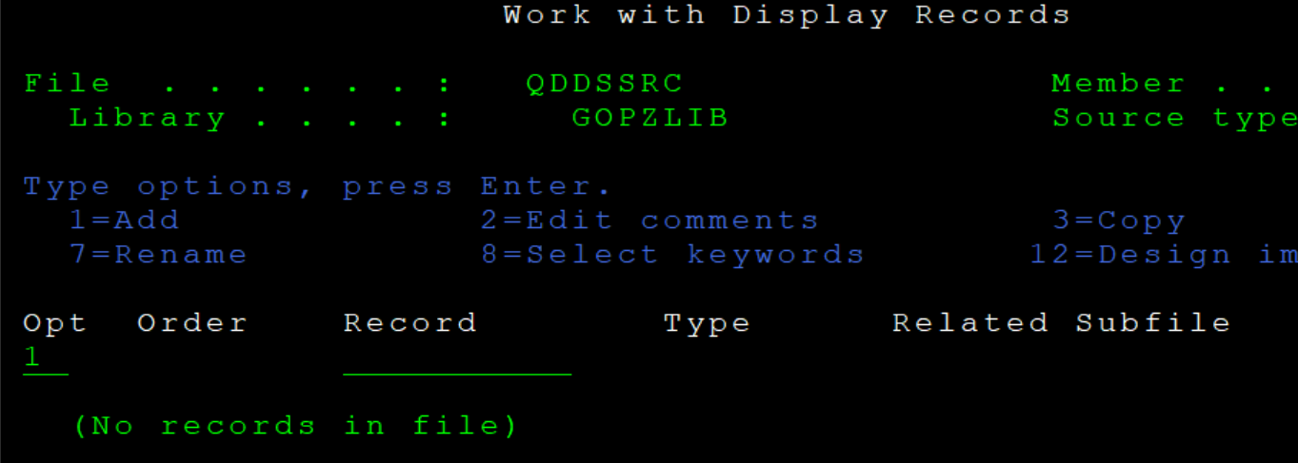

STEP 5 : Give record name, type as SFL and also give control record name

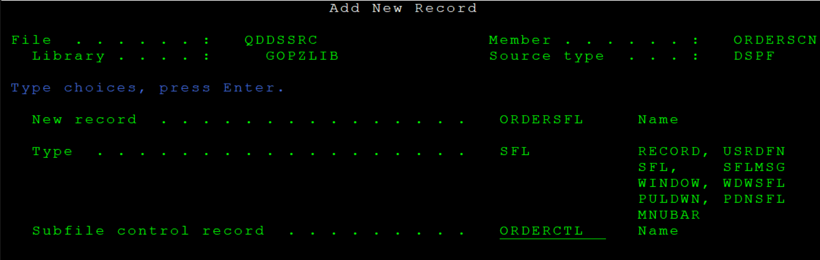

STEP 6 : No need to select any subfile keyword🡪 ENTER

In select subfile control keywords, give everything Y and ENTER

Define general keywords 🡪 SFLDSP, SFLDSPCTL, SFLCLR, & SFLEND with indicators 91,92,93, and 94 respectively 🡪 ENTER

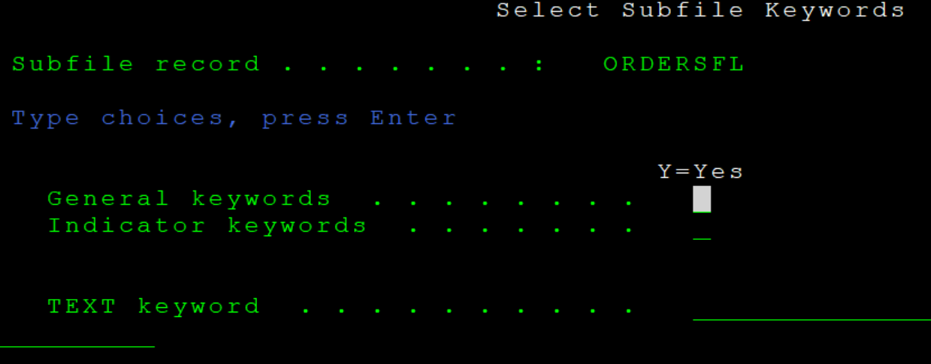

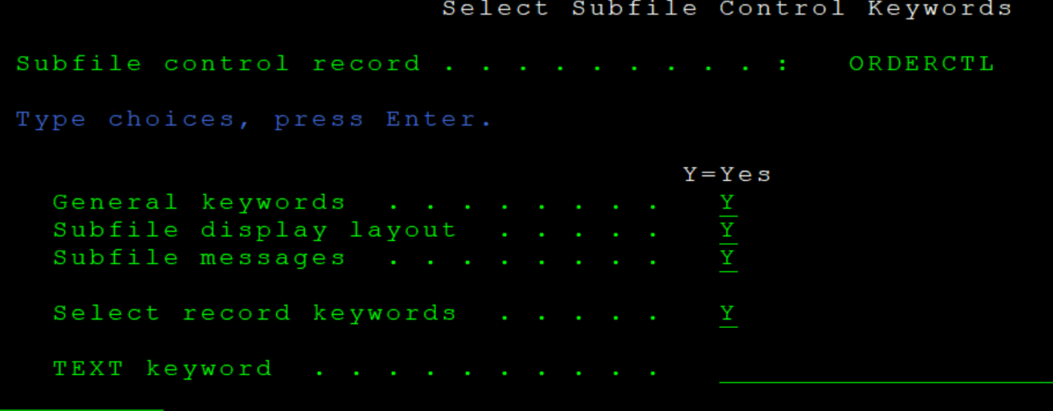

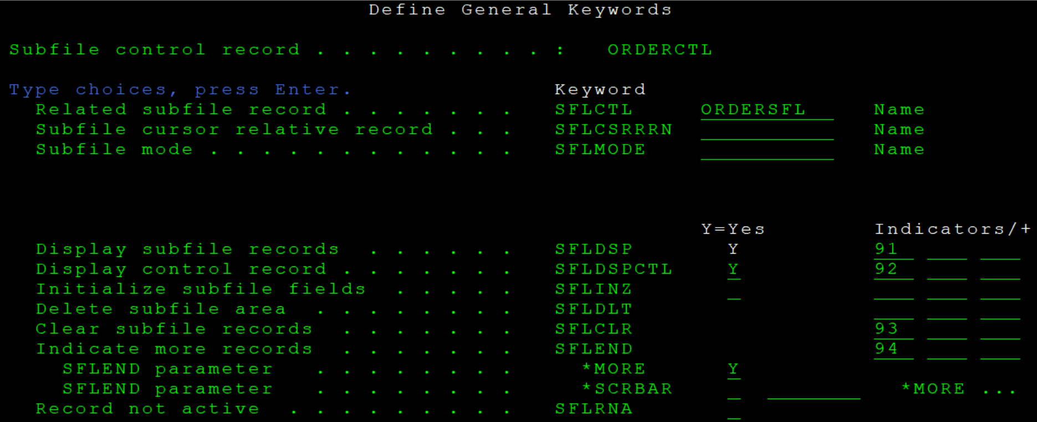

STEP 7 : Define display layout 🡪ENTER🡪ENTER

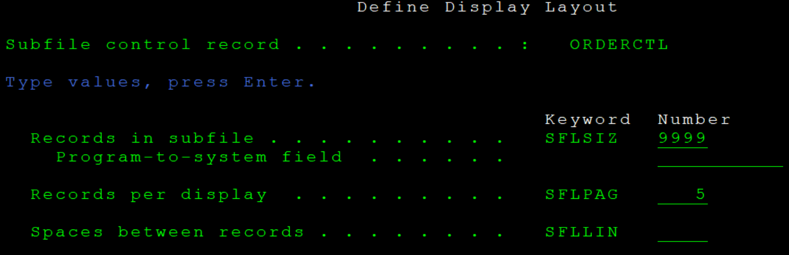

STEP 8 : Select record keywords. Give Y for indicator keywords and overlay keywords🡪ENTER

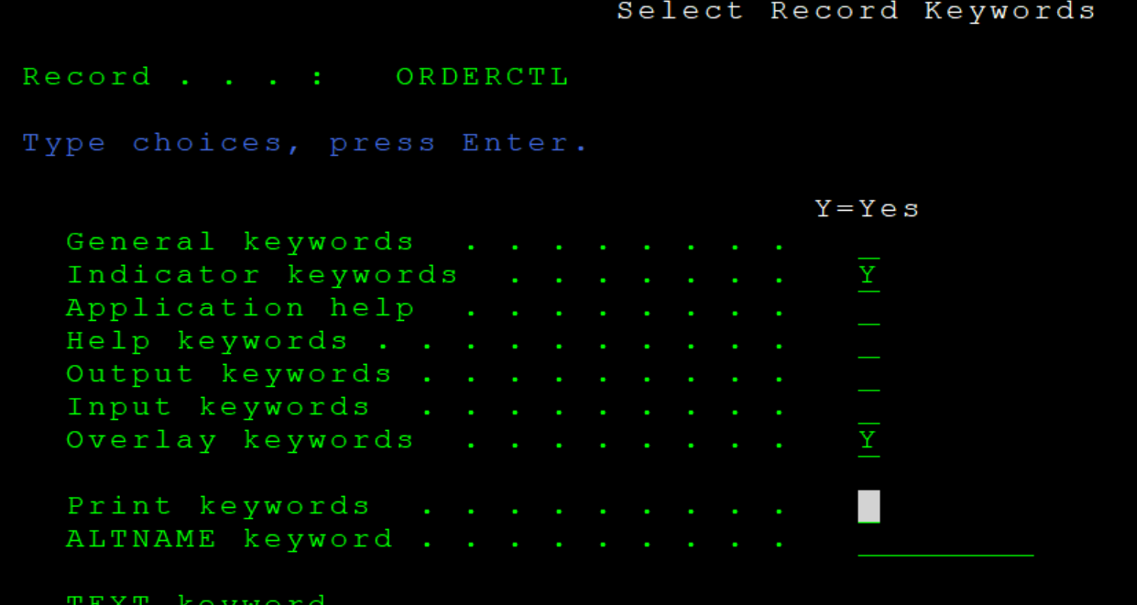

STEP 9 : Define the indicator keywords . Here, CA03 is used for EXIT and CA07 for generating reports in workspool 🡪 enter

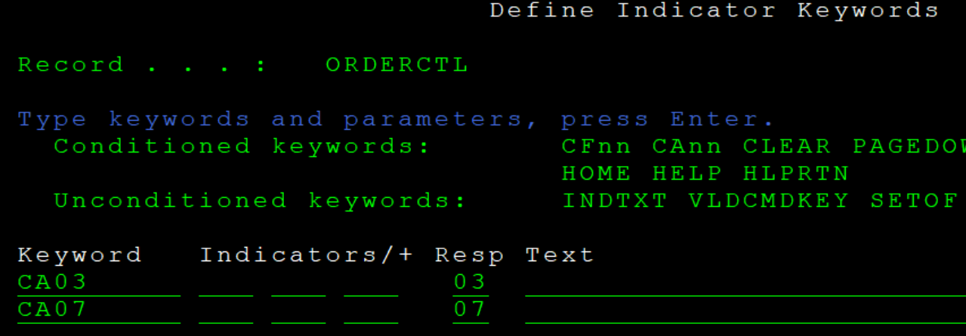

STEP 10 : Select overlay keywords as Y 🡪 ENTER 🡪 ENTER🡪 ENTER

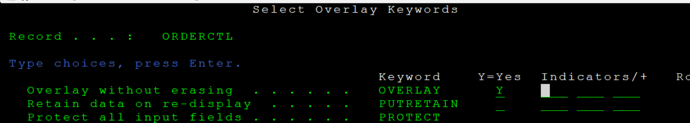

STEP 11 : Add new record as FOOTER

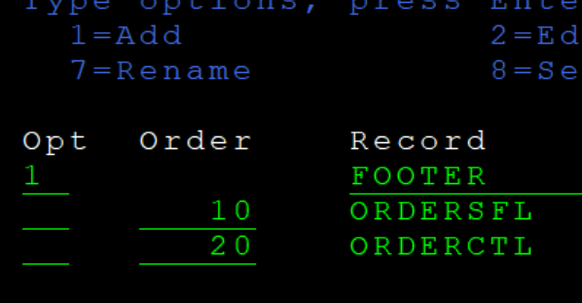

STEP 12 : Design the FOOTER pg as follows :

Give name to fields by placing ? before the field.

To cut and paste a content give ‘-‘ at both the ends and then give = at the destination

To change attributes give \* before the content



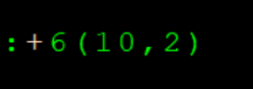

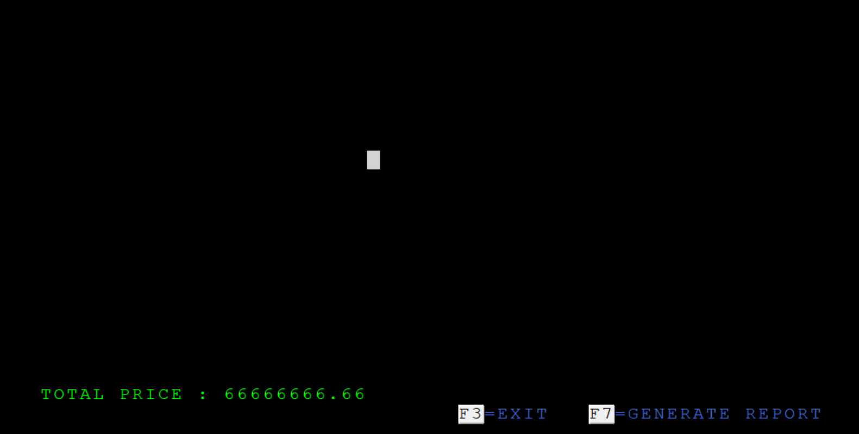

STEP 13 : Design the control part which will be static always

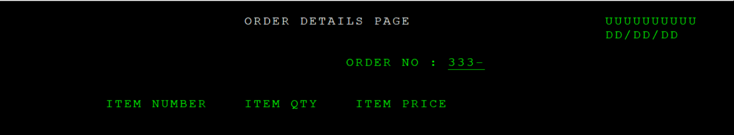

STEP 14 : Design the subfile part which is dynamic

If you want to get the fields from database files you can just click F10 and then select the required option and give the file and record name as follows. Then specify the correct number along with & to populate the fields

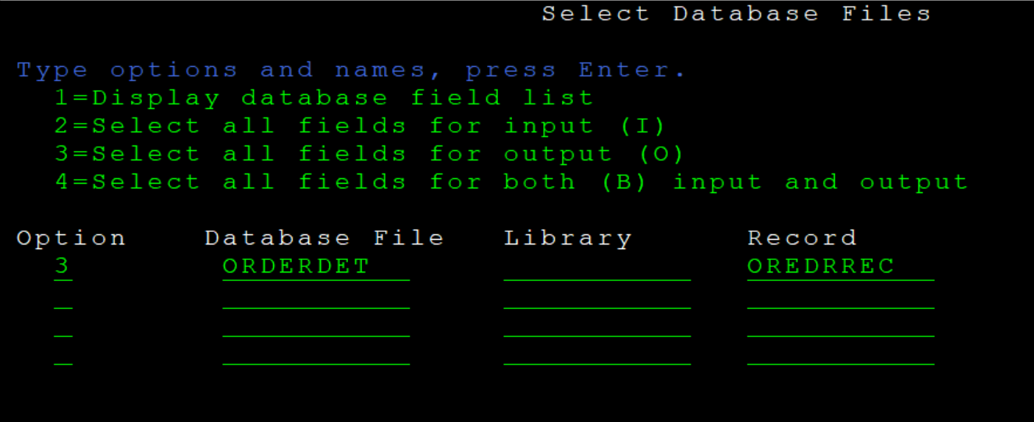

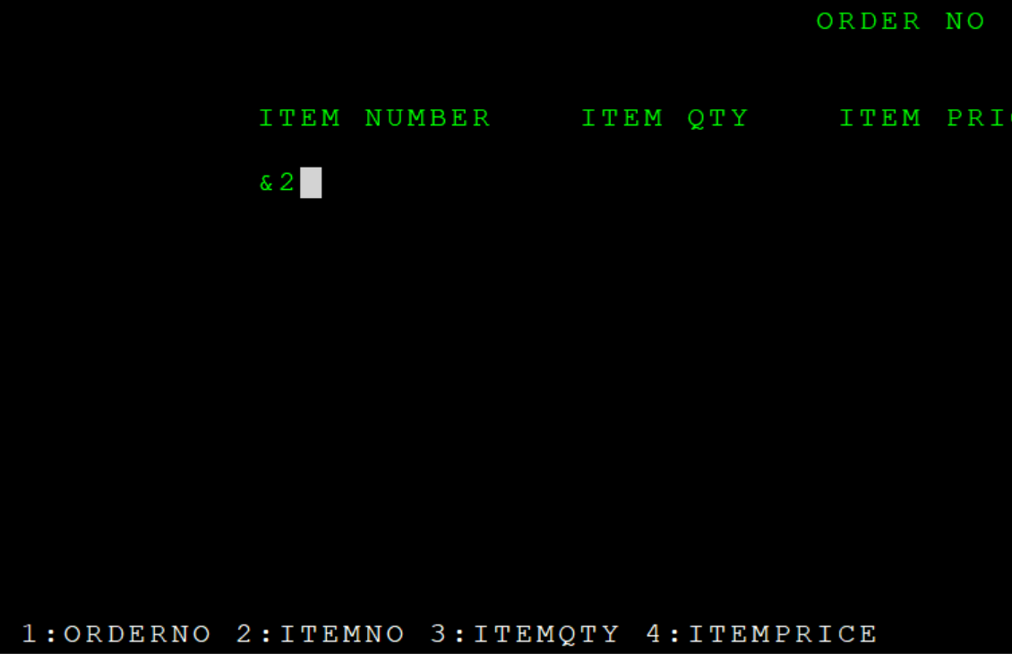

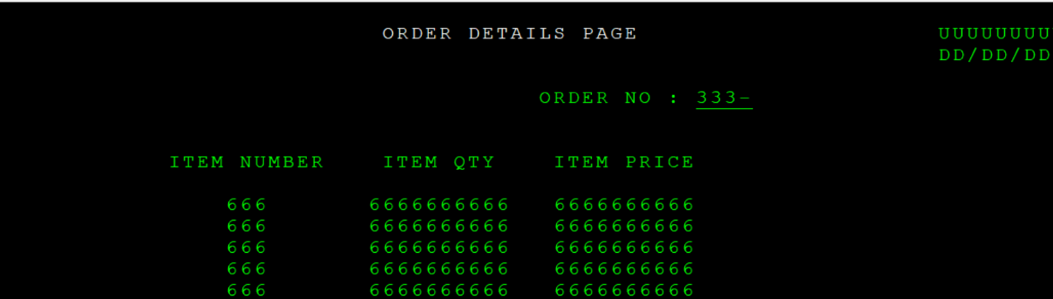

STEP 15 : Save the screen. Give blanks at submit create job in batch to know that your screen is created then and there. Else we need to go to wrksplf

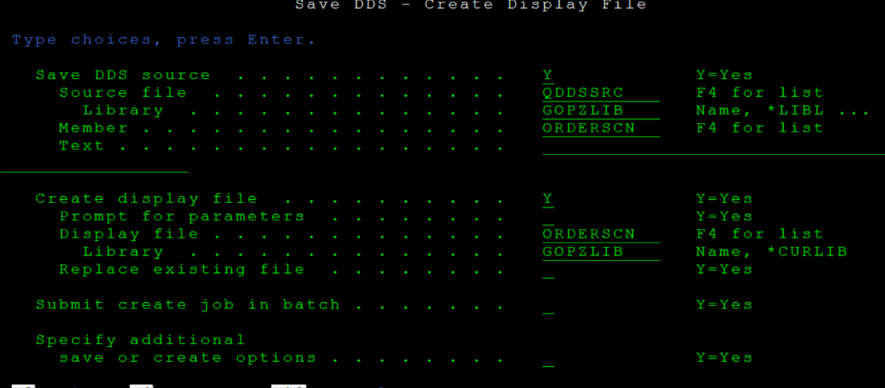

STEP 16 : Use STRRLU command to create reports. RLU(report layout utility)

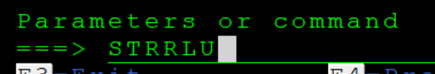

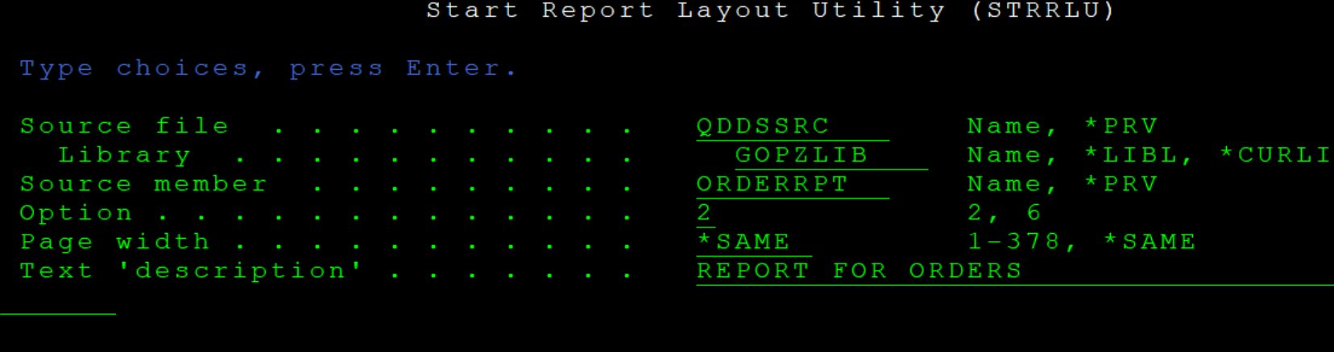

STEP 17 : Type I and the ENTER to go to next line. Type DR (define record) at the starting of line to create new record. Then type VF(view field) to create new field. To rename records SHIFT + F6 and then F10.

To define fields F11. To get fields from database F10.

For page field if you define the field as page itself the sys will automatically detect it as current date and display the same.

To align ..place cursor.. f13 mark data...place cursor at dest position - f15 move marked data

To delete entire record format -- D

To change length -- reduce or add dots(.) 🡪 ENTER

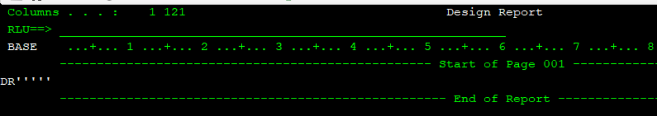

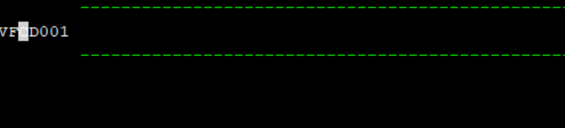

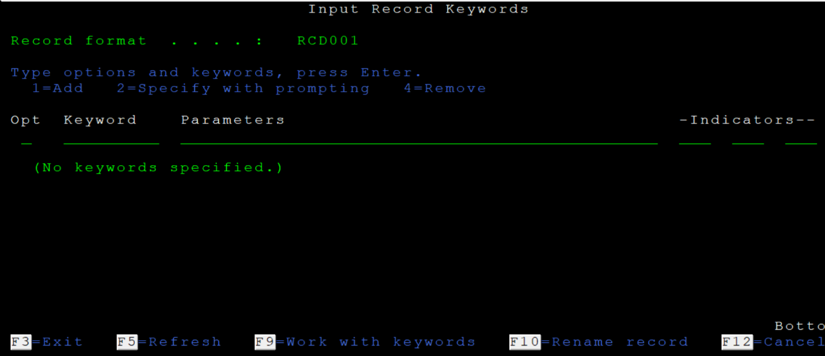

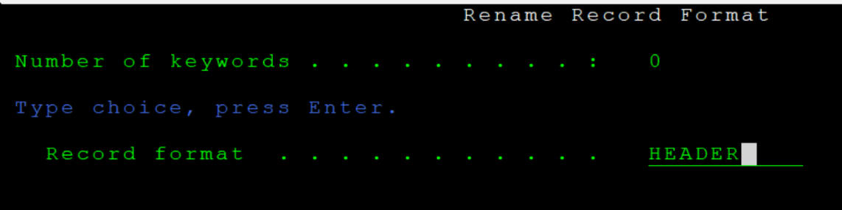

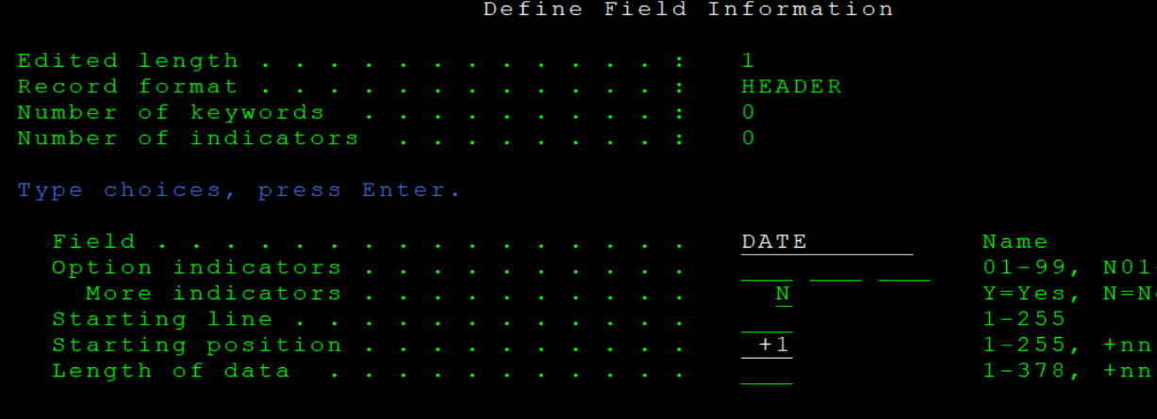

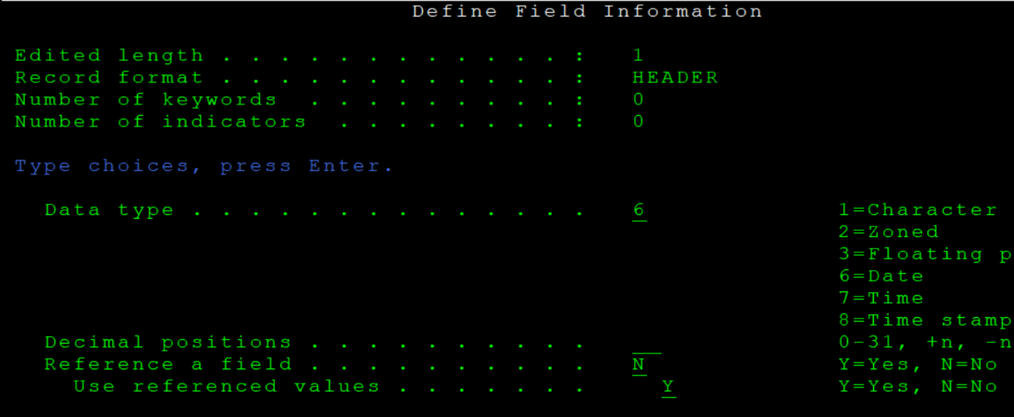

STEP 18 : Compilation 14 🡪 CRTPRTF

type - \*file

Type 19 to open RLU files

