**XML**

DS inside DS

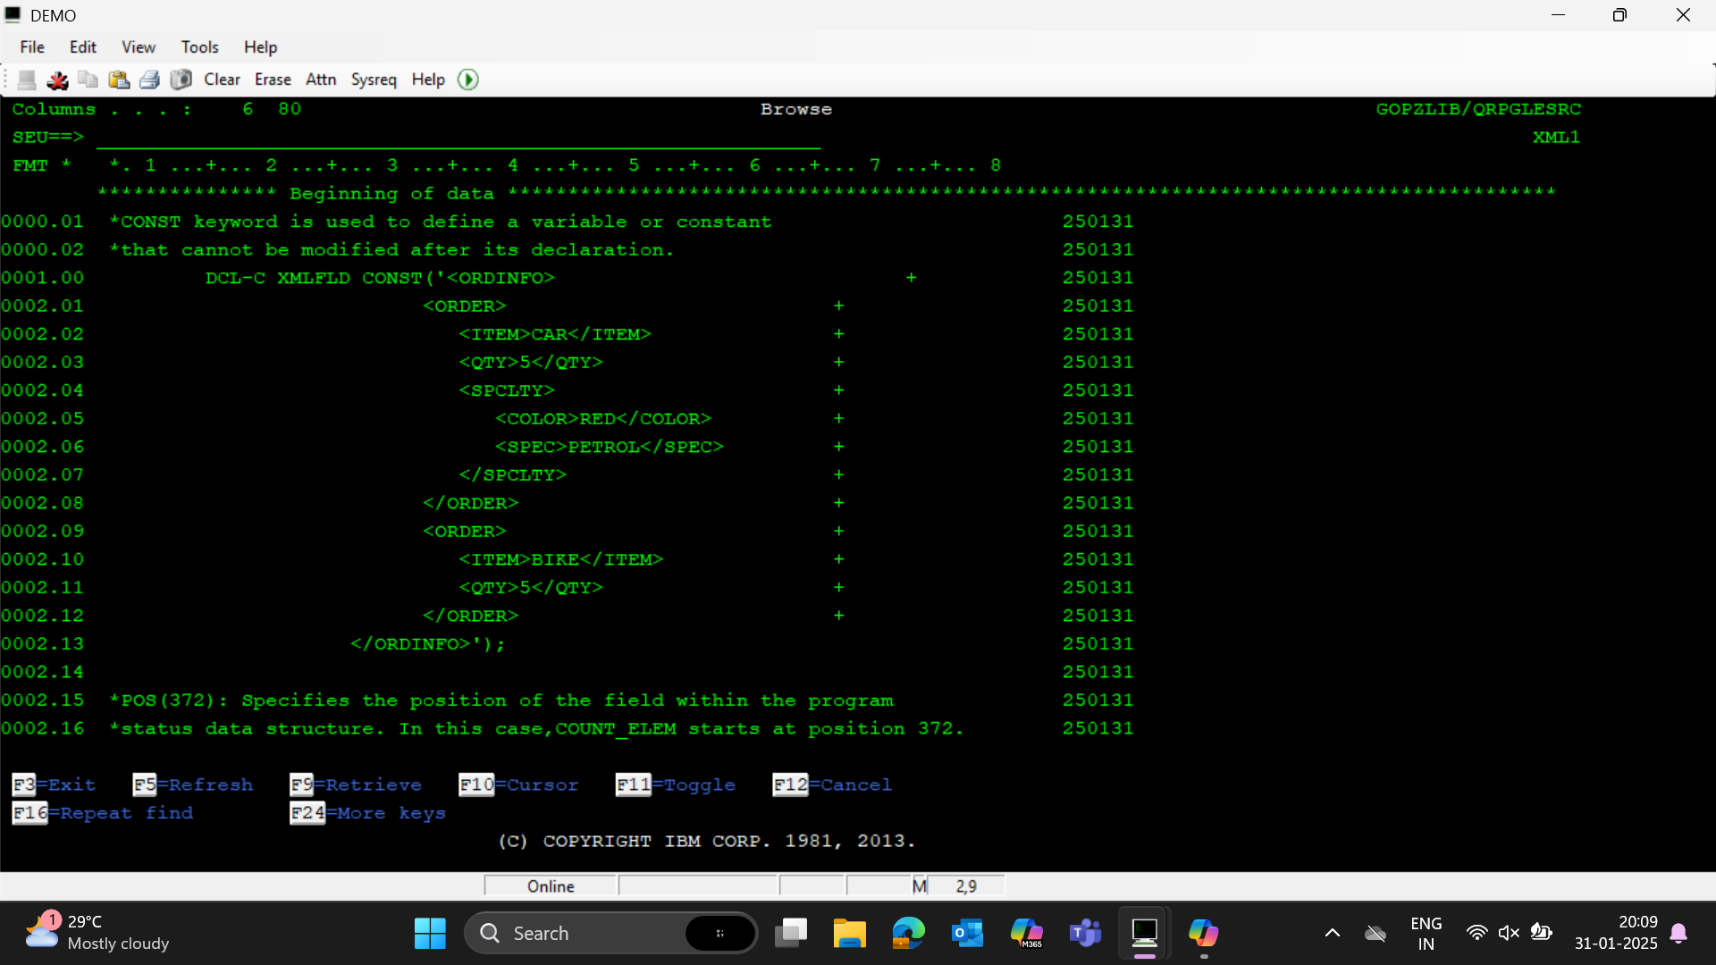

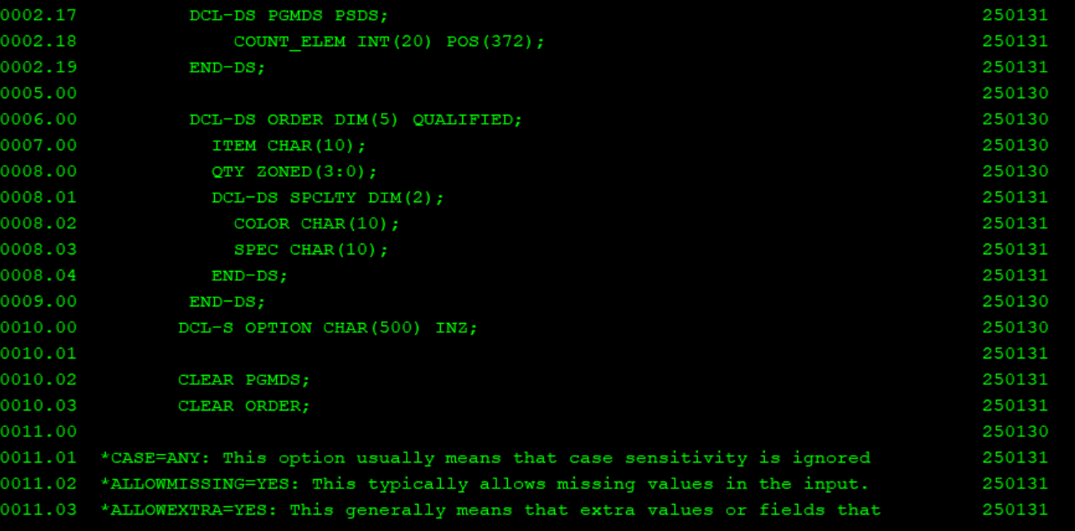

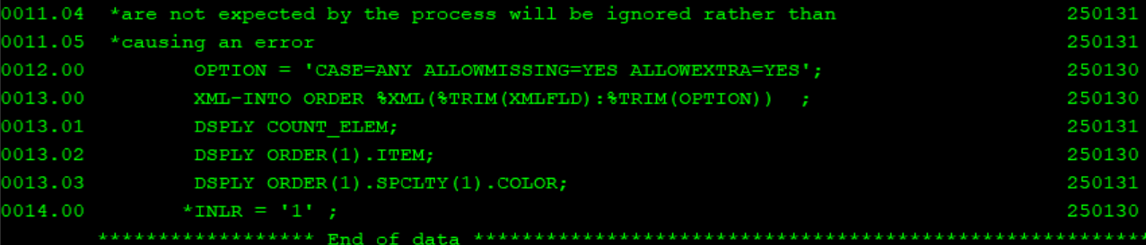

Writing into pf using SQLRPGLE and XML

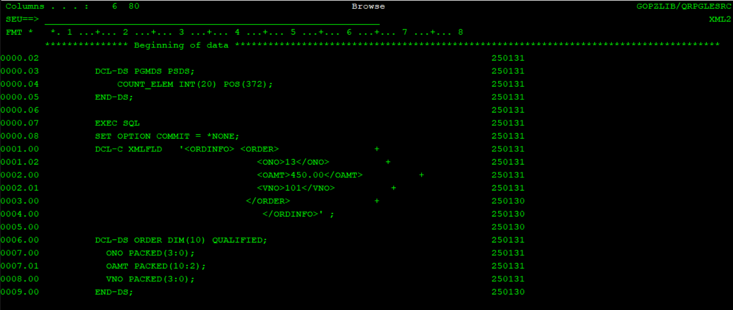

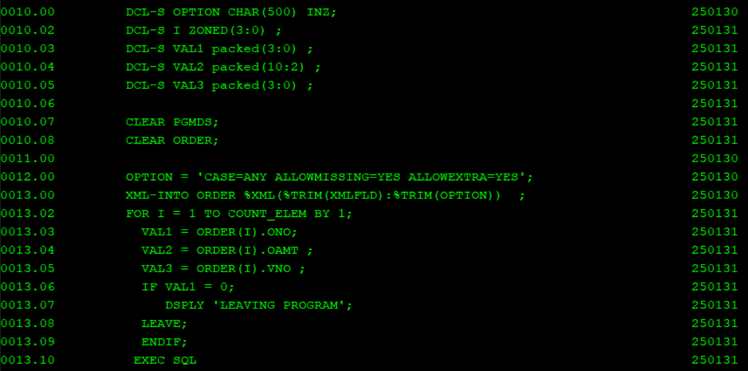

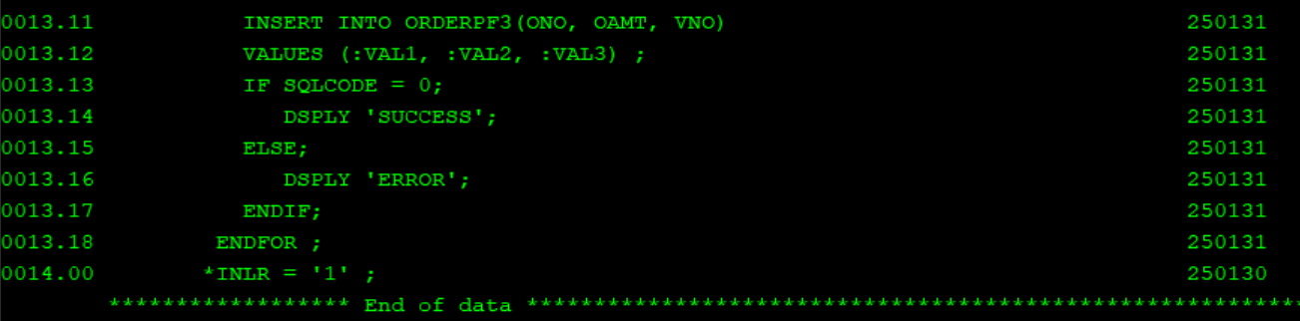

Writing using native rpg

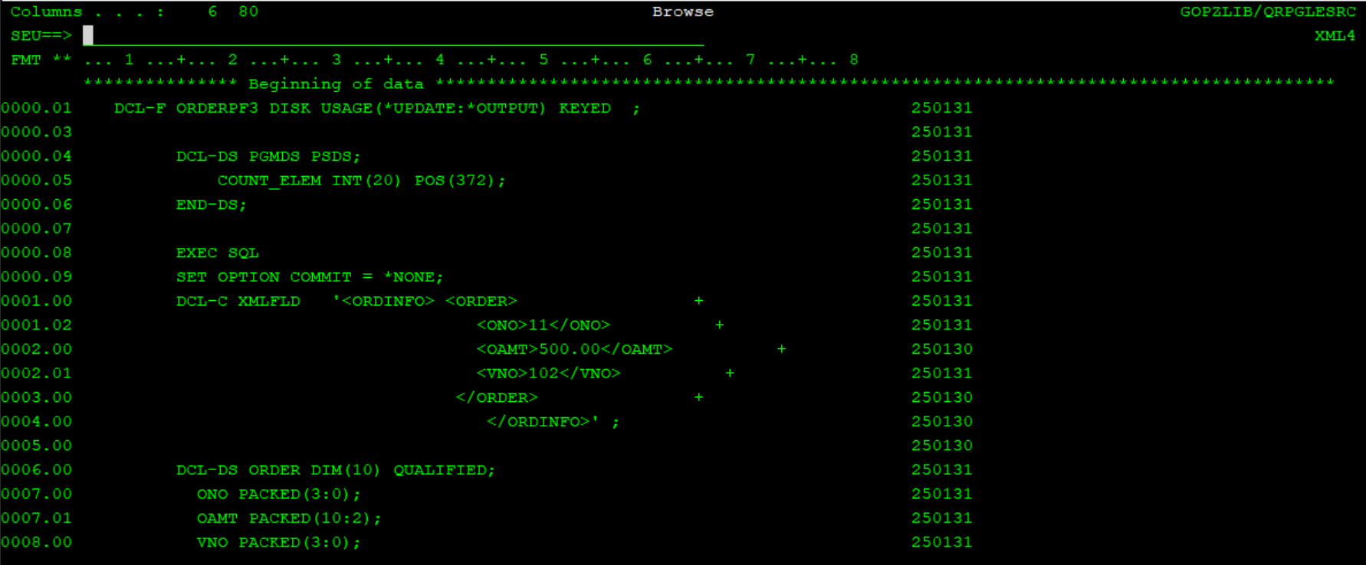

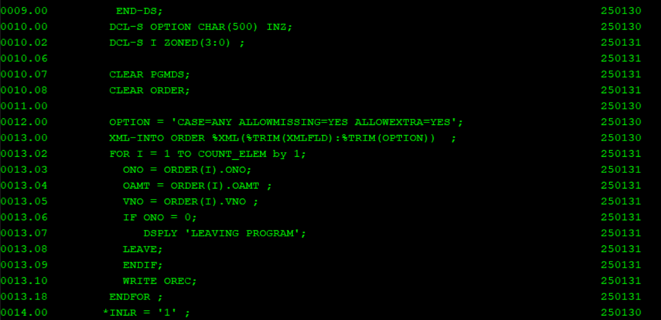

Using XML from IFS(Integrated File System)

First create a new file in the required directory using WRKLNK command

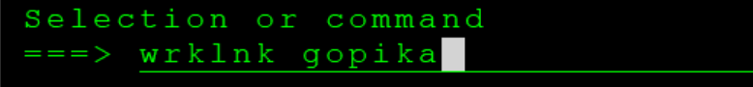

Choose option to to add files or edit residing files

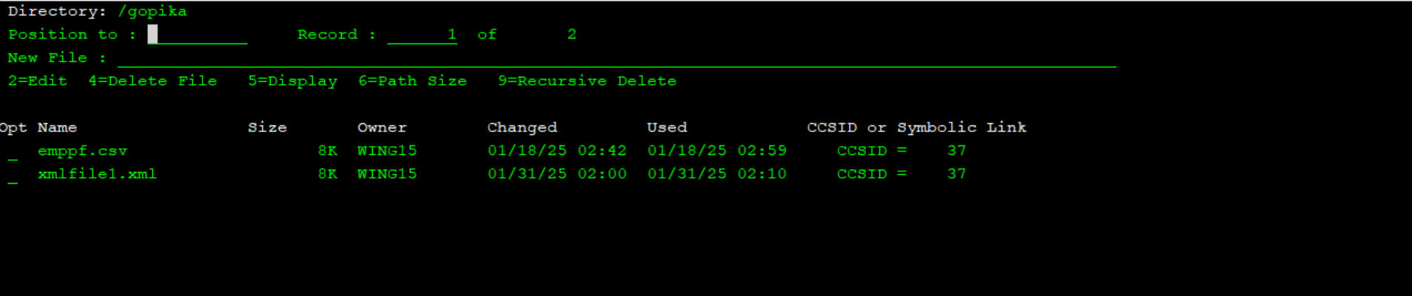

Give the name for the new file along with ‘.xml’ extension 🡪 ENTER 🡪 Add contents for new file🡪 press F3 to save or exit

Now define that filepath in the rpgle prgm , give options🡪doc=file and then call into that filepath

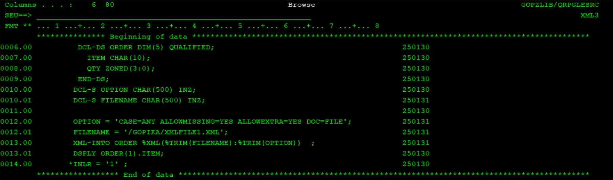

Create xml similar to vendor file details in ifs it should have vendor name, vendor address, vendor currency as tags and create free format sql rpgle program to fetch data from this xml to vendor table

Vendor no should be auto generated

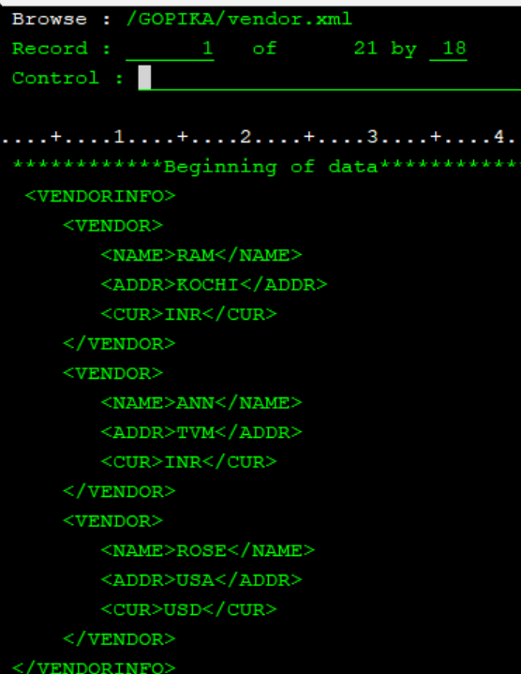

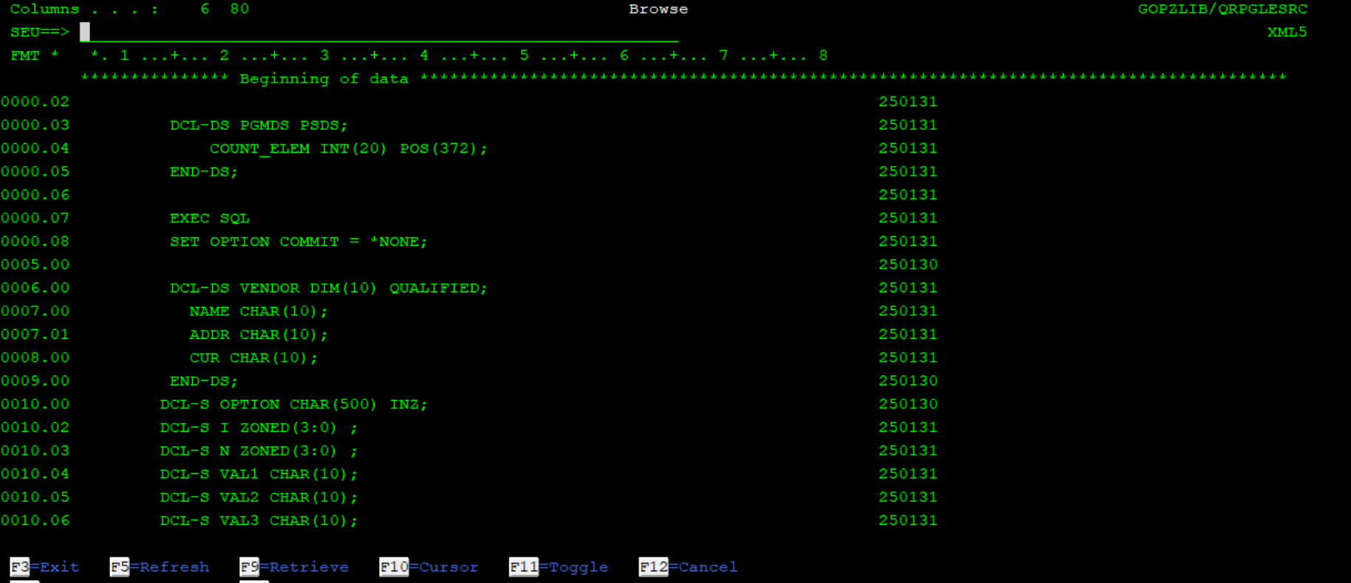

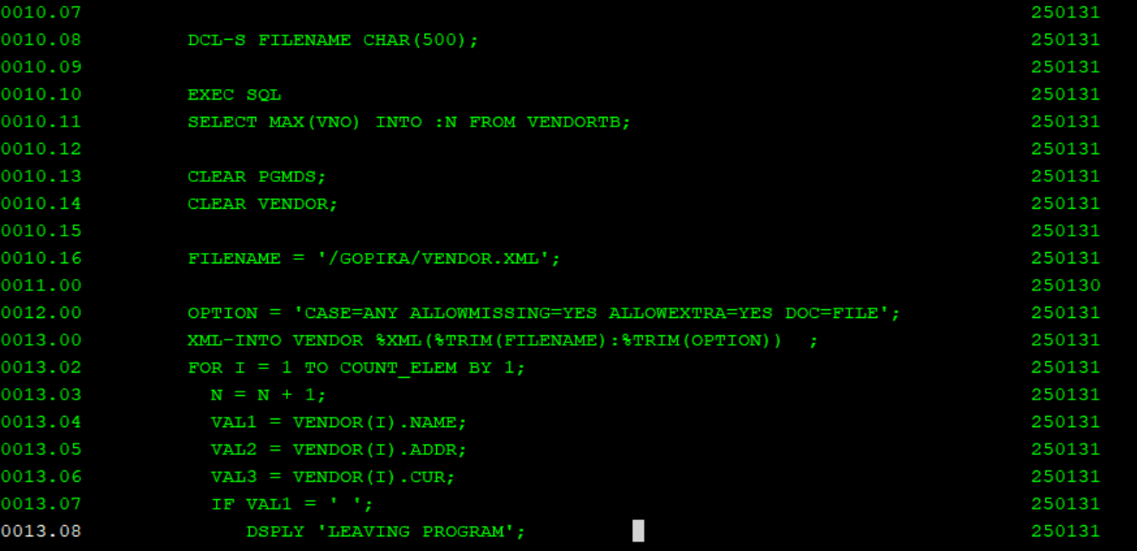

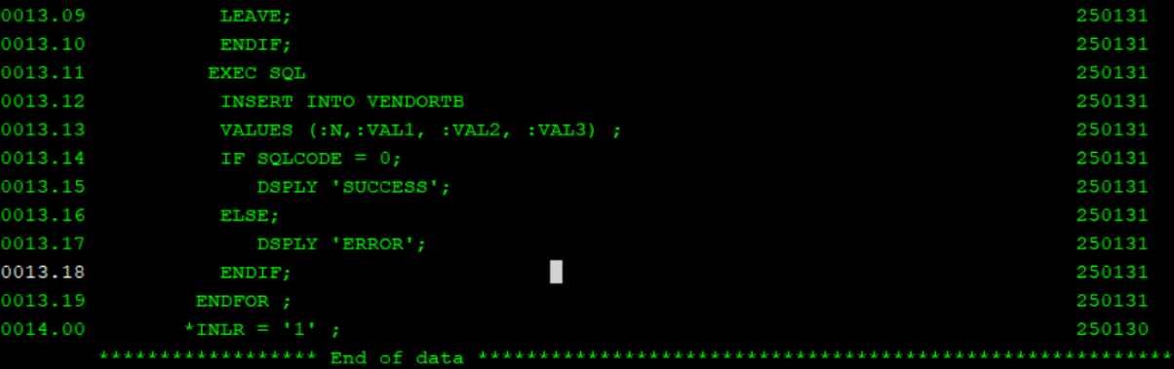

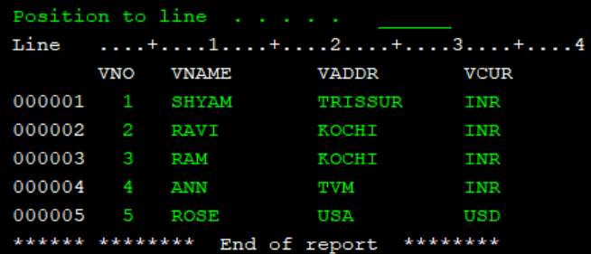

NAMESPACES🡪 REMOVE AND MERGE

Namespace are used to avoid name conflicts

Remove

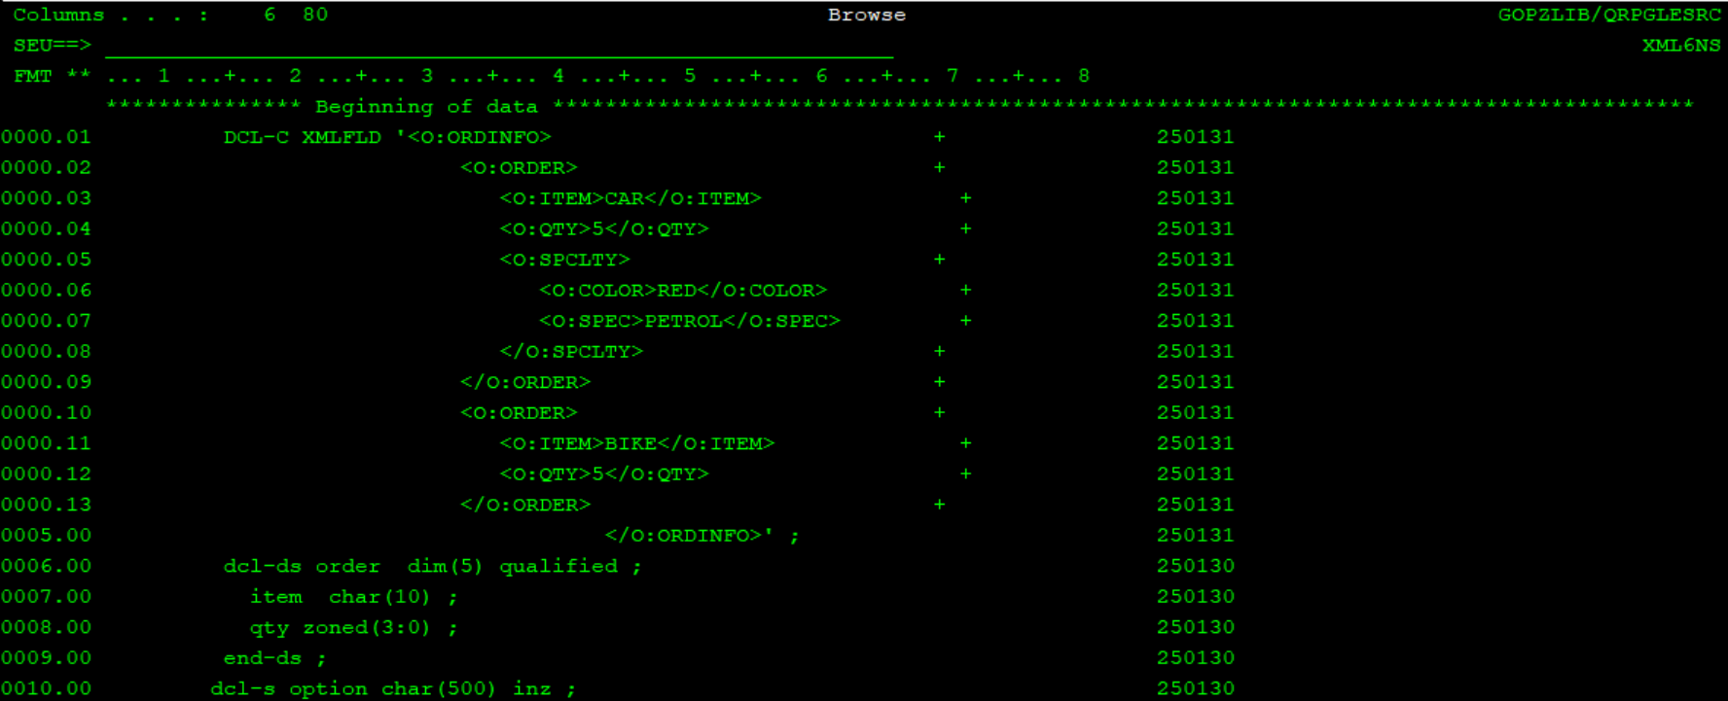

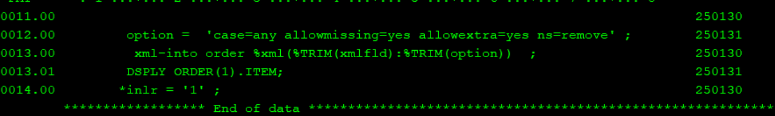

Merge

