**RLU: Report layout utility**

RLU is the tool which helps in designing reports in AS400.

RLU can be started by **STRRLU command** (similar to STRSDA for screen)

**Common function keys /Keyword to remember:**

**DR:** Define record.

VF: View fields.

F11: Define fields.

F16: Delete fields.

Keys for cut/copy/paste

F13: Mark/Unmark field/data

F14: Copy marked data.

F15: Move marked data.

F10: To refer fields directly from data base file.

F18: Record keywords (ca be used to rename record format name which was created earlier by default)

F17: File level keywords

F23: Field keywords

**STRRLU and press F4**

(Similar like SDA generates backend DDS source Screen, for reports RLU generates same). You need to give source physical file name and member name (Same as printer file name).

It is same as we do for other sources.

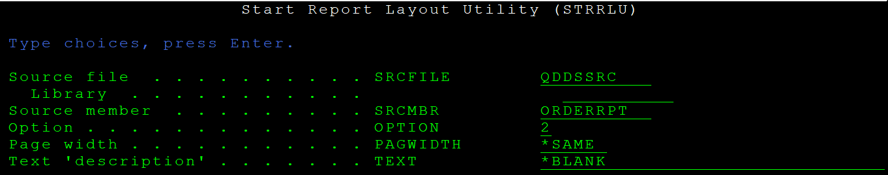

This Kind of window will come . Initially it will expanded full screen view ,after pressing enter it will shrink like below.

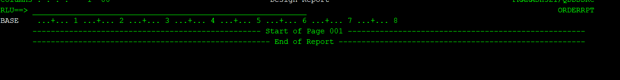

We need to define records first and then divide that records into fields.

**Use DR to define format.**

Consider below layout for header.

PAGE : 1 Order Detail report ‘Date:’

Press I + Enter

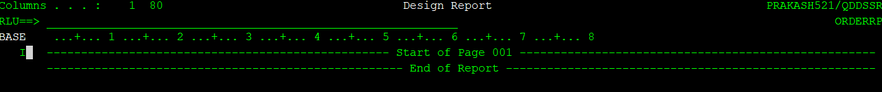

Then in blank dotted lines give DR to define record format.

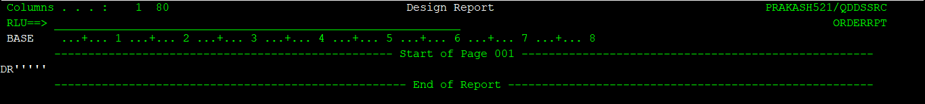

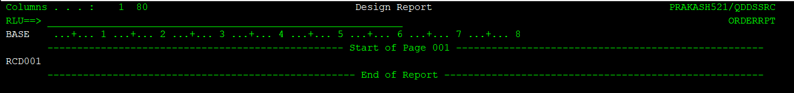

**For adding fields and heading right VF (View fields and press enter)**



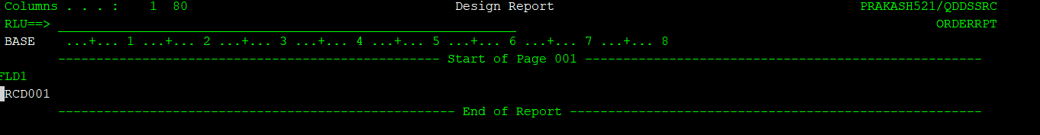

Now add fields in FLD1 line this is field place for this record.

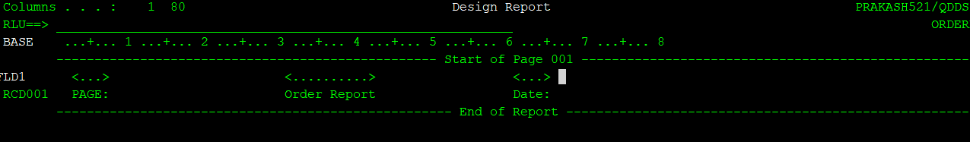

Now add PAGE and date fields to contain actual Page no and current date values. Place a cursor next to headings where we need field to appear and press F11 to define field

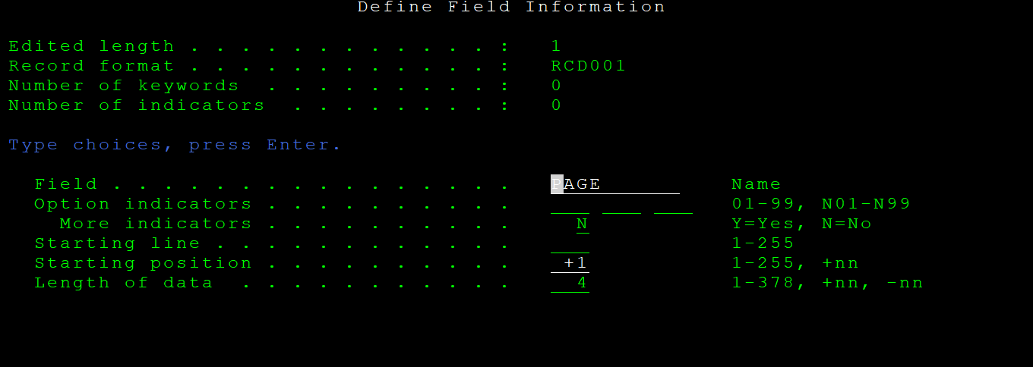

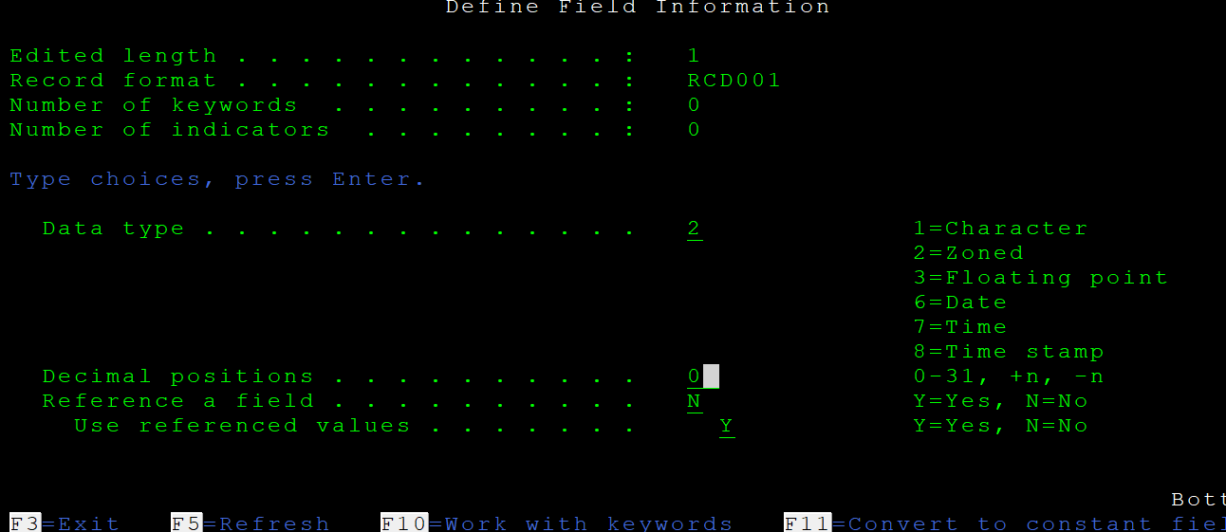

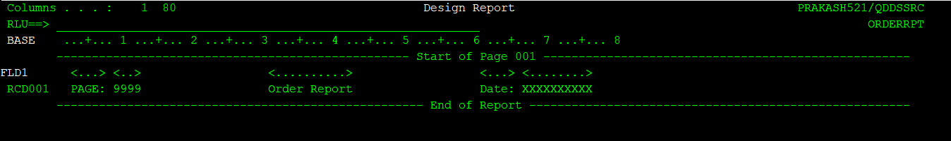

**For date type is 6 don’t give length decimal position when defining length field.**

Now you need to rename record format, which we will use in rpgle pgm for writing(except/WRITE)

ON RCD001 press F18 (SHIFT + F6) for record level keywords.

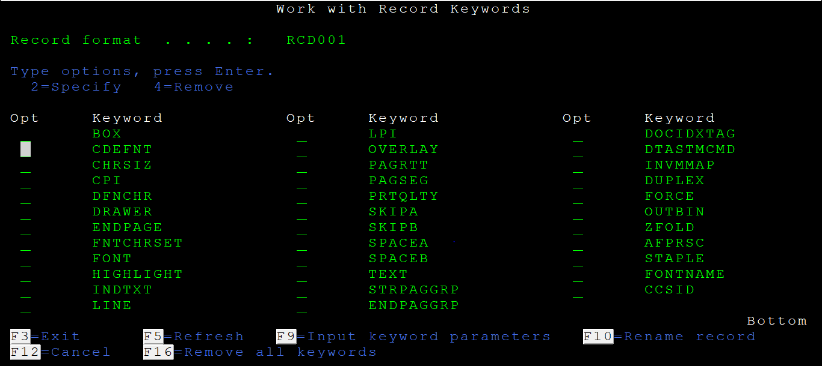

Press F10 in this screen to rename. You can use other keywords also based on need, most commonly used keywords are SKIPA/SKIPB/SPACEA/SPACEB

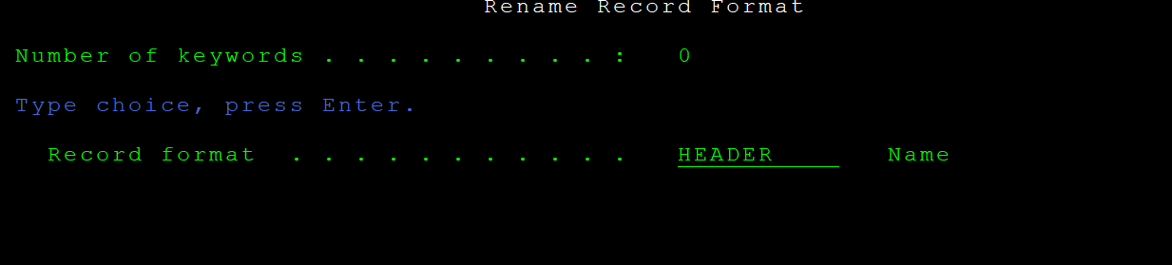

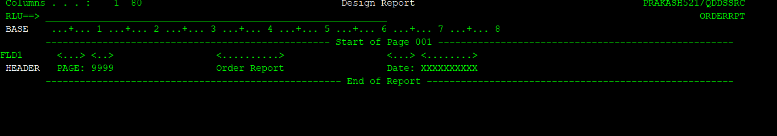

SIMILARLY define other header for headings.

Again type DR and press enter. Then VF to view fields.

Again rename shift +f6 then F10

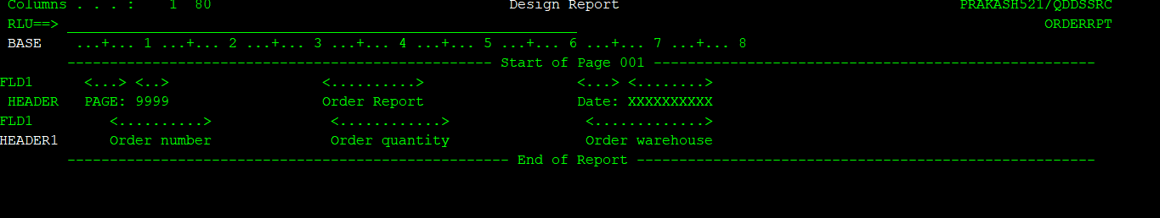

Now give field detail records. You can take definition from data base file or you can define your own field.

If you are defining own field add record format and fields like before.

If you are adding definition from database from data

**Press F10 to get from data base.**

If we need to do any modifications or alterations to report use option 19 from PDM menu

**SKIPA/SKIPB**

**SPACEA/SPACEB**

**Spaceb(3)**

SKIPA (Skip After) keyword in printer files

You use this file-level, record-level, or field-level keyword to specify that the printer device is to skip to a specific line number after it prints one or more lines.

The format of the keyword is:

SKIPA(skip-after-line-number)

The parameter value is required and must be in the range 1 through 255.

If you specify the keyword at the record level, skipping is performed after all the lines associated with the record print and before any file-level SKIPA keywords are applied.

# SKIPB (Skip Before) keyword in printer files

The format of the keyword is:

SKIPB(skip-before-line-number)

The parameter value is required and must be in the range 1 through 255.

If you specify this keyword at the record level, skipping is performed before any of the lines associated with that record print.

# SPACEA (Space After) keyword in printer files

You use this record-level or field-level keyword to specify that the printer device is to space some number of lines after it prints one or more lines.

The format of the keyword is:

SPACEA(space-after-value)

The parameter value is required and must be in the range 0 through 255.

If you specify this keyword at the record level, spacing occurs after all lines associated with that record are printed. You can specify this keyword only once at the record level and once for each field.

If you specify SPACEA at the field level, spacing is performed after the field is printed.

# SPACEB (Space Before) keyword in printer files

Last Updated: 2021-04-14

You use this record-level or field-level keyword to specify that the printer device is to space some number of lines before it prints the next line or lines.

The format of the keyword is:

SPACEB(space-before-value)

The parameter value is required and must be in the range 0 through 255.

If you specify this keyword at the record level, spacing occurs before any lines associated with that record are printed. You can specify this keyword only once at the record level or once for each field.

If you specify SPACEB at the field level, spacing is performed before the line containing that field prints.

This keyword is not valid for records with specified line numbers (positions 39 through 41). (The line numbers are flagged as errors.)

**Note:** If you do not use line numbers and do not specify space or skip keywords, overprinting can result.

Option indicators are valid for this keyword.

## **Example**

The following example shows how to specify the SPACEB keyword.

|...+....1....+....2....+....3....+....4....+....5....+....6....+....7....+....8

00010A FIELDA 25A 55SPACEB(3)

00011A FIELDB 30 100

A

**Sample program which generates report for reference:**

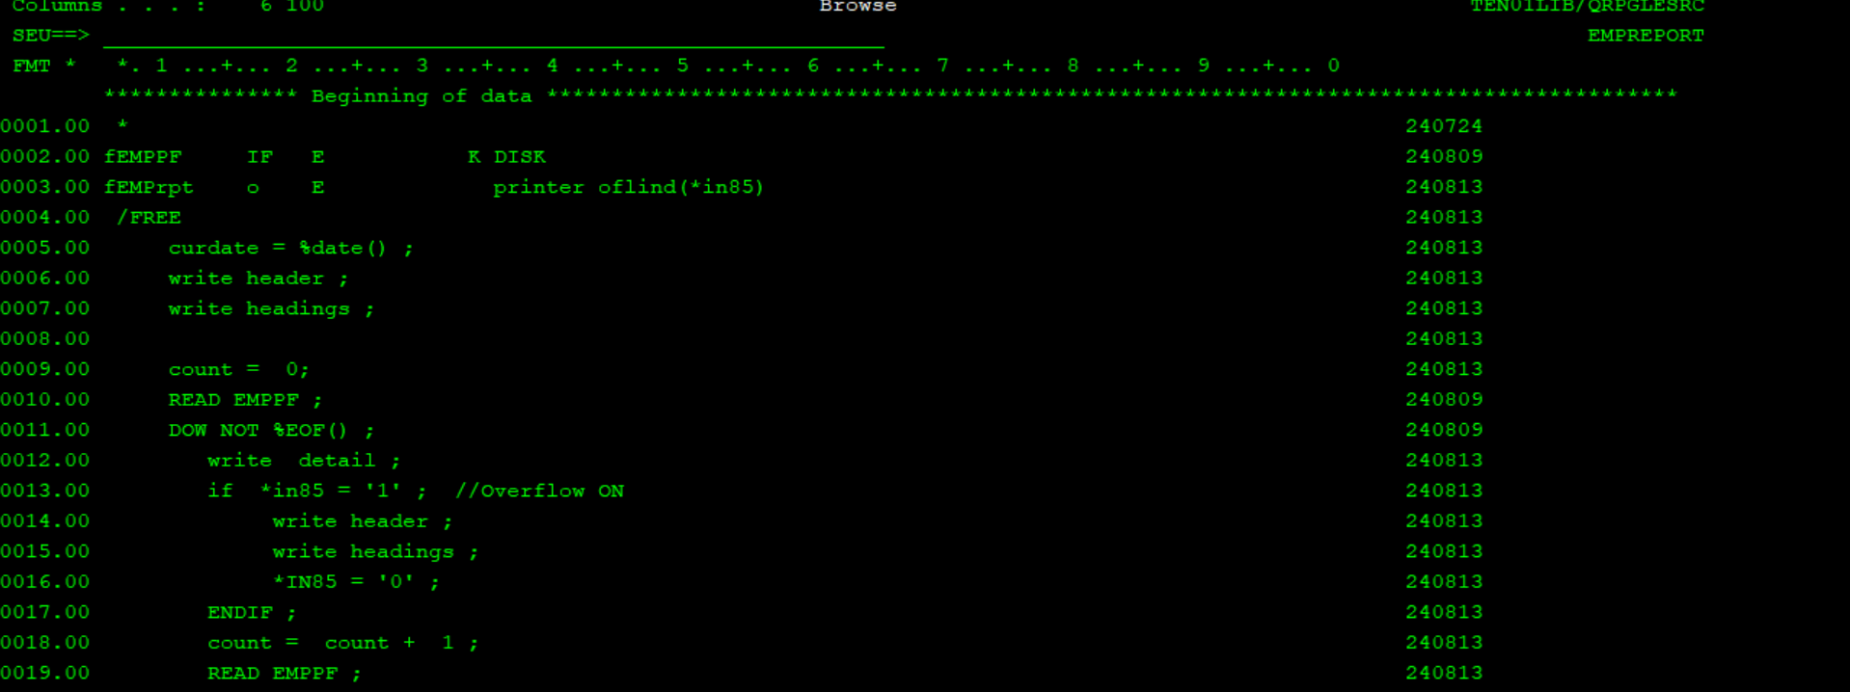

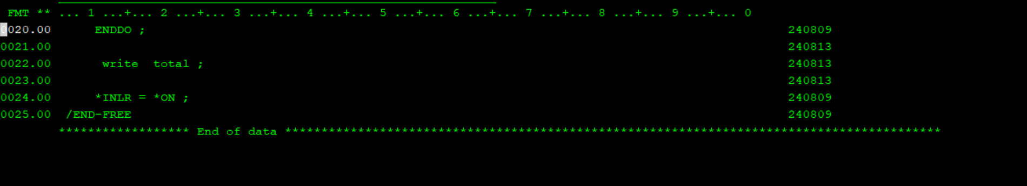

Once this program is called spool file will get generated with name EMPRPT.