**SCROLLABLE_CURSOR**

**Display last 5 transactions of a particular account number.**

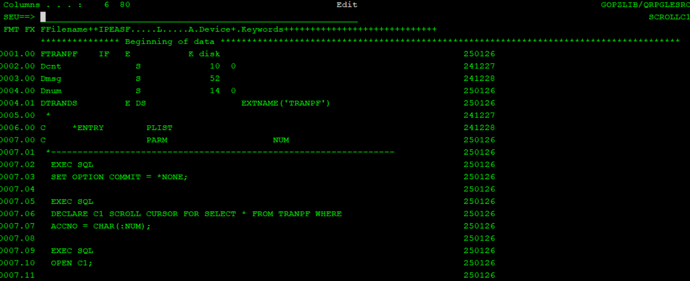

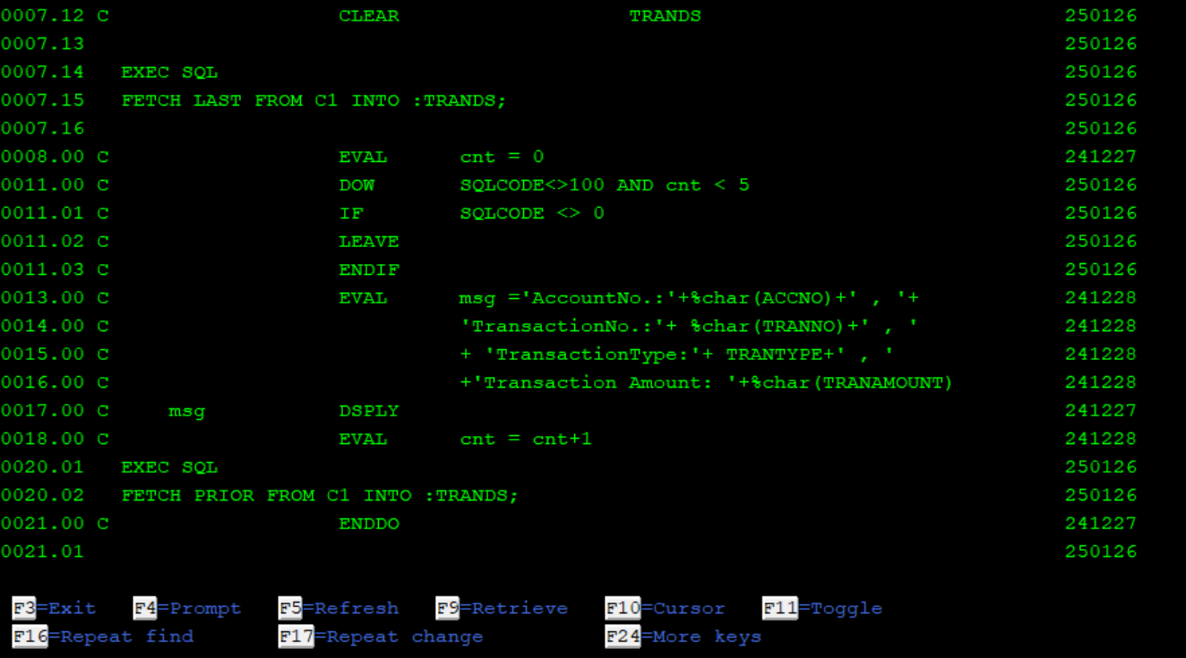

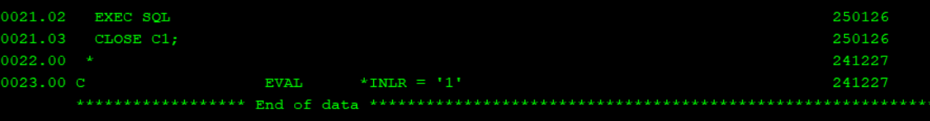

Date should be a proper date, else data mapping error will come at runtime.

In subfile

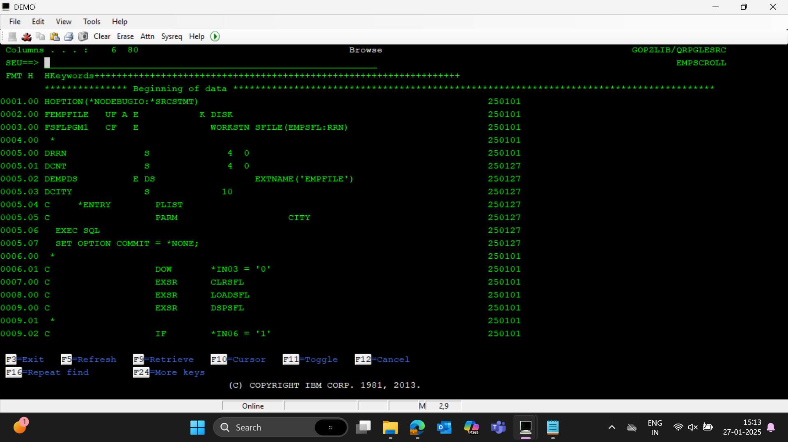

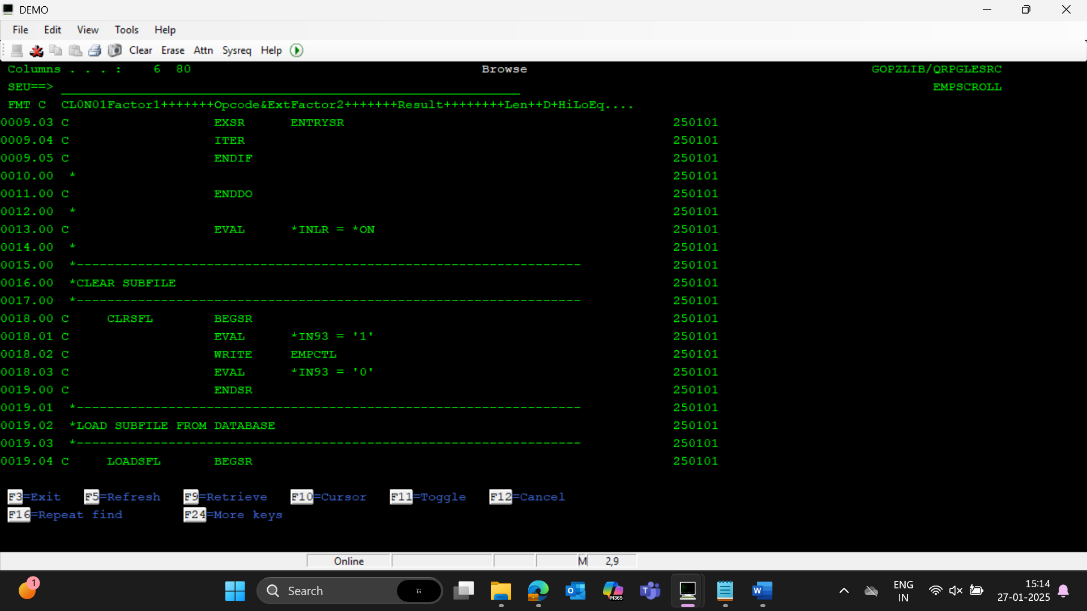

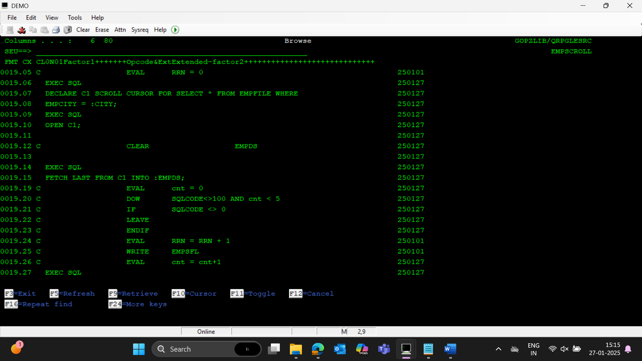

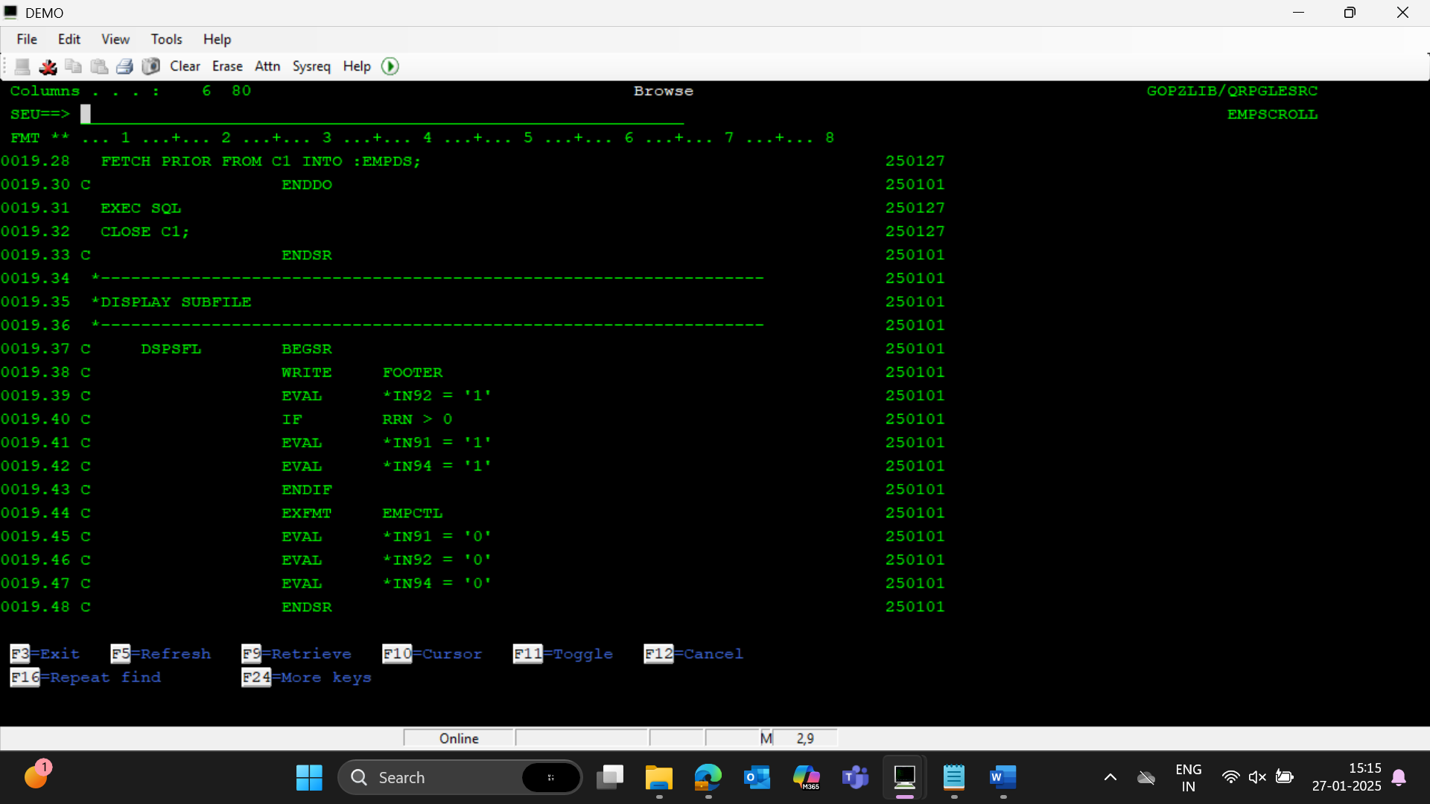

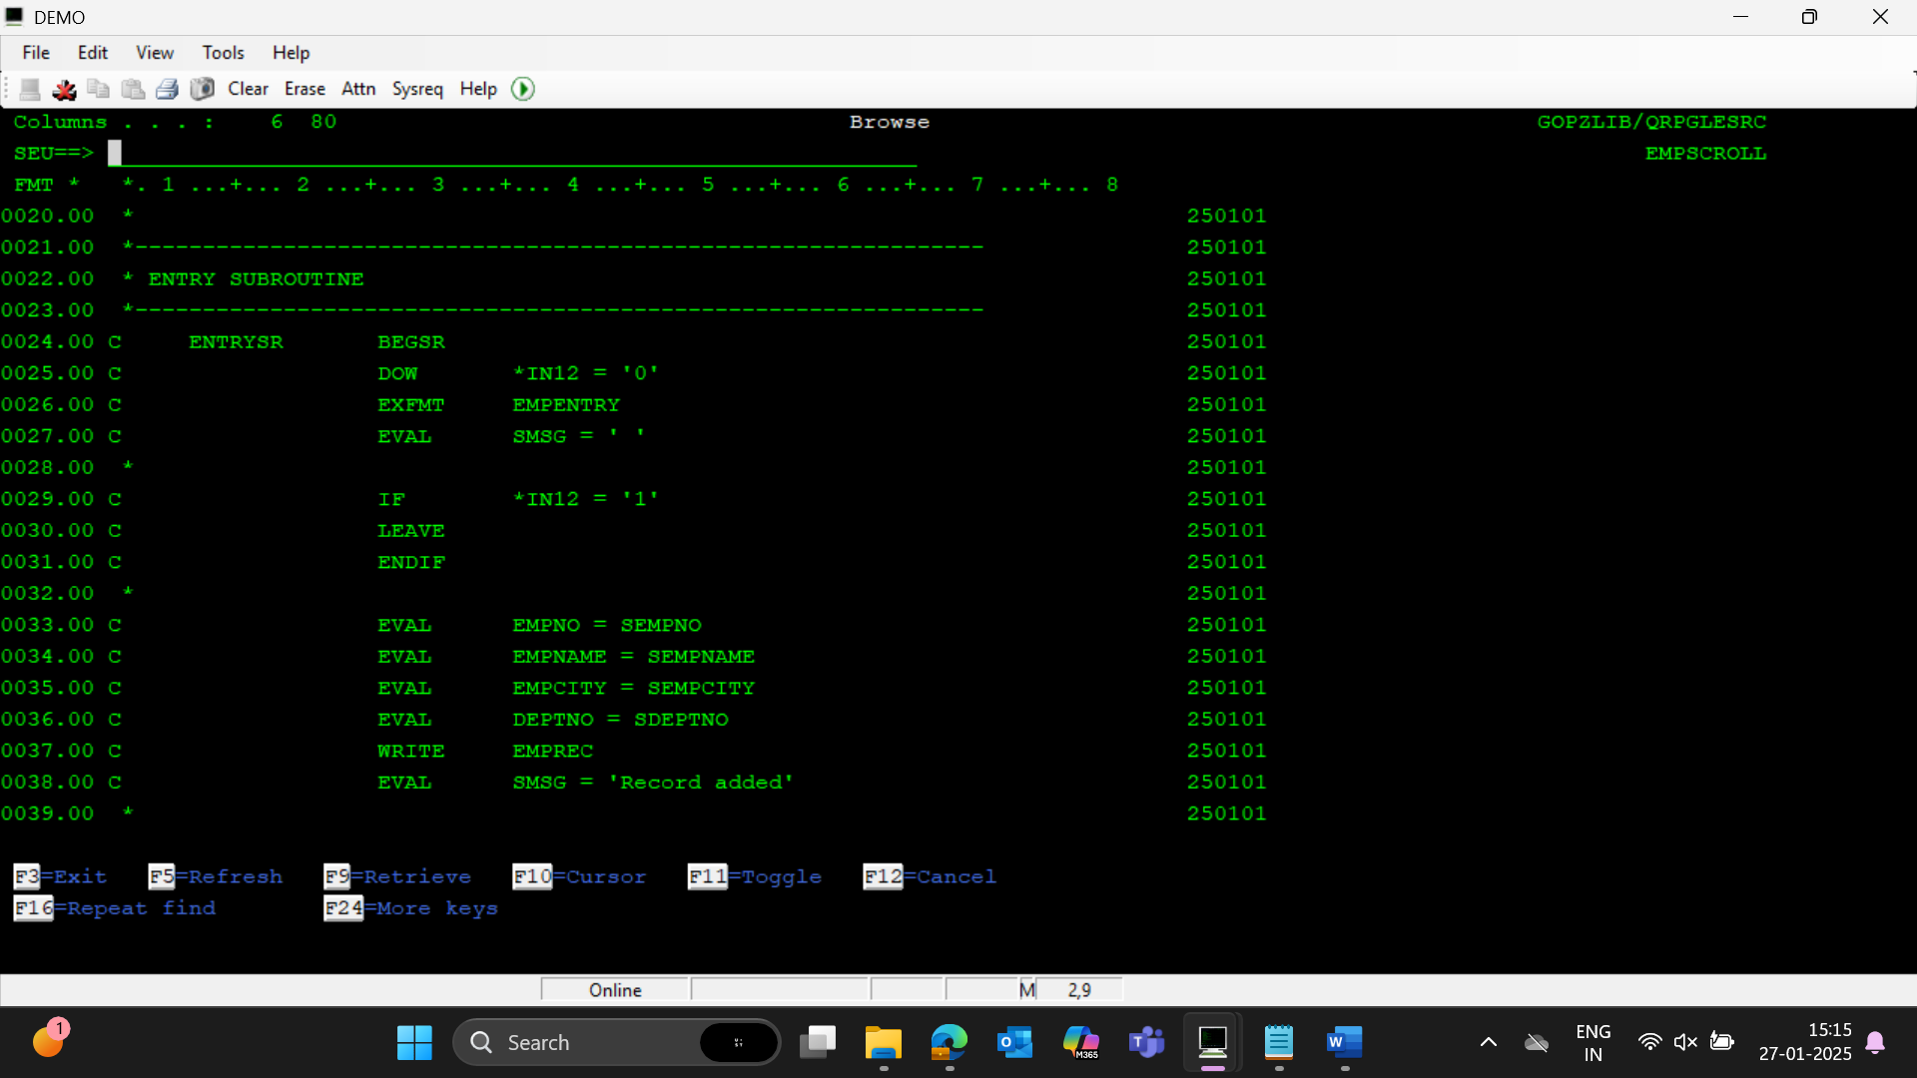

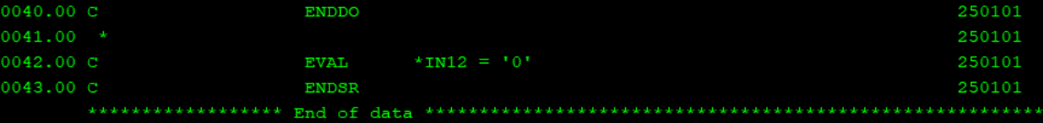

**JOURNALING**

STEP1 : Create journal receiver using CRTJRNRCV command

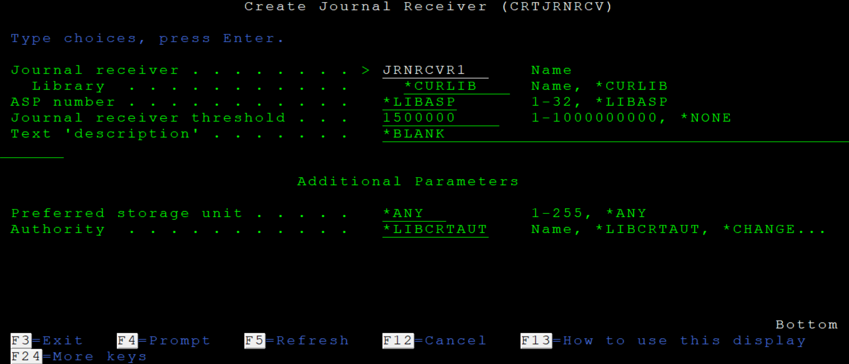



STEP2 : Create journal using CRTJRN command

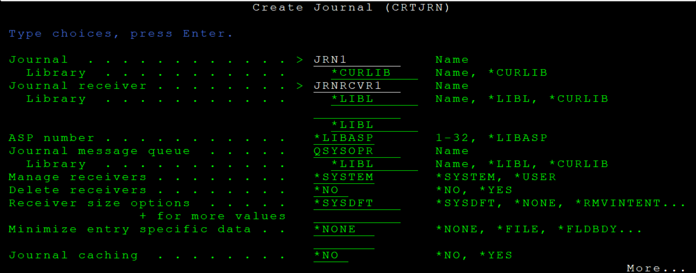 

STEP 3 : Jornal the required pf file using STRJRNPF command

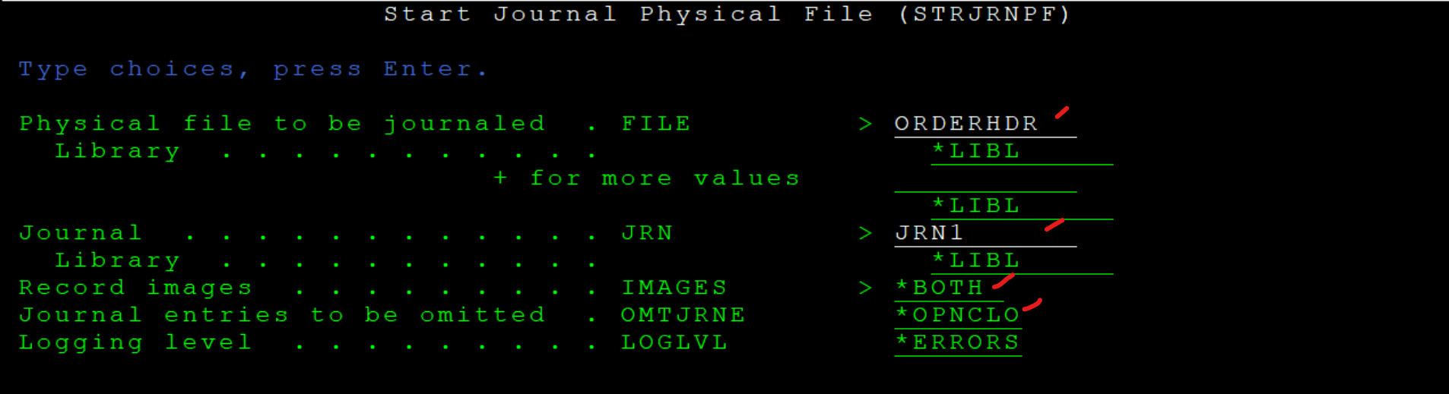



In case, to end journaling of all the files attached to a particular journal:

ENDJRNPF command

