**SQL ASSIGNMENT**

Gopikrishnan V Kaimal

2237008

**MURDER MYSTERY GAME**

A crime has taken place and the detective needs your help. The detective gave you the crime scene report, but you somehow lost it. You vaguely remember that the crime was a **​murder​** that occurred sometime on ​**Jan.15, 2018​** and that it took place in ​**SQL City​**. Start by retrieving the corresponding crime scene report from the police department’s database.

**QUERIES**

1. select * from crime_scene_report where date= 20180115 AND type = "murder" AND city= "SQL City"

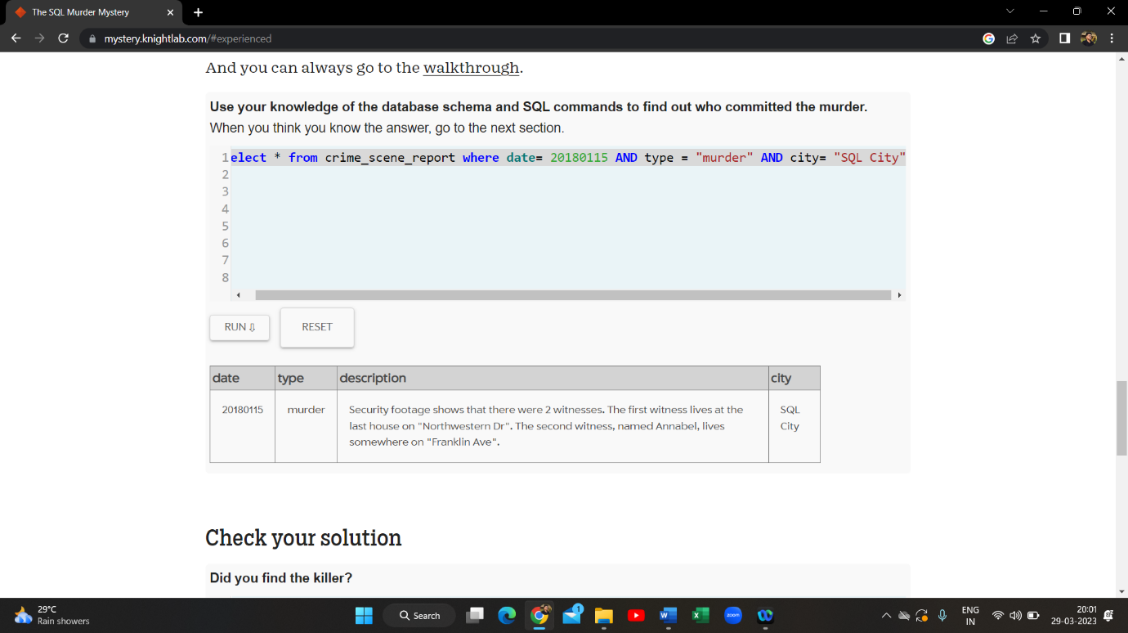

1. select * from person where address_street_name = "Northwestern Dr" or name = "Annabelle"

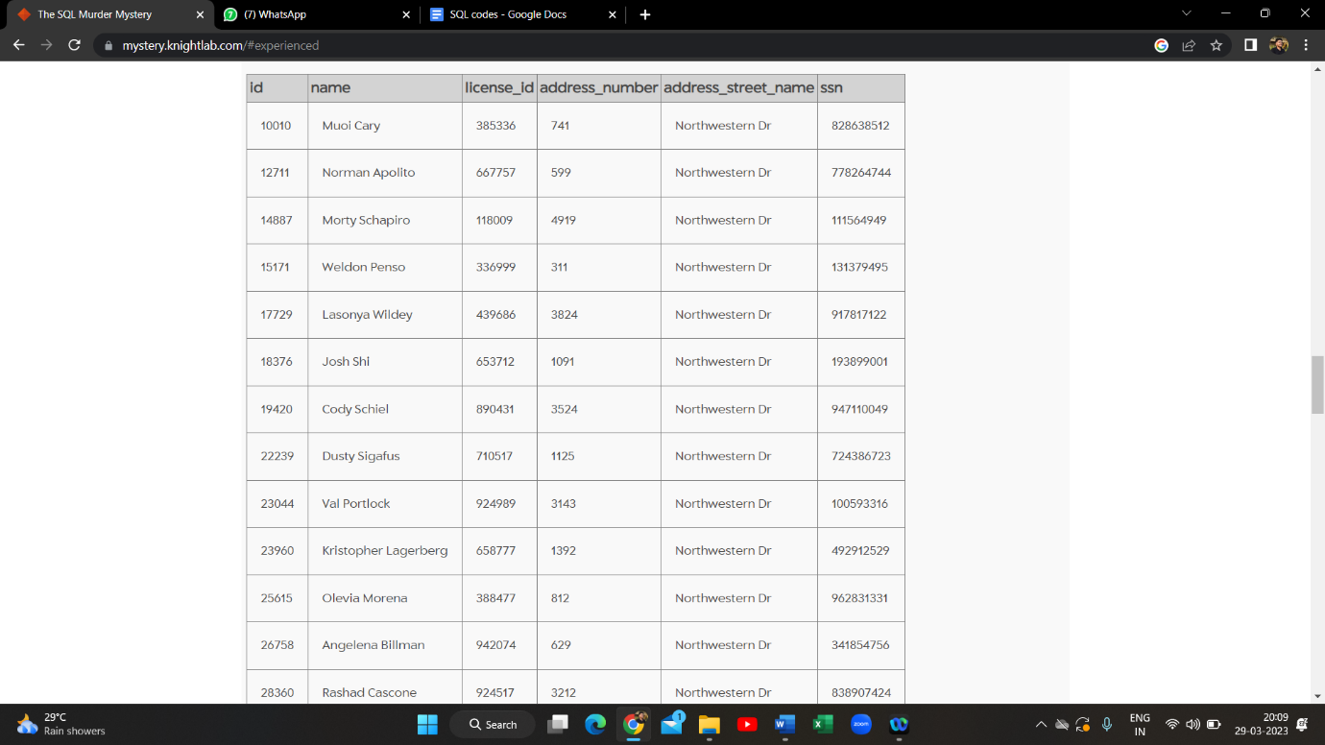

1. select * from facebook_event_checkin where date = 20180115

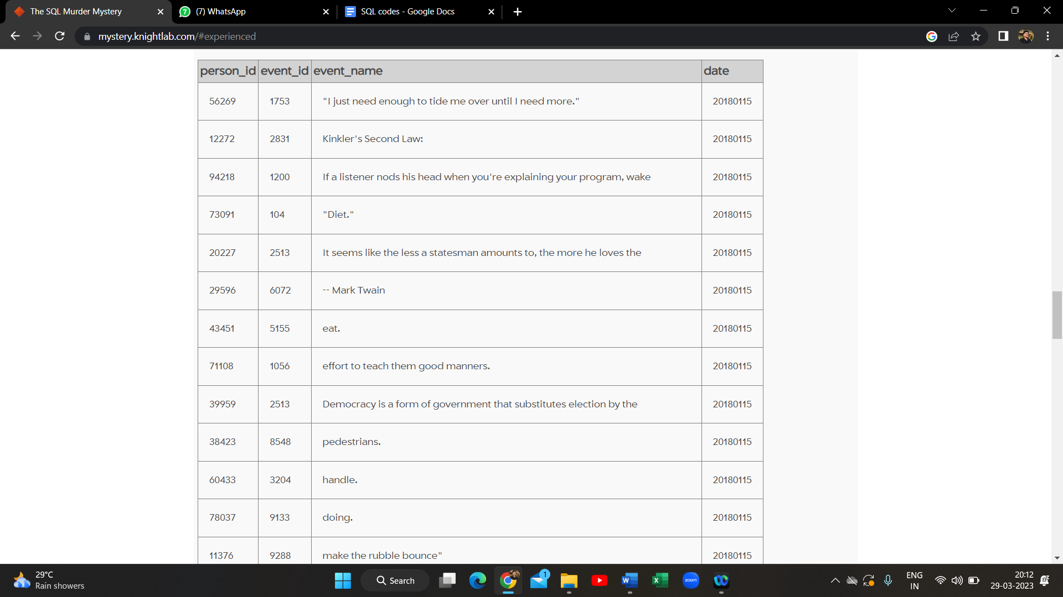

1. select * from get_fit_now_check_in where check_in_date = 20180115

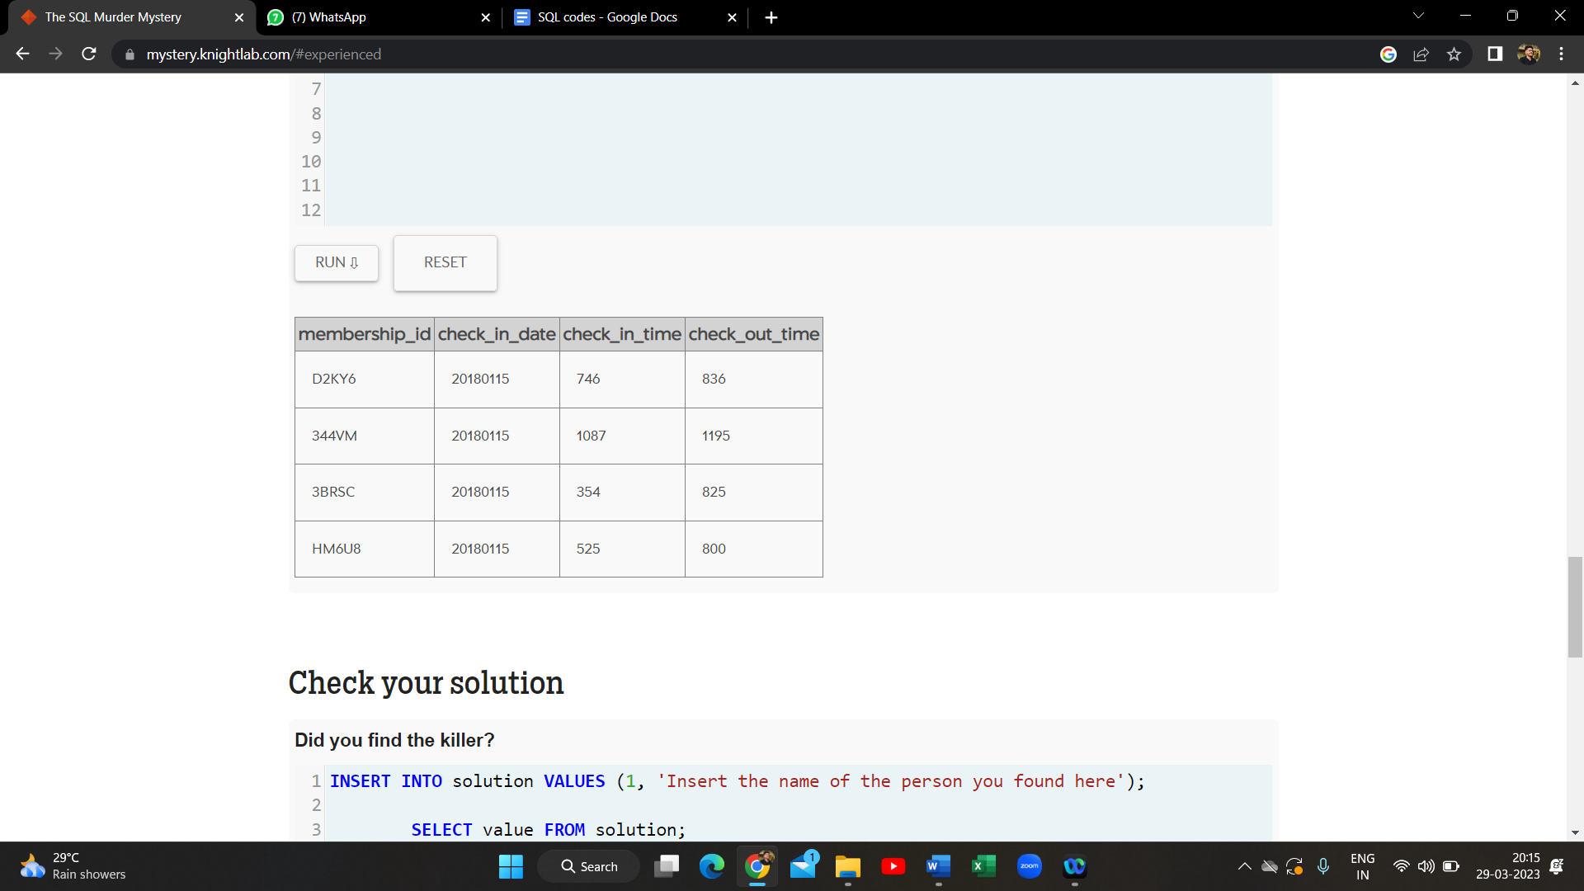

1. select * from person P Join drivers_license D ON P.license_id = D.id

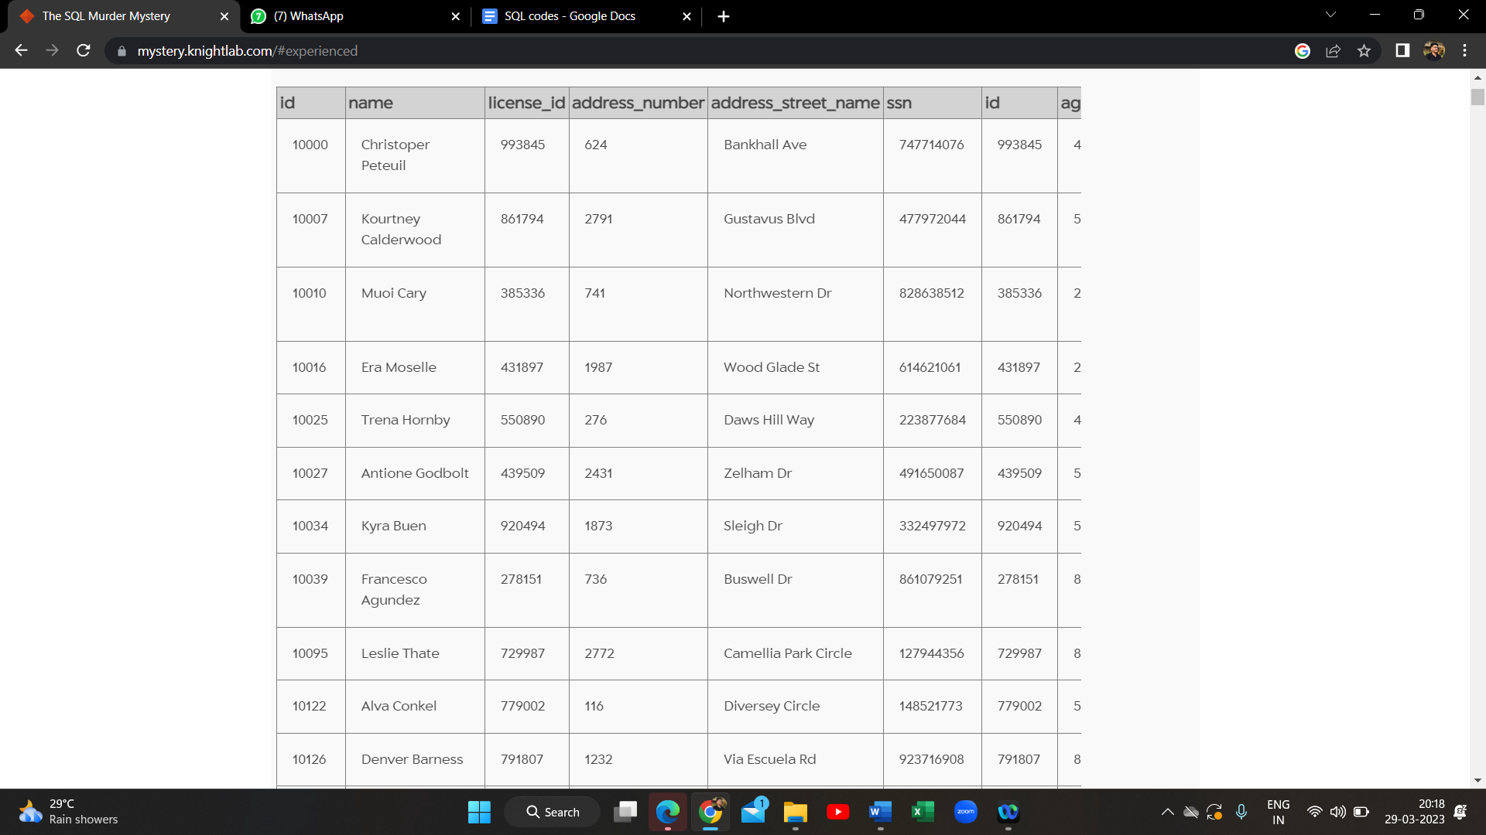

1. select name, address_street_name, license_id from person P Join drivers_license D ON P.license_id = D.id where address_street_name in("Northwestern Dr", "Franklin Ave")

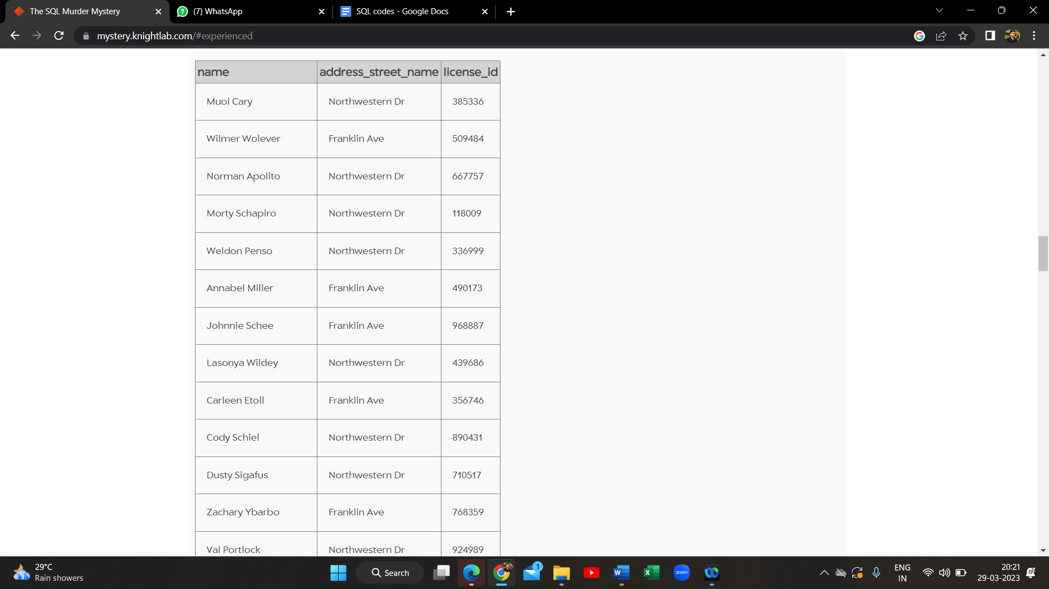

1. select * from person where name = "Annabel Miller"

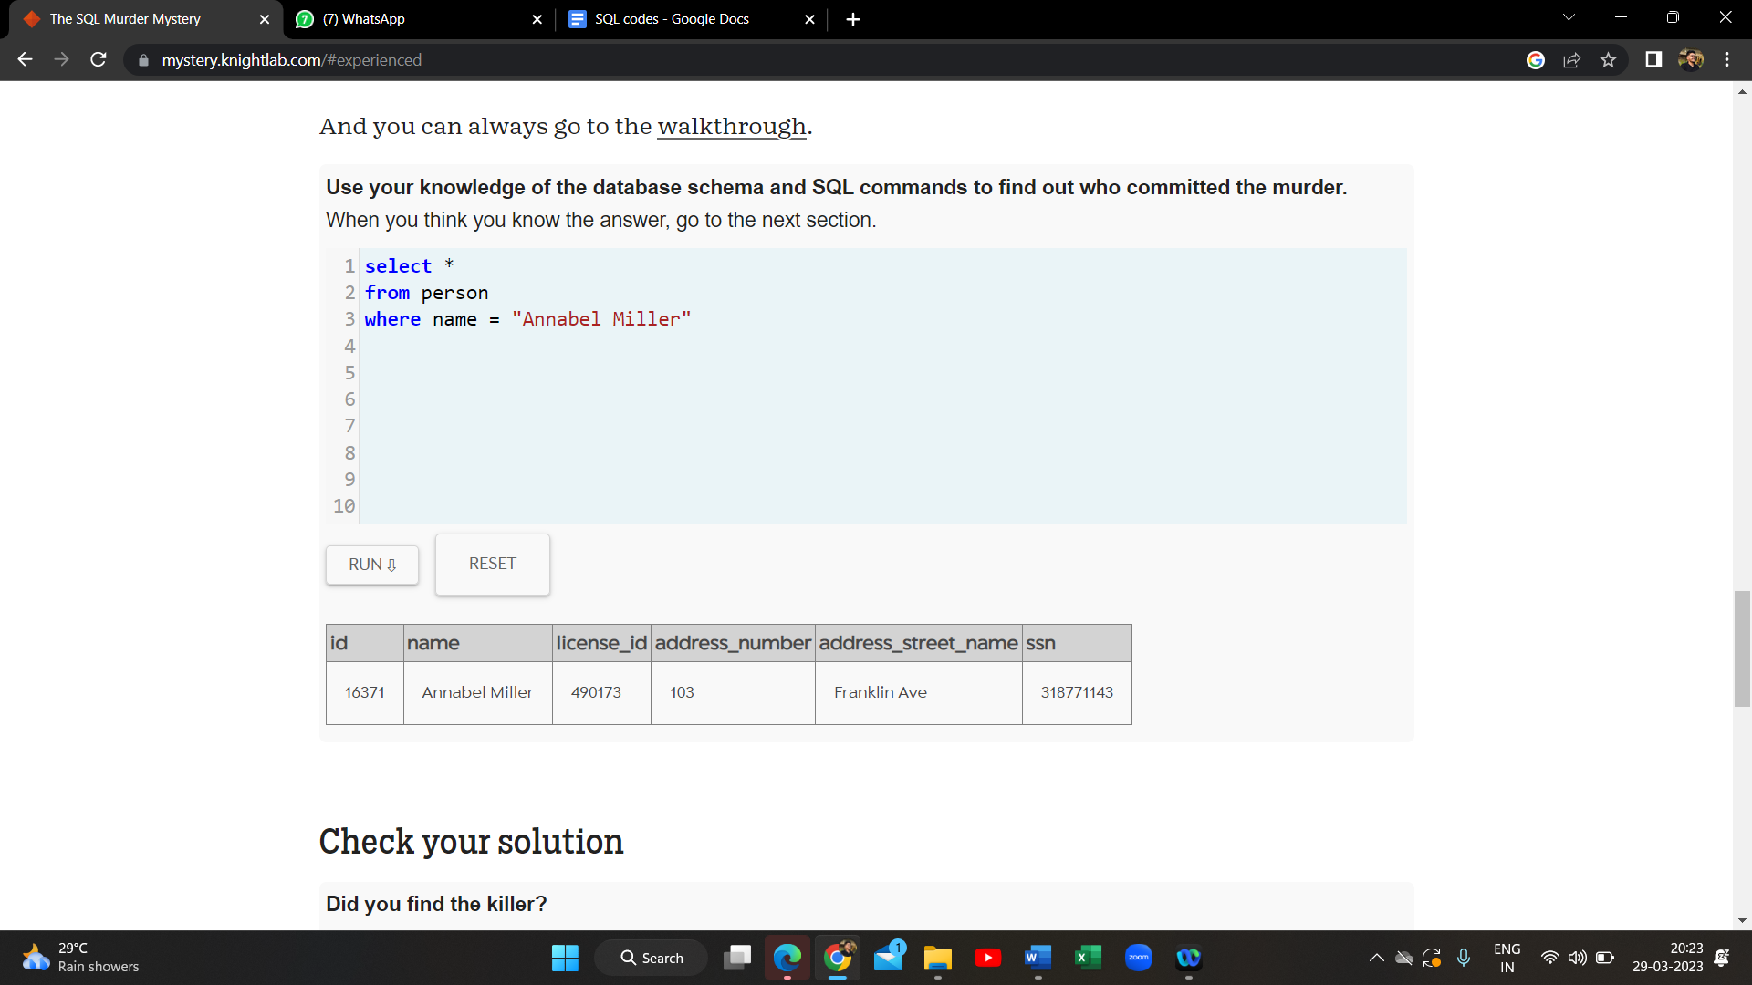

1. select * from facebook_event_checkin where person_id = 16371

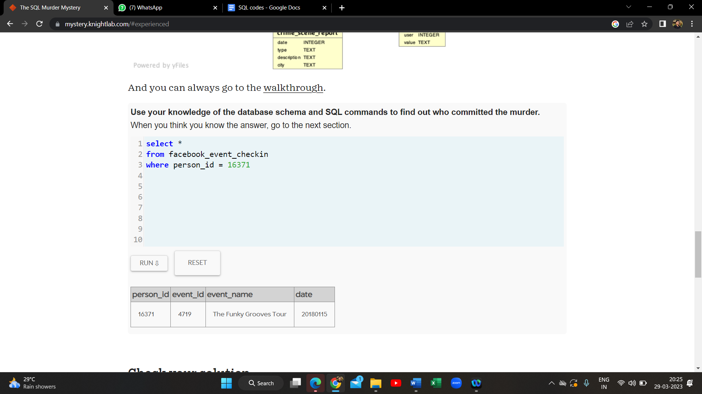

1. select * from facebook_event_checkin where event_id = 4719 AND date = 20180115

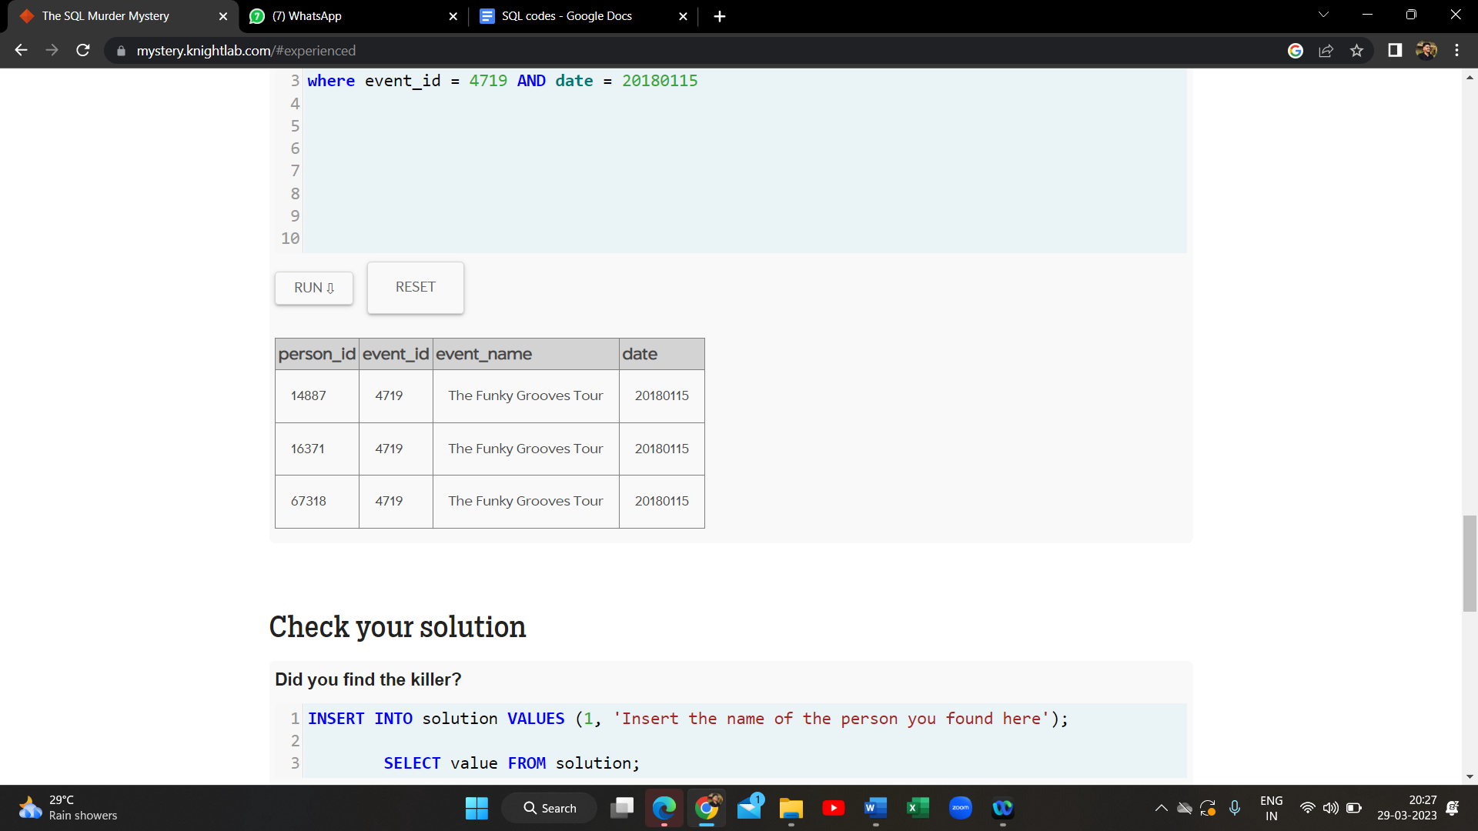

1. select * from person Where id in(14887,16371,67318)

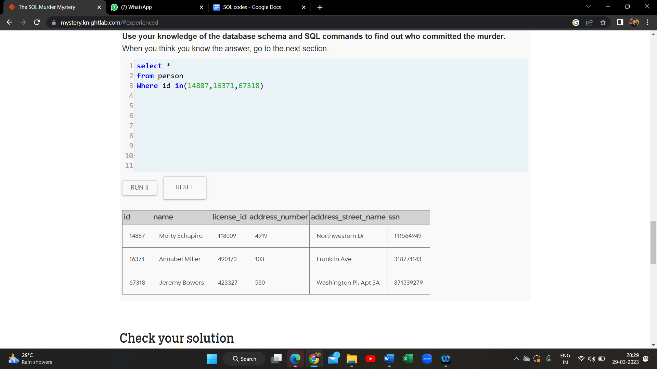

1. select * from interview where person_id = 67318

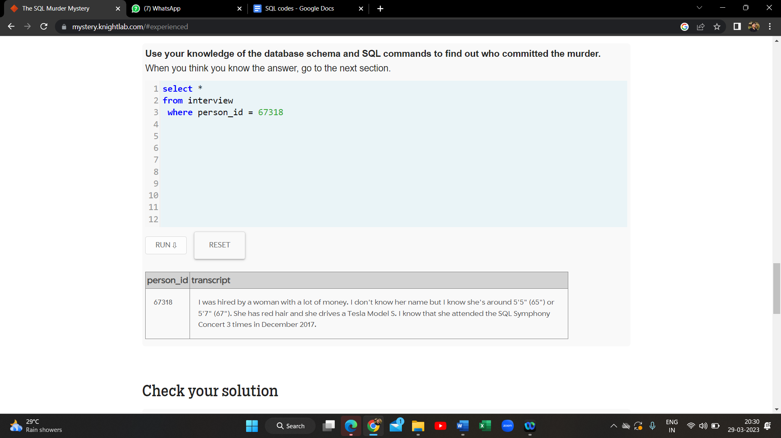

1. select * from drivers_license where hair_color = "red" AND car_make = "Tesla"

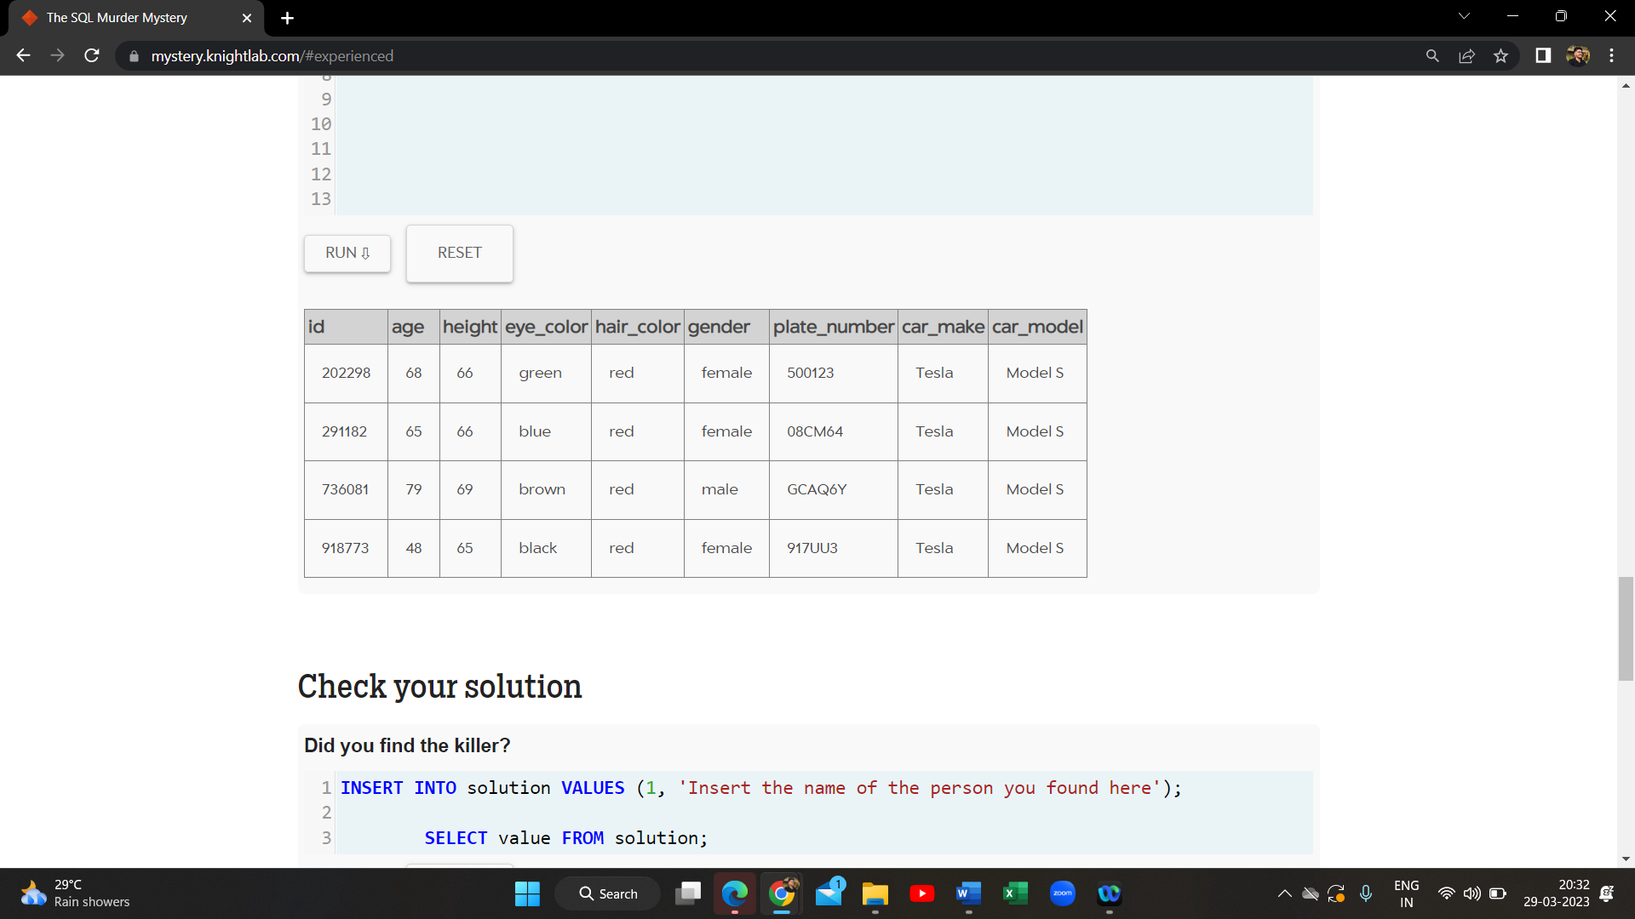

1. select * from person P join drivers_license D ON P.license_id = D.id where hair_color ="red" AND car_make = "Tesla"

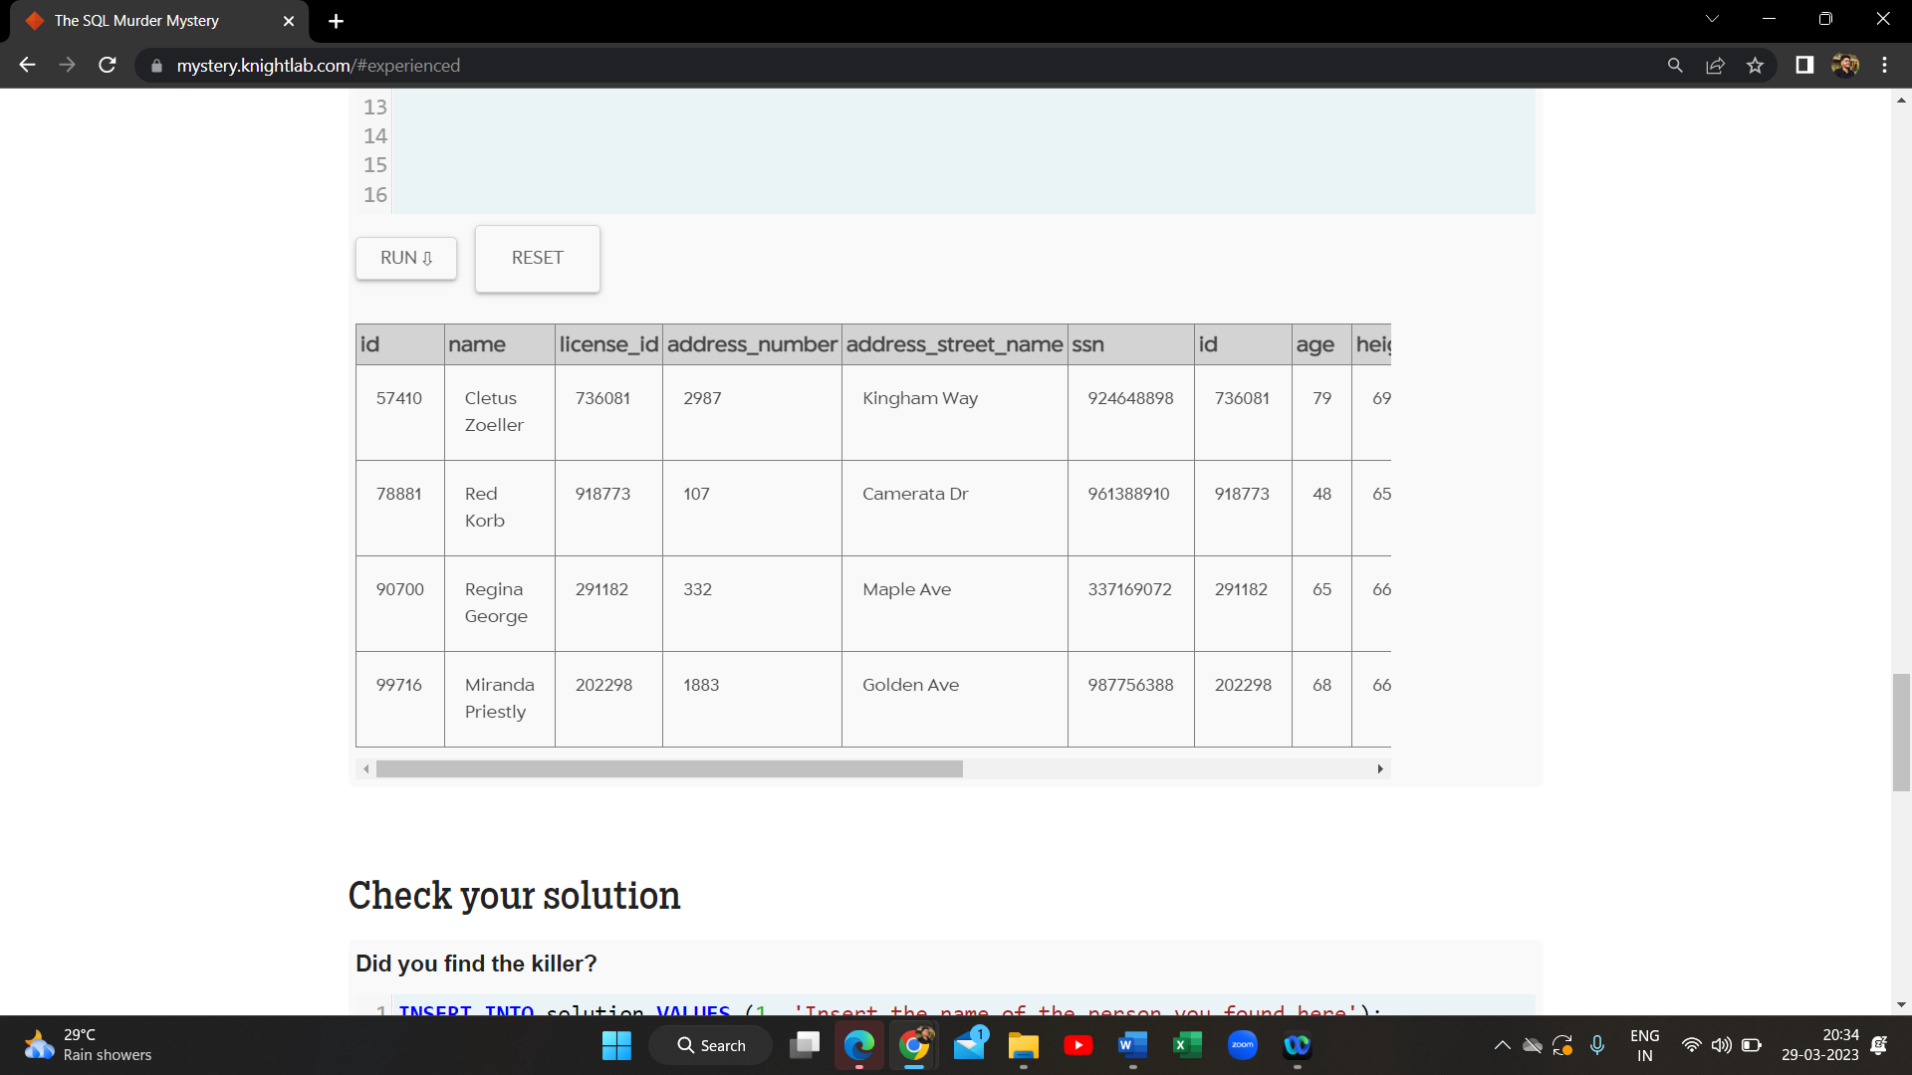

1. select * from facebook_event_checkin where date LIKE "201712%" AND event_name = "SQL Symphony Concert"

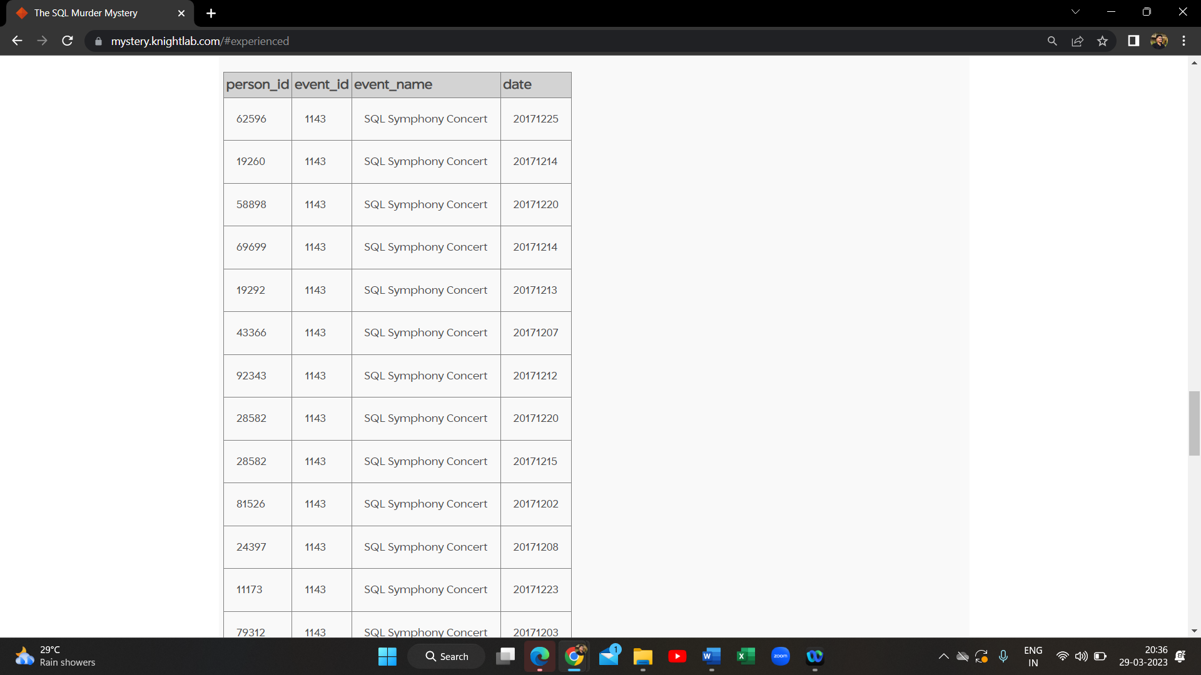

1. Create table redhair_tesla as select name, address_street_name, license_id from person P Join drivers_license D ON P.license_id = D.id where hair_color = "red" AND car_make = "Tesla"

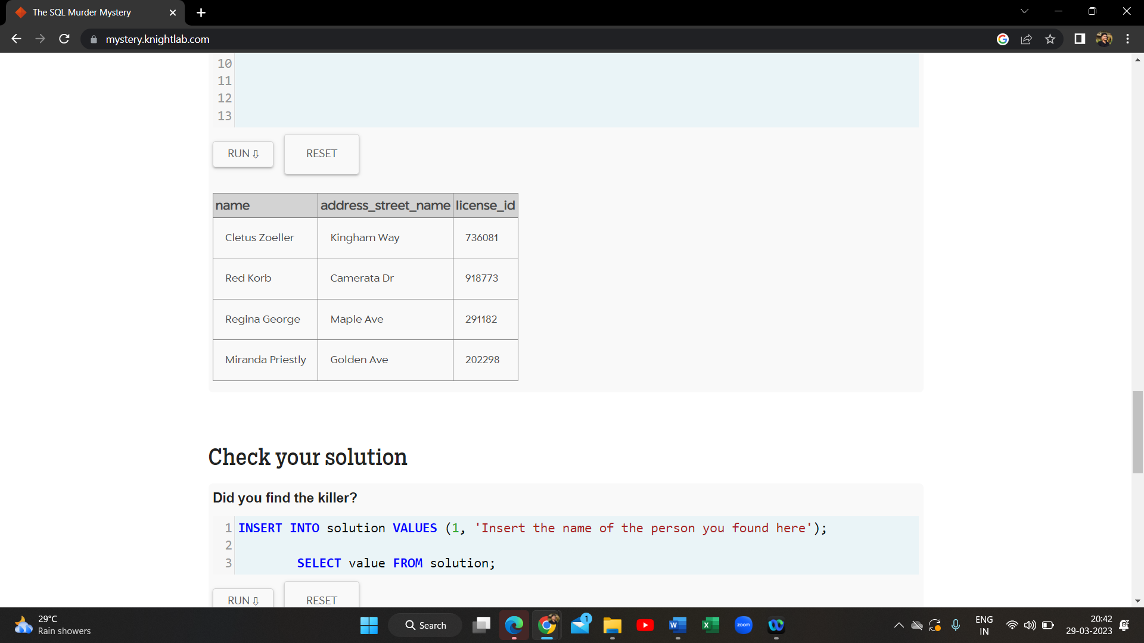

1. select * from redhair_tesla2 R join facebook_event_checkin F ON R.id = F.person_id

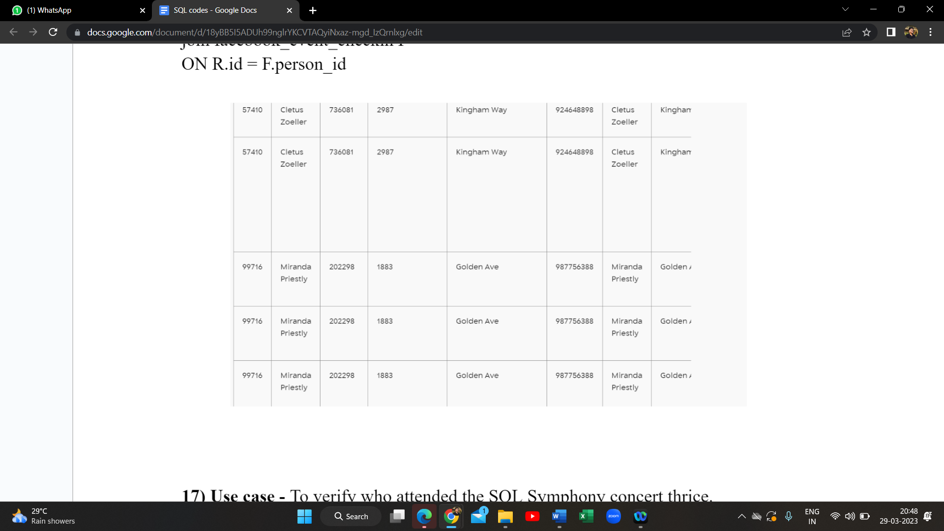

1. select * from redhair_tesla2 R join facebook_event_checkin F ON R.id = F.person_id where event_name = "SQL Symphony Concert"

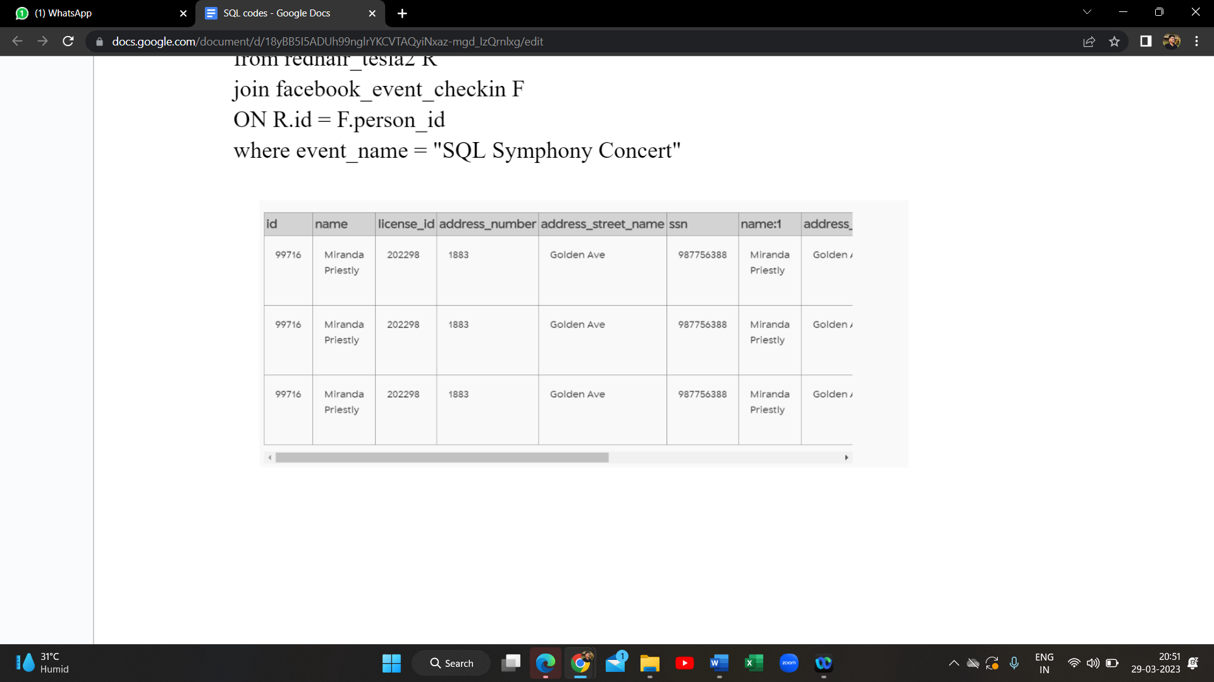

**SOLUTION**

1. INSERT INTO solution VALUES (1, 'Miranda Priestly'); SELECT value FROM solution;

