**Testing**

**Step 1: Uploaded a sample csv file inS3 Bucket**

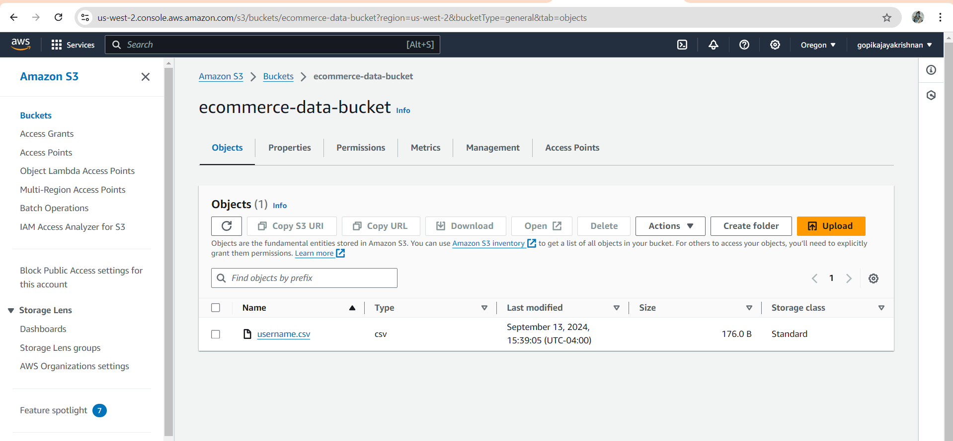

Step 2: In AWS Glue console and I start the Glue Crawler manually.

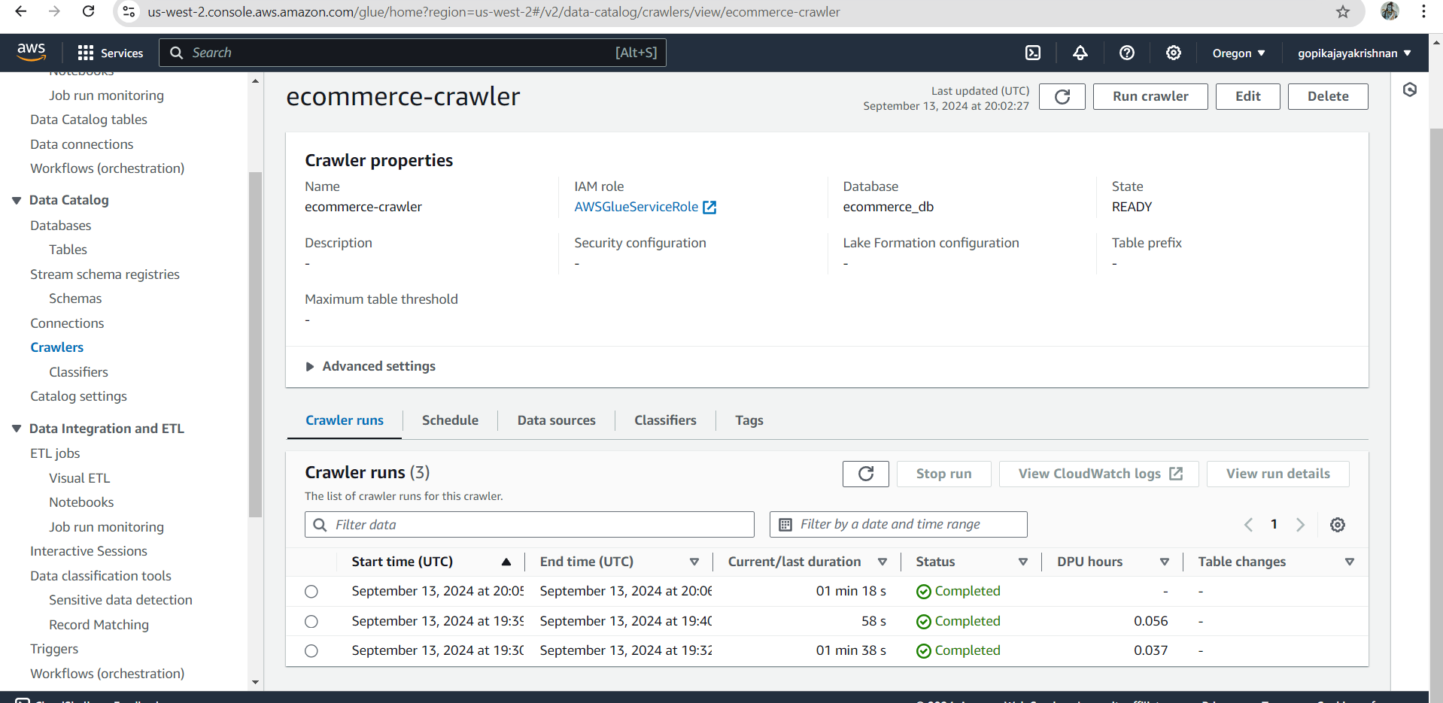

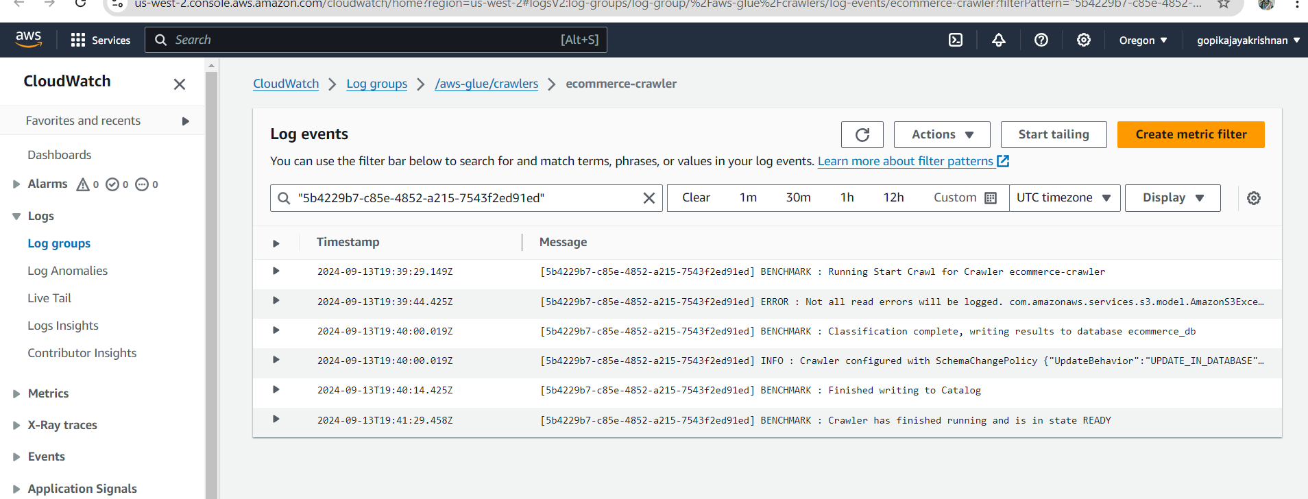

Added the table

