

SkyControl: A Hybrid AI-Assisted Air Traffic Management System
Closing Communication, Separation and Emergency-Handling Gaps in Current ATC, Validated on Real OpenSky Traffic
A Project Report
submitted in partial fulfilment of the requirements of the course
by
HARSHIT CHAUDHARY
[REGISTER NUMBER]
GOPIKA K S
[REGISTER NUMBER]
Under the guidance of
Dr. Sivaranjini Nagarajan
School of Computer Science Engineering and Information Systems
VIT, Vellore
October, 2026

EXECUTIVE SUMMARY
Air traffic control (ATC) still depends on a controller listening to every voice readback, remembering every cleared level, noticing similar callsigns and coordinating emergencies by telephone, supported by safety nets that look only about two minutes ahead. SkyControl is a hybrid human-AI air traffic management laboratory that does not try to replace this system. It closes nine specific gaps between today's tools and the people who use them, and it keeps the controller in command through explicit context switches between four automation levels (AUTO, CONSENT, ADVISORY and MANUAL) whenever the automation might be wrong.
Every result is computed on a real 90-minute OpenSky Network recording of London-Amsterdam traffic (906 aircraft, 86,447 position reports after removing 708 duplicates), with emergencies injected into the real traffic and 21 step-by-step scenarios. The system is a complete web application: a FastAPI back end with a SQLite database, a login portal with verified (PBKDF2-hashed) credentials that rejects wrong credentials and stores every attempt with its reason, a three.js 3D replay of the real airspace, a scenario lab that shows each scenario being handled in ten steps, a communication assistant and a statistical analysis section. It is tested by 93 automated tests (90% statement coverage), packaged with Docker and delivered through a Jenkins pipeline that ran end to end; the work was planned in six Scrum sprints for Jira.
On held-out real traffic the learned trajectory predictor reduced the five-minute position error from 6.845 NM to 4.482 NM (34.5% lower, p < 0.001). The intent-aware conflict probe raised 72.2% fewer alerts than a naive probe with the same five-minute look-ahead, at the alert rate of a two-minute safety net. Dead-reckoned coasting cut the error of dropped tracks from 6.24 NM to 1.48 NM, and 21 duplicate (ghost) targets were found in the real data. The readback verifier caught 98.0% of injected readback errors under simulated speech-recognition noise; in the modelled sector, undetected communication errors fell from 40.55 to 3.59 per 10,000 clearances. For 60 emergencies injected into real traffic, SkyControl found 2.73 conflicts with real aircraft per case and resolved 91.5% of them with verified level changes in about 90 ms. Across the 21 scenarios all 34 aircraft conflicts, runway conflicts, hazard breaches and fuel-deadline misses of the comparator were removed, and the modelled time to issue all instructions fell from 117.1 s to 38.7 s.
The results are labelled honestly as measured on real data, modelled (with sensitivity analyses) or scenario. SkyControl complements STCA, MTCD, CLAM, AMAN and CPDLC rather than beating them: it adds a second check behind the controller's hearback, a longer and quieter conflict look-ahead, an integrity layer for surveillance data, earlier hold prediction and an emergency assistant, all governed by an automation policy that knows when to step back. It is an academic simulation, not certified ATC software.

TABLE OF CONTENTS
CONTENTS Page No.
Executive Summary ii
Table of Contents iv
List of Figures vii
List of Tables ix
Abbreviations x
Symbols and Notations xi
1. INTRODUCTION 1
1.1 Background 1
1.2 Motivation 3
1.3 Objective 4
1.4 Problem Statement 4
1.5 Scope of the Work 5
1.6 Contributions 5
1.7 Organisation of the Report 6
2. LITERATURE SURVEY AND GAP ANALYSIS 7
2.1 How Air Traffic Control Works Today 7
2.2 Pilot-Controller Communication and Human Error 7
2.3 Conflict Detection and Safety Nets 8
2.4 Trajectory Prediction with Machine Learning 9
2.5 Surveillance Data: ADS-B and the OpenSky Network 9
2.6 Arrival Management and Airborne Holding 9
2.7 Anomaly Detection in Flight Data 10
2.8 Levels of Automation and Human-Automation Teaming 10
2.9 Summary of the Literature 11
2.10 Gap Analysis of Current ATC 11
3. TECHNICAL SPECIFICATION 14
3.1 Functional Requirements 14
3.2 Non-Functional Requirements 15
3.3 Dataset Specification 15
3.4 Hardware and Software Requirements 17
3.5 Technology Stack 17
3.6 Security Specification 17
3.7 Interface Specification 18
3.8 Acceptance Criteria 19
4. DESIGN APPROACH AND DETAILS 20
4.1 Design Approach 20
4.2 System Architecture 21
4.3 UML Design 23
4.4 Materials and Methods 29
4.5 Codes and Standards 38
4.6 Constraints, Alternatives and Trade-offs 38
5. IMPLEMENTATION 40
5.1 Project Structure 40
5.2 Back End 40
5.3 Login Portal and Attempt Storage 41
5.4 Analytics Pipeline 42
5.5 Scenario Lab Engine 43
5.6 Three-Dimensional Front End 44
5.7 Communication Assistant 44
5.8 Testing 44
5.9 Containerisation 45
5.10 Continuous Integration and Delivery 46
6. SCHEDULE, TASKS AND MILESTONES 47
6.1 Agile Methodology 47
6.2 Product Backlog and Epics 47
6.3 Sprint Plan 48
6.4 Sprint Backlogs 49
6.5 Jira Configuration 50
6.6 Version Control with GitHub 51
6.7 Jenkins Pipeline 51
6.8 Deployment with Docker 52
6.9 Milestones 53
7. RESULTS AND DISCUSSION 54
7.1 Evaluation Design 54
7.2 Login Portal and Security 55
7.3 Trajectory Prediction (G3) 56
7.4 Conflict Alerting (G3) 57
7.5 Surveillance Integrity (G4) 59
7.6 Communication Safety (G1, G2) 60
7.7 Holding and Hold Prediction (G5) 63
7.8 Detecting Emergency-Like Behaviour and Level Busts (G7) 64
7.9 Emergencies Injected into Real Traffic (G6) 65
7.10 Scenario Lab Results 68
7.11 Summary of Statistical Results 76
7.12 How SkyControl Complements Current ATC 76
7.13 Software Testing and Performance 77
7.14 User Interface 78
7.15 Cost Analysis 88
7.16 Discussion and Threats to Validity 89
8. SUMMARY 91
8.1 Findings 91
8.2 Conclusions 92
8.3 Recommendations and Future Work 92
9. REFERENCES 94
APPENDIX A SAMPLE CODE, USER MANUAL AND ADDITIONAL SCREENSHOTS –
A.1 User Manual and Demonstration Script –
A.2 Context-Switch Policy (backend/core/automation.py) –
A.3 Exact Conflict Verification (backend/core/separation.py) –
A.4 Container Smoke Test (scripts/smoke_test.sh) –
A.5 Docker Compose File –
A.6 Additional Screenshots –

LIST OF FIGURES
Fig. 1.1 Real London-Amsterdam Traffic Replayed in the SkyControl 3D Airspace 2
Fig. 2.1 ATC Gaps and Fixes Page of the Application 13
Fig. 3.1 Aircraft in View During the 90-Minute Recording 16
Fig. 3.2 Position Reports by Altitude Band and the Most Frequent Operators 16
Fig. 4.1 Component Architecture of SkyControl 21
Fig. 4.2 Data Flow from the OpenSky Recording to the User Interface 22
Fig. 4.3 Deployment Diagram 22
Fig. 4.4 Use Case Diagram 24
Fig. 4.5 Class Diagram of the Main Components 25
Fig. 4.6 Sequence Diagram of the Login Portal 26
Fig. 4.7 Sequence Diagram of Emergency Injection on Real Traffic 26
Fig. 4.8 Activity Diagram of the Ten-Step Handling Pipeline 27
Fig. 4.9 State Diagram of the Automation Levels (Context Switches) 28
Fig. 4.10 Entity-Relationship Diagram of the Main Tables 29
Fig. 5.1 Login Portal Rejecting a Wrong Password and Showing the Attempts Remaining 42
Fig. 6.1 Project Timeline of the Six Sprints 48
Fig. 6.2 Velocity per Sprint and Release Burndown (from the Sprint Plan) 49
Fig. 7.1 Login Attempt Log with Outcome, Reason, IP Address and Browser 55
Fig. 7.2 Prediction Error by Horizon: Straight Line versus Learned Predictor 56
Fig. 7.3 Five-Minute Prediction Error by Altitude Band 57
Fig. 7.4 Permutation Importance of the Predictor Features (Five-Minute Horizon) 57
Fig. 7.5 Alert Load and Warning Time of the Four Alerting Methods 58
Fig. 7.6 Gaps Between Position Reports in the Real Recording 59
Fig. 7.7 Position Error at Reappearance: Frozen Track versus Dead-Reckoned Coast 60
Fig. 7.8 Share of Readbacks Flagged by the Verifier, by Error Type 61
Fig. 7.9 Readback Error Scenario: the Verifier Catches FL140 Instead of FL120 61
Fig. 7.10 Sensitivity of the Communication Model and the Datalink Trade-off 62
Fig. 7.11 Aircraft Holding per Stack During the Recording 63
Fig. 7.12 Total Holding Time per Stack 63
Fig. 7.13 Hold Predictor: ROC Curve on Held-Out Arrivals and Model Coefficients 64
Fig. 7.14 Detection of Injected Emergencies by the Four Detectors 65
Fig. 7.15 Emergencies Injected into Real Traffic: Handling Time and Conflicts Resolved 66
Fig. 7.16 Selecting a Real Aircraft in the 3D Airspace to Inject an Emergency 66
Fig. 7.17 Hybrid Emergency Response for a Fuel Emergency on a Real Aircraft 67
Fig. 7.18 Problems Left by the Comparator and by SkyControl, and Automation Levels Chosen 69
Fig. 7.19 Modelled Time to Issue All Instructions in Each Scenario 69
Fig. 7.20 Fuel Emergency Paused at the Approval Gate for a Controller 70
Fig. 7.21 Fuel Emergency: the Ten Handling Steps after Supervisor Approval 71
Fig. 7.22 Fuel Emergency: Conventional and SkyControl Workflows (Modelled) 71
Fig. 7.23 Readback Error Scenario: Handling Steps 72
Fig. 7.24 Readback Error Scenario: Outcome Checks 73
Fig. 7.25 Converging Traffic Scenario in the 3D Scenario Lab 74
Fig. 7.26 Converging Traffic: Outcome Checks Before and After 74
Fig. 7.27 Ghost Target: Context Switches Logged During the Event 75
Fig. 7.28 AI Disagreement: Context Switch from CONSENT to MANUAL 75
Fig. 7.29 AI Disagreement: Trusting the Learned Model versus the Conservative Plan 76
Fig. 7.30 Median and 95th-Percentile Latency under Load (8 Concurrent Clients) 78
Fig. 7.31 Command Centre (Dashboard) 79
Fig. 7.32 Scenario Lab Catalogue of 21 Scenarios 80
Fig. 7.33 Statistical Analysis: Summary Tab 81
Fig. 7.34 Statistical Analysis: Conflict Alerting Tab 81
Fig. 7.35 Statistical Analysis: Surveillance Integrity Tab 82
Fig. 7.36 Statistical Analysis: Communication Tab 82
Fig. 7.37 Statistical Analysis: Holding Tab 83
Fig. 7.38 Statistical Analysis: Emergencies Tab 83
Fig. 7.39 Statistical Analysis: Scenarios Tab 84
Fig. 7.40 AI Models and Automation Page with the Context-Switch Simulator 84
Fig. 7.41 Communication Assistant Verifying a Readback 85
Fig. 7.42 Operations: Flight Management 85
Fig. 7.43 Operations: Runway Management 86
Fig. 7.44 Operations: Runway Scheduling Calendar 86
Fig. 7.45 Operations: Priority Queue 87
Fig. 7.46 Data and Provenance Page 87
Fig. 7.47 Security and Audit Page 88
Fig. A.1 Readback Verification Result in the Communication Assistant –
Fig. A.2 Context-Switch Simulator on the AI Models Page –
Fig. A.3 Callsign Confusion Scenario: Wrong Aircraft Detected –
Fig. A.4 Live Monitor of the 3D Airspace at One Moment of the Recording –
Fig. A.5 Alert Centre –
Fig. A.6 Statistical Analysis: Dataset Tab –

LIST OF TABLES
Table 1.1 Course Requirements and Where They Are Met 6
Table 2.1 Summary of the Literature Reviewed 11
Table 2.2 Gaps in Current ATC and the SkyControl Fixes 12
Table 3.1 Functional Requirements 14
Table 3.2 Non-Functional Requirements 15
Table 3.3 Specification of the Real Dataset 15
Table 3.4 Hardware and Software Requirements 17
Table 3.5 Technology Stack 17
Table 3.6 Security Controls of the Login Portal and API 18
Table 3.7 Main API Endpoint Groups 19
Table 4.1 Readback Verifier Verdicts 34
Table 4.2 Callsign Similarity Rules and Scores 35
Table 4.3 Context-Switch Policy (Evaluated Top to Bottom) 36
Table 4.4 Codes and Standards Followed 38
Table 4.5 Design Alternatives and Trade-offs 39
Table 5.1 The Ten Steps Used to Handle Every Scenario 43
Table 5.2 Pages of the Application 44
Table 6.1 Scrum Roles and Ceremonies 47
Table 6.2 Epics of the Product Backlog 48
Table 6.3 Sprint Plan 48
Table 6.4 User Stories by Sprint 49
Table 6.5 Git Workflow Conventions 51
Table 6.6 Stages of the Jenkins Pipeline 52
Table 6.7 Project Milestones 53
Table 7.1 Evaluation Plan per Gap 54
Table 7.2 Mean Position Error of Straight-Line and Learned Prediction on Held-Out Traffic 56
Table 7.3 Alerting Methods on the Real Recording 58
Table 7.4 Examples of Duplicate (Ghost) Targets Found in the Real Recording 59
Table 7.5 Readback Verifier Results by Error Type 60
Table 7.6 Modelled Communication Outcomes per Busy Sector-Hour 62
Table 7.7 Similar Callsigns Sharing Airspace in the Real Recording 63
Table 7.8 Confusion Matrix of the Hold Predictor on the Test Period (Threshold 0.5) 64
Table 7.9 Detection of Injected Emergencies (Detected of 27 per Kind) 65
Table 7.10 Scenario Benchmark: Comparator versus SkyControl 68
Table 7.11 Paired Comparisons: Current Practice versus SkyControl 76
Table 7.12 Current ATC and SkyControl Side by Side 77
Table 7.13 Automated Test Suite 77
Table 7.14 Development and Operating Cost (Indicative) 88

ABBREVIATIONS
Abbreviation | Expansion
ADS-B | Automatic Dependent Surveillance-Broadcast
AI | Artificial Intelligence
AMAN | Arrival Manager
API | Application Programming Interface
ASR | Automatic Speech Recognition
ATC | Air Traffic Control
ATM | Air Traffic Management
AUC | Area Under the (ROC) Curve
CI | Confidence Interval / Continuous Integration
CLAM | Cleared Level Adherence Monitoring
CPDLC | Controller-Pilot Data Link Communications
CSP | Content Security Policy
CSRF | Cross-Site Request Forgery
CSV | Comma-Separated Values
EGLL | ICAO code of London Heathrow airport
FL | Flight Level (hundreds of feet)
ICAO | International Civil Aviation Organization
JSON | JavaScript Object Notation
MTCD | Medium-Term Conflict Detection
NM | Nautical Mile (1,852 m)
PBKDF2 | Password-Based Key Derivation Function 2
R/T | Radiotelephony
REST | Representational State Transfer
ROC | Receiver Operating Characteristic
SPA | Single-Page Application
STAR | Standard Terminal Arrival Route
STCA | Short-Term Conflict Alert
TCAS | Traffic alert and Collision Avoidance System
TMA | Terminal Control Area
UML | Unified Modeling Language
UTC | Coordinated Universal Time
WAL | Write-Ahead Logging (SQLite journal mode)
XMAN | Cross-border Arrival Management

SYMBOLS AND NOTATIONS
Symbol | Meaning
x, y | Local east and north coordinates (NM) in the projection centred on 52°N, 0.5°E
z | Barometric altitude (ft)
φ, λ | Latitude and longitude (radians)
R | Earth radius, 3,440.065 NM
v | Velocity vector (NM/s); |v| ground speed
h | Prediction horizon (s)
p(t) | Position at time t; p̂ a predicted position
S_{h}, S_{v} | Horizontal and vertical separation thresholds (NM, ft)
d(t) | Horizontal distance between two aircraft at time t
E_{h} | Mean position error at horizon h (NM)
ψ | Track angle (degrees)
σ(·) | Logistic function 1/(1+e^−u)
β | Logistic-regression coefficients
s(x, n) | Isolation-forest anomaly score
c(n) | Average path length of an unsuccessful search in a binary tree
p_{rb} | Probability of a voice readback error
p_{miss} | Probability the controller misses a wrong readback
δ | Share of routine clearances sent by datalink
D | Verifier detection rate
T | Time to issue all instructions (s)
W | Wilcoxon signed-rank statistic
α | Significance level (0.05)
L | Automation level: AUTO, CONSENT, ADVISORY or MANUAL

CHAPTER 1
INTRODUCTION
Air traffic control (ATC) is the service that keeps aircraft safely separated from each other and from terrain while moving them efficiently between airports. A controller works a sector of airspace, watches a surveillance display, issues clearances by voice and listens to the pilot read them back. The system is extraordinarily safe, but it is also built around one scarce resource: the attention of the controller on a busy frequency. Most of its known weaknesses, from misheard levels and confused callsigns to late conflict alerts and improvised emergency handling, appear where that attention is overloaded or where a tool gives the controller information that is incomplete or wrong.
This project builds SkyControl, a hybrid human-AI air traffic management laboratory. It asks a practical question: which gaps in current ATC can artificial intelligence and well-known algorithms close today, without taking authority away from the controller, and how much do they help when measured on real traffic? The answer is delivered as a complete, deployable web application with a verified login portal, a 3D replay of real recorded traffic, a scenario lab, a communication assistant and a statistical analysis section, together with a reproducible evaluation.

1.1 Background
Modern ATC combines several layers. Surveillance comes from primary and secondary radar and, increasingly, from Automatic Dependent Surveillance-Broadcast (ADS-B), in which each aircraft broadcasts its own satellite-derived position, altitude, velocity and 24-bit ICAO address about twice per second. Controllers in a sector receive these tracks on a situation display. They communicate with pilots by radiotelephony (R/T) on a shared VHF frequency using the standard phraseology of ICAO Doc 4444 and Doc 9432, and the pilot reads back safety-related items such as levels, headings, speeds and frequencies so that the controller can hear back and correct any error (ICAO, 2016).
Ground-based safety nets sit behind the controller. Short-Term Conflict Alert (STCA) extrapolates current tracks for roughly two minutes and warns when two aircraft are predicted to lose separation. Medium-Term Conflict Detection (MTCD) uses flight-plan intent to look further ahead where it is deployed, Cleared Level Adherence Monitoring (CLAM) compares the aircraft's altitude with the level entered by the controller, and arrival managers (AMAN and the cross-border XMAN) compute landing sequences. Airborne, the Traffic alert and Collision Avoidance System (TCAS) is the last line of defence. Controller-Pilot Data Link Communications (CPDLC) replaces some routine voice clearances with text messages, but only for equipped aircraft and mostly en route.
Traffic around London is among the densest in the world. The recording used in this project, taken from the OpenSky Network on 2026-10-15 between 15:42 and 17:12 UTC over the region 49.5°N to 54.5°N and 2°W to 3°E, contains 906 different aircraft, an average of 244.9 aircraft in view at any moment and a peak of 279. It covers Heathrow, Gatwick, Stansted, Luton, London City and Amsterdam Schiphol and the holding stacks that feed them. Such a recording makes it possible to test assistance functions on real, messy data instead of idealised simulations: real tracks turn, climb, level off, hold and occasionally disappear or appear twice.
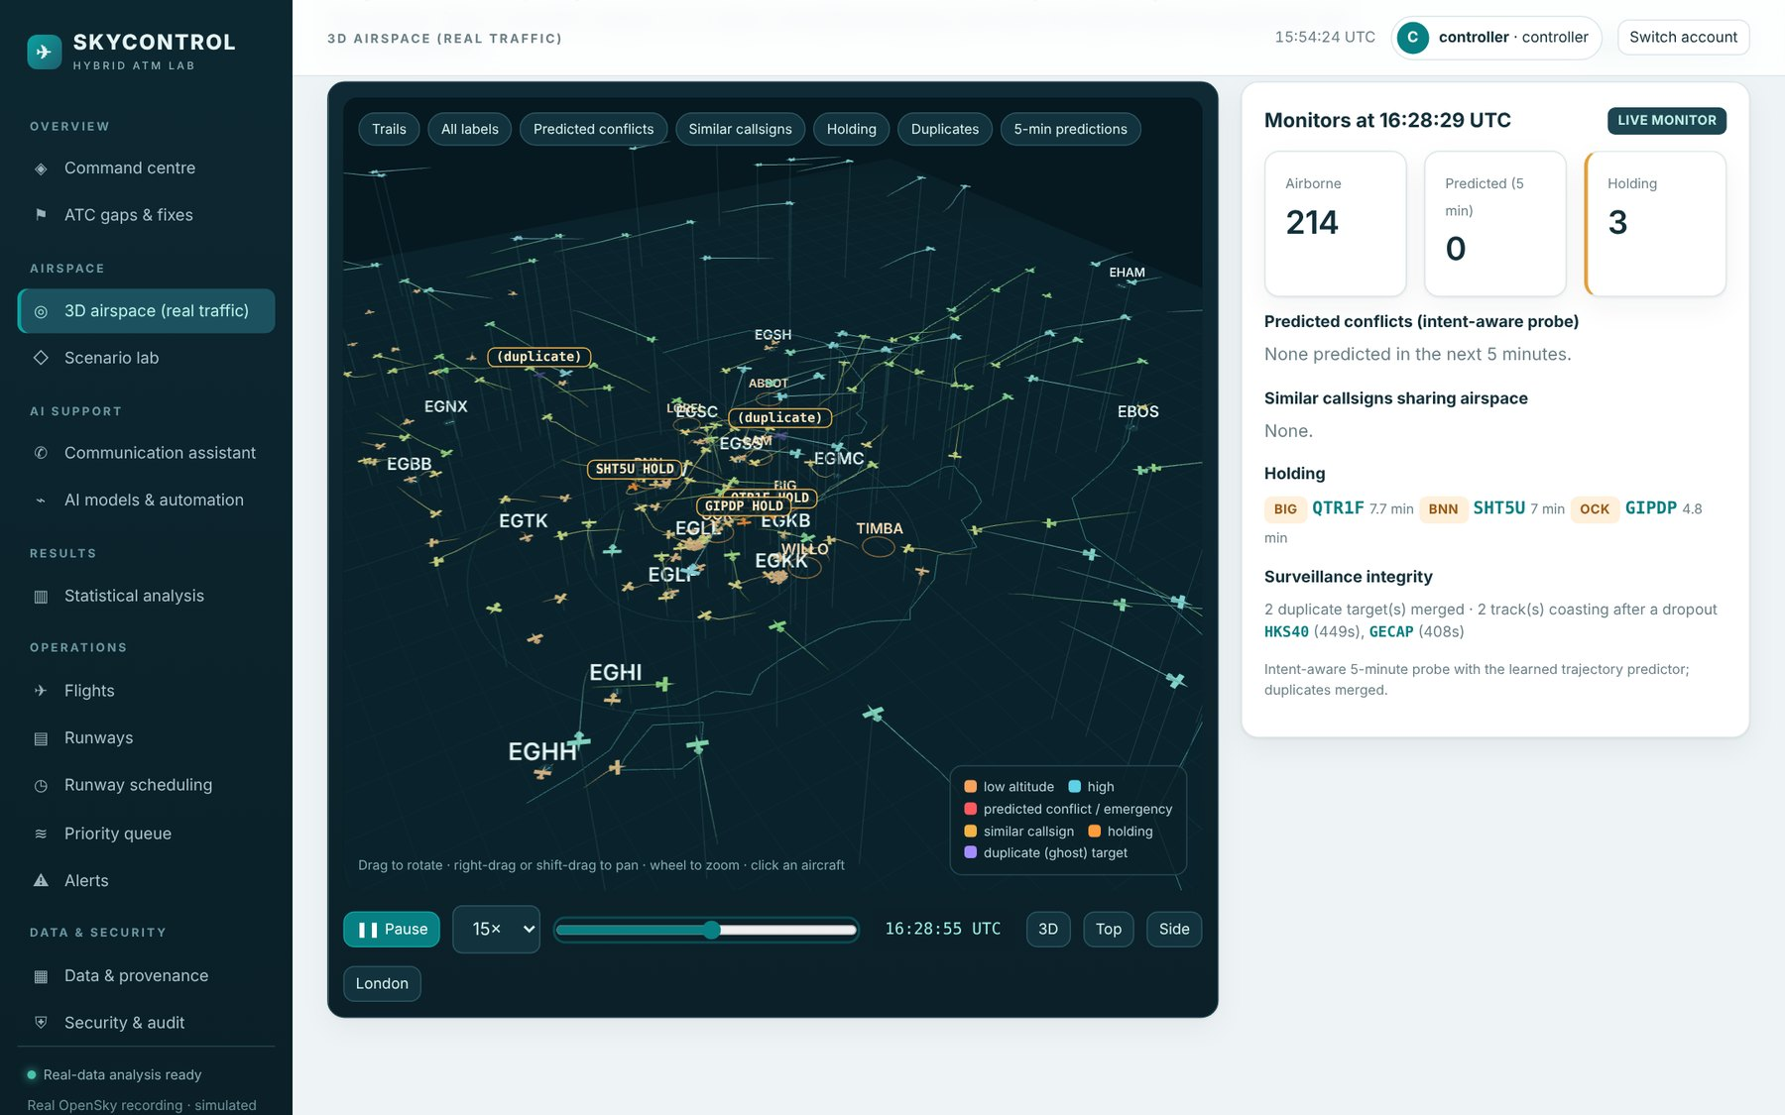
Fig. 1.1 Real London-Amsterdam Traffic Replayed in the SkyControl 3D Airspace
Fig. 1.1 shows the recording replayed in SkyControl at about 16:28 UTC: more than 200 aircraft are airborne at once, aircraft in the holding stacks around Heathrow are marked, a predicted conflict is highlighted in red and a pair of similar callsigns (HLE98 and HLE99) sharing the airspace is flagged. These are the kinds of situation in which the controller's attention is stretched and in which an assistant can help.

1.2 Motivation
Voice communication remains the single largest source of operational error in ATC. Analyses of controller-pilot transcripts found readback errors in the order of one per cent of transmissions, a substantial share of which the controller did not catch (Cardosi, 1993; Cardosi, Falzarano, & Han, 1998). Similar callsigns on the same frequency lead the wrong aircraft to take an instruction; EUROCONTROL's air-ground communication safety study ranked call sign confusion among the leading communication hazards (EUROCONTROL, 2004). These are human-communication errors: they do not come from a lack of skill but from the limits of listening to a busy, shared voice channel.
A second motivation is the look-ahead of conflict alerting. A two-minute safety net is essential, but in a dense terminal area any straight-line probe that looks further ahead produces hundreds of nuisance alerts per hour, because aircraft turn onto arrival routes and level off at cleared levels that the probe does not know. A third is emergency handling: a fuel, medical or engine emergency is managed from memory and checklists, alternates are chosen mentally and coordination happens by telephone while the rest of the traffic keeps calling. Finally, the surveillance picture itself can be wrong. ADS-B data contains duplicate targets created by corrupted addresses and gaps in coverage, and a frozen track can look perfectly valid on a display (Strohmeier, Lenders, & Martinovic, 2015).
Artificial intelligence can help with each of these, but only if it is honest about when it can be trusted. Research on human-automation interaction warns that automation which is either fully on or fully off invites complacency and automation bias (Bainbridge, 1983; Parasuraman & Manzey, 2010). The motivation of this project is therefore not to build an autonomous controller, but to build a hybrid in which the machine handles routine work, proposes verified plans for the rest, and hands control back to the human, explicitly and with a logged reason, in critical, uncertain or degraded situations.

1.3 Objective
The objectives of the project, derived from the problem statement and the course requirements, are:
1. Collect a real, relevant dataset of air traffic (a recorded OpenSky Network capture of London-Amsterdam traffic) and document its provenance and limitations.
2. Implement the system end to end, including a login portal with verified credentials that clearly rejects wrong credentials and stores every login attempt, successful or not, in the back-end database.
3. Cover the main ATC scenarios (converging traffic, emergencies, low fuel, runway incursion, weather, readback error, similar callsigns, surveillance faults and more) with verified algorithms, and use AI with a manual context switch in critical situations where the AI may be wrong.
4. Find concrete gaps in current ATC, design a fix for each, and measure on real traffic and simulated emergencies whether the hybrid improves reliability and efficiency and reduces miscommunication and human error compared with current practice.
5. Where a first result was not significant, change the design (context switching, pattern learning, prediction from historical trends) and measure again.
6. Deliver a demonstrable 3D web application with flight animation, a step-by-step scenario lab, a statistical results section and a simulation page, and deliver it with professional engineering practice: GitHub, Jira sprints, a Jenkins pipeline and Docker deployment.

1.4 Problem Statement
Current ATC relies on the controller to detect and correct voice communication errors, to notice similar callsigns, to anticipate conflicts beyond the two-minute horizon of the safety net, to trust or distrust the surveillance picture, to decide on holding late, and to coordinate emergencies manually. Existing tools address parts of these tasks but leave gaps between them. The problem addressed in this project is to identify these gaps on real traffic, to design a hybrid human-AI system that closes them while keeping the human in authority, and to show with statistical evidence, honestly labelled, where the hybrid improves on or complements current practice.

1.5 Scope of the Work
The work covers the following, and deliberately excludes certification and operational use:
● In scope: a research and teaching laboratory, the real 90-minute recording, nine gaps (G1 to G9), 21 scenarios, emergency injection into real traffic, learned models trained and tested on the recording, a Monte Carlo communication model, a full web application with authentication, a test suite, a container image, a CI/CD pipeline, a Scrum plan and this report.
● Out of scope: live operational use, integration with real ATC systems, certification (for example to EUROCONTROL or DGCA software assurance levels), real speech recognition of R/T audio, and real controller trials.
● Data limits: ADS-B carries no fuel, emergency or clearance information, so fuel states, emergencies and cleared levels are simulated or approximated and labelled as such.

1.6 Contributions
The main contributions of the project are:
● A gap catalogue of current ATC (G1 to G9), each with today's practice, the risk, the SkyControl fix, its relationship to existing tools and the evidence type.
● A learned trajectory predictor and an intent-aware five-minute conflict probe evaluated on held-out real traffic.
● A surveillance-integrity monitor that finds duplicate (ghost) targets and coasts dropped tracks.
● A readback verifier, a callsign-similarity monitor and a communication model with a sensitivity analysis.
● A holding analysis with a learned hold predictor, an anomaly detector and a cleared-level monitor, and an emergency assistant evaluated by injecting emergencies into real traffic.
● An adaptive automation policy with four levels and explicit, logged context switches, used in every scenario.
● A complete, tested and containerised web application with a secure login portal and a CI/CD pipeline.

1.7 Organisation of the Report
Chapter 2 surveys the literature and derives the gap analysis. Chapter 3 gives the technical specification, including the dataset. Chapter 4 presents the design approach, the architecture, the UML diagrams, the algorithms and equations, the codes and standards followed and the trade-offs made. Chapter 5 describes the implementation. Chapter 6 covers the schedule, the Scrum sprints in Jira and the GitHub, Jenkins and Docker workflow. Chapter 7 presents the results, statistical tests, screenshots and cost analysis, and Chapter 8 summarises the work. Chapter 9 lists the references in APA format, and Appendix A contains sample code and the user manual.
Table 1.1 Course Requirements and Where They Are Met
Requirement | How SkyControl meets it | Section
Real, relevant dataset | Recorded OpenSky capture, 906 aircraft, 86,447 reports, provenance and SHA-256 stored | 3.3, 7.2
Login with verified credentials; wrong attempts stored | PBKDF2 hashes, uniform error message, every attempt stored with reason, IP and browser, lockout | 3.6, 5.3, 7.3
All ATC scenarios with verified algorithms | 21 scenarios, exact conflict verification of every plan, ten-step pipeline | 4.4, 5.5, 7.10
AI with manual context switch | Four automation levels chosen by an explicit policy, supervisor approval for critical events | 4.4.12, 7.10
Real traffic plus simulated emergencies; effectiveness vs ATC | Learned models on held-out traffic, 60 emergencies injected, paired statistical tests | 7.4 to 7.9, 7.11
Improve if not significant | Intent-aware probe, duplicate merging, hold prediction and CLAM added after first results | 4.6, 7.4, 7.8
3D web app, animation, results and simulation pages | three.js airspace replay and scenario lab, eight-tab statistics page | 5.6, 7.15
GitHub, Jira, Jenkins, Docker | Guides, CSV backlog, validated Jenkinsfile run, multi-stage Dockerfile | Chapter 6

CHAPTER 2
LITERATURE SURVEY AND GAP ANALYSIS
This chapter reviews the literature that underpins SkyControl: how ATC works and where it fails, conflict detection, machine-learning trajectory prediction, ADS-B surveillance and its weaknesses, arrival management, anomaly detection, and the theory of levels of automation. It ends with a gap analysis that turns these findings into nine concrete gaps that the system addresses.

2.1 How Air Traffic Control Works Today
ICAO Annex 11 defines the objectives of air traffic services as preventing collisions between aircraft, expediting and maintaining an orderly flow of traffic and providing information and alerting (ICAO, 2018). In controlled airspace these objectives are met by sector controllers applying separation minima, typically 3 NM or 5 NM horizontally depending on the surveillance environment and 1,000 ft vertically, using the procedures of ICAO Doc 4444 (ICAO, 2016). A clearance is valid only after the pilot has read it back correctly; the controller is responsible for listening to the readback and correcting it, a step known as hearback.
Automation has grown around this core rather than replacing it. Safety nets such as STCA (EUROCONTROL, 2007) and TCAS (Kochenderfer, Holland, & Chryssanthacopoulos, 2012) act when separation is about to be lost. Planning tools such as MTCD and AMAN support the controller further ahead. The SESAR programme in Europe and NextGen in the United States both describe a future in which trajectory-based operations, datalink and higher levels of automation support higher capacity, but they keep the human controller responsible for separation (SESAR Joint Undertaking, 2020).

2.2 Pilot-Controller Communication and Human Error
Cardosi (1993) analysed thousands of en-route controller-pilot transmissions and found that readback errors occurred in under one per cent of transmissions but were more frequent in complex clearances, and that controllers failed to catch a meaningful share of them. A later analysis of Aviation Safety Reporting System reports showed that most communication incidents involved altitude clearances, that similar callsigns were a frequent factor and that hearback errors were common under high workload (Cardosi, Falzarano, & Han, 1998). Prinzo and Britton (1993) surveyed the literature on voice communications and identified message length, non-standard phraseology and frequency congestion as the main contributors.
EUROCONTROL's air-ground communication safety study found that call sign confusion, readback/hearback errors and blocked transmissions were the dominant communication hazards in European airspace (EUROCONTROL, 2004). Datalink is the accepted mitigation for routine clearances: CPDLC messages are unambiguous and are addressed to a logged-on aircraft rather than to a spoken callsign. However, CPDLC response times of tens of seconds mean that urgent instructions must remain on voice. Automatic speech recognition (ASR) of controller speech has been shown to reduce controller workload when it pre-fills system inputs (Helmke, Ohneiser, Mühlhausen, & Wies, 2016), which suggests that a recogniser can also be used to check readbacks automatically.

2.3 Conflict Detection and Safety Nets
Kuchar and Yang (2000) classified conflict detection and resolution methods by how they propagate the future (nominal, worst-case or probabilistic), by detection threshold and by resolution method (geometric, optimised, force-field or manual). Nominal straight-line propagation, as used by STCA, is simple and transparent but produces false alerts when aircraft turn or level off, while worst-case propagation produces many more. Probabilistic and intent-based methods reduce nuisance alerts but need information about the aircraft's intended trajectory. Erzberger (2006) showed that automated resolution in an advisory role can solve most conflicts with a single manoeuvre when trajectories are known accurately.
STCA specifications deliberately use short look-ahead times, around two minutes, to keep nuisance alerts acceptable (EUROCONTROL, 2007). The consequence is that the safety net warns late by design; any probe that looks further ahead must be more accurate than straight-line extrapolation or it will overwhelm the controller with alerts. This trade-off between look-ahead and alert rate is the central design problem for gap G3 in this project.

2.4 Trajectory Prediction with Machine Learning
Trajectory prediction is the basis of every conflict probe. Physics-based predictors use aircraft performance models such as OpenAP (Sun, Hoekstra, & Ellerbroek, 2020) together with intent. Data-driven predictors learn from historical trajectories: Ayhan and Samet (2016) used hidden Markov models on gridded airspace, and deep-learning approaches with weather inputs have improved long-horizon predictions (Pang, Zhao, Yan, & Liu, 2021). Gradient-boosted decision trees (Friedman, 2001), in efficient histogram-based implementations (Ke et al., 2017; Pedregosa et al., 2011), are strong learners for tabular features and are fast enough to run on every aircraft at every radar update.
A common weakness of reported results is evaluation on the same period that was used for training, which overstates accuracy. SkyControl therefore learns a residual correction to straight-line extrapolation (so that it degrades gracefully to the baseline) and evaluates it only on a later, held-out part of the recording.

2.5 Surveillance Data: ADS-B and the OpenSky Network
The OpenSky Network is a crowd-sourced network of ADS-B and Mode S receivers that makes air traffic data available for research (Schäfer, Strohmeier, Lenders, Martinovic, & Wilhelm, 2014). State vectors contain the ICAO 24-bit address, callsign, position, barometric and geometric altitude, velocity, track and vertical rate. Tools such as the traffic library (Olive, 2019) and the BlueSky open-source ATC simulator (Hoekstra & Ellerbroek, 2016) have made such data a standard basis for ATM research.
ADS-B has known integrity weaknesses. Messages are unauthenticated, corrupted address bits produce duplicate tracks, receivers have coverage gaps and the reported position can be stale (Strohmeier et al., 2015). Operational trackers fuse several sources to mitigate this, but a display generally shows whatever the tracker outputs without telling the controller how far to trust it. This motivates gap G4.

2.6 Arrival Management and Airborne Holding
London's major airports absorb arrival delay in four holding stacks around Heathrow (BNN, LAM, OCK and BIG) and further stacks for Gatwick, Stansted and Luton. Holding at low level burns fuel at a high rate per minute and adds workload. Arrival managers and cross-border arrival management (XMAN) aim to absorb part of this delay en route with small speed reductions, an approach often called linear holding (SESAR Joint Undertaking, 2020). The benefit depends on knowing early which arrivals will have to hold, which is a prediction problem that historical traffic can inform.

2.7 Anomaly Detection in Flight Data
Emergencies are rare and are not labelled in ADS-B data, so supervised learning is not possible. Unsupervised anomaly detection learns what normal flight looks like and flags departures from it. Isolation Forest isolates anomalies with random partitions and needs no distance metric, which makes it fast and robust on mixed features (Liu, Ting, & Zhou, 2008). Autoencoders have been used on Mode S data to detect controller actions and unusual trajectories (Olive, Grignard, Dubot, & Saint-Lot, 2018). Rule-based monitoring such as CLAM remains the most reliable detector of level busts, but only when the cleared level is known to the system.

2.8 Levels of Automation and Human-Automation Teaming
Parasuraman, Sheridan and Wickens (2000) proposed that automation should be designed at different levels for the four stages of information acquisition, analysis, decision selection and action implementation, and that the level should depend on the consequences of automation errors. Bainbridge (1983) described the ironies of automation: the more reliable a system, the less prepared the human is to take over when it fails. Parasuraman and Manzey (2010) reviewed evidence of complacency and automation bias, in which operators follow confident but wrong advice. Endsley (1995) linked performance to situation awareness, which automation can either support or erode.
These findings lead directly to the design principle of SkyControl: the level of automation is not fixed but chosen by an explicit policy for each situation, based on severity, confidence, data quality, disagreement between learned and rule-based components, novelty and security. A change of level is a context switch that is shown to the user and logged, so that the human always knows who is in charge.

2.9 Summary of the Literature
Table 2.1 Summary of the Literature Reviewed
Work | Contribution | Limitation addressed by SkyControl
Cardosi (1993); Cardosi et al. (1998) | Readback error rates and hearback misses in real R/T | Hearback depends on the controller alone
EUROCONTROL (2004) | Communication hazards in European airspace | Callsign confusion handled by vigilance
Helmke et al. (2016) | ASR reduces controller workload | ASR not used to verify readbacks
Kuchar & Yang (2000) | Taxonomy of conflict detection and resolution | Trade-off between look-ahead and false alerts
EUROCONTROL (2007) | STCA specification | Short look-ahead, no intent
Ayhan & Samet (2016); Pang et al. (2021) | Data-driven trajectory prediction | Evaluation on held-out data, real-time cost
Schäfer et al. (2014); Strohmeier et al. (2015) | OpenSky data; ADS-B weaknesses | Integrity not shown to the controller
Liu et al. (2008); Olive et al. (2018) | Unsupervised anomaly detection | Emergencies unlabelled; needs a rule partner
Parasuraman et al. (2000); Bainbridge (1983) | Levels of automation; ironies of automation | Automation level fixed, not context-dependent
Parasuraman & Manzey (2010) | Complacency and automation bias | No explicit signal of when not to trust the AI

2.10 Gap Analysis of Current ATC
Combining the literature with an analysis of the real recording gives nine gaps, listed in Table 2.2. Each gap is a place where the current system relies on a single human check, a short look-ahead or information it does not have. For each gap SkyControl adds a specific fix, states how the fix relates to existing ATC tools and states what kind of evidence supports it. SkyControl is designed to complement existing ATC: it never removes a safety net, and the human keeps authority over every non-routine decision.
Table 2.2 Gaps in Current ATC and the SkyControl Fixes
Gap | Problem | Today | SkyControl fix | Evidence
G1 | Voice readback and hearback errors | Controller must hear the wrong readback | Structured clearances, datalink for routine items, automatic readback verification | Measured component + modelled system
G2 | Similar callsigns on one frequency | Planning-stage deconfliction and vigilance | Live similarity scoring, label warnings, wrong-aircraft detection | Measured on real data
G3 | Short look-ahead and nuisance alerts | STCA about 2 min, straight line | Learned prediction + cleared-level intent + duplicate merging (5 min) | Measured on real data
G4 | Untrusted surveillance | Tracker output assumed correct | Duplicate detection, dead-reckoned coasting, switch to MANUAL | Measured on real data
G5 | Delay absorbed in low-level holding | Holding decided near the stack | Hold prediction 30-80 NM out, linear-holding estimate | Measured + modelled
G6 | Emergency handling by memory and phone | Checklists, mental alternates, telephone | Airport ranking, path checked against real traffic, re-sequencing | Real traffic + modelled workflow
G7 | Level busts seen late | CLAM only if the level is entered | Cleared level always known from the digital clearance | Real tracks + injected events
G8 | Automation that cannot say when not to trust it | Tools on or off | Four levels with explicit context switches | Scenario
G9 | Runway safety and closures | Manual re-planning | Occupancy-aware sequencing and re-planning | Scenario

The gaps fall into four groups. G1 and G2 are human-communication gaps, the most direct answer to the request to reduce miscommunication and human error. G3, G4 and G7 are separation and surveillance gaps, where the controller acts on predictions and data that may be late or wrong. G5 and G6 are efficiency and emergency gaps, where workload and fuel are at stake. G8 and G9 concern trust in automation and runway safety. Fig. 2.1 shows the gap catalogue as it appears in the application, where each gap links to its evidence and to the scenario that demonstrates it.
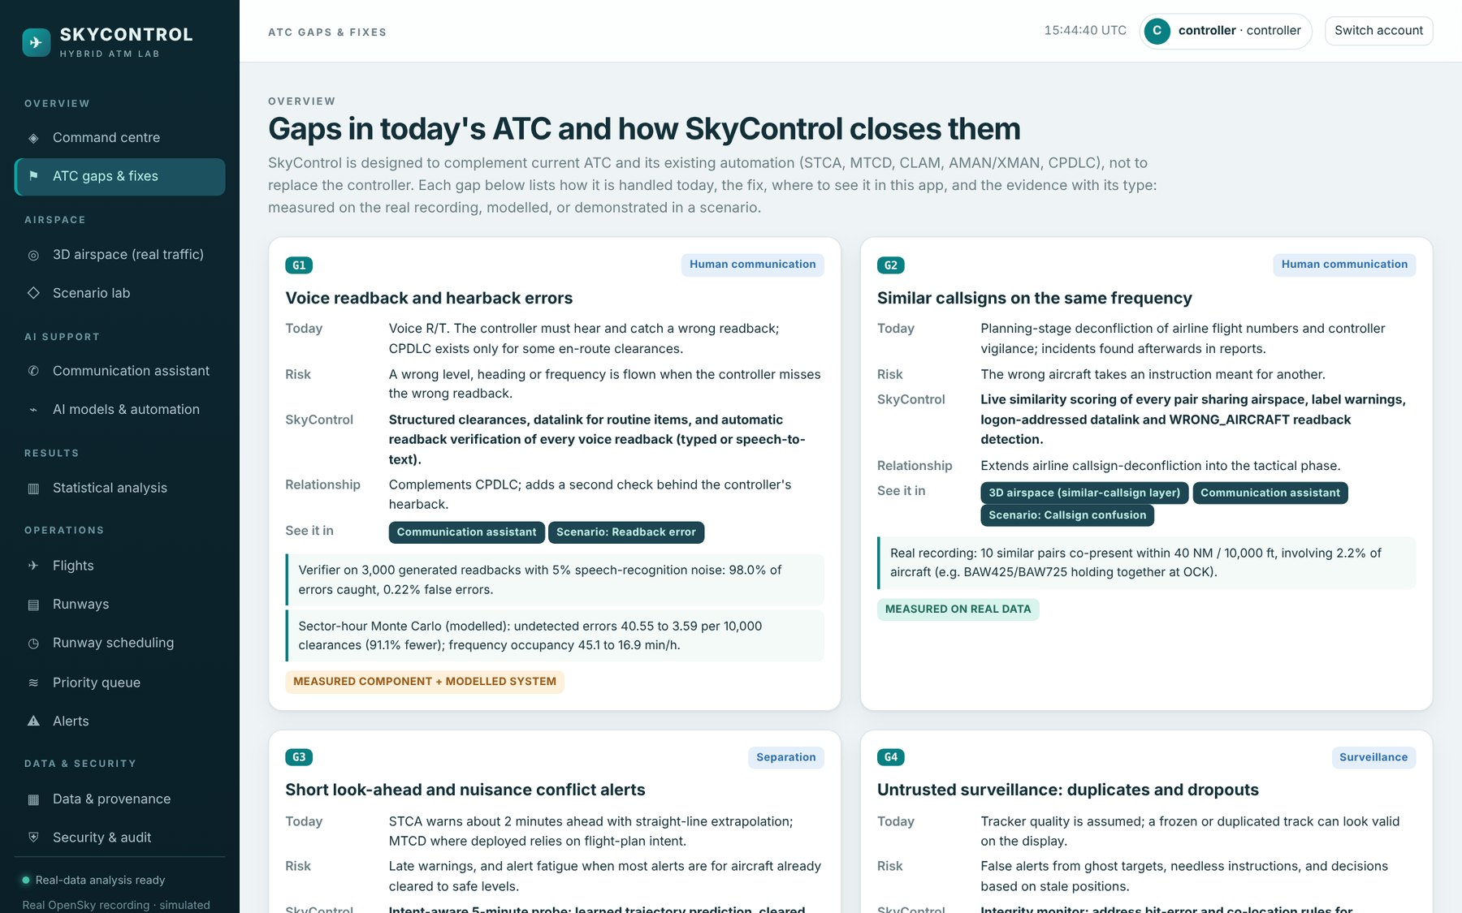
Fig. 2.1 ATC Gaps and Fixes Page of the Application
The gaps were found in two steps. First, the literature above identified candidate weaknesses. Second, each candidate was checked against the real recording: for example, the recording contains holding at every Heathrow stack, ten pairs of similar callsigns sharing airspace, 21 duplicate-target pairs and 234 dropouts of more than a minute, which confirms that G2, G4 and G5 are real in today's traffic and not only in the literature. Where the data cannot answer a question, for instance how often a controller misses a wrong readback, the report uses a stated model with a sensitivity analysis.

CHAPTER 3
TECHNICAL SPECIFICATION
This chapter specifies what SkyControl must do and under which constraints: the functional and non-functional requirements, the dataset, the hardware and software environment, the technology stack, the security policy and the programming interface between the browser and the server.

3.1 Functional Requirements
Table 3.1 Functional Requirements
ID | Requirement
FR1 | Users log in with a username and password verified against a salted hash; wrong credentials are rejected with one uniform message.
FR2 | Every login attempt is stored with time, username tried, IP address, browser, success flag and reason.
FR3 | A username is locked for 15 minutes after 7 failures; an IP is limited after 40 failures in 15 minutes.
FR4 | Two roles exist: controller and supervisor. Supervisors approve critical plans, overrides, runway closures and user management.
FR5 | The real recording is replayed in 3D with trails, labels, predicted conflicts, similar callsigns, holding, duplicates and predictions.
FR6 | An emergency (low fuel, medical, engine failure, emergency descent, lost communications) can be injected on any real aircraft.
FR7 | The scenario lab runs 21 scenarios, each shown as a ten-step pipeline with an approval gate and a comparison with conventional ATC.
FR8 | Every plan is verified conflict-free (aircraft, runway, hazard, deadline) before it can be executed.
FR9 | The automation level is chosen by an explicit policy and every change is logged as a context switch.
FR10 | The communication assistant builds ICAO phraseology, verifies readbacks (typed or spoken) and warns of similar callsigns.
FR11 | The statistical analysis page shows measured, modelled and scenario results with tests and confidence intervals.
FR12 | Operations pages manage flights, runways, runway bookings, the priority queue, alerts and incident reports.
FR13 | The data page shows dataset provenance and allows importing snapshots; the audit page lists every change.
FR14 | Learned models are trained on one part of the recording and evaluated on another part.

3.2 Non-Functional Requirements
Table 3.2 Non-Functional Requirements
Quality | Requirement
Security | PBKDF2-SHA256 with 310,000 iterations; no default passwords; CSRF tokens; security headers; least-privilege container user
Reliability | All plans verified by exact geometry; automated tests for every module; health check endpoint
Performance | Interactive pages respond within about 100 ms (p50) after the one-off analysis; scenario creation under 0.5 s
Usability | Single-page app; every scenario explains itself step by step; works in current Chrome, Edge and Firefox
Portability | Runs on Windows, Linux and macOS with Python 3.12, or anywhere with Docker
Maintainability | Layered modules, lint (ruff) clean, 90% test coverage, documented algorithms
Honesty | Every result labelled measured, modelled or scenario; limitations stated; not presented as operational

3.3 Dataset Specification
The main dataset is a recorded OpenSky Network capture stored as a compressed JSON file (data/london_amsterdam_opensky.json.gz, format skycontrol.opensky.recording.v1). Each frame contains the state vectors of all aircraft in the bounding box at one time. The dataset register in the application stores the provider, period, number of records and SHA-256 hash so that every result can be traced to the exact file. Table 3.3 summarises the recording.
Table 3.3 Specification of the Real Dataset
Property | Value
Provider | OpenSky Network (ADS-B / Mode S state vectors)
Period | 2026-10-15 15:42:28 to 17:12:28 UTC (90 minutes)
Region | 49.5°N to 54.5°N, 2.0°W to 3.0°E (London TMA, North Sea, Amsterdam)
Frames | 353, median interval 13 s
Position reports | 87,155 in the file, 86,447 used after removing 708 duplicates
Aircraft | 906 distinct ICAO 24-bit addresses; 81.6% of reports airborne
Fields used | ICAO address, callsign, latitude, longitude, barometric altitude, on-ground flag, time of position
Derived fields | Velocity, track, vertical rate and turn rate (finite differences), local x/y in NM
Reference data | 18 airports and 8 holding fixes (data/reference/london_reference.json)
SHA-256 | a1414d56cfc459bbf60f4770dd727455…

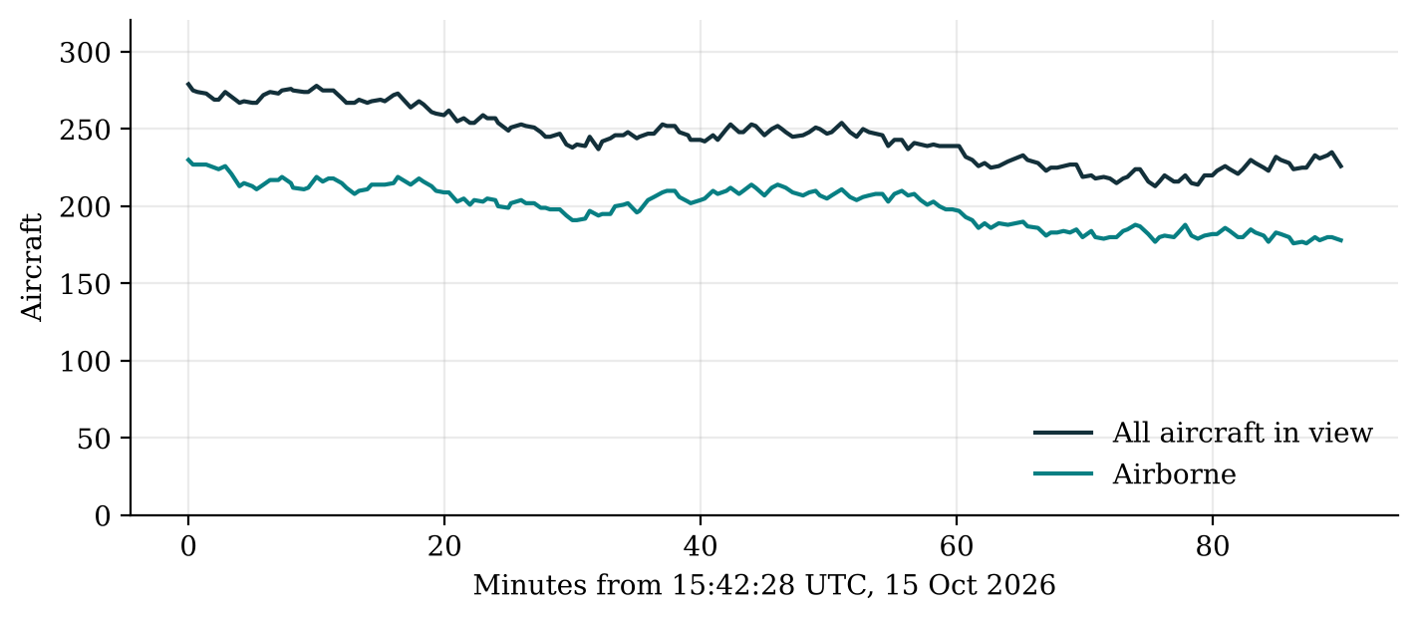
Fig. 3.1 Aircraft in View During the 90-Minute Recording
As Fig. 3.1 shows, traffic stays between about 210 and 280 aircraft throughout, of which roughly 200 are airborne. Fig. 3.2 shows the distribution of position reports by altitude band and the most frequent operators. The many reports below 5,000 ft come from arrivals and departures around the London airports, and the large share between 30,000 and 40,000 ft from overflights; Ryanair, easyJet and British Airways together operate more than a quarter of the aircraft.
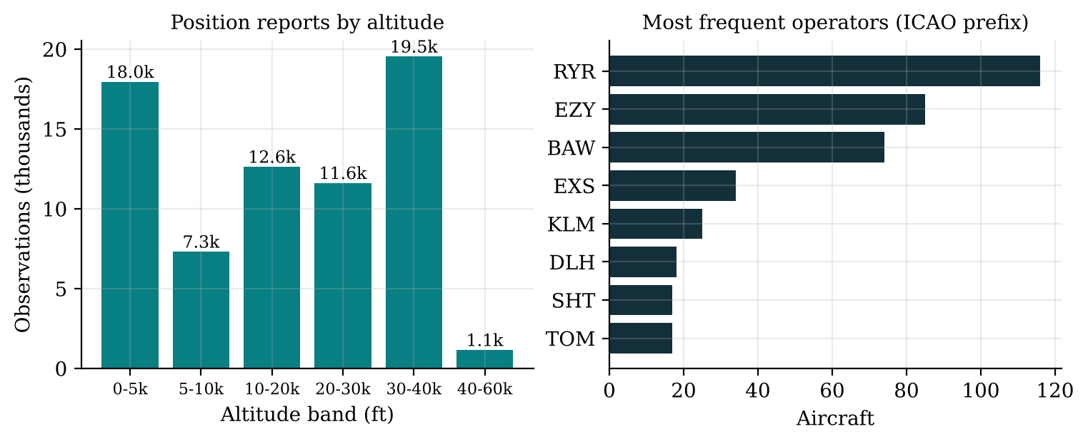
Fig. 3.2 Position Reports by Altitude Band and the Most Frequent Operators
Two additional datasets are registered: an OpenSky snapshot of Indian airspace kept from the earlier version of the project, and a historical airport traffic table (2011). They are shown on the data page with their provenance but are not used for the evaluation. Fuel states, emergencies, clearances and controller actions are not contained in any ADS-B dataset; where they are needed they are simulated and labelled.

3.4 Hardware and Software Requirements
Table 3.4 Hardware and Software Requirements
Item | Minimum | Used for development and testing
Processor | 2 cores, 64-bit | 4 vCPU (x86-64)
Memory | 4 GB | 8 GB
Disk | 1 GB free | About 600 MB including the Docker image
Operating system | Windows 10/11, Ubuntu 22.04+, macOS 13+ | Ubuntu (container), Windows 11 (VS Code)
Python | 3.12 | 3.12 / 3.13
Browser | Chrome, Edge or Firefox with WebGL | Chromium (headless tests), Chrome
Docker (optional) | Docker Engine 24+ with Compose v2 | Docker 27
Jenkins (optional) | Jenkins LTS with Pipeline, JUnit, Credentials Binding | jenkinsfile-runner with the same plug-ins

3.5 Technology Stack
Table 3.5 Technology Stack
Layer | Technology | Version | Reason
Web framework | FastAPI + Uvicorn | 0.144.0 / 0.54.0 | Typed, fast, automatic validation
Numerics | NumPy, SciPy | 2.5.4 / 1.18.1 | Vectorised geometry and statistics
Machine learning | scikit-learn | 1.9.1 | Gradient boosting, logistic regression, isolation forest
Database | SQLite (WAL mode) | Python stdlib | Zero administration, transactional
3D graphics | three.js | 0.160.0 | WebGL scene, vendored locally
Charts | Chart.js | 4.4.4 | Lightweight charts, vendored locally
Front end | HTML, CSS, ES modules | — | No build step, strict CSP
Testing | pytest, pytest-cov, httpx, Playwright | 8.x | Unit, API and browser tests
Lint | ruff | 0.6+ | Fast static checks
Containers | Docker, Compose | 27 / v2 | Reproducible deployment
CI/CD | Jenkins, GitHub Actions | LTS | Automated test, build, deploy
Planning | Jira Software (Scrum) | Cloud | Backlog, sprints, reports

3.6 Security Specification
Authentication follows NIST SP 800-63B guidance for memorised secrets (Grassi et al., 2017) and the OWASP recommendations for password storage and session management (OWASP Foundation, 2021). Table 3.6 lists the controls. The login portal deliberately returns the same message for an unknown username and a wrong password, so that it does not reveal which usernames exist, while the database records the precise reason for each failure for the security audit.
Table 3.6 Security Controls of the Login Portal and API
Control | Specification
Password storage | PBKDF2-HMAC-SHA256, 310,000 iterations, 16-byte random salt per user (RFC 8018)
Password policy | At least 12 characters with letters and digits; set at first start or from environment variables
Wrong credentials | HTTP 401 "Wrong username or password" with the number of attempts remaining
Attempt log | Every attempt stored: time, username, IP, user agent, success, reason (7 reason codes)
Lockout | 7 failures per username or 40 per IP within 15 minutes → HTTP 429 until the window passes
Sessions | 256-bit random token, stored only as SHA-256 hash; HTTP-only, SameSite=Lax cookie; 12-hour expiry
CSRF | Per-session token required in a header for every state-changing request
Authorisation | Role checks on every route; supervisor-only actions enforced server side
Headers | Content-Security-Policy script-src self, X-Frame-Options DENY, nosniff, no-referrer, no-store for API
Audit | Every change written to audit_events with actor, action, entity and details

3.7 Interface Specification
The browser talks to the server only through a JSON REST API under /api. Table 3.7 lists the main endpoint groups; the complete list has 61 routes. All routes except login and health require a session, and state-changing routes require the CSRF token.
Table 3.7 Main API Endpoint Groups
Group | Examples | Purpose
/api/auth | POST login, logout, password; GET me, attempts, users | Login portal, attempt log, user management
/api/airspace | GET meta, tracks, frame, predictions; POST emergency | 3D replay of real traffic and emergency injection
/api/lab | GET catalog, benchmark, runs/{id}; POST runs, runs/{id}/control | Scenario lab, approvals and replay control
/api/analysis, /api/gaps, /api/models | GET analysis/{section}, gaps, models | Statistical results and gap catalogue
/api/comms | POST phraseology, verify, similarity; GET log | Communication assistant
/api/automation | POST decide | Context-switch policy simulator
/api (operations) | flights, runways, schedule, priority-queue, alerts, incident-reports, dashboard | Operations management
/api/data, /api/audit | datasets, snapshots, import, feed-health, audit | Data provenance and audit trail
/api/health | GET | Liveness and analytics readiness (used by Docker and Jenkins)

3.8 Acceptance Criteria
The project is accepted when the following criteria are demonstrated:
● A wrong password is rejected with a clear message and the attempt appears in the security log with its reason.
● All 21 scenarios produce a plan that passes exact verification, and critical plans cannot be executed by a controller without supervisor approval.
● Learned models improve on their baselines on held-out real data, with paired statistical tests reported.
● An emergency can be injected on a real aircraft and the response is shown step by step.
● The automated test suite passes in the Jenkins pipeline, the Docker image passes the smoke test and is deployed.

CHAPTER 4
DESIGN APPROACH AND DETAILS
This chapter explains how SkyControl is designed. It first states the design approach and the architecture, then presents the UML model of the system, then the materials and methods (the data processing, algorithms and models, with their equations), the codes and standards followed, and finally the constraints, alternatives and trade-offs that shaped the design.

4.1 Design Approach
Three principles guided the design. The first is complement, do not replace. SkyControl never removes an existing safety net or procedure. The STCA-style safety net, the controller's hearback and the supervisor's authority remain; SkyControl adds a second check, a longer look-ahead, an integrity signal or a verified plan beside them. This keeps the system acceptable to the people who would use it and keeps the comparison with current ATC fair.
The second principle is verified automation with an explicit human in the loop. Any plan that SkyControl proposes, whether it comes from a heuristic, a search algorithm or a learned model, is checked by an exact geometric verifier before it can be executed. The level of automation is decided by a transparent policy, and the human can approve, reject or override with a reason. When the learned model and the deterministic rule disagree, the rule wins and the human decides, which is the "manual context switch in critical situations where the AI can be wrong" required by the project brief.
The third principle is evidence first. Every function was designed together with the measurement that would show whether it works on real traffic. Learned models are always evaluated on data they did not see. Where a first design did not give a significant or useful result, the design was changed. For example, a plain five-minute probe produced 522.7 alerts per hour on the real recording, which would be useless to a controller, so duplicate merging, level-flight intent, cleared-level intent, learned trajectories and hysteresis were added until the alert rate matched the two-minute safety net.
The development itself followed an iterative Scrum approach (Chapter 6): each sprint delivered a working increment, from the login portal and data ingestion in Sprint 1 to the 3D application and DevOps pipeline in the last sprints.

4.2 System Architecture
SkyControl is a layered client-server application (Fig. 4.1). The browser runs a single-page application that renders the 3D views with three.js and the charts with Chart.js. It communicates over JSON with a FastAPI server. The server has four layers: the API routes (authentication, validation, role checks, CSRF and audit), the decision engine (core/: scenario planning, separation verification, communication, automation policy, workflow model and gap catalogue), the analytics layer (analytics/: everything computed on the real recording) and the persistence layer (SQLite in write-ahead-log mode). The analytics results and the trained predictor are cached on disk, keyed by the SHA-256 of the recording and the analysis version, so the expensive analysis runs once.
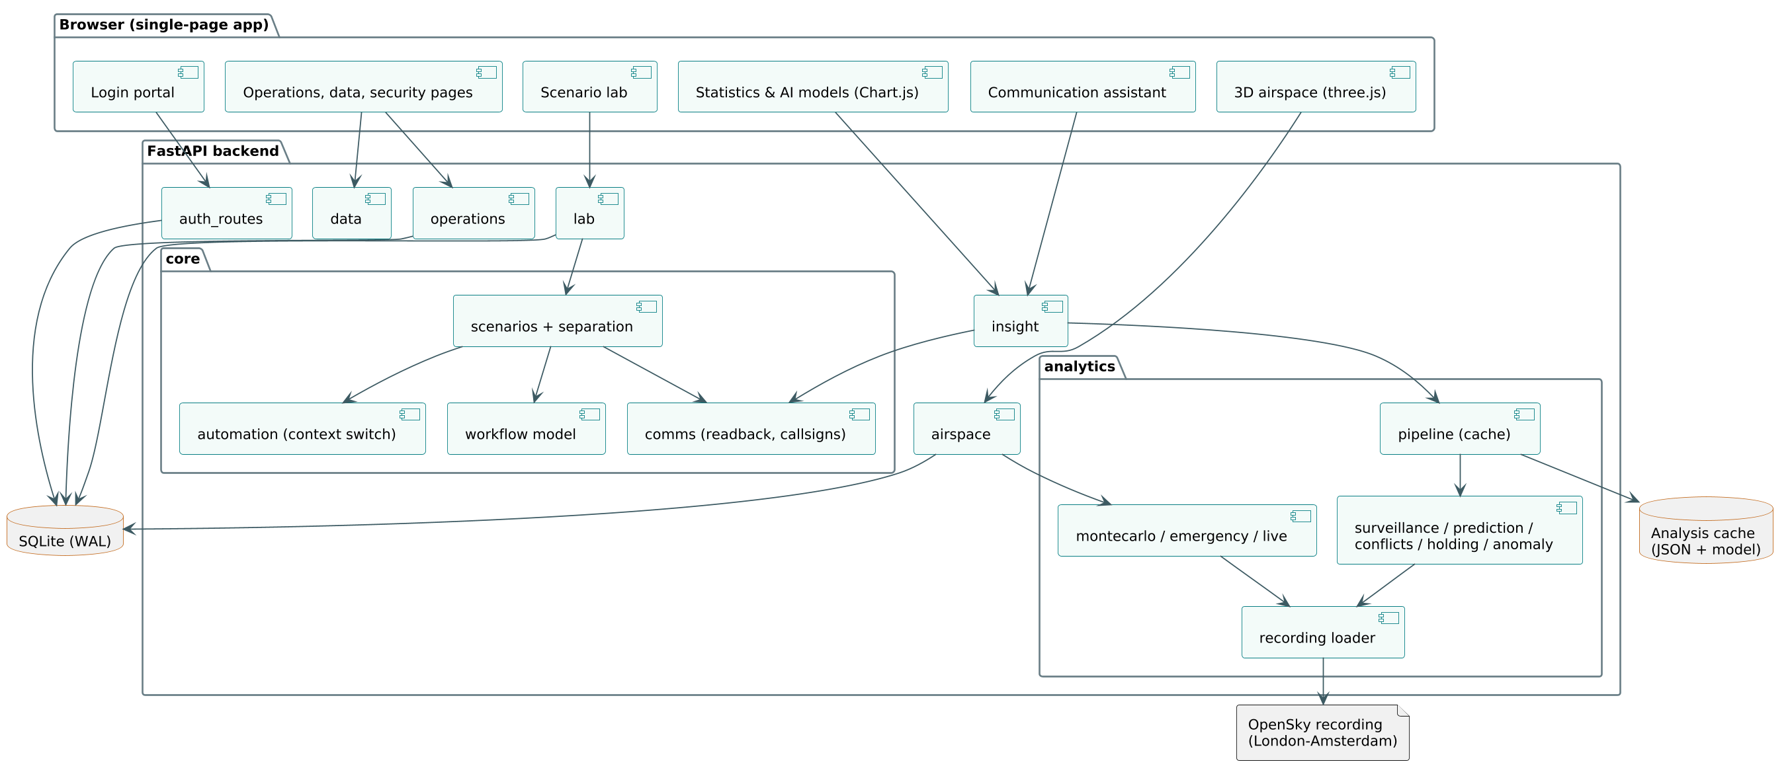
Fig. 4.1 Component Architecture of SkyControl
Fig. 4.2 shows the data flow from the raw recording to the user. The recording is loaded, cleaned and projected, then each analysis consumes the cleaned arrays. The live views used by the 3D replay are computed per frame from the same models, so what the user sees in the replay is exactly what the statistics measure.
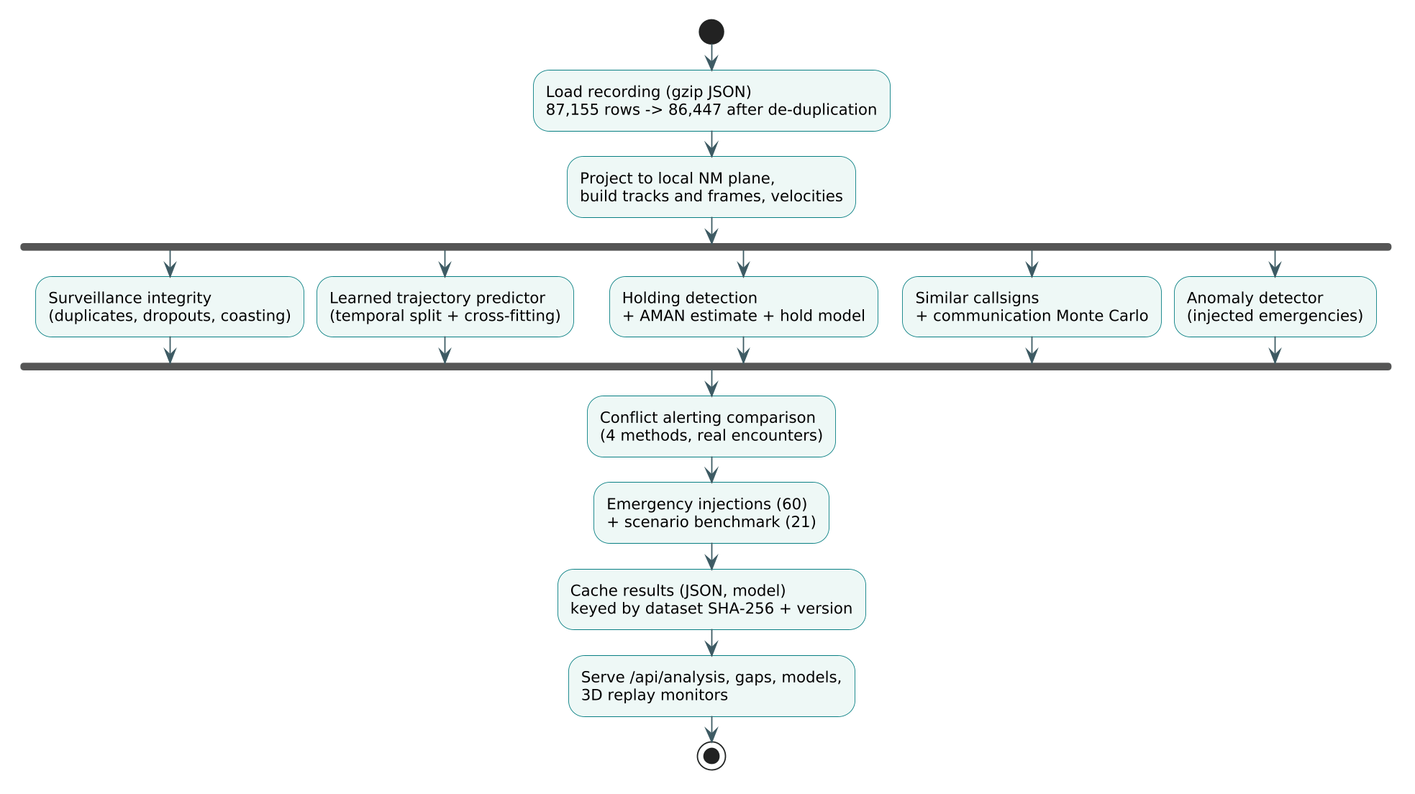
Fig. 4.2 Data Flow from the OpenSky Recording to the User Interface
The deployment view (Fig. 4.3) shows the production arrangement. The application runs in a single Docker container as an unprivileged user, with the database on a named volume. Jenkins builds, tests and deploys the container, and GitHub holds the source and runs a second CI workflow.
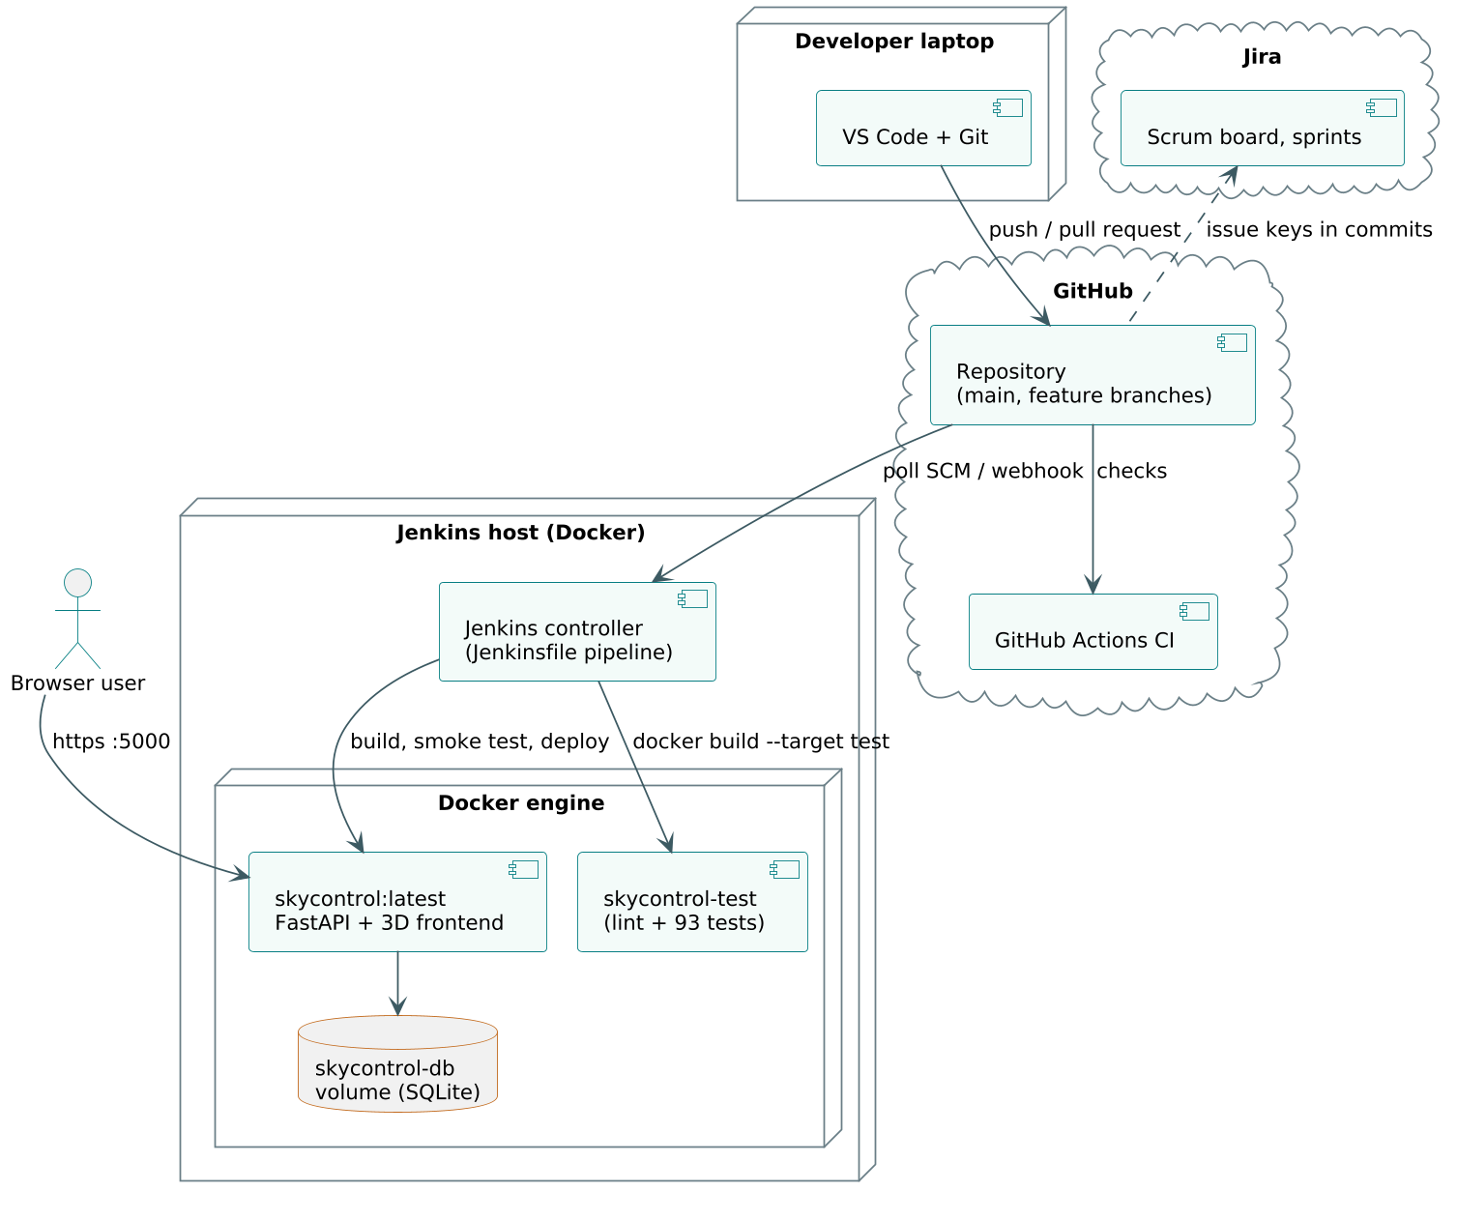
Fig. 4.3 Deployment Diagram

4.3 UML Design

4.3.1 Use Case Diagram
Three actors use SkyControl (Fig. 4.4). The controller logs in, monitors the real airspace, runs scenarios, consents to plans for high-severity events, verifies readbacks and manages flights, runways and alerts. The supervisor can do everything the controller can and additionally approves critical plans, overrides plans with a reason, reviews emergency responses, manages users and reads the audit trail. The automation (SkyControl itself) acts as a system actor that detects situations, plans, verifies and switches context.
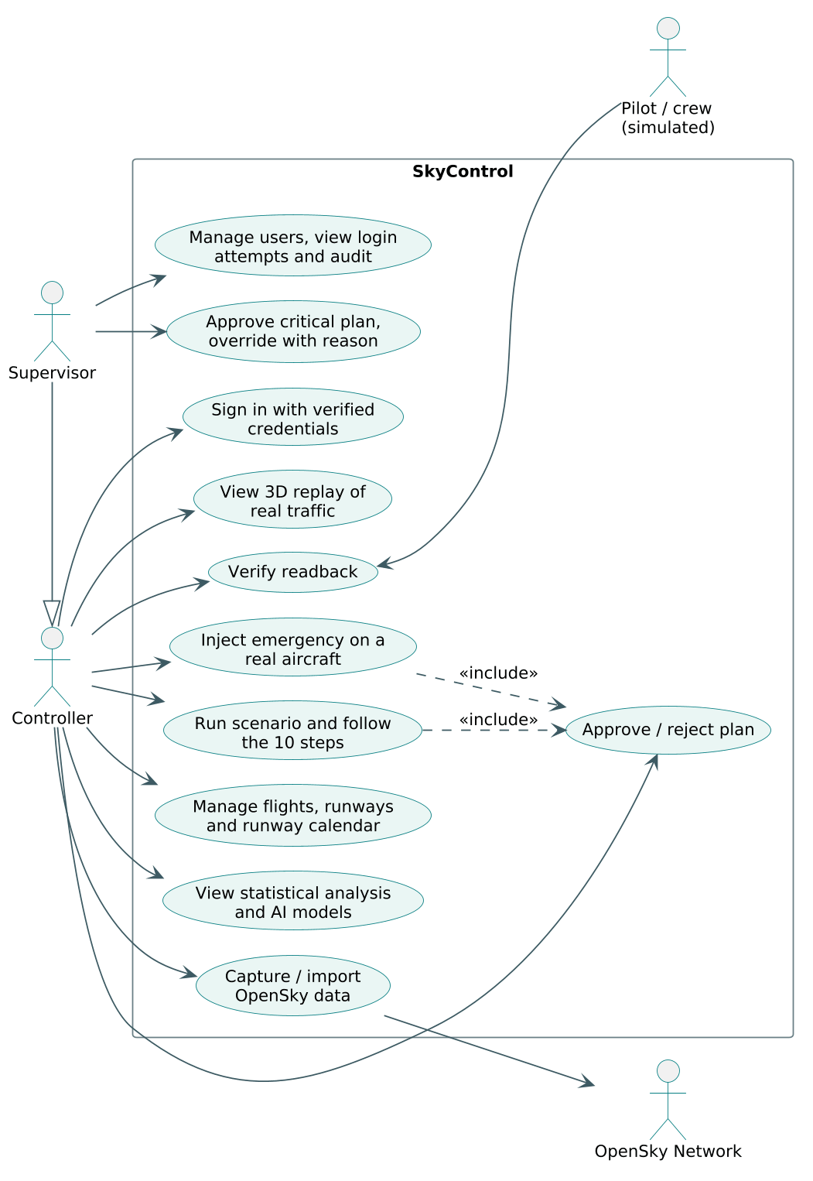
Fig. 4.4 Use Case Diagram

4.3.2 Class Diagram
The class diagram (Fig. 4.5) shows the main domain and analysis classes. A Recording holds the cleaned arrays of the real data. A TrajectoryPredictor owns one pair of gradient-boosted models per horizon. A Scenario is built by the scenario builder and contains Aircraft with routes, the comparator plan and the SkyControl plan, the pipeline Step list, the ContextSwitch log and the Message list. A Clearance produces phraseology and is compared with a readback by the verifier.
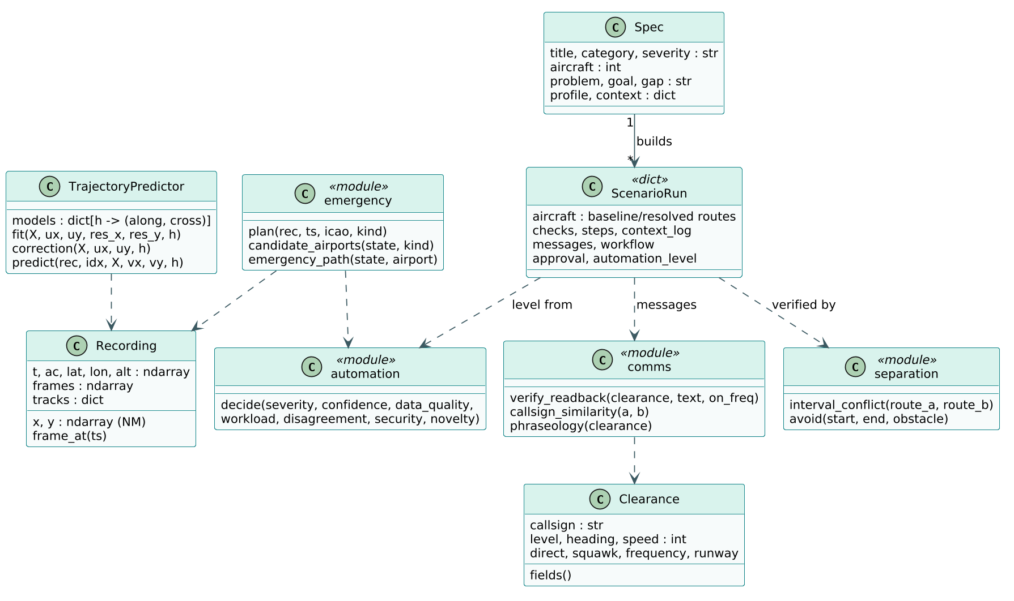
Fig. 4.5 Class Diagram of the Main Components

4.3.3 Sequence Diagrams
The login sequence (Fig. 4.6) shows how a wrong password is handled. The server counts recent failures for the username and the IP address inside one transaction, checks the PBKDF2 hash, always writes an attempt row with the reason, and either returns 401 with the remaining attempts, 429 when locked, or creates a session.
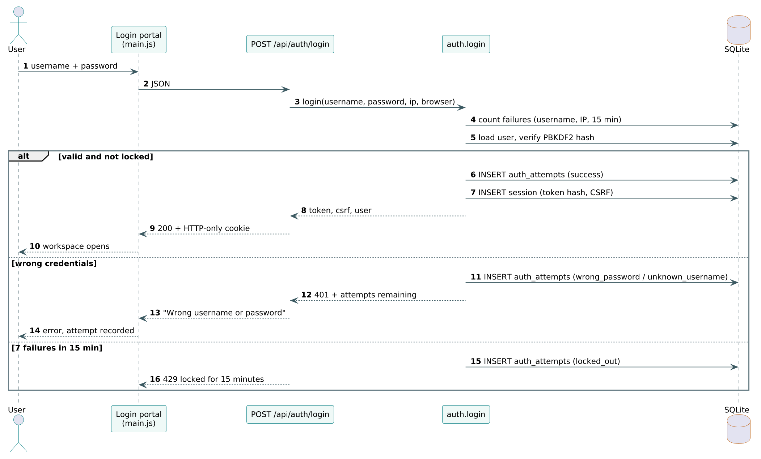
Fig. 4.6 Sequence Diagram of the Login Portal
The emergency sequence (Fig. 4.7) shows what happens when an emergency is injected on a real aircraft: the emergency planner ranks airports, builds a descent path, checks it against all recorded traffic, proposes level changes, re-sequences arrivals, drafts the messages and asks the automation policy for the level; the result is stored and a supervisor reviews it.
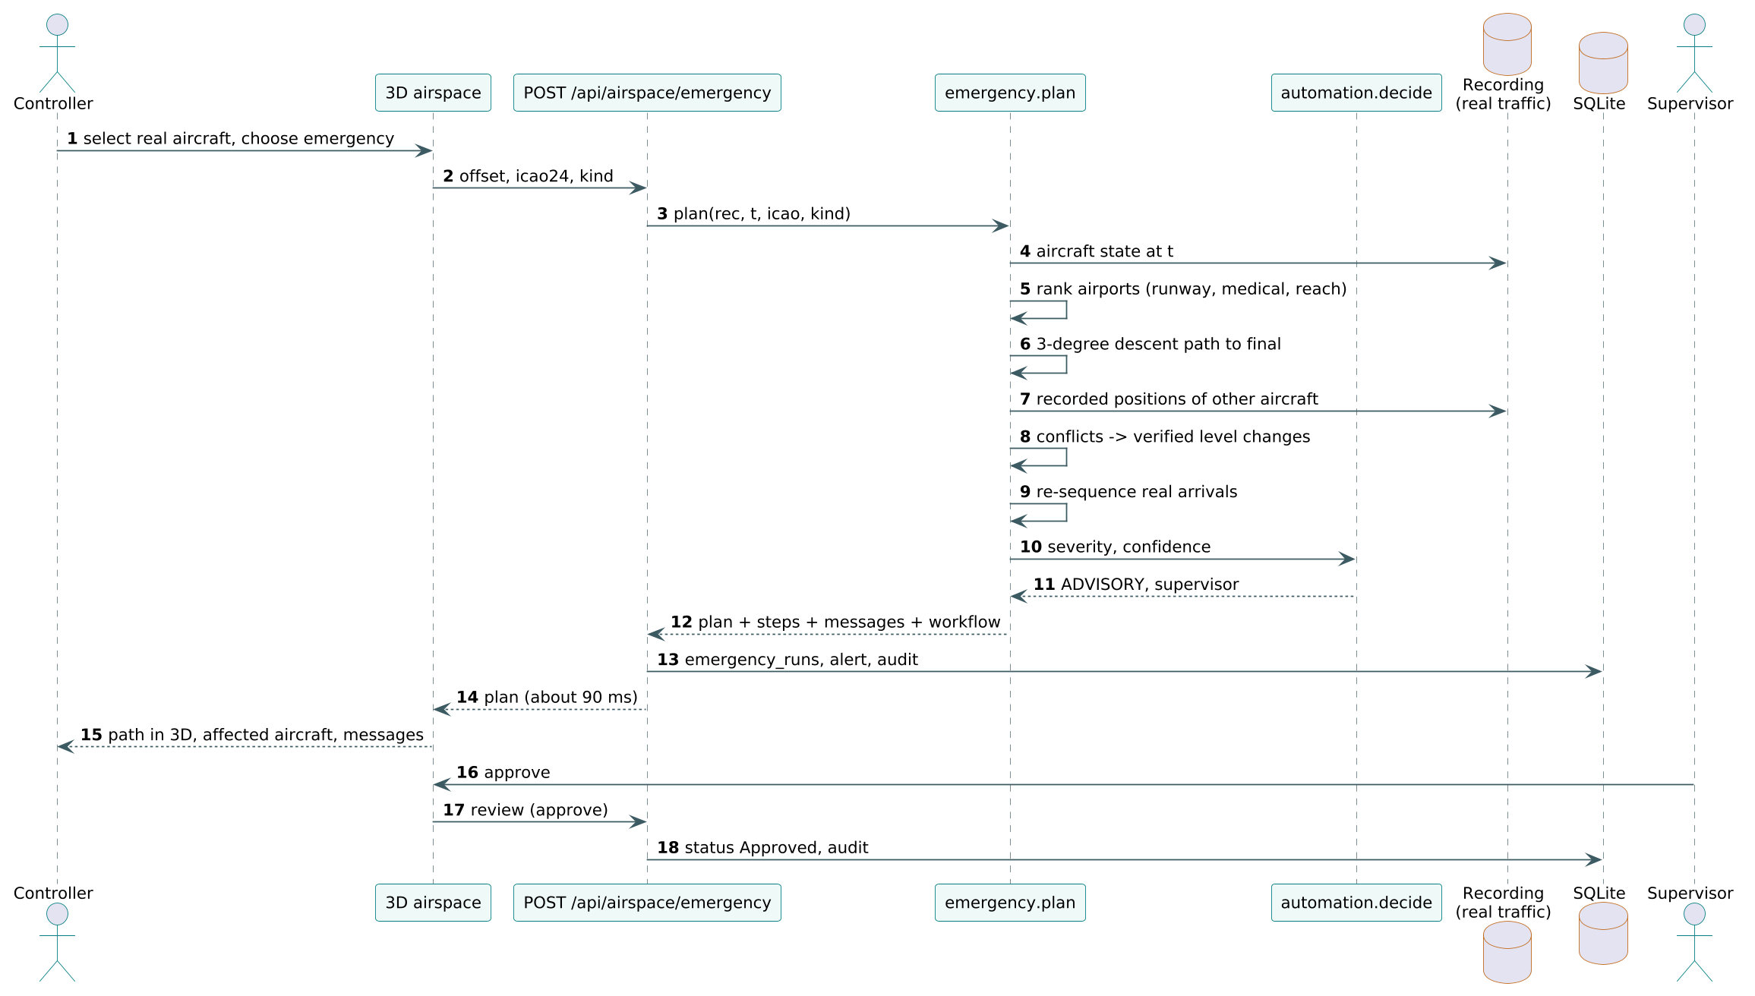
Fig. 4.7 Sequence Diagram of Emergency Injection on Real Traffic

4.3.4 Activity and State Diagrams
Every scenario and every injected emergency is handled by the same ten-step pipeline (Fig. 4.8): DETECT, ASSESS, CONTEXT SWITCH, PLAN, VERIFY, AUTHORISE, COMMUNICATE, EXECUTE, MONITOR and CLOSE. The AUTHORISE step is a decision point: AUTO plans continue, CONSENT plans wait for one controller click, ADVISORY and MANUAL plans wait for the required role, and a rejected plan returns to the human.
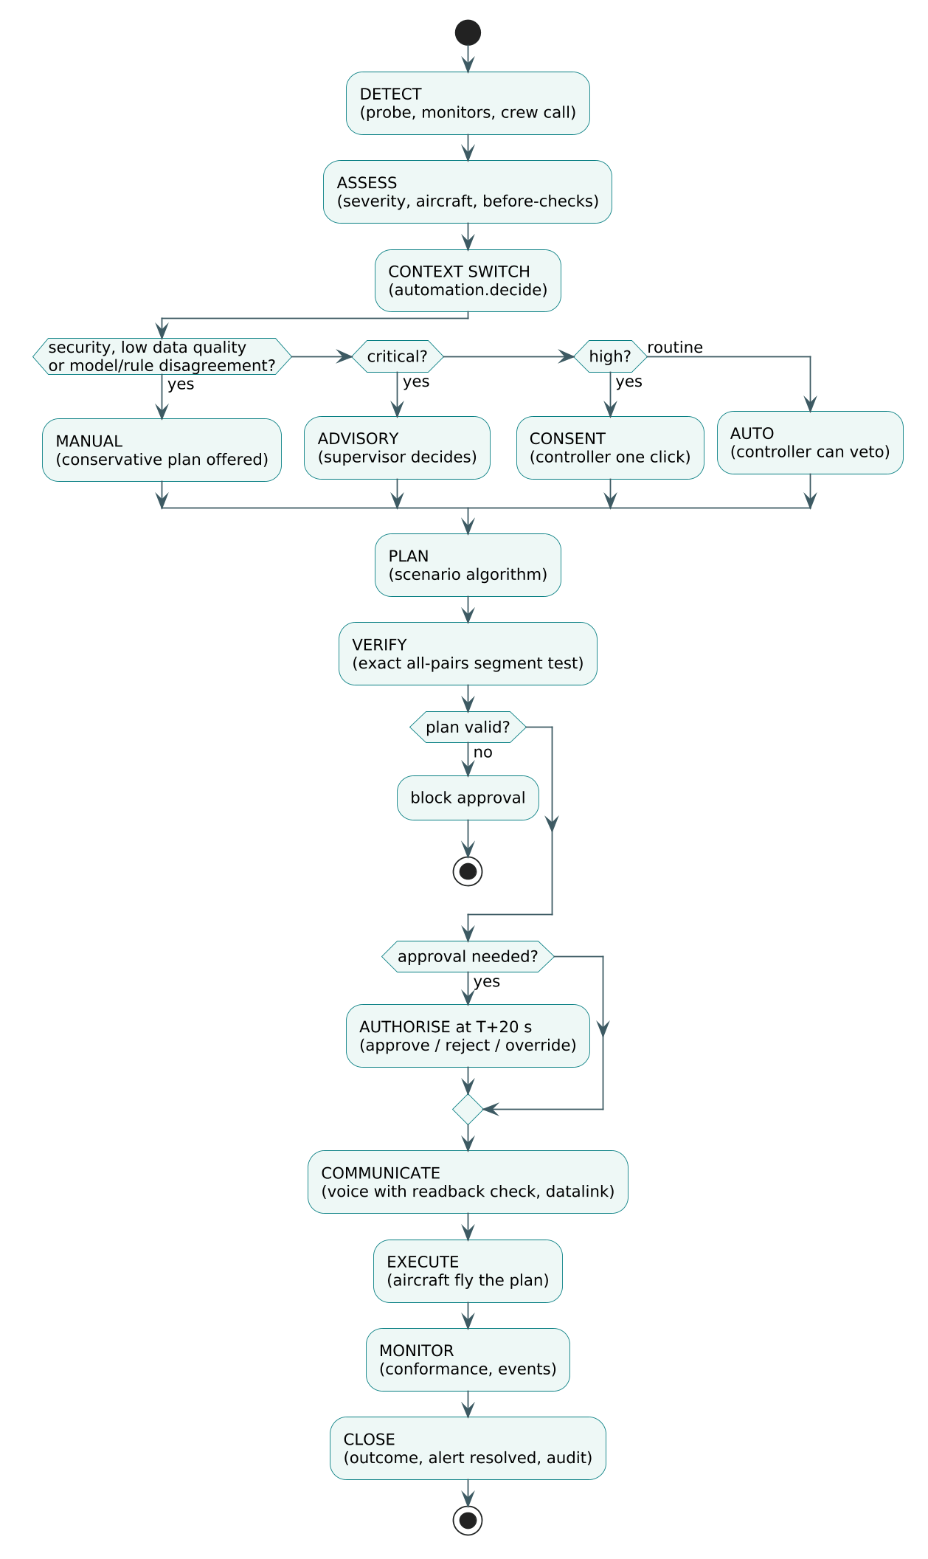
Fig. 4.8 Activity Diagram of the Ten-Step Handling Pipeline
The automation level is a state machine (Fig. 4.9). Events such as a degraded surveillance signal, a disagreement between model and rule, a security signal or a critical severity move the system to a lower level of automation; recovery of data quality and confidence moves it back. Every transition is a context switch that is shown in the user interface and logged.
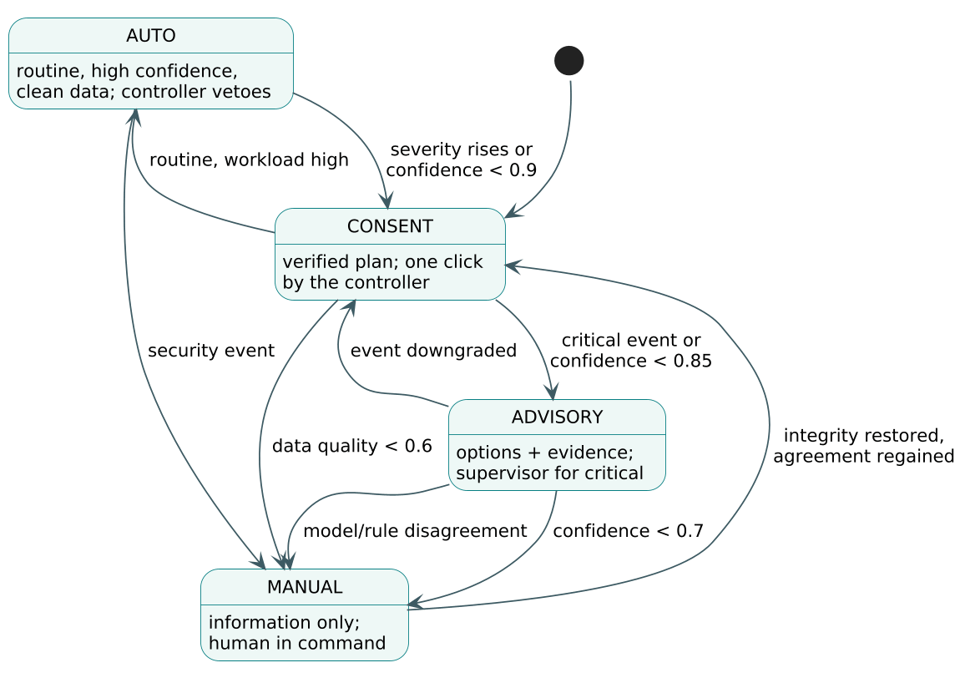
Fig. 4.9 State Diagram of the Automation Levels (Context Switches)

4.3.5 Database Design
The database (Fig. 4.10) has 16 tables. The security tables are users, sessions and auth_attempts; the operations tables are flights, runways, runway_slots, alerts and incident_reports; the lab and assistant tables are lab_runs, emergency_runs and comm_checks; the data tables are datasets, snapshots, state_vectors and feed_events; and audit_events records every change. Foreign keys and CHECK constraints enforce valid statuses, priorities and roles.
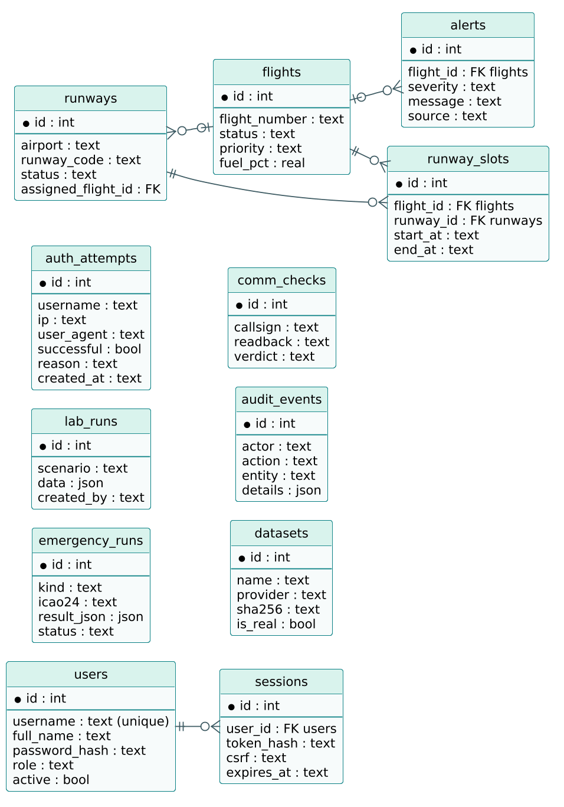
Fig. 4.10 Entity-Relationship Diagram of the Main Tables

4.4 Materials and Methods
This section describes the methods used for each gap. The material is the real recording described in Section 3.3; the methods are the algorithms implemented in backend/analytics and backend/core.

4.4.1 Data Preparation and Projection
The recording is loaded frame by frame. Reports with a missing position are dropped, and repeated reports of the same aircraft with an unchanged time of position are removed (708 of 87,155). Positions are projected onto a local plane centred on 52°N, 0.5°E with the equirectangular approximation of Eqn. 4.1, which is accurate to well under 0.1% over the 300 NM extent of the region.
$x = R\left(λ − λ_{0}\right)\cos{φ_{0}}, y = R\left(φ − φ_{0}\right)$ (4.1)
In Eqn. 4.1, R is the Earth radius in nautical miles, φ and λ are latitude and longitude, and φ₀, λ₀ the centre of the projection. Velocities are derived from consecutive reports of the same aircraft by finite differences, Eqn. 4.2, and the track angle, ground speed, vertical rate and turn rate follow from them.
$v_{i} = \frac{p_{i} − p_{i−1}}{t_{i} − t_{i−1}}$ (4.2)

4.4.2 Surveillance Integrity Monitor (G4)
Duplicate (ghost) targets are detected with three rules applied to aircraft within 300 ft vertically: two targets with the same callsign within 5 NM; two targets whose 24-bit addresses differ in at most two bits (a typical corruption) within 1 NM for at least two frames; and an anonymous target (no callsign) sitting within 0.5 NM and 100 ft of another aircraft. Different callsigns flying that close are treated as a formation, not a duplicate. The duplicate track is merged into the real one before any alerting.
When an aircraft stops reporting for more than 60 s, the conventional display freezes its last position. SkyControl instead coasts the track by dead reckoning, Eqn. 4.3, and shows the growing uncertainty. If the share of stale or duplicated tracks around an event is high, data quality falls and the automation policy switches to MANUAL.
$\hat{p}(t) = p\left(t_{last}\right) + v\left(t_{last}\right)·\left(t − t_{last}\right)$ (4.3)

4.4.3 Learned Trajectory Prediction (G3)
The baseline used by current safety nets is straight-line extrapolation, Eqn. 4.4. SkyControl keeps this as its backbone and learns a correction. For each horizon h of 60, 120 and 300 s, two gradient-boosted regression models predict the along-track residual a_{h} and the cross-track residual c_{h} from eight features: x, y, ground speed, the sine and cosine of the track, turn rate, altitude and vertical rate. The learned prediction is Eqn. 4.5, where û is the unit vector along the current track and n̂ the unit vector to its right.
${\hat{p}}_{SL}(t + h) = p(t) + v(t)·h$ (4.4)
${\hat{p}}_{L}(t + h) = {\hat{p}}_{SL}(t + h) + a_{h}(f)·\hat{u} + c_{h}(f)·\hat{n}$ (4.5)
The models are scikit-learn HistGradientBoostingRegressors with 250 iterations, learning rate 0.06 and 31 leaves. Training uses only the first 60 minutes of the recording, and a target position must also fall inside that period; testing uses the last 30 minutes. The evaluation metric is the mean horizontal position error at each horizon, Eqn. 4.6, compared pairwise with the straight-line error on the same test points.
$E_{h} = \frac{1}{N}\sum_{i=1}^{N}{\left\|{\hat{p}}_{i}(t + h) − p_{i}(t + h)\right\|}$ (4.6)
Learning a residual rather than the full position has two advantages. If the model knows nothing useful, it predicts a residual close to zero and the prediction falls back to the straight line; and the trees only need to learn the structure of the airspace (turns onto arrival routes, stack entries, level-offs), not basic kinematics.

4.4.4 Intent-Aware Conflict Probe (G3)
A conflict is predicted when two predicted positions come closer than the horizontal threshold S_{h} and the vertical threshold S_{v} at the same future time within the look-ahead H, Eqn. 4.7. S_{h} is 3 NM below FL245 and 5 NM above, S_{v} is 1,000 ft with a 100 ft tolerance for 25 ft altitude quantisation, and only aircraft at or above 3,000 ft are considered. The probe samples the predicted paths every 5 s.
$\left\|{\hat{p}}_{a}(t) − {\hat{p}}_{b}(t)\right\| < S_{h} ∧ \left|{\hat{z}}_{a}(t) − {\hat{z}}_{b}(t)\right| < S_{v}, t ∈ [0, H]$ (4.7)
Four alerting methods are compared on the same real traffic. The STCA-style safety net extrapolates straight lines for 120 s and trusts every target. The naive probe does the same for 300 s. The filtered probe adds duplicate merging, level-flight intent (an aircraft with a vertical rate below 300 ft/min is treated as level) and two-frame hysteresis. The intent-aware probe adds the learned trajectories of Eqn. 4.5 and the cleared level of each aircraft, so that a climbing or descending aircraft is predicted to stop at its cleared level instead of continuing through it. With digital clearances the ground system knows the cleared level; in the recording it is approximated by the level at which the aircraft actually levels off next, which is stated as a counterfactual in the results.
Ground truth is the set of encounters actually observed in the recording: pairs inside the screening volume of 3 NM or 5 NM and 900 ft. An alert episode is a run of alert samples for the same pair with gaps of no more than 45 s. An alert that is not followed by an encounter within the look-ahead is a nuisance alert. Warning time is the time between the first alert and the start of the encounter.

4.4.5 Exact Verification of Planned Routes
Planned routes in the scenario lab are piecewise linear in space and time. For any pair of overlapping segments the relative motion is linear, so the squared horizontal distance is a quadratic in time τ, Eqn. 4.8, where Δp and Δv are the relative position and velocity at the start of the overlap.
$d^{2}(τ) = {\left|Δv\right|}^{2}τ^{2} + 2(Δp·Δv)τ + {\left|Δp\right|}^{2}$ (4.8)
The horizontal condition d(τ) < S_{h} therefore holds between the roots of Eqn. 4.9, with A = |Δv|², B = 2Δp·Δv and C = |Δp|² − S_{h}². The vertical condition holds in the interval of Eqn. 4.10. A conflict exists if the intersection of the two intervals with the overlap of the segments is not empty. This test is exact, not sampled, so a plan that passes it cannot hide a short loss of separation between samples.
$τ_{1,2} = \frac{−B ∓ \sqrt{B^{2} − 4AC}}{2A}$ (4.9)
$τ ∈ \left[\frac{−S_{v} − Δz}{Δż}, \frac{S_{v} − Δz}{Δż}\right]$ (4.10)
Routes around weather cells and closed airspace are found with Dijkstra's shortest-path algorithm (Dijkstra, 1959) on a visibility graph of 16 nodes placed on a ring around the buffered obstacle. Converging traffic is resolved by greedy flight-level assignment: aircraft are taken in order of priority and each receives the nearest level that is conflict-free against all aircraft already assigned, verified with Eqn. 4.9. Arrival sequencing puts priority traffic (fuel, medical and other emergencies) first and then keeps the original order, adding holding circuits until every arrival is at least 120 s after the previous one and no runway closure window is violated.

4.4.6 Holding Detection and Linear-Holding Estimate (G5)
A hold is detected when an airborne aircraft above 4,000 ft accumulates at least 330° of turn within 8 minutes, Eqn. 4.11, and it is attributed to the nearest published holding fix within 15 NM. Fuel burned in the hold is estimated with Eqn. 4.12 at a nominal 40 kg per minute (sensitivity range 30 to 100 kg per minute), and CO₂ with the standard factor of 3.16 kg per kg of fuel.
kΔψk ≥ 330°, tend − tstart ≤ 480 s (4.11)
F = fholdjmj, CO2 = 3.16 F (4.12)
The delay that could instead be absorbed en route by an arrival manager with a longer horizon is estimated per flight with Eqn. 4.13, where D is the horizon (350 NM), V the cruise speed (450 kt) and r the maximum speed reduction (10%). The absorbable delay of each hold is the smaller of the hold duration and this cap.
${Δt}_{absorbed} = \frac{D}{V}\left(\frac{1}{1 − r} − 1\right)$ (4.13)

4.4.7 Hold Prediction (G5)
To absorb delay early, the system must know early which arrivals will hold. Every stack-bound arrival is sampled at the first moment it is 30 to 80 NM from the stack, before any hold. The label is whether it later held at that stack (from the real tracks). The six features are what a ground system knows at that moment: distance, altitude, ground speed, the number of aircraft already holding at the stack, the number within 25 NM of it and the number of inbound aircraft ahead. A logistic regression with standardised features, Eqn. 4.14, is trained on the first 55 minutes and tested on the rest. P_{hold}(x) is the predicted probability that an arrival with features x will hold.
$P_{hold}(x) = σ\left(β_{0} + β^{T}x\right) = \frac{1}{1 + e^{−(β_{0} + β^{T}x)}}$ (4.14)

4.4.8 Anomaly Detection and Cleared-Level Monitoring (G7)
Because emergencies are not labelled in ADS-B data, an Isolation Forest is trained on normal kinematics (vertical rate, absolute turn rate, speed change, vertical acceleration, altitude and speed) from the training period. Its anomaly score is Eqn. 4.15, where E[h(x)] is the mean path length needed to isolate x in the random trees and c(n) the average path length of an unsuccessful search in a binary search tree of n points, Eqn. 4.16. The threshold is set for a 1% false-alarm rate on normal test observations.
$s(x, n) = 2^{−\frac{E[h(x)]}{c(n)}}$ (4.15)
$c(n) = 2H(n − 1) − \frac{2(n − 1)}{n}$ (4.16)
The conventional comparator is a fixed rule, |vertical rate| > 4,000 ft/min. The SkyControl hybrid detector is the union of the rule and the forest. Cleared-level adherence monitoring (CLAM) raises an alert when the altitude departs from the cleared level by more than 300 ft without a clearance; it is only possible when the cleared level is known, which the digital clearance record of SkyControl guarantees. Detection is measured by injecting three kinds of emergency into copies of real test-period tracks: an emergency descent at −6,000 ft/min, an engine-out drift-down with a 20% speed decay, and an unannounced turn-back.

4.4.9 Readback Verification and Callsign Similarity (G1, G2)
A clearance is represented as a structured object with optional fields: level, heading, speed, direct-to waypoint, squawk, frequency and runway. The phraseology generator turns it into ICAO-style words ("climb flight level one two zero"). The verifier tokenises the readback, reads numbers spoken as digits, NATO letters or "thousand/hundred" forms, identifies the answering callsign among those on frequency, and compares each required field. The result is one of four verdicts (Table 4.1). If digits were evidently lost, as happens with clipped transmissions or speech recognition, the field is marked unclear and the crew is asked to confirm rather than being told they are wrong.
Table 4.1 Readback Verifier Verdicts
Verdict | Condition | Action shown to the controller
CORRECT | All required fields match | None
INCOMPLETE | A required field is missing or unclear | Ask the crew to confirm (soft alert)
MISMATCH | A field has a different value | Correct immediately: "negative, I say again ..."
WRONG_AIRCRAFT | Another aircraft on frequency answered | Cancel and re-issue to both aircraft

Callsign similarity follows the patterns known to cause confusion (Table 4.2). Every pair of aircraft within 40 NM and 10,000 ft of each other, a proxy for sharing a sector frequency, is scored continuously; pairs scoring 0.7 or more are flagged on the display and in the communication assistant.
Table 4.2 Callsign Similarity Rules and Scores
Pattern | Example | Score
Same operator, same characters in a different order | BAW425 / BAW452 | 0.95
Same operator, one character differs | HLE98 / HLE99 | 0.90
Same operator, same final characters | BAW425 / BAW725 | 0.75
Same operator, same leading characters | EZY71A / EZY71Q | 0.70
Same operator, one character added or dropped | RYR52 / RYR522 | 0.65
Different operator, same flight number | KLM1234 / DLH1234 | 0.60

4.4.10 Communication Model (G1, G2)
The effect of the communication functions on a whole sector cannot be measured from ADS-B data, so it is modelled by Monte Carlo simulation of 4,000 busy sector-hours with 300 clearances per hour (Poisson). In the voice baseline a readback error (probability p_{rb}) or a callsign confusion goes undetected when the controller misses it (p_{miss}). In the hybrid, a share δ of routine clearances goes by datalink with a small residual error p_{dl}, similar-callsign warnings prevent a share a of confusions, and an error on voice goes undetected only if both the controller and the verifier (detection rate D, measured) miss it. The expected numbers of undetected errors per hour are approximately Eqn. 4.17 and Eqn. 4.18, where e is the similar-callsign exposure measured on the real recording and p_{cc} the confusion probability when similar callsigns share a frequency.
$U_{voice} = N\left(p_{rb} + p_{cc}e\right)p_{miss}$ (4.17)
$U_{hyb} = N\left[\left(1 − δ\right)\left(p_{rb} + p_{cc}e(1 − a)\right)p_{miss}\left(1 − D\right) + δp_{dl}\right]$ (4.18)
Because p_{rb} and p_{miss} come from the literature rather than from measurement, the model is run over a grid of values (p_{rb} from 0.5% to 3%, p_{miss} from 20% to 60%) and the datalink share is varied from 0 to 90%. The verifier detection rate D is measured on a corpus of 3,000 readbacks generated from real callsigns, both clean and with 5% simulated speech-recognition word noise.

4.4.11 Emergency Planning on Real Traffic (G6)
When an emergency is declared for a real aircraft, candidate airports are filtered by runway length, medical support and reachability within the endurance of the emergency type, and ranked by distance. The emergency trajectory goes direct to a 10 NM final with a 3° descent profile, Eqn. 4.19; if the aircraft is too high for the distance, a dog-leg is inserted to lengthen the track. The trajectory is checked every 10 s for 15 minutes against the recorded future positions of every other aircraft (5 NM, 1,000 ft). For each conflicting aircraft, level changes between 3,000 ft and 41,000 ft are tried in order of size and re-checked against all other traffic; aircraft close to an airfield at low level are re-sequenced instead. The emergency receives the first landing slot, with 120 s behind it and 90 s between following arrivals, and only arrivals whose original slot is affected are delayed.
$d_{descent} = \frac{z_{now} − z_{aerodrome}}{318 ft/NM}$ (4.19)

4.4.12 Adaptive Automation and Context Switching (G8)
The automation level is chosen by an explicit rule policy inspired by the levels-of-automation model of Parasuraman et al. (2000). Its inputs are the severity of the event, the plan confidence (agreement between the planner's checks and the learned models), the surveillance data quality, the controller workload, disagreement between learned and deterministic components, a novelty (anomaly) score and a security flag. Table 4.3 gives the rules in order of precedence. Each decision returns the level, the role that must approve and the reasons, which are displayed as a context switch.
Table 4.3 Context-Switch Policy (Evaluated Top to Bottom)
Condition | Level | Approver
Security event (e.g. unlawful interference) | MANUAL | Supervisor
Surveillance data quality below 60% | MANUAL | Controller
Learned model disagrees with the safety rule | MANUAL | Controller
Novelty score above 0.8 (situation unlike training data) | ADVISORY | Supervisor if critical
Critical severity and confidence below 70% | MANUAL | Supervisor
Critical severity, verified plan | ADVISORY | Supervisor
High severity and confidence of at least 85% | CONSENT | Controller
High severity, lower confidence | ADVISORY | Controller
Routine, confidence ≥ 90% and data quality ≥ 90% | AUTO | None (controller can veto)
Routine, otherwise | CONSENT | Controller

4.4.13 Controller Workflow Model
To compare handling time with conventional ATC, every scenario and every emergency is also expressed as a controller workflow. In the conventional workflow the controller detects, decides, performs manual tasks (checklist, alternate search), telephones adjacent units and then issues every instruction by voice with a readback, Eqn. 4.20. In the hybrid workflow detection comes from the monitors, the plan is computed and verified automatically, one review is needed if the level is not AUTO, coordination is digital, and urgent voice instructions run in parallel with routine datalink messages, Eqn. 4.21.
Tconv = tdet + tdec + ktk + nctphone + nti + trb + nprbtcorr (4.20)
$T_{hyb} = t_{det}′ + t_{plan} + t_{rev} + t_{dig} + max\left(n_{u}\left(t_{i} + t_{rb}\right), t_{dl}\right)$ (4.21)
The task durations (5 s per voice instruction, 4 s per readback, 25 s per telephone call, 30 s for a checklist, 60 s for an alternate search, 30 s datalink response) are modelling assumptions informed by Cardosi (1993) and CPDLC experience. They are stored in one place (core/workflow.py) so that they can be changed, and the results are reported as modelled.

4.4.14 Statistical Evaluation
Wherever the baseline and SkyControl are evaluated on the same cases (the same test points, the same dropouts, the same encounters, the same injected emergencies or the same scenarios), the comparison is paired. The one-sided Wilcoxon signed-rank test (Wilcoxon, 1945) is used because the differences are not normally distributed; its statistic is the sum of the ranks of the positive differences, Eqn. 4.22. The uncertainty of the mean paired improvement is reported as a 95% bootstrap confidence interval (Efron & Tibshirani, 1993) from 2,000 resamples, Eqn. 4.23. Classifier performance is reported as the area under the ROC curve (Fawcett, 2006) with a bootstrap interval, and detection rates with Wilson intervals. The significance level is α = 0.05.
W⁺ = di > 0Ri (4.22)
${CI}_{95} = \left[Q_{0.025}\left(\overline{d^{*}}\right), Q_{0.975}\left(\overline{d^{*}}\right)\right]$ (4.23)

4.4.15 Password Hashing
Passwords are never stored. The stored value is the output of PBKDF2 with HMAC-SHA256 as the pseudo-random function (Moriarty, Kaliski, & Rusch, 2017), Eqn. 4.24, where P is the password, s a random 16-byte salt per user, c the iteration count and ℓ the key length in bytes; the salt and the iteration count are stored with the key. Verification recomputes the key and compares it in constant time.
$DK = PBKDF2\left(P, s, c, ℓ\right), c = 310 000, ℓ = 32$ (4.24)

4.5 Codes and Standards
The design follows aviation, software-engineering and security standards where they apply to a laboratory system. Table 4.4 lists them and how they are used.
Table 4.4 Codes and Standards Followed
Standard | Use in SkyControl
ICAO Annex 11, Air Traffic Services | Objectives of ATC used to define the gaps
ICAO Doc 4444, PANS-ATM | Separation minima (3/5 NM, 1,000 ft), readback requirements, emergency handling
ICAO Doc 9432, Manual of Radiotelephony | Phraseology generated by the communication assistant
ICAO Annex 10 Vol. II | Communication procedures, numbers and NATO alphabet
EUROCONTROL STCA specification | Look-ahead and alerting behaviour of the safety-net baseline
NIST SP 800-63B | Password length, no composition tricks beyond letters+digits, throttling
RFC 8018 (PKCS #5 v2.1) | PBKDF2 key derivation for password storage
OWASP Top 10 (2021) and ASVS | Session management, CSRF, security headers, access control, logging
ISO/IEC 25010 | Quality attributes used for the non-functional requirements
PEP 8 and ruff | Python code style and static checks
Semantic versioning | Application version 6.0.0
OpenSky Network terms of use | Data used for non-commercial research and teaching with attribution

4.6 Constraints, Alternatives and Trade-offs
The main constraints were the data (one region, 90 minutes, no clearances, no fuel or emergency fields), the absence of controllers for user trials, the need to run on an ordinary laptop, and the requirement that the result be demonstrable in a browser. Table 4.5 summarises the main design alternatives and why the chosen option was preferred.
Table 4.5 Design Alternatives and Trade-offs
Decision | Alternatives considered | Choice and reason
Trajectory predictor | LSTM / transformer; physics model with intent | Gradient-boosted residuals: accurate on tabular features, fast on CPU, degrades to straight line
Conflict probe | Naive 5-min probe; probabilistic probe | Intent-aware probe: the naive probe gave 522.7 alerts/h, unusable
Anomaly detection | Supervised classifier; autoencoder | Isolation forest + rule: no labels exist, fast, transparent with the rule
Hold prediction | Gradient boosting | Logistic regression: only 174 samples, interpretable coefficients
Automation control | Learned policy | Rule policy: auditable, predictable, matches the levels-of-automation literature
Verification | Sampled checks | Exact interval geometry: no gaps between samples
Database | PostgreSQL | SQLite WAL: zero administration for a lab; migration path documented
Front end | React / Angular with a build step | Vanilla ES modules: no build, strict CSP, easy to read
3D library | CesiumJS; deck.gl | three.js: small, flexible, vendored locally
Speech | Cloud ASR | Browser speech API + typed input: no external service or keys
Deployment | Virtual machine; Kubernetes | Single Docker container + Compose: right size for the project

Two trade-offs deserve emphasis. First, accuracy against honesty: the intent-aware probe uses the next observed level-off as a stand-in for the cleared level. This makes the probe look ahead realistically, but it is optimistic, so the report presents it as what a digital clearance record would make possible rather than as a measured operational result. Second, automation against authority: a higher automation level would always be faster in the workflow model, but SkyControl deliberately drops to ADVISORY or MANUAL in critical, uncertain or degraded situations and accepts the extra time, because the literature on automation bias shows that this is where blind automation is most dangerous.

CHAPTER 5
IMPLEMENTATION
This chapter describes how the design was implemented: the project structure, the back end, the login portal, the analytics pipeline, the scenario lab, the 3D front end, the communication assistant, the tests and the deployment artefacts. Short code excerpts illustrate the key parts; longer samples are in Appendix A.

5.1 Project Structure
The repository is organised by layer, as shown in the listing below.
SkyControl/
├── backend/
│ ├── app.py FastAPI app, security headers, static files, health
│ ├── auth.py PBKDF2 hashing, login, lockout, sessions, CSRF, roles
│ ├── database.py SQLite connection (WAL), schema.sql, audit helper
│ ├── seed.py accounts from environment, runways, dataset register
│ ├── routes/ auth, operations, lab, airspace, insight, data
│ ├── core/ scenarios, separation, comms, automation, workflow, gaps
│ └── analytics/ recording, surveillance, prediction, conflicts, holding,
│ hold_model, anomaly, callsigns, montecarlo, emergency,
│ stats, live, pipeline
├── frontend/ index.html, css/, js/ (pages/, scene3d.js), vendor/
├── data/ OpenSky recording (.json.gz), reference data, snapshots
├── tests/ 93 pytest tests
├── scripts/ build_analysis.py, smoke_test.sh, load_test.py
├── jenkins/ Jenkins controller image with Docker CLI
├── jira/ backlog CSV, sprint plan
├── docs/ architecture, gap analysis, guides, evidence, report
├── Dockerfile, docker-compose.yml, Jenkinsfile, .github/workflows/ci.yml
└── run.py, setup_accounts.py, start_windows.bat, start_linux_mac.sh

5.2 Back End
The back end is a FastAPI application. On start-up a lifespan handler creates the schema, seeds the accounts from environment variables (there are no default passwords), the runways and the dataset register, and starts a background thread that builds or loads the cached real-data analysis, so that the login page is available immediately. Middleware adds gzip compression and the security headers. The static front end is served from the same origin, which allows a strict Content-Security-Policy without any cross-origin requests.
Routes are grouped into six routers. Each route declares its input with type hints and Pydantic validation, obtains the caller's identity with require(request, supervisor, mutation), which checks the session, the CSRF token for mutations and the supervisor role where needed, performs its work inside a database transaction, and writes an audit event.

5.3 Login Portal and Attempt Storage
The login function is the heart of requirement 2. It runs inside an immediate transaction so that concurrent attempts cannot bypass the lockout, determines a precise reason for the outcome, always stores the attempt and only then decides the response. The excerpt below is taken from backend/auth.py.
def login(username, password, ip, user_agent=''):
with connect() as db:
db.execute('BEGIN IMMEDIATE')
failures = db.execute('SELECT COUNT(*) FROM auth_attempts WHERE username=? '
'AND successful=0 AND created_at>=?',
(username, cutoff)).fetchone()[0]
ip_failures = ... # same count per IP address
user = one(db.execute('SELECT * FROM users WHERE username=?', (username,)))
valid = bool(user and user['active'] and check_password(password, user['password_hash']))
if not username: reason = 'missing_username'
elif ip_failures >= LOGIN_IP_LIMIT: reason = 'ip_rate_limited'
elif failures >= LOGIN_LOCKOUT_FAILURES: reason = 'locked_out'
elif valid: reason = 'success'
elif user and not user['active']: reason = 'account_disabled'
elif user: reason = 'wrong_password'
else: reason = 'unknown_username'
db.execute('INSERT INTO auth_attempts (username, ip, user_agent, successful, '
'reason, created_at) VALUES (?,?,?,?,?,?)',
(username, ip, user_agent[:200], int(reason == 'success'), reason, utcnow()))
if reason != 'success':
db.commit()
raise HTTPException(429 if locked else 401,
{'message': 'Wrong username or password',
'attempts_remaining': remaining})
... # session token (stored as SHA-256) and CSRF token

In the browser, the login page shows the server message and the number of attempts remaining (Fig. 5.1). The security page lists every attempt with the username tried, the IP address, the browser, the outcome and the reason, can filter to failed attempts only, and charts the outcomes; it is shown in Chapter 7.
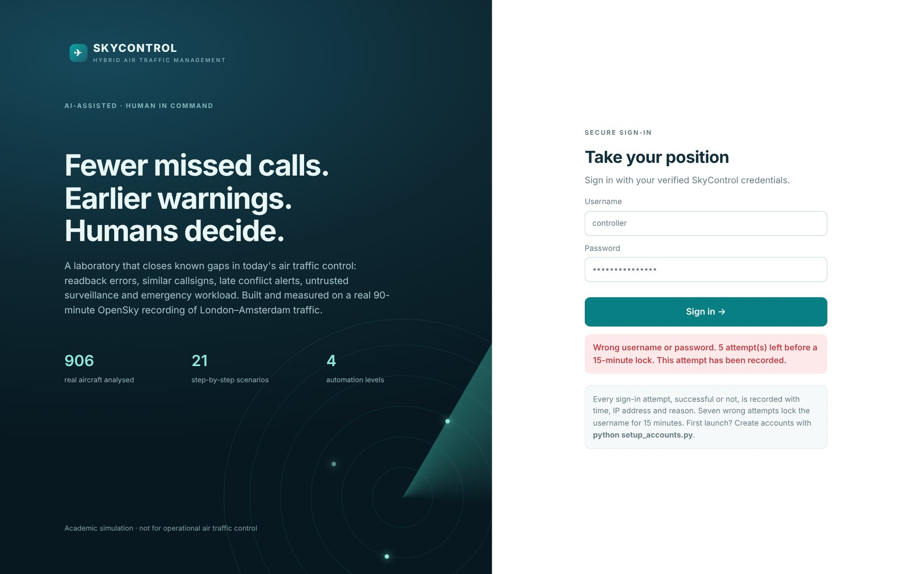
Fig. 5.1 Login Portal Rejecting a Wrong Password and Showing the Attempts Remaining

5.4 Analytics Pipeline
The module analytics/pipeline.py runs all analyses in order: recording integrity, surveillance (ghosts, gaps and coasting), trajectory prediction (training and held-out evaluation), conflict alerting with the four methods, holding and the AMAN estimate, hold prediction, anomaly detection with injected emergencies, callsign similarity, the communication model, 60 emergency injections and the scenario benchmark. The complete analysis takes about 45 s on four CPU cores. The result is a JSON document of about 170 KB plus the trained predictor (about 4 MB); both are cached by dataset hash and analysis version. In the Docker image the cache is built during the image build, so a container starts with the analysis ready.
The live views of the 3D replay (analytics/live.py) reuse the same models. For a chosen moment they compute the intent-aware predicted conflicts, duplicates, similar callsigns sharing airspace, aircraft holding and tracks being coasted, and the five-minute straight-line and learned predicted positions of every aircraft. Results are cached per recorded frame with a least-recently-used cache, which brings the median response time of a frame to 23 ms.
The core of the vectorised conflict probe is shown below; it compares all nearby pairs at all future sample times at once.
px, py, pz = _predicted_paths(rec, eligible, ts, cfg, levels, learned) # shape (aircraft, samples)
i, j = np.triu_indices(len(eligible), 1) # all pairs
near = np.hypot(rec.x[eligible[i]] - rec.x[eligible[j]],
rec.y[eligible[i]] - rec.y[eligible[j]]) < 80 # pre-filter 80 NM
i, j = i[near], j[near]
thr = horizontal_threshold(rec.alt[eligible[i]], rec.alt[eligible[j]])[:, None] # 3 or 5 NM
inside = (np.hypot(px[i] - px[j], py[i] - py[j]) < thr) & (np.abs(pz[i] - pz[j]) < V_THRESHOLD)
for k in np.flatnonzero(inside.any(axis=1)):
first = int(np.argmax(inside[k])) * SAMPLE_S # seconds to predicted conflict

5.5 Scenario Lab Engine
The scenario engine (core/scenarios.py) holds the specification of 21 scenarios in eight categories. A builder creates the aircraft (with callsigns taken from aircraft airborne in the real recording when the user chooses that source), the hazard, the comparator plan and the SkyControl plan. Both plans are verified with the exact interval method, outcome checks are computed (aircraft conflicts, runway conflicts, hazard or closure violations and fuel deadline misses), and the ten pipeline steps, the context-switch log, the message log with readback verification and the workflow comparison are generated. Table 5.1 shows what each step does.
Table 5.1 The Ten Steps Used to Handle Every Scenario
Step | Actor | What happens
1 DETECT | Monitors | Probe, integrity monitor, readback verifier or emergency monitor detects the situation
2 ASSESS | SkyControl | Severity, aircraft involved and the comparator's outcome are computed
3 CONTEXT SWITCH | Automation policy | Level and approver chosen; reasons shown and logged
4 PLAN | Planner | Levels, reroutes, sequence or holding computed
5 VERIFY | Safety checker | Exact all-pairs separation, runway, hazard and deadline checks
6 AUTHORISE | Human | Run pauses at T+20 s for approval, rejection or override with a reason
7 COMMUNICATE | Controller + datalink | Urgent voice with verified readback; routine by datalink
8 EXECUTE | Aircraft | Manoeuvres flown in the replay
9 MONITOR | SkyControl | Conformance monitored until all aircraft reach their final state
10 CLOSE | SkyControl | Outcome recorded, alert resolved and audit trail written

Runs are stored in the database so that a run started by a controller is kept when a supervisor logs in to approve it. The replay clock advances on the server and stops at the approval gate until a user with the required role acts; the browser animates the aircraft between server updates.

5.6 Three-Dimensional Front End
The front end is a single-page application written as ES modules without a build step. main.js handles login, navigation and the session; each page is a module under js/pages/. The 3D views use a shared Airspace3D class (js/scene3d.js) built on three.js: aircraft are instanced meshes coloured by altitude or state, with trails, vertical stems to the ground, text labels, airports, holding fixes, a coastline, predicted conflict lines and prediction segments. Orbit, pan and zoom controls and preset views (3D, top, side) are provided. Chart.js renders the statistics. three.js and Chart.js are vendored locally with their licences so that the CSP can forbid external scripts.
Table 5.2 Pages of the Application
Page | Content
Command centre | Key results, live counts, failed logins in the last 24 hours, open alerts
ATC gaps and fixes | Gap catalogue G1-G9 with evidence and links to scenarios
3D airspace | Real traffic replay with layers, live monitor and emergency injection
Scenario lab | 21 scenarios with 3D replay, ten steps, approvals, messages and comparison
Communication assistant | Clearance builder, phraseology, readback verification, similar callsigns
AI models and automation | Model cards and the context-switch simulator
Statistical analysis | Eight tabs: summary, conflicts, surveillance, communication, holding, emergencies, scenarios, dataset
Operations | Flights, runways, runway scheduling, priority queue, alerts
Data and provenance | Dataset register, snapshots, import, feed health
Security and audit | Login attempts, outcomes chart, users, password change, audit trail

5.7 Communication Assistant
The communication assistant lets the user build a clearance from structured fields, shows the ICAO phraseology and the frequency occupancy it would need, and verifies a readback typed by the user or spoken through the browser's speech-recognition interface. The verdict is shown with the field-by-field comparison and the advice for the controller. A log of checks is stored in comm_checks, and a similarity panel warns of similar callsigns on the frequency.

5.8 Testing
Testing used three levels. Unit and integration tests (pytest) cover every module and route: authentication and attempt storage, operations, all 21 scenarios, the lab API and approval gates, communication and automation, the real-data analytics and the application shell. API tests use FastAPI's test client with a temporary database. Browser tests with Playwright and headless Chromium exercise every page and the interactive flows, and a container smoke test checks the deployed image. The test fixture sets the account passwords through environment variables, exactly as in production.
def test_wrong_password_is_rejected_and_stored(api, supervisor):
r = api.post('/api/auth/login',
json={'username': 'controller', 'password': 'not-the-password1'})
assert r.status_code == 401
assert r.json()['error'] == 'Wrong username or password'
assert r.json()['details']['attempts_remaining'] == 6
attempts = api.get('/api/auth/attempts', headers=supervisor).json()['attempts']
failed = [a for a in attempts
if a['username'] == 'controller' and not a['successful']]
assert len(failed) == 1 and failed[0]['reason'] == 'wrong_password'

def test_lockout_after_seven_failures_even_with_correct_password(api, supervisor):
for _ in range(7):
r = api.post('/api/auth/login', json={'username': 'controller', 'password': 'WRONG-pass-1'})
assert r.status_code == 401
blocked = api.post('/api/auth/login',
json={'username': 'controller', 'password': CONTROLLER_PASSWORD})
assert blocked.status_code == 429

5.9 Containerisation
The Dockerfile has three stages. The base stage installs the runtime dependencies and copies the application and data. The test stage adds the development dependencies and the tests and runs ruff and pytest with JUnit and coverage reports; Jenkins builds this stage, so the build agent needs only Docker. The runtime stage pre-computes the analysis, creates an unprivileged user, declares the database volume and a health check, and starts the server.
FROM python:3.12-slim AS base
WORKDIR /app
COPY requirements.txt .
RUN pip install -r requirements.txt
COPY backend backend
COPY frontend frontend
...
FROM base AS test
RUN pip install -r requirements-dev.txt
COPY tests tests
CMD ["sh", "-c", "ruff check . && python -m pytest --junitxml=reports/junit.xml ..."]

FROM base AS runtime
ENV SKYCONTROL_CACHE_DIR=/app/cache
RUN python scripts/build_analysis.py # analysis ready at start-up
RUN useradd --create-home --uid 10001 skycontrol \
&& mkdir -p /app/data/db && chown -R skycontrol /app/data /app/cache
USER skycontrol
EXPOSE 5000
VOLUME ["/app/data/db"]
HEALTHCHECK CMD python -c "import urllib.request; \
urllib.request.urlopen('http://127.0.0.1:5000/api/health')"
CMD ["python", "run.py"]

docker-compose.yml runs the image with the passwords taken from an .env file (an example file is provided and the real one is excluded from Git), maps port 5000 and mounts a named volume for the database.

5.10 Continuous Integration and Delivery
The Jenkinsfile is a declarative pipeline with five stages: Checkout, Lint and tests (in the test image, with JUnit and coverage reports published), Build image (tagged with the build number and latest), Smoke test (a temporary container on port 5099 checked by scripts/smoke_test.sh using credentials from the Jenkins credentials store) and Deploy (replace the running container, keep the database volume, wait for the health check). The pipeline is described in Chapter 6. A GitHub Actions workflow (.github/workflows/ci.yml) runs lint, tests and a Docker build on every push and pull request.

CHAPTER 6
SCHEDULE, TASKS AND MILESTONES
The project was run as a Scrum project of six two-week sprints between 3 August and 23 October 2026. This chapter describes the method, the backlog and sprints as they are set up in Jira, the version-control workflow on GitHub, the Jenkins pipeline, the Docker deployment and the milestones.

6.1 Agile Methodology
Scrum (Schwaber & Sutherland, 2020) was chosen because the requirements were expected to change as results on real data came in, which is exactly what happened: the conflict probe, the emergency planner and the readback verifier were all redesigned after their first evaluation. Each sprint started with planning, in which stories were pulled from the ordered backlog up to the team's velocity, had short daily stand-ups, and ended with a review, in which the increment was demonstrated in the running application, and a retrospective that produced one improvement action. The definition of done required that the code was merged through a pull request, that lint and all tests passed in CI and Jenkins, that the acceptance criteria were shown in the application and that the documentation was updated.
Table 6.1 Scrum Roles and Ceremonies
Item | How it was used
Product owner | Owns the order of the backlog: login and data first, then analytics, scenarios, UI, DevOps
Scrum master | Runs the ceremonies and removes blockers (dataset access, Docker set-up)
Development team | Designs, implements and tests the stories; everyone writes tests for their own stories
Guide | Reviews the increment at sprint reviews and advises on scope and evaluation
Sprint planning | Stories pulled up to the average velocity of about 34 points
Daily stand-up | 15 minutes; Jira board updated
Sprint review | Increment demonstrated in the running app
Retrospective | One improvement per sprint, tracked as an issue labelled retro

6.2 Product Backlog and Epics
The backlog contains 47 user stories grouped into nine epics with a total of 205 story points (Table 6.2). Story points were estimated with planning poker on the Fibonacci scale. The largest epics are the real-data analytics and the AI models, which reflects the emphasis of the project on evidence.
Table 6.2 Epics of the Product Backlog
Epic | Title | Story points
E1 | Secure login portal and user management | 17
E2 | Real data pipeline (OpenSky recording) | 13
E3 | Operations management | 15
E4 | Real-data analytics and statistics | 34
E5 | AI models and adaptive automation | 34
E6 | Scenario lab (21 step-by-step scenarios) | 32
E7 | 3D web application and UX | 27
E8 | DevOps and quality | 23
E9 | Documentation, report and demonstration | 10
 | Total | 205

6.3 Sprint Plan
Table 6.3 gives the six sprints with their dates, goals and committed points.
Table 6.3 Sprint Plan
Sprint | Dates | Sprint goal | Points
Sprint 1 | 08-03 to 08-14 | Secure login portal, project skeleton and real data ingestion | 25
Sprint 2 | 08-17 to 08-28 | Operations management and surveillance-integrity analytics | 26
Sprint 3 | 08-31 to 09-11 | AI models: learned trajectory prediction, conflict probe, holding, anomaly detection | 32
Sprint 4 | 09-14 to 09-25 | Communication safety, context-switch policy and the scenario engine | 47
Sprint 5 | 09-28 to 10-09 | 3D web app: airspace replay, scenario lab, statistics and emergency injection | 43
Sprint 6 | 10-12 to 10-23 | DevOps (Docker, Jenkins, GitHub Actions), testing, report and release | 32

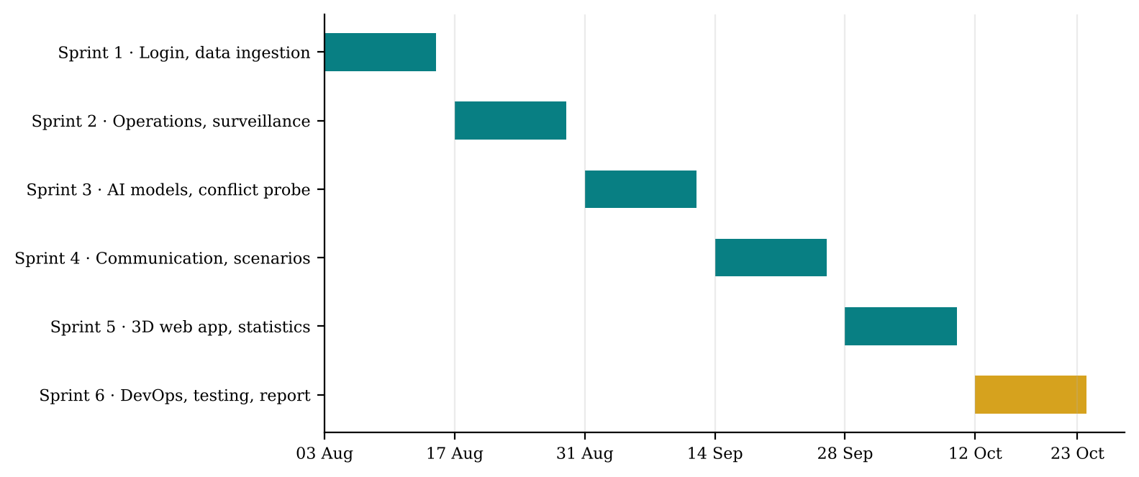
Fig. 6.1 Project Timeline of the Six Sprints
Fig. 6.1 shows the timeline. Sprints 1 to 5 delivered the application increment; Sprint 6 delivers the DevOps pipeline, the test suite, this report and the release, and is the sprint that is run live on the Jira board.
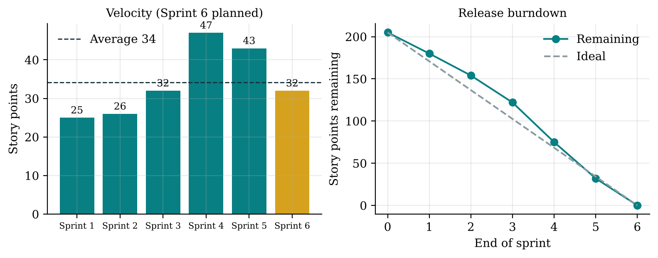
Fig. 6.2 Velocity per Sprint and Release Burndown (from the Sprint Plan)
The velocity chart in Fig. 6.2 shows that the team committed 25 and 26 points in the first two sprints, while the stack and the data pipeline were being established, and then 32 to 47 points once the architecture was stable. Sprint 4 was the largest because the communication functions and the scenario engine were closely coupled and were planned together. The release burndown reaches zero at the end of Sprint 6.

6.4 Sprint Backlogs
Table 6.4 lists every story with its epic, sprint and estimate, as imported into Jira.
Table 6.4 User Stories by Sprint
Sprint | Epic | User story | Pts
S1 | E1 | Login with verified credentials | 5
S1 | E1 | Store every login attempt in the backend | 3
S1 | E1 | Lock a username after 7 failures in 15 minutes | 3
S1 | E1 | Sessions, CSRF protection and logout | 3
S1 | E2 | Load the London-Amsterdam OpenSky recording | 5
S1 | E2 | Dataset register with provenance | 3
S1 | E8 | Project skeleton, linting and test harness | 3
S2 | E2 | Import and live-capture OpenSky snapshots | 3
S2 | E3 | Flight CRUD, search and cancellation | 5
S2 | E3 | Runway allocation with conflict blocking | 5
S2 | E3 | Runway calendar with alternatives | 3
S2 | E3 | Priority queue and alert centre | 2
S2 | E4 | Detect duplicate (ghost) targets | 5
S2 | E4 | Coast dropped tracks and measure the error | 3
S3 | E4 | Compare STCA-style alerting with the SkyControl probe | 8
S3 | E4 | Detect holding and estimate AMAN linear holding | 5
S3 | E4 | Similar callsigns sharing airspace | 3
S3 | E5 | Learned trajectory predictor | 8
S3 | E5 | Hold predictor (30-80 NM before the stack) | 3
S3 | E5 | Emergency anomaly detector | 5
S4 | E4 | Communication Monte Carlo with sensitivity analysis | 5
S4 | E5 | Adaptive automation (context switch) policy | 5
S4 | E5 | Readback verifier | 8
S4 | E6 | Scenario engine with exact conflict verification | 8
S4 | E6 | Communication scenarios | 5
S4 | E6 | Surveillance and automation scenarios | 5
S4 | E6 | Emergency and runway scenarios | 5
S4 | E6 | Ten-step handling pipeline per scenario | 3
S4 | E6 | Workflow model: conventional vs hybrid | 3
S5 | E1 | Supervisor user management and attempt log page | 3
S5 | E4 | Statistical analysis page | 5
S5 | E5 | Emergency injection into real traffic | 5
S5 | E6 | Approval gate and role rules | 3
S5 | E7 | 3D airspace replay of the recording | 8
S5 | E7 | Scenario lab page with step-by-step view | 8
S5 | E7 | Communication assistant page | 5
S5 | E7 | Command centre and gap analysis pages | 3
S5 | E7 | AI models page with policy simulator | 3
S6 | E2 | OpenSky multi-frame recorder script | 2
S6 | E8 | Automated test suite | 5
S6 | E8 | Multi-stage Dockerfile and compose | 5
S6 | E8 | Jenkins pipeline | 5
S6 | E8 | GitHub repository and Actions CI | 3
S6 | E8 | Smoke and load tests | 2
S6 | E9 | Project report (VIT template) | 5
S6 | E9 | Guides: GitHub, Jenkins, Jira, Docker | 3
S6 | E9 | Faculty demonstration script | 2

6.5 Jira Configuration
The backlog is provided as a CSV file (jira/skycontrol_jira_import.csv, 56 issues: 9 epics and 47 stories) for Jira Cloud's external-system import, together with a step-by-step guide (docs/JIRA_GUIDE.md). A company-managed Scrum project with key SKY is created, the six sprints are created first with exactly the names in the CSV, and the import maps Issue Id, Parent Id (linking stories to epics), Issue Type, Summary, Description, Priority, Story Points, Sprint, Labels and Status. Sprints 1 to 5 are imported as Done, so velocity reports are meaningful, and Sprint 6 is imported as To Do so that it can be started and run on the board to produce a genuine burndown chart.
● Board workflow: To Do → In Progress → In Review → Done.
● Traceability: branches and commits start with the issue key (for example feature/SKY-48-jenkins-pipeline, SKY-48 Add container smoke test); the GitHub for Jira app shows branches, commits, pull requests and builds in each issue's Development panel.
● Reports used: backlog, active sprint board, sprint burndown, velocity chart, timeline of the nine epics.

6.6 Version Control with GitHub
The source is kept in a GitHub repository. docs/GITHUB_GUIDE.md explains how to create the repository, push the project for the first time and work with branches and pull requests. The .gitignore excludes the virtual environment, caches, the database and the .env file, so that no password or generated data is ever committed.
Table 6.5 Git Workflow Conventions
Convention | Rule
Main branch | main is always releasable; protected, changes only through pull requests
Feature branches | feature/SKY-<n>-short-name, one per story
Commits | Start with the Jira key, imperative mood: SKY-12 Store every login attempt
Pull requests | Reviewed by the other team member; CI (GitHub Actions) must be green
Releases | Tagged with semantic versions, e.g. v6.0.0
Secrets | Never committed; .env.example documents the variables

git init
git add .
git commit -m "SKY-1 Initial SkyControl 6.0.0"
git branch -M main
git remote add origin https://github.com/<user>/skycontrol.git
git push -u origin main
git checkout -b feature/SKY-48-jenkins-pipeline # one branch per story

6.7 Jenkins Pipeline
The Jenkinsfile defines the continuous integration and delivery pipeline (Table 6.6). Python runs only inside containers, so the Jenkins agent needs nothing but the Docker CLI and curl. The account passwords used by the smoke test and the deployment are stored as Jenkins secret-text credentials and are masked in the log. A ready-to-run Jenkins controller with the Docker CLI is provided in jenkins/.
Table 6.6 Stages of the Jenkins Pipeline
Stage | What it does | Fails when
Checkout | Checks out the repository and locates the application folder | Repository unreachable
Lint and tests | Builds the test image, runs ruff and 93 pytest tests, publishes JUnit and coverage | Any lint error or failing test
Build image | Builds the runtime image tagged with the build number, Git hash and latest | Docker build error
Smoke test container | Starts the image on port 5099 and runs scripts/smoke_test.sh | Health, login, wrong-credential or attempt-log check fails
Deploy | Replaces the running container on port 5000, keeps the database volume, waits for health | Container not healthy within 60 s

The pipeline was executed end to end with Jenkins (jenkinsfile-runner with the Pipeline, JUnit and Credentials Binding plug-ins). Build 9 passed every stage. The excerpt below is from the console log kept in docs/evidence/jenkins_console_build9.txt; the JUnit and coverage reports of the same build are stored next to it.
+ docker build --target test -t skycontrol-test:9 .
+ docker run --name skycontrol-tests skycontrol-test:9
All checks passed!
TOTAL 3722 390 90%
93 passed, 1 warning in 122.21s (0:02:02)
[Pipeline] { (Build image)
[Pipeline] { (Smoke test container)
Masking supported pattern matches of $SKYCONTROL_CONTROLLER_PASSWORD
or $SKYCONTROL_SUPERVISOR_PASSWORD
+ sh scripts/smoke_test.sh http://127.0.0.1:5099 supervisor ****
Frontend: OK
Wrong credentials rejected: OK (401)
Login with verified credentials: OK
Scenario lab: readback_error plan verified
Failed login stored in the backend: OK
Smoke test passed
[Pipeline] { (Deploy)
+ docker run -d --name skycontrol --restart unless-stopped -p 5000:5000
-v skycontrol-db:/app/data/db ... skycontrol:latest
CONTAINER ID IMAGE STATUS PORTS
e8f3155d83ae skycontrol:latest Up 4 seconds (health: starting) 0.0.0.0:5000->5000/tcp
SkyControl build 9 passed every stage.
Finished: SUCCESS

6.8 Deployment with Docker
Deployment uses the multi-stage Dockerfile of Section 5.9. For a manual deployment, the team copies .env.example to .env, sets the two account passwords and runs Docker Compose. The database lives on the named volume skycontrol-db, so updating the application (rebuilding and recreating the container) keeps users, attempts, runs and the audit trail. docs/DOCKER_GUIDE.md also covers logs, backup and restore of the volume, and troubleshooting.
cp .env.example .env # then set the two account passwords in .env
docker compose up -d --build # build and start on http://localhost:5000
docker compose ps # STATUS shows (healthy) after the health check
docker compose logs -f skycontrol # follow the logs
docker compose down # stop (the database volume is kept)

6.9 Milestones
Table 6.7 Project Milestones
Milestone | Date | Deliverable | Status
M1 Secure portal and data | 14 Aug 2026 | Login portal with attempt log; recording loaded and registered | Done
M2 Operations and integrity | 28 Aug 2026 | Flights, runways, alerts; ghost targets and coasting measured | Done
M3 AI models | 11 Sep 2026 | Trajectory predictor, conflict probe, holding, anomaly detector | Done
M4 Communication and scenarios | 25 Sep 2026 | Readback verifier, context-switch policy, 21 scenarios | Done
M5 3D application | 09 Oct 2026 | Airspace replay, scenario lab, statistics, emergency injection | Done
M6 Pipeline and release | 23 Oct 2026 | Docker, Jenkins, GitHub, tests, report, demonstration | Pipeline validated; release at sprint end

CHAPTER 7
RESULTS AND DISCUSSION
This chapter presents the results of SkyControl on the real recording, the injected emergencies and the scenarios, compares them with current ATC practice, reports the software tests and performance, shows the user interface and gives a cost analysis. It closes with a discussion of what the results mean and of their limits.

7.1 Evaluation Design
Each result in this chapter carries one of three labels. Measured results are computed from the real recording; learned models are always evaluated on data they did not see (the last 30 minutes for the trajectory predictor and the anomaly detector, the last 35 minutes for the hold predictor). Modelled results depend on stated assumptions (error rates, task times, fuel burn) and come with a sensitivity analysis. Scenario results come from constructed exercises; they demonstrate behaviour and are not statistical evidence. Paired comparisons use the one-sided Wilcoxon signed-rank test and a 95% bootstrap confidence interval of the mean improvement (Section 4.4.14).
Table 7.1 Evaluation Plan per Gap
Gap | Comparison | Cases | Label
G3 | Straight line vs learned predictor (60/120/300 s) | 48,632 held-out points | Measured
G3 | STCA-style, naive, filtered and intent-aware alerting | 90 min, 8 real encounters | Measured
G4 | Frozen vs dead-reckoned track after dropouts | 196 dropouts | Measured
G1 | Readback verifier detection and false alarms | 3,000 readbacks, clean and noisy | Measured (generated corpus)
G1, G2 | Voice-only vs hybrid communication | 4,000 sector-hours | Modelled
G2 | Similar callsigns sharing airspace | 906 aircraft | Measured
G5 | Holding, linear-holding estimate, hold predictor | 27 holds, 174 arrivals | Measured + modelled
G7 | Rule vs ML vs hybrid vs CLAM detection | 81 injected events | Measured on real tracks
G6 | Emergency planning in real traffic; workflow | 60 injections | Real traffic + modelled
G8, G9 | Comparator vs SkyControl in every scenario | 21 scenarios | Scenario + modelled

7.2 Login Portal and Security
The login portal meets requirement 2. A wrong password or an unknown username returns HTTP 401 with the message "Wrong username or password" and the number of attempts remaining (Fig. 5.1). Every attempt is stored with the username tried, the IP address, the browser, the success flag and one of seven reasons (success, wrong_password, unknown_username, locked_out, account_disabled, ip_rate_limited, missing_username); passwords are never stored. Fig. 7.1 shows the attempt log on the security page during testing, including the failures created by the demonstration and the automated browser runs.
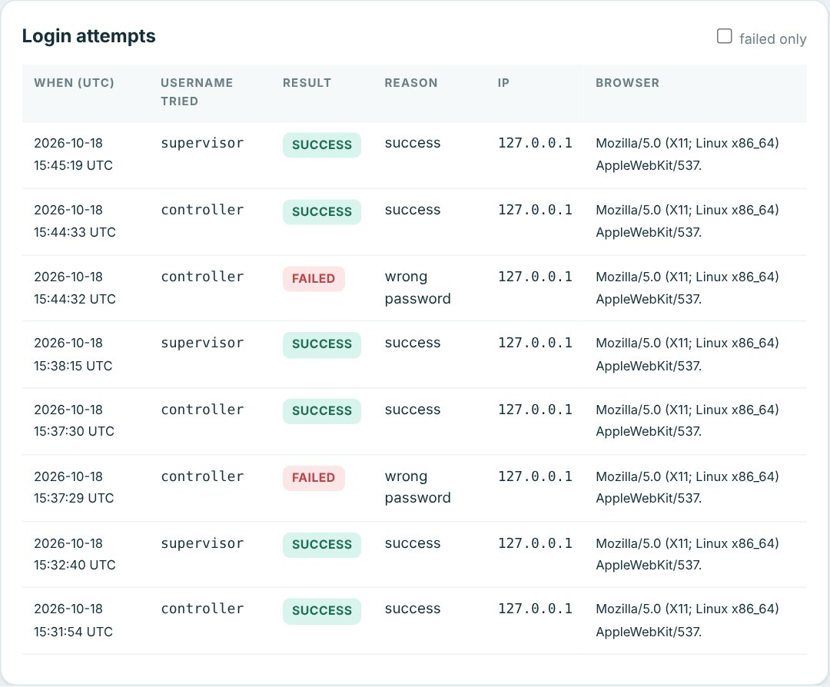
Fig. 7.1 Login Attempt Log with Outcome, Reason, IP Address and Browser
Nine automated tests verify this behaviour: the uniform message, the stored reason for wrong passwords and unknown usernames, that no password text appears in any stored data, the lockout after seven failures even when the eighth attempt uses the correct password, that only supervisors can read the log, CSRF protection, user management, password change and logout. The container smoke test in Jenkins repeats the essential check against the deployed image: a wrong password is rejected with 401 and the failed attempt is found in the back end.

7.3 Trajectory Prediction (G3)
Table 7.2 and Fig. 7.2 compare the learned predictor with straight-line extrapolation on held-out traffic. The improvement grows with the horizon, because the further ahead the prediction, the more the aircraft's route structure matters. At five minutes the mean error falls from 6.845 NM to 4.482 NM (34.5% lower, 95% CI of the improvement 2.26 to 2.47 NM), and the 95th-percentile error from 23.452 NM to 14.233 NM. All three differences are significant (p < 0.001).
Table 7.2 Mean Position Error of Straight-Line and Learned Prediction on Held-Out Traffic
Horizon | n | Straight line (NM) | Learned (NM) | Improvement | 95% CI (NM) | p
60 s | 17,994 | 0.555 | 0.449 | 19.1% | 0.09 to 0.12 | < 0.0001
120 s | 16,873 | 1.635 | 1.267 | 22.5% | 0.34 to 0.40 | < 0.0001
300 s | 13,765 | 6.845 | 4.482 | 34.5% | 2.26 to 2.47 | < 0.0001

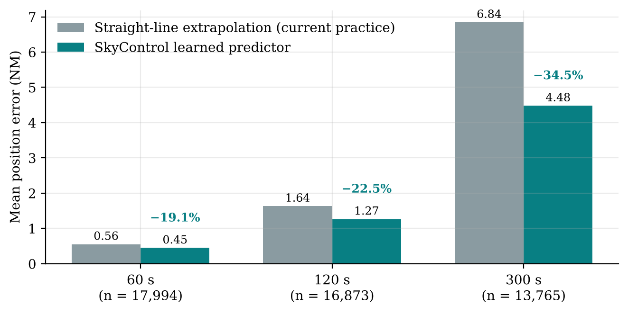
Fig. 7.2 Prediction Error by Horizon: Straight Line versus Learned Predictor
The gain is concentrated where straight lines fail. For the 1,683 test points where the aircraft was turning, the five-minute error falls from 15.283 NM to 7.452 NM, roughly half. The median error at short horizons is almost unchanged (0.192 NM against 0.215 NM at 60 s): for an aircraft flying straight and level the straight line is already right, and the learned correction correctly leaves it alone. Fig. 7.3 shows that the improvement holds in every altitude band, and is largest in the terminal area below 20,000 ft where arrivals turn onto the stacks and final approach.
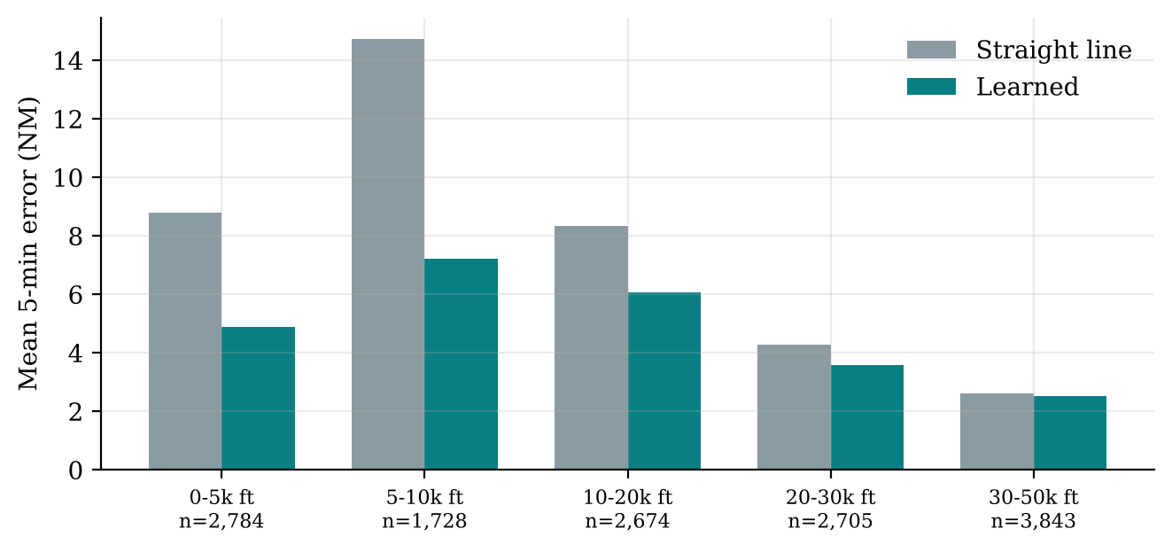
Fig. 7.3 Five-Minute Prediction Error by Altitude Band
Permutation importance (Fig. 7.4) shows that altitude and speed carry most of the information: together they tell the model whether an aircraft is an arrival about to turn, a departure still accelerating or an overflight in cruise. Position (x, y) adds the local route structure.
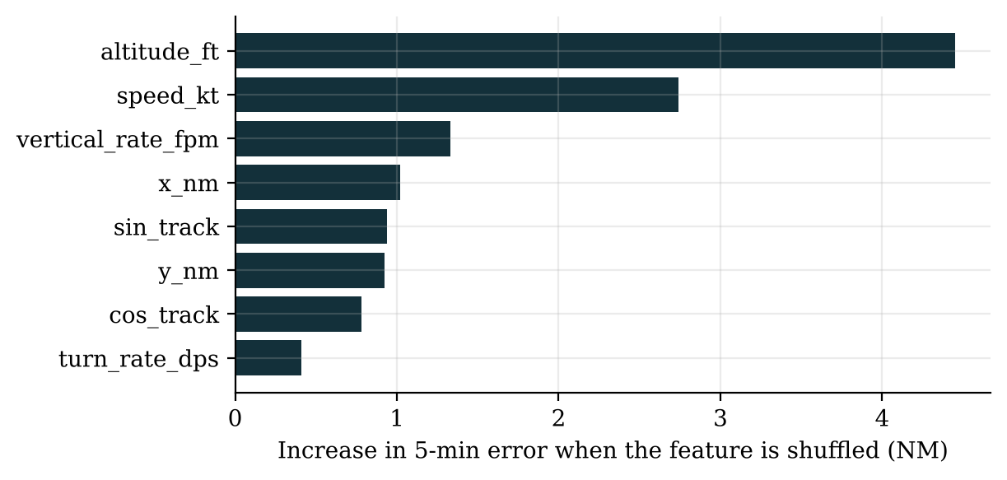
Fig. 7.4 Permutation Importance of the Predictor Features (Five-Minute Horizon)

7.4 Conflict Alerting (G3)
In the 90 minutes there were 9 real encounters inside the screening volume, of which 8 occurred after the five-minute warm-up and could be evaluated; most are legitimate proximity (in-trail sequencing, climbs and descents through traffic, arrival sequencing to Heathrow). Table 7.3 compares the four alerting methods on the same traffic.
Table 7.3 Alerting Methods on the Real Recording
Method | Look-ahead | Alerts per hour | Encounters alerted | Alerted ≥30 s ahead | Mean warning (s) | Nuisance share
STCA-style safety net | 120 s | 148.7 | 5 of 8 | 4 | 33.4 | 96.0%
Naive 5-min probe | 300 s | 522.7 | 5 of 8 | 4 | 43.4 | 98.5%
SkyControl filtered probe | 300 s | 204.7 | 5 of 8 | 4 | 43.4 | 97.1%
SkyControl intent-aware probe | 300 s | 145.3 | 5 of 8 | 5 | 47.1 | 95.0%

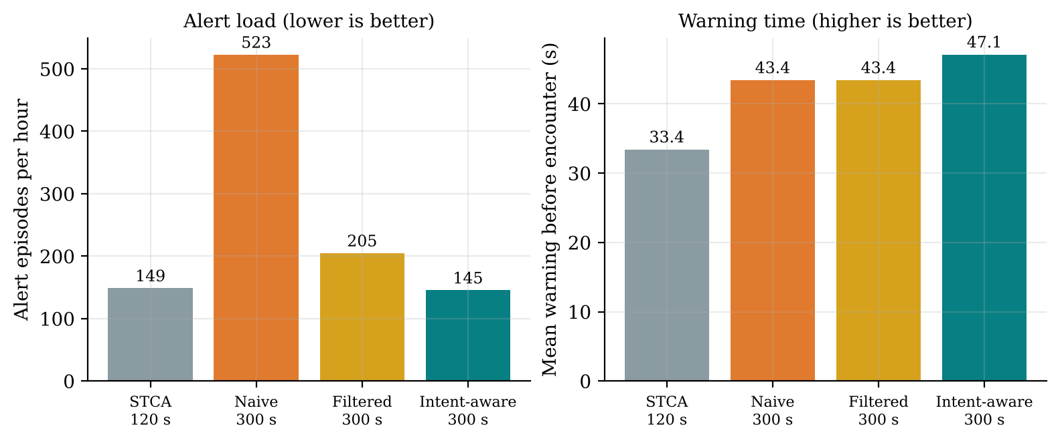
Fig. 7.5 Alert Load and Warning Time of the Four Alerting Methods
The result shows why simply looking further ahead does not work, and how the design was improved. The naive five-minute probe raised 522.7 alerts per hour, 3.5 times the safety net, almost all of them nuisance alerts. Merging duplicate targets, recognising level flight and adding hysteresis brought this down to 204.7. The intent-aware probe, with the learned trajectories and cleared levels, brought it to 145.3 per hour (72.2% fewer than the naive probe), slightly below the two-minute safety net, while looking 2.5 times further ahead. It alerted 5 of 8 encounters at least 30 s ahead, against 4 for the safety net, with a mean warning of 47.1 s against 33.4 s.
The warning-time gain of 13.75 s on average (95% CI 1.25 to 30.5 s) is not statistically significant (Wilcoxon p = 0.125), because only eight encounters were available and three of them improved. The honest conclusion is that SkyControl achieves a longer look-ahead at the same alert load as the safety net, which is measured with confidence, while the earlier warning is indicative and needs more data. The cleared level used here is approximated from the recording; with a real digital clearance record the probe would know it directly. The probe complements STCA, which stays in place as the last ground-based safety net.

7.5 Surveillance Integrity (G4)
The integrity monitor found 21 duplicate-target pairs involving 19 ghost tracks and 665 reports (0.77% of all reports). Table 7.4 shows examples. A typical case is RYR52ZT, whose address 4cafc1 appears for 436 s as a second target 4caf41, one bit different, 0.1 NM away with the same callsign. A conventional safety net would see two aircraft 0.1 NM apart and raise an alert; SkyControl merges them before alerting.
Table 7.4 Examples of Duplicate (Ghost) Targets Found in the Real Recording
Real target | Ghost | Bit errors | Same callsign | Min. distance (NM) | Duration (s)
RYR52ZT (4cafc1) | 4caf41 | 1 | yes | 0.1 | 436
4063CE (4063ce) | 4273ce | 2 | no | 0.22 | 201
EJU16JD (4403bb) | 44033b | 1 | yes | 0.0 | 325
LOG34JD (407d46) | 406d46 | 1 | yes | 0.33 | 197
PRF65 (43c8c4) | 43c8d5 | 2 | no | 0.6 | 83
RYR2VG (4cadc1) | 4caf41 | 2 | no | 0.68 | 69
RYR55FV (4cafd0) | 4caf50 | 1 | yes | 0.08 | 148
SHT9P (40097f) | 40097b | 1 | yes | 0.0 | 62

Position reports were missing for more than 60 s 234 times on 217 of 906 tracks (Fig. 7.6); most gaps are short, but 36 exceed ten minutes. For the 196 dropouts after which the aircraft reappeared, the frozen last position was on average 6.24 NM from the true position at reappearance, while the dead-reckoned coast was 1.48 NM away, a 76.2% reduction (95% CI of the improvement 4.11 to 5.34 NM, p < 0.001; Fig. 7.7). The median error falls from 6.36 NM to 0.26 NM.
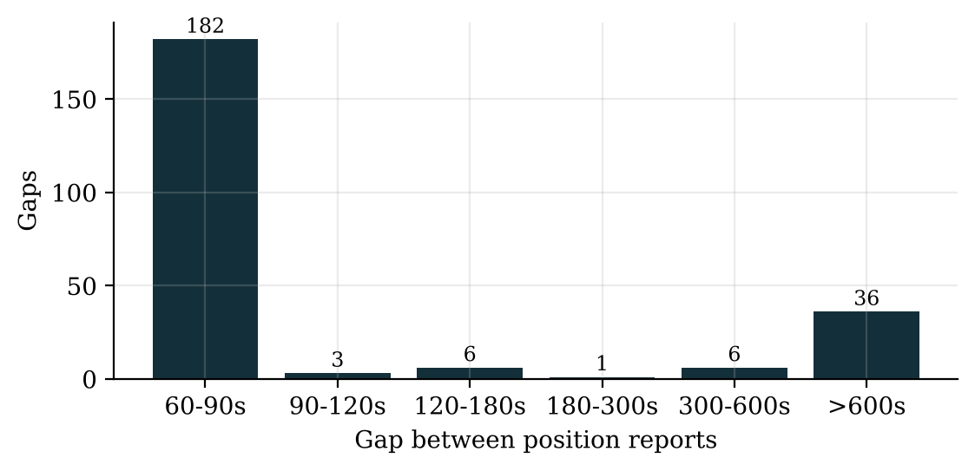
Fig. 7.6 Gaps Between Position Reports in the Real Recording
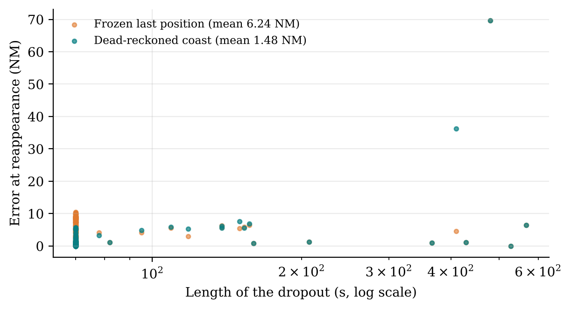
Fig. 7.7 Position Error at Reappearance: Frozen Track versus Dead-Reckoned Coast
Coasting is not always better: for long gaps in which the aircraft turned, a straight coast can be further off than the frozen position, which is why the display shows the coasted track with a growing uncertainty and why low data quality makes the automation policy switch to MANUAL rather than act on the coasted position.

7.6 Communication Safety (G1, G2)

7.6.1 Readback Verifier
The verifier was evaluated on 3,000 readbacks generated from real callsigns of the recording with random clearances and injected errors (wrong digit, swapped digits, omitted item, wrong aircraft answering), once as clean text and once with 5% speech-recognition word noise. On clean text it detected 96.2% of the erroneous readbacks with no false alarm; with ASR noise it detected 98.0% with a hard false-alarm rate (a correct readback called wrong) of 0.22% (Table 7.5, Fig. 7.8).
Table 7.5 Readback Verifier Results by Error Type
Readback type | Clean: n | Clean: flagged | ASR noise: n | ASR noise: flagged | ASR: hard / soft
Wrong value | 753 | 94.2% | 781 | 97.8% | 577 / 187
Wrong aircraft | 61 | 100.0% | 61 | 90.2% | 54 / 1
Omitted item | 336 | 100.0% | 323 | 100.0% | 1 / 322
Correct readback | 1850 | 0.0% | 1835 | 27.2% | 4 / 495

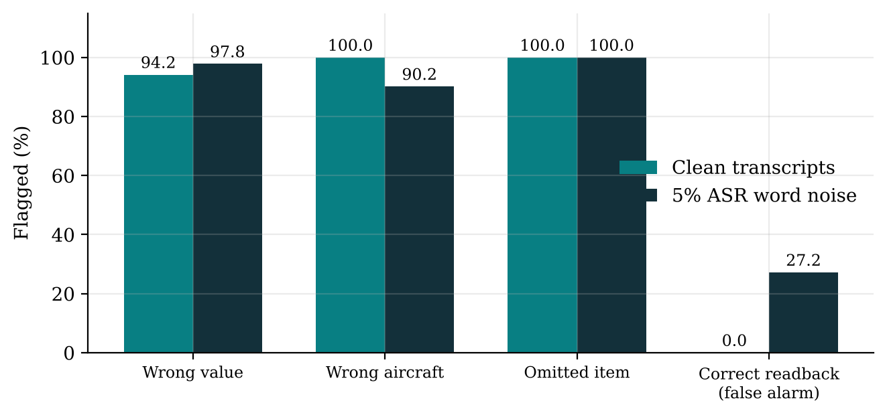
Fig. 7.8 Share of Readbacks Flagged by the Verifier, by Error Type
The cost of noise is visible in the last row: with ASR noise, 27.2% of correct readbacks receive a soft "please confirm" request because a digit may have been lost, although only 4 of 1,835 are wrongly called errors. This is a deliberate design choice: an uncertain field is never silently accepted, but it is also not called wrong. In practice it means that the verifier should be used with a good recogniser or with typed or datalink readbacks, and that its confirmation requests add some frequency time, which the model below includes. The corpus was generated by the same team that wrote the verifier, so the detection rates are an upper bound until the verifier is tested on real R/T recordings.
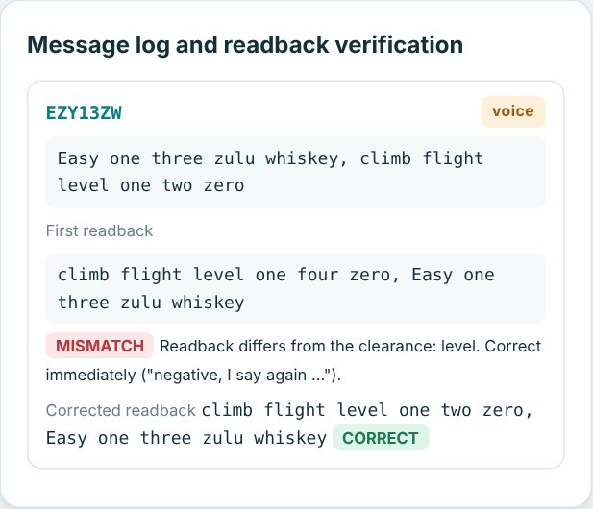
Fig. 7.9 Readback Error Scenario: the Verifier Catches FL140 Instead of FL120

7.6.2 Sector Communication Model
In the Monte Carlo model of 4,000 busy sector-hours, undetected communication errors fell from 40.55 to 3.59 per 10,000 clearances (91.1% fewer; 95% CI of the reduction 35.8 to 38.22 per 10,000), and frequency occupancy fell from 45.1 to 16.9 minutes per hour because 70% of routine clearances move to datalink (Table 7.6).
Table 7.6 Modelled Communication Outcomes per Busy Sector-Hour
Measure | Voice only | SkyControl hybrid | Change
Undetected errors per 10,000 clearances | 40.55 | 3.59 | −91.1%
Frequency occupancy (min per hour) | 45.1 | 16.9 | −62.5%
Voice transmissions per hour | 598.8 | 180.0 | −69.9%

Because the error rates come from the literature, the sensitivity analysis in Fig. 7.10 matters more than the single headline number. Across all combinations of readback error rate (0.5% to 3%) and controller miss rate (20% to 60%), the hybrid stays at about 3.6 undetected errors per 10,000 while the voice baseline ranges from 10 to 180; the reduction is therefore between 65% and 98%. The right-hand panel shows a real trade-off: moving more clearances to datalink frees the frequency, but the residual datalink error slowly increases the undetected errors, so the best datalink share is a design decision rather than "as much as possible".
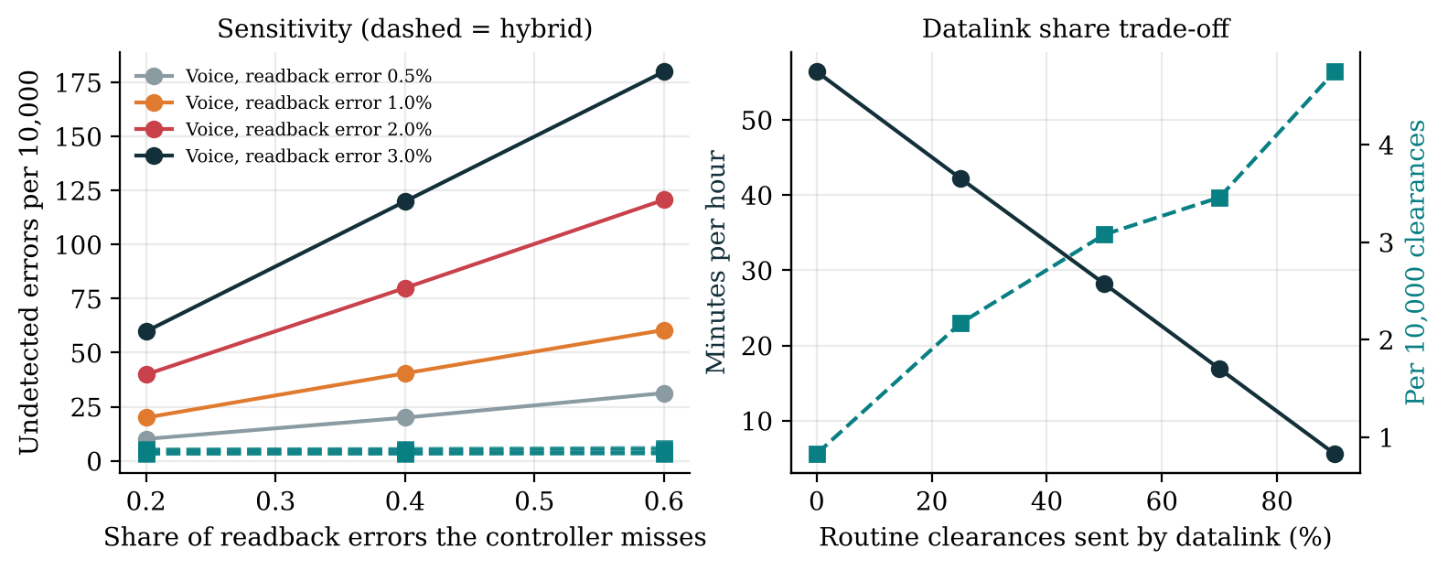
Fig. 7.10 Sensitivity of the Communication Model and the Datalink Trade-off

7.6.3 Similar Callsigns
In the real recording, 10 pairs of similar callsigns shared airspace (within 40 NM and 10,000 ft), involving 20 aircraft (2.2% of aircraft with a callsign), with on average 2.1 aircraft exposed at any moment (Table 7.7). LDG33 and LDG39 came within 0.3 NM of each other, and BAW425 and BAW725 held together in the OCK stack, exactly the situation in which one aircraft takes the other's descent. Today such pairs are found by planning-stage deconfliction and controller vigilance; SkyControl flags them live and detects a wrong aircraft answering.
Table 7.7 Similar Callsigns Sharing Airspace in the Real Recording
Pair | Pattern | Score | Co-present (min) | Closest (NM)
HLE98 / HLE99 | one character differs | 0.90 | 19.1 | 22.4
BAW332 / BAW334 | one character differs | 0.90 | 17.7 | 10.7
LDG33 / LDG39 | one character differs | 0.90 | 16.7 | 0.3
BAW425 / BAW725 | one character differs | 0.90 | 9.4 | 4.8
BAW575 / BAW875 | one character differs | 0.90 | 9.0 | 2.5
BAW935 / BAW938 | one character differs | 0.90 | 7.6 | 13.5
CPA238 / CPA239 | one character differs | 0.90 | 5.8 | 22.4
BAW293 / BAW29G | one character differs | 0.90 | 5.8 | 13.6
BAW168 / BAW968 | one character differs | 0.90 | 1.0 | 28.1
BAW751 / BAW754 | one character differs | 0.90 | 0.8 | 3.5

7.7 Holding and Hold Prediction (G5)
The recording contains 27 holds at published stacks (plus 4 other orbits), totalling 268.2 aircraft-minutes in 90 minutes, at times with several aircraft holding in each Heathrow stack (Fig. 7.11, Fig. 7.12). At the nominal 40 kg per minute this is about 10,728 kg of fuel (range 8,046 to 26,820 kg) and 33,900 kg of CO₂.
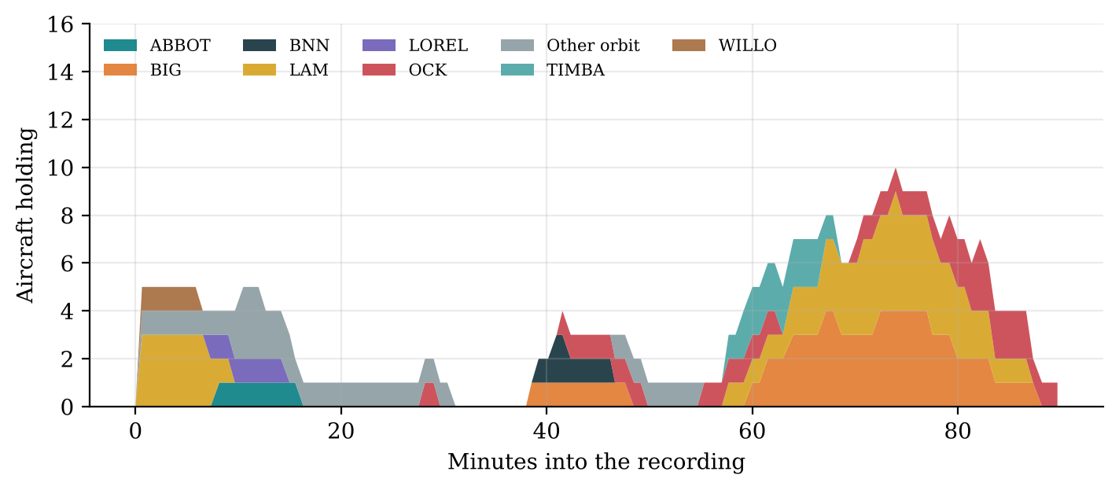
Fig. 7.11 Aircraft Holding per Stack During the Recording
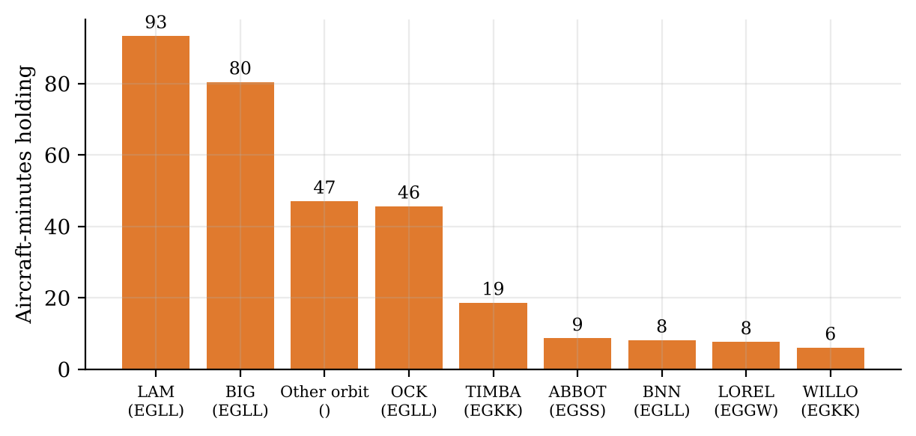
Fig. 7.12 Total Holding Time per Stack
With the speed-control horizon actually observed in the recording, only 39.6 minutes could have been absorbed en route, because many arrivals entered the region shortly before holding. With an extended arrival-management horizon of 350 NM and at most 10% speed reduction, 131.4 minutes (49.0%) could be absorbed, saving about 3,943 kg of fuel and 12,461 kg of CO₂ in these 90 minutes (modelled). Linear holding of this kind is the aim of extended AMAN; SkyControl's contribution is the prediction that makes it possible early enough.
The hold predictor was trained on 135 arrivals and tested on 39 later arrivals (7 of which held). It reached a test AUC of 0.759 (95% CI 0.589 to 0.915) and a Brier score of 0.168; the hold was predicted on average 11.5 minutes before it began (Fig. 7.13, Table 7.8). Higher altitude at 30 to 80 NM (still far from the descent) and more inbound aircraft ahead raise the probability; a greater distance lowers it. The sample is small and the confidence interval wide, so the result is indicative: the model ranks arrivals better than chance and gives useful lead time, but it needs more days of data before its threshold can be relied on.
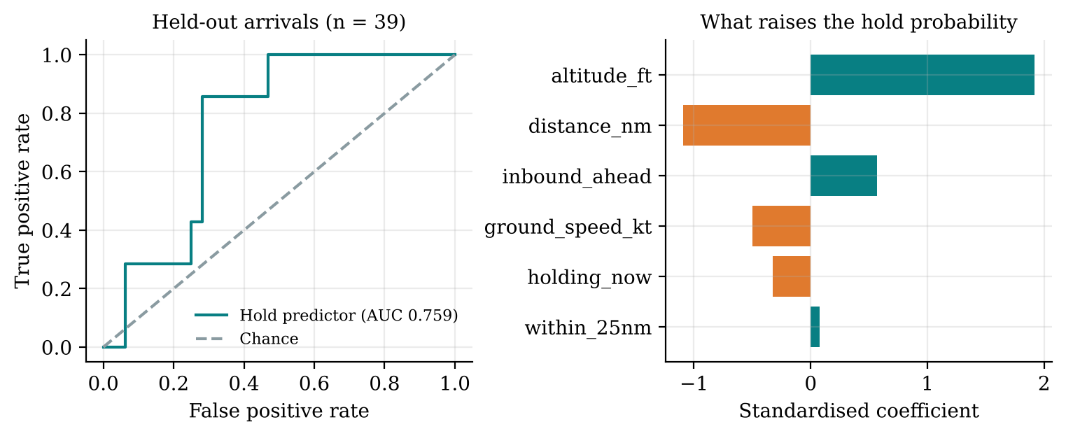
Fig. 7.13 Hold Predictor: ROC Curve on Held-Out Arrivals and Model Coefficients
Table 7.8 Confusion Matrix of the Hold Predictor on the Test Period (Threshold 0.5)
 | Predicted hold | Predicted no hold
Held | 3 | 4
Did not hold | 9 | 23

7.8 Detecting Emergency-Like Behaviour and Level Busts (G7)
Eighty-one emergencies were injected into real test-period tracks: 27 emergency descents, 27 engine-out drift-downs and 27 unannounced turn-backs. The vertical-rate rule, the kind of single threshold a display can show, detected only the descents (27 of 81). The Isolation Forest, at a 1% false-alarm rate on normal traffic, detected 50, and the hybrid (rule or forest) 52. CLAM with the cleared level from the digital clearance record detected all 81 (Fig. 7.14, Table 7.9).
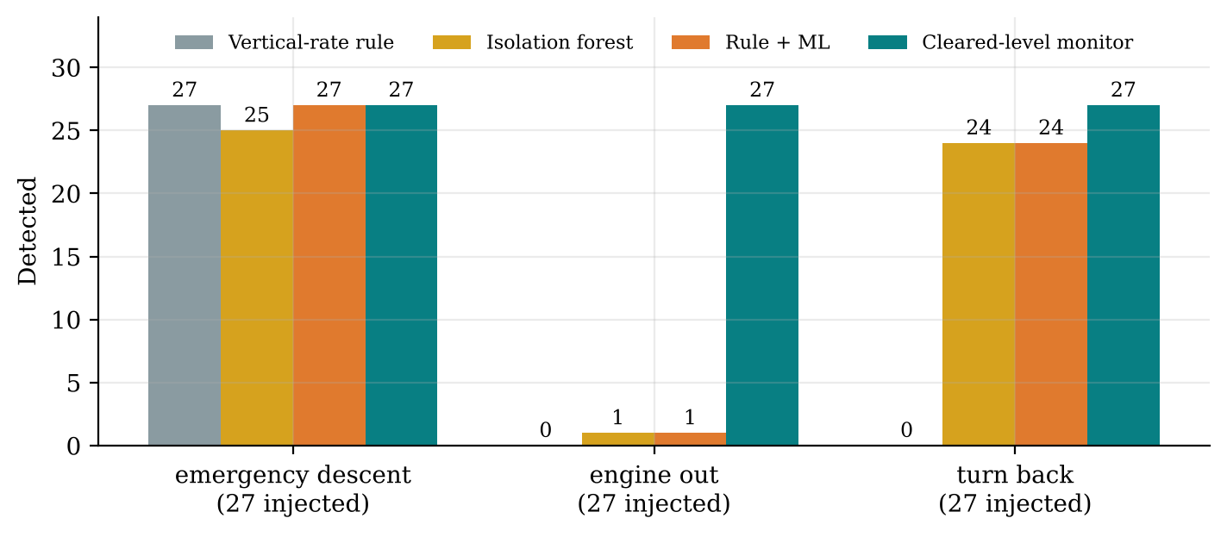
Fig. 7.14 Detection of Injected Emergencies by the Four Detectors
Table 7.9 Detection of Injected Emergencies (Detected of 27 per Kind)
Emergency | Rule | Isolation forest | Hybrid | CLAM | Median delay (s)
emergency descent | 27 | 25 | 27 | 27 | 18.0
engine out | 0 | 1 | 1 | 27 | 21.0
turn back | 0 | 24 | 24 | 27 | 22.0
False alarms on normal traffic | 0.25% | 1.00% | 1.16% | —

The engine-out drift-down shows the value of combining methods: its descent rate is ordinary and its speed decay gradual, so neither the rule nor the forest sees it, but it departs from the cleared level, which CLAM catches within about 21 s. This was one of the design changes made after the first results, in which the learned detector alone missed most drift-downs. Lost communications have no kinematic signature at all and are therefore handled by the communication monitor (an aircraft that does not acknowledge), which is stated as a limitation.

7.9 Emergencies Injected into Real Traffic (G6)
Sixty emergencies (twelve of each of the five kinds) were injected on real aircraft at different moments of the recording. Each emergency path was checked against the recorded positions of on average 330 other aircraft. In 63.3% of cases the emergency path conflicted with real traffic, with 2.73 conflicts per case on average and 164 in total. SkyControl resolved 150 of them (91.5%) with level changes that were re-verified against all other traffic; the rest were handed to the controller with the automation level lowered. The emergency got the first landing slot and on average 4.92 real arrivals were delayed by a total of 584 s. The median planning time was 90 ms.
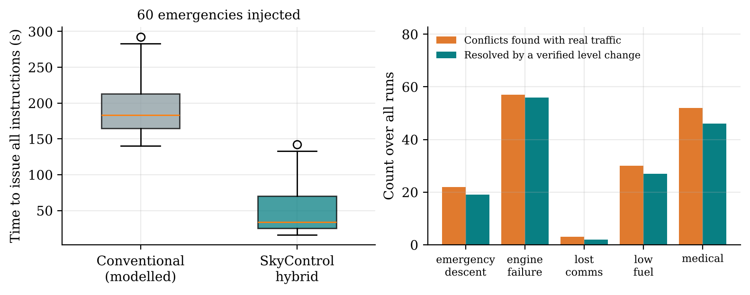
Fig. 7.15 Emergencies Injected into Real Traffic: Handling Time and Conflicts Resolved
In the workflow model the time to issue all instructions fell from 190.8 s (median 183.2 s) for the conventional workflow to 47.8 s (median 34.0 s) for the hybrid, a 75.0% reduction (95% CI 140.1 to 145.6 s, Wilcoxon p < 0.0001), mainly because the checklist, the alternate search and the telephone calls are replaced by an automatic ranking and digital coordination. The number of voice transmissions is almost the same (7.1 against 7.07) because emergency instructions stay on voice, as they should.
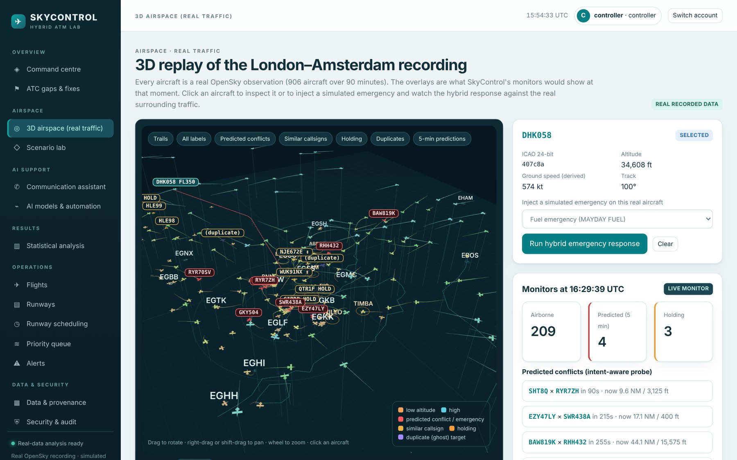
Fig. 7.16 Selecting a Real Aircraft in the 3D Airspace to Inject an Emergency
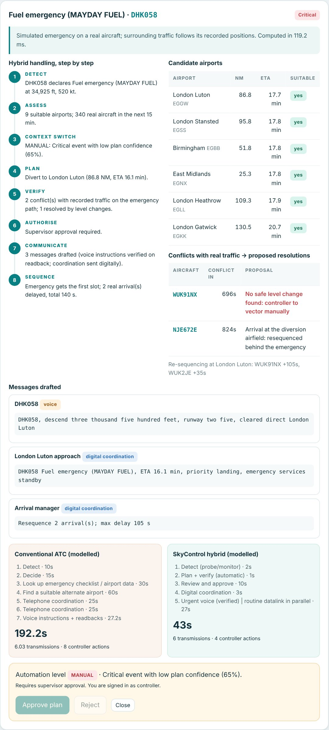
Fig. 7.17 Hybrid Emergency Response for a Fuel Emergency on a Real Aircraft
In Fig. 7.17 the airports are ranked by arrival time rather than distance: from FL350 a 3° descent needs about 110 NM of track, so even East Midlands, 25 NM away, would need a long descent dog-leg and is reached no sooner than Luton. The example is also useful because the AI could not solve everything. For DHK058 the planner found two conflicts with real traffic; one arrival was re-sequenced behind the emergency, but no safe level change existed for WUK91NX. The plan confidence was therefore only 65%, and the policy switched to MANUAL with supervisor approval: the system shows the controller what it found, drafts the messages and the coordination, and leaves the unresolved conflict to the human. This is the manual context switch required by the project brief, triggered by the data rather than hard-coded.

7.10 Scenario Lab Results
All 21 scenarios produced a SkyControl plan that passed exact verification. Table 7.10 lists each scenario with its category, severity, the automation level chosen, the problems left by the comparator (conflicts, runway conflicts, hazard or closure breaches and fuel-deadline misses) and the modelled time to issue all instructions. The comparator is the conventional handling for each scenario, for example first-come-first-served sequencing without emergency priority or a voice-only readback without automatic verification.
Table 7.10 Scenario Benchmark: Comparator versus SkyControl
Scenario | Category | Severity | Level | Problems | Time (s)
Normal approach | Capacity | Low | AUTO | 0 → 0 | 52 → 32
Converging traffic | Separation | Critical | ADVISORY | 15 → 0 | 120 → 58
Traffic overload | Capacity | High | CONSENT | 0 → 0 | 161 → 46
Fuel emergency | Emergency | Critical | ADVISORY | 1 → 0 | 121 → 46
Medical priority | Emergency | Critical | ADVISORY | 0 → 0 | 137 → 46
Engine failure | Emergency | Critical | ADVISORY | 1 → 0 | 163 → 34
Emergency descent | Emergency | Critical | ADVISORY | 2 → 0 | 99 → 26
Bird strike | Emergency | High | CONSENT | 3 → 0 | 142 → 47
Runway incursion | Runway | Critical | ADVISORY | 3 → 0 | 92 → 43
Runway closure | Runway | High | CONSENT | 11 → 0 | 171 → 45
Go-around | Runway | High | CONSENT | 3 → 0 | 52 → 43
Diversion | Capacity | High | CONSENT | 6 → 0 | 167 → 46
Severe weather | Hazard | High | CONSENT | 5 → 0 | 115 → 46
Radio failure | Communication | High | CONSENT | 6 → 0 | 112 → 51
Readback error | Communication | High | CONSENT | 1 → 0 | 144 → 21
Callsign confusion | Communication | High | CONSENT | 1 → 0 | 132 → 21
Level bust | Separation | Critical | ADVISORY | 1 → 0 | 143 → 32
Ghost target | Surveillance | High | CONSENT | 1 → 0 | 29 → 12
Surveillance gap | Surveillance | High | MANUAL | 3 → 0 | 127 → 49
AI disagreement | Automation | High | MANUAL | 1 → 0 | 54 → 22
Security signal | Emergency | Critical | MANUAL | 2 → 0 | 123 → 46

Over all scenarios the comparator left 34 aircraft conflicts, 10 runway conflicts, 21 hazard or closure breaches and 1 fuel-deadline miss; SkyControl left none (Fig. 7.18). The price is a longer total route length (3,951 NM against 4,550 NM, +15%) from reroutes around weather and holding circuits. The modelled time to issue all instructions fell from 117.1 s to 38.7 s (67.0% less, Wilcoxon p = 3.0e-05), radio transmissions from 130.7 to 74 and controller actions from 113 to 57 (Fig. 7.19).
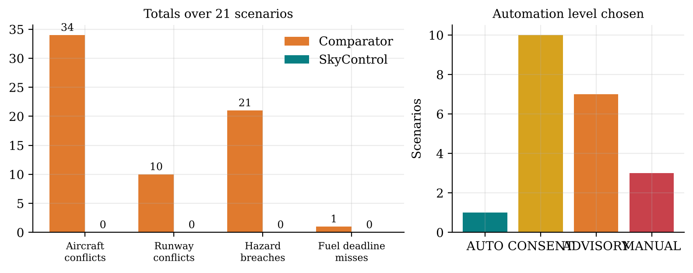
Fig. 7.18 Problems Left by the Comparator and by SkyControl, and Automation Levels Chosen
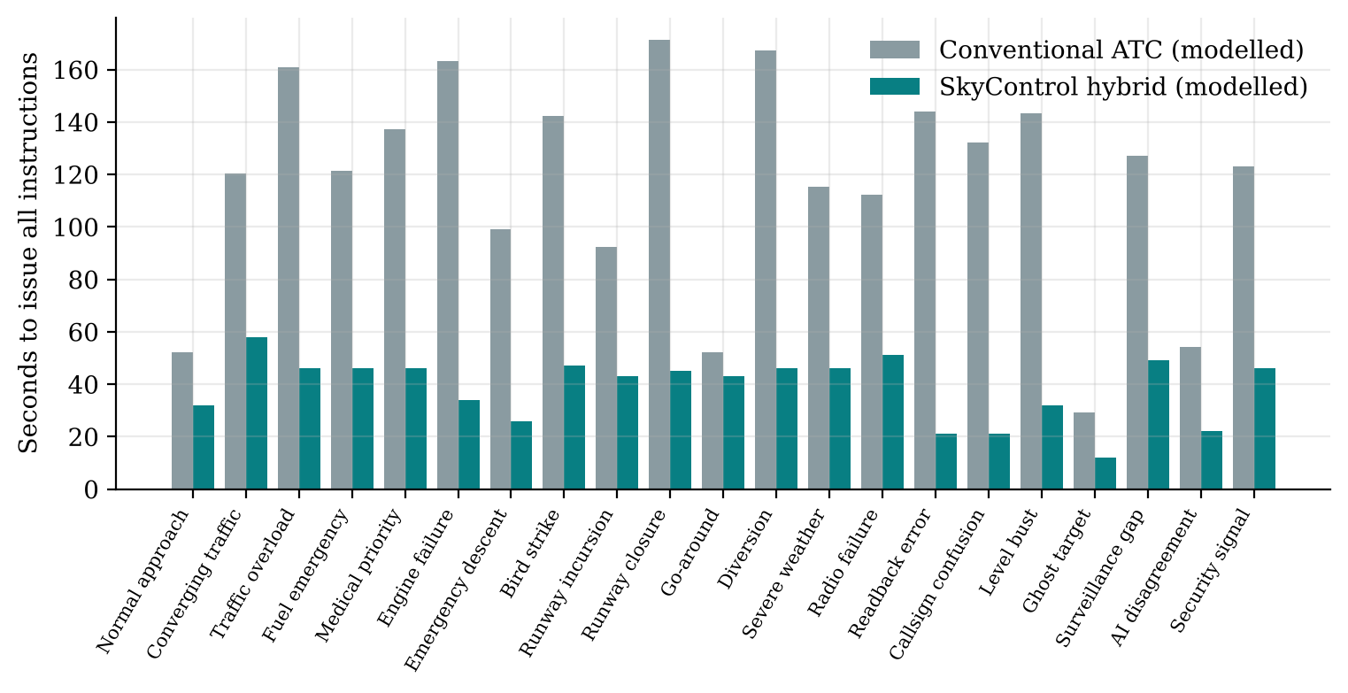
Fig. 7.19 Modelled Time to Issue All Instructions in Each Scenario
The automation levels chosen (1 AUTO, 10 CONSENT, 7 ADVISORY and 3 MANUAL) show that SkyControl acts autonomously only in routine traffic. All critical emergencies require a supervisor; the security signal, the AI disagreement and the surveillance gap put the human fully in charge. The following subsections walk through five scenarios step by step, as they appear in the scenario lab.

7.10.1 Fuel Emergency: Approval Gate and Ten Steps
A low-fuel arrival is last in a queue of four. The comparator (first-come-first-served without emergency priority) lands it after its simulated fuel deadline. SkyControl detects the emergency, assesses it as critical, and the policy chooses ADVISORY with supervisor approval. The run pauses at T+20 s; a controller cannot approve it (Fig. 7.20). After a supervisor approves, the plan (emergency first, holding circuits for the others, 120 s spacing) is executed and all ten steps complete (Fig. 7.21). Fig. 7.22 compares the workflows: 121.3 s and about eight radio transmissions conventionally, 46 s with SkyControl.
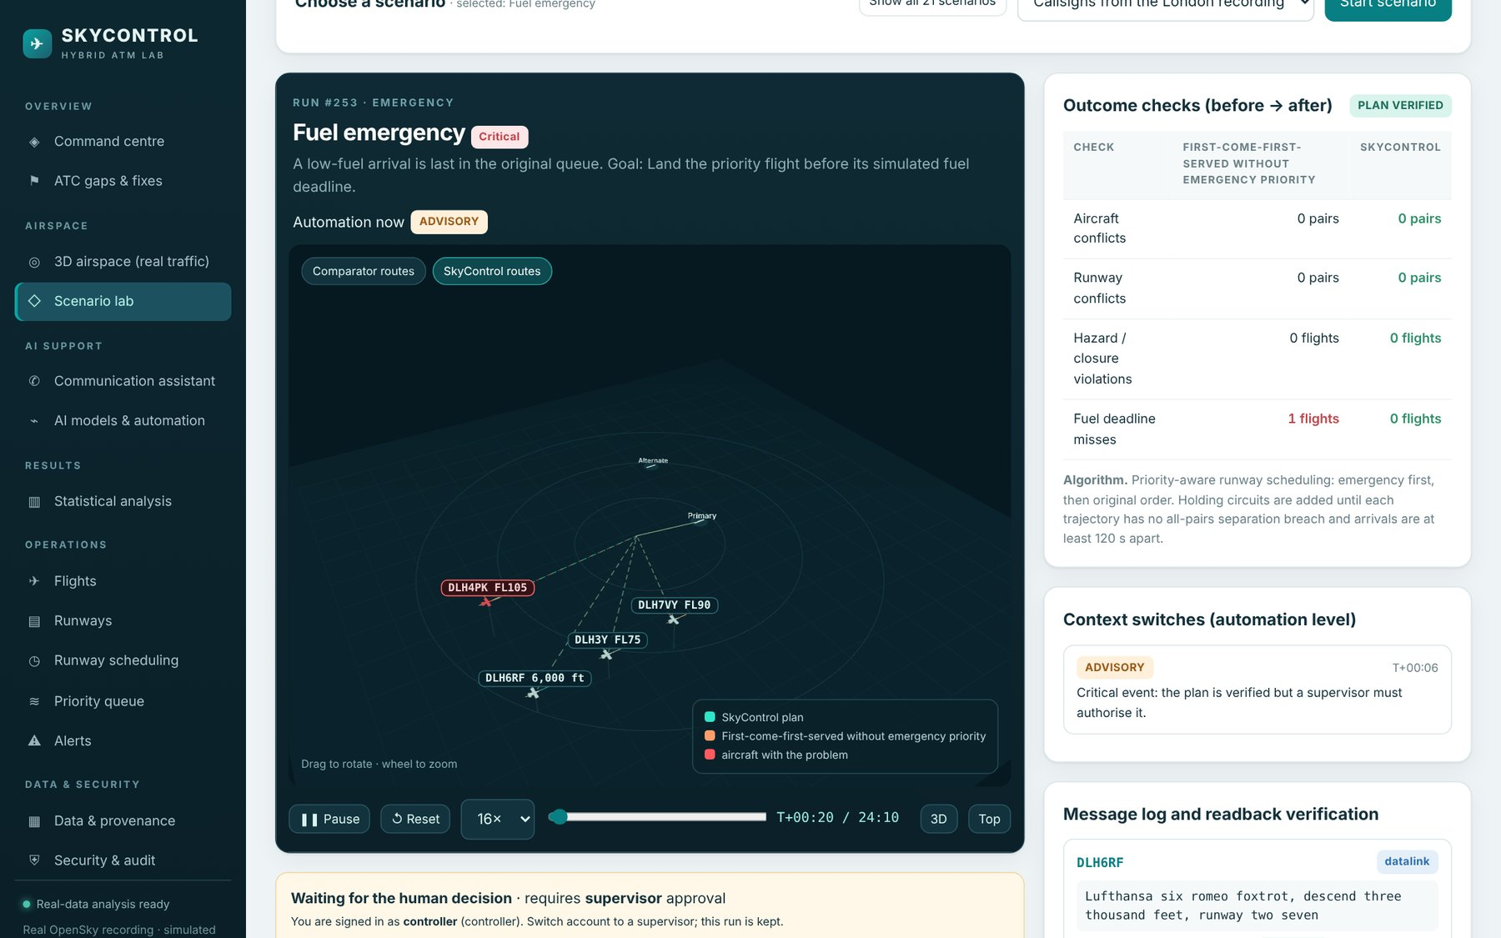
Fig. 7.20 Fuel Emergency Paused at the Approval Gate for a Controller
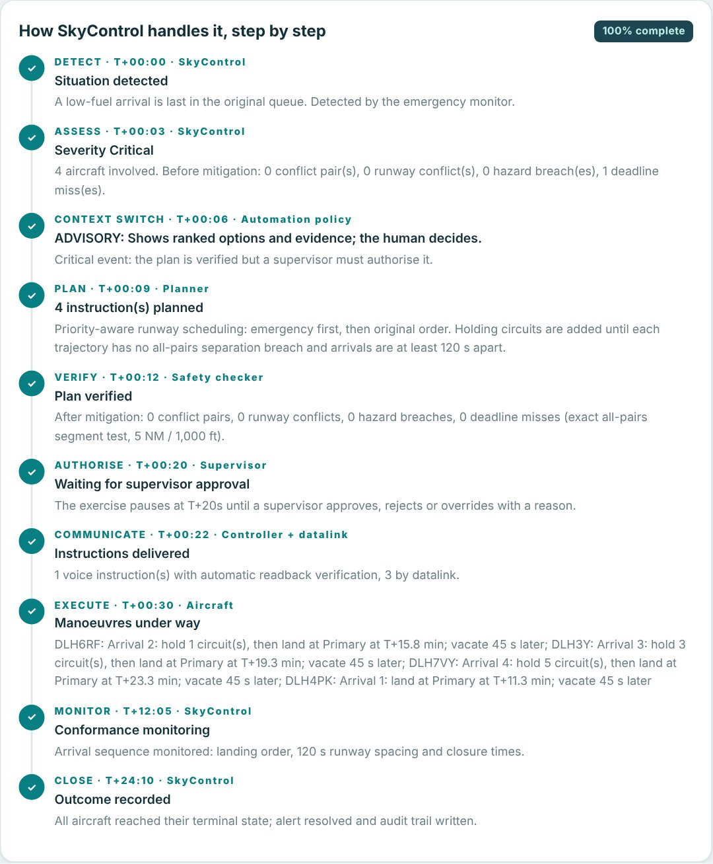
Fig. 7.21 Fuel Emergency: the Ten Handling Steps after Supervisor Approval
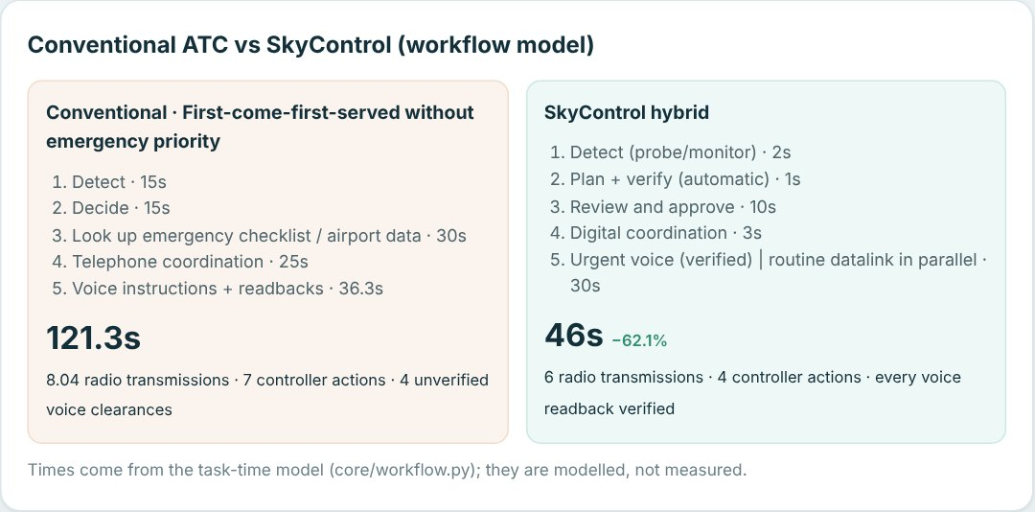
Fig. 7.22 Fuel Emergency: Conventional and SkyControl Workflows (Modelled)

7.10.2 Readback Error
EZY13ZW is cleared to FL120 and reads back FL140. In the comparator the controller must hear the wrong number; if it is missed, the aircraft climbs into the level of conflicting traffic, which the scenario shows as a conflict. SkyControl's verifier flags MISMATCH on the level field immediately, the correction is issued, and the corrected readback is verified CORRECT (Fig. 7.9). Fig. 7.23 shows the steps and Fig. 7.24 the outcome checks.
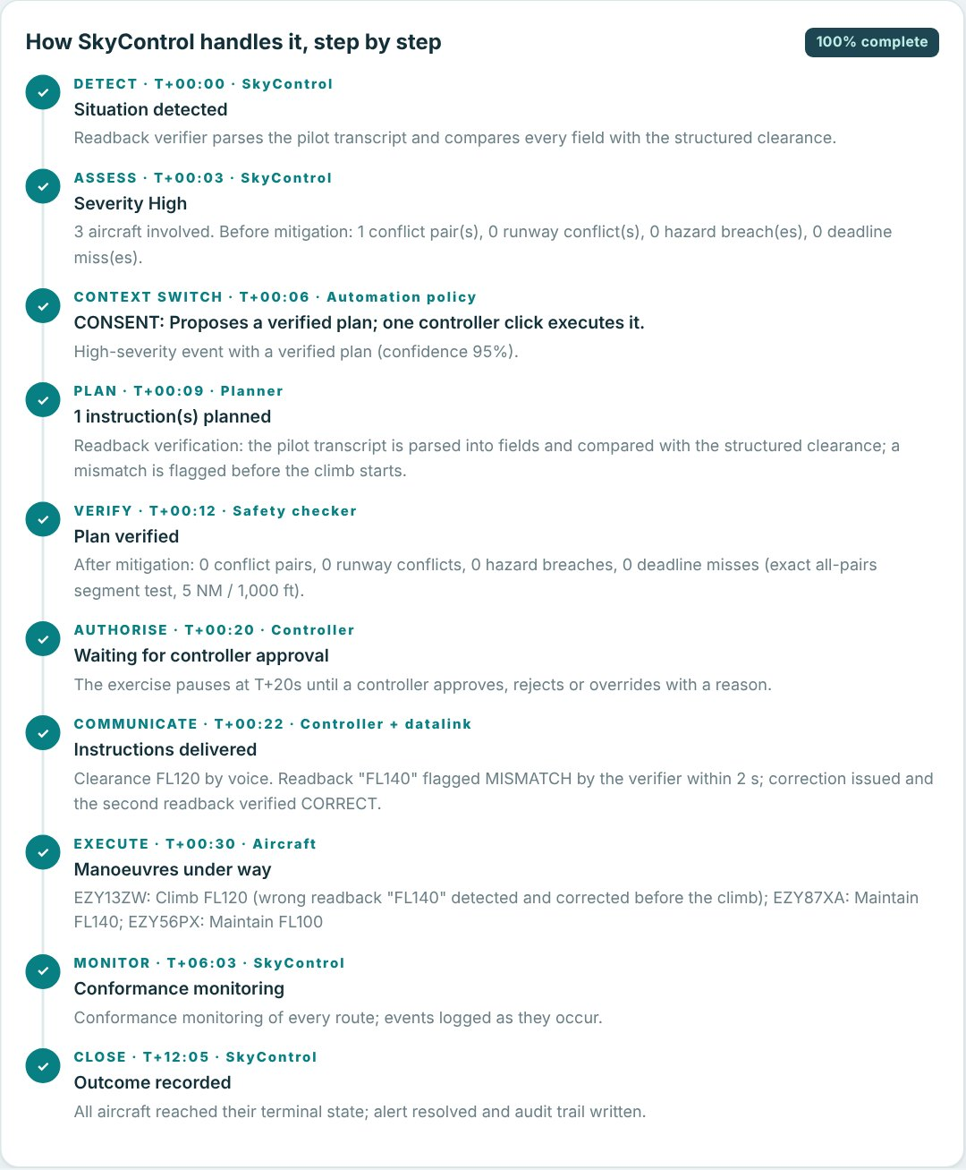
Fig. 7.23 Readback Error Scenario: Handling Steps
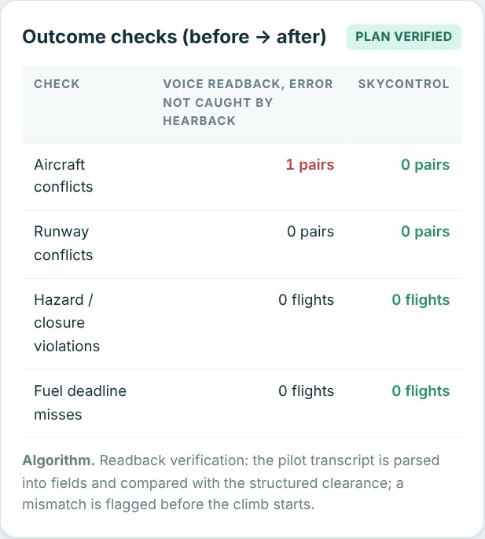
Fig. 7.24 Readback Error Scenario: Outcome Checks

7.10.3 Converging Traffic
Six aircraft converge on one crossing point at similar levels. Without intervention, 15 pairs would lose separation; serial voice resolution takes the controller a long time. SkyControl assigns flight levels greedily in priority order and verifies all 15 pairs exactly, removing every conflict with level changes only (Fig. 7.25, Fig. 7.26). Because the event is critical, a supervisor authorises the plan.
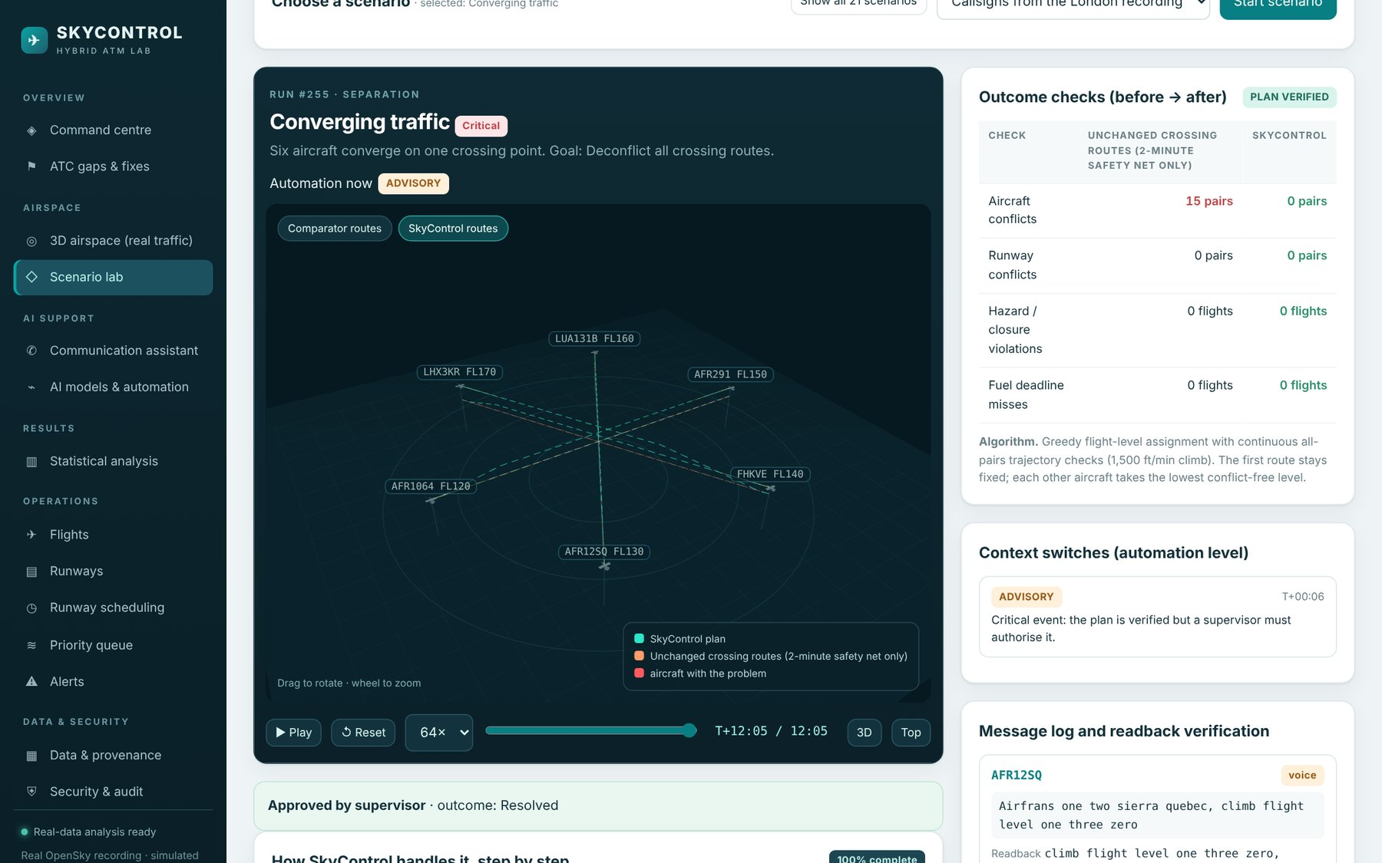
Fig. 7.25 Converging Traffic Scenario in the 3D Scenario Lab
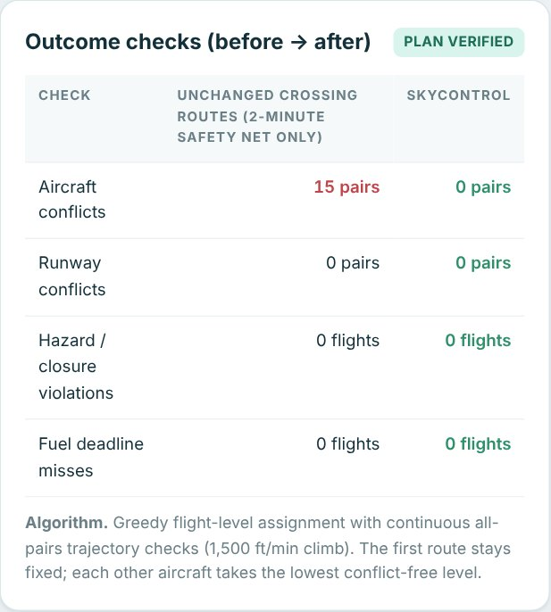
Fig. 7.26 Converging Traffic: Outcome Checks Before and After

7.10.4 Ghost Target
A duplicate radar target appears on top of a real aircraft. A comparator that trusts every target sees a conflict and issues an unnecessary avoidance instruction. SkyControl's integrity monitor identifies the duplicate from the address bit error; the automation level first drops to ADVISORY while the integrity check runs, then returns to CONSENT once the duplicate is confirmed and merged and data quality is restored (Fig. 7.27); no instruction is needed.
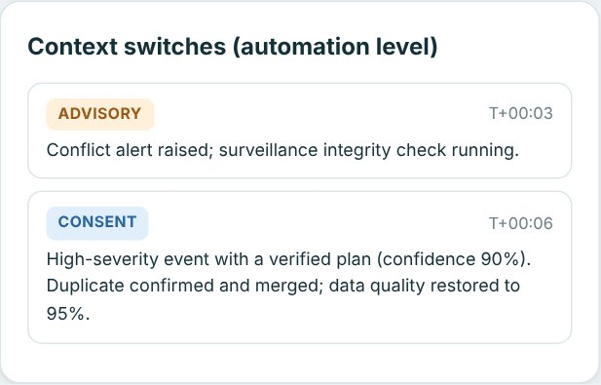
Fig. 7.27 Ghost Target: Context Switches Logged During the Event

7.10.5 AI Disagreement: When the AI Is Wrong
This scenario tests the central safety idea of the project. The learned model predicts that an aircraft will turn away with 82% confidence, so trusting it would leave the aircraft on course. The deterministic rule, which extrapolates the current motion, predicts a conflict. Because the two disagree, the policy drops from CONSENT to MANUAL: the rule wins and the human decides (Fig. 7.28). In the replay the aircraft does not turn, so the comparator that trusted the AI loses separation (one pair), while the conservative plan keeps all aircraft separated (Fig. 7.29).
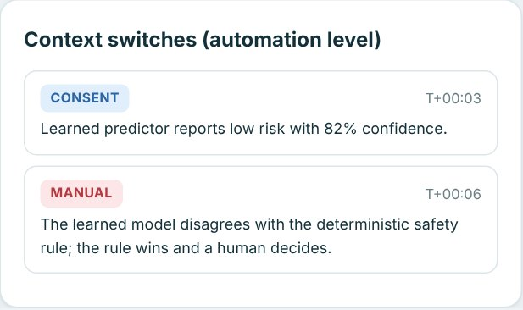
Fig. 7.28 AI Disagreement: Context Switch from CONSENT to MANUAL
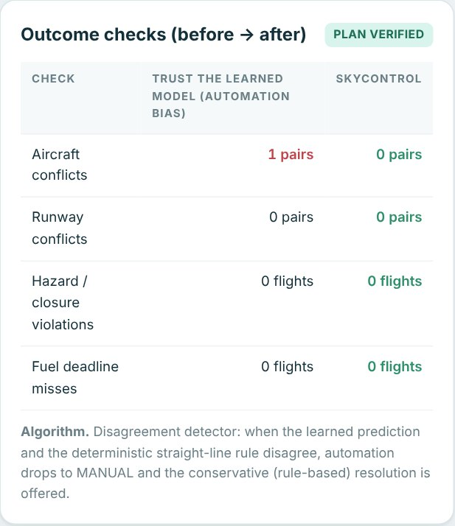
Fig. 7.29 AI Disagreement: Trusting the Learned Model versus the Conservative Plan

7.11 Summary of Statistical Results
Table 7.11 summarises the paired comparisons. Six of the seven comparisons are significant at α = 0.05; the warning time of the conflict probe is not, because only eight real encounters were available.
Table 7.11 Paired Comparisons: Current Practice versus SkyControl
Comparison | n | Current | SkyControl | Change | p | Evidence
Prediction error, 60 s (NM) | 17,994 | 0.555 | 0.449 | 19.1% | < 0.0001 | Measured
Prediction error, 120 s (NM) | 16,873 | 1.635 | 1.267 | 22.5% | < 0.0001 | Measured
Prediction error, 300 s (NM) | 13,765 | 6.845 | 4.482 | 34.5% | < 0.0001 | Measured
Track error after dropout (NM) | 196 | 6.24 | 1.48 | 76.2% | < 0.0001 | Measured
Conflict warning time (s, higher better) | 8 | 33.4 | 47.1 | +41.2% | 0.125 | Measured (small n)
Emergency handling time (s) | 60 | 190.8 | 47.8 | 75.0% | < 0.0001 | Real traffic, modelled time
Scenario handling time (s) | 21 | 117.1 | 38.7 | 67.0% | < 0.0001 | Scenario, modelled

7.12 How SkyControl Complements Current ATC
SkyControl was not built to win against current ATC but to strengthen it where it is weak. Table 7.12 summarises, for each function, what current ATC does, what SkyControl adds and how the two work together.
Table 7.12 Current ATC and SkyControl Side by Side
Function | Current ATC | SkyControl adds | Effect (evidence)
Readback | Controller hearback | Automatic verification of every voice readback; datalink for routine items | Undetected errors −91% (modelled)
Callsigns | Planning deconfliction, vigilance | Live similarity alerts; wrong-aircraft detection | 10 real pairs flagged (measured)
Conflict alerting | STCA, ~2 min | Intent-aware 5-min probe; STCA kept | 2.5× look-ahead at the same alert rate (measured)
Surveillance | Tracker output trusted | Ghost detection, coasting, integrity-driven context switch | 21 ghosts; track error −76% (measured)
Holding | Decided near the stack | Hold prediction 30-80 NM out; linear-holding estimate | AUC 0.76, 11.5 min lead; 49% absorbable (modelled)
Level busts | CLAM if the level is entered | Cleared level always known | 81 of 81 injected events (measured)
Emergencies | Checklists, phone, memory | Airport ranking, path checked against real traffic, digital coordination | 91.5% conflicts resolved; time −75% (modelled)
Automation | On or off | Four levels with logged context switches | Humans approve all critical plans (scenario)
Runways | Manual re-planning | Occupancy-aware sequencing | All runway conflicts removed (scenario)

7.13 Software Testing and Performance
The automated test suite has 93 tests, all passing locally and in the Jenkins pipeline, with 90% statement coverage of the back end (Table 7.13). ruff reports no lint errors. Browser tests with headless Chromium loaded all 14 pages without JavaScript errors and exercised the interactive flows: the wrong-login message, the blocked critical plan for a controller and its approval by a supervisor, a readback-error scenario through all ten steps, emergency injection on a real aircraft, a MISMATCH readback check and all eight statistics tabs.
Table 7.13 Automated Test Suite
Test file | Tests | What is verified
test_auth.py | 9 | Uniform wrong-credential message, stored attempts with reasons, no passwords stored, lockout, CSRF, roles, users
test_operations.py | 6 | Flight CRUD and validation, runway conflicts, calendar, priority queue, alerts, dashboard
test_scenarios.py | 47 | All 21 scenarios verified conflict-free, comparator problems, ten steps, context switches, readback, fuel deadline
test_lab_api.py | 5 | Supervisor gate, controller consent, AUTO runs, replay controls, override reason, data sources
test_comms_and_automation.py | 10 | Readback verdicts, NATO letters, phraseology, callsign similarity, policy, exact geometry
test_analytics.py | 12 | Recording integrity, known ghost pair, coasting, predictor on held-out data, alerts, holding, emergencies
test_app.py | 4 | Health, static front end, security headers, dataset register, audit access
Total | 93 | 90% statement coverage

A load test with eight concurrent clients and 120 requests per endpoint measured the latencies in Fig. 7.30. Interactive endpoints answer in 18 to 50 ms at the median. Creating a scenario, which plans and verifies all aircraft pairs and builds the pipeline, takes about 343 ms. The first request for a new frame of the 3D replay computes the intent-aware probe for all aircraft (up to 2.5 s); later requests for the same frame are served from the cache in about 23 ms.
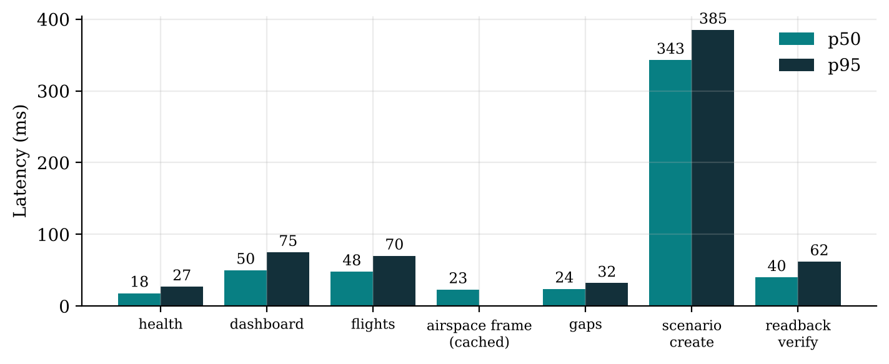
Fig. 7.30 Median and 95th-Percentile Latency under Load (8 Concurrent Clients)

7.14 User Interface
The following screenshots show the main pages of the application as used in the faculty demonstration. The command centre (Fig. 7.31) summarises the key results and the live state, including failed logins in the last 24 hours. The scenario lab catalogue (Fig. 7.32) groups the 21 scenarios by category and states the gap each one demonstrates. The statistical analysis page has eight tabs (Fig. 7.33 to Fig. 7.39). The AI models page (Fig. 7.40) documents each model and contains the context-switch simulator, and the communication assistant (Fig. 7.41) verifies readbacks. The operations, data and security pages complete the application.
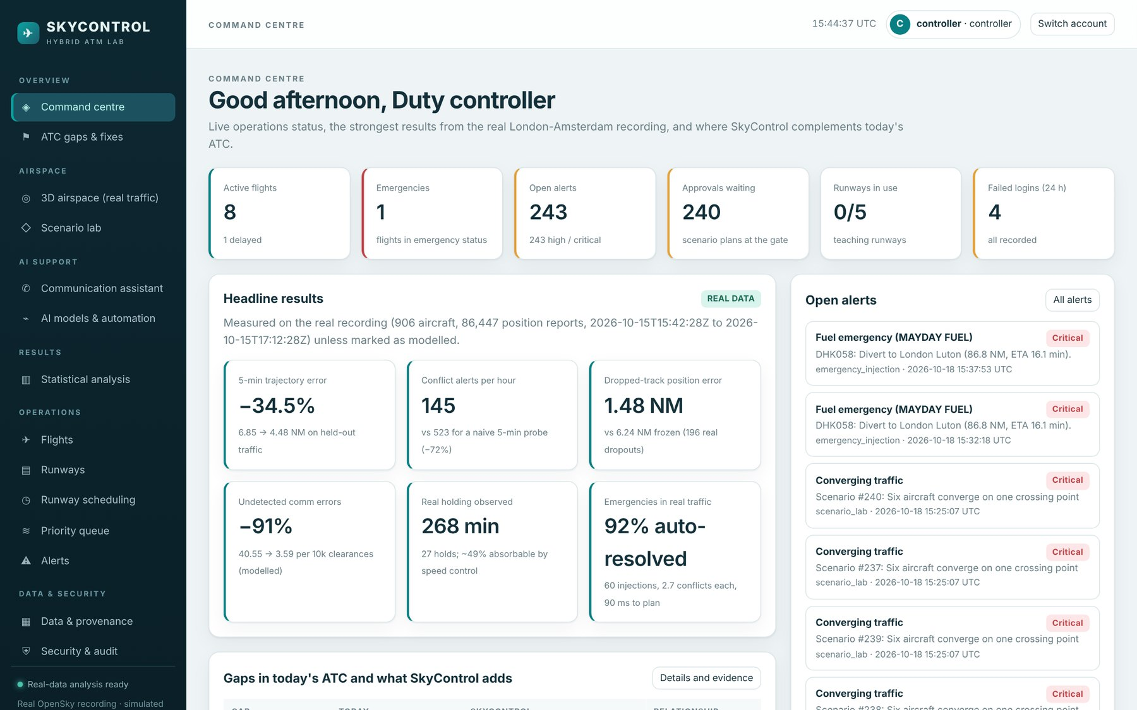
Fig. 7.31 Command Centre (Dashboard)
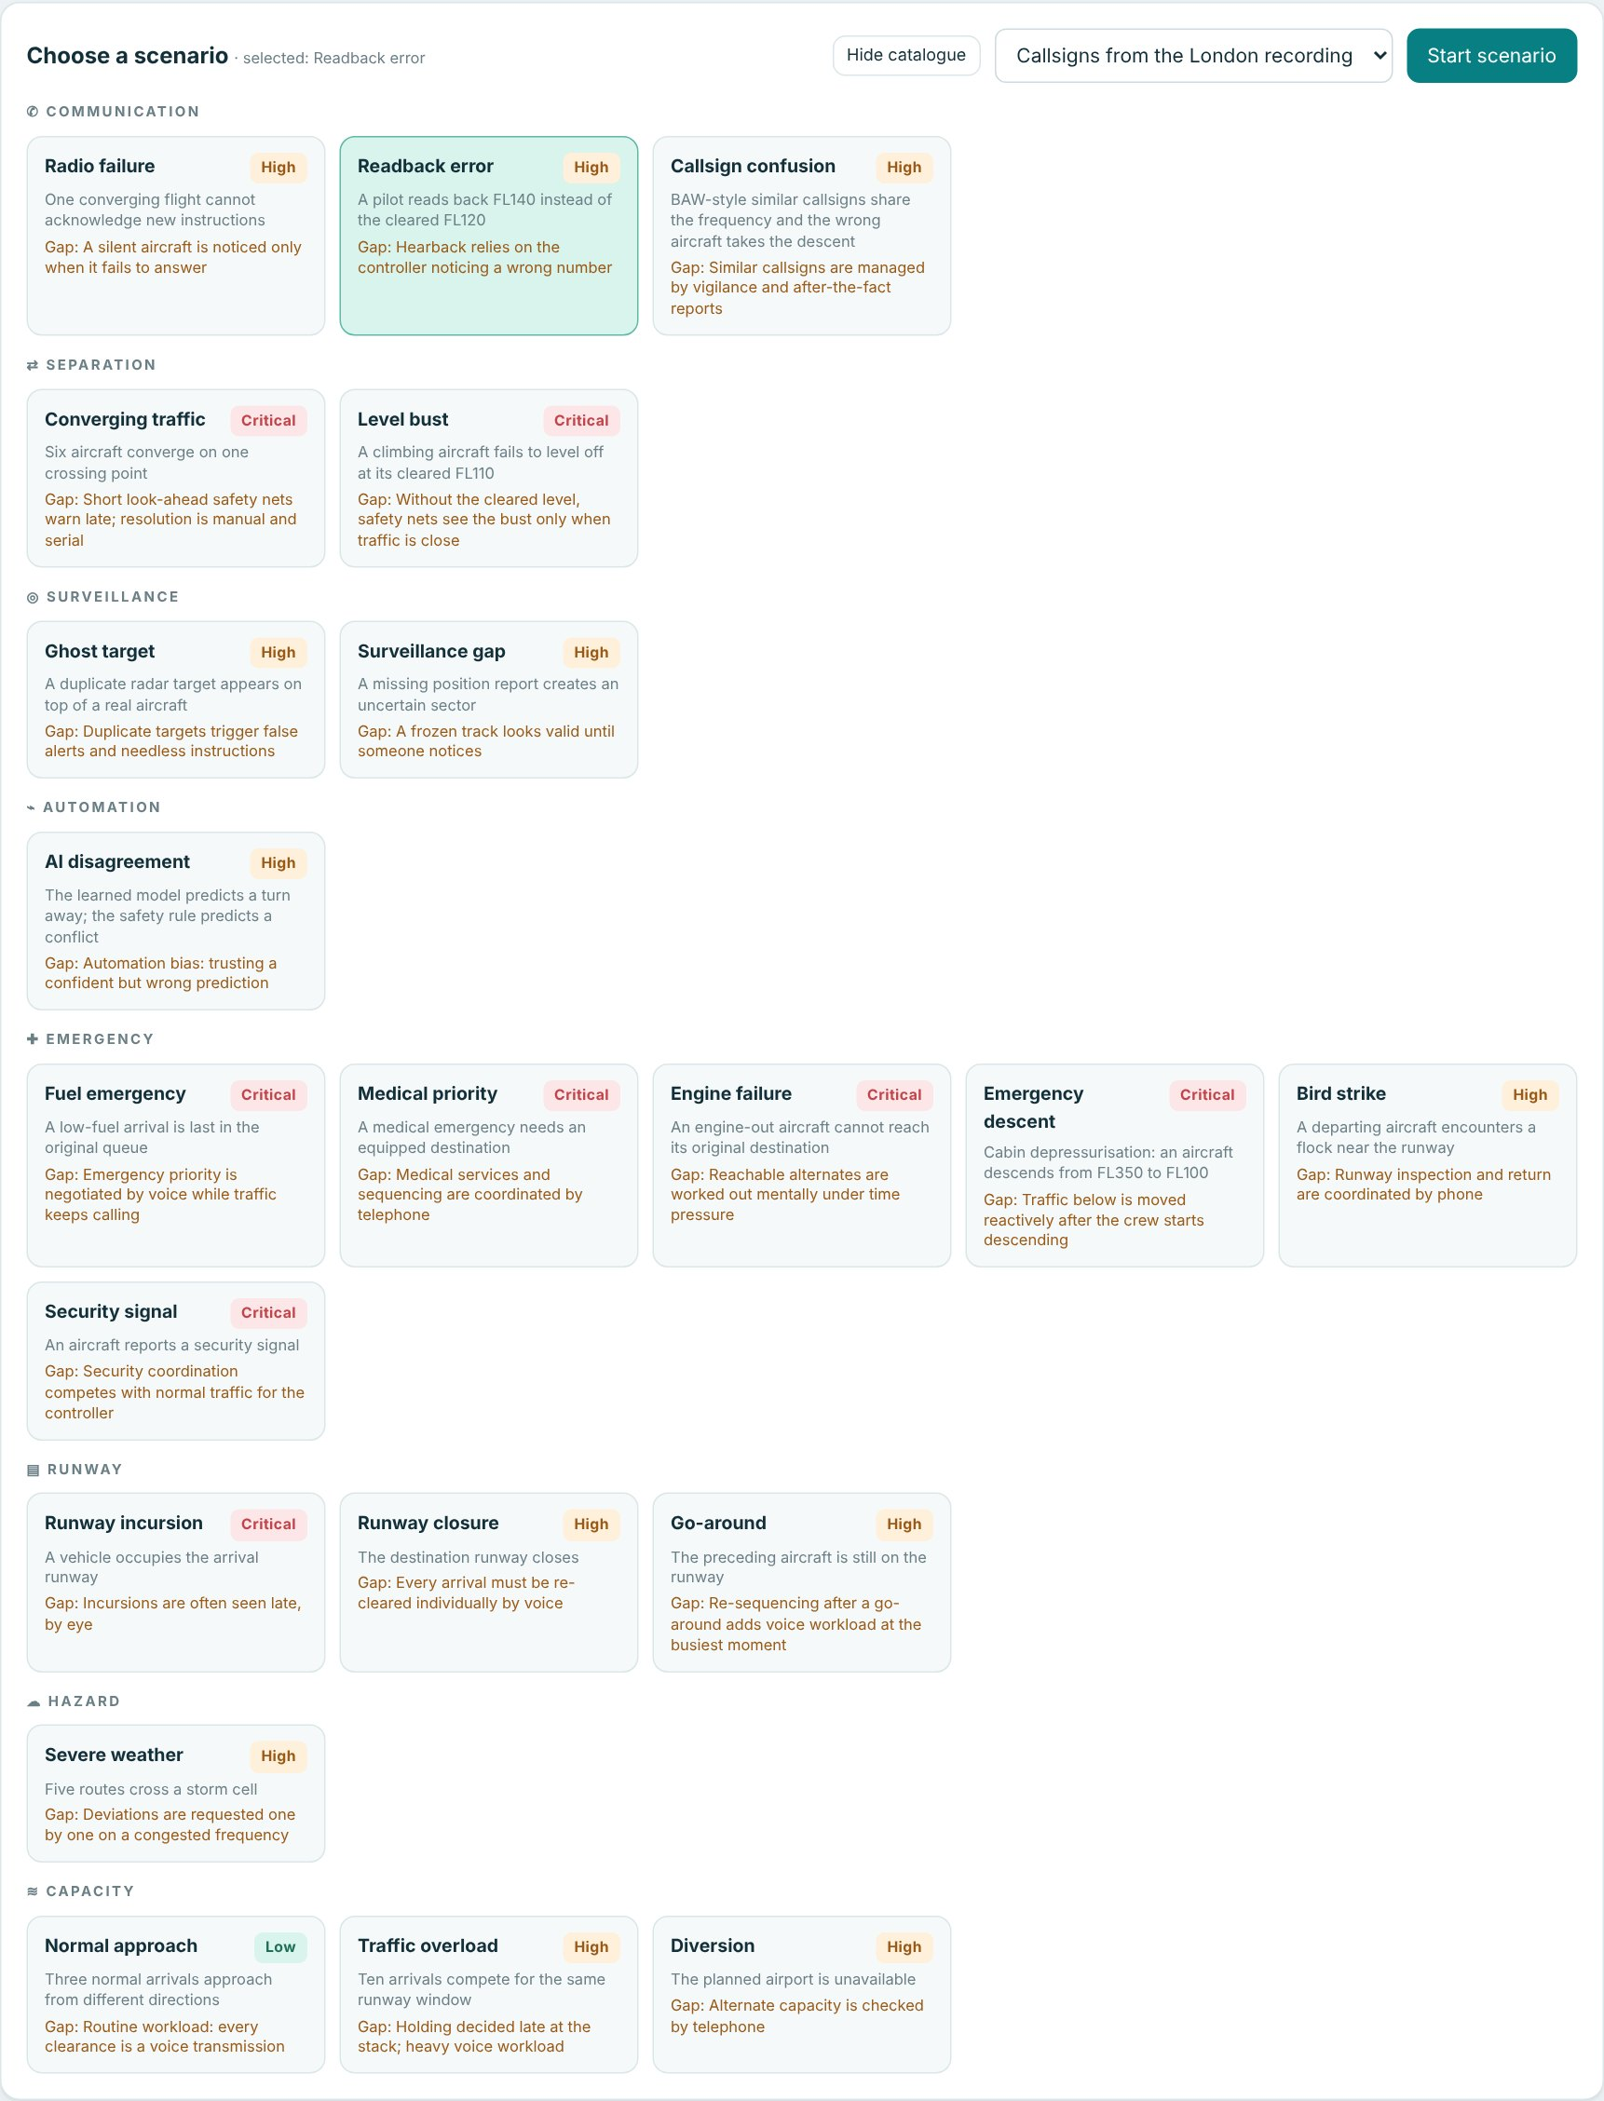
Fig. 7.32 Scenario Lab Catalogue of 21 Scenarios
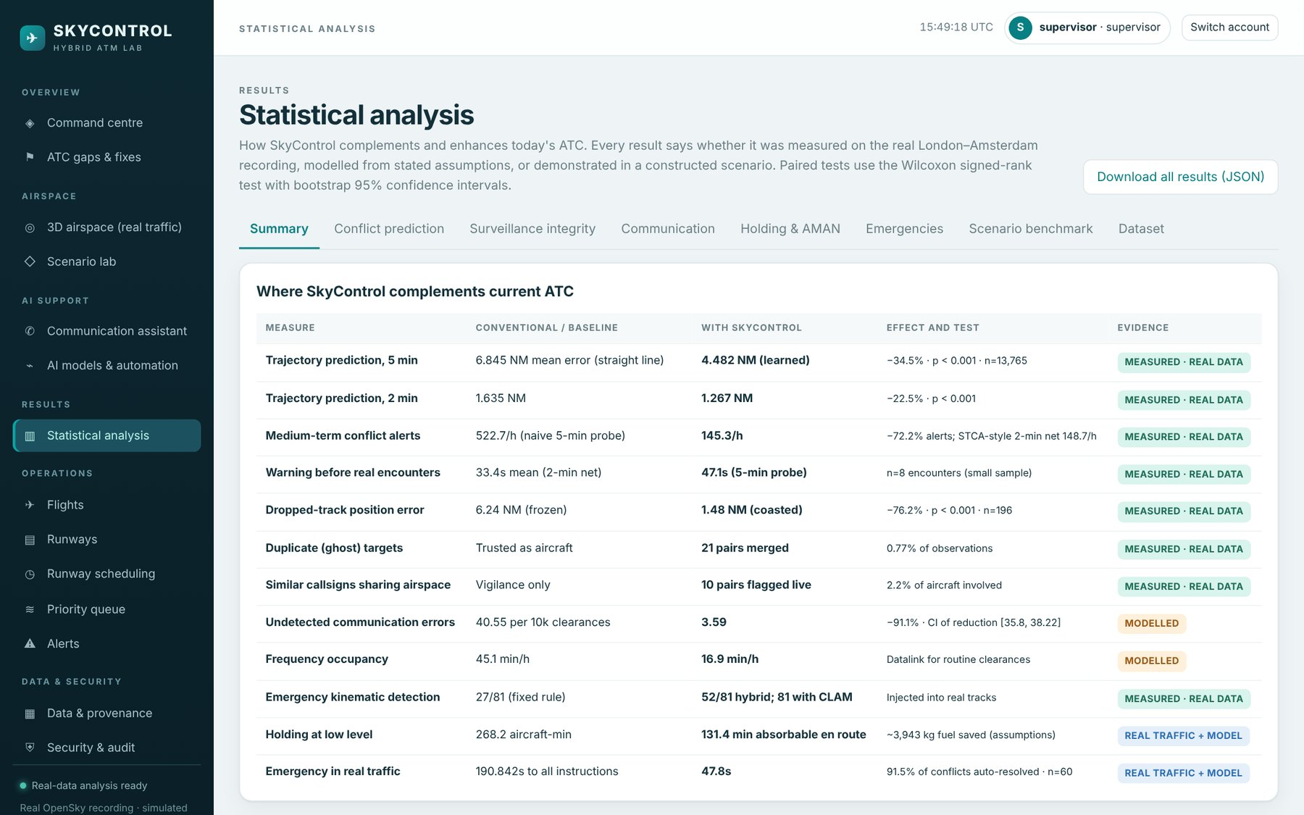
Fig. 7.33 Statistical Analysis: Summary Tab
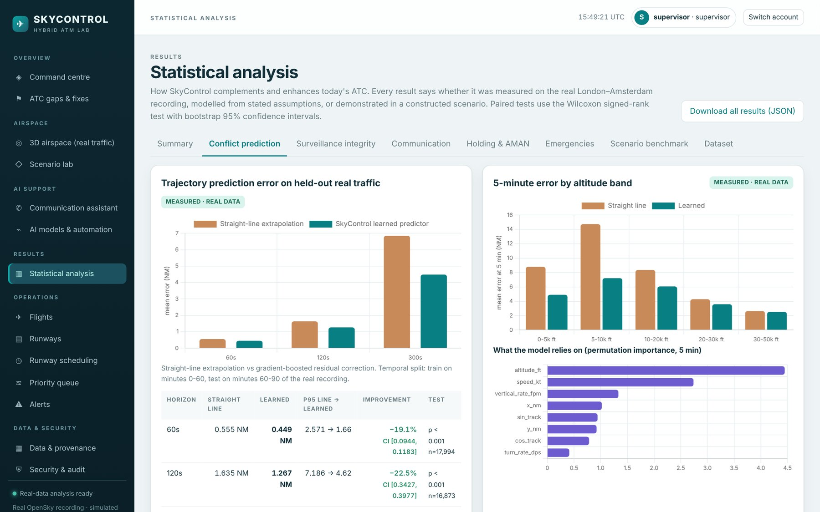
Fig. 7.34 Statistical Analysis: Conflict Alerting Tab
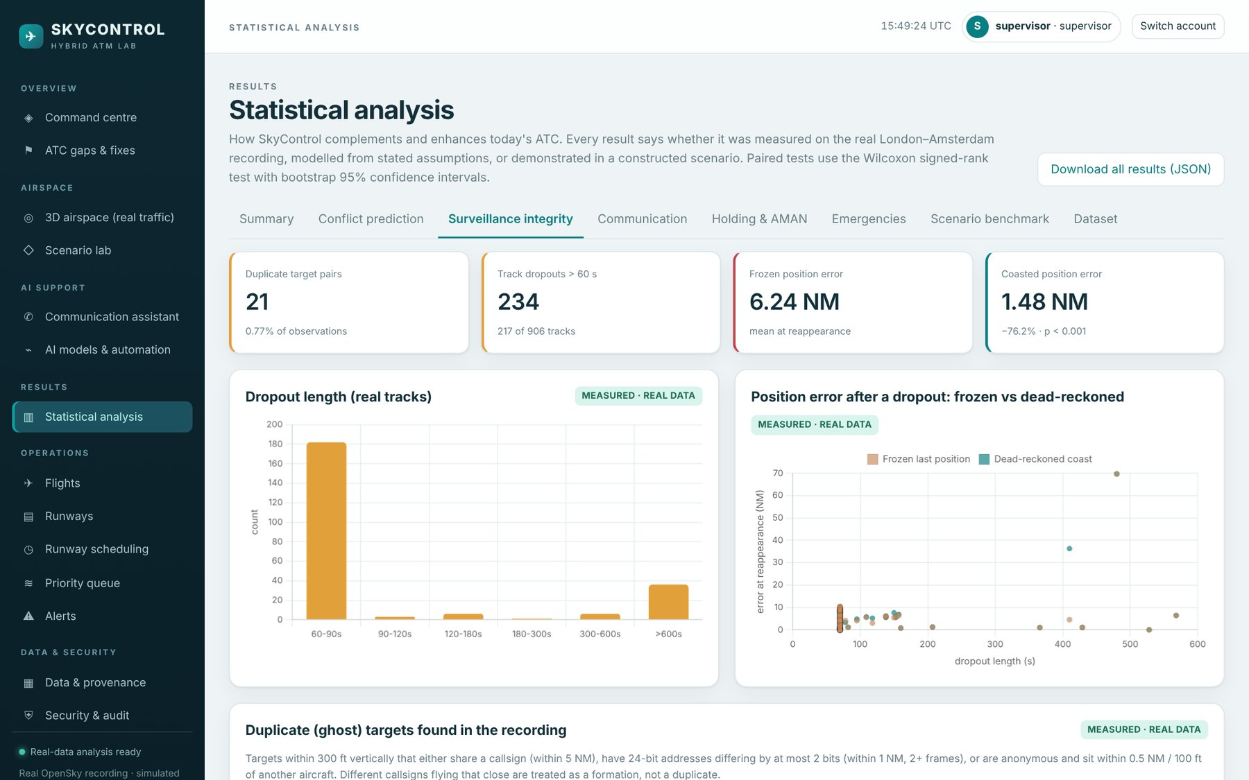
Fig. 7.35 Statistical Analysis: Surveillance Integrity Tab
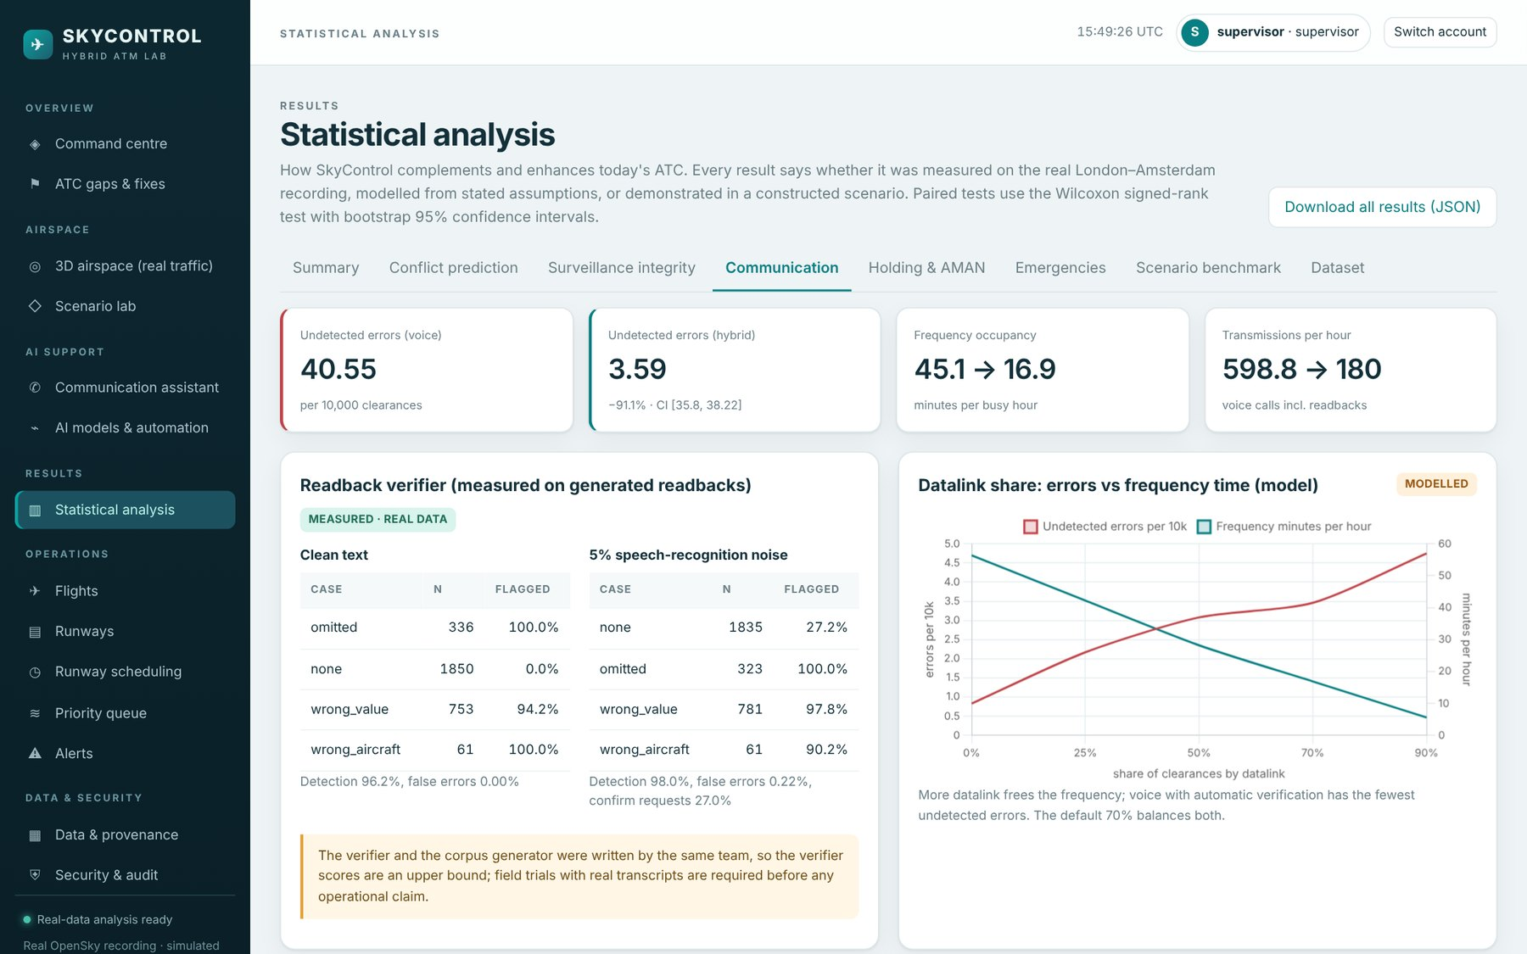
Fig. 7.36 Statistical Analysis: Communication Tab
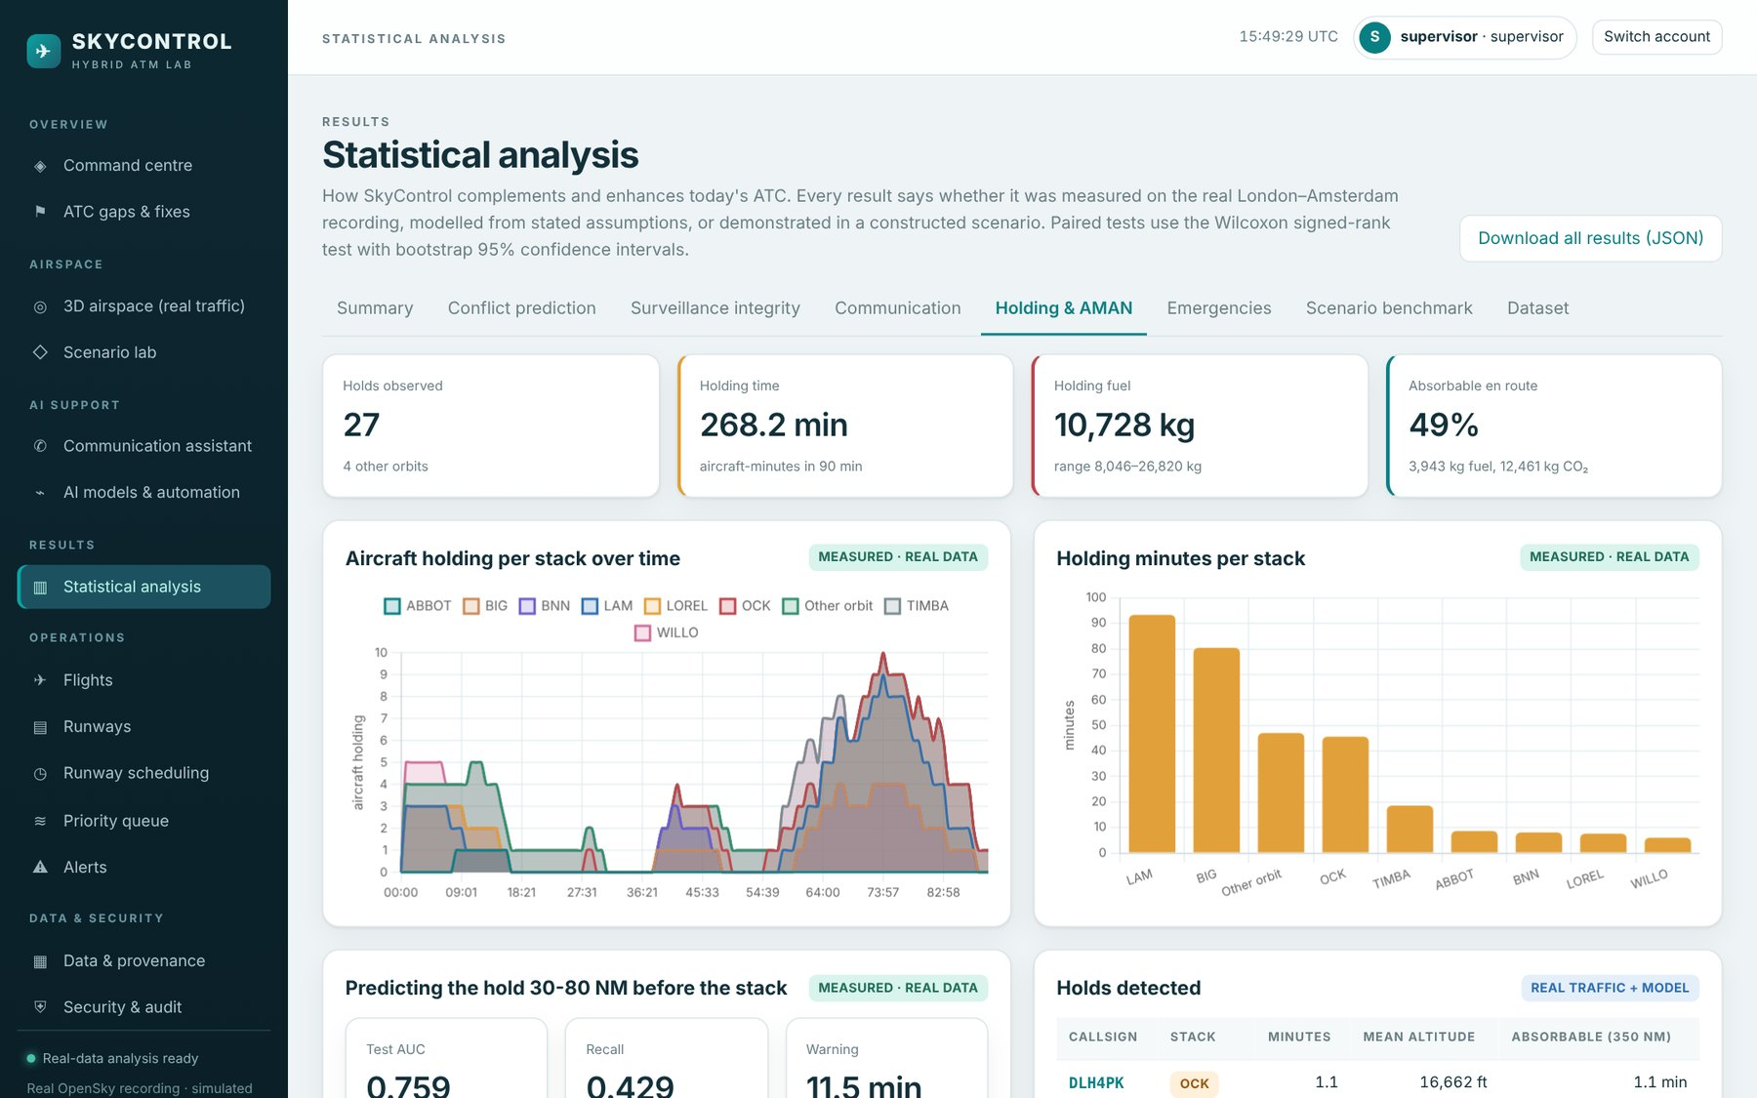
Fig. 7.37 Statistical Analysis: Holding Tab
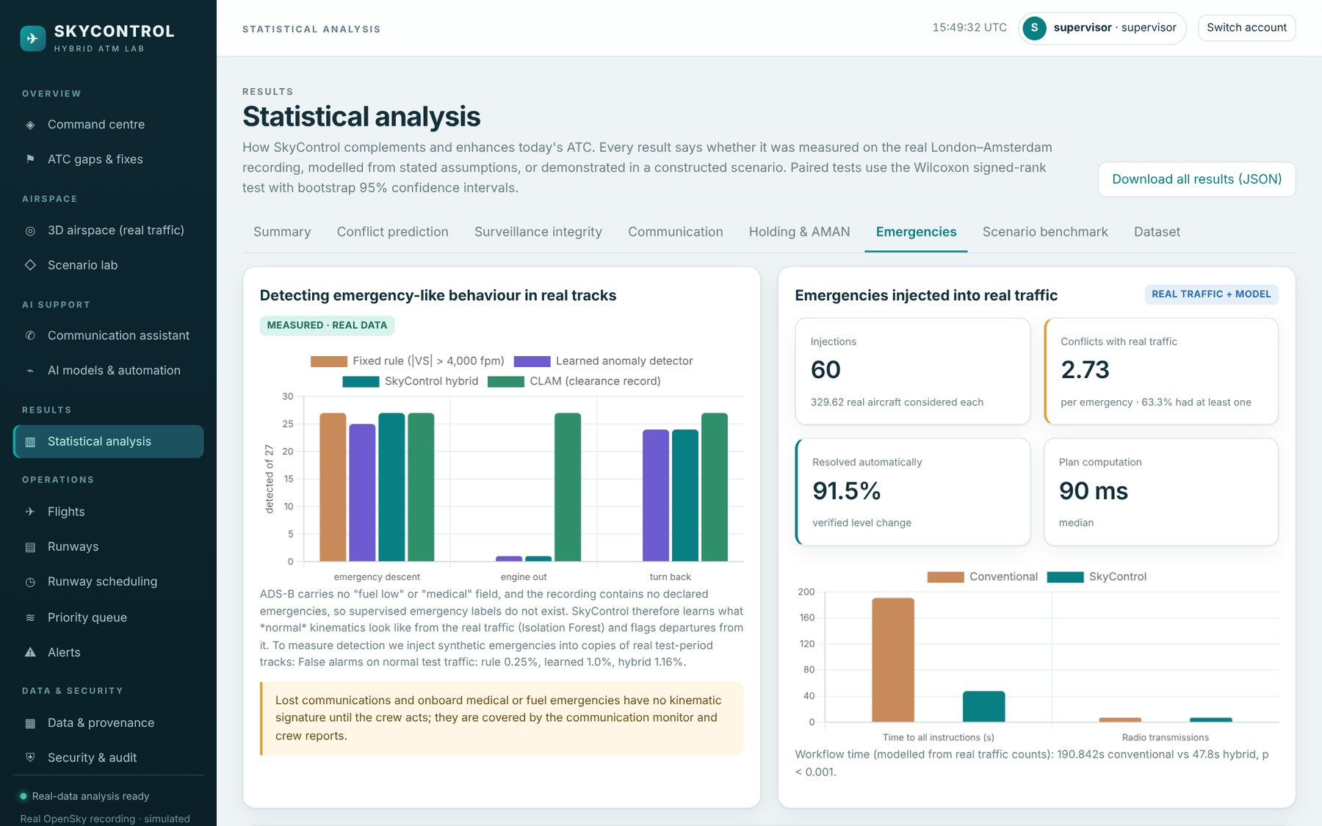
Fig. 7.38 Statistical Analysis: Emergencies Tab
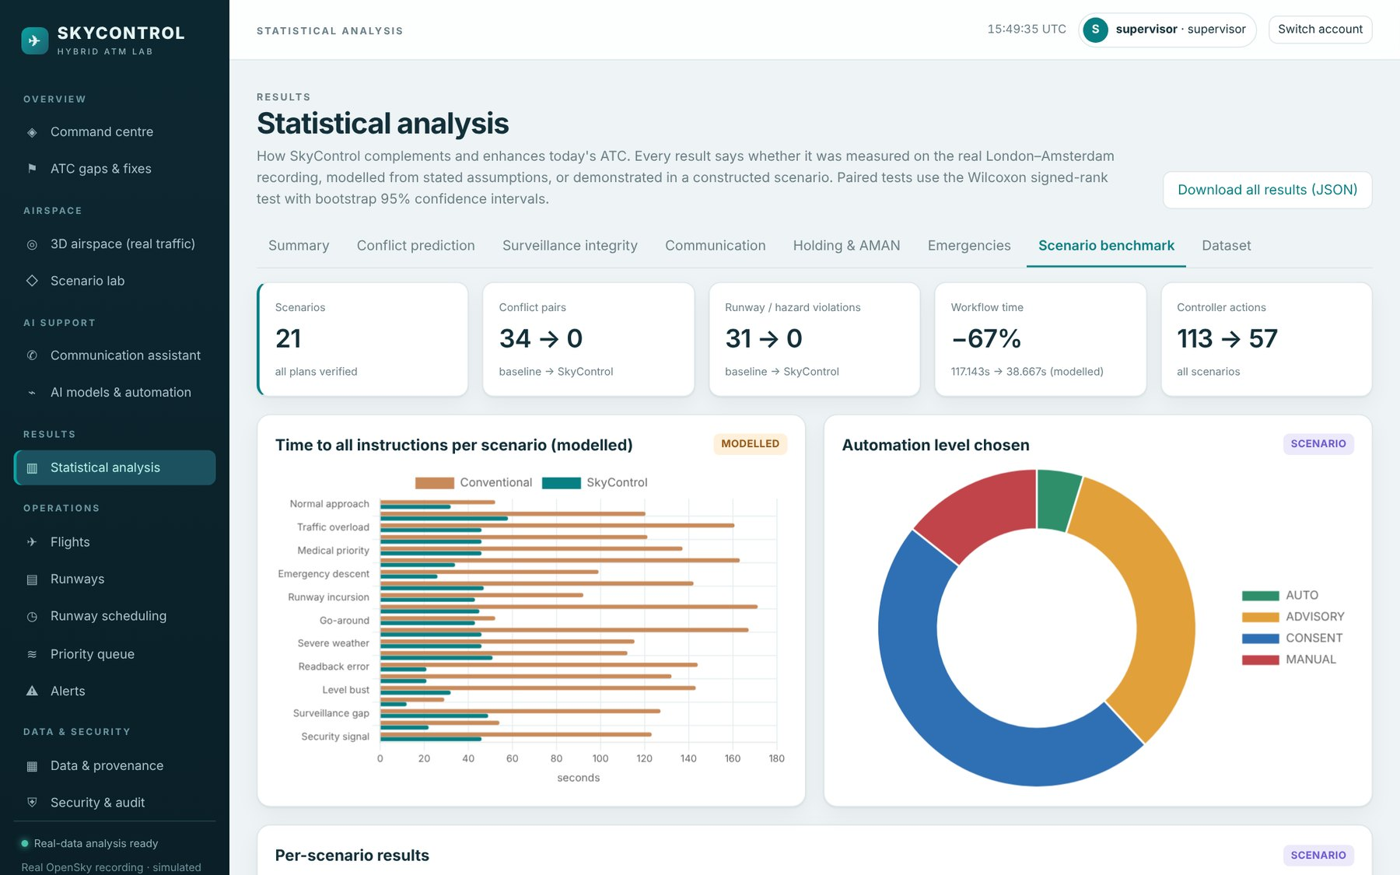
Fig. 7.39 Statistical Analysis: Scenarios Tab
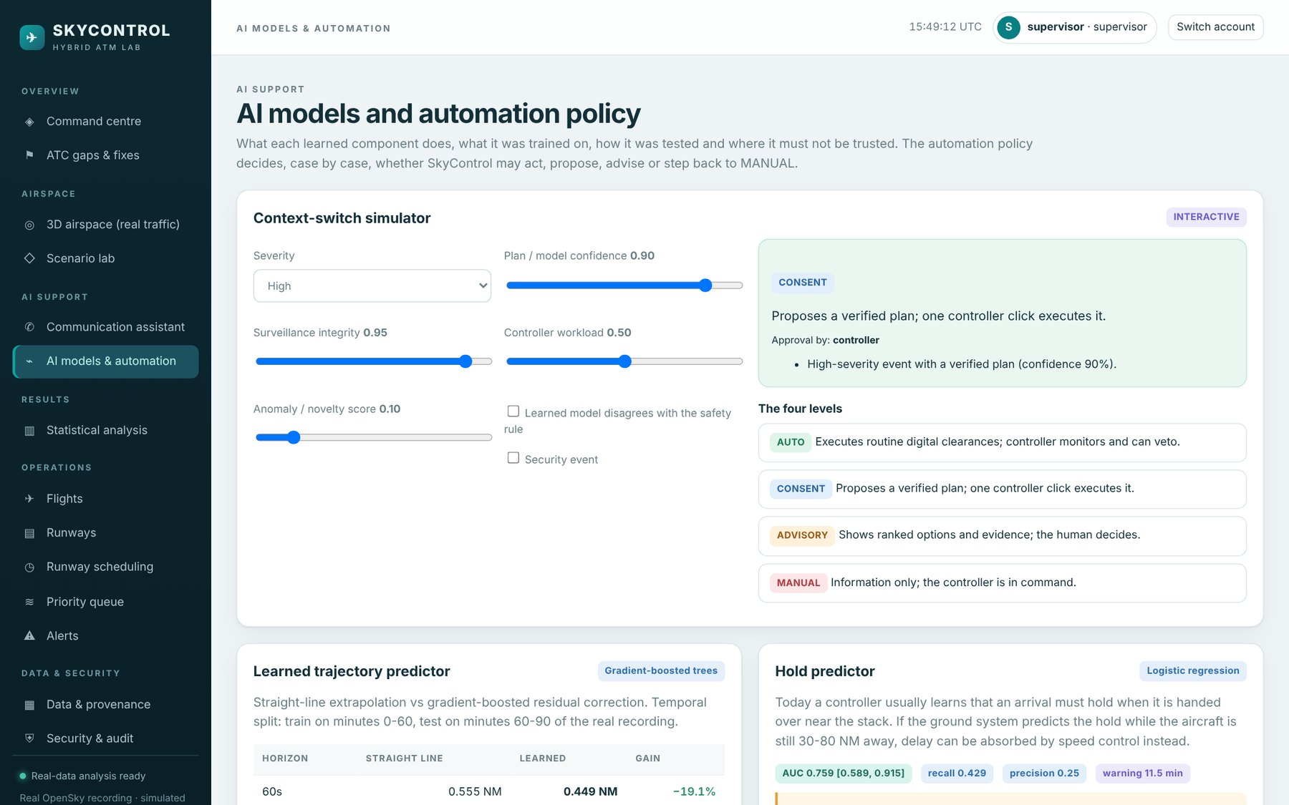
Fig. 7.40 AI Models and Automation Page with the Context-Switch Simulator
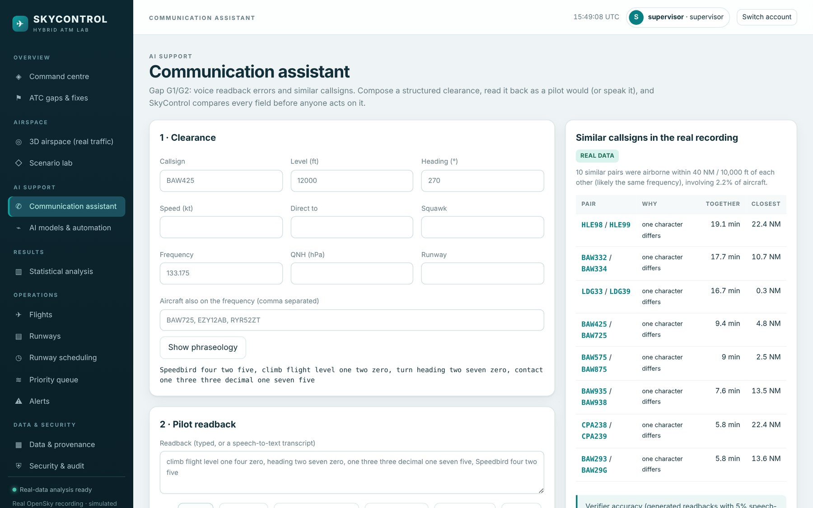
Fig. 7.41 Communication Assistant Verifying a Readback
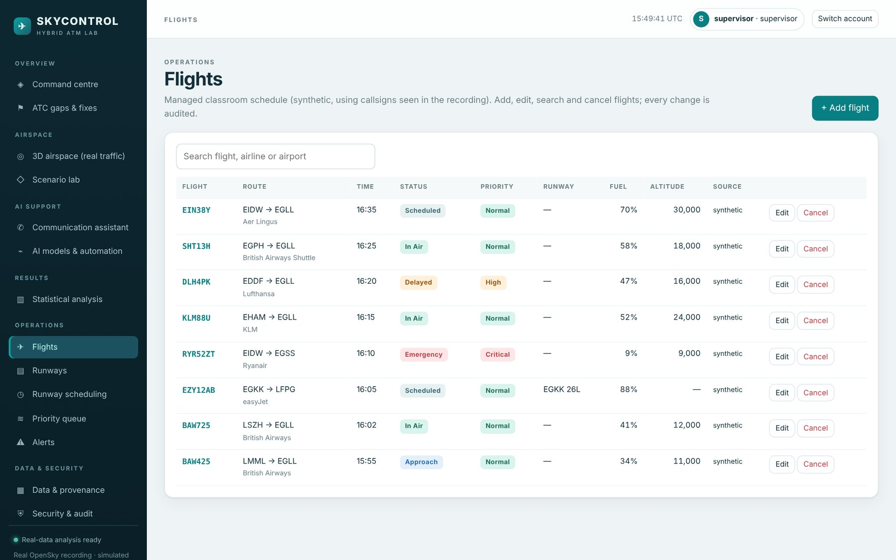
Fig. 7.42 Operations: Flight Management
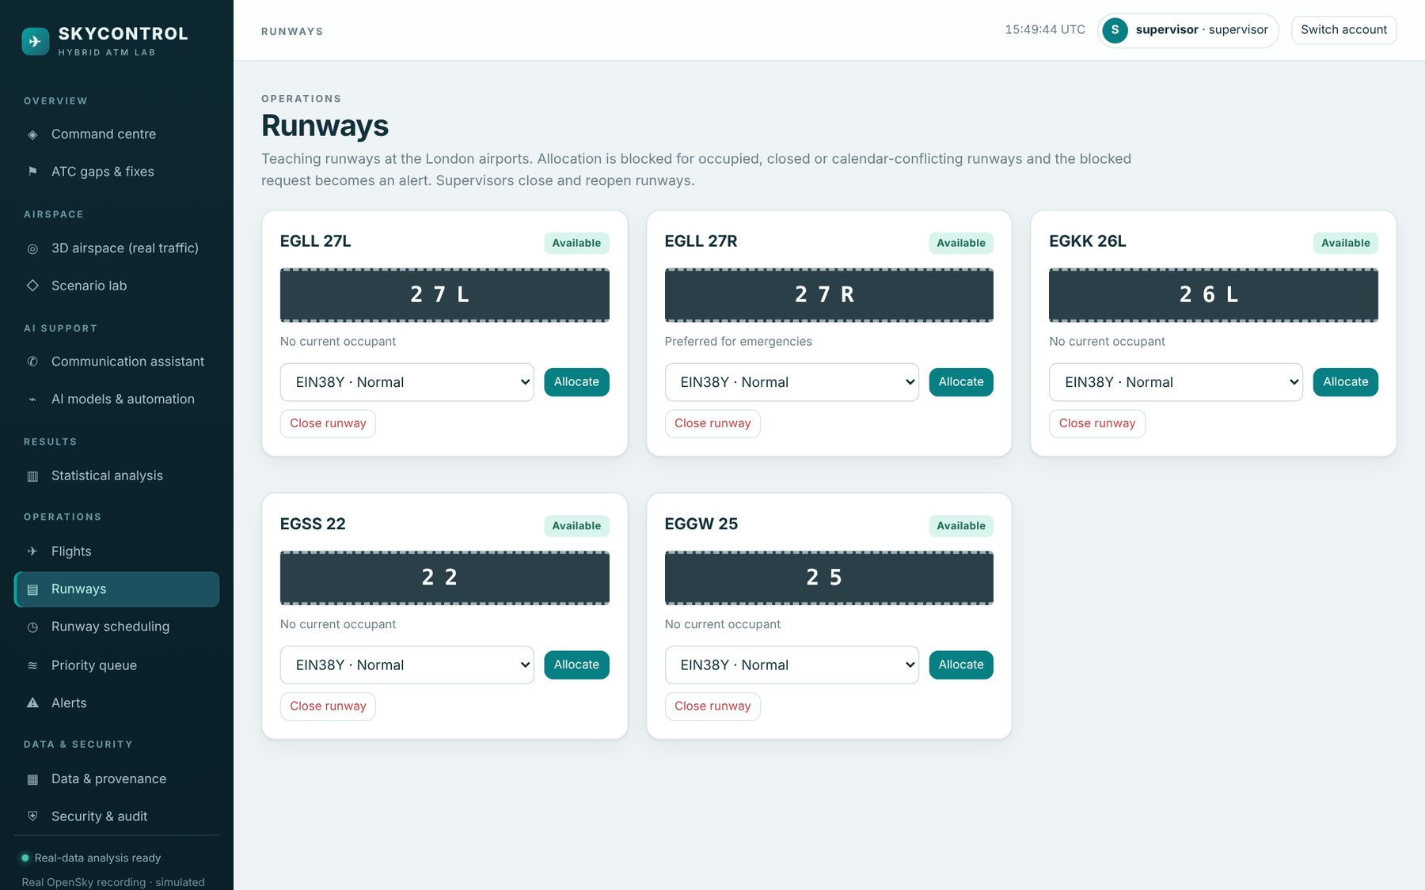
Fig. 7.43 Operations: Runway Management
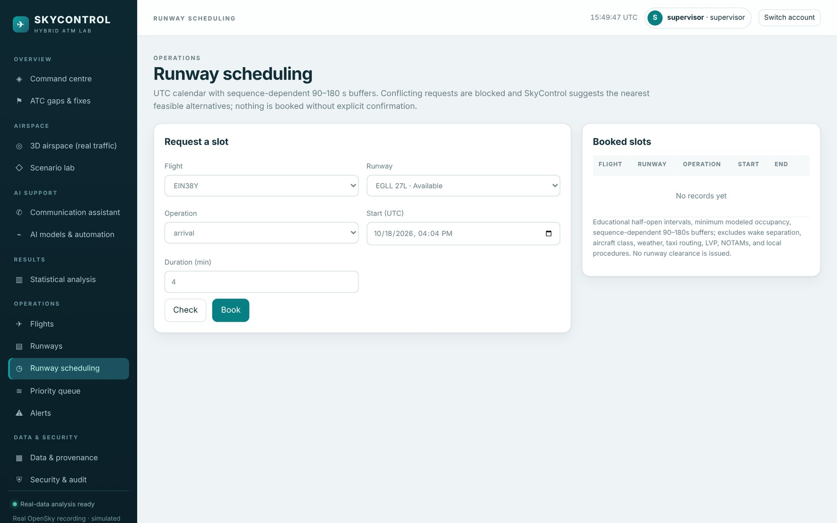
Fig. 7.44 Operations: Runway Scheduling Calendar
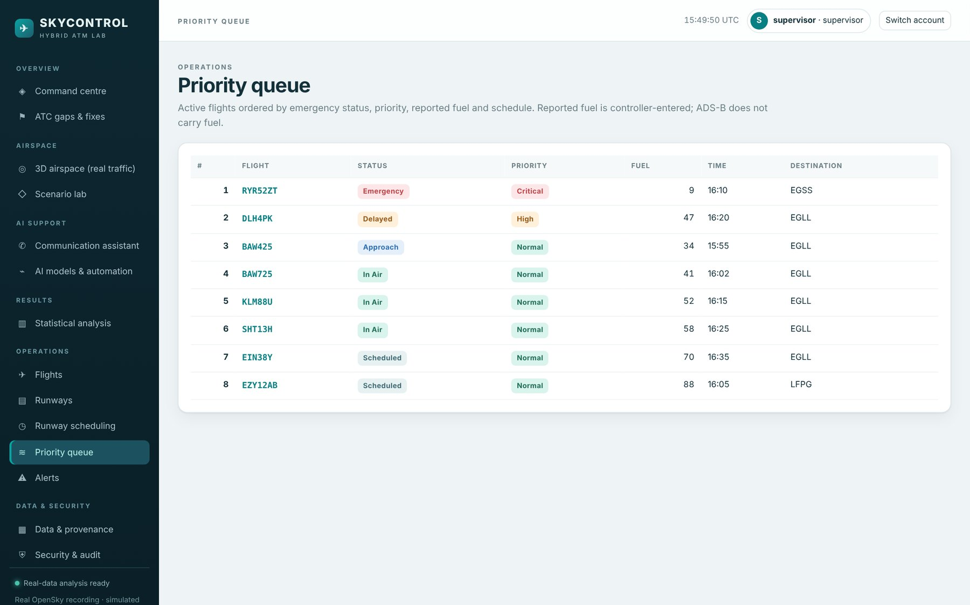
Fig. 7.45 Operations: Priority Queue
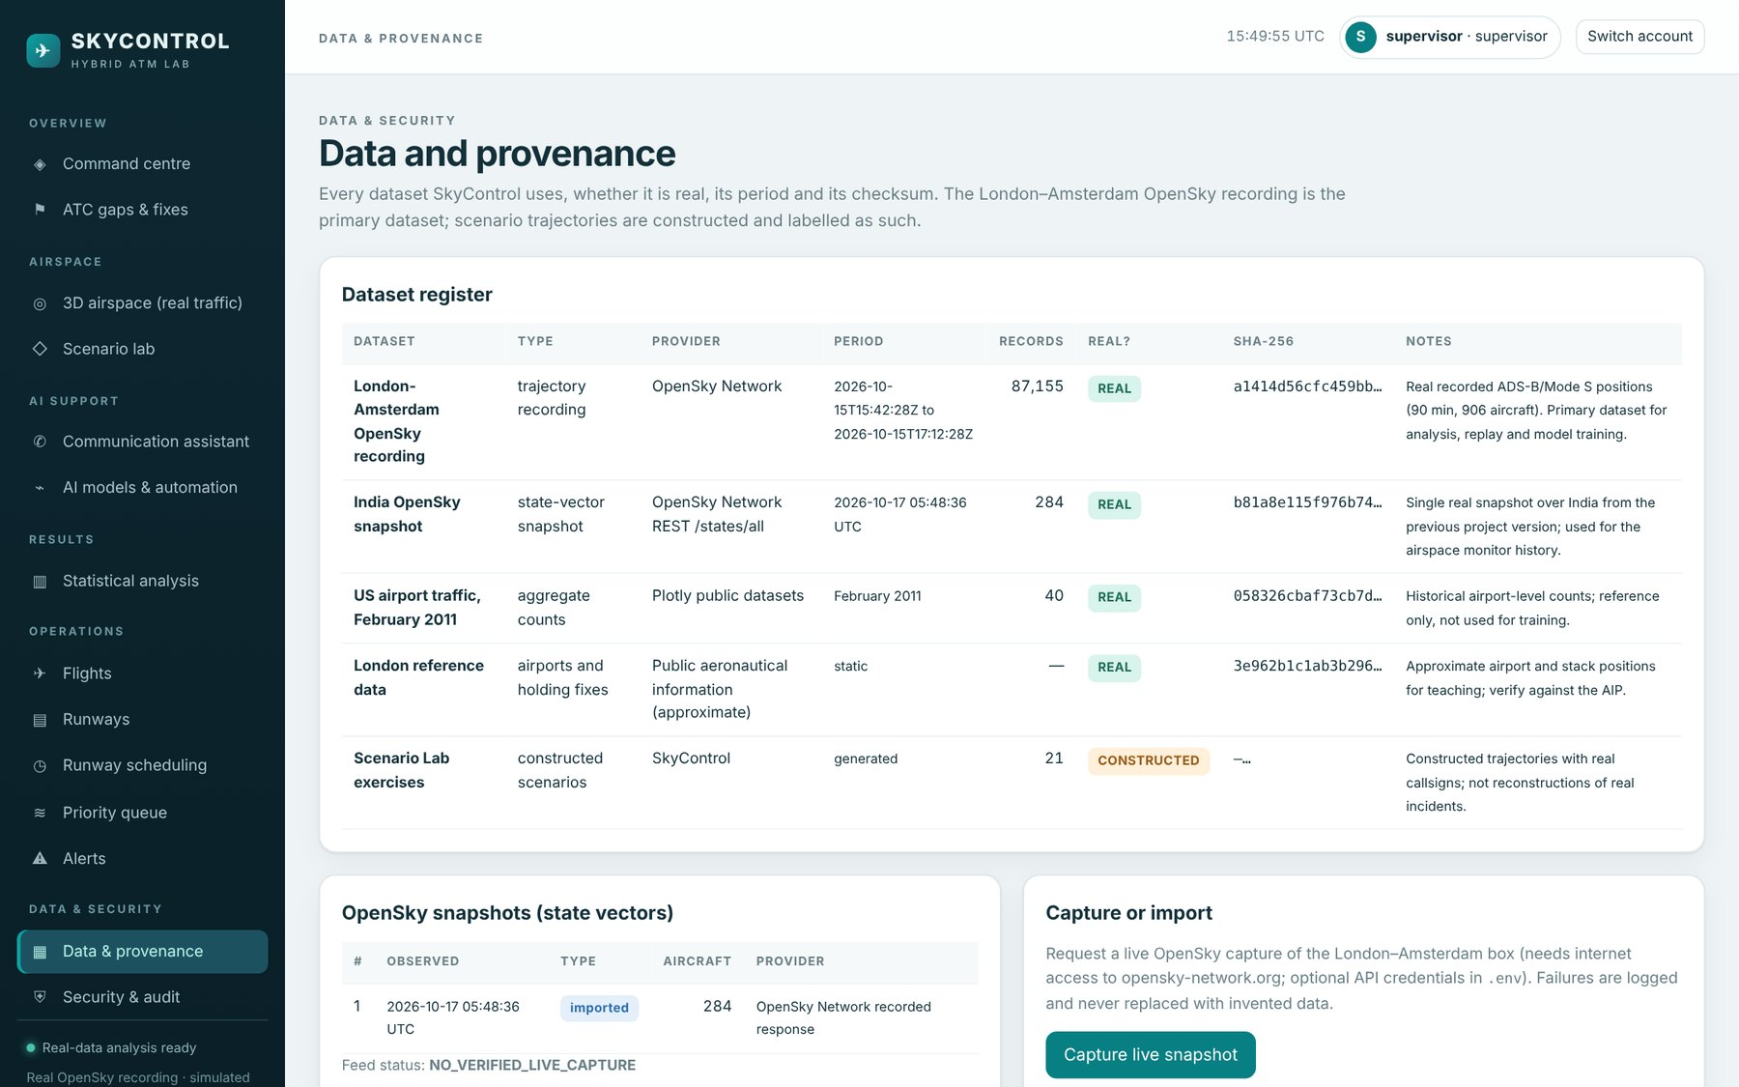
Fig. 7.46 Data and Provenance Page
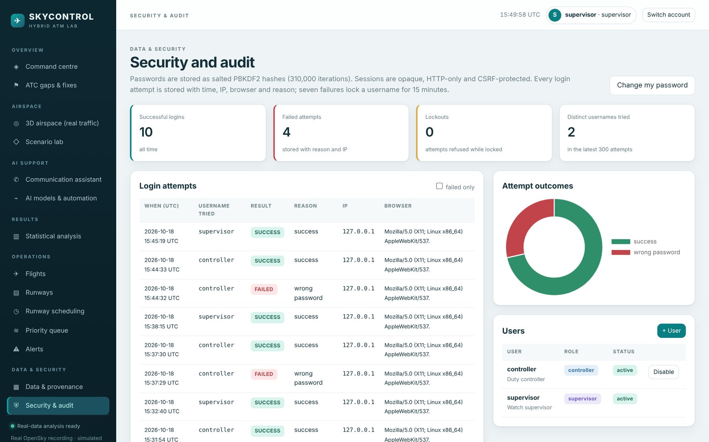
Fig. 7.47 Security and Audit Page

7.15 Cost Analysis
SkyControl is built entirely from open-source software, so there are no licence costs. Table 7.14 estimates the cost of developing and running it. Effort is taken from the sprint plan (205 story points over 12 weeks for a team of two); infrastructure costs are indicative prices for a small cloud virtual machine and are stated as ranges.
Table 7.14 Development and Operating Cost (Indicative)
Item | Basis | Cost
Software licences | Python, FastAPI, scikit-learn, three.js, Chart.js, SQLite, Docker, Jenkins (open source) | ₹0
Data | OpenSky Network data for research and teaching | ₹0
Planning and CI | Jira Cloud free plan (up to 10 users), GitHub free, Jenkins self-hosted | ₹0
Development hardware | Existing student laptops (8 GB RAM) | ₹0 additional
Development effort | 2 students × 12 weeks × about 15 h/week ≈ 360 person-hours | Academic project (not charged)
Hosting (optional) | Small cloud VM, 2 vCPU / 4 GB, for a shared demonstration | about ₹1,500-2,500 per month
Domain and TLS (optional) | Domain name; free certificate (Let's Encrypt) | about ₹800-1,200 per year

On the benefit side, the measured holding in the 90-minute recording corresponds to about 10,728 kg of fuel, of which about 3,943 kg (12,461 kg of CO₂) could be saved by early speed control in the modelled extended-AMAN case. These figures are for one region and one busy afternoon period; extrapolating them to a day or a year would multiply the uncertainty and is not attempted here. The communication and emergency benefits are safety benefits, which are not priced.

7.16 Discussion and Threats to Validity
The results support the main claim of the project: on real traffic, AI and well-known algorithms can close specific gaps in current ATC while the human stays in charge, and the hybrid improves reliability (fewer undetected communication errors, more accurate predictions, trustworthy surveillance, all verified plans conflict-free) and efficiency (fewer alerts for a longer look-ahead, faster emergency handling, less frequency time). The context switch turned out to be essential rather than decorative: the emergency example in Section 7.9 and the AI-disagreement scenario both show cases in which acting on the automation alone would have been wrong.
The results also have clear limits, which are stated here so that they are not over-read:
● One recording. All measured results come from one 90-minute recording of one region. The learned models must be retrained and re-validated on more days and other airspace before any operational claim.
● Small samples. Eight real encounters and 39 held-out arrivals are too few for strong conclusions about warning time and hold prediction; these results are reported as indicative.
● Approximated intent. The cleared level used by the intent-aware probe is the next observed level-off, a stand-in for a digital clearance record that makes the probe optimistic.
● Modelled human performance. Communication error rates, controller miss rates and task times come from the literature and assumptions, not from controllers; sensitivity analyses bound their effect.
● Generated corpus. The readback verifier was evaluated on generated transcripts with simulated recognition noise, not on real R/T audio.
● No user study. The interface and the automation policy were not evaluated with air traffic controllers.
Within these limits, the evidence is consistent across very different methods (held-out machine-learning evaluation, injected events in real tracks, Monte Carlo modelling and exact verification), which gives confidence that the direction of each result is right even where its size is uncertain.

CHAPTER 8
SUMMARY
This project set out to find where current air traffic control is weak and to show, on real traffic, how a hybrid human-AI system can close those gaps without taking authority away from the controller. SkyControl, the resulting system, is a complete and deployable web application built on a real 90-minute OpenSky recording of London-Amsterdam traffic. It has a login portal with verified credentials that rejects wrong credentials clearly and stores every attempt; a 3D replay of the real airspace with live monitors and emergency injection; a scenario lab that handles 21 scenarios in ten visible steps with explicit context switches and approval gates; a communication assistant; and a statistical analysis section. It is tested, containerised and delivered by a Jenkins pipeline, and it was planned and run as six Scrum sprints.

8.1 Findings
● Prediction and alerting. A learned residual predictor cut the five-minute position error on held-out real traffic by 34.5%. Combined with cleared-level intent and duplicate merging, it allowed a five-minute conflict probe to run at the alert rate of a two-minute safety net (145.3 against 148.7 alerts per hour, against 522.7 for a naive probe).
● Surveillance integrity. Duplicate targets and dropouts are real in today's data (21 ghost pairs, 234 dropouts); dead-reckoned coasting reduced the error of dropped tracks by 76%.
● Communication. The readback verifier caught 98% of injected errors under recognition noise with 0.22% false errors; the sector model predicts 91.1% fewer undetected communication errors and 63% less frequency time, with the reduction staying between 65% and 98% across the sensitivity range.
● Holding. 268 aircraft-minutes of holding in 90 minutes, about half of which could be absorbed en route with early prediction; the hold predictor gives about 11.5 minutes of warning (indicative).
● Level busts and emergencies. Cleared-level monitoring with a digital clearance record detected all 81 injected events; for 60 emergencies in real traffic SkyControl resolved 91.5% of conflicts in about 90 ms and cut the modelled handling time by 75%.
● Scenarios and context switching. All 21 plans were verified conflict-free; every comparator problem was removed, and the automation policy kept humans in charge of every critical plan and switched to MANUAL when the AI and the rule disagreed, when data was degraded or when a plan could not be fully resolved.

8.2 Conclusions
The central conclusion is that AI is most useful in ATC as a complement that removes single points of failure around the controller: a second check behind hearback, a longer and quieter look-ahead beside the safety net, an integrity signal in front of the display, an earlier view of holding and an assistant for emergencies. The second conclusion is that the context switch is as important as the AI itself. The cases in which SkyControl stepped back were exactly the cases in which blind automation would have been wrong, which supports the levels-of-automation literature with concrete, testable behaviour.
The evidence is strongest for the measured results on real data (prediction, alert load, coasting, ghosts, holding and detection of injected events) and weaker, though consistent, for the modelled human-performance results and the small-sample results (warning time, hold prediction). The report labels each result accordingly.

8.3 Recommendations and Future Work
1. Retrain and validate the learned models on several weeks of recordings from different regions and seasons, and evaluate warning time on hundreds of real encounters.
2. Replace the approximated cleared levels with real clearance data (for example from a simulator or CPDLC logs) to measure the intent-aware probe without the counterfactual.
3. Evaluate the readback verifier on real R/T recordings with an aviation-trained speech recogniser.
4. Run a human-in-the-loop study with controllers or trained students to measure workload, trust and decision time with and without the context-switch display.
5. Add probabilistic trajectory prediction (uncertainty bands) so that the probe can adapt its thresholds to confidence.
6. Harden the deployment for multi-user use: PostgreSQL, multi-factor authentication and HTTPS by default.

CHAPTER 9
REFERENCES
Ayhan, S., & Samet, H. (2016). Aircraft trajectory prediction made easy with predictive analytics. In Proceedings of the 22nd ACM SIGKDD International Conference on Knowledge Discovery and Data Mining (pp. 21–30). ACM. https://doi.org/10.1145/2939672.2939694
Bainbridge, L. (1983). Ironies of automation. Automatica, 19(6), 775–779. https://doi.org/10.1016/0005-1098(83)90046-8
Cardosi, K. M. (1993). An analysis of en route controller-pilot voice communications (Report No. DOT/FAA/RD-93/11). Federal Aviation Administration.
Cardosi, K., Falzarano, P., & Han, S. (1998). Pilot-controller communication errors: An analysis of Aviation Safety Reporting System (ASRS) reports (Report No. DOT/FAA/AR-98/17). Federal Aviation Administration.
Dijkstra, E. W. (1959). A note on two problems in connexion with graphs. Numerische Mathematik, 1(1), 269–271. https://doi.org/10.1007/BF01386390
Efron, B., & Tibshirani, R. J. (1993). An introduction to the bootstrap. Chapman & Hall.
Endsley, M. R. (1995). Toward a theory of situation awareness in dynamic systems. Human Factors, 37(1), 32–64. https://doi.org/10.1518/001872095779049543
Erzberger, H. (2006). Automated conflict resolution for air traffic control. In Proceedings of the 25th International Congress of the Aeronautical Sciences (ICAS 2006). International Council of the Aeronautical Sciences.
EUROCONTROL. (2004). Air-ground communication safety study: An analysis of pilot-controller occurrences (Edition 1.0). EUROCONTROL.
EUROCONTROL. (2007). EUROCONTROL specification for short term conflict alert (EUROCONTROL-SPEC-0108, Edition 1.0). EUROCONTROL.
Fawcett, T. (2006). An introduction to ROC analysis. Pattern Recognition Letters, 27(8), 861–874. https://doi.org/10.1016/j.patrec.2005.10.010
Friedman, J. H. (2001). Greedy function approximation: A gradient boosting machine. The Annals of Statistics, 29(5), 1189–1232. https://doi.org/10.1214/aos/1013203451
Grassi, P. A., Fenton, J. L., Newton, E. M., Perlner, R. A., Regenscheid, A. R., Burr, W. E., Richer, J. P., Lefkovitz, N. B., Danker, J. M., Choong, Y.-Y., Greene, K. K., & Theofanos, M. F. (2017). Digital identity guidelines: Authentication and lifecycle management (NIST Special Publication 800-63B). National Institute of Standards and Technology. https://doi.org/10.6028/NIST.SP.800-63b
Helmke, H., Ohneiser, O., Mühlhausen, T., & Wies, M. (2016). Reducing controller workload with automatic speech recognition. In 2016 IEEE/AIAA 35th Digital Avionics Systems Conference (DASC). IEEE. https://doi.org/10.1109/DASC.2016.7778024
Hoekstra, J. M., & Ellerbroek, J. (2016). BlueSky ATC simulator project: An open data and open source approach. In Proceedings of the 7th International Conference on Research in Air Transportation (ICRAT).
Humble, J., & Farley, D. (2010). Continuous delivery: Reliable software releases through build, test, and deployment automation. Addison-Wesley.
International Civil Aviation Organization. (2007). Manual of radiotelephony (Doc 9432, 4th ed.). ICAO.
International Civil Aviation Organization. (2016). Procedures for air navigation services: Air traffic management (Doc 4444, 16th ed.). ICAO.
International Civil Aviation Organization. (2018). Annex 11 to the Convention on International Civil Aviation: Air traffic services (15th ed.). ICAO.
International Organization for Standardization. (2011). Systems and software engineering: Systems and software Quality Requirements and Evaluation (SQuaRE): System and software quality models (ISO/IEC 25010:2011).
Ke, G., Meng, Q., Finley, T., Wang, T., Chen, W., Ma, W., Ye, Q., & Liu, T.-Y. (2017). LightGBM: A highly efficient gradient boosting decision tree. In Advances in Neural Information Processing Systems 30 (pp. 3146–3154). Curran Associates.
Kochenderfer, M. J., Holland, J. E., & Chryssanthacopoulos, J. P. (2012). Next-generation airborne collision avoidance system. Lincoln Laboratory Journal, 19(1), 17–33.
Kuchar, J. K., & Yang, L. C. (2000). A review of conflict detection and resolution modeling methods. IEEE Transactions on Intelligent Transportation Systems, 1(4), 179–189. https://doi.org/10.1109/6979.898217
Liu, F. T., Ting, K. M., & Zhou, Z.-H. (2008). Isolation forest. In 2008 Eighth IEEE International Conference on Data Mining (pp. 413–422). IEEE. https://doi.org/10.1109/ICDM.2008.17
Merkel, D. (2014). Docker: Lightweight Linux containers for consistent development and deployment. Linux Journal, 2014(239), Article 2.
Moriarty, K., Kaliski, B., & Rusch, A. (2017). PKCS #5: Password-based cryptography specification version 2.1 (RFC 8018). Internet Engineering Task Force. https://doi.org/10.17487/RFC8018
Olive, X. (2019). traffic, a toolbox for processing and analysing air traffic data. Journal of Open Source Software, 4(39), 1518. https://doi.org/10.21105/joss.01518
Olive, X., Grignard, J., Dubot, T., & Saint-Lot, J. (2018). Detecting controllers' actions in past Mode S data by autoencoder-based anomaly detection. In Proceedings of the 8th SESAR Innovation Days.
OWASP Foundation. (2021). OWASP Top 10: 2021. https://owasp.org/Top10/
Pang, Y., Zhao, X., Yan, H., & Liu, Y. (2021). Data-driven trajectory prediction with weather uncertainties: A Bayesian deep learning approach. Transportation Research Part C: Emerging Technologies, 130, 103326. https://doi.org/10.1016/j.trc.2021.103326
Parasuraman, R., & Manzey, D. H. (2010). Complacency and bias in human use of automation: An attentional integration. Human Factors, 52(3), 381–410. https://doi.org/10.1177/0018720810376055
Parasuraman, R., Sheridan, T. B., & Wickens, C. D. (2000). A model for types and levels of human interaction with automation. IEEE Transactions on Systems, Man, and Cybernetics, Part A: Systems and Humans, 30(3), 286–297. https://doi.org/10.1109/3468.844354
Pedregosa, F., Varoquaux, G., Gramfort, A., Michel, V., Thirion, B., Grisel, O., Blondel, M., Prettenhofer, P., Weiss, R., Dubourg, V., Vanderplas, J., Passos, A., Cournapeau, D., Brucher, M., Perrot, M., & Duchesnay, É. (2011). Scikit-learn: Machine learning in Python. Journal of Machine Learning Research, 12, 2825–2830.
Prinzo, O. V., & Britton, T. W. (1993). ATC/pilot voice communications: A survey of the literature (Report No. DOT/FAA/AM-93/20). Federal Aviation Administration, Office of Aviation Medicine.
Schäfer, M., Strohmeier, M., Lenders, V., Martinovic, I., & Wilhelm, M. (2014). Bringing up OpenSky: A large-scale ADS-B sensor network for research. In Proceedings of the 13th International Symposium on Information Processing in Sensor Networks (IPSN) (pp. 83–94). IEEE. https://doi.org/10.1109/IPSN.2014.6846743
Schwaber, K., & Sutherland, J. (2020). The Scrum guide. Scrum.org.
SESAR Joint Undertaking. (2020). European ATM master plan: Digitalising Europe's aviation infrastructure (2020 ed.). Publications Office of the European Union.
Strohmeier, M., Lenders, V., & Martinovic, I. (2015). On the security of the automatic dependent surveillance-broadcast protocol. IEEE Communications Surveys & Tutorials, 17(2), 1066–1087. https://doi.org/10.1109/COMST.2014.2365951
Sun, J., Hoekstra, J. M., & Ellerbroek, J. (2020). OpenAP: An open-source aircraft performance model for air transportation studies and simulations. Aerospace, 7(8), 104. https://doi.org/10.3390/aerospace7080104
Wilcoxon, F. (1945). Individual comparisons by ranking methods. Biometrics Bulletin, 1(6), 80–83. https://doi.org/10.2307/3001968
Data Sets and Software
OpenSky Network. (2026). London-Amsterdam state vectors, 15 October 2026, 15:42-17:12 UTC [Data set, recorded through the OpenSky REST API]. https://opensky-network.org
Cabello, R., & three.js authors. (2023). three.js (Version 0.160.0) [Computer software]. https://threejs.org
Chart.js contributors. (2024). Chart.js (Version 4.4.4) [Computer software]. https://www.chartjs.org
Ramírez, S. (2026). FastAPI (Version 0.144.0) [Computer software]. https://fastapi.tiangolo.com

APPENDIX A
SAMPLE CODE, USER MANUAL AND ADDITIONAL SCREENSHOTS
This appendix contains the faculty demonstration script, the commands to run the project, selected source code and additional screenshots. The complete source code, tests and guides are in the project archive and the GitHub repository.

A.1 User Manual and Demonstration Script
Running the application. On Windows with VS Code, open the SkyControl folder and run:
py -3.12 -m venv .venv
.venv\Scripts\python.exe -m pip install -r requirements.txt
.venv\Scripts\python.exe run.py # choose the two passwords at first start

Or with Docker (any operating system):
cp .env.example .env # then set the two account passwords in .env
docker compose up -d --build # open http://localhost:5000

Ten-minute faculty demonstration:
1. Login portal: type a wrong password; the page shows "Wrong username or password" and the attempts left. Sign in as supervisor.
2. Command centre: headline results from the real recording.
3. ATC gaps and fixes: the nine gaps with today's practice, the fix and the evidence.
4. 3D airspace: press Play at 15×, turn on the 5-minute predictions, watch predicted conflicts, similar callsigns, holds and duplicates; click an aircraft above FL200 and run a medical emergency; approve the plan.
5. Scenario lab: run Readback error through its ten steps; run Fuel emergency as controller (blocked), switch to supervisor and approve; run AI disagreement to show the switch to MANUAL.
6. Communication assistant: choose "Wrong aircraft answers" and Verify.
7. Statistical analysis: Summary, Conflict prediction and Communication tabs.
8. AI models: move the sliders of the context-switch simulator.
9. Security and audit: the attempt log shows the wrong password from step 1.

A.2 Context-Switch Policy (backend/core/automation.py)
def decide(severity='Low', confidence=0.95, data_quality=1.0, workload=0.5, disagreement=False,
security=False, novelty=0.0):
reasons = []
if security:
reasons.append('Security event: decisions stay with the human chain of command.')
return 'MANUAL', 'supervisor', reasons
if data_quality < 0.6:
reasons.append(f'Surveillance integrity {data_quality:.0%} is below 60%: '
'automation cannot be trusted.')
return 'MANUAL', 'controller', reasons
if disagreement:
reasons.append('The learned model disagrees with the deterministic safety rule; '
'the rule wins and a human decides.')
return 'MANUAL', 'controller', reasons
if novelty > 0.8:
reasons.append('Situation is outside the learned traffic patterns (high anomaly score).')
return 'ADVISORY', 'supervisor' if severity == 'Critical' else 'controller', reasons
if severity == 'Critical':
if confidence < 0.7:
reasons.append(f'Critical event with low plan confidence ({confidence:.0%}).')
return 'MANUAL', 'supervisor', reasons
reasons.append('Critical event: the plan is verified but a supervisor must authorise it.')
return 'ADVISORY', 'supervisor', reasons
if severity == 'High':
level = 'CONSENT' if confidence >= 0.85 else 'ADVISORY'
return level, 'controller', reasons
if confidence >= 0.9 and data_quality >= 0.9:
reasons.append('Routine traffic, high confidence and clean data.')
return 'AUTO', None, reasons
return 'CONSENT', 'controller', reasons

A.3 Exact Conflict Verification (backend/core/separation.py)
def interval_conflict(route_a, route_b, h=SEPARATION_NM, v=SEPARATION_FT):
"""First time (s) at which two routes are inside h NM and v ft of each other, else None."""
for a, b in zip(route_a, route_a[1:]):
for c, d in zip(route_b, route_b[1:]):
lo, hi = max(a['t'], c['t']), min(b['t'], d['t'])
if hi - lo < 1e-7:
continue
pa, pb = pos([a, b], lo), pos([c, d], lo)
rx, ry, rz = pa['x'] - pb['x'], pa['y'] - pb['y'], pa['altitude_ft'] - pb['altitude_ft']
vx, vy = vel(a, b, 'x') - vel(c, d, 'x'), vel(a, b, 'y') - vel(c, d, 'y')
vz = vel(a, b, 'altitude_ft') - vel(c, d, 'altitude_ft')
A, B, C = vx * vx + vy * vy, 2 * (rx * vx + ry * vy), rx * rx + ry * ry - h * h
left, right = 0.0, hi - lo
if A < 1e-12:
if C >= -1e-8:
continue
else:
disc = B * B - 4 * A * C
if disc <= 0:
continue
left = max(left, (-B - math.sqrt(disc)) / (2 * A))
right = min(right, (-B + math.sqrt(disc)) / (2 * A))
if abs(vz) < 1e-12:
if abs(rz) >= v - 1e-7:
continue
else:
z1, z2 = (-v - rz) / vz, (v - rz) / vz
left, right = max(left, min(z1, z2)), min(right, max(z1, z2))
if right - left > 1e-6:
return round(lo + max(0.0, left), 2)
return None

A.4 Container Smoke Test (scripts/smoke_test.sh)
CODE=$(curl -s -o /dev/null -w '%{http_code}' -H 'Content-Type: application/json' \
-d "{\"username\":\"$USER\",\"password\":\"wrong-password-123\"}" "$BASE/api/auth/login")
[ "$CODE" = "401" ]
echo "Wrong credentials rejected: OK ($CODE)"

TOKEN=$(curl -fsS -H 'Content-Type: application/json' \
-d "{\"username\":\"$USER\",\"password\":\"$PASS\"}" \
"$BASE/api/auth/login" | sed -n 's/.*"token":"\([^"]*\)".*/\1/p')
[ -n "$TOKEN" ]
echo "Login with verified credentials: OK"

ATTEMPTS=$(curl -fsS -H "Authorization: Bearer $TOKEN" "$BASE/api/auth/attempts?failed_only=true")
echo "$ATTEMPTS" | grep -q '"reason":"wrong_password"'
echo "Failed login stored in the backend: OK"

A.5 Docker Compose File
services:
skycontrol:
build: .
image: skycontrol:latest
container_name: skycontrol
ports:
- "5000:5000"
env_file: .env # copy .env.example to .env and choose the two passwords first
volumes:
- skycontrol-db:/app/data/db
restart: unless-stopped

volumes:
skycontrol-db:

A.6 Additional Screenshots
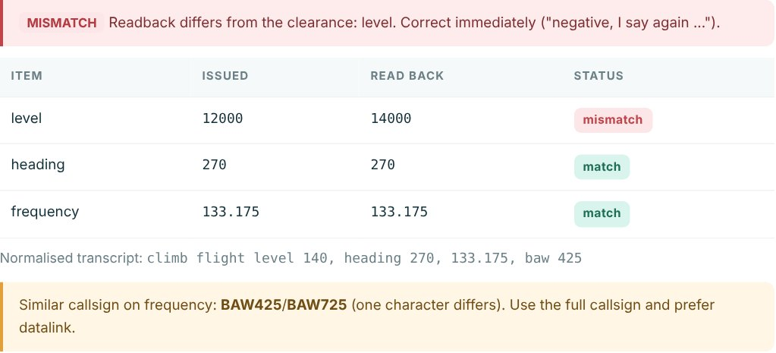
Fig. A.1 Readback Verification Result in the Communication Assistant
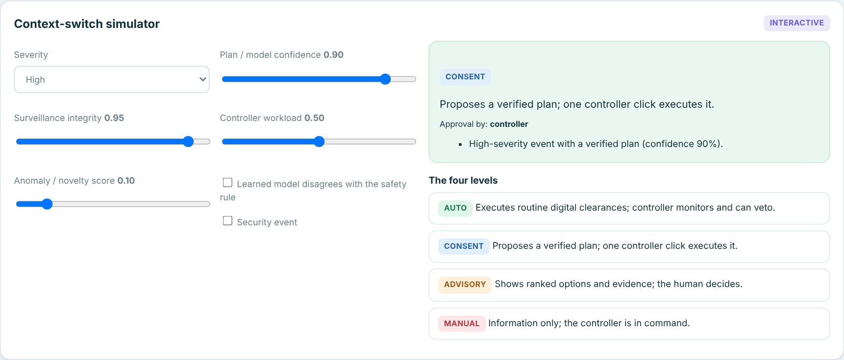
Fig. A.2 Context-Switch Simulator on the AI Models Page
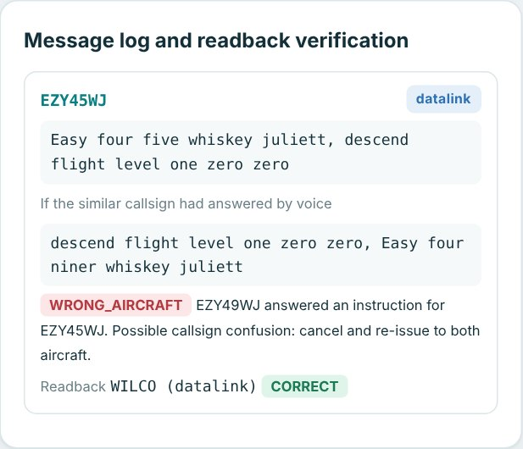
Fig. A.3 Callsign Confusion Scenario: Wrong Aircraft Detected
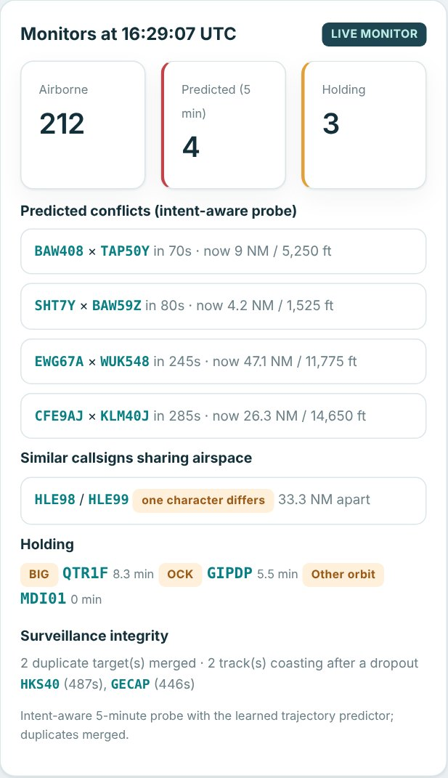
Fig. A.4 Live Monitor of the 3D Airspace at One Moment of the Recording
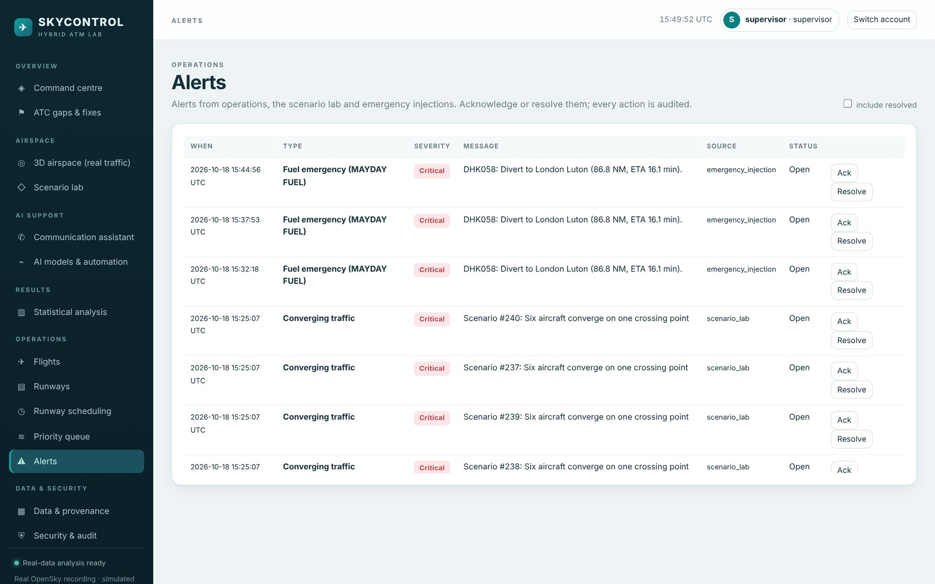
Fig. A.5 Alert Centre
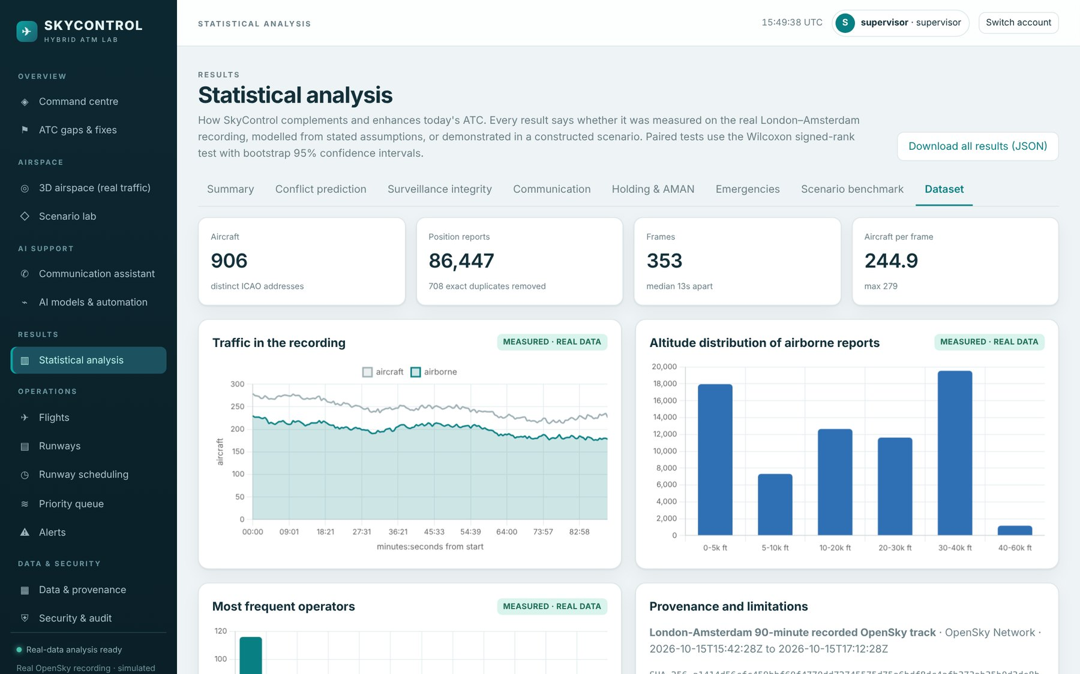
Fig. A.6 Statistical Analysis: Dataset Tab

