Step1.-Chatbot open with a welcome message

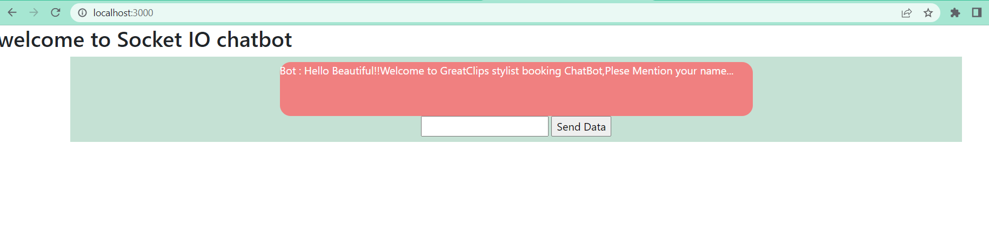

Step2.-We need to provide customer name in the text box and click send Data button

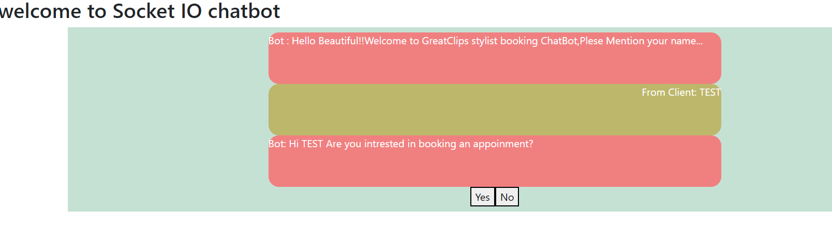

Step3.-The bot will ask the user whether the user want to book an appointment, the user must select the YES/NO by clicking the buttons

Step4.-If the user selects Yes,the bot will asks for the service the user want to select

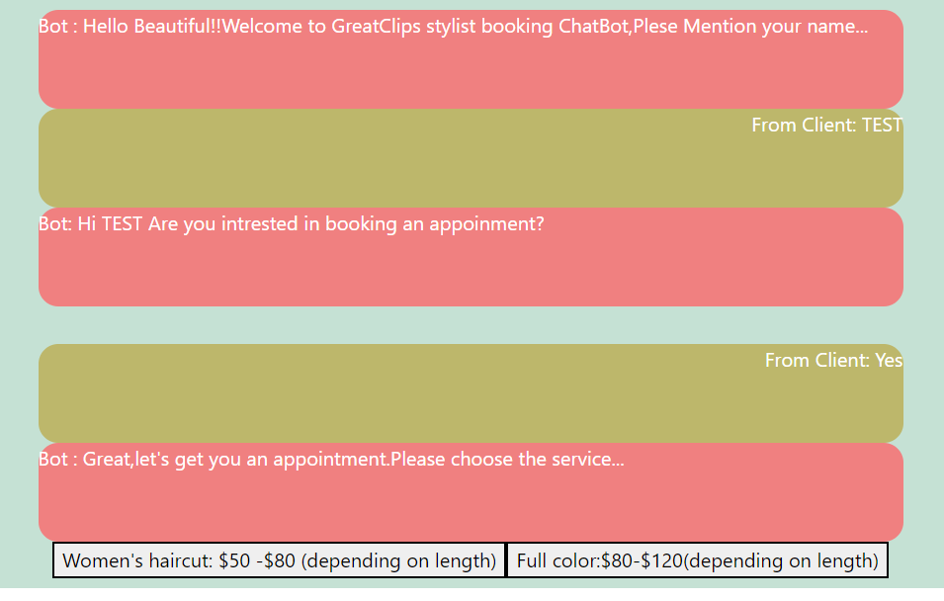

Step5.-The user need to click the services by clicking the buttons,the next bot will asks the user to type the day in the textbox

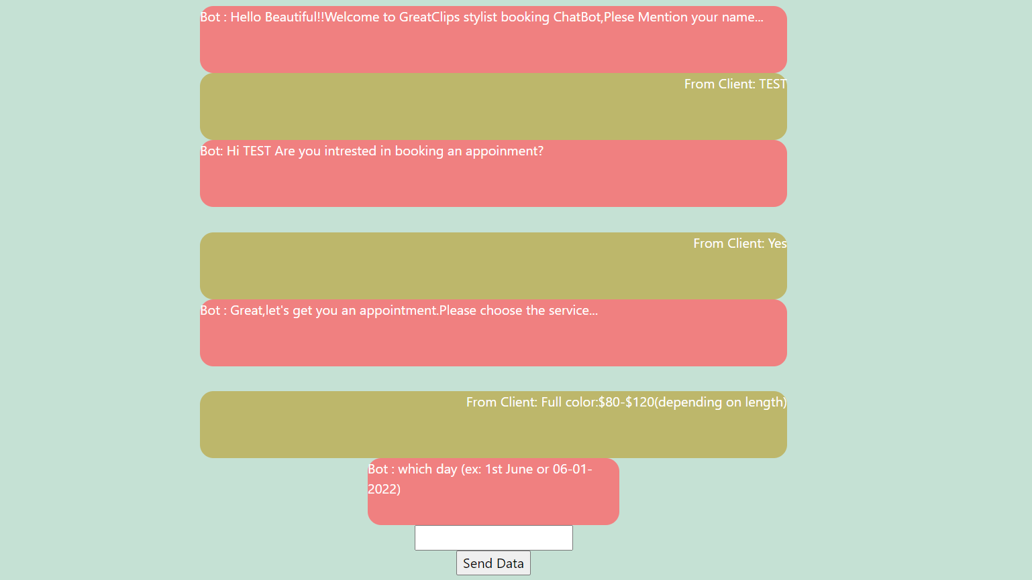

The day should be in any format,no validations added for date checking

Step6.-Next the user need to choose the time by clicking the provided time slots

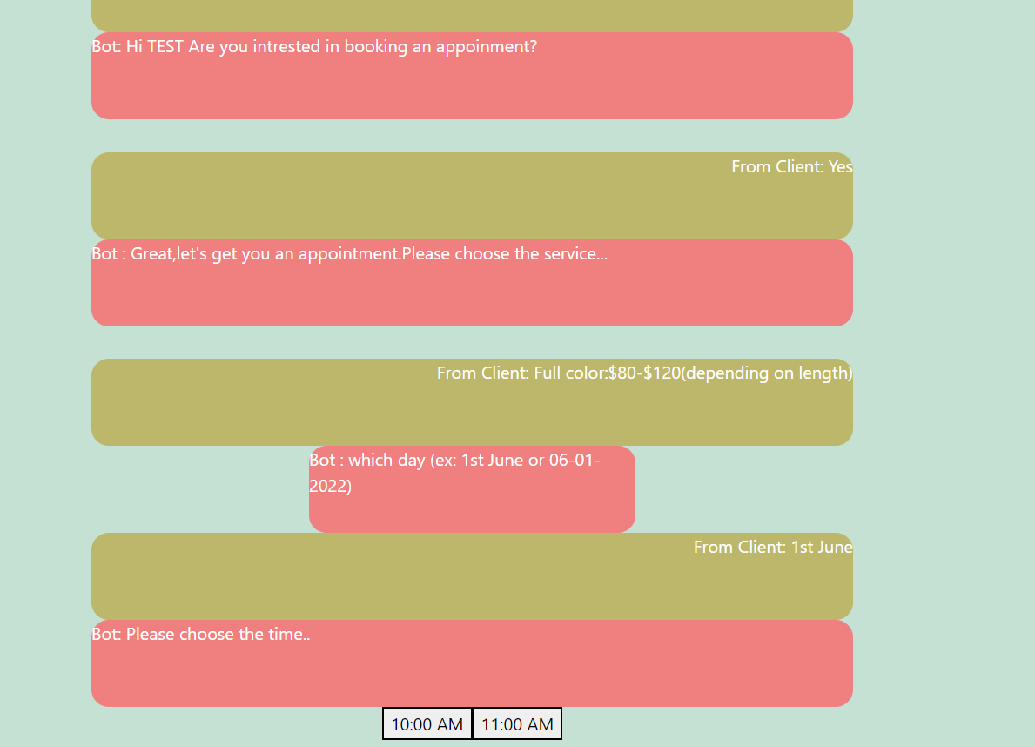

Step7.-Once the time selected the bot will end up the convesrsation and show the Download chat history button to download the chat history

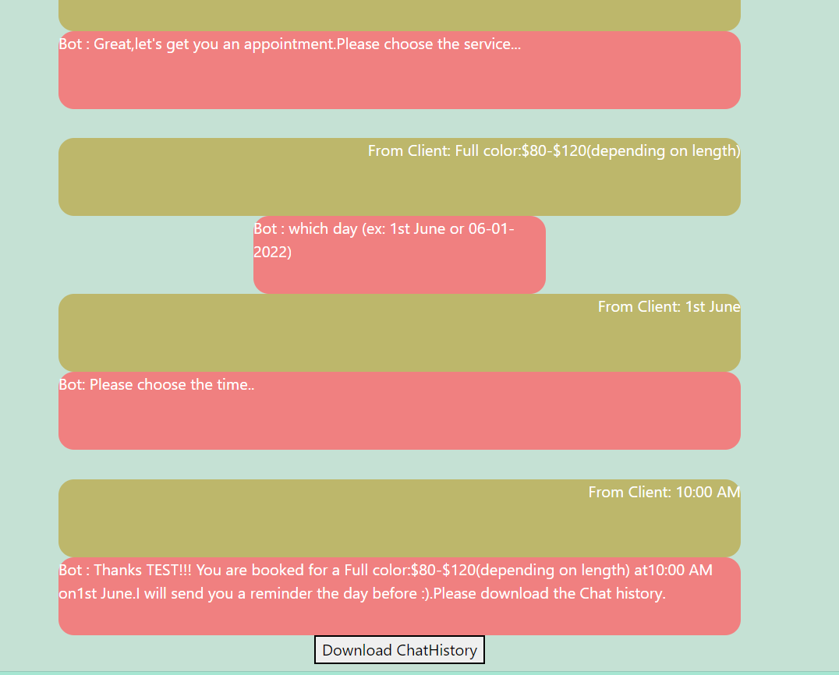

Step8.-Once you click the download chathistory the chat history will be downloaded

Please find the attached example



Step9.-The chat history will also be saved in the mongodb database

