Screenshot 1-Home Page

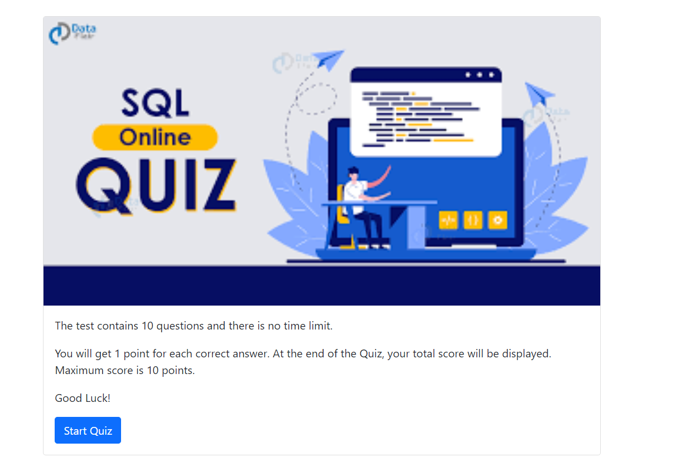

Screenshot 2-Question Page

Question before answering

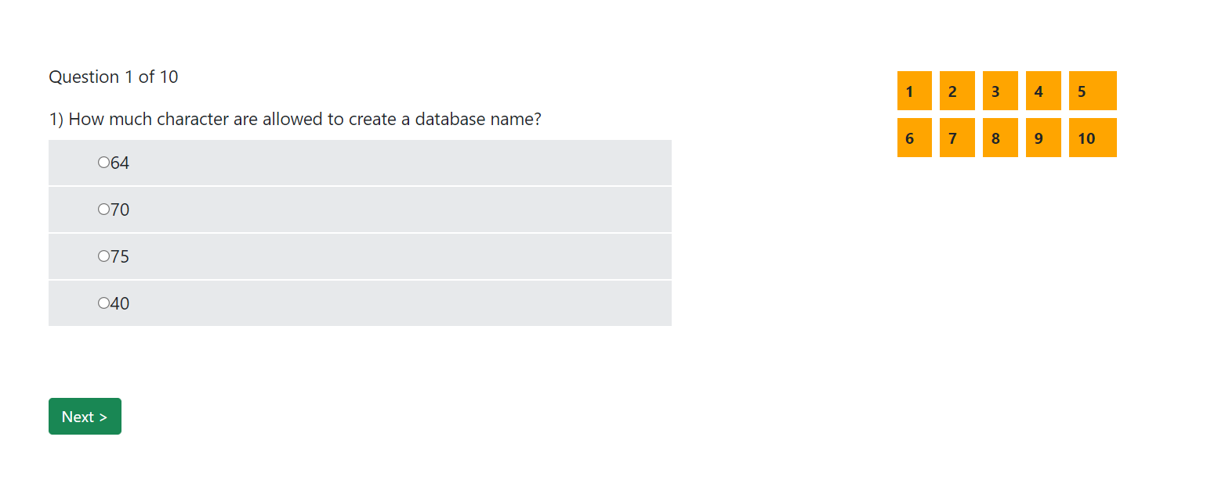

Question after answering

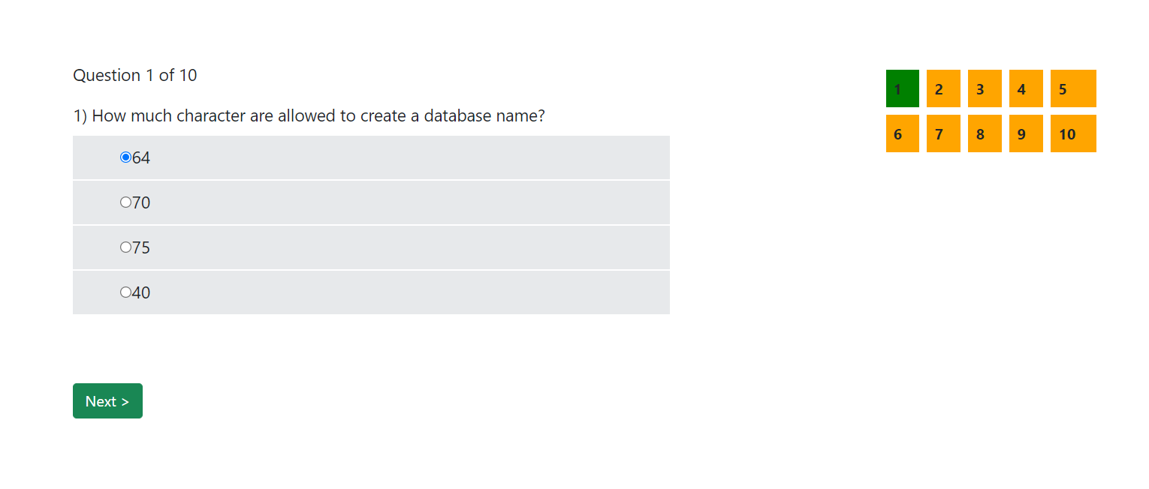

On the Right and side, once the question answered the corresponding question will be marked as green

Validation Message

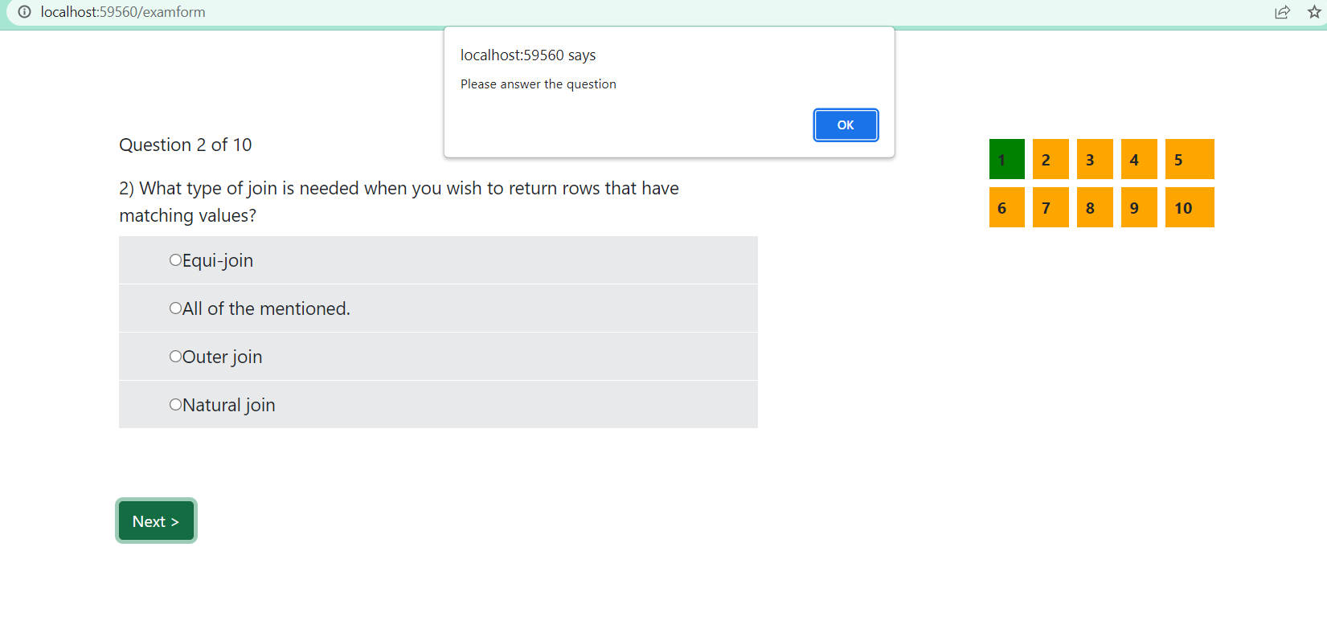

The Alert will be appeared if the user click Next without answering the question

Screenshot 3-Score Message

If you score more than 4 point

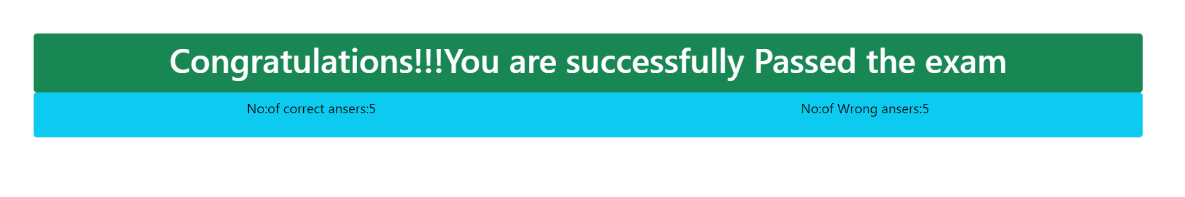

If you score less than or equal to 4 points



Screenshot 4-Discussion forum,Contact and footer

