**LAB -3**

**Bank Database**

**Question**

**(Week 3)**

* Branch (branch-name: String, branch-city: String, assets: real)
* BankAccount(accno: int, branch-name: String, balance: real)
* BankCustomer (customer-name: String, customer-street: String, customer-city: String) Depositer(customer-name: String, accno: int)
* LOAN (loan-number: int, branch-name: String, amount: real)
* Create the above tables by properly specifying the primary keys and the foreign keys. - Enter at least five tuples for each relation.
* Display the branch name and assets from all branches in lakhs of rupees and rename the assets column to 'assets in lakhs'.
* Find all the customers who have at least two accounts at the same branch (ex. SBI_ResidencyRoad).
* Create a view which gives each branch the sum of the amount of all the loans at the branch.

**Schema Diagram**

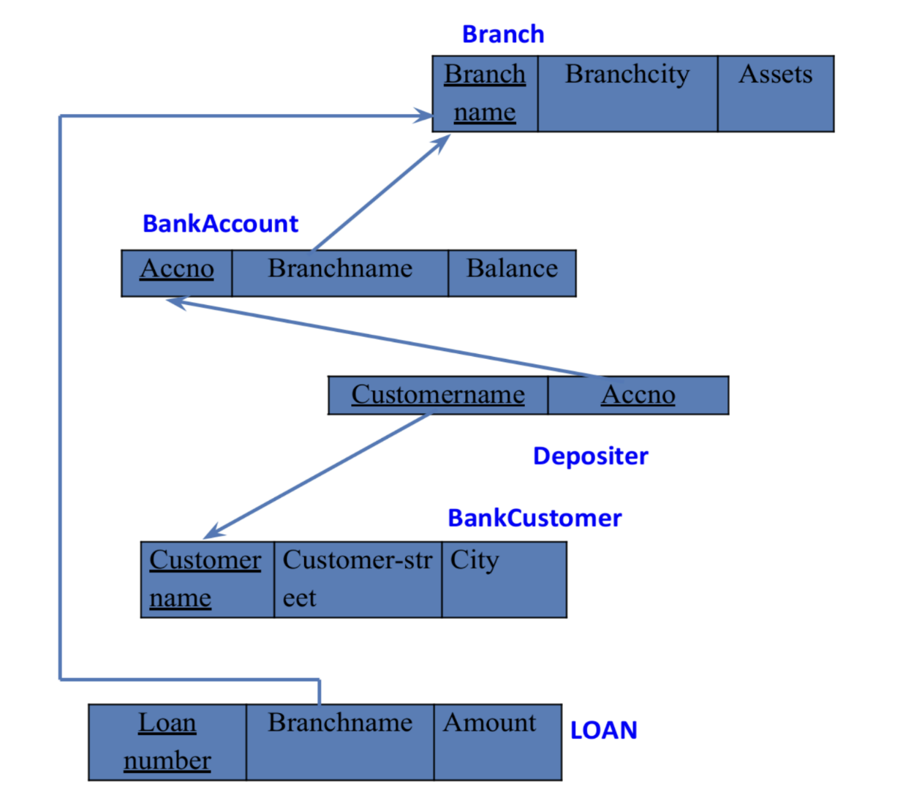

**Create database**

create database bank_101;

USE bank_101;

**Create table**

create table branch_101(

branch_name varchar(20),

branch_city varchar(20),

assets int,

primary key(branch_name));

create table bankacc_101(

accno int,

branch_name varchar(20),

balance int,

primary key(accno),

foreign key(branch_name) references branch_101(branch_name));

create table bankcustomer_101(

customer_name varchar(20),

customer_street varchar(20),

city varchar(20),

primary key(customer_name));

create table depositor_101(

customer_name varchar(20),

accno int,

foreign key(customer_name) references bankcustomer_101(customer_name),

foreign key(accno) references bankacc_101(accno));

create table loan_101(

loan_number int,

branch_name varchar(20),

amount int,

primary key(loan_number),

foreign key (branch_name) references branch_101(branch_name));

**Structure of tables**

desc branch_101;

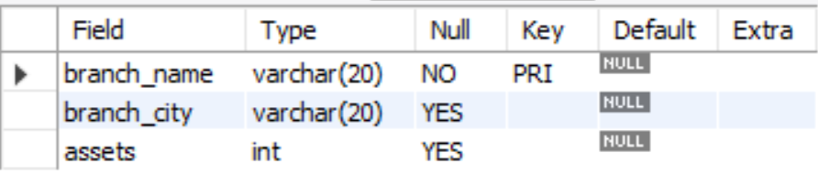

desc bankacc_101;

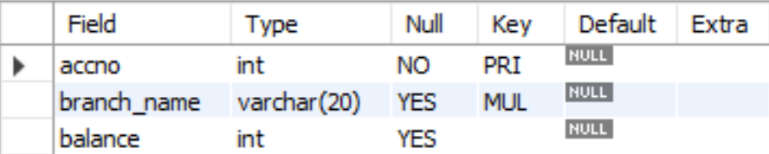

desc bankcustomer_101;

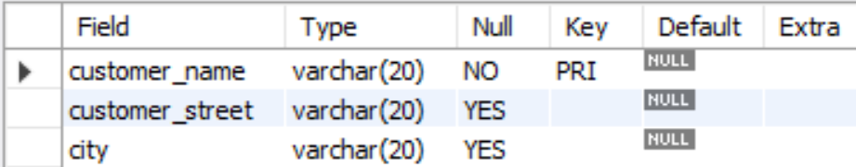

desc depositor_101;

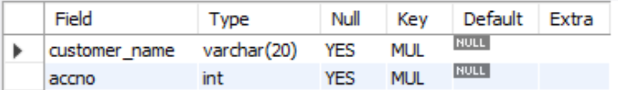 desc loan_101;

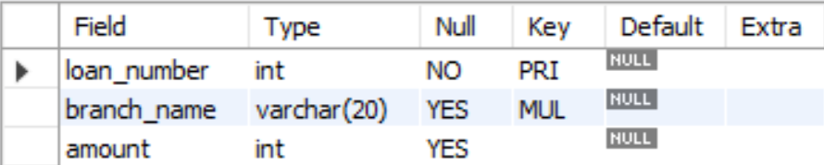

**Inserting Values to the table**

insert into branch_101 values("SBI_Chamarajpet","Bangalore",50000);

insert into branch_101 values("SBI_ResidencyRoad","Bangalore",10000);

insert into branch_101 values("SBI_ShivajiRoad","Bombay",20000);

insert into branch_101 values("SBI_ParliamentRoad","Delhi",10000);

insert into branch_101 values("SBI_Jantarmantar","Delhi",20000);

insert into bankacc_101 values(1,"SBI_Chamarajpet",2000);

insert into bankacc_101 values(2,"SBI_ResidencyRoad",5000);

insert into bankacc_101 values(3,"SBI_ShivajiRoad",6000);

insert into bankacc_101 values(4,"SBI_ParliamentRoad",9000);

insert into bankacc_101 values(5,"SBI_Jantarmantar",8000);

insert into bankacc_101 values(6,"SBI_ShivajiRoad",4000);

insert into bankacc_101 values(8,"SBI_ResidencyRoad",4000);

insert into bankacc_101 values(9,"SBI_ParliamentRoad",3000);

insert into bankacc_101 values(10,"SBI_ResidencyRoad",5000);

insert into bankacc_101 values(11,"SBI_Jantarmantar",2000);

insert into bankcustomer_101 values("Avinash","Bull_temple_road","Bangalore");

insert into bankcustomer_101 values("Dinesh","Bannergatta_Road","Bangalore");

insert into bankcustomer_101 values("Mohan","NationalCollege_Road","Bangalore");

insert into bankcustomer_101 values("Nikil","Akbar_Road","Delhi");

insert into bankcustomer_101 values("Ravi","Prithviraj_Road","Delhi");

insert into depositor_101 values("Avinash",1);

insert into depositor_101 values("Dinesh",2);

insert into depositor_101 values("Nikil",4);

insert into depositor_101 values("Ravi",5);

insert into depositor_101 values("Avinash",8);

insert into depositor_101 values("Nikil",9);

insert into depositor_101 values("Dinesh",10);

insert into depositor_101 values("Nikil",11);

insert into loan_101 values(1,"SBI_Chamarajpet",1000);

insert into loan_101 values(2,"SBI_ResidencyRoad",2000);

insert into loan_101 values(3,"SBI_ShivajiRoad",3000);

insert into loan_101 values(4,"SBI_ParliamentRoad",4000);

insert into loan_101 values(5,"SBI_Jantarmantar",5000);

select * from branch_101;

select * from depositor_101;

select * from loan_101;

select * from bankcustomer_101;

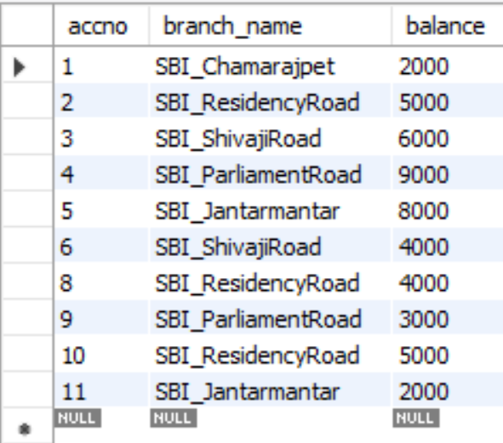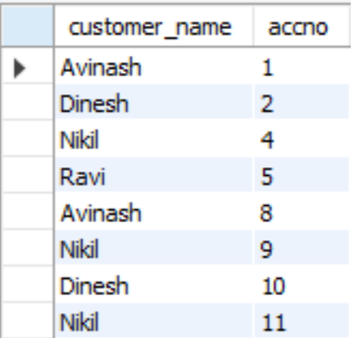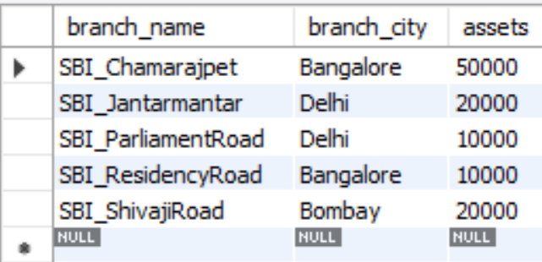select * from bankacc_101;

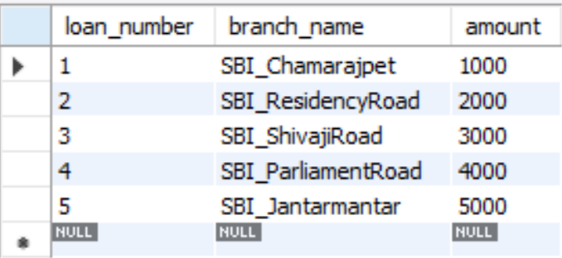

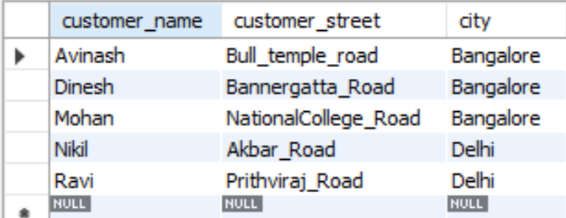

**Queries**

* **Display the branch name and assets from all branches and rename the assets column to 'assets in lakhs'.**

select branch_name,assets/100000 as assets_in_lakhs

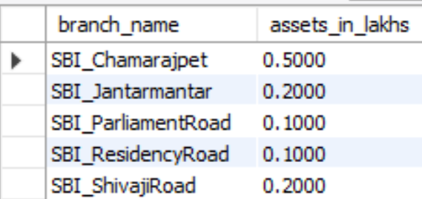from branch_101;

* **Find all the customers who have at least two accounts at the same branch (ex.SBI_ResidencyRoad).**

select customer_name,count(*)

from depositor_101,bankacc_101

where bankacc_101.accno=depositor_101.accno

and branch_name="SBI_ResidencyRoad"

group by customer_name

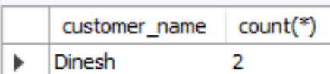having count(*)>1;

* **Create a view which gives each branch the sum of the amount of all the loans at the branch.**

create view loansum as (

select branch_name, sum(amout)

from loans_101

group by branch_name

);

select * from loansum;

