**LAB-4**

**Bank Database**

**Question**

**(Week 4)**

- Branch (branch-name: String, branch-city: String, assets: real)

- BankAccount(accno: int, branch-name: String, balance: real)

- BankCustomer (customer-name: String, customer-street: String, customer-city: String) -Depositer(customer-name: String, accno: int)

- LOAN (loan-number: int, branch-name: String, amount: real)

- Find all the customers who have an account at all the branches located in a specific city (Ex. Delhi).

- Find all customers who have a loan at the bank but do not have an account.

- Find all customers who have both an account and a loan at the Bangalore branch

- Find the names of all branches that have greater assets than all branches located in Bangalore.

- Demonstrate how you delete all account tuples at every branch located in a specific city (Ex. Bombay).

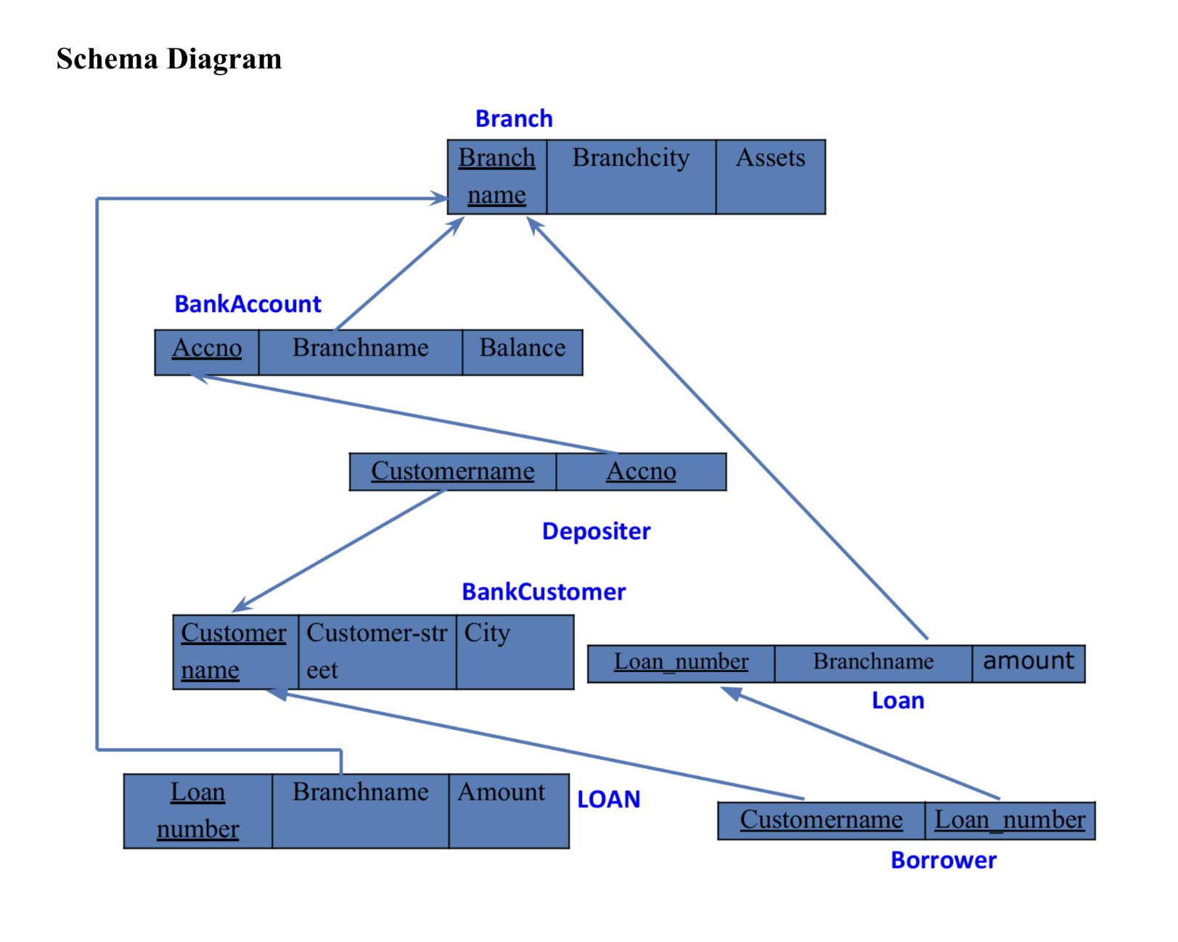- Update the Balance of all accounts by 5%

**Creating Table:**

create table borrower_101(

customer_name varchar(20),

loan_number int,

foreign key(customer_name) references bankcustomer_101(customer_name),

foreign key(loan_number) references loan_101(loan_number)

);

**Inserting values:**

insert into branch_101 values ("SBI_MantriMarg", "Delhi", 200000);

insert into bankacc_101 values (12, "SBI_MantriMarg", 2000);

insert into depositor_101 values("Nikil", 12);

insert into borrower_101 values ("Avinash", 1), ("Dinesh", 2), ("Mohan", 3), ("Nikil", 4), ("Ravi", 5);

**Queries**

**● Find all the customers who have an account at all the branches located in a**

**specific city (Ex. Delhi).**

select customer_name

from bankcustomer_101

where city="Delhi";

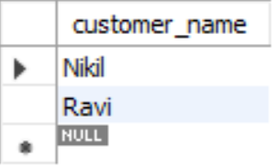

**● Find all customers who have a loan at the bank but do not have an account.**

select customer_name, loan_101.loan_number

from (borrower_101 right outer join loan_101

on loan_101.loan_number = borrower_101.loan_number)

where customer_name not in (select customer_name

from depositor_101, bankacc_101 where depositor_101.accno = bankacc_101.accno

group by customer_name, branch_name);

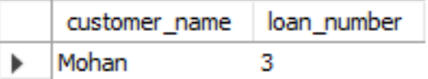

* **Find all customers who have both an account and a loan at the Bangalore**

**branch.**

select distinct customer_name from depositor_101

where customer_name in (select depositor_101.customer_name from branch_101,

bankacc_101, depositor_101

where branch_101.branch_city = "Bangalore" and branch_101.branch_name =

bankacc_101.branch_name and bankacc_101.accno = depositor_101.accno) and

customer_name in (select customer_name from borrower_101, loan_101 where branch_name in

(select branch_name from branch_101 where branch_city = "Bangalore"));

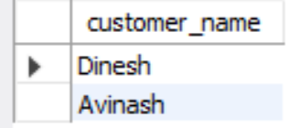

* **Find the names of all branches that have greater assets than all branches located in Bangalore.**

select branch_name from branch_101

where assets > all(select assets

from branch_101 where branch_city = "Bangalore");

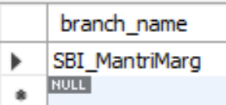

* **Update the Balance of all accounts by 5%**

update bankacc_101 set balance = 1.05*balance;

* **Demonstrate how you delete all account tuples at every branch located in a**

**specific city (Ex. Bombay).**

delete from bankacc_101

where branch_name in (select branch_name

from branch_101

where branch_city = "Bombay");