**LAB-5**

**Employee Database**

**Question**

**(Week 5)**

1. Using Scheme diagram, Create tables by properly specifying the primary keys and the foreign keys.
2. Enter greater than five tuples for each table.
3. Retrieve the employee numbers of all employees who work on project located in Bengaluru, Hyderabad, or Mysuru
4. Get Employee ID’s of those employees who didn’t receive incentives
5. Write a SQL query to find the employees name, number, dept, job_role, department location and project location who are working for a project location same as his/her department location.

**Schema Diagram**

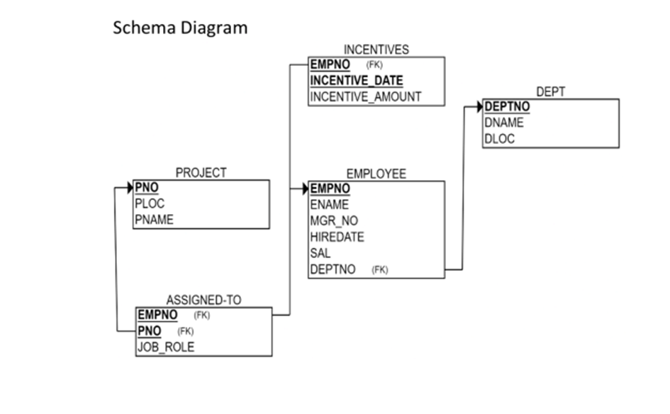

**Create database**

create database employee_database_101;

use employee_database_101;

**Create table**

create table project_101(

pno int primary key,

ploc varchar(20),

pname varchar(20));

create table dept_101(

deptno int primary key,

dname varchar(30),

dloc varchar(20));

create table employee_101(

empno int primary key,

ename varchar(20),

mgr_no int,

hiredate date,

sal double,

deptno int,

foreign key(deptno) references dept_101(deptno));

create table assigned_to_101(

empno int primary key,

pno int,

job_role varchar(20),

foreign key(empno) references employee_101(empno),

foreign key(pno) references project_101(pno));

create table incentives_101(

empno int,

incentive_date date primary key,

incentive_amount double,

foreign key(empno) references employee_101(empno));

**Structure of the table**

desc project_101;

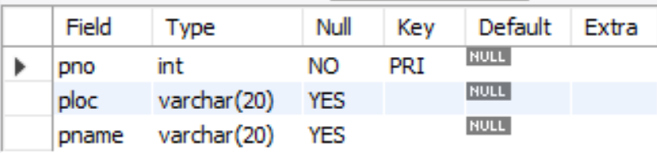desc dept_101;

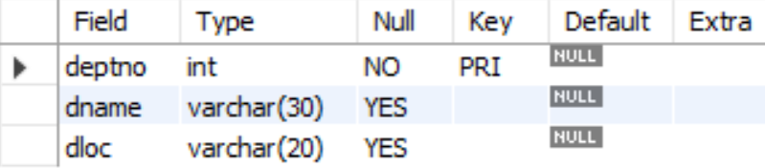

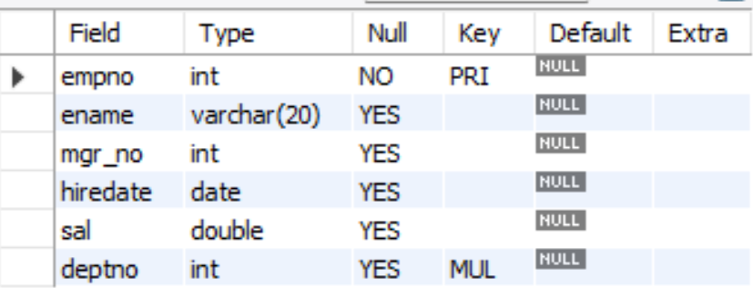desc employee_101;

desc assigned_to_101;

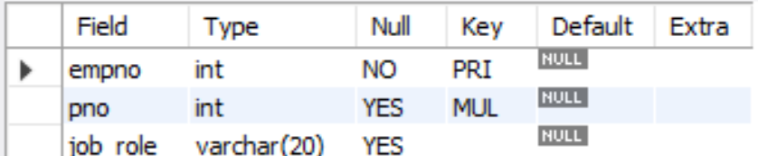

desc incentives_101;

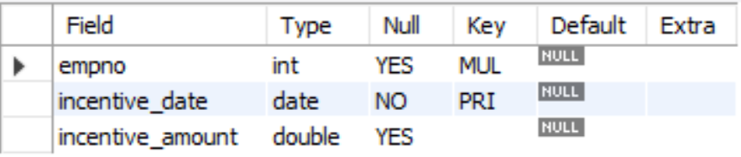

**Inserting Values to the table**

insert into project_101 values (1,"bengaluru","abcd"), (2,"hyderabad","bcda"), (3,"bengaluru","abab"), (4,"bengaluru","baba"), (5,"hyderabad","cdcd"), (6, "mysuru","efef");

select * from project_101;

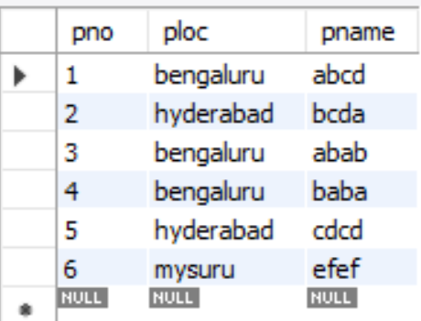

insert into dept_101 values (1,"cse","bengaluru"), (2,"ise","hyderabad"), (3,"ece","bengaluru"), (4,"ete","hyderabad"), (5,"ime","bengaluru"), (6, "mech", "mysuru");

select * from dept_101;

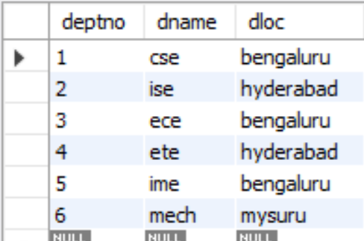

insert into employee_101 values (1,"a",null,"2023-11-9",70000,1), (2,"b",2,"2023-8-9",70000,1), (3,"c",3,"2023-6-8",70000,2), (4,"d",null,"2023-8-6",70000,2), (5,"e",null,"2023-5-4",70000,3), (6, "f", null, "2023-6-1", 90000, 6);

select * from employee_101;

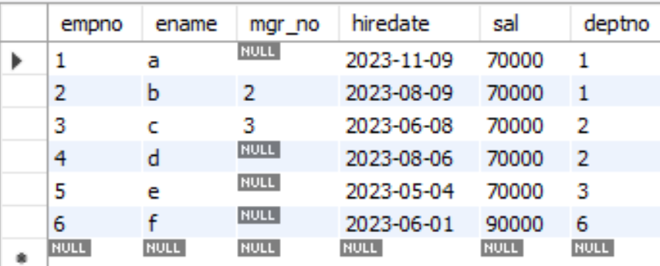

insert into incentives_101 values (1,"2023-12-9",10000), (2,"2023-8-9",10000),

(3,"2023-6-8",10000), (4,"2023-5-4",10000), (5,"2023-12-8",10000);

select * from incentives_101;

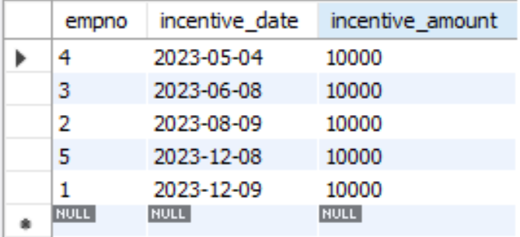

insert into assigned_to_101 values (1,1, "employee"), (2,1, "manager"), (3,2, "manager"),

(4,3, "employee"), (5,4, "employee"), (6, 6, "employee");

select * from assigned_to_101;

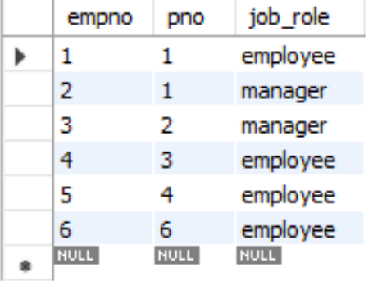

**Queries**

● **Retrieve the employee numbers of all employees who work on project located in Bengaluru, Hyderabad, or Mysuru**.

select assigned_to_101.empno

from assigned_to_101, project_101

where assigned_to_101.pno = project_101.pno and project_101.ploc in ("bengaluru", "mysuru", "hyderabad");

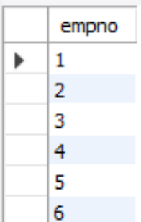

● **Get Employee ID’s of those employees who didn’t receive incentives**

select empno

from employee_101

where empno not in (select empno from incentives_101);

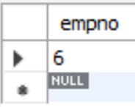

● **Write a SQL query to find the employees name, number, dept, job_role, department location and project location who are working for a project location same as his/her department location.**

select employee_101.empno, ename, dname, job_role, dloc, ploc

from employee_101, assigned_to_101, project_101, dept_101

where ploc = dloc and assigned_to_101.empno = employee_101.empno and employee_101.deptno = dept_101.deptno and project_101.pno = assigned_to_101.pno;

