**LAB-6**

**Employee Database**

**Question (Week 6)**

1. Using Scheme diagram, Create tables by properly specifying the primary keys and the foreign keys.
2. Enter greater than five tuples for each table.
3. List the name of the managers with the maximum employees
4. Display those managers name whose salary is more than average salary of his employee.
5. Find the name of the second top level managers of each department.
6. Find the employee details who got the second maximum incentive in January 2019.
7. Display those employees who are working in the same department where his the manager is working.

**Schema Diagram**

**Queries**

* **List the name of the managers with the maximum employees**

select e1.ename

from employee_101 e1, employee_101 e2

where e1.empno=e2.mgr_no group by e1.ename

having count(e1.mgr_no)=(select count(e1.ename)

from employee_101 e1, employee_101 e2 where e1.empno=e2.mgr_no

group by e1.ename order by count(e1.ename) desc limit 1);

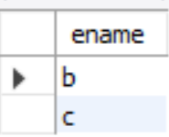

● **Display those managers name whose salary is more than average salary of his employee**

select m.ename from employee_101 m

where m.empno in

(select mgr_no from employee_101)

and m.sal>(select avg(n.sal) from employee_101 n

where n.mgr_no=m.empno);



**● Find the employee details who got second maximum incentive in January 2019.**

select * from employee_101 where empno=

(select i.empno from incentives_101 i

where i.incentive_amount= (select max(n.incentive_amount) from incentives_101 n

where n.incentive_amount < (select max(inc.incentive_amount) from incentives_101 inc

where inc.incentive_date between 2023-01-01 and 2023-12-31 and incentive_date between 2023-01-01 and 2023-12-31)));

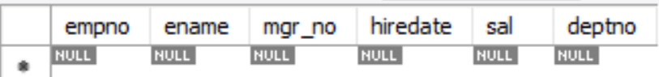

● **Display those employees who are working in the same department where his manager is working.**

select e2.ename

from employee_204 e1, employee_101 e2

where e1.empno=e2.mgr_no and e1.deptno=e2.deptno;

