**LAB-7**

**NoSQL Lab 1**

**Question**

**(Week 8)**

Perform the following DB operations using MongoDB.

1. Create a database “Student” with the following attributes Rollno, Age,

ContactNo, Email-Id.

2. Insert appropriate values

3. Write query to update Email-Id of a student with rollno 10.

4. Replace the student name from “ABC” to “FEM” of rollno 11.

5. Drop the table

**Create database**

db.createCollection("Student");

**Create table & Inserting Values to the table**

db.Student.insert({RollNo:1,Age:21,Cont:9876,email:"antara.de9@gmail.com"});

db.Student.insert({RollNo:2,Age:22,Cont:9976,email:"anushka.de9@gmail.com"});

db.Student.insert({RollNo:3,Age:21,Cont:5576,email:"anubhav.de9@gmail.com"});

db.Student.insert({RollNo:4,Age:20,Cont:4476,email:"pani.de9@gmail.com"});

db.Student.insert({RollNo:10,Age:23,Cont:2276,email:"rekha.de9@gmail.com"});

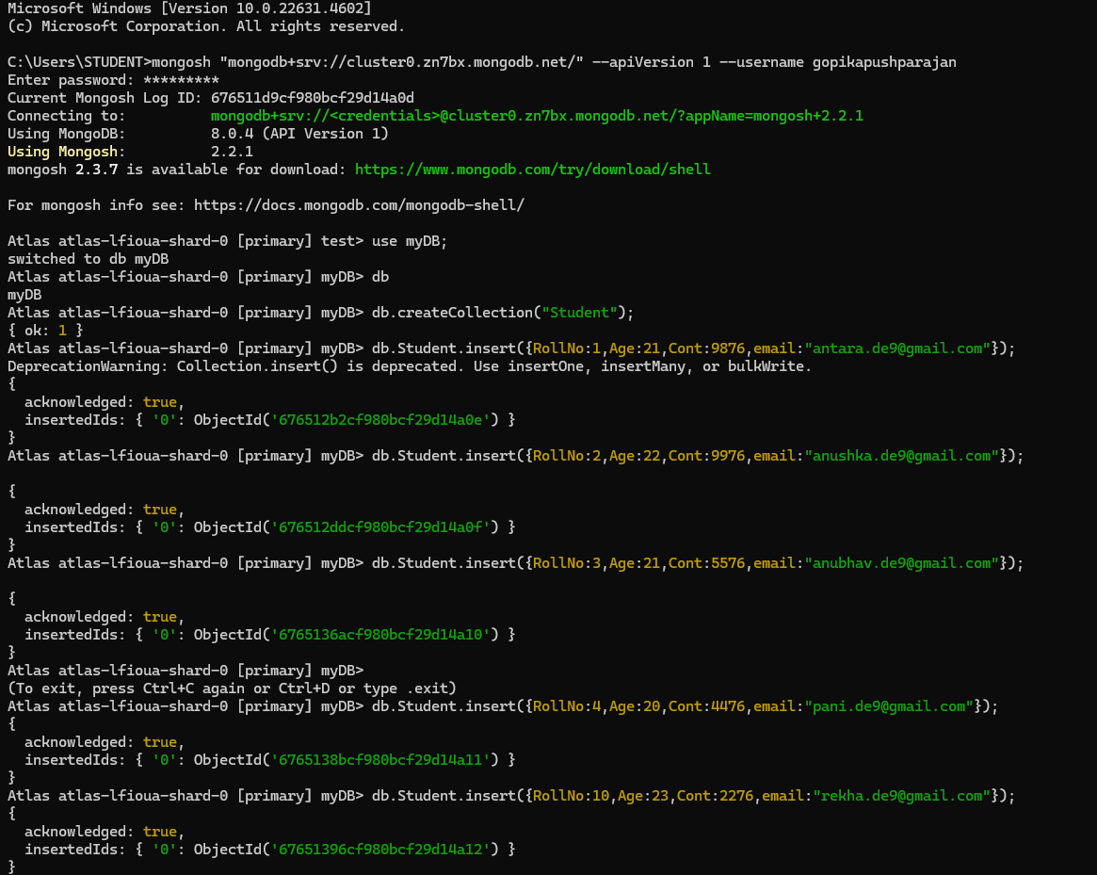

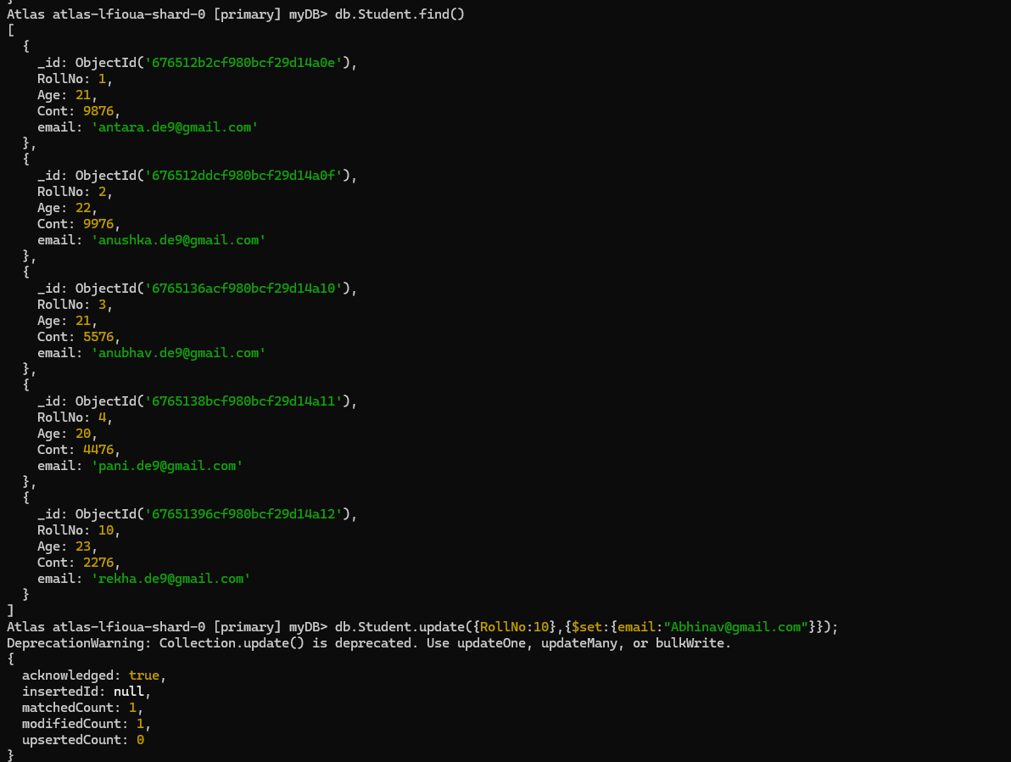db.Student.find();

**Queries**

**● Write a query to update the Email-Id of a student with rollno 5.**

db.Student.update({rollno:5},{$set:{email:"abhinav@gmail.com"}});



**● Replace the student name from “ABC” to “FEM” of rollno 11.**

db.Student.insert({rollno:11,age:22,name:"ABC",cont:2276,email:"madhura@gmail.com"});

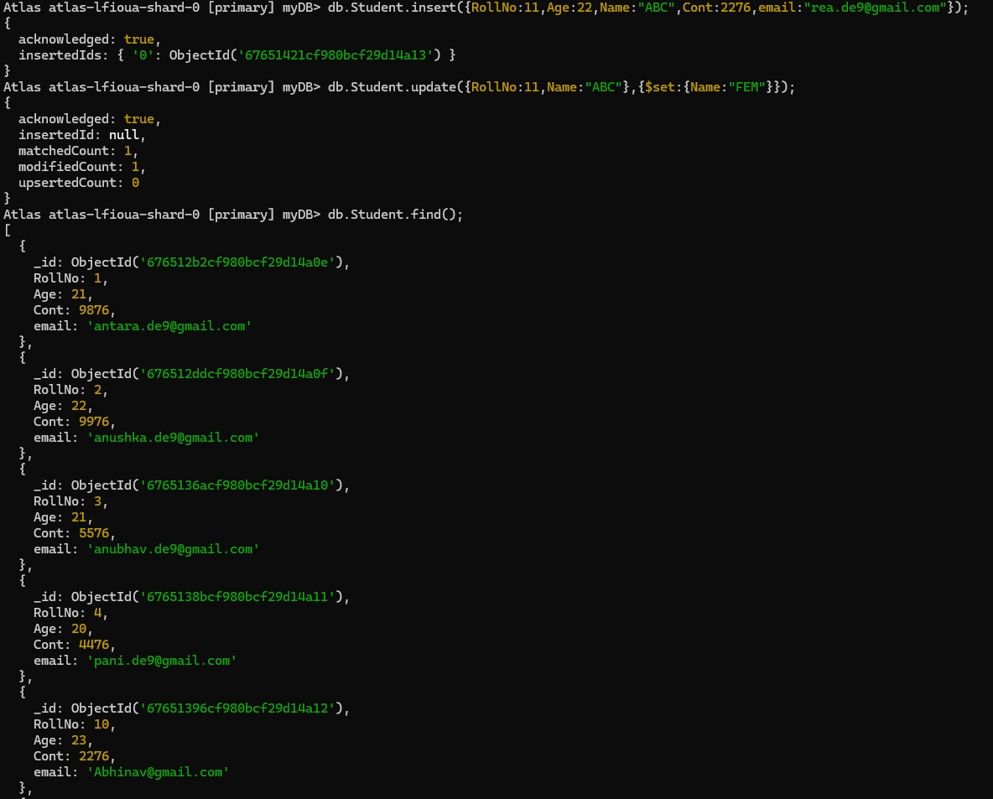db.Student.update({rollno:11,name:"ABC"},{$set:{name:"FEM"}})

**● Drop the table**

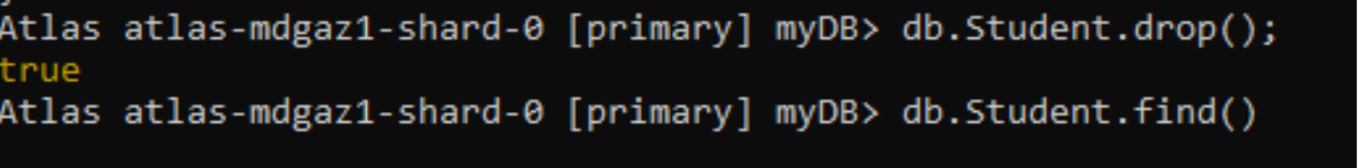db.Student.drop();