**LAB-8**

**NoSQL Lab 2**

**Question**

**(Week 9)**

Perform the following DB operations using MongoDB.

1. Create a collection by name Customers with the following attributes.

Cust_id, Acc_Bal, Acc_Type

2. Insert at least 5 values into the table

3. Write a query to display those records whose total account balance

is greater than 1200 of account type ‘Checking’ for each customer_id.

4. Determine Minimum and Maximum account balance for each

customer_id.

5. Drop the table

**Create Table:**

db.createCollection("Customer");



**Inserting Values:**

db.Customer.insertMany([{custid: 1, acc_bal:10000, acc_type: "Saving"}, {custid: 1, acc_bal:20000,

acc_type: "Checking"}, {custid: 3, acc_bal:50000, acc_type: "Checking"}, {custid: 4, acc_bal:10000,

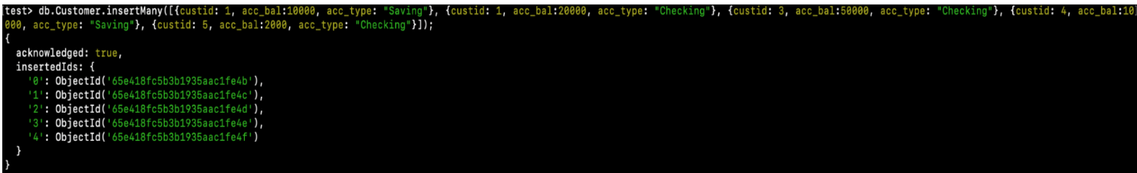acc_type: "Saving"}, {custid: 5, acc_bal:2000, acc_type: "Checking"}]);

**Queries:**

**● Finding all checking accounts with balance greater than 12000**

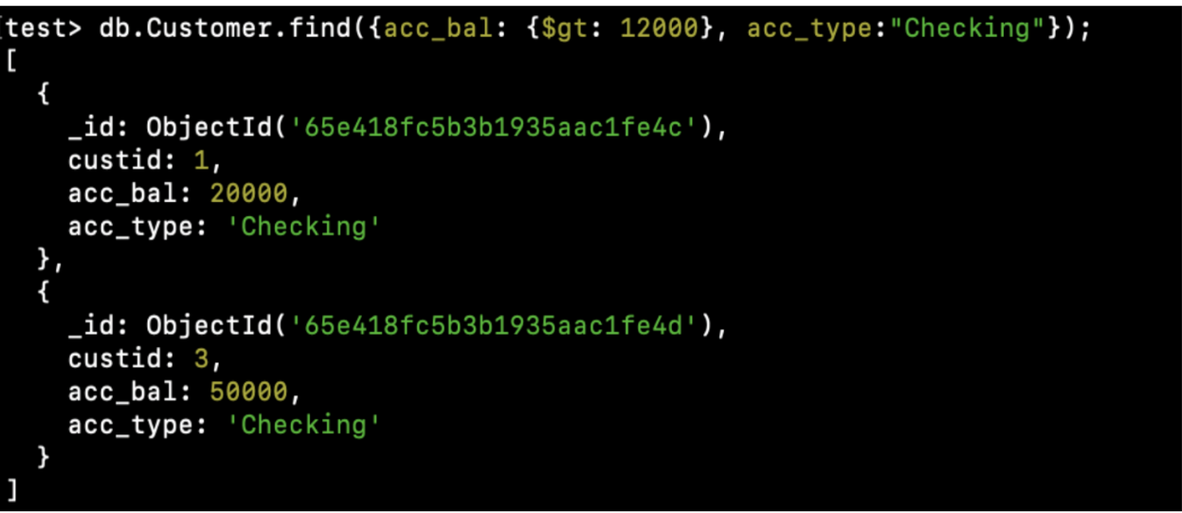db.Customer.find({acc_bal: {$gt: 12000}, acc_type:"Checking"});

**● Finding the maximum and minimum balance of each customer**

db.Customer.aggregate([{$group:{_id:"$custid", minBal:{$min:"$acc_bal"}, maxBal:

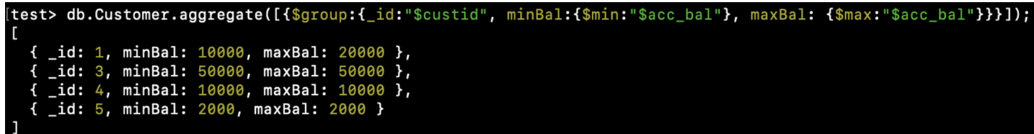{$max:"$acc_bal"}}}]);

**● Dropping collection “Customer”**

db.Customer.drop();