**LAB-1**

**Insurance Database**

**Question**

**(Week 1)**

**-** PERSON (driver_id: String, name: String, address: String)

**-** CAR (reg_num: String, model: String, year: int)

**-** ACCIDENT (report_num: int, accident_date: date, location: String)

**-** OWNS (driver_id: String, reg_num: String)

**-** PARTICIPATED (driver_id: String,reg_num: String, report_num: int, damage_amount: int)

**-** Create the above tables by properly specifying the primary keys and the foreign keys. **-** Enter at least five tuples for each relation

**-** Display Accident date and location

**-** Update the damage amount to 25000 for the car with a specific reg_num (example 'K A053408' ) for which the accident report number was 12.

**-** Add a new accident to the database.

**-** To Do

**-** Display Accident date and location

**-** Display driver id who did accident with damage amount greater than or equal to Rs.25000

**Schema Diagram**

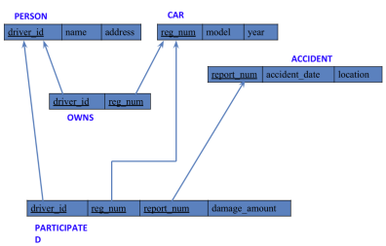**Create database**

create database insurance_101;

use insurance_101;

**Create table**

create table person_101(

driver_id varchar(20),

name varchar (30),

address varchar(50),

primary key(driver_id)

);

create table car_101(

reg_num varchar(10),

model varchar(15),

year int,

primary key(reg_num)

);

create table owns_101(

driver_id varchar(20),

reg_num varchar(10),

primary key(driver_id,reg_num),

foreign key(driver_id) references person_101(driver_id),

foreign key(reg_num) references car_101(reg_num)

);

create table accident_101(

report_num int,

accident_date date,

location varchar(50),

primary key(report_num)

);

create table participitated_101(

driver_id varchar(20),

reg_num varchar(10),

report_num int,

damage_amount int,

primary key(driver_id,reg_num,report_num),

foreign key(driver_id) references person_101(driver_id),

foreign key(reg_num) references car_101(reg_num),

foreign key(report_num) references accident_101(report_num)

);

**Structure of the table**

desc person_101;

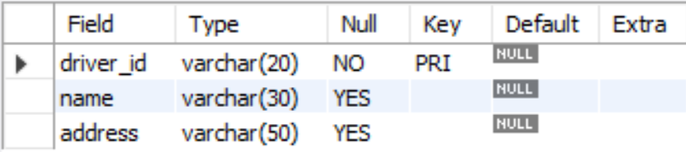

desc accident_101;

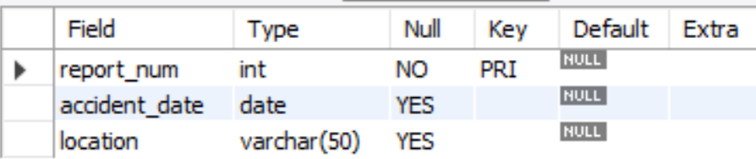

desc participitated_101;

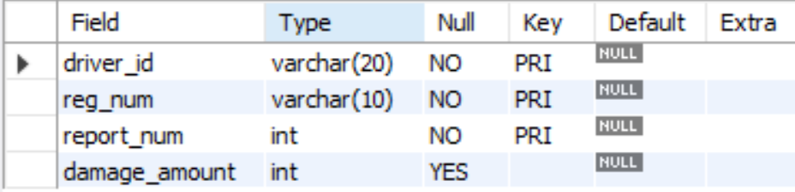

desc car_101;

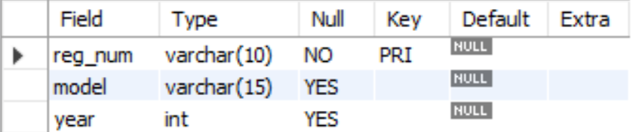

desc owns_101;

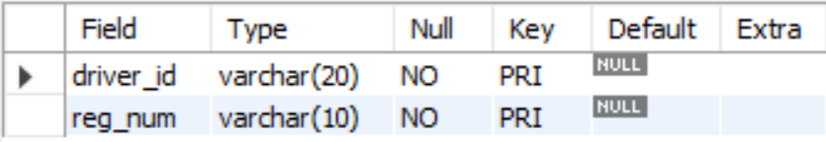

**Inserting Values to the table**

insert into person_101 values("A01","Richard","Srinivas nagar");

insert into person_101 values("A02","Pradeep","Rajaji nagar");

insert into person_101 values("A03","Smith","Ashok nagar");

insert into person_101 values("A04","Venu","N R Colony");

insert into person_101 values("A05","John","Hanumanth nagar");

select * from person_101;

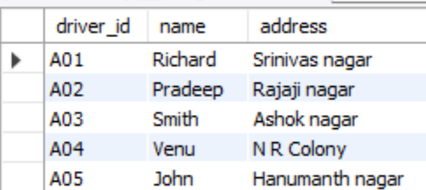

insert into car_101 values("KA052250","Indica",1990);

insert into car_101 values("KA031181","Lancer",1957);

insert into car_101 values("KA095477","Toyota",1998);

insert into car_101 values("KA053408","Honda",2008);

insert into car_101 values("KA041702","Audi",2005);

select * from car_101;

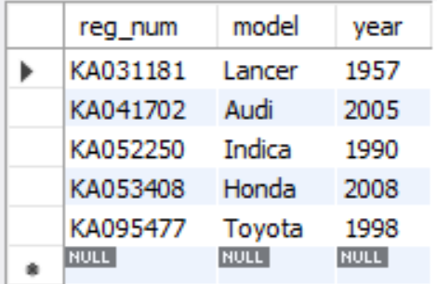

insert into owns_101 values("A01","KA052250");

insert into owns_101 values("A02","KA031181");

insert into owns_101 values("A03","KA095477");

insert into owns_101 values("A04","KA053408");

insert into owns_101 values("A05","KA041702");

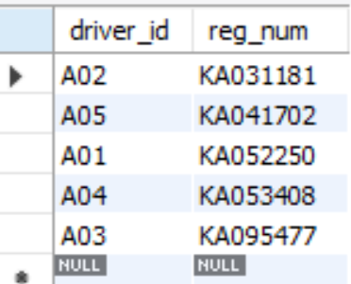

insert into accident_101 values(11,"2003-01-01","MysoreRoad");

insert into accident_101 values(12,"2004-02-02","SouthEndCircle");

insert into accident_101 values(13,"2003-01-21","BullTempleRoad");

insert into accident_101 values(14,"2008-02-17","MysoreRoad");

insert into accident_101 values(15,"2003-01-01","KanakpuraRoad");

select * from accident_101;

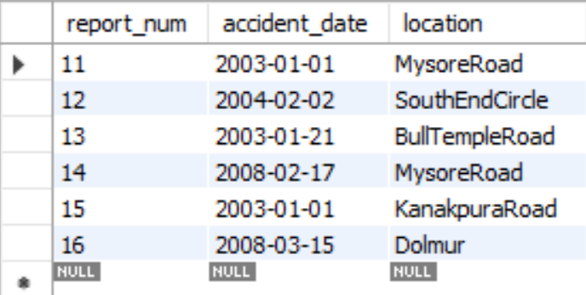

insert into participitated_101 values("A01","KA052250",11,10000);

insert into participitated_101 values("A02","KA031181",12,50000);

insert into participitated_101 values("A03","KA095477",13,25000);

insert into participitated_101 values("A04","KA053408",14,3000);

insert into participitated_101 values("A05","KA041702",15,5000);

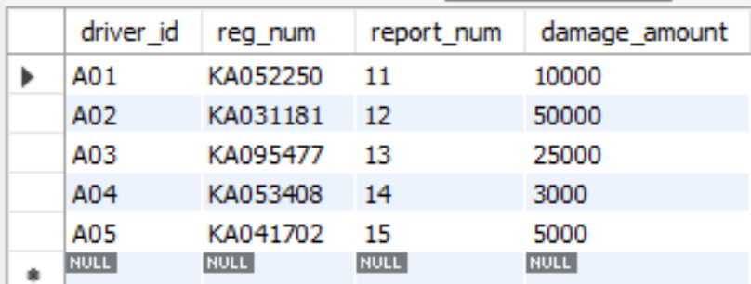select * from participitated_101;

**Queries**

**Update the damage amount to 25000 for the car with a specific reg-num (example 'KA053408' ) for which the accident report number was 12.**

update participitated_101

set damage_amount=25000

where reg_num='KA031181' and report_num=12;

commit;

select * from participitated_101;

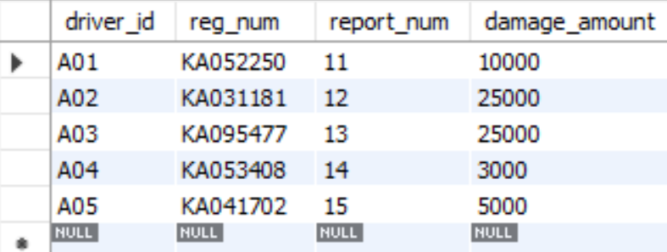

**Find the total number of people who owned cars that were involved in accidents in 2008.**

select count(distinct driver_id) CNT

from participitated_101, accident_101

where participitated_101.report_num=accident_101.report_num and accident_101.accident_date like

'__08%';

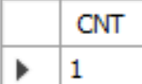

**Add a new accident to the database.**

insert into accident values(16,'2008-03-08',"Domlur");

select * from accident_101;

**TO DO:**

**● Display accident date and location**

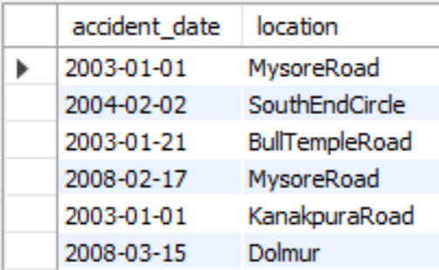

**● Display driver id who did accident with damage amount greater than or equal to Rs.25000**

select driver_id

from participitated_101

where damage_amount>=25000;

