QN1. <?xml version="1.0" encoding="utf-8"?>
<android.support.constraint.ConstraintLayout xmlns:android="http://schemas.android.com/apk/res/android"
xmlns:app="http://schemas.android.com/apk/res-auto"
xmlns:tools="http://schemas.android.com/tools"
android:layout_width="match_parent"
android:layout_height="match_parent"
tools:context=".MainActivity">
<EditText
android:id="@+id/ed1"
android:layout_width="wrap_content"
android:layout_height="wrap_content"
android:layout_marginStart="62dp"
android:layout_marginLeft="62dp"
android:layout_marginTop="16dp"
android:layout_marginEnd="95dp"
android:layout_marginRight="95dp"
android:ems="10"
android:hint="first_no"
android:inputType="textPersonName"
app:layout_constraintEnd_toEndOf="parent"
app:layout_constraintStart_toStartOf="parent"
app:layout_constraintTop_toTopOf="parent" />
<EditText
android:id="@+id/ed2"
android:layout_width="wrap_content"
android:layout_height="wrap_content"
android:layout_marginStart="68dp"
android:layout_marginLeft="68dp"
android:layout_marginTop="20dp"
android:layout_marginEnd="101dp"
android:layout_marginRight="101dp"
android:ems="10"
android:hint="second_no"
android:inputType="textPersonName"
app:layout_constraintEnd_toEndOf="parent"
app:layout_constraintStart_toStartOf="parent"
app:layout_constraintTop_toBottomOf="@+id/ed1" />
<Button
android:id="@+id/b1"
android:layout_width="wrap_content"
android:layout_height="wrap_content"
android:layout_marginStart="122dp"
android:layout_marginLeft="122dp"
android:layout_marginTop="21dp"
android:layout_marginEnd="174dp"
android:layout_marginRight="174dp"
android:text="Add"
android:onClick="add"
app:layout_constraintEnd_toEndOf="parent"
app:layout_constraintStart_toStartOf="parent"
app:layout_constraintTop_toBottomOf="@+id/ed2" />
<Button
android:id="@+id/button2"
android:layout_width="wrap_content"
android:layout_height="wrap_content"
android:layout_marginStart="122dp"
android:layout_marginLeft="122dp"
android:layout_marginTop="11dp"
android:layout_marginEnd="174dp"
android:layout_marginRight="174dp"
android:text="sub"
android:onClick="Sub"
app:layout_constraintEnd_toEndOf="parent"
app:layout_constraintStart_toStartOf="parent"
app:layout_constraintTop_toBottomOf="@+id/b1" />
<Button
android:id="@+id/button3"
android:layout_width="wrap_content"
android:layout_height="wrap_content"
android:layout_marginStart="122dp"
android:layout_marginLeft="122dp"
android:layout_marginTop="16dp"
android:layout_marginEnd="174dp"
android:layout_marginRight="174dp"
android:text="mul"
android:onClick="Mul"
app:layout_constraintEnd_toEndOf="parent"
app:layout_constraintStart_toStartOf="parent"
app:layout_constraintTop_toBottomOf="@+id/button2" />
<Button
android:id="@+id/button4"
android:layout_width="wrap_content"
android:layout_height="wrap_content"
android:layout_marginStart="122dp"
android:layout_marginLeft="122dp"
android:layout_marginTop="16dp"
android:layout_marginEnd="174dp"
android:layout_marginRight="174dp"
android:text="div"
android:onClick="Div"
app:layout_constraintEnd_toEndOf="parent"
app:layout_constraintStart_toStartOf="parent"
app:layout_constraintTop_toBottomOf="@+id/button3" />
<TextView
android:id="@+id/tv"
android:layout_width="wrap_content"
android:layout_height="wrap_content"
android:layout_marginStart="139dp"
android:layout_marginLeft="139dp"
android:layout_marginTop="28dp"
android:layout_marginEnd="183dp"
android:layout_marginRight="183dp"
android:text="result"
app:layout_constraintEnd_toEndOf="parent"
app:layout_constraintStart_toStartOf="parent"
app:layout_constraintTop_toBottomOf="@+id/button4" />
</android.support.constraint.ConstraintLayout>
Java code:
package com.example.sjcet.calculatorexam1;
import android.support.v7.app.AppCompatActivity;
import android.os.Bundle;
import android.view.View;
import android.widget.EditText;
import android.widget.TextView;
public class MainActivity extends AppCompatActivity {
EditText num1;
EditText num2;
int ed1,ed2;
TextView tv;
@Override
protected void onCreate(Bundle savedInstanceState) {
super.onCreate(savedInstanceState);
setContentView(R.layout.activity_main);
}
public void add(View view) {
num1=(EditText)findViewById(R.id.ed1);
num2=(EditText)findViewById(R.id.ed2);
tv=(TextView)findViewById(R.id.tv);
String s1=num1.getText().toString();
String s2=num2.getText().toString();
ed1=Integer.parseInt(s1);
ed2=Integer.parseInt(s2);
int add=ed1+ed2;
tv.setText(Integer.toString(add));
}
public void Sub(View view) {
num1=(EditText)findViewById(R.id.ed1);
num2=(EditText)findViewById(R.id.ed2);
tv=(TextView)findViewById(R.id.tv);
String s1=num1.getText().toString();
String s2=num2.getText().toString();
ed1=Integer.parseInt(s1);
ed2=Integer.parseInt(s2);
int add=ed1+ed2;
tv.setText(Integer.toString(add));
}
public void Mul(View view) {
num1=(EditText)findViewById(R.id.ed1);
num2=(EditText)findViewById(R.id.ed2);
tv=(TextView)findViewById(R.id.tv);
String s1=num1.getText().toString();
String s2=num2.getText().toString();
ed1=Integer.parseInt(s1);
ed2=Integer.parseInt(s2);
int add=ed1+ed2;
tv.setText(Integer.toString(add));
}
public void Div(View view) {
num1=(EditText)findViewById(R.id.ed1);
num2=(EditText)findViewById(R.id.ed2);
tv=(TextView)findViewById(R.id.tv);
String s1=num1.getText().toString();
String s2=num2.getText().toString();
ed1=Integer.parseInt(s1);
ed2=Integer.parseInt(s2);
int add=ed1+ed2;
tv.setText(Integer.toString(add));
}
}
output:
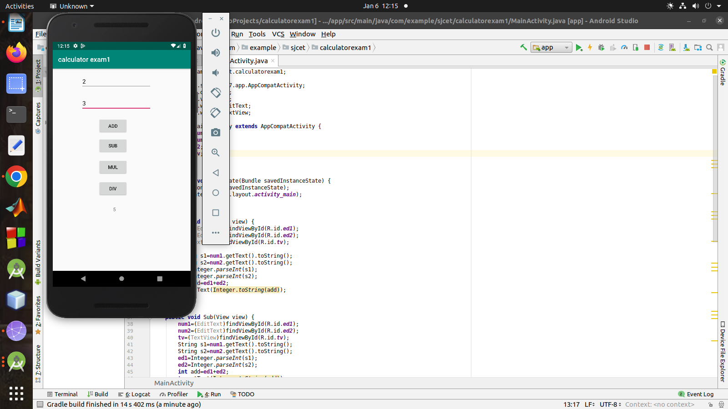
qn2 )
main_activity.xml
<?xml version="1.0" encoding="utf-8"?>
<android.support.constraint.ConstraintLayout xmlns:android="http://schemas.android.com/apk/res/android"
xmlns:app="http://schemas.android.com/apk/res-auto"
xmlns:tools="http://schemas.android.com/tools"
android:layout_width="match_parent"
android:layout_height="match_parent"
tools:context=".MainActivity">
<TextView
android:id="@+id/tv1"
android:layout_width="wrap_content"
android:layout_height="wrap_content"
android:layout_marginStart="16dp"
android:layout_marginLeft="16dp"
android:layout_marginTop="16dp"
android:layout_marginEnd="310dp"
android:layout_marginRight="310dp"
android:text="TextView"
app:layout_constraintEnd_toEndOf="parent"
app:layout_constraintStart_toStartOf="parent"
app:layout_constraintTop_toTopOf="parent"
tools:text="Ajay" />
<TextView
android:id="@+id/tv2"
android:layout_width="wrap_content"
android:layout_height="wrap_content"
android:layout_marginStart="32dp"
android:layout_marginLeft="32dp"
android:layout_marginTop="12dp"
android:layout_marginEnd="294dp"
android:layout_marginRight="294dp"
android:text="TextView"
app:layout_constraintEnd_toEndOf="parent"
app:layout_constraintHorizontal_bias="0.0"
app:layout_constraintStart_toStartOf="parent"
app:layout_constraintTop_toBottomOf="@+id/tv1"
tools:text="Sachin" />
<TextView
android:id="@+id/tv3"
android:layout_width="wrap_content"
android:layout_height="wrap_content"
android:layout_marginStart="32dp"
android:layout_marginLeft="32dp"
android:layout_marginTop="20dp"
android:layout_marginEnd="292dp"
android:layout_marginRight="292dp"
android:text="TextView"
app:layout_constraintEnd_toEndOf="parent"
app:layout_constraintHorizontal_bias="0.217"
app:layout_constraintStart_toStartOf="parent"
app:layout_constraintTop_toBottomOf="@+id/tv2"
tools:text="Sumit" />
<TextView
android:id="@+id/tv4"
android:layout_width="wrap_content"
android:layout_height="wrap_content"
android:layout_marginStart="32dp"
android:layout_marginLeft="32dp"
android:layout_marginTop="24dp"
android:layout_marginEnd="290dp"
android:layout_marginRight="290dp"
android:text="TextView"
app:layout_constraintEnd_toEndOf="parent"
app:layout_constraintHorizontal_bias="0.192"
app:layout_constraintStart_toStartOf="parent"
app:layout_constraintTop_toBottomOf="@+id/tv3"
tools:text="Tarun" />
<TextView
android:id="@+id/tv5"
android:layout_width="wrap_content"
android:layout_height="wrap_content"
android:layout_marginStart="32dp"
android:layout_marginLeft="32dp"
android:layout_marginTop="20dp"
android:layout_marginEnd="294dp"
android:layout_marginRight="294dp"
android:text="TextView"
app:layout_constraintEnd_toEndOf="parent"
app:layout_constraintStart_toStartOf="parent"
app:layout_constraintTop_toBottomOf="@+id/tv4"
tools:text="Yogesh" />
</android.support.constraint.ConstraintLayout>

java code:
package com.example.sjcet.contextmenu_exam;
import android.support.v7.app.AppCompatActivity;
import android.os.Bundle;
import android.view.ContextMenu;
import android.view.MenuItem;
import android.view.View;
import android.widget.Switch;
import android.widget.TextView;
import android.widget.Toast;
public class MainActivity extends AppCompatActivity {
TextView tv1;
TextView tv2;
TextView tv3;
TextView tv4;
@Override
protected void onCreate(Bundle savedInstanceState) {
super.onCreate(savedInstanceState);
setContentView(R.layout.activity_main);
tv1=(TextView)findViewById(R.id.tv1);
tv2=(TextView)findViewById(R.id.tv2);
tv3=(TextView)findViewById(R.id.tv3);
tv4=(TextView)findViewById(R.id.tv4);
}
@Override
public void onCreateContextMenu(ContextMenu menu, View v, ContextMenu.ContextMenuInfo menuInfo) {
super.onCreateContextMenu(menu,v,menuInfo);
getMenuInflater().inflate(R.menu.main_menu,menu);
}
public void onContextMenuItemSelected(MenuItem item)
{
switch(item.getItemId())
{
case R.id.Call:
Toast.makeText(getApplicationContext(), "Call", Toast.LENGTH_SHORT).show();
break;
case R.id.SMS:
Toast.makeText(getApplicationContext(), "SMS", Toast.LENGTH_SHORT).show();
break;
default:
}
super.onContextItemSelected(item);
}
}
main_menu.xml:
<?xml version="1.0" encoding="utf-8"?>
<menu xmlns:android="http://schemas.android.com/apk/res/android">
<item
android:id="@+id/id1"
android:title="Call"/>
<item
android:id="@+id/id2"
android:title="SMS"/>
</menu>
output:

