# Accessibility Considerations: M&R Visitor Profile Fortnightly Client

April 9, 2019

Valorie Sundby and Roberto Perez

## General accessibility considerations:

* + Test all text and icons with the [Colour contrast analyser](https://hubconnect.uhg.com/docs/DOC-96316)
    1. Text contrast needs to have sufficient contrast against background color.
    2. Non-decorative icons need sufficient contrast against background color.
  + A visible focus indicator needs to be clearly visible on all actionable elements when they gain keyboard focus.
  + HTML must pass [Nu Html Checker](https://hubconnect.uhg.com/docs/DOC-62055) and [aXe plug-in](https://hubconnect.uhg.com/docs/DOC-62054) with no errors.
  + Semantic markup:
    1. Visually defined headings need html heading markup (<h1> thru <h6>)
    2. Plain text needs html <p> markup
    3. Listed items need html list markup (<ul> or <ol> with list items as <li>, definition list markup may be used in specific cases)
  + Programmatically associate for inputs with labels using <label> with a for attribute that matches the id attribute on the <input> (preferred).
  + Programmatically associate error messages to their respective inputs using aria-describedby on the input element and set aria-invalid=”true” on the affected fields.
  + Clear the error message as soon as the user enters a new value and set aria-invalid=”false” on the affected field.
  + Required form fields:
    1. Use aria-required=”true” when applicable.
    2. When 4 or more form fields are present in a form: Indicate the presence of required fields visually and programmatically. If all fields are required, indicate that in text as part of the instructions.
  + Popups:
    1. Dialog (modal): Follow the W3C WAI-ARIA Authoring Practices for Dialog (Modal) including Keyboard Interactions and WAI-ARIA Name Role and Properties.
    2. Non-modal popups that expand and collapse content should follow the W3C WAI-ARIA Authoring Practices for Accordion including Keyboard Interactions and WAI-ARIA Name Role and Properties.

## Shopping cart, Already a member?, Home page Sign In

* + Shopping cart needs an accessible name. Since the link uses an <img>, the best practice is to use the alt attribute in the <img> to describe the purpose of the link.
  + Popups that are available onHover or with mouse click need to be available to keyboard users.

Example 1: In the mock-up, if the keyboard user navigates to the shopping cart and selects Enter, they are taken to a new page and do not have access to the popup that is available to mouse users.

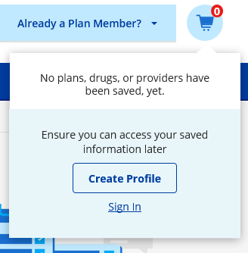

Example 2: "Already a Plan Member" is a custom element that when clicked, opens a popup that allows the user to Sign In. When keyboard users navigate to the element it disappears from view. Users can tab to several hidden items and will not know the purpose of these tab stops.

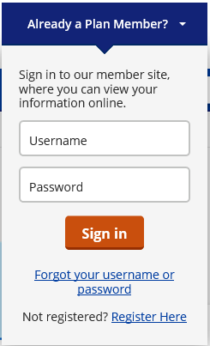

* + Visible focus indicators (vfi) need to be consistent. The vfi on inputs is much lighter (#c0e9ff, #81bbf8) thinner (2px, 3px) and more difficult to see than on buttons. Follow the vfi Best Practices at <https://hubconnect.uhg.com/docs/DOC-139143>. Visible focus indicator on the input in light blue is difficult to see and the indicator on the button is darker blue and easier to see but needs to be slightly darker to meet 3:1 ratio.

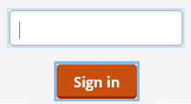

* + The "Sign in to see your saved items" section needs to be defined in a <section> container with an accessible name. Use aria-labelledby to reference the heading within the section (preferred).

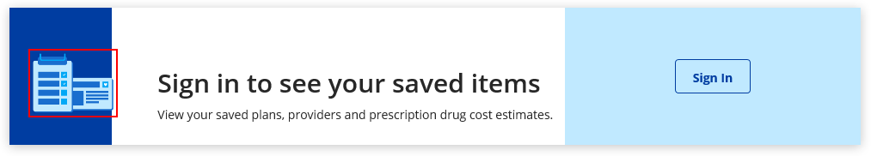

* + The "Sign in to see your saved items" section (continued). All text needs appropriate semantic markup:
    1. Headings defined with <h#> with proper nesting in relation to other headings on the page to create an outline. Headings should be use for content only, not navigation.
    2. Use <p> for plain text elements.
  + Cognitive support images need to be ignored by assistive technology (AT) such as screen readers:
    1. Use alt=”” (no spaces) on <img> elements
    2. Define using CSS when possible
    3. Use role=”presentation” on <svg> elements, note, SVG elements also need focusable=”false” so that they do not get keyboard focus in IE.
  + Elements that take a user to a new page need to be semantically defined as links (<a>) and contain the href attribute to support keyboard access.
  + Elements that open a dialog need to be defined as a button (<button> or role=”button” and support keyboard interaction for both the Enter key and the Space bar).
  + For links that open a new window, this information should be conveyed visually (an icon) and programmatically (visually hidden text for assistive technology.)

## Dashboard with and without Sign In

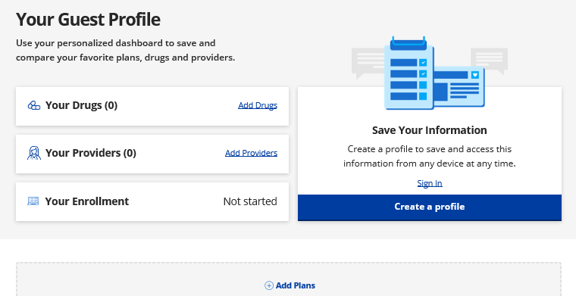

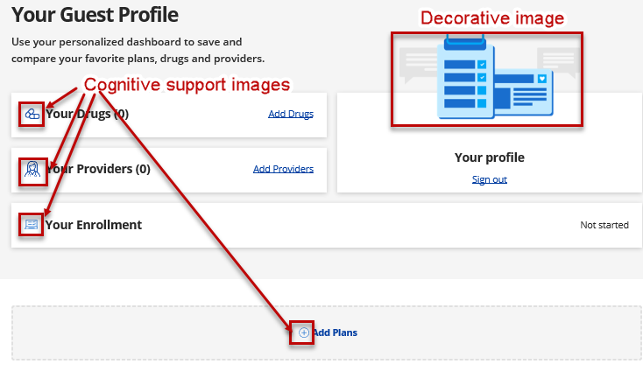

* + All text needs appropriate semantic markup:
    1. Headings defined with <h#> with proper nesting in relation to other headings on the page to create an outline. Headings should be use for content only, not navigation.
    2. Use <p> for plain text elements.
  + Cognitive support images need to be ignored by assistive technology (AT) such as screen readers:
    1. Use alt=”” (no spaces) on <img> elements
    2. Define using CSS when possible
    3. Use role=”presentation” on <svg> elements, note, SVG elements also need focusable=”false”’ to prevent them from receiving keyboard focus.
  + Elements that take a user to a new page need to be semantically defined as links (<a>) and contain the href attribute to support keyboard access.
  + Use list semantics to define visually defined list of "Your drugs", "Your providers" and "Your enrollment".
  + Use heading semantics to define visually defined headings of "Your drugs", "Your providers", "Your enrollment" and "Your profile" (signed in), "Save your information" (not signed in).

## Resources:

[Accessibility on Hub Connect](https://hubconnect.uhg.com/groups/accessibility)

[Accessibility Knowledge Center](https://hubconnect.uhg.com/groups/accessibility/pages/knowledge-center)

[WAI-ARIA authoring practices 1.1](https://www.w3.org/TR/wai-aria-practices-1.1/)

[Web Content Accessibility Guidelines (WCAG)](https://www.w3.org/WAI/standards-guidelines/wcag/)

[Optum Design Pattern Library](https://dpl.optum.com/)

[Optum UI Toolkit Showcase](http://webrd1268.uhc.com/)