* Install Python 3.4
* Install all modules in Case Study 1/Case_Study_1/requirements.txt
* Open DS_Model_frontend.py in Python IDLE
* Run Module
* You will be presented with empty window

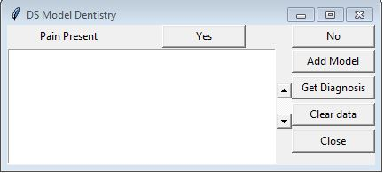

* Click on Add Model
* Click on either Yes or the No button on top
* Click on get diagnosis button to get a ranked diagnosis list

