A Project Report On
Online Book Shopping


As Part of Internship Program

INDEX

1. PROJECT OVERVIEW

2. E-COMMERCE CONSEPTION

3. PREFACE

4. NATURE OF PROJECT

5. SCREENSHOT OF PROJECT

6. PROJECT REQUIREMENTS

7. FLOWCHART

8. DATA DICTIONARY

9. TESTING & IMPLEMENTATION

10. THE BOOKSHOP.COM INFORMATION

PROJECT OVERVIEW

This project is followed the concept of the E-commerce thoroughly. This project is developed to sell the products on line of various Book Collection Category mentioned in the project.

This project definitely helps the user to buy anything from the internet because in the ONLINE BOOK SHOP you can purchase anything with clicking of the some button of the mouse and pressing some keys of the keyboard & entering your credit card no. in that.

By using this project, the user can save his or her time by purchasing the product which time they are wasting by roaming in the market. From here, they can get most probably all the things they want besides fast moving Entertainment goods. They have various choices in the one Collection.

E-COMMERCE CONCEPTION

E-commerce means the purchasing and selling of the products through the Internet.

Now days the internet is used very widely so that the some businessmen always think in the advance who have the vision of the future from the evolution of the internet some are think to implement the internet for the business and that comes true with the evolution of the E-commerce.

In our project, we have tried to implement the concept of the E-commerce thoroughly but as we know that, we have to do the project while learning the E-commerce it means that studying & implementing that concept we have to do simultaneously. We tried to make it perfect but humans are doing mistakes only so that we have put suggestion part also for the customer so that they can help us to improving our site by giving their suggestion to us.

preface

First of all I would like to say that project is very essential part of our educational quota. If we are going only for theory parts, it can not give us perfect knowledge.

This project report of Online Book shopping Web Site is present against you for project as a subject in

This web site is developed for study purpose of the Computer’s Student. It provides computer e-book. It also provider’s educational software to students. In this web site It requires only registration of the Buyers which is also free. For that student must have valid email account like yahoo, rediff, hotmail etc. This Bookshopping.com web site is developed in JSP language.

This web site is quite easy in operating so that any student can able to use it easily.

Your co-operation in form of suggestions and comments are most welcome, to improve any knowledge and project.

NATURE OF PROJECT

We develop this Web Site “Bookshop.com” which is developed in the Hyper Text Preprocessor (php) as the Front end and MySql as Back end.

I have put a fair amount of effort in the design of this web site. I have tried my best to satisfy the all requirement in an efficient manner.

This web site provided facilities like make the user account based on emailed and it will provide to student to download the computer e-book totally free. As well as it provide the Software which is useful for students and lots of?

SCREENSHOT OF PROJECT

Homepage

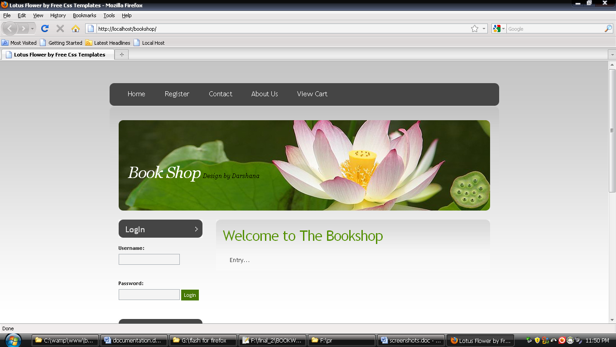

Registration Form

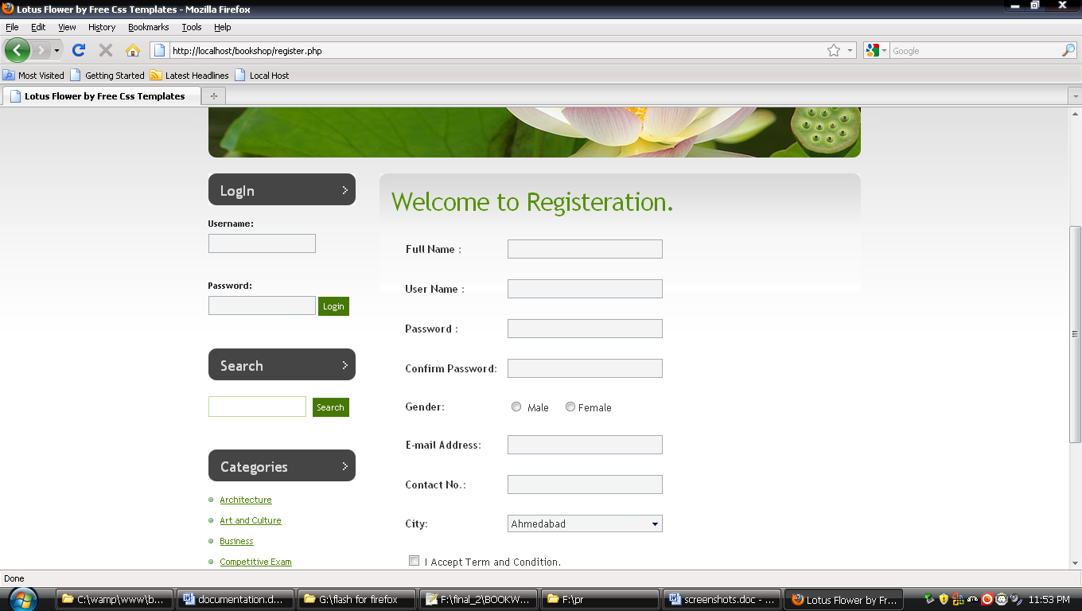

Admin

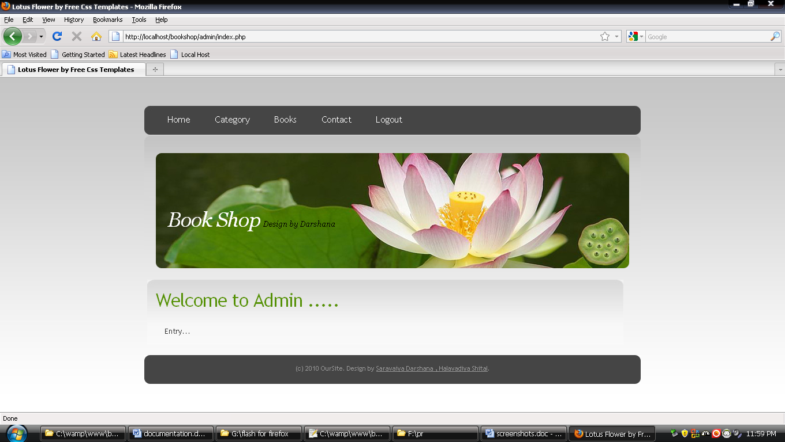

Category

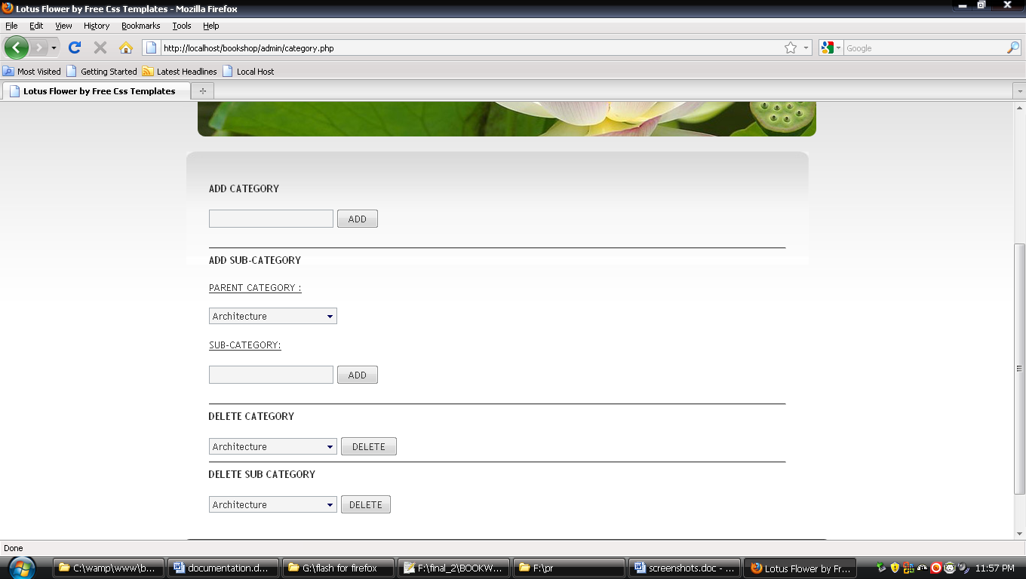

Item Details

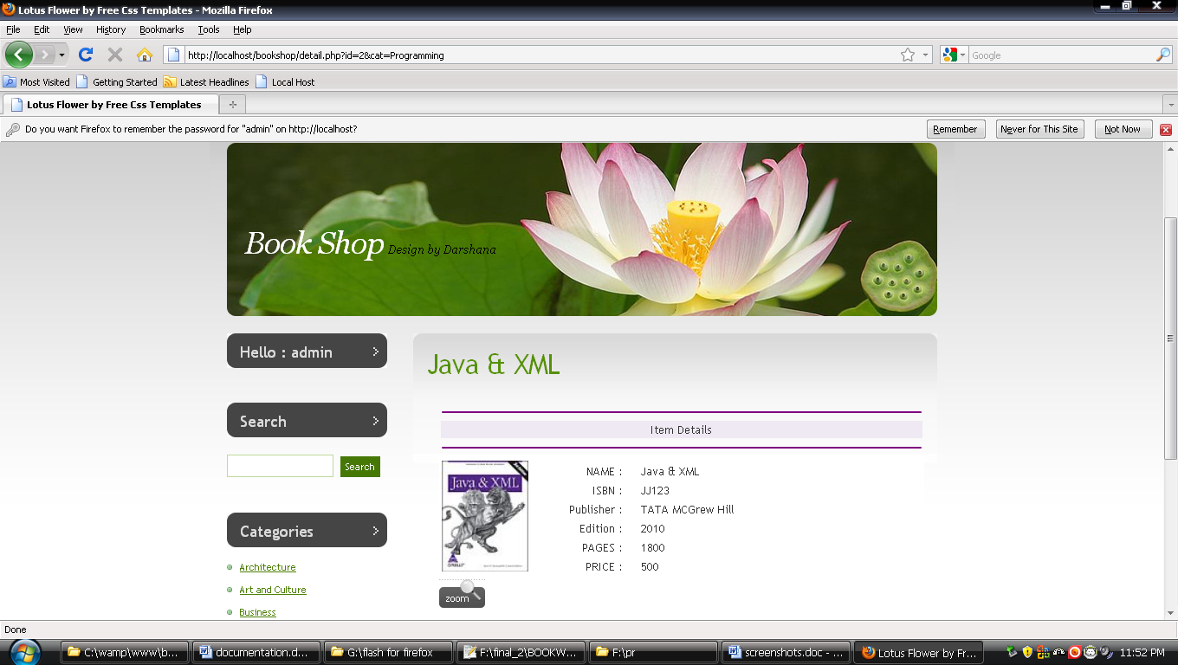

View Cart

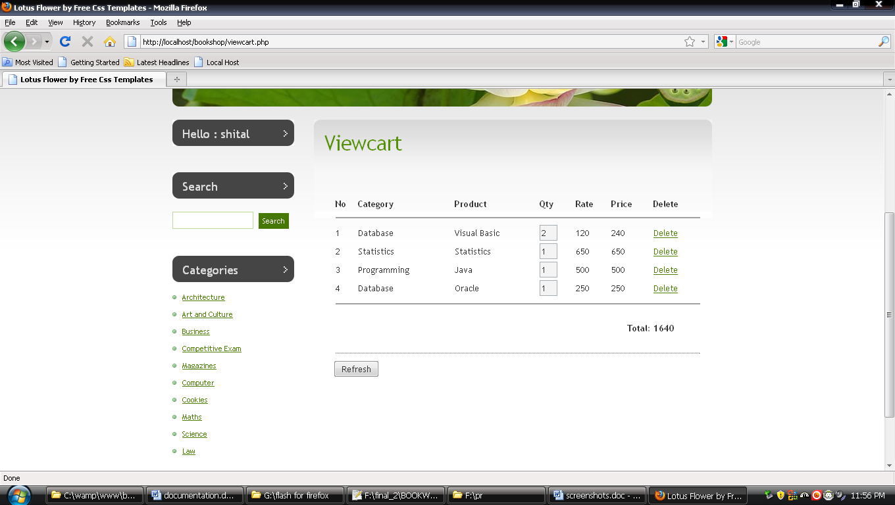

Book List

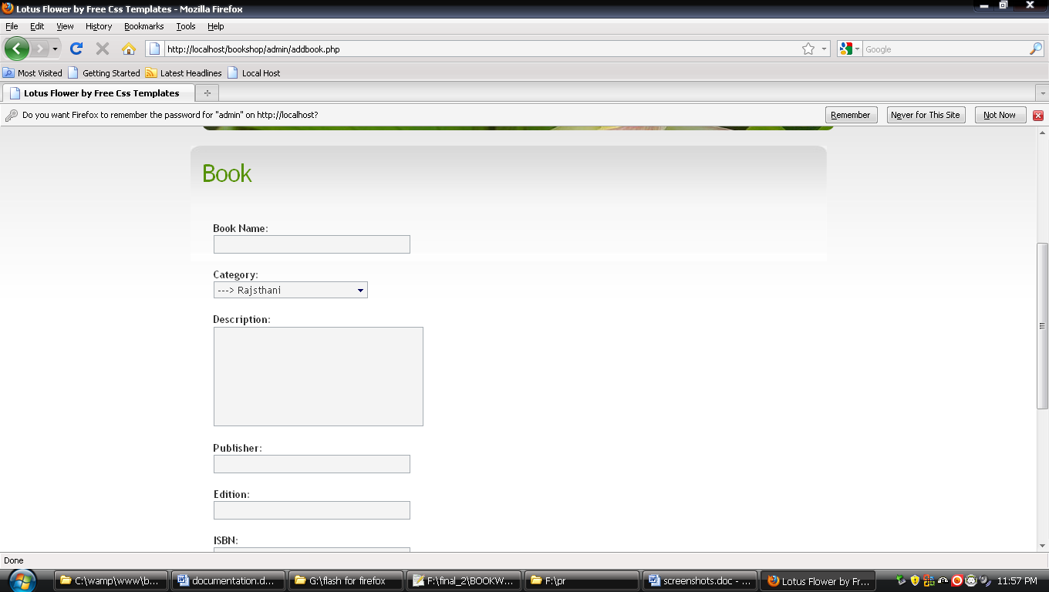

Contact

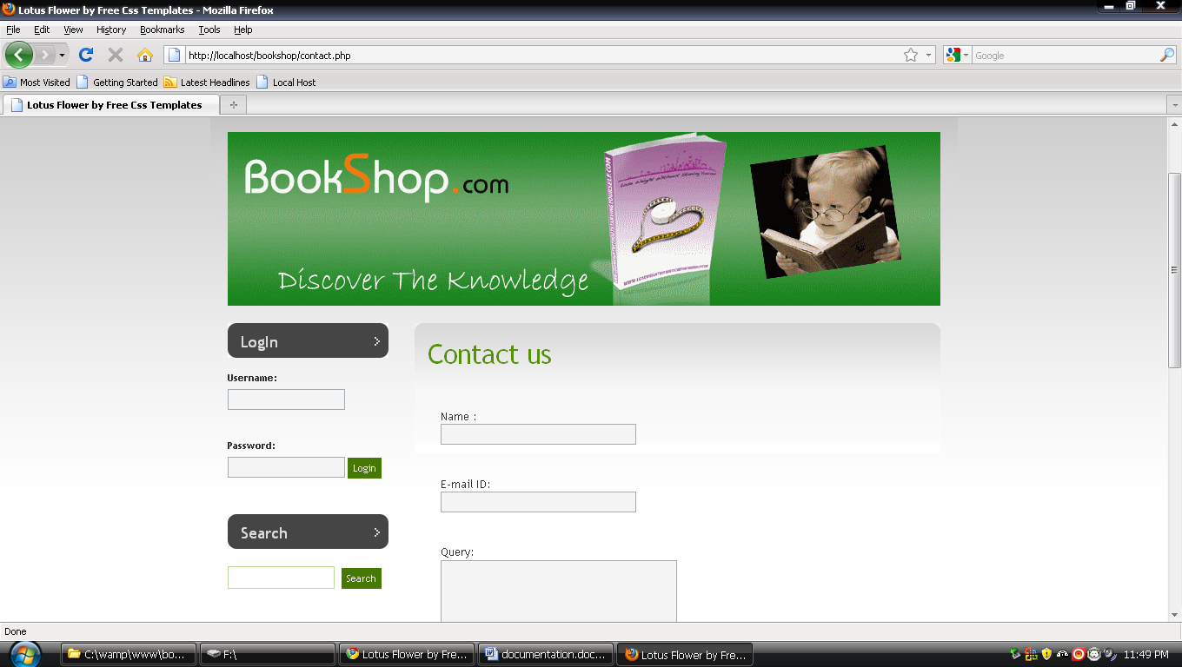

Project Requirement

- Software Requirement

  - Mysql

  - Web server

  - PHP (PHP Hypertext Preprocessor)

  - Notepad++

  - Micromedia Flash 8

System Analysis
2.1 STUDY OF THE SYSTEM
To provide flexibility to the users, the interfaces have been developed that are accessible through a browser. The GUI’S at the top level have been categorized as
- Administrative user interface
- The operational or generic user interface

The ‘administrative user interface’ concentrates on the consistent information that is practically, part of the organizational activities and which needs proper authentication for the data collection. These interfaces help the administrators with all the transactional states like Data insertion, Data deletion and Date updation along with the extensive data search capabilities.

The ‘operational or generic user interface’ helps the end users of the system in transactions through the existing data and required services. The operational user interface also helps the ordinary users in managing their own information in a customized manner as per the included flexibilities

2.2 INPUT & OUTPOUT REPRESENTETION

Input design is a part of overall system design. The main objective during the input design is as given below:
- To produce a cost-effective method of input.
- To achieve the highest possible level of accuracy.
- To ensure that the input is acceptable and understood by the user.

INPUT STAGES:
The main input stages can be listed as below:
- Data recording
- Data transcription
- Data conversion
- Data verification
- Data control
- Data transmission
- Data validation
- Data correction

INPUT TYPES:
It is necessary to determine the various types of inputs. Inputs can be categorized as follows:
- External inputs, which are prime inputs for the system.
- Internal inputs, which are user communications with the system.
- Operational, which are computer department’s communications to the system?
- Interactive, which are inputs entered during a dialogue.

INPUT MEDIA:
At this stage choice has to be made about the input media. To conclude about the input media consideration has to be given to;
- Type of input
- Flexibility of format
- Speed
- Accuracy
- Verification methods
- Rejection rates
- Ease of correction
- Storage and handling requirements
- Security
- Easy to use
- Portability
Keeping in view the above description of the input types and input media, it can be said that most of the inputs are of the form of internal and interactive. As Input data is to be the directly keyed in by the user, the keyboard can be considered to be the most suitable input device.
OUTPUT DESIGN:
In general are:
- External Outputs whose destination is outside the organization.
- Internal Outputs whose destination is with in organization and they are the User’s main interface with the computer. Outputs from computer systems are required primarily to communicate the results of processing to users. They are also used to provide a permanent copy of the results for later consultation. The various types of outputs
- Operational outputs whose use is purely with in the computer department.
- Interface outputs, which involve the user in communicating directly with the system.

OUTPUT DEFINITION

The outputs should be defined in terms of the following points:
    - Type of the output
    - Content of the output
    - Format of the output
    - Location of the output
    - Frequency of the output
    - Volume of the output
    - Sequence of the output

It is not always desirable to print or display data as it is held on a computer. It should be decided as which form of the output is the most suitable.

For Example
- Will decimal points need to be inserted
- Should leading zeros be suppressed.

OUTPUT MEDIA:
In the next stage it is to be decided that which medium is the most appropriate for the output. The main considerations when deciding about the output media are:
- The suitability for the device to the particular application.
- The need for a hard copy.
- The response time required.
- The location of the users
- The software and hardware available.
Keeping in view the above description the project is to have outputs mainly coming under the category of internal outputs. The main outputs desired according to the requirement specification are:
The outputs were needed to be generated as a hard copy and as well as queries to be viewed on the screen. Keeping in view these outputs, the format for the output is taken from the outputs, which are currently being obtained after manual processing. The standard printer is to be used as output media for hard copies.

2.3 PROCESS MODEL USED WITH JUSTIFICATION

SDLC (Umbrella Model):
Umbrella Activity
Umbrella Activity
Umbrella Activity
Feasibility Study
TEAM FORMATION
Project Specification PREPARATION

Business Requirement Documentation
ANALYSIS & DESIGN
CODE
UNIT TEST
DOCUMENT CONTROL

ASSESSMENT

TRAINING
INTEGRATION & SYSTEM TESTING

DELIVERY/INSTALLATION
ACCEPTANCE TEST
Requirements Gathering
SDLC is nothing but Software Development Life Cycle. It is a standard which is used by software industry to develop good software.

Stages in SDLC:
- Requirement Gathering
- Analysis
- Designing
- Coding
- Testing
- Maintenance
Requirements Gathering stage:
The requirements gathering process takes as its input the goals identified in the high-level requirements section of the project plan. Each goal will be refined into a set of one or more requirements. These requirements define the major functions of the intended application, define operational data areas and reference data areas, and define the initial data entities. Major functions include critical processes to be managed, as well as mission critical inputs, outputs and reports. A user class hierarchy is developed and associated with these major functions, data areas, and data entities. Each of these definitions is termed a Requirement. Requirements are identified by unique requirement identifiers and, at minimum, contain a requirement title and
textual description.
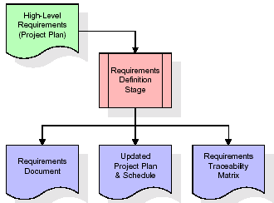

These requirements are fully described in the primary deliverables for this stage: the Requirements Document and the Requirements Traceability Matrix (RTM). The requirements document contains complete descriptions of each requirement, including diagrams and references to external documents as necessary. Note that detailed listings of database tables and fields are not included in the requirements document. The title of each requirement is also placed into the first version of the RTM, along with the title of each goal from the project plan. The purpose of the RTM is to show that the product components developed during each stage of the software development lifecycle are formally connected to the components developed in prior stages.
In the requirements stage, the RTM consists of a list of high-level requirements, or goals, by title, with a listing of associated requirements for each goal, listed by requirement title. In this hierarchical listing, the RTM shows that each requirement developed during this stage is formally linked to a specific product goal. In this format, each requirement can be traced to a specific product goal, hence the term requirements traceability.
The outputs of the requirements definition stage include the requirements document, the RTM, and an updated project plan.
- Feasibility study is all about identification of problems in a project.
- No. of staff required to handle a project is represented as Team Formation, in this case only modules are individual tasks will be assigned to employees who are working for that project.
- Project Specifications are all about representing of various possible inputs submitting to the server and corresponding outputs along with reports maintained by administrator

Analysis Stage:
The planning stage establishes a bird's eye view of the intended software product, and uses this to establish the basic project structure, evaluate feasibility and risks associated with the project, and describe appropriate management and technical approaches.
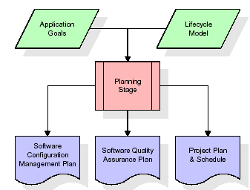
The most critical section of the project plan is a listing of high-level product requirements, also referred to as goals. All of the software product requirements to be developed during the requirements definition stage flow from one or more of these goals. The minimum information for each goal consists of a title and textual description, although additional information and references to external documents may be included. The outputs of the project planning stage are the configuration management plan, the quality assurance plan, and the project plan and schedule, with a detailed listing of scheduled activities for the upcoming Requirements stage, and high level estimates of effort for the out stages.
Designing Stage:
The design stage takes as its initial input the requirements identified in the approved requirements document. For each requirement, a set of one or more design elements will be produced as a result of interviews, workshops, and/or prototype efforts. Design elements describe the desired software features in detail, and generally include functional hierarchy diagrams, screen layout diagrams, tables of business rules, business process diagrams, pseudo code, and a complete entity-relationship diagram with a full data dictionary. These design elements are intended to describe the software in sufficient detail that skilled programmers may develop the software with minimal additional input.
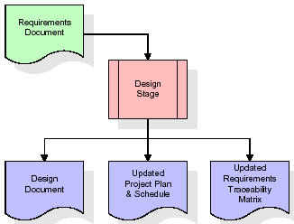

When the design document is finalized and accepted, the RTM is updated to show that each design element is formally associated with a specific requirement. The outputs of the design stage are the design document, an updated RTM, and an updated project plan.

Development (Coding) Stage:
The development stage takes as its primary input the design elements described in the approved design document. For each design element, a set of one or more software artifacts will be produced. Software artifacts include but are not limited to menus, dialogs, data management forms, data reporting formats, and specialized procedures and functions. Appropriate test cases will be developed for each set of functionally related software artifacts, and an online help system will be developed to guide users in their interactions with the software.
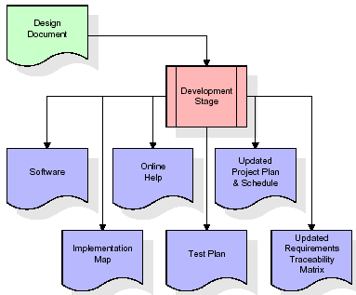

The RTM will be updated to show that each developed artifact is linked to a specific design element, and that each developed artifact has one or more corresponding test case items. At this point, the RTM is in its final configuration. The outputs of the development stage include a fully functional set of software that satisfies the requirements and design elements previously documented, an online help system that describes the operation of the software, an implementation map that identifies the primary code entry points for all major system functions, a test plan that describes the test cases to be used to validate the correctness and completeness of the software, an updated RTM, and an updated project plan.
Integration & Test Stage:
During the integration and test stage, the software artifacts, online help, and test data are migrated from the development environment to a separate test environment. At this point, all test cases are run to verify the correctness and completeness of the software. Successful execution of the test suite confirms a robust and complete migration capability. During this stage, reference data is finalized for production use and production users are identified and linked to their appropriate roles. The final reference data (or links to reference data source files) and production user list are compiled into the Production Initiation Plan.
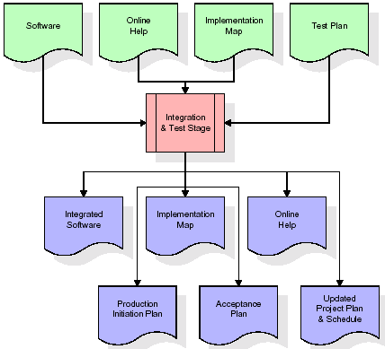
The outputs of the integration and test stage include an integrated set of software, an online help system, an implementation map, a production initiation plan that describes reference data and production users, an acceptance plan which contains the final suite of test cases, and an updated project plan.
Installation & Acceptance Test:
During the installation and acceptance stage, the software artifacts, online help, and initial production data are loaded onto the production server. At this point, all test cases are run to verify the correctness and completeness of the software. Successful execution of the test suite is a prerequisite to acceptance of the software by the customer.
After customer personnel have verified that the initial production data load is correct and the test suite has been executed with satisfactory results, the customer formally accepts the delivery of the software.
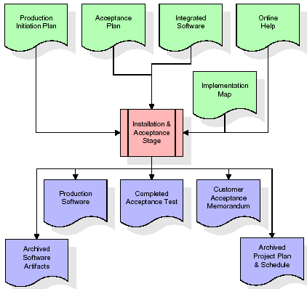

The primary outputs of the installation and acceptance stage include a production application, a completed acceptance test suite, and a memorandum of customer acceptance of the software. Finally, the PDR enters the last of the actual labor data into the project schedule and locks the project as a permanent project record. At this point the PDR "locks" the project by archiving all software items, the implementation map, the source code, and the documentation for future reference.
Maintenance:
Outer rectangle represents maintenance of a project, Maintenance team will start with requirement study, understanding of documentation later employees will be assigned work and they will undergo training on that particular assigned category. For this life cycle there is no end, it will be continued so on like an umbrella (no ending point to umbrella sticks).
Modules:
- Pre-Processor
- Feature Extraction
- Content Match
- Action Module
- Result Analysis
- This module deals with the prior operations to feature extraction like digitization, binarization and noise elimination. This is the primary module that performs all prerequisite operations before feature extraction.
- This is the core module that performs character extraction, word splitting, and feature detection. This module splits the given text into possible segments without any feature loss.
- This module is the main implementation module that implements the Hybrid PSO and BP algorithms for context verification. This module adds the intelligence by implementing the specified matching algorithms.
- This is the output module that shows the final actions by applying the specified algorithms for hand-written recognition. This is the final UI that gives clear idea about the outcome of the specified algorithm.
- This module provides graphical analysis of final outcome over existing system based on given parameters. We can see the various improvements based on given parameters, over the current recognition system.

SYSTEM REQUIREMENTS
Software Requirements
Operating System : Windows 2000 server Family
Front End : HTML, CSS
Technology : PHP
Database : MySQL

Hardware Requirements
Processor : Any Processor above 500 MHz.
Hard Disk : 10 GB and above.
Ram : 128 MB and above.

Flow chart

- Home Page

HOME

CONTACT
ABOUT US

HOME PAGE
REGISTER

VIEW CART

CATEGORY
ADMIN

BOOK

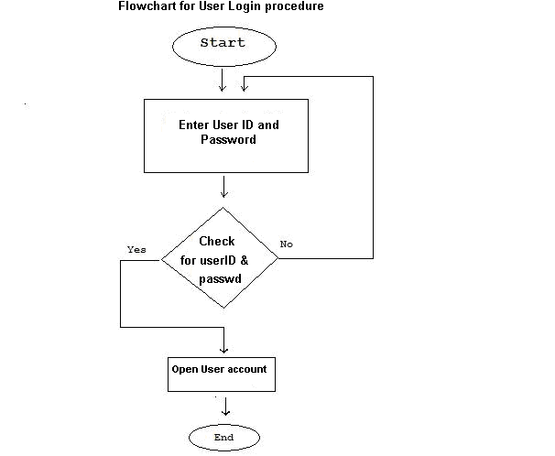

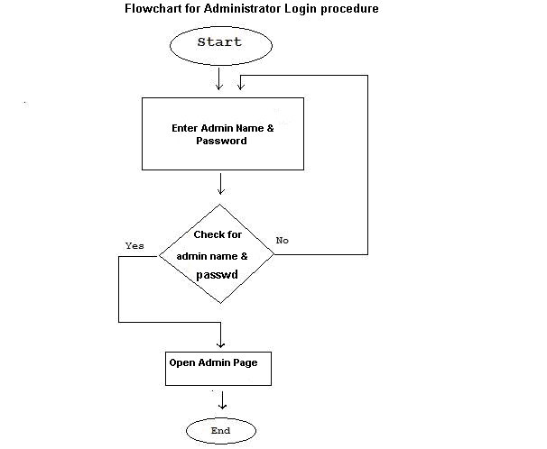

Data Dictionary

The Data Dictionary is very important part of the project through which we can know that where data are stored in the project. The Data Dictionary in this project is as below.

DATABASE NAME: Bookshop

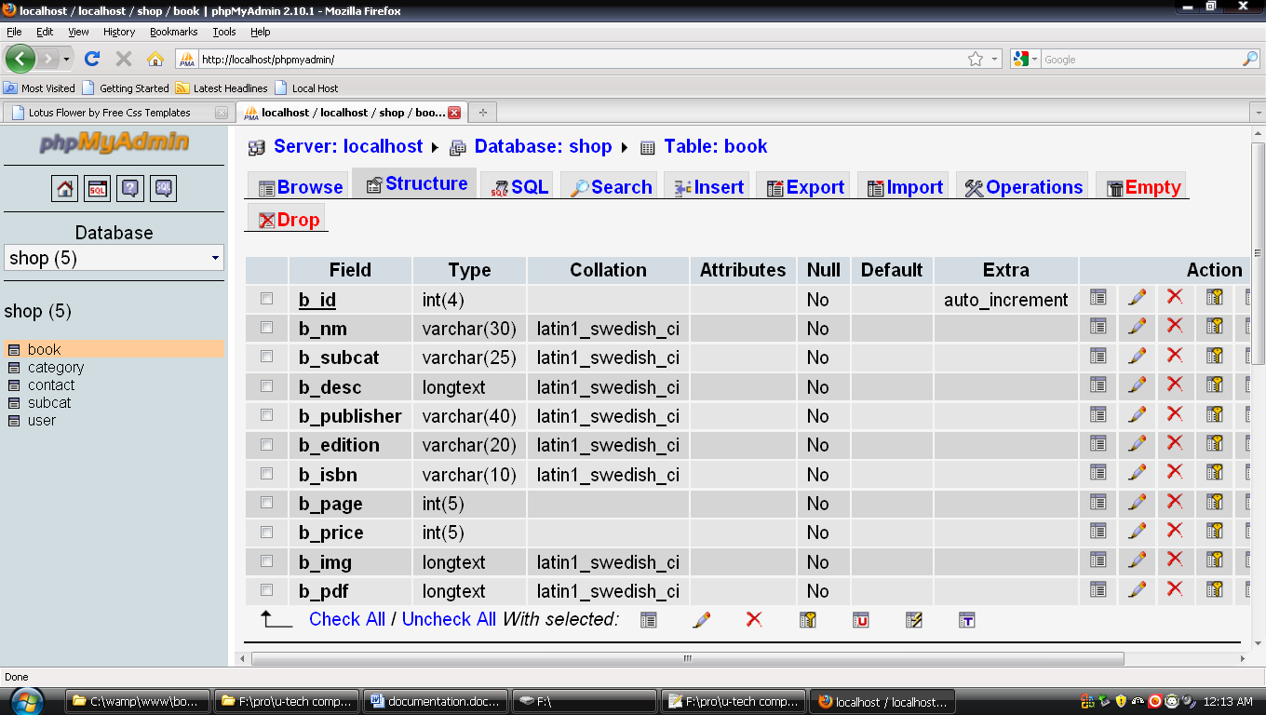
- Book Table

2. Category Table
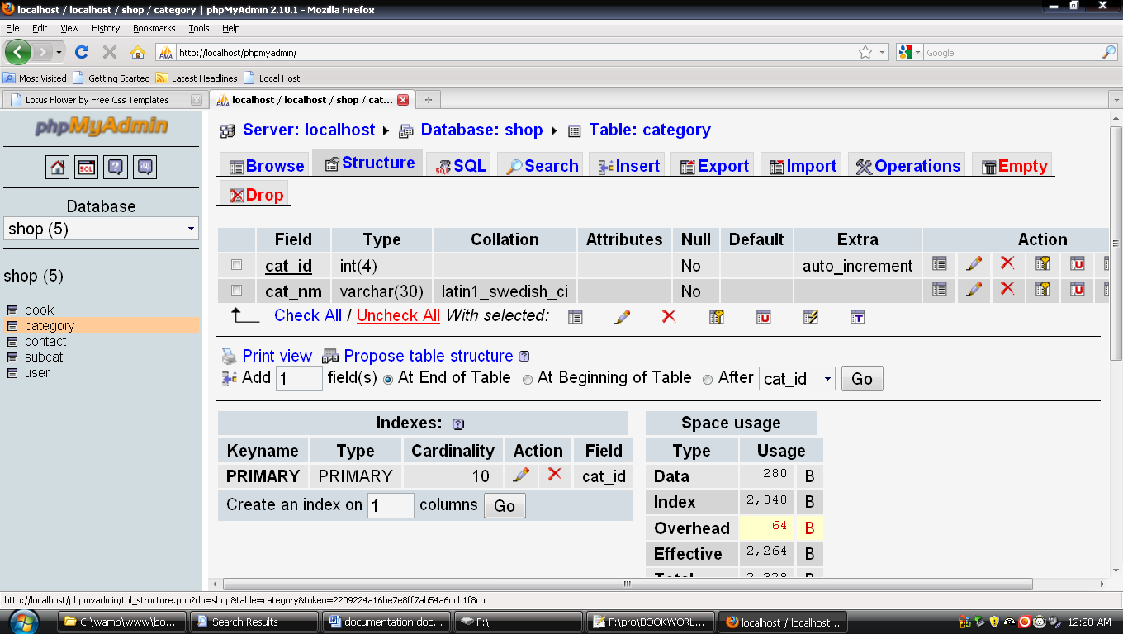

3. Contact Table
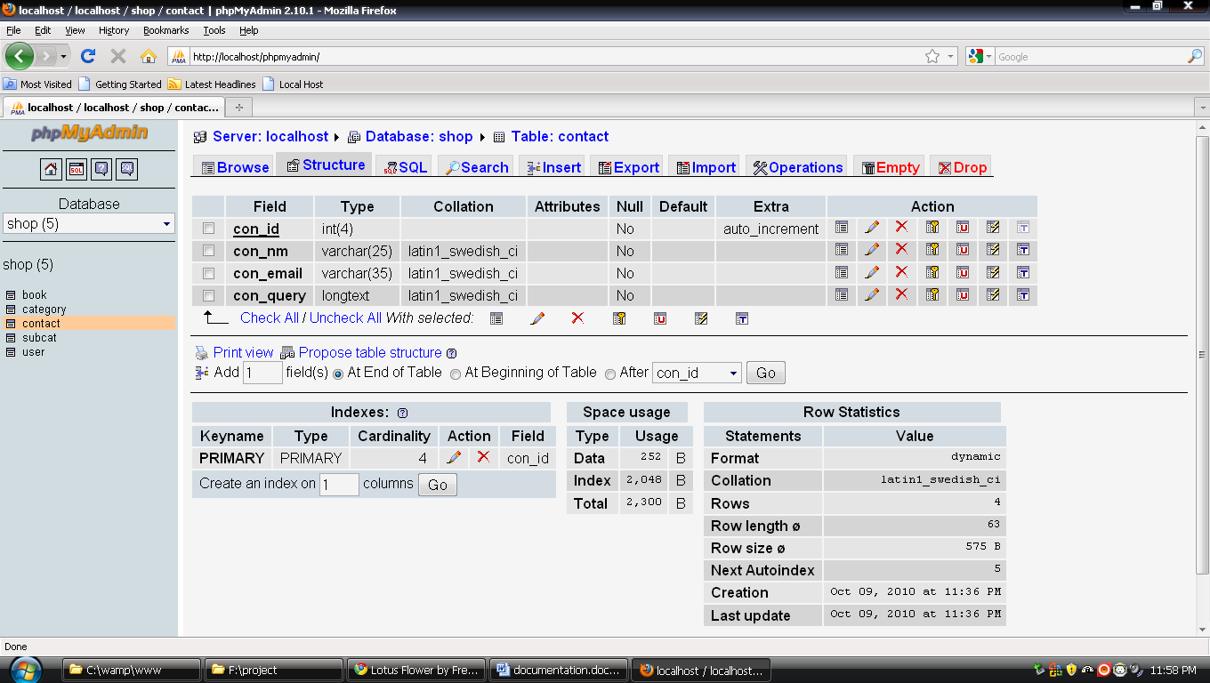

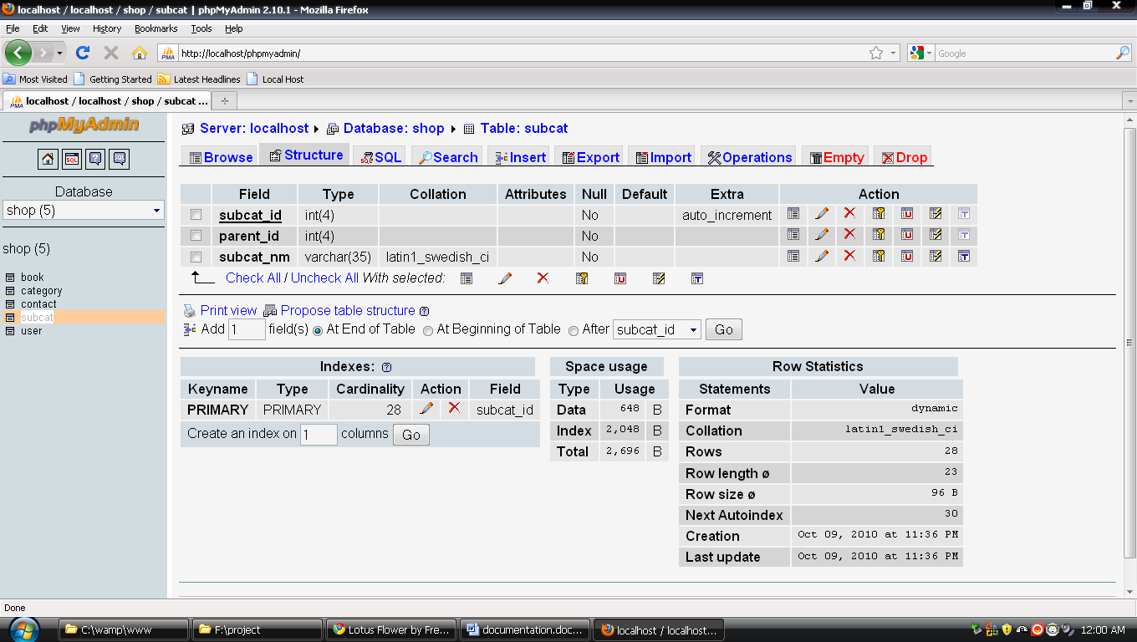
4. Subcat Table

5. User Table

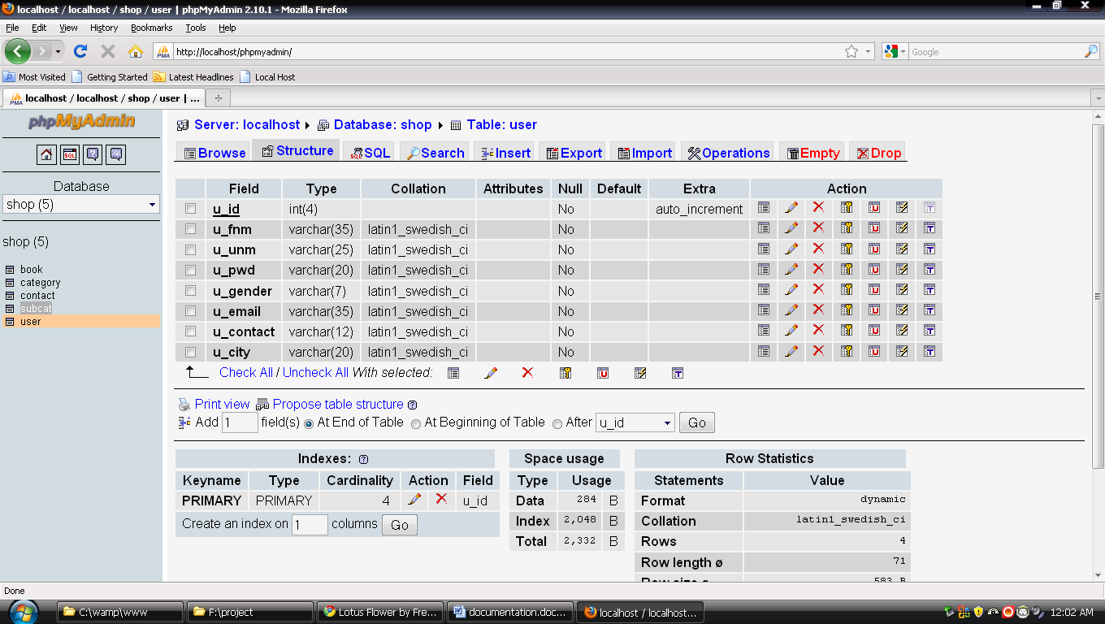

Testing & Implementation

Testing is critical element of software quality assurance and represents the ultimate review of specification, design and coding. It is unusual for the organization to spent 30 or 40 percent of total project effort on testing.

Testing presents the software an interesting anomaly for the software engineer. The engineer creates the series of test cases that are intended to demolish the software that has been built. In fact, testing us one-step in the software engineering process that could be viewed as destructive rather than constructive.

Testing Objectives

The following are the objectives for the testing.

- Testing is a process of executing a program with the intent of finding an error.

- A good test case is one that has a high probability of finding an as-yet undiscovered error.

- A successful test is one that uncovers as-set undiscovered error.

THE BOOKSHOP.COM INFORMATION

General
What is TheBookShop.com?
TheBookShop.com a true marketplace for publishers, which means that you can find all the publishers selling their items under one platform.
There can also be independent sellers and distributors selling their items.
This gamut of choices allows customers to choose to buy a book they want at the price they want to pay.
What can I get here?
You can find books, books and more books. TheBookShop is a one-stop shop for you to look at, read about,
compare and finally buy all books published in India by Indian publishers and also a wide selection of titles from USA and UK.
Are these books only in English?
No. TheBookShop.com has books in all languages from publishers of all sizes throughout the country.
We have books of all regional languages such as Punjabi, Hindi, Marathi, Gujarati, Bengali, Malayalam, and Urdu.
You can specifically search for these books.

TheBookShop.com Account and Registration
How do I purchase an item on TheBookShop.com?
Purchasing an item is a simple 3-step process.
- Create TheBookShop.com account on TheBookShop.com
- Search and add items to your shopping cart
- Enter your credit card details and submit the order
That is it. The item you purchase will be delivered to your doorstep
Can I order without creating TheBookShop.com account?
No, you cannot order without creating TheBookShop.com account.
Do I need a credit card to create TheBookShop.com account?
You do not need a credit card to create TheBookShop.com account.
Credit card information is required only at the time of ordering.
How do I create TheBookShop.com account?
You can create TheBookShop.com account using your email address and relevant information through My Account tab on our website.
Do you charge for creating TheBookShop.com account?
No, TheBookShop.com account creation is free of any charge whatsoever.
What if I forget my password?
You can use our Forgot Password services to send/reset your password.

Order Processing
How can I find an item to order?
If you remember the category of the item, you can browse for the item by category.
For example you can Browse for Computing books under our categories.
If you remember the exact item or some details about it, you can search for the item by Title, ISBN,
Publisher or Author in our powerful Search function. You can also filter this search by Language.
Can I order multiple items in one order?
Yes you can add multiple items to your shopping cart at one time and place it under one order.
However there will be a separate shipping charge for each item on the order.
Can I pre-order?
We do not have the pre-order feature at this time.

