**Probability** **Assignment**

**Homework 1.1**

Jerry and Susan have a joint bank account.

Jerry goes to the bank 20% of the days.

Susan goes there 30% of the days.

Together they are at the bank 8% of the days.

1. Susan was at the bank last Monday. What’s the probability that Jerry was there too?
2. Last Friday, Susan wasn’t at the bank. What’s the probability that Jerry was there?
3. Last Wednesday at least one of them was at the bank. What is the probability that both of them were there?

**ANSWER:**

Let’s draw Venn-Diagram from given information.

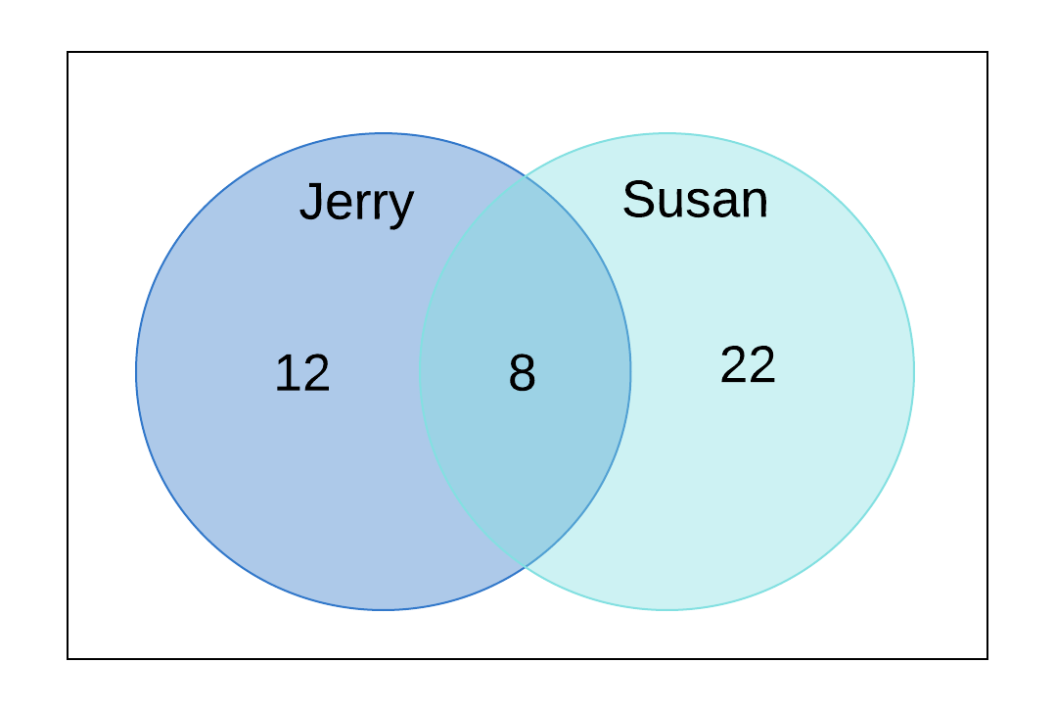

OR

|  |  |  |  |
| --- | --- | --- | --- |
|  | SUSAN @BANK | SUSAN NOT @BANK |  |
| JERRY @BANK | 8 | 12 | 20 |
| JERRY NOT @BANK | 22 | 58 | 80 |
|  | 30 | 70 |  |

1. P (Jerry was at the bank on last Monday | Susan was at the bank on last Monday) = 8/30 **= 0.2667 = 26.67%**
2. P(Jerry was at the bank on last Friday | Susan wasn’t at the bank on last Friday ) = 12/70 **= 0.1714 = 17.14%**
3. P(both of them at the bank | at least one of them was at the bank on last Wednesday ) = 8/42 **= 0.1905 = 19.05%**

**Homework 1.2**

Harold and Sharon are studying for a test.

Harold’s chances of getting a “B” are 80%. Sharon’s chances of getting a “B” are 90%.

The probability of at least one of them getting a “B” is 91%.

1. What is the probability that only Harold gets a “B”?
2. What is the probability that only Sharon gets a “B”?
3. What is the probability that both won’t get a “B”?

**ANSWER:**

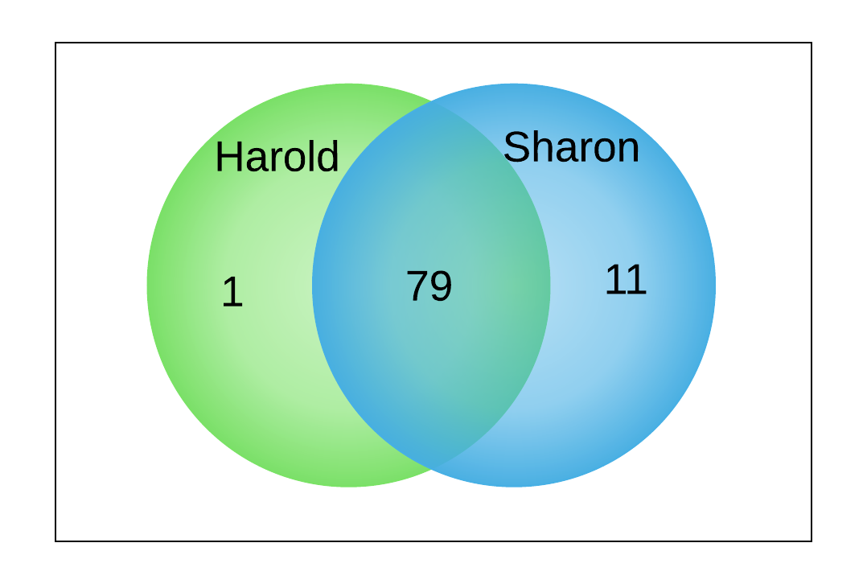

**(1)** P (only Harold gets a “B”) = **1 % = 0.01**

**(2)** P (only Sharon gets a “B”) = **11% = 0.11**

**(3)** P (both won’t get a “B”) = **9% = 0.09**

**Homework 1.3**

Jerry and Susan have a joint bank account. Jerry goes to the bank 20% of the days. Susan goes there 30% of the days.  
Together they are at the bank 8% of the days.

Are the events “Jerry is at the bank” and “Susan is at the bank” independent?

**ANSWER:**



**No,** The events “Jerry is at the bank” and “Susan is at the bank” are **not independent.**

Both events are **dependent** as P(Jerry is at the bank and Susan is at the bank) != P(Jerry is at the bank) . P(Susan is at the bank**)**

**Which is, 0.42 != 0.2*0.6**

**Homework 1.4**

You roll 2 dice.

1. Are the events “the sum is 6” and “the second die shows 5” independent?
2. Are the events “the sum is 7” and “the first die shows 5” independent?

**ANSWER:**

1. **No**, the events “the sum is 6” and “the second die shows 5**” are not independent.**

Because it doesn’t follow the rule: Events A and B are independent if

P(A and B) =P(A) *P(B)

Here, P(A)=5/36, P(B)=1/6 and P(A and B)=1/36 , which violates this rule.

1. **Yes**, the events “the sum is 7” and “the first die shows 5” **are independent**

Because, P(A)=1/6, P(B)=1/6 and P(A and B)=1/36

Here, P(A and B) =P(A) *P(B) is satisfied.

**Homework 1.5**

An oil company is considering drilling in either TX, AK and NJ. The company may operate in only one state. There is 60% chance the company will choose TX and 10% chance – NJ.

There is 30% chance of finding oil in TX, 20% - in AK, and 10% - in NJ.

1. What’s the probability of finding oil?
2. The company decided to drill and found oil. What is the probability that they drilled in TX?

**ANSWER:**

Probability of Finding Oil in TX = 0.3 * 0.6 = 0.18

Probability of Finding Oil in AK = 0.2 * 0.2 = 0.06

Probability of Finding Oil in NJ = 0.1 * 0.1 = 0.01

|  |  |  |  |  |
| --- | --- | --- | --- | --- |
|  | TX | AK | NJ | Total |
| Drilling | 60% | 30% | 10% | 100% |
| Finding Oil | 30% | 20% | 10% |  |
| Drilling and Finding Oil | 18% | 6% | 1% | **25%** |

**(1)** P (finding oil) **=** 25% **= 0.25**

**(2)** P (they drilled in TX and found oil| they drilled and found oil) = (0.6 * 0.3)/0.25 = **0.72 =72%**

**Homework 1.6**

The following slide shows the survival status of individual passengers on the Titanic. Use this information to answer the following questions

1. What is the probability that a passenger did not survive?
2. What is the probability that a passenger was staying in the first class?
3. Given that a passenger survived, what is the probability that the passenger was staying in the first class?
4. Are survival and staying in the first class independent?
5. Given that a passenger survived, what is the probability that the passenger was staying in the first class and the passenger was a child?
6. Given that a passenger survived, what is the probability that the passenger was an adult?
7. Given that a passenger survived, are age and staying in the first class independent?

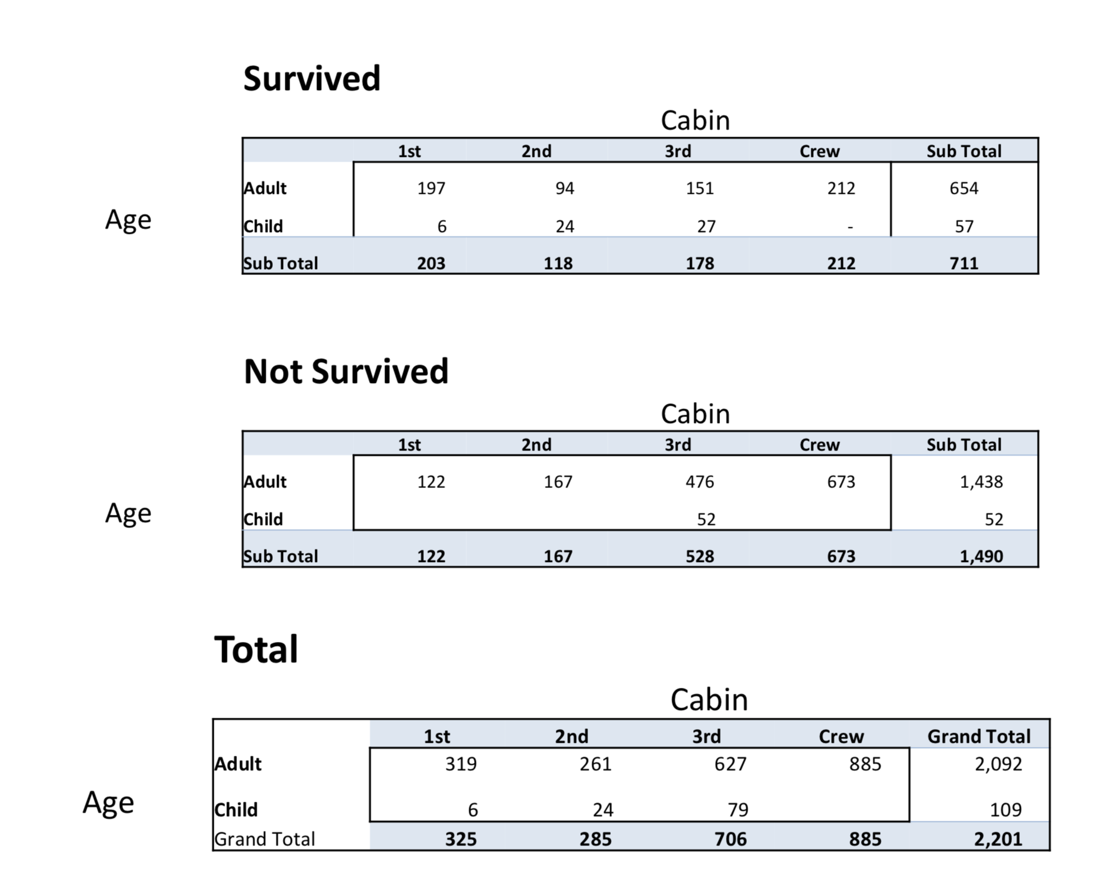

**ANSWER:**

1. What is the probability that a passenger did not survive?

P(not survived)= 1490/2201 = **0.6778=67.78%**

1. What is the probability that a passenger was staying in the first class?

=325/2201 **= 0.1477=14.77%**

1. Given that a passenger survived, what is the probability that the passenger was staying in the first class?

204/711 **= 0.2869=28.69%**

1. Are survival and staying in the first class independent?

**No**, survival and staying in the first class are **not independent.**

Because it doesn’t follow the rule: Events A and B are independent if P(A∩B)=P(A)*P(B)

1. Given that a passenger survived, what is the probability that the passenger was staying in the first class and the passenger was a child?

P(staying in 1st class and was a child | survived) = 6/711 = **0.008439=84.39%**

1. Given that a passenger survived, what is the probability that the passenger was an adult?

P(adult | survived) = 654/711 = **0.9198 =91.98**

1. Given that a passenger survived, are age and staying in the first class independent?

**Yes**, they are **independent**.

P(A)= P(survived | Adult in first class) = 197/203 =97.04%

P(B)= P(survived | Child in first class) = 6/203 = 2.96%

We know that events A and B are independent if P(A and B) = P(A) * P(B)

Here, P(A) * P(B) = 0.2873 and P(A and B) = 0.2855

So, they are independent.

A= age in 1st class | survived

B= staying in 1st class | survived

P(A) = 203/711 ,P(B)=203/711

**Homework 1.7**

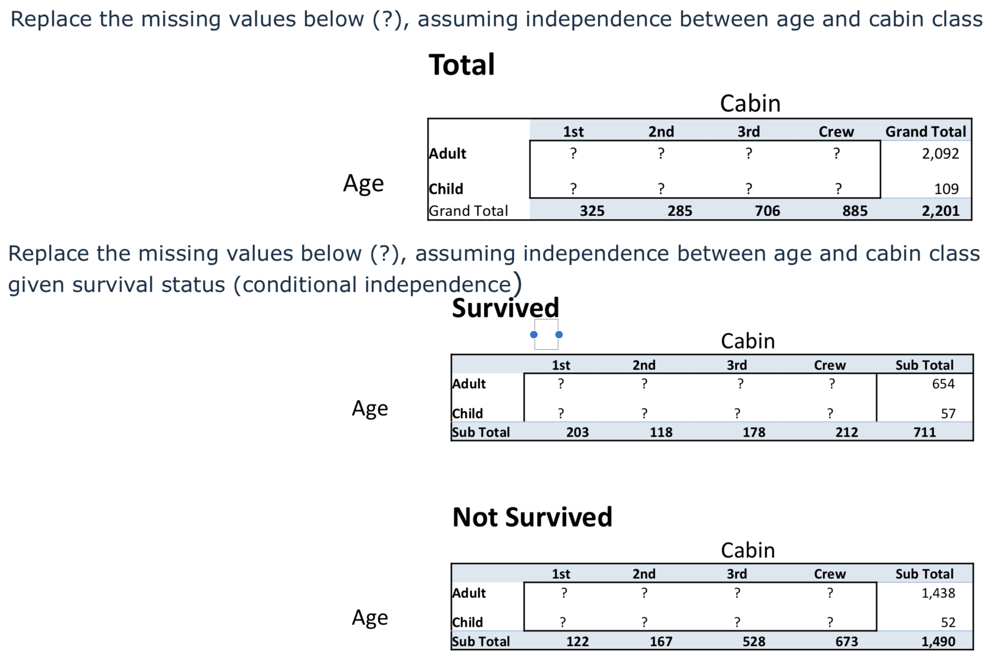

**ANSWER:**

Here, we can derive missing values (called as Joint Probability) from given Marginal Probability.

|  |  |  |  |  |  |
| --- | --- | --- | --- | --- | --- |
| TOTAL |  |  | (Cabin) |  |  |
|  | **1st** | **2nd** | **3rd** | **Crew** | **Sub Total** |
| Adult | 309 | 271 | 671 | 841 | **2092** |
| Child | 16 | 14 | 35 | 44 | **109** |
| Sub Total | **325** | **285** | **706** | **885** | **2201** |

309

(Joint Probability) = 325 * 2092 / 2201

16

(Joint Probability) = 325 * 109 / 2201

Likewise, rule applies to all joint probabilities.

|  |  |  |  |  |  |
| --- | --- | --- | --- | --- | --- |
| SURVIVED |  |  | (Cabin) |  |  |
|  | **1st** | **2nd** | **3rd** | **Crew** | **Sub Total** |
| Adult | 187 | 108 | 164 | 195 | 654 |
| Child | 16 | 10 | 14 | 17 | 57 |
| Sub Total | **203** | **118** | **178** | **212** | **711** |

|  |  |  |  |  |  |
| --- | --- | --- | --- | --- | --- |
| NOT SURVIVED |  |  | (Cabin) |  |  |
|  | 1st | 2nd | 3rd | Crew | Sub Total |
| Adult | 118 | 161 | 509 | 650 | **1438** |
| Child | 4 | 6 | 19 | 23 | **52** |
| Sub Total | **122** | **167** | **528** | **673** | **1490** |

P(A/B)?= P(A) dep. Upon whether they are independent or not?

P(A/B) = P(A intersection B) / P(b) ?= P(A)

P(A intersection B) =P(A) P(B)