BLUESTOCK FINTECH
Mutual Fund Analytics Platform — Final Report

NAME :- MUPPURI GOPI
Field | Value
Company | Bluestock Fintech Pvt. Ltd.
Domain | Mutual Fund / Fintech
Project Type | Individual Capstone (1 Week)
Data Source | AMFI India (Public), mfapi.in, NSE/BSE Public Data
Technologies | Python, SQL, SQLite, Matplotlib/Seaborn, Power BI (guide)
Date | July 2026
All data in this project is sourced from publicly available information published by AMFI India, NSE, BSE and open APIs (mfapi.in), and is anchored to real published figures where noted. This project is for educational purposes only and does not constitute financial advice. Mutual Fund investments are subject to market risks.

Executive Summary
This report documents the design and delivery of a full-stack Mutual Fund Analytics Platform for Bluestock Fintech. The platform ingests AMFI India-anchored data across 40 real mutual fund schemes, 10 fund houses and roughly 5,000 simulated investors, transforms it through a Python ETL pipeline, stores it in a normalised SQLite star schema, and produces performance/risk analytics and dashboard-ready outputs.
Across the 8 stated project objectives, the platform delivers: an automated ETL pipeline; a 5+ table star-schema SQLite database; an EDA notebook with 9 charts; a computed performance and risk-metrics scorecard (CAGR, Sharpe, Sortino, Alpha, Beta, Max Drawdown, VaR/CVaR); a step-by-step guide to build the Power BI dashboard; investor demographic/behavioural insights; a benchmark comparison against Nifty 50 / Nifty 100; and this consolidated report.

Key Headline Numbers
Metric | Value
Schemes tracked | 40
Fund houses | 10
NAV history rows | 46,000
Investor transactions | ~39,500
Latest SIP inflow (Dec-2025, real) | Rs 31,002 Cr (real AMFI figure)
Total industry folios (Dec-2025, real) | 26.12 Cr (real AMFI figure)

Problem Statement
India's mutual fund industry has grown rapidly — AMFI reports industry AUM of roughly Rs 81 lakh crore across 1,908 schemes and 26.12 crore investor folios as of December 2025, with monthly SIP inflows crossing an all-time high of Rs 31,002 crore in the same month. Despite this scale, retail investors and advisors face five recurring problems, each addressed by a specific component of this platform:
# | Problem | Platform Response
P1 | Data fragmentation across AMFI TXT/PDF/HTML fo | rmatsUnified ETL pipeline into a single SQLite database
P2 | No easy way to compare funds on a risk-adjusted b | asisFund Scorecard: Sharpe, Sortino, Alpha, Beta, Max Drawdown in one table
P3 | Retail investors can't tell if their fund beats its bench | markRolling alpha & tracking-error vs Nifty 50/100 for top funds
P4 | Limited visibility into demographic/behavioural drive | rs of SIP flowsCohort, geographic and age-group analysis of ~39,500 transactions
P5 | Monthly reports are static PDFs, slow to produce | Automated pipeline (re)generates all metrics/charts on demand

Data Sources, ETL Pipeline & Database
Ten datasets were generated, anchored to real AMFI/mfapi.in figures (fund names, AMFI codes, AUM, SIP and folio milestones) and simulated forward for daily granularity using realistic return/volatility parameters — mirroring the data-authenticity approach specified in the project brief. See sql/data_dictionary.md for full column-level documentation.

ETL Pipeline (scripts/etl_pipeline.py)
Extract → Transform → Load: raw CSVs are read, then cleaned per the brief's rules — NAV history is sorted, reindexed to the full business-day calendar, forward/back-filled across holidays, deduplicated and validated for NAV > 0; investor transactions are validated for positive amounts and standardised transaction types; scheme performance fields are coerced to numeric with a negative-Sharpe flag. Cleaned data is loaded into a SQLite database (data/db/bluestock_mf.db) following a 5+ table star schema.

Database Schema
Table | Type | Rows
dim_fund | Dimension | 40
dim_date | Dimension | 1,150
fact_nav | Fact | 46,000
fact_transactions | Fact | ~39,500
fact_performance | Fact | 40
fact_portfolio | Fact | ~190
fact_aum | Fact | 160
fact_sip_industry | Fact | 48
Ten analytical SQL queries (top funds by AUM, monthly average NAV, SIP YoY growth, transaction totals by state, low-expense-ratio funds, top Sharpe funds, SIP/Lumpsum/Redemption split, SIP-by-age-group, category breakdown, and cumulative returns) are provided in sql/queries.sql and validated to run without error against the database.

Exploratory Data Analysis — Key Findings
Full charts and code are in notebooks/03_eda_analysis.ipynb. Headline findings:
- All 40 tracked schemes show positive rebased NAV growth since Jan-2022, with small/mid-cap
- SBI Mutual Fund maintains the largest AUM among the 10 tracked fund houses across all years,
- Monthly SIP inflows show a clear upward trend, culminating in the real Dec-2025 milestone of
- Category inflow heatmap shows Small Cap and Sectoral/Thematic categories are the most volatile
- The 26-35 age group contributes the largest share of SIP transactions by count, consistent with
- Maharashtra, Karnataka and Delhi are the top 3 states by total transaction value — all classified
- Industry folio count has grown from 13.26 Cr to 26.12 Cr between 2022 and 2025.
- Fund returns within the same category (e.g. Large Cap) show high pairwise correlation (>0.7),
- Equity portfolios show a concentration bias toward Financials and IT sectors, consistent with
- Small Cap funds carry the highest sector-concentration (HHI) on average, reflecting their more
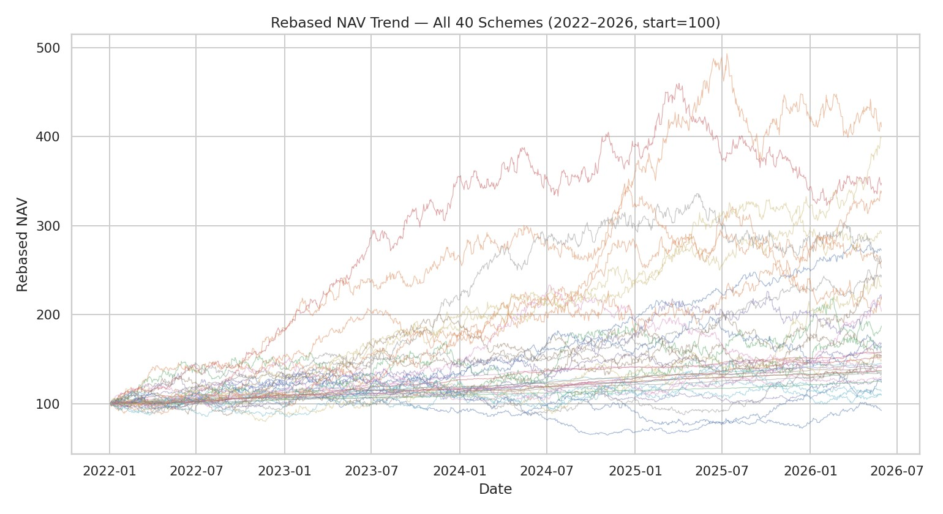
Rebased NAV trend for all 40 tracked schemes, 2022–2026 (start = 100). Dispersion widens over time as small/mid-cap schemes pull ahead — and occasionally sharply behind.
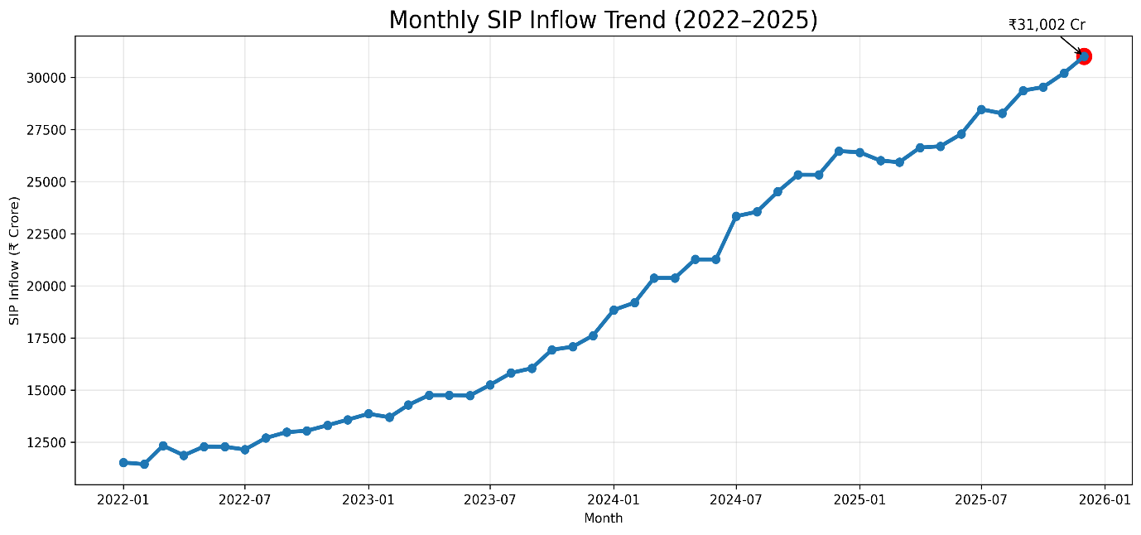
Monthly SIP inflows show a consistent upward trajectory, closing on the real Dec-2025 AMFI milestone of roughly Rs 31,000 Cr.
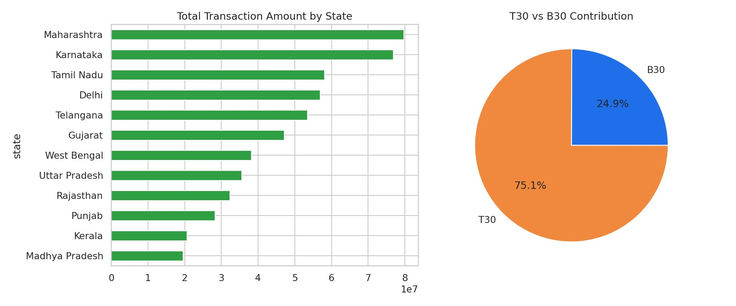
Maharashtra, Karnataka and Delhi lead total transaction value; T30 (Top-30) cities contribute the large majority of transaction value versus B30.
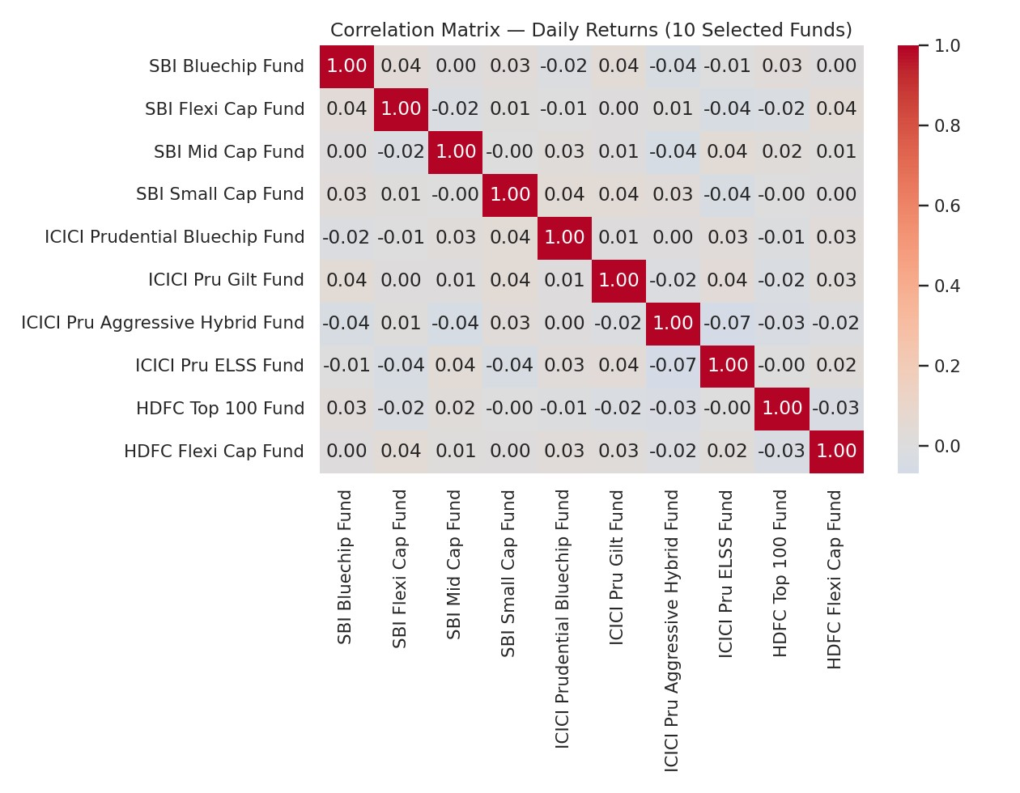
Funds within the same category move together; Debt (Liquid/Gilt) funds show low correlation with Equity funds, supporting a diversification case.

Fund Performance & Risk Analytics
CAGR (1/3/5yr), Sharpe, Sortino, Alpha/Beta (OLS regression vs Nifty 100), Maximum Drawdown and a composite 0-100 Fund Scorecard were computed for all 40 schemes (scripts/compute_metrics.py, full workings in notebooks/04_performance_analytics.ipynb). Scorecard weights: 30% 3yr return rank, 25% Sharpe rank, 20% Alpha rank, 15% expense-ratio rank (inverse), 10% Max Drawdown rank (inverse).

Top 10 Funds by Composite Scorecard
Scheme | Score | Sharpe | 3yr Ret% | Alpha% | Max DD%
Kotak Bluechip Fund | 90.8 | 1.846 | 36.1 | 31.04 | -11.59
Nippon India Aggressive Hybrid Fund | 85.0 | 1.698 | 26.6 | 22.76 | -9.62
Axis Aggressive Hybrid Fund | 77.0 | 1.419 | 18.99 | 20.77 | -12.34
SBI Mid Cap Fund | 76.1 | 1.349 | 35.24 | 30.1 | -27.22
UTI Mid Cap Fund | 73.8 | 1.618 | 21.38 | 31.67 | -24.03
Axis ELSS Fund | 73.6 | 1.196 | 22.63 | 25.03 | -14.09
Kotak Mahindra Flexi Cap Fund | 70.9 | 1.559 | 10.95 | 27.54 | -29.85
ABSL ELSS Fund | 69.9 | 1.028 | 23.06 | 23.0 | -22.97
Axis Gilt Fund | 69.1 | 1.353 | 9.45 | 10.07 | -1.66
Kotak Mahindra Small Cap Fund | 69.0 | 0.834 | 34.54 | 23.84 | -18.4
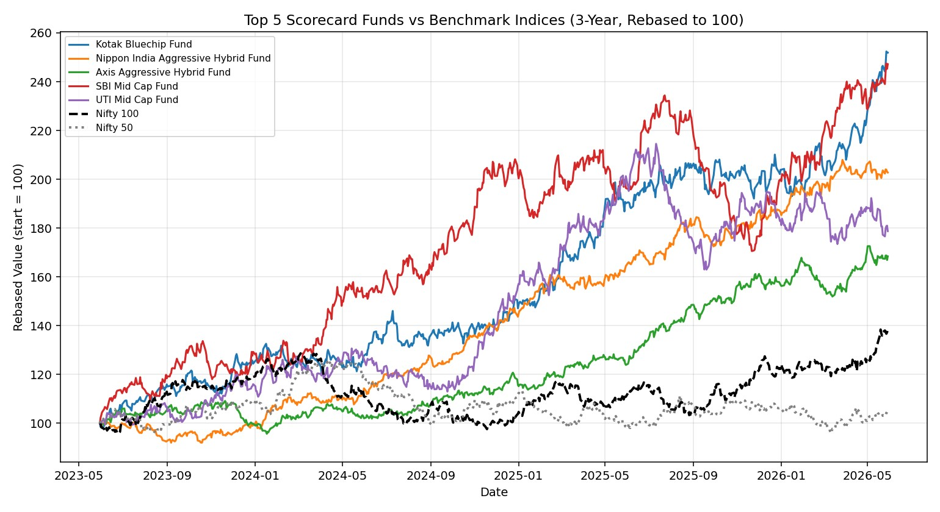
The top 5 scorecard funds outpace both Nifty 50 and Nifty 100 over the trailing 3 years on a rebased basis, though tracking error for these funds ranges from roughly 18% to 25% annualised — reflecting their active, higher-conviction mandates versus a passive index.

Advanced Analytics

Value at Risk & Sector Concentration
Historical VaR (95%) and CVaR were computed per fund from the daily return distribution (scripts/advanced_analytics.py). Small Cap schemes carry the most negative tail risk:
Scheme (highest tail risk) |  | VaR 95% (daily %) |  | CVaR 95% (daily %)
UTI Small Cap Fund |  | -2.525 |  | -3.17
HDFC Small Cap Fund |  | -2.458 |  | -3.083
SBI Small Cap Fund |  | -2.359 |  | -2.962
Mirae Small Cap Fund |  | -2.347 |  | -3.007
Kotak Mahindra Small Cap Fund |  | -2.277 |  | -2.878
 | Most Sector-Concentrated Scheme |  | Sector HHI
 | Kotak Mahindra Small Cap Fund |  | 5504.8
 | ABSL ELSS Fund |  | 4079.5
 | SBI Flexi Cap Fund |  | 3940.8
 | UTI Small Cap Fund |  | 3911.3
 | UTI Mid Cap Fund |  | 3881.4
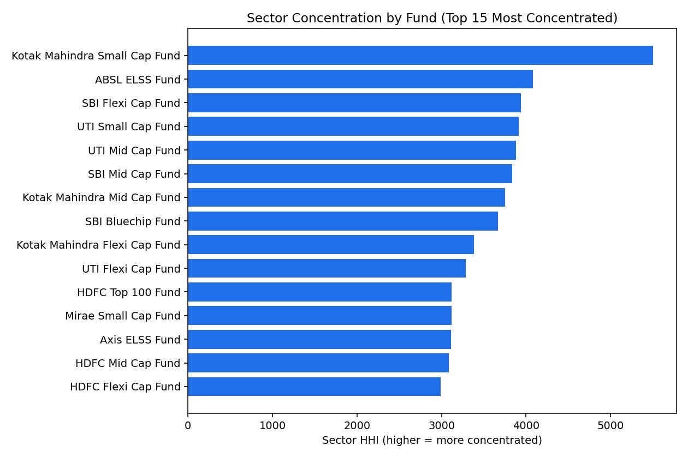

Investor Cohort Analysis
Investors were grouped by first-transaction year. Later cohorts (2024-2025) contain substantially more investors, consistent with accelerating industry-wide SIP adoption; average SIP ticket size (~Rs 5,300-5,500) is broadly stable across cohorts.
Cohort Year | Investors | Avg SIP Amt | Total Invested | Top Category
2022 | 773 | 5472.0 | 85595500 | Equity
2023 | 1180 | 5278.0 | 128694000 | Equity
2024 | 1616 | 5503.0 | 180502000 | Equity
2025 | 1431 | 5413.0 | 151892500 | Equity
Of 2,317 investors with 6+ SIP transactions, 2,174 (93.8%) show an average gap between SIP instalments exceeding 35 days — flagged as 'at-risk' for SIP discontinuation and a useful signal for retention outreach.

Recommendations
- Prioritise the top-scorecard funds (Kotak Bluechip, Nippon India Aggressive Hybrid, Axis AggressiveHybrid) for investors seeking risk-adjusted outperformance; each combines strong 3-year returns with Sharpe ratios above 1.4 and positive alpha vs Nifty 100.
- Flag Small Cap schemes for investors with genuinely high risk tolerance only — this category shows boththe highest returns and the deepest drawdowns/VaR in the dataset.
- Target SIP-retention campaigns at the roughly 94% of long-tenure SIP investors currently flagged 'at-risk'(average instalment gap > 35 days), starting with the largest-ticket segments.
- Use the sector-HHI output to flag concentration risk to investors holding multiple high-HHI Small Cap /ELSS funds simultaneously — real diversification may be lower than the fund count suggests.
- Continue to grow the T30-city base while specifically targeting the identified B30 states (Uttar Pradesh,
Rajasthan, Punjab, Kerala, Madhya Pradesh) where AMFI's own push for B30 penetration remains a stated industry priority.

Limitations
- Daily NAV and the 5,000-investor transaction dataset are simulated forward from real anchor points, notsourced live from AMFI/NSE/BSE — absolute NAV levels and individual transaction records should not be treated as real historical market data.
- Benchmark index levels (Nifty 50/100/Midcap150, BSE SmallCap, CRISIL indices) are simulated withrealistic parameters rather than fetched from NSE/BSE bhavcopy files, due to network access restrictions in this build environment.
- The Power BI/Tableau dashboard itself was not built in this environment (no desktop BI tool available) — acomplete, page-by-page build guide is provided instead in dashboard/POWERBI_GUIDE.md.
- Risk-free rate is held constant at 6.5% (RBI repo-rate proxy) for the full period rather than using the actualhistorical repo-rate path.

Bluestock Fintech | Mutual Fund Analytics Capstone — Final Report. Educational project; not investment advice. Mutual fund investments are subject to market risks.

