
Department of Artificial Intelligence & Data Science

PLANT SPECIES DETECTION USING DEEP LEARNING
Submitted in partial fulfilment of the requirements for the degree of

BACHELOR OF TECHNOLOGY
In
ARTIFICIAL INTELLIGENCE & DATA SCIENCE
Submitted By
Team Members
- Gopinath N (814724243046)
- Dhayanithi R (814724243038)
- Abishake T (814724243006)
- Gowtham R (814724243048)

Under the Guidance of
Mrs. R. Kalaiyarasi
SRM TRP ENGINEERING COLLEGE
Academic Year: 2026-27 (ODD)

Department of Artificial Intelligence & Data Science
CERTIFICATE
This is to certify that Gopinath N, Dhayanithi R and Gowtham R, Abishake T from Third year AI&DS has successfully completed her work titled “Mini Project Title” at SRM TRP Engineering, Trichy in the partial fulfillment of the Bachelor’s of Technology in Artificial Intelligence & Data Science.

Mrs. R. Kalaiyarasi  (Faculty In-charge)  Artificial Intelligence & Data Science | Dr. R. Perumal Raja  (Head of Department)  Artificial Intelligence & Data Science

ACKNOWLEDGEMENT
It is with sincere gratitude and deep appreciation that I take this opportunity to acknowledge the invaluable support and guidance I have received throughout the course of this project. This journey has been both intellectually enriching and personally rewarding, significantly enhancing my understanding of the subject and its practical applications.
I would like to express my heartfelt thanks to all those who provided guidance, encouragement, and constructive feedback during the development of this project. Their insights and support were instrumental in shaping the direction and quality of the work.
I also extend my appreciation to the department for fostering an environment that promotes learning, innovation, and academic growth. The resources and opportunities provided played a vital role in the successful completion of this project. A special note of thanks goes to the supporting staff for their cooperation and timely assistance, which ensured that the process remained smooth and efficient at every stage.
Finally, I would like to express my deepest gratitude to my parents for their constant support, encouragement, and belief in my abilities. Their motivation has been a source of strength throughout this journey. This project has not only strengthened my knowledge but has also emphasized the importance of dedication, perseverance, and continuous learning. I remain sincerely thankful to everyone who contributed, directly or indirectly, to the successful completion of this project.
Academic Year: 2026-2027
Gopinath N
Dhayanithi R
Gowtham R
Abishake T

TABLE OF CONTENTS
Sr. No. | Title | Page No.
1 | Acknowledgement | 3
2 | Abstract | 5
3 | Introduction | 6
4 | System Requirements | 7
5 | Methodology | 8–13
6 | Implementation | 14
7 | Conclusion | 15
8 | References | 15

Note: Page numbers follow the original report and may shift when opened in Word. Right-click and update fields, or edit this table manually before final submission. Team details and implementation screenshots may be completed before final submission.

ABSTRACT
Plant species identification is an important task in agriculture, biodiversity monitoring, forestry and environmental education. Traditionally, identifying a plant requires botanical knowledge and careful observation of characteristics such as leaf shape, venation, colour, texture and arrangement. Manual identification can be time-consuming and may be difficult for beginners, especially when two species have similar visual features. This mini project proposes a deep learning-based image classification system that predicts a plant species from an input leaf or plant image.
The proposed system uses a Convolutional Neural Network (CNN), a deep learning architecture designed to learn spatial patterns from images. A labelled image dataset is collected and organized into species-wise folders. The images are checked, resized to a fixed dimension and normalized before being supplied to the network. Data augmentation techniques such as rotation, horizontal flipping and zooming can be applied to improve the model’s ability to recognize images captured under different conditions.
The CNN learns features in stages. Early convolutional layers identify simple patterns such as edges and curves, while deeper layers learn more complex patterns such as leaf outlines, vein structures and textures. Pooling layers reduce the spatial dimensions, and dense layers combine the learned features to produce class scores. A softmax output layer converts these scores into probabilities for the selected plant species.
The dataset is divided into training, validation and testing subsets. The model is trained using categorical cross-entropy loss and an optimizer such as Adam. Performance can be measured using test accuracy, precision, recall, F1-score and a confusion matrix. The system can be extended into a simple web or mobile application where a user uploads a plant image and receives the predicted species name with its confidence score.
The expected outcome is a working prototype that demonstrates how deep learning can support plant identification. Actual accuracy depends on dataset quality, the number of species, image diversity and training configuration. The project is intended as an educational decision-support tool and not as a replacement for expert botanical verification.

INTRODUCTION

1.1 Background
Plants are essential to ecosystems and human life. They provide food, medicine, oxygen, materials and habitats for other organisms. Correct identification of plant species is useful in crop management, conservation, ecological surveys and scientific research. However, plant identification from visual appearance can be challenging because leaf shape, size and colour may change with age, season, disease and environmental conditions.

1.2 Need for the Project
A beginner may not know the botanical terms required to compare leaf margins, venation patterns or arrangements. Field guides and manual search methods require time and experience. A computer vision system can assist by comparing an uploaded image with visual patterns learned from labelled examples. Such a tool can make introductory plant identification more accessible and consistent.

1.3 Deep Learning Approach
Deep learning is a branch of machine learning that uses multi-layer neural networks to learn representations directly from data. CNNs are widely used for image classification because they preserve spatial relationships and learn filters that respond to visual patterns. Unlike traditional approaches that depend on manually designed image features, a CNN learns useful features during training.

1.4 Problem Definition
The problem is to develop a system that accepts a digital image of a plant leaf or plant part and predicts one species from a predefined set of classes. The system must standardize the image, extract discriminative visual features and return the class with the highest predicted probability. The quality of the result depends on the classes represented in the training dataset.

1.5 Objectives
- Collect and organize labelled plant images.
- Preprocess images into a consistent input format.
- Build and train a CNN-based classifier.
- Evaluate the model on images not used for training.
- Display the predicted species and confidence score.

1.6 Scope
The prototype focuses on a limited set of species represented in the selected dataset. It does not guarantee identification for species outside those classes, and it may be affected by poor lighting, blurred images, occlusion or background clutter.

SYSTEM REQUIREMENTS
Category | Requirement | Description
Operating System | Windows / Linux / macOS | A compatible environment for Python and deep learning libraries.
Processor | Intel i5 / AMD Ryzen 5 or above | A multi-core CPU supports image preprocessing and model execution.
GPU (recommended) | NVIDIA CUDA-compatible GPU | Accelerates CNN training; a CPU can be used for small experiments.
RAM | Minimum 8 GB; 16 GB recommended | Supports dataset loading, batching and model training.
Storage | At least 5–10 GB free | Stores images, notebooks, trained model and outputs; larger datasets need more.
Language | Python 3.x | Used for data handling, model development and evaluation.
Framework | TensorFlow/Keras or PyTorch | Provides CNN layers, training loops and model saving.
Image Processing | Pillow / OpenCV | Used to load, resize and inspect images.
Data Libraries | NumPy, Pandas | Used for numerical operations and dataset metadata.
Visualization | Matplotlib, Seaborn | Used to plot accuracy, loss and confusion matrix.
IDE | Jupyter Notebook / VS Code | Used to write, run and debug the project.
Dataset | PlantVillage or a curated leaf image dataset | Provides labelled images for supported plant classes.

Software installation (example)
Python, TensorFlow, NumPy, Matplotlib and scikit-learn can be installed in a virtual environment. The exact package versions should be recorded in the final implementation so that the experiment can be reproduced.

METHODOLOGY

2.1 Overview
The methodology follows a complete image classification pipeline: dataset selection, data inspection, preprocessing, dataset splitting, CNN design, model training, evaluation and prediction. Each stage contributes to the reliability of the final classifier. The same preprocessing operations used during training must also be applied to new input images.

2.2 Overall System Workflow
Stage | Operation | Output
1 | Collect labelled images | Species-wise image folders
2 | Inspect and clean data | Valid and consistent images
3 | Resize and normalize | Numerical image tensors
4 | Split dataset | Training, validation and test sets
5 | Train CNN | Learned model weights
6 | Evaluate model | Metrics and confusion matrix
7 | Predict new image | Species label and confidence

2.3 Dataset Selection
A suitable dataset should contain clear images and reliable species labels. PlantVillage is a commonly used public dataset for plant image classification and includes images of crop leaves with healthy and diseased categories. If the project focuses only on species, labels should be mapped to plant names and disease-condition categories should be handled consistently. A separate field-image dataset is useful for testing images captured in natural backgrounds.
Dataset considerations:
- Include sufficient images for every selected species.
- Avoid incorrect or duplicate labels.
- Keep class counts reasonably balanced.
- Record the dataset source and usage terms.
- Reserve test images that are not used during training or tuning.

METHODOLOGY – DATA PREPROCESSING

2.4 Data Organization
Images should be arranged into folders named after their target classes. For example, a dataset may contain folders such as Mango, Neem, Tulsi and Hibiscus. The folder name can be used as the label by a directory-based data loader. The selected species list must be fixed before training so that class indices remain consistent.

2.5 Image Preprocessing
Images may have different dimensions, formats and colour profiles. The following steps standardize them before training:
- Image loading: Read each file and convert it to RGB so that all images have three colour channels.
- Resizing: Resize every image to a fixed size, for example 224 × 224 pixels.
- Normalization: Convert pixel values from the 0–255 range to the 0–1 range by dividing by 255.
- Label encoding: Convert species names into integer class indices or one-hot encoded vectors.
- Data validation: Skip unreadable files and verify that each image has a valid label.

2.6 Data Augmentation
Augmentation creates modified training examples and helps the model learn that a species can appear at different orientations and scales. Possible transformations include small rotations, horizontal flips, zooming, width/height shifts and mild brightness changes. Augmentation should be applied only to training images. Validation and test images should remain unchanged apart from required resizing and normalization.

2.7 Dataset Splitting
A practical split is 70% training, 15% validation and 15% testing, using stratified sampling where possible so each class is represented in all subsets. The training set updates model weights, the validation set helps select hyperparameters and monitor overfitting, and the test set provides a final independent evaluation. When images come from the same plant or photo session, related images should be kept in one split to reduce data leakage.

Preprocessing result
The output of this stage is a collection of consistently sized image tensors paired with class labels, ready to be passed to the CNN.

METHODOLOGY – CNN MODEL ARCHITECTURE

2.8 Convolutional Neural Network
A CNN is composed of layers that learn visual features from image data. Convolutional filters slide across the image and produce feature maps. Activation functions introduce non-linearity, while pooling layers reduce feature-map dimensions and help control computation. Dense layers use the extracted features to classify the input.
Proposed model structure:
Layer | Purpose | Example configuration
Input | Receives standardized image | 224 × 224 × 3
Conv2D + ReLU | Learns edges and basic patterns | 32 filters, 3 × 3
MaxPooling2D | Reduces spatial dimensions | 2 × 2 pool
Conv2D + ReLU | Learns textures and vein patterns | 64 filters, 3 × 3
MaxPooling2D | Downsamples feature maps | 2 × 2 pool
Conv2D + ReLU | Learns higher-level shapes | 128 filters, 3 × 3
GlobalAveragePooling | Summarizes feature maps | One value per channel
Dense + Dropout | Combines features; reduces overfitting | 128 units; dropout 0.3
Output Dense | Predicts species classes | Softmax; N classes

2.9 Output Layer
For N plant species, the final dense layer contains N units with softmax activation. The output is a probability distribution across the supported classes. The class with the highest probability is selected as the predicted label. A confidence score is useful for displaying model certainty, but it is not a guarantee that the prediction is correct.

2.10 Alternative: Transfer Learning
For a small dataset, a pre-trained model such as MobileNetV2 or EfficientNet can be used as a feature extractor. The final classification layer is replaced with a layer matching the project classes. Initially, the pre-trained base may be frozen; selected layers can later be fine-tuned with a low learning rate.

METHODOLOGY – MODEL TRAINING

2.11 Training Procedure
During training, the CNN receives a batch of images and produces class probabilities. The predicted probabilities are compared with the true labels using a loss function. Backpropagation calculates gradients, and the optimizer updates model parameters to reduce the loss. This process is repeated over multiple epochs.
Training configuration (starting point):
Parameter | Suggested value | Purpose
Image size | 224 × 224 | Fixed input dimensions
Batch size | 32 | Images processed in one update
Epochs | 20–30 initially | Number of passes over training data
Optimizer | Adam | Adaptive gradient-based optimization
Learning rate | 0.001 initially | Controls weight update size
Loss | Categorical cross-entropy | Suitable for multi-class labels
Metric | Accuracy | Tracks correct predictions
Callbacks | Early stopping; model checkpoint | Stops unnecessary training and saves best model

2.12 Loss Function
Categorical cross-entropy measures the difference between the true class distribution and the model’s predicted probability distribution. For a single correct class, the loss penalizes the model when it assigns a low probability to the correct label. If labels are stored as integer class indices, sparse categorical cross-entropy can be used instead.

2.13 Overfitting Control
A model may memorize training images rather than learn general plant features. Warning signs include training accuracy increasing while validation accuracy stops improving, or training loss decreasing while validation loss rises. Data augmentation, dropout, early stopping, balanced classes and transfer learning can help reduce overfitting.

METHODOLOGY – MODEL EVALUATION

2.14 Evaluation Strategy
After training, the saved model is evaluated on the test subset, which must not have been used for parameter tuning. Overall accuracy gives the proportion of correctly classified test images. However, accuracy alone may hide poor performance on less frequent classes, so class-wise metrics should also be examined.
Evaluation metrics:
Metric | Meaning
Accuracy | Correct predictions divided by total predictions.
Precision | Of the images predicted as a class, the proportion that truly belongs to that class.
Recall | Of the images belonging to a class, the proportion correctly identified.
F1-score | Harmonic mean of precision and recall.
Confusion matrix | Shows true classes against predicted classes and highlights common misclassifications.

2.15 Error Analysis
Misclassifications should be reviewed using example images and the confusion matrix. Similar leaf outlines, overlapping species characteristics, poor focus, shadows, damaged leaves and complex backgrounds can lead to incorrect predictions. If errors are concentrated in one class, collect more diverse examples for that class or review its labels.

2.16 Fair and Reliable Use
The model should display only the classes it was trained to recognize. If the input is unrelated to plants or belongs to an unsupported species, the system may still return a known class with misleading confidence. A practical application should include a warning that predictions are estimates and should be verified by a knowledgeable person.

Reporting results
Record the dataset name and version, class list, train/validation/test split, image dimensions, model architecture, epoch count, software versions and measured test metrics. Do not report an assumed accuracy as an experimental result.

METHODOLOGY – PREDICTION AND DEPLOYMENT

2.17 Prediction on a New Image
When a user selects an image, the application loads it, converts it to RGB, resizes it to the training input dimensions and normalizes its pixel values. The processed image is passed to the trained model. The model returns probabilities for all supported species, and the application displays the class with the highest probability.
Prediction sequence:
- User uploads or captures a plant image.
- The application validates the file type and image dimensions.
- The image is resized and normalized using the same training pipeline.
- The saved CNN model performs inference.
- The highest-probability class is selected.
- The species label and confidence score are displayed.

2.18 Possible Deployment
A basic prototype can be built using Streamlit or Flask as a simple web interface. The trained model is loaded once when the application starts. A user interface can include an image upload control, preview area, prediction button and result section. For mobile deployment, the model can later be converted to TensorFlow Lite or another supported mobile format.

2.19 Challenges
- Similar-looking species may have overlapping leaf features.
- Natural backgrounds can distract the model.
- Images captured in different seasons may vary in colour and shape.
- Unequal class counts can bias predictions.
- Low-resolution, blurred or partially hidden leaves reduce useful information.
- A limited dataset may not represent real-world conditions.

2.20 Optimization
Use more diverse field images, balance the dataset, tune the learning rate and batch size, apply suitable augmentation and consider transfer learning. Use a separate test set and inspect class-wise errors after every major change. Model size and inference speed should also be considered if the system is intended for mobile devices.

2.21 Methodology Summary
The workflow converts labelled plant photographs into a trained CNN classifier. Standardized preprocessing, controlled training and independent evaluation provide a repeatable approach. The prediction interface then applies the same preprocessing to a new image and returns a species estimate.

IMPLEMENTATION

3.1 Tools and Project Structure
The implementation can be organized as follows. The exact folder names may be adapted to the selected dataset.
plant_species_detection/
dataset/
train/
Mango/ Neem/ Tulsi/ ...
validation/
Mango/ Neem/ Tulsi/ ...
test/
Mango/ Neem/ Tulsi/ ...
model/
plant_cnn.keras
train.py
app.py

3.2 Example CNN Training Code
The listing below is an illustrative example that follows the architecture and training configuration described in Chapter 2. The code in the original PDF was truncated, so this version has been reconstructed from the methodology.
import tensorflow as tf
from tensorflow.keras import layers, models

IMG_SIZE = (224, 224)
BATCH = 32

train_ds = tf.keras.utils.image_dataset_from_directory(
"dataset/train", image_size=IMG_SIZE, batch_size=BATCH)
val_ds = tf.keras.utils.image_dataset_from_directory(
"dataset/validation", image_size=IMG_SIZE, batch_size=BATCH)
class_names = train_ds.class_names

augment = tf.keras.Sequential([
layers.RandomFlip("horizontal"),
layers.RandomRotation(0.1),
layers.RandomZoom(0.1),
])

model = models.Sequential([
layers.Input(shape=(224, 224, 3)),
augment,
layers.Rescaling(1.0 / 255),
layers.Conv2D(32, 3, activation="relu"),
layers.MaxPooling2D(),
layers.Conv2D(64, 3, activation="relu"),
layers.MaxPooling2D(),
layers.Conv2D(128, 3, activation="relu"),
layers.GlobalAveragePooling2D(),
layers.Dense(128, activation="relu"),
layers.Dropout(0.3),
layers.Dense(len(class_names), activation="softmax"),
])

model.compile(
optimizer=tf.keras.optimizers.Adam(learning_rate=0.001),
loss="sparse_categorical_crossentropy",
metrics=["accuracy"])

callbacks = [
tf.keras.callbacks.EarlyStopping(patience=5, restore_best_weights=True),
tf.keras.callbacks.ModelCheckpoint("model/plant_cnn.keras", save_best_only=True),
]

model.fit(train_ds, validation_data=val_ds, epochs=25, callbacks=callbacks)

3.3 Expected Output
Image loaded : tulsi_leaf_01.jpg
Preprocessing : RGB, 224 x 224, normalized (0-1)

Class probabilities:
Tulsi 0.91
Neem 0.05
Mango 0.03
Hibiscus 0.01

Predicted species : Tulsi
Confidence : 0.91
Sample output (illustrative only; not a measured result).
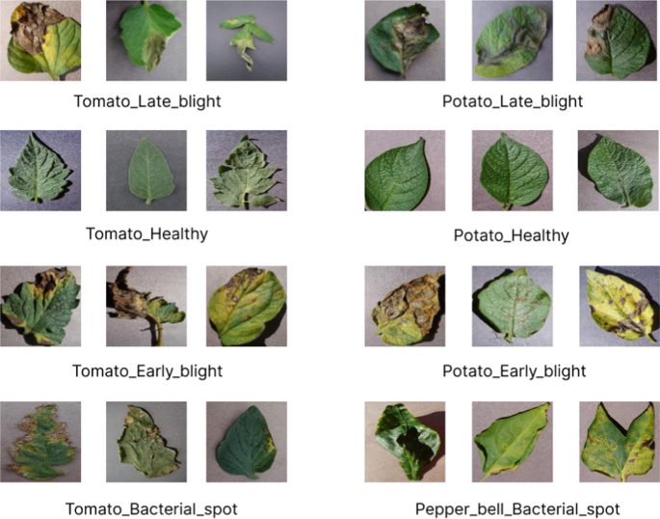  Figure 3.1: Sample plant leaf images (healthy and diseased classes) | 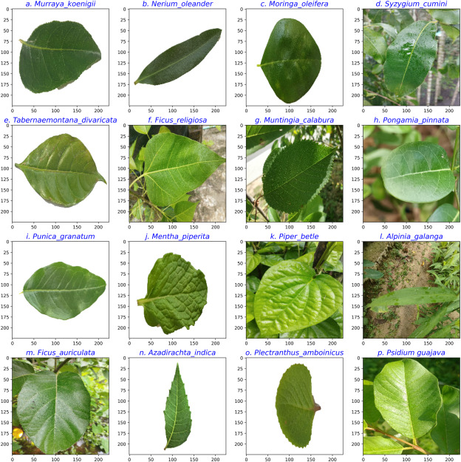  Figure 3.2: Sample leaf images of different plant species

CONCLUSION
The Plant Species Detection using Deep Learning mini project presents a computer vision approach for identifying plant species from leaf or plant images. The proposed CNN pipeline includes dataset collection, image preprocessing, augmentation, model design, training, evaluation and prediction. CNN layers learn visual features such as leaf edges, textures and vein patterns, which are useful for distinguishing between the classes represented in the dataset.
The project demonstrates how a trained image classifier can be connected to a simple user interface to make predictions from newly uploaded images. Its usefulness depends on the quality, diversity and correctness of the training data. Test-set evaluation and error analysis are necessary before the system can be considered reliable. The model should be treated as an assistive tool, because a prediction may be incorrect when an image is unclear or the species is not included in the training classes.
Future enhancements may include adding more native and medicinal plant species, collecting images in natural outdoor conditions, using transfer learning, building an Android application, and displaying additional botanical information such as common name, scientific name and habitat. A confidence threshold and an unknown-class rejection mechanism can also help reduce misleading predictions.

REFERENCES
- Hughes, D. P., and Salathé, M. “An open access repository of images on plant health to enable the development of mobile disease diagnostics.” arXiv:1511.08060, 2015. (PlantVillage dataset background).
- TensorFlow. “Image classification.” https://www.tensorflow.org/tutorials/images/classification
- Keras Documentation. “Image data loading and preprocessing.” https://keras.io/api/data_loading/image/
- PyTorch Documentation. “torchvision — Datasets and Models.” https://pytorch.org/vision/stable/index.html
- OpenCV Documentation. https://docs.opencv.org/
- Goodfellow, I., Bengio, Y., and Courville, A. Deep Learning. MIT Press, 2016. https://www.deeplearningbook.org/
- PlantVillage Dataset. https://plantvillage.psu.edu/

Submission reminder: Fill in team member names, verify the dataset and class list used, and add genuine screenshots and measured evaluation results from your implementation.

