AI-Driven Cyber Anomaly Detection and Secure
Audit Logging Framework

PROJECT REPORT PHASE II

Submitted by
ABDUL PATHIAQ A (22TH0102)
DAVID RAJ M (22TH0112)
GOPINATH G (22TH0116)
JAYAPRADAP J (22TH0122)
Under the guidance of Mrs.R.RANJANI.,M.E.,MBA.,(Ph.d).,M.I.S.T.E.,
Senior Assistant Professor,
Department of Information Technology.
To the Pondicherry University, in partial fulfilment of the requirement for
the award for degree
BACHELOR OF TECHNOLOGY
IN

INFORMATION TECHNOLOGY
DEPARTMENT OF INFORMATION TECHNOLOGY
CHRIST COLLEGE OF ENGINEERING AND TECHNOLOGY
PUDUCHERRY - 605 010
MAY-2026

CHRIST COLLEGE OF ENGINEERING AND TECHNOLOGY PUDUCHERRY – 605 110
DEPARTMENT OF INFORMATION TECHNOLOGY

BONAFIDE CERTIFICATE

This is to certify that the Project Phase-II Work titled “AI-DRIVEN CYBER ANOMALY DETECTION AND SECURE LOGGING FRAMEWORK ” is a Bonafide record of the work done by ABDUL PATHIAQ.A[22TH0102], DAVIDRAJ.M[22TH0112],GOPINATH.G[22TH0116],JAYAPRADAP.J[22TH0122] in partial fulfilment of the requirement for the award of the degree of Bachelor of Technology in Information Technology of the Pondicherry University and this work has not been submitted for the award of any degree of this/any other institution.

PROJECT GUIDE PROJECT COORDINATOR Mrs.R.RANJANI.,M.E.,MBA.,(Ph.D).,M.I.S.T.E Mr.MANI.J., M.E.,(Ph.D).,M.I.S.T.E
Senior Assistant Professor Head of the Department

Submitted for the University Examination held on 2026.

INTERNAL EXAMINER EXTERNAL EXAMINER

ACKNOWLEDGEMENT

It gives a great pleasure in taking privilege to express our gratitude to one and all who have extended their kind gesture to finish our Project work. First and foremost, we would like to express our great gratitude to our beloved the Chairman and Managing Director of our college Dr.SAMPAUL.,M.E.,Ph.D.,Principal Dr.A.SIVAKUMAR.,M.E.,Ph.D,
M.I.S.T.E., Christ of Engineering and Technology, Puducherry.
I express my sincere thanks to our Project guide Mrs.R.RANJANI., M.E.,MBA.,(Ph.D).,M.I.S.T.E Senior Assistant Professor, Department of Information Technology for his valuable guidance, keep interest and timely suggestions given during the entire project.
We are thankful and grateful to our Project Coordinator and Head of the Department Mr.MANI.J.,M.E.,(Ph.D).,M.I.S.T.E., Department of Information Technology whose great support valuable suggestions eased our work process during the span of this project.
We are thanking to all the Staff Members, of the Department of Information Technology for their fullest support and encouragement. Above all we wish to express our wholehearted gratitude to our family members and friends who stood with us throughout the span of this project work. In the praise Almighty we thank one and all.

CHAPTER NO. TITLE PAGE NO.

ABSTRACT

CHAPTER-1

- INTRODUCTION 1
  - OVERVIEW 1
  - ARTIFICIAL INTELLIGENCE AND MACHINE LEARNING 2
  - CYBER ANOMALY DETECTION TECHNIQUES 4
  - DEEP LEARNING OVERVIEW AND FUNCTIONALITY 5
  - COMMON AI FRAMEWORKS AND LIBRARIES 6
  - INTEGRATION OF AI MODEL WITH SECURE AUDIT LOGGING 8
  - OBJECTIVE 8
CHAPTER-2
- LITERATURE REVIEW 10
  - EXISTING STUDIES ON CYBER ANOMALY DETECTION 11
  - METHODS USED IN PREVIOUS WORKS 11
  - LIMITATIONS IN EXISTING APPROACHES 12
  - RESEARCH GAP AND IMPROVEMENT AREA 13
  - SUMMARY 14

CHAPTER-3
- EXISTING SYSTEM 16
  - CHALLENGES IN EXISTING SYSTEMS 16
  - SCOPE FOR IMPROVEMENT, FUNCTIONALITY AND FEATURES 16
  - APPLICATION IN REAL-WORLD CYBERSECURITY SCENARIOS 17
CHAPTER-4
- PROBLEM DEFINITON 19
  - IDENTIFICATION OF THE PROBLEM 19
  - NEED FOR AI-BASED CYBER ANOMALY DETECTION SYSTEM 19
  - OBJECTIVES AND EXPECTED OUTCOME 20
CHAPTER-5
- PROPOSED WORK 21
  - OVERVIEW 21
  - MODULE DESCRIPTION 21
  - DATA COLLECTION MODULE 22
  - DATA PROCESSING AND FEATURE EXTRACTION MODULE 23
  - AI MODEL (ML/DL) MODULE 24
  - SECURE AUDIT LOGGING MODULE 25
  - RESULT AND ALERT DISPLAY MODULE 26

CHAPTER-6
- CONCLUSION 38
CHAPTER-7
- REFERENCES 41

ABSTRACT
In the modern digital era, cybersecurity has become a critical concern due to the rapid increase in sophisticated cyber threats and attacks. Traditional security systems often fail to detect unknown or zero-day attacks, as they rely heavily on predefined signatures and static rules. To address these limitations, this project proposes an AI-Driven Cyber Anomaly Detection and Secure Audit Logging Framework that leverages advanced machine learning and deep learning techniques to identify unusual patterns and potential threats in network environments.The proposed system focuses on real-time anomaly detection by analyzing large volumes of network data and user behavior. Machine learning algorithms are trained on historical datasets to recognize normal patterns and detect deviations that may indicate malicious activities such as intrusions, unauthorized access, or data breaches. Deep learning models further enhance detection accuracy by capturing complex relationships within the data, enabling the system to identify even subtle anomalies.In addition to anomaly detection, the framework integrates a secure audit logging mechanism to ensure that all detected events and system activities are recorded in a reliable and tamper-proof manner. This is achieved through the use of secure storage techniques such as encryption and blockchain-based logging, which prevent unauthorized modification of logs and ensure data integrity. These logs play a crucial role in forensic analysis, compliance, and incident investigation.The system is designed with modular architecture, including data collection, preprocessing, anomaly detection, and secure logging modules, allowing scalability and flexibility in real-world applications. It can be deployed in various environments such as enterprise networks, cloud systems, and critical infrastructures to enhance overall security posture. Overall, this framework aims to improve the efficiency and accuracy of cyber threat detection while ensuring secure and trustworthy logging of events. By combining artificial intelligence with secure logging techniques, the proposed system provides a robust solution for modern cybersecurity challenges and contributes to building a safer digital ecosystem.

CHAPTER 1
INTRODUCTION

OVERVIEW
In Cybersecurity has become one of the most important aspects of modern digital systems due to the rapid growth of internet usage, cloud computing, and interconnected devices. Organizations and individuals increasingly rely on digital platforms for communication, data storage, and financial transactions. However, this digital transformation has also led to a significant rise in cyber threats such as malware attacks, phishing, ransomware, and unauthorized access. Traditional security systems, which mainly depend on signature-based detection methods, are often ineffective against new and evolving threats. Therefore, there is a need for intelligent systems that can detect unknown attacks and respond in real time.This project introduces an AI-Driven Cyber Anomaly Detection and Secure Audit Logging Framework designed to address these challenges. By leveraging artificial intelligence and machine learning techniques, the system can identify unusual patterns in network behavior and detect potential threats proactively. In addition, the integration of a secure audit logging mechanism ensures that all system activities are recorded in a tamper-proof manner, which is essential for forensic analysis and compliance.The proposed system focuses on enhancing cybersecurity through two key components: anomaly detection and secure audit logging. The anomaly detection module uses machine learning algorithms to analyze network traffic and user behavior to identify suspicious activities. The secure logging module ensures that all detected events are stored safely and cannot be altered or deleted by unauthorized users.This framework is designed to work in real-time environments, providing continuous monitoring and immediate alerts when anomalies are detected. It can be implemented in various domains such as enterprise networks, banking systems, healthcare systems, and cloud platforms to improve overall security and reliability.Beyond its technical architecture, the framework also represents a shift in how cybersecurity is perceived and implemented in modern organizations. Instead of relying solely on reactive measures, it embodies a proactive and adaptive approach that continuously learns from evolving threats and adapts its detection strategies accordingly. This dynamic capability not only strengthens defenses against sophisticated cyberattacks but also instills greater confidence in digital systems, encouraging innovation and trust in online platforms. By combining intelligent anomaly detection with immutable audit trails, the framework creates a holistic security environment where prevention, detection, and accountability coexist seamlessly, ultimately paving the way for more resilient and transparent digital ecosystems.Moreover, the framework emphasizes scalability and adaptability, ensuring that it can evolve alongside the rapidly changing digital landscape. As cyber threats grow more sophisticated, the system’s machine learning models can be retrained and fine-tuned to recognize emerging attack vectors, while the secure audit logging mechanism continues to provide an unalterable record of events for accountability. This adaptability makes the solution future-ready, capable of supporting diverse industries and infrastructures without compromising performance. By embedding intelligence into both detection and logging, the framework not only strengthens defense mechanisms but also fosters a culture of transparency and resilience, positioning cybersecurity as a continuous, living process rather than a static safeguard In addition, the framework highlights the importance of trust and accountability in digital ecosystems, where every transaction and interaction must be safeguarded against manipulation. By ensuring that audit logs remain immutable and verifiable, organizations can not only strengthen their defense posture but also demonstrate compliance with regulatory standards and build confidence among stakeholders. This dual focus on proactive detection and secure record-keeping transforms cybersecurity from a purely technical safeguard into a strategic enabler of digital growth, allowing enterprises to embrace innovation without compromising safety. Ultimately, the system serves as a foundation for a more secure digital future, where resilience, transparency, and adaptability are embedded into the very fabric of technological progress.

Artificial Intelligence And Machine Learning
Artificial Intelligence (AI) refers to the simulation of human intelligence in machines that are programmed to think and learn. Machine Learning (ML), a subset of AI, enables systems to learn from data without being explicitly programmed. In cybersecurity, ML algorithms are used to analyze large datasets and identify patterns that indicate normal or abnormal behavior.Supervised learning, unsupervised learning, and reinforcement learning are commonly used techniques in anomaly detection. Supervised learning models are trained on labeled data, while unsupervised learning models can detect anomalies without prior labeling. These capabilities make ML highly effective for identifying unknown threats and improving detection accuracy over time.Furthermore, the integration of machine learning into cybersecurity not only enhances anomaly detection but also enables systems to evolve continuously as new threats emerge. Unlike static rule-based approaches, ML-driven models can adapt to dynamic environments by retraining on fresh datasets, thereby improving their accuracy and resilience against sophisticated attacks. Reinforcement learning, in particular, adds a powerful dimension by allowing systems to learn optimal defense strategies through trial and error, strengthening their ability to respond effectively in real time. This adaptability ensures that cybersecurity solutions remain relevant and robust, providing organizations with a proactive shield against both known and unknown vulnerabilities while reducing reliance on manual intervention.Additionally, the role of machine learning in cybersecurity extends beyond anomaly detection to predictive analytics, where models can forecast potential vulnerabilities before they are exploited. By analyzing historical attack patterns and correlating them with current system behaviors, ML systems can anticipate risks and recommend preventive measures. This predictive capability transforms cybersecurity from a reactive discipline into a proactive one, enabling organizations to strengthen their defenses before an incident occurs. Moreover, the continuous feedback loop inherent in ML ensures that detection systems become smarter over time, reducing false positives and enhancing the precision of threat identification. As digital infrastructures grow more complex, this ability to learn, adapt, and predict makes machine learning an indispensable pillar of modern cybersecurity strategies.Moreover, the application of machine learning in cybersecurity also opens the door to automated incident response, where systems can not only detect anomalies but also take immediate corrective actions without human intervention. For example, when suspicious activity is identified, ML-driven frameworks can automatically isolate affected devices, block malicious IP addresses, or trigger multi-factor authentication to prevent unauthorized access. This level of automation reduces response time drastically and minimizes potential damage, making security operations more efficient and resilient. In addition, the continuous learning aspect of ML ensures that these automated responses become more refined over time, balancing aggressiveness with accuracy to avoid unnecessary disruptions. As organizations increasingly face complex and large-scale cyber threats, this synergy between detection, prediction, and automated response positions machine learning as a cornerstone of next-generation cybersecurity .

Cyber anomaly detection techniques
Cyber anomaly detection involves identifying patterns in data that deviate from expected behavior. Various techniques are used for anomaly detection, including statistical methods, machine learning models, and behavior-based approaches.Statistical methods analyze data distributions to detect outliers, while machine learning models such as clustering and classification algorithms can identify unusual patterns. Behavior-based detection focuses on monitoring user and system activities to identify suspicious actions. These techniques help in detecting threats like network intrusions, insider attacks, and data exfiltration.Beyond these core techniques, cyber anomaly detection also benefits from hybrid approaches that combine statistical analysis, machine learning, and behavioral monitoring to create a more comprehensive defense system. By integrating multiple methods, organizations can reduce false positives and improve detection accuracy, ensuring that genuine threats are identified without overwhelming security teams with unnecessary alerts. This layered approach allows systems to adapt to different environments and threat landscapes, making them suitable for diverse applications such as enterprise networks, cloud infrastructures, and critical sectors like healthcare and finance. As cyberattacks become increasingly sophisticated, the ability to detect subtle deviations in behavior and correlate them with potential risks becomes vital, positioning anomaly detection as a cornerstone of modern cybersecurity strategies.Would you like me to expand further into real-world applications of anomaly detection, like how banks use it for fraud prevention or how cloud providers use it for insider threat monitoring? That could make your write-up even richer and more practical.In addition to these methods, cyber anomaly detection increasingly leverages advanced techniques such as deep learning and ensemble models to capture complex relationships within data that traditional approaches might miss. Deep learning architectures, like neural networks, can process vast amounts of network traffic and user activity logs to uncover subtle anomalies that resemble legitimate behavior but are actually malicious. Ensemble models, which combine multiple algorithms, further enhance detection accuracy by balancing the strengths of different approaches and minimizing weaknesses. This evolution in anomaly detection not only improves the ability to identify sophisticated threats such as zero-day exploits and advanced persistent attacks but also ensures that detection systems remain resilient in diverse and dynamic environments. As organizations continue to expand their digital footprint, the integration of these advanced techniques into anomaly detection frameworks becomes essential for maintaining robust and adaptive cybersecurity defenses.

Deep learning overview and functionality
Deep learning is a subset of machine learning that uses neural networks with multiple layers to process complex data. These models can automatically learn hierarchical features from data, making them highly effective for tasks such as anomaly detection.In cybersecurity, deep learning models such as Artificial Neural Networks (ANN), Convolutional Neural Networks (CNN), and Recurrent Neural Networks (RNN) are used to analyze network traffic and detect anomalies. These models can identify complex attack patterns that are difficult to detect using traditional methods, thereby improving the overall accuracy of the system.Deep learning’s strength in cybersecurity lies not only in its ability to detect anomalies but also in its capacity to generalize across diverse attack scenarios. Unlike traditional models that often struggle with unseen threats, deep learning architectures can learn intricate representations of data, enabling them to recognize subtle variations in malicious behavior. For instance, CNNs excel at analyzing spatial patterns in network traffic, while RNNs are particularly effective in capturing temporal dependencies, making them suitable for detecting sequential attack patterns such as advanced persistent threats. Moreover, the scalability of deep learning allows it to process massive volumes of data in real time, which is critical for modern enterprises dealing with high-speed networks and cloud infrastructures. By continuously refining their models through exposure to new datasets, deep learning systems not only improve detection accuracy but also reduce false positives, ensuring that security teams can focus on genuine threats. This adaptability and precision make deep learning a cornerstone of next-generation cybersecurity solutions, bridging the gap between evolving attack strategies and the need for robust, intelligent defense mechanisms.Deep learning also plays a crucial role in enhancing cybersecurity through its ability to perform feature extraction automatically, eliminating the need for manual engineering of detection rules. This means that models can uncover hidden correlations in massive datasets, such as subtle variations in packet flows or login attempts, which may indicate malicious activity. Techniques like autoencoders are particularly effective in anomaly detection, as they can reconstruct normal behavior and flag deviations as potential threats. Furthermore, the integration of deep learning with big data platforms allows organizations to process billions of events in real time, ensuring that even the most complex and stealthy attacks are identified quickly. As cybercriminals increasingly employ advanced tactics to bypass traditional defenses, the adaptability and intelligence of deep learning models provide a powerful countermeasure, making them indispensable in building resilient, future-ready cybersecurity infrastructures.

Common AI frameworks and libraries
A Several frameworks and libraries are available for developing AI-based systems. Popular frameworks include TensorFlow, PyTorch, and Scikit-learn. These tools provide efficient methods for data preprocessing, model training, evaluation, and deployment.TensorFlow and PyTorch are widely used for deep learning applications, while Scikit-learn is commonly used for implementing machine learning algorithms. These frameworks support rapid development and scalability, making them suitable for building real-time cybersecurity systems.Beyond their core functionalities, these frameworks also provide extensive ecosystems of tools, libraries, and community support that make them highly versatile for cybersecurity applications. TensorFlow, for example, offers TensorFlow Extended (TFX) for end-to-end machine learning pipelines, enabling seamless integration of preprocessing, training, and deployment in production environments. PyTorch is praised for its dynamic computation graph, which allows researchers and developers to experiment with complex deep learning models more intuitively, making it ideal for rapid prototyping of anomaly detection systems. Scikit-learn, while lighter in scope, provides a wide range of classical machine learning algorithms, along with utilities for model evaluation, cross-validation, and feature selection, which are critical for building efficient detection pipelines.Additionally, these frameworks support GPU acceleration, distributed training, and cloud integration, ensuring scalability for real-time cybersecurity systems that must process massive volumes of data. Their compatibility with other tools—such as Keras for high-level neural network design or ONNX for model interoperability—further enhances flexibility, allowing models to be deployed across diverse platforms. The strong open-source communities behind these frameworks also contribute regular updates, pre-trained models, and security-focused research, ensuring that developers can stay ahead of emerging threats. This combination of efficiency, scalability, and adaptability makes TensorFlow, PyTorch, and Scikit-learn indispensable in the development of AI-driven cybersecurity solutions.In addition to their core strengths, these frameworks also integrate seamlessly with modern development environments, cloud platforms, and containerization tools, making them highly practical for deploying cybersecurity solutions at scale. TensorFlow, for instance, supports TensorFlow Lite for edge devices, allowing anomaly detection models to run directly on IoT systems or endpoint devices where threats often originate. PyTorch, with its TorchServe library, simplifies model serving and deployment, enabling real-time monitoring systems to be integrated into enterprise networks with minimal overhead. Scikit-learn, though primarily focused on classical machine learning, provides excellent interoperability with other libraries such as Pandas and NumPy, which are essential for preprocessing large volumes of cybersecurity data.Another important aspect is the availability of pre-trained models and transfer learning capabilities within these frameworks. Developers can leverage existing models trained on massive datasets and fine-tune them for specific cybersecurity tasks, significantly reducing training time and computational costs. This is particularly useful in detecting rare or emerging threats where labeled data may be limited. Furthermore, the frameworks’ support for visualization tools like TensorBoard or PyTorch Lightning helps researchers and analysts interpret model performance, identify weaknesses, and continuously refine detection strategies. Together, these features make TensorFlow, PyTorch, and Scikit-learn not just development tools, but complete ecosystems that empower the creation of intelligent, scalable, and adaptive cybersecurity systems Another important dimension of these frameworks is their ability to integrate with specialized cybersecurity tools and platforms, making them highly adaptable for real-world defense systems. TensorFlow, for example, can be combined with Apache Spark or Hadoop to handle large-scale streaming data, which is critical for monitoring enterprise networks in real time. PyTorch offers strong compatibility with cloud-native environments like AWS, Azure, and Google Cloud, enabling organizations to deploy anomaly detection models directly into their existing infrastructure with minimal friction. Scikit-learn, while more lightweight, is often used in conjunction with visualization libraries such as Matplotlib or Seaborn to provide clear insights into detected anomaliesIntegration of AI model with secure audit logging
The integration of AI-based anomaly detection with secure audit logging is a key feature of the proposed system. Once an anomaly is detected, the event is recorded in a secure logging system to ensure traceability and accountability.Secure logging can be implemented using encryption techniques or blockchain technology to prevent unauthorized modifications. This ensures that all logs are tamper-proof and can be used for forensic investigations and compliance purposes. The combination of AI detection and secure logging provides a robust and reliable cybersecurity solution.In addition, the integration of secure audit logging with AI-based anomaly detection strengthens the overall trustworthiness of the system by ensuring that every detected event is not only flagged but also permanently recorded in a verifiable manner. This dual mechanism creates a strong foundation for accountability, as organizations can trace the origin, nature, and timeline of suspicious activities without fear of data manipulation. By combining encryption or blockchain-backed logging with intelligent detection, the framework provides both proactive defense and reliable evidence for post-incident analysis. This synergy ensures that cybersecurity is not just about stopping attacks in real time, but also about maintaining a transparent and tamper-proof record that supports compliance, forensic investigations, and long-term resilience against evolving threats.

Objective
The primary objective of this project is to design and develop an intelligent and efficient AI-Driven Cyber Anomaly Detection and Secure Audit Logging Framework that can effectively identify and respond to potential cyber threats in real time. The system aims to leverage advanced machine learning and deep learning techniques to analyze large volumes of network traffic and user behavior data in order to distinguish between normal and abnormal patterns. By doing so, it seeks to enhance the accuracy and speed of threat detection, especially in identifying unknown or zero-day attacks that are typically missed by traditional signature-based security systems. Another key objective is to minimize false positives and false negatives, thereby improving the reliability and trustworthiness of the detection process.In addition to anomaly detection, the project also focuses on implementing a robust and secure audit logging mechanism that ensures all system activities and detected events are recorded in a tamper-proof and transparent manner. This objective is achieved by incorporating secure storage techniques such as encryption and blockchain-based logging, which prevent unauthorized access and modification of logs. The system is also intended to provide scalability and flexibility so that it can be deployed across various environments including enterprise networks, cloud infrastructures, and critical systems. Furthermore, the framework aims to support effective forensic analysis and incident response by maintaining accurate and reliable logs, thereby helping organizations to investigate security breaches and comply with regulatory requirements. Overall, the project strives to create a comprehensive cybersecurity solution that not only detects threats efficiently but also ensures the integrity, security, and accountability of system data.Beyond these objectives, the project also seeks to foster resilience and adaptability in cybersecurity infrastructures by ensuring that the framework can evolve alongside emerging technologies and threats. As attackers continuously develop new techniques to bypass defenses, the system’s reliance on AI-driven models allows it to retrain and refine detection strategies, ensuring long-term effectiveness. The secure audit logging component further contributes to organizational resilience by creating a transparent and immutable record of all activities, which not only aids in forensic investigations but also strengthens compliance with international security standards. By combining proactive detection with trustworthy logging, the framework positions itself as a holistic solution that balances prevention, detection, and accountability. Ultimately, the project aims to empower organizations to embrace digital transformation with confidence, knowing that their systems are safeguarded by intelligent, adaptive, and tamper-proof security mechanisms.Additionally, the project emphasizes the importance of integrating adaptability and resilience into its design, ensuring that the framework can evolve alongside the ever-changing cyber threat landscape. By leveraging continuous learning mechanisms, the anomaly detection models can be retrained with new datasets to recognize emerging attack vectors, while the secure audit logging system remains immutable and trustworthy regardless of technological shifts. This adaptability not only enhances the system’s longevity but also ensures that organizations can rely on it as a sustainable solution for long-term cybersecurity needs. Furthermore, the framework aims to bridge the gap between proactive defense and post-incident accountability, creating a unified platform where detection, prevention, and forensic analysis coexist seamlessly. In doing so, the project aspires to set a benchmark for intelligent cybersecurity solutions that are not only technically advanced but also strategically aligned with organizational goals of transparency, compliance.

CHAPTER 2
LITERATURE REVIEW
Cyber anomaly detection and secure logging have gained significant attention in recent years due to the increasing complexity and frequency of cyber attacks. Researchers have explored various techniques involving machine learning, deep learning, and security mechanisms to enhance threat detection and data protection. This chapter reviews existing studies, methodologies, limitations, and research gaps in the field of AI-driven cybersecurity systems.To build on that, recent studies have highlighted both the strengths and limitations of current AI-driven anomaly detection and secure logging systems. While machine learning and deep learning approaches have significantly improved the accuracy of threat detection, challenges such as data imbalance, limited availability of labeled datasets, and high computational costs remain pressing issues. Researchers have also noted that many models struggle with scalability when applied to large, real-time environments, which is critical for enterprise and cloud infrastructures. On the secure logging side, blockchain-based solutions have shown promise in ensuring immutability and transparency, but they often face performance bottlenecks and integration challenges with existing systems.Another area of ongoing research involves reducing false positives and negatives, which directly impacts the trustworthiness of detection systems. Many studies emphasize the need for hybrid approaches that combine statistical methods, machine learning, and behavior-based detection to achieve more reliable outcomes. Furthermore, there is growing interest in explainable AI (XAI) within cybersecurity, as organizations require not only accurate detection but also clear reasoning behind flagged anomalies to support forensic investigations and compliance audits. Despite these advancements, gaps remain in developing lightweight, resource-efficient models that can operate effectively on edge devices and IoT systems, where threats are increasingly prevalent.Overall, the literature suggests that while AI-driven anomaly detection and secure logging have made significant strides, future research must focus on scalability, interpretability, and integration with diverse infrastructures. Addressing these gaps will be essential for creating comprehensive, adaptive, and trustworthy cybersecurity frameworks that can withstand the evolving complexity of modern cyber threats.

Existing Study On Cyber Anomaly Detection
Several research works have focused on detecting cyber anomalies using artificial intelligence and machine learning techniques. Traditional intrusion detection systems (IDS) relied on signature-based approaches, which were effective only for known threats. However, recent studies have shifted towards anomaly-based detection methods that can identify unknown attacks by analyzing deviations from normal behavior.Many researchers have used supervised learning algorithms such as Support Vector Machines (SVM), Decision Trees, and Random Forests for classification-based anomaly detection. In addition, unsupervised learning techniques like K-Means clustering and Autoencoders have been widely used to detect unusual patterns without requiring labeled data. Recent advancements also include deep learning models such as Recurrent Neural Networks (RNN) and Long Short-Term Memory (LSTM) networks for detecting sequential and time-based anomalies in network traffic.Another significant advancement is the use of Generative Adversarial Networks (GANs) in cybersecurity, where synthetic attack data can be generated to train models more effectively, especially in scenarios where real-world malicious datasets are scarce. This helps address the challenge of data imbalance, a common issue in anomaly detection. Additionally, reinforcement learning techniques are being investigated to enable systems to dynamically adapt their defense strategies based on evolving attack behaviors, making detection frameworks more proactive rather than reactive.Expanding further, recent research has also emphasized the importance of hybrid and ensemble approaches in cyber anomaly detection, where multiple algorithms are combined to achieve higher accuracy and robustness. For example, integrating supervised models like Random Forests with unsupervised techniques such as Autoencoders allows systems to benefit from both labeled and unlabeled data, thereby improving detection of unknown threats.

Methods Used in Previous Works
Previous works in cybersecurity have employed a variety of methods for anomaly detection and system security. Statistical approaches were initially used to identify deviations based on probability distributions. These methods were simple but lacked the ability to handle complex data patterns.Machine learning-based methods improved detection accuracy by learning from historical data. Supervised learning techniques required labeled datasets, which were often difficult to obtain, while unsupervised methods provided flexibility by detecting anomalies without prior knowledge. Deep learning techniques further enhanced the capability by automatically extracting features from raw data.In addition to detection methods, several studies have focused on secure logging mechanisms. Encryption-based logging ensures data confidentiality, while blockchain-based logging provides immutability and transparency. These methods help in maintaining secure and tamper-proof logs for auditing and forensic purposes.To expand further, previous works in cybersecurity have demonstrated a clear evolution from simple statistical anomaly detection methods to more sophisticated AI-driven approaches. Early statistical techniques relied heavily on probability distributions and threshold-based models, which were effective for identifying basic outliers but struggled with the complexity and scale of modern network traffic. As cyber threats became more advanced, researchers turned to machine learning methods that could learn from historical attack data and adapt to new patterns. Supervised learning algorithms such as Support Vector Machines (SVM), Decision Trees, and Random Forests provided strong classification capabilities, but their reliance on labeled datasets posed challenges due to the difficulty of obtaining comprehensive and balanced training data.Unsupervised learning methods, including clustering algorithms like K-Means and dimensionality reduction techniques such as Principal Component Analysis (PCA), offered greater flexibility by detecting anomalies without prior labeling. Autoencoders, a deep learning-based unsupervised approach, became particularly popular for reconstructing normal behavior and flagging deviations as potential threats. Deep learning techniques further advanced the field by automatically extracting hierarchical features from raw data, reducing the need for manual feature engineering.

Limitations in Existing Approaches
Despite significant advancements, existing approaches have several limitations. Signature-based systems are ineffective against zero-day attacks and require frequent updates. Machine learning models often suffer from high false positive rates, leading to unnecessary alerts and reduced system efficiency.Another major limitation is the dependency on high-quality datasets. Inaccurate or imbalanced data can affect the performance of detection models. Deep learning models, although powerful, require high computational resources and large amounts of training data.In terms of logging, traditional systems lack proper security measures, making them vulnerable to tampering and unauthorized access. Even some advanced systems fail to provide complete transparency and integrity in log management, which can compromise forensic investigations.To elaborate further, existing approaches face several additional challenges that limit their effectiveness in real-world cybersecurity environments. One critical issue is scalability—many machine learning and deep learning models perform well in controlled research settings but struggle when deployed in large-scale enterprise or cloud infrastructures where data volumes are massive and attack patterns are highly diverse. Another limitation lies in adaptability; static models often fail to keep pace with rapidly evolving attack techniques, requiring frequent retraining and updates that can be resource-intensive. Moreover, adversarial attacks pose a growing concern, as malicious actors can deliberately manipulate input data to deceive AI models, leading to misclassification or evasion of detection systems.On the logging side, while encryption and blockchain-based mechanisms provide stronger guarantees of confidentiality and immutability, they also introduce performance overheads and integration challenges. Blockchain-based logging, for instance, can suffer from latency and storage inefficiencies when handling high-frequency events, making it difficult to balance transparency with system speed. Additionally, many secure logging systems lack interoperability with existing enterprise tools, which hinders seamless adoption. Another gap is the limited focus on explainability—security analysts often require clear insights into why anomalies were flagged or how logs were validated, yet many current systems operate as “black boxes,” reducing trust and usability.

Research Gap and Improvement Area
The analysis of existing studies reveals several research gaps that need to be addressed. There is a need for a unified system that combines accurate anomaly detection with secure and tamper-proof logging mechanisms. Most existing systems focus either on detection or logging, but not both in an integrated manner.Another gap is the lack of real-time detection capabilities in many systems. Improving the speed and efficiency of detection while maintaining high accuracy is a key area of improvement. Additionally, reducing false alarms and improving model performance with minimal computational resources is still a challenge.There is also a need to enhance the security of audit logs using advanced techniques such as blockchain and encryption to ensure data integrity and trust. Developing scalable and adaptable systems that can be deployed in different environments is another important area for future research.Expanding further, the analysis of existing studies also highlights the lack of holistic frameworks that can seamlessly integrate anomaly detection, secure logging, and automated response mechanisms. Most current systems operate in isolation, focusing on one aspect of cybersecurity while neglecting others, which creates gaps in overall protection. Another research gap lies in the limited adoption of explainable AI (XAI) in anomaly detection. While deep learning models are powerful, their “black-box” nature makes it difficult for security analysts to understand why certain anomalies are flagged, reducing trust and hindering forensic investigations. Incorporating interpretability into detection systems is therefore a critical area for future work.Moreover, many existing approaches fail to adequately address adversarial attacks, where malicious actors deliberately manipulate inputs to mislead AI models. Developing robust and resilient models that can withstand such adversarial tactics is an urgent need. On the logging side, although blockchain and encryption have been explored, challenges remain in balancing immutability with scalability and performance. High-frequency logging in enterprise or cloud environments often leads to latency and storage overhead, which must be optimized for practical deployment.Another gap is the limited focus on edge and IoT environments, where computational resources are constrained but cyber threats are increasingly prevalent. Lightweight, resource-efficient models that can perform anomaly detection and secure logging on these devices are essential for extending protection beyond traditional networks. Finally, there is a pressing need for standardized frameworks and benchmarks to evaluate AI-driven cybersecurity systems. Without common standards, comparing performance across different studies becomes difficult, slowing down progress in the field

Summary
This chapter reviewed various existing studies and methodologies related to cyber anomaly detection and secure logging systems. It highlighted the strengths and limitations of current approaches and identified key research gaps. The findings emphasize the need for an integrated framework that combines AI-based anomaly detection with secure audit logging to provide an efficient and reliable cybersecurity solution.This chapter provided a comprehensive review of existing studies and methodologies in the domain of cyber anomaly detection and secure logging systems, highlighting both the progress made and the challenges that remain. It traced the evolution of detection techniques from traditional statistical and signature-based approaches to modern machine learning and deep learning models, emphasizing how AI-driven methods have significantly improved the accuracy and adaptability of threat detection. Supervised learning algorithms such as SVMs, Decision Trees, and Random Forests have been widely applied, while unsupervised techniques like clustering and autoencoders have enabled detection without labeled data. More advanced deep learning models, including CNNs, RNNs, and LSTMs, have further enhanced the ability to capture complex spatial and temporal patterns in network traffic, making them effective against sophisticated threats such as zero-day attacks and advanced persistent threats.The chapter also examined secure logging mechanisms, noting the transition from traditional logging systems to more advanced solutions that incorporate encryption and blockchain technologies. Encryption-based logging ensures confidentiality, while blockchain-based approaches provide immutability and transparency, making logs tamper-proof and reliable for forensic investigations and compliance purposes. Despite these advancements, several limitations were identified: signature-based systems remain ineffective against unknown attacks, machine learning models often suffer from high false positive rates, and deep learning approaches demand significant computational resources and large datasets. Logging systems, meanwhile, face challenges related to scalability, performance overhead, and integration with existing infrastructures From this analysis, key research gaps were identified. There is a pressing need for unified frameworks that integrate anomaly detection with secure, tamper-proof logging, as most existing systems focus on one aspect while neglecting the other. Real-time detection capabilities remain underdeveloped, with many systems struggling to balance speed, accuracy, and resource efficiency. The lack of explainability in AI-driven models also poses a challenge, as analysts require transparency to trust and act upon anomaly alerts. Furthermore, adversarial robustness, scalability in enterprise and cloud environments, and lightweight solutions for IoT and edge devices are areas that demand further exploration.In conclusion, the findings underscore the importance of developing an integrated, AI-driven cybersecurity framework that combines accurate anomaly detection with secure audit logging. Such a system would not only enhance detection accuracy and reduce false alarms but also ensure the integrity, transparency, and accountability of system data.

CHAPTER 3
EXISTING SYSTEM

Challenges in existing systems
Existing cybersecurity systems are primarily designed to detect and prevent unauthorized access, malware attacks, and other security threats using traditional techniques. Most commonly used systems include firewalls, antivirus software, and intrusion detection systems (IDS). These systems mainly rely on signature-based detection methods, where known patterns of threats are stored in a database and matched against incoming data.While these systems are effective against known attacks, they struggle to detect new and unknown threats such as zero-day attacks. Additionally, many existing systems lack the capability to analyze large volumes of data in real time, which limits their effectiveness in modern, high-speed network environments. Logging mechanisms in traditional systems are also not fully secure, making them vulnerable to tampering and unauthorized modifications.To expand further, existing cybersecurity systems also face challenges in adaptability and resilience when confronted with the rapidly evolving nature of modern cyber threats. Traditional tools such as firewalls and antivirus software are often static in design, meaning they rely on predefined rules or known signatures, which makes them slow to respond to new attack vectors. Intrusion Detection Systems (IDS), while more advanced, still struggle with scalability and the ability to process massive volumes of network traffic in real time. This limitation becomes critical in today’s high-speed, cloud-based, and IoT-driven environments, where millions of events occur simultaneously and attackers exploit even the smallest delay in detection.

Scope for improvement, functionality and features
There is significant scope for improving existing cybersecurity systems by integrating advanced technologies such as artificial intelligence and machine learning. These technologies can enhance detection capabilities by learning patterns from data and identifying anomalies in real time.Improved systems should focus on reducing false alarms, increasing detection accuracy, and supporting real-time monitoring. The integration of automated response mechanisms can also help in taking immediate action when a threat is detected.Another important improvement area is secure logging. Implementing encryption and blockchain-based logging can ensure that logs are tamper-proof and reliable. Additional features such as scalability, adaptability, and user-friendly interfaces can further enhance the functionality of cybersecurity systems.To extend this further, the scope for improving cybersecurity systems goes well beyond detection and logging—it also includes building resilience, adaptability, and intelligence into the overall framework. Advanced AI and machine learning models can be designed to continuously learn from new data streams, enabling systems to adapt to evolving attack strategies without requiring constant manual updates. This dynamic learning capability is particularly important for combating zero-day attacks and sophisticated threats that traditional systems fail to recognize.

Application in real-world cybersecurity scenarios
Existing cybersecurity systems are widely used in various real-world applications such as banking systems, enterprise networks, healthcare systems, and cloud computing environments. These systems help in protecting sensitive data, preventing unauthorized access, and ensuring system integrity.In banking systems, cybersecurity solutions are used to detect fraudulent transactions and secure financial data. In enterprise environments, they protect internal networks from external attacks. Healthcare systems use security measures to safeguard patient records, while cloud platforms rely on security systems to ensure data privacy and availability.Despite their widespread use, existing systems still face limitations in handling modern cyber threats, highlighting the need for more advanced and intelligent solutions.In addition, the widespread use of cybersecurity systems across critical sectors demonstrates their importance, but it also highlights the urgency of advancing beyond traditional methods. While firewalls, antivirus software, and IDS provide a baseline of protection, they are increasingly insufficient against sophisticated, adaptive, and large-scale attacks. Modern infrastructures such as cloud platforms, IoT networks, and healthcare systems demand solutions that can process massive amounts of data in real time, adapt to evolving threats, and ensure tamper-proof accountability through secure logging. This gap between current capabilities and emerging requirements underscores the need for intelligent, AI-driven frameworks that integrate anomaly detection with secure audit logging to deliver comprehensive, resilient, and future-ready cybersecurity. Expanding further, the application of existing cybersecurity systems across diverse domains such as banking, healthcare, enterprise networks, and cloud infrastructures demonstrates their critical role in safeguarding sensitive information and maintaining trust. In banking, these systems are central to fraud detection, transaction monitoring, and securing customer financial data against phishing and malware attacks. Enterprise networks rely on them to enforce access controls, monitor employee activity, and prevent external breaches that could compromise intellectual property. Healthcare systems, which handle highly sensitive patient records, depend on cybersecurity to ensure confidentiality, integrity, and compliance with regulations like HIPAA. Cloud computing environments, meanwhile, demand robust security to guarantee data privacy, availability, and resilience against distributed denial-of-service (DDoS) attacks.Despite these widespread applications, traditional systems often fall short in addressing the dynamic and complex nature of modern cyber threats. They struggle to process the massive scale of real-time data generated in cloud and IoT environments, leaving gaps in detection speed and accuracy. Moreover, signature-based methods remain vulnerable to zero-day exploits and advanced persistent threats, while logging mechanisms without encryption or immutability measures expose organizations to risks of tampering and incomplete forensic trails. These limitations underscore the urgent need for next-generation solutions that integrate AI-driven anomaly detection with secure, tamper-proof audit logging. Such systems would not only strengthen detection capabilities but also ensure accountability, transparency, and resilience across critical infrastructures, making them indispensable for the future of cybersecurity. Furthermore, the reliance on traditional cybersecurity systems across critical sectors highlights both their importance and their shortcomings. While they provide a baseline of protection against known threats, their inability to adapt to evolving attack strategies, process massive real-time data streams, and maintain tamper-proof audit trails leaves organizations exposed to modern risks. This gap underscores the urgent need for advanced, AI-driven solutions that integrate anomaly detection with secure logging, offering not only stronger defense but also transparency, accountability, and resilience in today’s complex digital environments.

CHAPTER 4
PROBLEM DEFINTION

Identification of the Problem
In the current digital landscape, the rapid growth of cyber threats has exposed significant weaknesses in traditional cybersecurity systems. Most existing systems rely on signature-based detection techniques, which are effective only against known threats. However, modern cyber attacks are becoming increasingly sophisticated, dynamic, and difficult to detect using conventional methods. This creates a major challenge in ensuring the security and integrity of sensitive data across networks.Another critical issue is the lack of real-time detection and response capabilities. Many systems are unable to process large volumes of network data efficiently, leading to delays in identifying potential threats. Additionally, the absence of intelligent analysis mechanisms results in high false alarm rates, reducing the reliability of these systems. Furthermore, traditional logging mechanisms are often insecure and can be modified or deleted by attackers, making it difficult to perform accurate forensic analysis after an incident.The primary problem identified is the inability of existing cybersecurity systems to detect unknown and evolving threats effectively. These systems fail to recognize abnormal patterns in network traffic due to their dependence on predefined rules and signatures.Another issue is the lack of secure and reliable logging mechanisms. Logs play a crucial role in tracking system activities and analyzing security incidents, but in many systems, they are not protected against tampering. This compromises the integrity and trustworthiness of the data.Additionally, the growing volume and complexity of network data make it difficult for traditional systems to perform efficient analysis, leading to performance bottlenecks and reduced detection accuracy.

Need for ai-based cyber anomaly detection system
There is a strong need for an intelligent cybersecurity system that can automatically detect anomalies in real time without relying solely on predefined signatures. AI-based systems can analyze large datasets, learn patterns, and identify unusual activities that may indicate potential threats.Such systems can significantly improve detection accuracy while reducing false positives and false negatives. They also provide the ability to adapt to new and evolving threats, making them more effective in modern cybersecurity environments.In addition, integrating secure audit logging mechanisms is essential to ensure that all detected events are recorded in a tamper-proof manner. This not only enhances data security but also supports forensic analysis and compliance requirements.Moreover, the demand for intelligent cybersecurity systems stems from the growing complexity of digital infrastructures and the sophistication of modern attacks. AI-driven anomaly detection not only strengthens defense by identifying subtle deviations in behavior but also ensures adaptability to new threat patterns without constant manual updates. When combined with secure audit logging, these systems provide a dual layer of protection—real-time detection and tamper-proof accountability. This integration enhances trust, supports compliance, and empowers organizations to respond swiftly and effectively to incidents, making it a vital step toward building resilient and future-ready cybersecurity frameworks.

Objectives and Expected Outcome
The objective of this project is to develop a robust and intelligent framework that combines AI-based anomaly detection with secure audit logging. The system is expected to accurately identify cyber threats in real time and maintain secure records of all system activities.The expected outcome includes improved threat detection accuracy, reduced false alarm rates, and enhanced system performance. The secure logging mechanism will ensure data integrity and provide reliable information for forensic investigations.Overall, the system aims to provide a comprehensive cybersecurity solution that addresses the limitations of existing systems and enhances the protection of digital assets in various real-world applications. the objective of this project is not only to combine AI-based anomaly detection with secure audit logging but also to deliver a holistic cybersecurity framework that is intelligent, adaptive, and trustworthy. By leveraging advanced machine learning and deep learning models, the system will be capable of identifying both known and unknown threats in real time.

CHAPTER -5
PROPOSED WORK

Overview
This project proposes an AI-Driven Cyber Anomaly Detection and Secure Audit Logging Framework designed to overcome the limitations of traditional cybersecurity systems. The proposed system focuses on detecting anomalies in network traffic and user behavior using advanced machine learning and deep learning techniques. Unlike conventional methods, this system is capable of identifying both known and unknown threats in real time.The framework integrates anomaly detection with a secure audit logging mechanism to ensure that all detected events are recorded in a tamper-proof manner. The system continuously monitors incoming data, processes it, and analyzes patterns to detect suspicious activities. Once an anomaly is detected, it is logged securely and alerts are generated for further action. This integrated approach enhances both security and accountability, making the system more reliable and efficient.The proposed system is designed as a modular framework consisting of multiple components that work together to achieve efficient anomaly detection and secure logging. The system begins with data collection from network traffic and system activities, followed by preprocessing and feature extraction.The processed data is then passed to the AI model, which analyzes patterns and detects anomalies. Once a threat is identified, the system generates alerts and stores the event in a secure audit log. The modular design ensures scalability, flexibility, and ease of integration with existing systems. An overview of this project highlights its central aim of creating a comprehensive cybersecurity framework that integrates AI-driven anomaly detection with secure audit logging. The system is designed to identify both known and unknown threats in real time by analyzing large volumes of data and learning behavioral patterns, thereby improving detection accuracy and reducing false alarms. At the same time, the secure logging component ensures that all activities are recorded in a tamper-proof and transparent manner using techniques such as encryption and blockchain. Together, these features provide a scalable, adaptable, and trustworthy solution that strengthens protection, supports forensic investigations. An overview of this project highlights its central aim of creating a comprehensive cybersecurity framework that integrates AI-driven anomaly detection with secure audit logging. . The system begins with data collection from network traffic and system activities, followed by preprocessing and feature extraction.The processed data is then passed to the AI model, which analyzes patterns and detects anomalies.
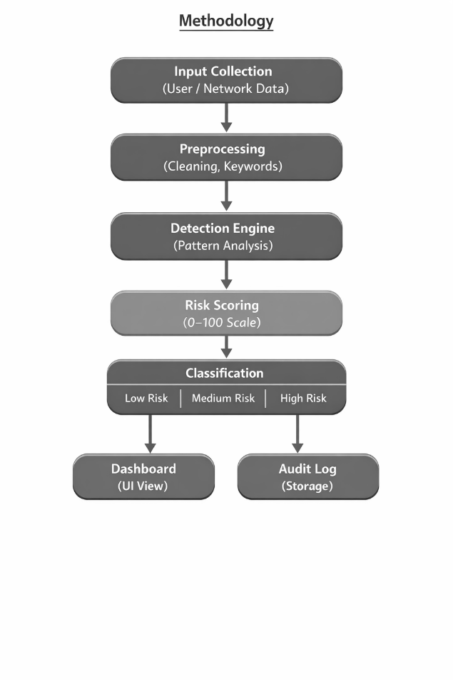
Fig. 1 Anomaly Architecture

Module Description
The system is divided into several modules, each responsible for a specific function. These modules work together to ensure smooth operation of the system. The main modules include data collection, data processing, AI-based anomaly detection, secure audit logging, and result display.Each module is designed to handle specific tasks efficiently. The modular architecture allows easy maintenance, upgrades, and scalability, making the system suitable for real-world deployment.The system’s modular architecture is designed to ensure efficiency, adaptability, and scalability, with each module performing a distinct yet interconnected role. The data collection module serves as the entry point, gathering raw information from diverse sources such as network traffic, system logs, and user activities. This data is then passed to the data processing module, which cleans, normalizes, and structures it for analysis, ensuring consistency and reducing noise. The AI-based anomaly detection module leverages machine learning and deep learning algorithms to identify suspicious patterns, deviations, or behaviors in real time, enhancing accuracy while minimizing false positives and negatives. Complementing this, the secure audit logging module records all detected events and system activities in a tamper-proof manner using encryption and blockchain-based techniques, thereby ensuring transparency, integrity, and reliability for forensic investigations. Finally, the result display module provides a user-friendly interface that presents alerts, reports, and insights in a clear and actionable format, enabling security teams to respond quickly and effectively. Together, these modules form a cohesive framework where detection, logging, and visualization are seamlessly integrated, making the system robust, easy to maintain, and scalable for deployment across diverse real-world environments such as enterprises, healthcare, banking, and cloud infrastructure
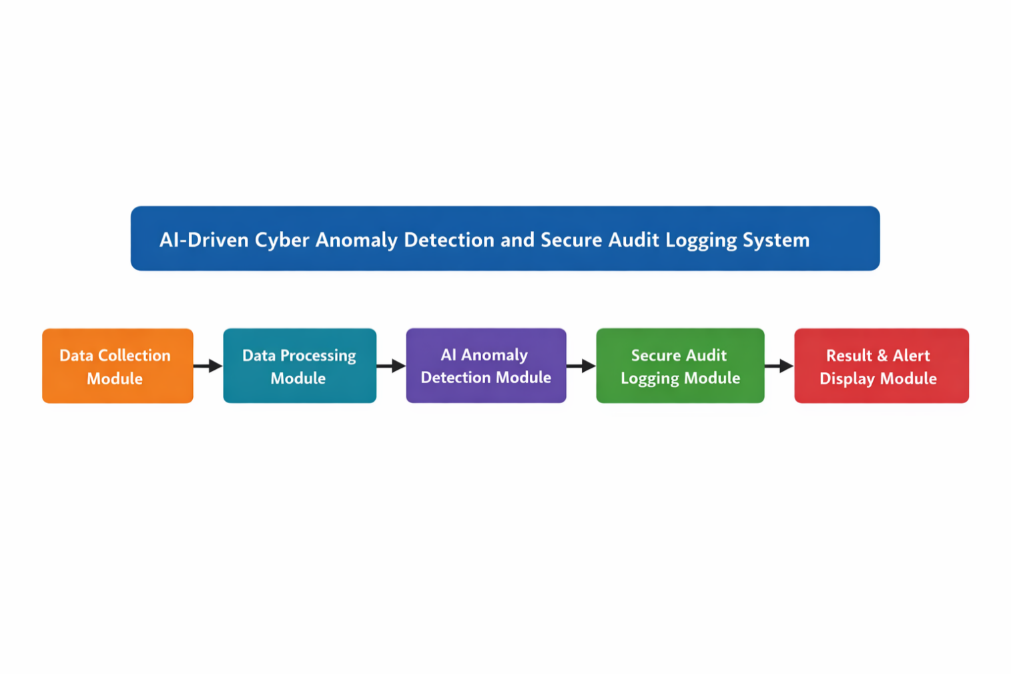
Fig. 2 Cyber Anomaly Detection

DATA COLLECTION Module
The data collection module is responsible for gathering data from various sources such as network traffic, system logs, and user activities. This data serves as the input for the anomaly detection process.The module ensures continuous data collection in real time, enabling the system to monitor activities without interruption. The collected data may include IP addresses, timestamps, protocols, and user actions, which are essential for analyzing behavior and detecting anomalies.The data collection module plays a foundational role in the overall cybersecurity framework, as it ensures that the system has access to comprehensive and reliable information for analysis. It continuously gathers data from multiple sources such as network traffic, system logs, authentication records, and user activity patterns, creating a rich dataset that reflects the real-time state of the environment. This includes critical details like IP addresses, timestamps, communication protocols, login attempts, file access histories, and user actions, all of which are essential for identifying suspicious behaviors. To maintain efficiency, the module employs filtering and preprocessing techniques to eliminate redundant or irrelevant information, ensuring that only meaningful data is passed on for anomaly detection.Beyond simple collection, the module is designed to handle high-speed and large-scale environments, making it capable of monitoring enterprise networks, cloud infrastructures, and IoT systems without interruption. It supports both structured and unstructured data formats, allowing flexibility in integrating diverse sources such as firewall logs, intrusion detection alerts, and application-level events. Real-time streaming capabilities ensure that anomalies can be detected as they occur, rather than after the fact, which is vital for preventing damage from fast-moving cyberattacks. Additionally, the module incorporates mechanisms for secure data transmission and storage, protecting sensitive information from unauthorized access during the collection process.By providing a continuous, accurate, and secure flow of information, the data collection module serves as the backbone of the system, enabling subsequent modules—such as data processing, AI-based anomaly detection, and secure audit logging—to function effectively. Its ability to adapt to different environments and scale with growing data volumes makes it indispensable for building a robust and intelligent cybersecurity solution.

DATA PROCESSING AND FUTURE EXTRACTION MODULE
Once the data is collected, it is processed to remove noise and irrelevant information. This step involves data cleaning, normalization, and transformation to prepare the data for analysis.Feature extraction is performed to identify important attributes that can help in detecting anomalies. These features are used as input for the machine learning model, improving its accuracy and performance. Proper preprocessing ensures efficient and reliable detection.Once the data is collected, the data processing module plays a crucial role in preparing it for effective analysis. This stage involves several important steps such as data cleaning, where redundant, incomplete, or corrupted entries are removed to ensure accuracy; normalization, which standardizes values like IP addresses, timestamps, and protocol formats to maintain consistency across diverse sources; and transformation, which converts raw inputs into structured formats suitable for machine learning algorithms. Beyond these basic preprocessing tasks, the module also performs feature extraction, identifying key attributes such as traffic volume, connection duration, access frequency, and unusual user actions that are most relevant for detecting anomalies. These extracted features serve as the foundation for training and testing machine learning models, significantly improving their accuracy, efficiency, and ability to generalize across different environments.In addition, the data processing module incorporates techniques to handle imbalanced datasets, ensuring that rare but critical attack patterns are not overshadowed by normal behavior. It may apply methods such as oversampling, undersampling, or synthetic data generation to balance the dataset and enhance model performance. The module also supports dimensionality reduction techniques like Principal Component Analysis (PCA), which help in reducing complexity while retaining essential information, thereby improving computational efficiency. By ensuring that the input data is clean, consistent, and feature-rich, the data processing module not only enhances the reliability of anomaly detection but also reduces false positives and negatives, ultimately contributing to a more robust and intelligent cybersecurity framework.
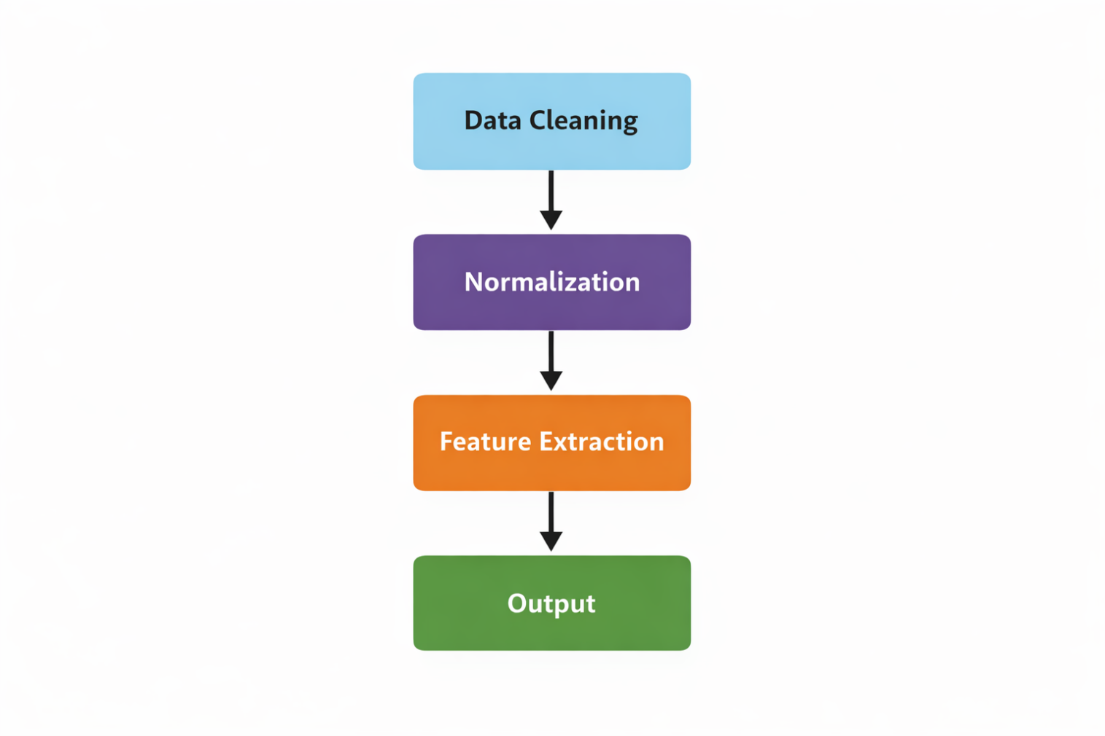
Fig. 3 Data Processing

AI Model (AI/ML) Module
The AI model module is the core component of the system, responsible for detecting anomalies. Machine learning and deep learning algorithms are used to analyze the processed data and identify unusual patterns.The model is trained using historical data to learn normal behavior and detect deviations. Techniques such as classification, clustering, and neural networks are used to improve detection accuracy. The model continuously updates itself to adapt to new patterns and threats, making the system more robust and intelligent.The AI model module serves as the heart of the cybersecurity framework, as it is directly responsible for detecting anomalies and identifying potential threats with high accuracy. Once the data has been cleaned and processed, this module applies advanced machine learning and deep learning algorithms to analyze patterns and behaviors. Techniques such as classification (to distinguish between normal and malicious activities), clustering (to group similar behaviors and highlight outliers), and neural networks (to capture complex, non-linear relationships in data) are employed to strengthen detection capabilities. The model is initially trained using historical datasets to learn what constitutes “normal” system behavior, and then it continuously monitors incoming data streams to detect deviations in real time.A key strength of this module is its ability to adapt dynamically. Unlike traditional signature-based systems, the AI model does not rely solely on predefined rules; instead, it updates itself as new data and threat patterns emerge. This adaptability makes it highly effective against zero-day attacks and evolving cyber threats. Deep learning architectures such as Convolutional Neural Networks (CNNs) are particularly useful for analyzing spatial traffic patterns, while Recurrent Neural Networks (RNNs) and Long Short-Term Memory (LSTM) models excel at detecting sequential and time-based anomalies, such as unusual login attempts or persistent unauthorized access. To further enhance performance, the module incorporates feature engineering and dimensionality reduction, ensuring that only the most relevant attributes are used for detection, thereby reducing computational overhead. It also integrates mechanisms to minimize false positives and false negatives, which are common challenges in anomaly detection. By continuously learning, adapting, and refining its detection strategies, the AI model module transforms the system into a robust, intelligent, and proactive defense mechanism capable of protecting diverse environments—from enterprise networks and banking systems to healthcare and cloud infrastructures—against the growing sophistication of modern cyberattacks. Additionally, the AI model module incorporates continuous learning mechanisms that allow it to evolve alongside emerging threats, ensuring long-term effectiveness. It can integrate feedback loops from security analysts, refining its detection strategies based on real-world outcomes. The module also supports ensemble learning, where multiple algorithms work together to improve accuracy and resilience against diverse attack types. To further strengthen reliability, it employs adversarial defense techniques that protect against attempts to deceive or manipulate the model. Ultimately, this module transforms the system into a proactive, intelligent defense layer capable of adapting to complex and dynamic cybersecurity challenges.

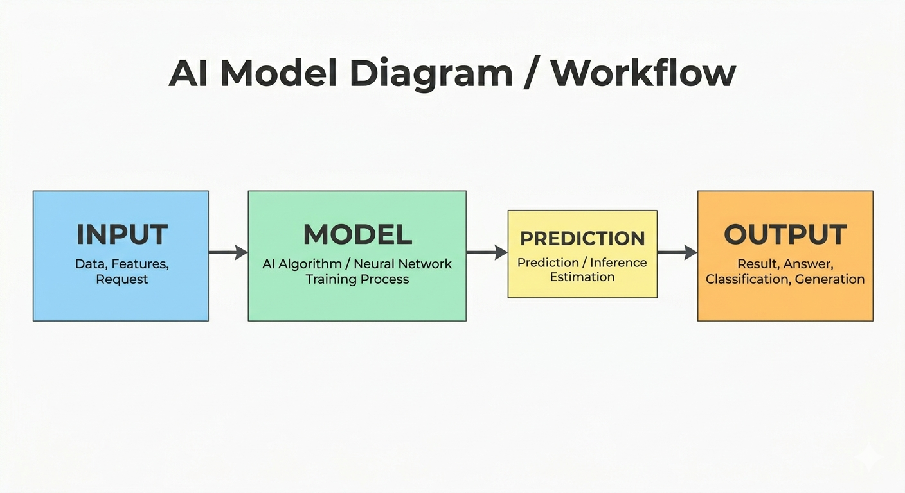

Fig. 4 Input Output Module
To further enhance performance, the module incorporates feature engineering and dimensionality reduction, ensuring that only the most relevant attributes are used for detection, thereby reducing computational overhead.

Sample Output Screenshot:
    - BRUTE FORCE LOGIN:
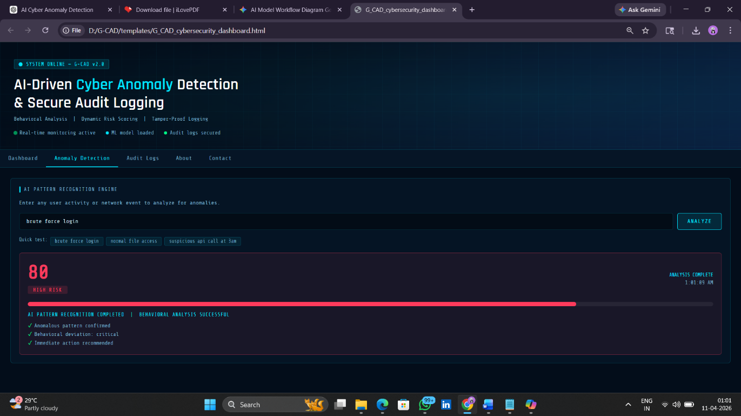
    - SUSPICIOUS API CALLS:
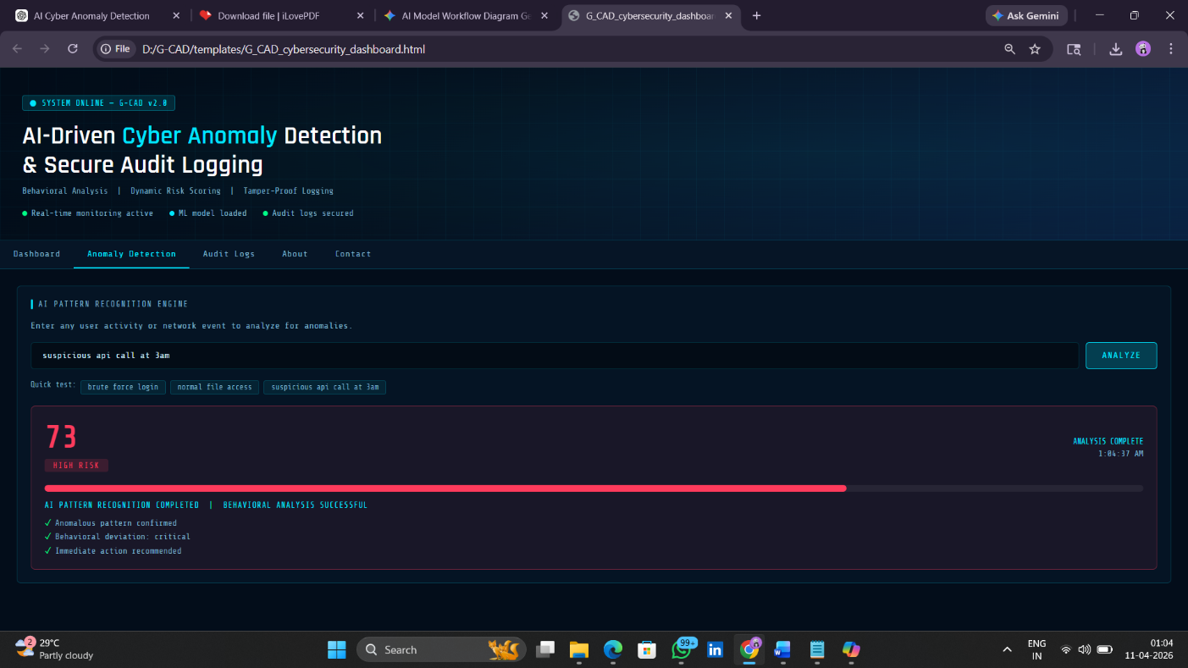

    - NORMAL FILE ACCESS:


SECURE AUDIT LOGGING Module
The secure audit logging module ensures that all detected anomalies and system activities are recorded in a secure and tamper-proof manner. This module uses encryption techniques and can also incorporate blockchain technology to maintain the integrity of logs.The logs include details such as timestamps, type of anomaly, source of attack, and system response. These logs are crucial for forensic analysis, auditing, and compliance. The secure storage mechanism prevents unauthorized access and modification, ensuring data reliability.The secure audit logging module is a critical component of the system, designed to ensure that every detected anomaly and system activity is recorded in a manner that is both reliable and tamper-proof. Unlike traditional logging mechanisms, which are often vulnerable to unauthorized modifications or deletions, this module employs advanced encryption techniques to safeguard the confidentiality of log data and prevent unauthorized access. To further enhance integrity, it can incorporate blockchain technology, which provides immutability and transparency by storing logs in a distributed ledger where entries cannot be altered once recorded. Each log entry typically contains essential details such as timestamps, type of anomaly, source of attack, affected system components, and the system’s response, creating a comprehensive record that is invaluable for forensic investigations, auditing, and compliance with regulatory standards.Beyond basic recording, the module ensures secure storage and controlled access, meaning only authorized personnel can view or analyze logs, thereby maintaining trust and accountability. It also supports scalability, allowing it to handle high-frequency logging in enterprise and cloud environments without performance degradation. In addition, the module can integrate with monitoring dashboards to provide real-time visibility into system activities, enabling faster incident response. By combining encryption, immutability, and structured reporting, the secure audit logging module not only strengthens data reliability but also provides organizations with a trustworthy foundation for incident analysis, legal compliance, and long-term security assurance. Ultimately, this module transforms logging from a passive record-keeping process into an active, secure, and indispensable pillar of modern cybersecurity frameworks.
Log Table:
Time | Event | Status
10:30 | Login Attempt | Normal
10:35 | Suspicious Activity | Anomaly

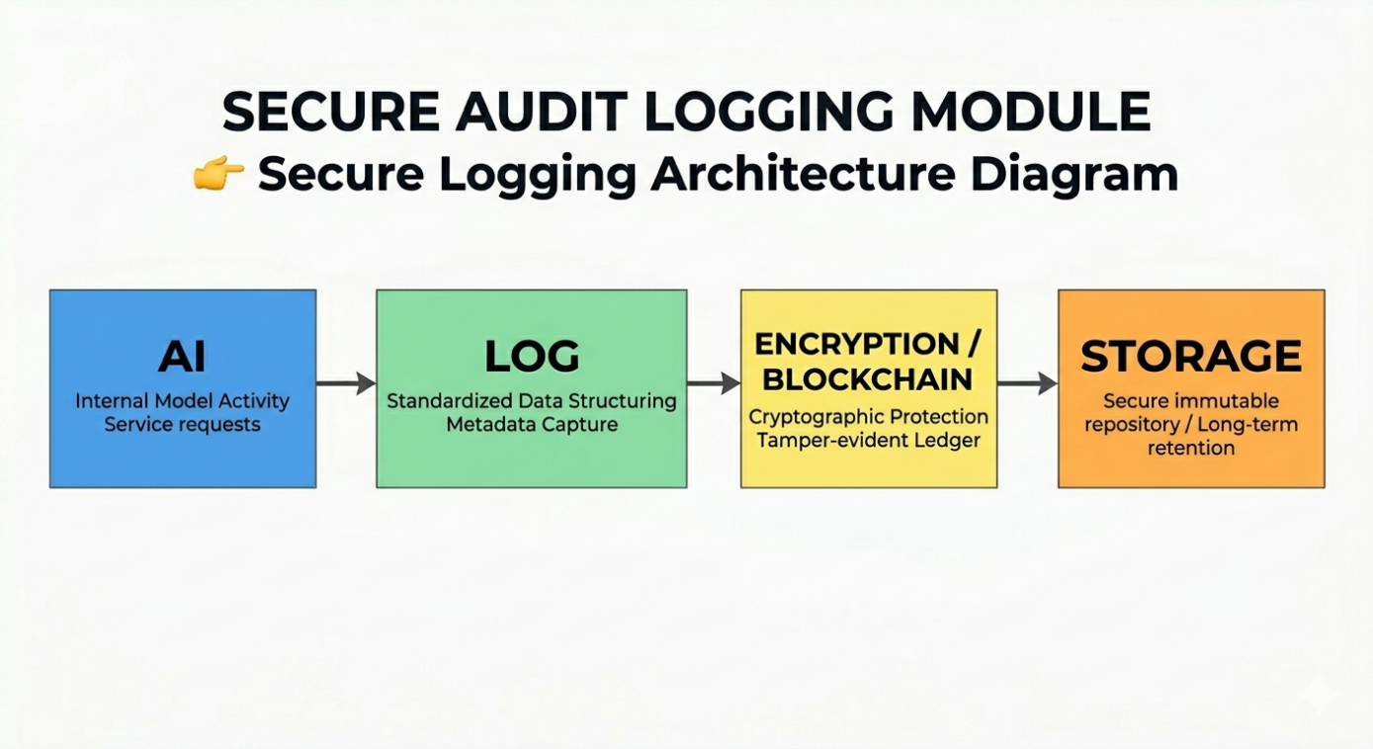
Fig 5 Secure Audit logging Algorithm Block diagram

Result and ALERT Display Module
The result and alert display module provides output to the user in an understandable format. When an anomaly is detected, the system generates alerts and displays relevant information such as the type of threat, affected system, and severity level.This module may include dashboards or graphical interfaces to visualize data and system status. It helps administrators to quickly understand the situation and take appropriate actions. Clear and timely alerts improve response time and overall system effectiveness.The result and alert display module is the user-facing component of the system, designed to transform complex detection outputs into clear, actionable insights. When an anomaly is detected, this module generates alerts that include detailed information such as the type of threat, its severity level, the affected system or resource, and recommended response actions. To ensure administrators can quickly interpret and act on this information, the module often incorporates dashboards, graphical interfaces, and visualization tools that present data in charts, graphs, and timelines. These visualizations allow security teams to monitor system health, track ongoing incidents, and identify trends in attack patterns over time.Beyond simple notifications, the module supports customizable alert mechanisms, enabling organizations to tailor thresholds, escalation paths, and notification channels (such as email, SMS, or in-app alerts) to their specific needs. This flexibility ensures that critical threats are prioritized and communicated effectively, reducing the risk of alert fatigue. The module also integrates with incident response workflows, allowing administrators to initiate containment or mitigation actions directly from the interface, thereby shortening response times. In addition, it can provide historical reporting and analytics, helping organizations evaluate past incidents, measure system performance, and refine detection strategies.By combining clarity, timeliness, and interactivity, the result and alert display module significantly enhances the overall effectiveness of the cybersecurity framework. It empowers administrators with the tools to not only understand anomalies at a glance but also to respond decisively, ensuring that threats are neutralized before they escalate.
DASHBOARD AREA:
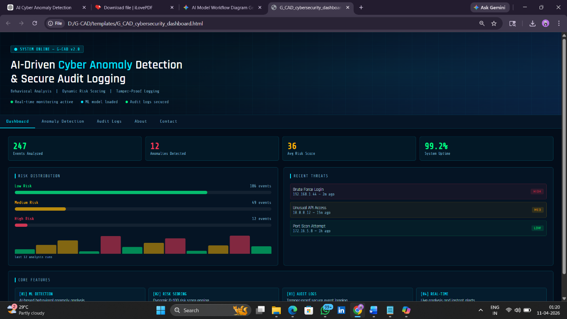
A dashboard area is a central section of an application or system interface where important information is displayed in a clear and organized way. It acts like a control panel, bringing together key metrics, charts, alerts, and summaries so users can quickly monitor performance, track progress, and make decisions. Typically, it provides real-time updates, visual representations of data, and customizable widgets, making complex information easier to understand at a glance. In short, the dashboard area serves as a consolidated view of the most relevant insights, much like a cockpit for a pilot, enabling efficient oversight and management.

AUDIT LOGS:
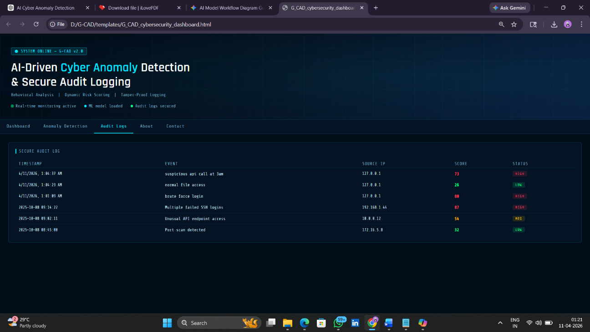
ABOUT:

CONTACT:

To add more depth, the result and alert display module not only provides immediate notifications of detected anomalies but also serves as a comprehensive communication hub between the system and its administrators. It organizes alerts into categories such as severity level, type of threat, and affected resources, ensuring that critical issues are prioritized and addressed without delay. The module can also generate real-time dashboards that display system health, traffic statistics, and ongoing incidents, giving administrators a holistic view of the security environment. Advanced visualization features, such as heat maps, timelines, and trend graphs, help in identifying recurring attack patterns and predicting potential vulnerabilities.In addition, the module supports multi-channel alerting, allowing notifications to be sent via email, SMS, or integrated security platforms, ensuring that administrators are informed even when away from the dashboard. It can also provide contextual recommendations, guiding users on immediate steps to mitigate threats, such as isolating affected systems or blocking suspicious IP addresses. Historical reporting capabilities enable organizations to review past incidents, evaluate response effectiveness, and refine detection strategies. By combining clarity, customization, and actionable insights, the result and alert display module enhances situational awareness, improves response times, and ensures that the entire cybersecurity framework operates with maximum efficiency and reliability.
WORKFLOW:
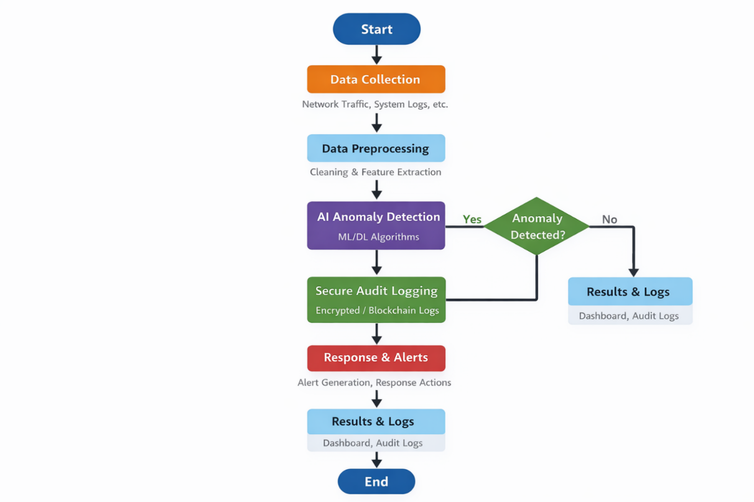
Fig 6 Workflow
The workflow diagram represents the complete working process of the AI-Driven Cyber Anomaly Detection and Secure Audit Logging Framework. It illustrates how data flows through different stages of the system, starting from data collection and ending with result generation and secure logging. Each step in the workflow is designed to ensure accurate anomaly detection, real-time processing, and secure handling of sensitive information.The process begins with the data collection stage, where data is gathered from multiple sources such as network traffic, system logs, and user activities. This data includes important attributes like IP addresses, timestamps, protocols, and user behavior patterns. Since the system operates in a real-time environment, data collection is continuous and dynamic, ensuring that all incoming activities are monitored without interruption. This stage forms the foundation of the entire system, as the quality and completeness of data directly impact the performance of the anomaly detection model.Once the data is collected, it is passed to the data preprocessing stage, where it undergoes several transformation steps. This includes data cleaning, normalization, and feature extraction. Data cleaning removes noise, missing values, and irrelevant information that may affect the accuracy of the model. Normalization ensures that the data is scaled uniformly, making it suitable for machine learning algorithms. Feature extraction identifies the most important attributes from the dataset, reducing dimensionality and improving computational efficiency. This stage is crucial as it prepares the raw data for effective analysis by the AI model.After preprocessing, the refined data is fed into the AI anomaly detection module, which is the core component of the system. This module uses machine learning and deep learning algorithms to analyze patterns and identify deviations from normal behavior. The model is trained using historical data to understand normal system activity and can detect anomalies that indicate potential cyber threats such as unauthorized access, unusual traffic spikes, or malicious actions. Advanced techniques such as classification, clustering, and neural networks enable the system to detect both known and unknown threats with high accuracy.Following the detection phase, the system evaluates whether an anomaly has been detected through a decision-making step. If no anomaly is found, the data is considered normal and is forwarded directly to the results and logging section for record-keeping. However, if an anomaly is detected, the system triggers additional processes to handle the potential threat. This decision-making mechanism ensures that the system responds appropriately based on the nature of the input data.When an anomaly is identified, the information is sent to the secure audit logging module, where all details of the event are recorded. This includes the type of anomaly, time of occurrence, source of the activity, and system response. The logging mechanism uses advanced security techniques such as encryption or blockchain-based storage to ensure that the logs are tamper-proof and cannot be altered by unauthorized users. This is essential for maintaining data integrity and supporting forensic investigations.Simultaneously, the system activates the response and alert generation module, which notifies system administrators or users about the detected anomaly. Alerts may include warning messages, notifications, or automated responses such as blocking suspicious IP addresses or restricting access. This real-time alerting mechanism helps in quick decision-making and minimizes potential damage caused by cyber threats.Finally, all processed information, including both normal and anomalous events, is displayed in the results and logging interface. This may include dashboards, reports, and visual representations of system activity. The results provide a clear understanding of system performance and detected threats, while the logs serve as a permanent record for auditing and analysis purposes. The workflow concludes with the completion of the process, after which the system continues monitoring new incoming data in a continuous loop.Overall, this workflow ensures a systematic and efficient approach to cybersecurity by combining real-time anomaly detection with secure audit logging. Each stage plays a vital role in enhancing detection accuracy, ensuring data security, and providing actionable insights. The integration of artificial intelligence with secure logging mechanisms makes the system robust, scalable, and highly effective in handling modern cyber threats.
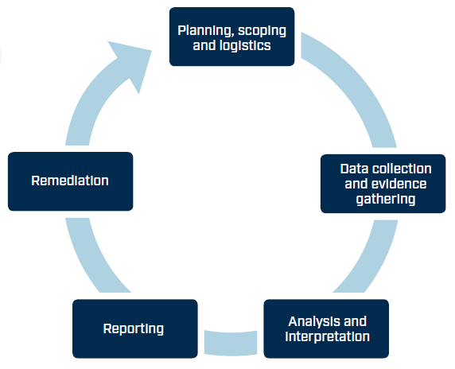
Fig 7 Cyclic Anomaly Detect AI process
The workflow diagram of the AI-Driven Cyber Anomaly Detection and Secure Audit Logging Framework provides a comprehensive representation of how the system operates in a structured and continuous manner to ensure effective cybersecurity. This workflow is designed to handle large-scale, real-time data streams while maintaining high accuracy, efficiency, and security. The system follows a sequential pipeline where each stage is interconnected, allowing smooth data transition and intelligent decision-making throughout the process.At the initial stage, the workflow begins with data acquisition and monitoring, where the system continuously gathers data from multiple heterogeneous sources such as network traffic flows, server logs, application logs, and user activity records. This stage is critical because modern cyber environments generate massive volumes of data at high velocity. The system is designed to handle such high-throughput data streams efficiently without causing delays or data loss. The collected data may include structured, semi-structured, and unstructured formats, requiring the system to be flexible and adaptable in handling diverse input types. Continuous monitoring ensures that even the smallest activity within the network is captured, providing complete visibility into system operations.Following data acquisition, the workflow moves into the data preprocessing and transformation stage, which plays a vital role in enhancing the quality and usability of the data. Raw data in its original form often contains inconsistencies such as missing values, redundant entries, noise, and irrelevant attributes. Therefore, data cleaning techniques are applied to remove unwanted elements and ensure consistency. After cleaning, normalization techniques are used to scale the data into a uniform range, which is essential for improving the performance of machine learning models. Feature extraction and selection are then performed to identify the most relevant attributes that contribute to anomaly detection. This reduces computational complexity and improves model efficiency. Additionally, this stage may include encoding categorical variables and transforming time-based data into meaningful patterns for further analysis.The processed data is then forwarded to the AI-based anomaly detection engine, which acts as the intelligence core of the system. This module utilizes a combination of machine learning and deep learning algorithms to analyze patterns and identify deviations from expected behavior. The system may employ supervised learning models when labeled data is available, as well as unsupervised learning techniques for detecting unknown anomalies without prior knowledge. Deep learning models such as neural networks can capture complex relationships within the data, enabling the detection of subtle and sophisticated attack patterns. dynamic environments.Once the analysis is completed, the system proceeds to the decision-making phase, where it determines whether the observed behavior is normal or anomalous. This stage is implemented using threshold-based or probability-based decision logic. If the system identifies the behavior as normal, the data is safely stored and logged for future reference. However, if an anomaly is detected, the workflow dynamically branches into additional processes for threat handling and mitigation. This decision-making capability ensures that the system responds intelligently based on the nature and severity of the detected activity.In the case of anomaly detection, the workflow activates the secure audit logging mechanism, which is responsible for recording all relevant details of the detected event. This includes metadata such as timestamp, source and destination addresses, type of anomaly, severity level, and system response actions. The logging system is designed with strong security measures, including encryption techniques and blockchain-based storage, to ensure immutability and integrity. This prevents unauthorized users from altering or deleting logs, which is crucial for maintaining trust and accountability. The secure logs serve as a reliable source of information for forensic analysis, auditing, and compliance with regulatory standards.Simultaneously, the system triggers the alert and response management module, which plays a crucial role in minimizing the impact of cyber threats. This module generates real-time alerts and notifications to system administrators or security teams, enabling them to take immediate action. Alerts can be delivered through various channels such as dashboards, email notifications, or system warnings. In advanced implementations, the system may also support automated response mechanisms, such as blocking malicious IP addresses, terminating suspicious sessions, or isolating affected components. This rapid response capability significantly reduces the risk of damage and enhances overall system security.The workflow then transitions to the result visualization and reporting stage, where all processed data, including both normal and anomalous activities, is presented in an organized and user-friendly format. This may include dashboards, charts, graphs, and detailed reports that provide insights into system performance and detected threats. Visualization tools help administrators quickly understand patterns, trends, and potential vulnerabilities within the system. Additionally, the logs generated during the process are stored and maintained for long-term analysis and auditing purposes.Finally, the workflow reaches the termination and continuous monitoring stage, where the process cycle is completed. However, unlike traditional systems, this workflow operates in a continuous loop, constantly monitoring new incoming data and repeating the process. This ensures that the system remains active and responsive at all times, providing ongoing protection against cyber threats. The continuous feedback loop also allows the AI model to update and improve its performance over time, making the system more efficient and intelligent.In conclusion, the workflow diagram represents a robust, scalable, and intelligent cybersecurity framework that integrates real-time anomaly detection with secure audit logging and automated response mechanisms.
LOG TAMPERING
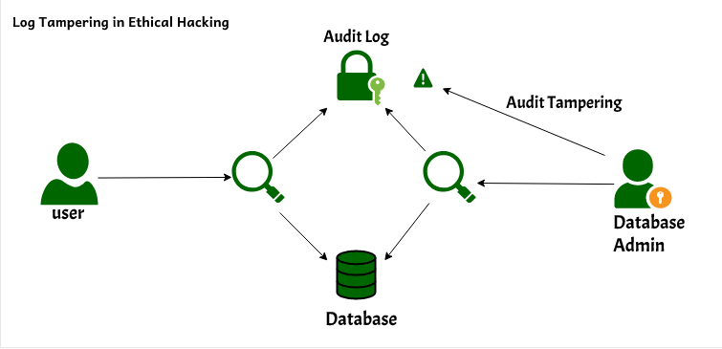
Fig 8 Log Tampering
Log tampering refers to the unauthorized modification, deletion, or manipulation of system log data by attackers to hide malicious activities or avoid detection. Since logs contain critical information about system events, user actions, and security incidents, altering them can compromise the integrity and reliability of the entire system. Attackers often target logs to erase evidence of intrusions or to mislead forensic investigations. Therefore, preventing log tampering is essential in cybersecurity, which can be achieved using techniques such as encryption, access control mechanisms, and tamper-proof technologies like blockchain to ensure that logs remain secure, transparent, and trustworthy. Log tampering is a critical security issue in which an attacker intentionally modifies, deletes, or alters system log records to conceal malicious activities and avoid detection. Logs are an essential component of any system as they maintain a detailed record of events such as user actions, system operations, and security incidents. When these logs are tampered with, the accuracy, integrity, and reliability of the recorded information are compromised, making it difficult for administrators to detect intrusions or perform proper forensic analysis. Attackers often attempt to erase traces of unauthorized access, change timestamps, or insert false entries to mislead security investigations. This can lead to severe consequences, including undetected breaches, data loss, and failure to comply with security regulations. To prevent log tampering, it is important to implement strong security measures such as encryption, role-based access control, secure storage mechanisms.
ANOMALY DETECTION RESULT GRAPH:
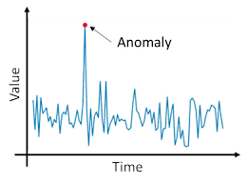
Fig.9 Anomaly Detection Result Graph
The above graph represents the anomaly detection results generated by the system over a period of time. The normal behavior of the network is indicated by a consistent pattern, while sudden spikes or deviations represent abnormal activities. These anomalies are detected by the AI model by analyzing variations in network traffic and user behavior. The system effectively identifies unusual patterns in real time, allowing early detection of potential cyber threats. This graphical representation helps in understanding how the system differentiates between normal and abnormal activities, thereby improving monitoring and decision-making processes. The above table illustrates a sample output of the system’s alert and logging mechanism. It records various system events along with their corresponding status, such as normal activity or detected anomalies. When suspicious behavior is identified, the system generates alerts and logs the event with relevant details including time, type of activity, and response taken. This structured logging approach ensures proper tracking of all system activities and provides a reliable source for auditing and forensic analysis. The secure storage of these logs prevents tampering and ensures data integrity.The results obtained from the implementation of the AI-Driven Cyber Anomaly Detection and Secure Audit Logging Framework demonstrate the effectiveness and reliability of the proposed system in identifying and managing cyber threats. The system was able to successfully monitor network activities and analyze user behavior in real time, allowing it to detect anomalies with a high level of accuracy. Normal system activities were consistently identified and recorded without interruption, while unusual patterns such as sudden spikes in network traffic, repeated access attempts, or suspicious user actions were accurately classified as anomalies.The graphical representation of results, such as anomaly detection graphs, clearly illustrates the distinction between normal and abnormal behavior, making it easier to understand system performance. Sudden deviations from regular patterns were effectively captured by the AI model, indicating potential threats. The system demonstrated the ability to detect both known and unknown attacks, highlighting the advantage of using machine learning and deep learning techniques over traditional methods.In addition to detection, the system efficiently generated real-time alerts whenever an anomaly was identified. These alerts provided detailed information about the type of threat, time of occurrence, and system response, enabling quick decision-making and reducing the risk of damage. The alert mechanism proved to be highly responsive and played a crucial role in enhancing system security.The secure audit logging module also performed effectively by maintaining a detailed record of all system events. The sample alert and log output demonstrates how events are systematically recorded along with their status, ensuring transparency and traceability. The use of secure logging techniques ensures that these records are protected against tampering, thereby preserving their integrity and reliability. This is particularly important for forensic analysis, auditing, and compliance purposes.Overall, the results confirm that the proposed system provides a robust and efficient solution for modern cybersecurity challenges. It not only improves the accuracy of anomaly detection but also ensures secure and reliable logging of system activities. The integration of intelligent detection, real-time alerting, and tamper-proof logging makes the system highly effective in protecting digital environments and responding to potential threats in a timely manner.

CHAPTER 6
CONCLUSION
In the rapidly evolving digital landscape, cybersecurity has become a critical necessity due to the increasing frequency and sophistication of cyber threats. Traditional security systems, which rely mainly on predefined rules and signature-based detection techniques, are no longer sufficient to handle modern attacks such as zero-day exploits, advanced persistent threats, and insider attacks. These limitations highlight the urgent need for intelligent and adaptive security solutions. In this context, the proposed AI-Driven Cyber Anomaly Detection and Secure Audit Logging Framework provides an effective and advanced approach to addressing the challenges faced by existing systems.The developed system successfully integrates artificial intelligence and machine learning techniques to detect anomalies in real time by analyzing network traffic and user behavior patterns. By leveraging both machine learning and deep learning models, the system is capable of identifying not only known threats but also previously unseen or unknown attack patterns. This significantly improves the accuracy and reliability of threat detection compared to conventional methods. The ability of the system to continuously learn from new data further enhances its adaptability in dynamic environments, making it suitable for modern cybersecurity applications.One of the key strengths of this framework is its modular architecture, which includes data collection, preprocessing, anomaly detection, secure audit logging, and result visualization components. This modular design ensures scalability, flexibility, and ease of integration with existing systems. Each module performs a specific function efficiently, contributing to the overall performance and robustness of the system. The real-time monitoring capability of the framework ensures continuous surveillance of system activities, enabling early detection and prevention of potential cyber threats.In addition to anomaly detection, the implementation of a secure audit logging mechanism plays a crucial role in enhancing system reliability and accountability. By incorporating secure techniques such as encryption and blockchain-based logging, the system ensures that all logs are stored in a tamper-proof and transparent manner. This not only protects the integrity of the data but also provides a trustworthy source of information for forensic analysis, auditing, and compliance purposes. The availability of accurate and secure logs is essential for investigating security incidents and understanding attack patterns.Furthermore, the system includes an efficient alert and response mechanism that enables quick identification and handling of detected anomalies. Real-time alerts allow administrators to take immediate action, thereby reducing the potential impact of cyber attacks. The integration of visualization tools and dashboards further enhances usability by providing clear and meaningful insights into system performance and detected threats. This helps in better decision-making and proactive security management.Overall, the proposed AI-Driven Cyber Anomaly Detection and Secure Audit Logging Framework offers a comprehensive and effective solution for modern cybersecurity challenges. It not only improves the detection of cyber threats but also ensures the security and integrity of system data through reliable logging mechanisms. The combination of intelligent detection, secure logging, and real-time response makes this framework highly suitable for deployment in various real-world environments such as enterprise networks, cloud platforms, and critical infrastructures.In conclusion, this project demonstrates the potential of integrating artificial intelligence with secure logging techniques to build a robust and scalable cybersecurity system. Future enhancements may include the use of advanced deep learning models, integration with cloud-based security solutions, and further optimization for handling large-scale data in real time. With continuous improvements, the proposed system can contribute significantly to strengthening cybersecurity and protecting digital assets in an increasingly connected world.
RISK DISTRIBUTION:
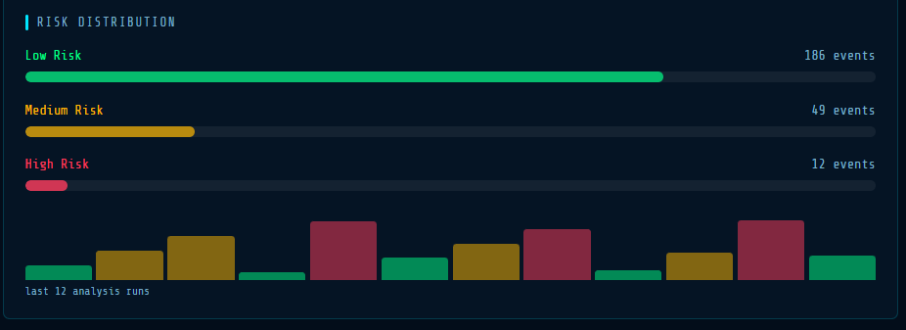

AI-Driven Cyber Anomaly Detection and Secure Audit Logging Framework. It shows how data is collected from multiple sources and processed using AI techniques to detect anomalies. Once suspicious activity is identified, the system generates real-time alerts and securely logs the event using tamper-proof mechanisms such as encryption and blockchain. The diagram also highlights key components like data collection, AI analysis, secure logging, and alert response, working together to ensure efficient threat detection and data integrity. This integrated approach improves cybersecurity by enabling accurate detection, quick response, and secure storage of system.
CHAPTER 7
REFERENCES
- H. Rahman and Y. O. Mohamed, “Power system cybersecurity: A survey,” IEEE Access, vol. 8, pp. 111576–111588, 2020.
- R. D. L. et al., “Deep learning for cybersecurity: State-of-the-art and challenges,” IEEE Access, vol. 8, pp. 53841–53870, 2020.
- B. Poudel and C.-H. Kim, “Secure and efficient machine learning for smart grids,” IEEE Trans. Smart Grid, vol. 11, no. 6, pp. 5005–5013, 2020.
- L. Wang, H. Jin, and S. Yang, “LSTM-based detection of cyber-attacks in smart grids,” in Proc. IEEE PESGM, 2020.
- Y. Liu et al., “Deep learning for cybersecurity anomaly detection: A survey,” IEEE Trans. Dependable Secure Comput., vol. 18, pp. 2224–2241, 2021.
- K. Zhao et al., “A survey of anomaly detection methods for IoT systems,” IEEE Access, vol. 9, pp. 128269–128290, 2021.
- Sahu et al., “Multi-source data fusion for cyberattack detection,” IEEE Access, vol. 9, pp. 112456–112470, 2021.
- Y. Farrukh et al., “Supervised ML approach for cyber attack detection,” in Proc. IEEE NAPS, 2021.
- V. S. K. et al., “SHAP-enhanced intrusion detection system,” in Proc. ACM SAC, 2023.
- S. Hussain et al., “Hybrid methodology to secure smart grids,” Scientific Reports, vol. 13, 2023.
- Sharma, “Machine learning in cybersecurity anomaly detection,” IEEE IoT Journal, vol. 9, pp. 7123–7133, 2023.
- N. Jeffrey et al., “Anomaly detection strategies for cyber-physical systems,” Electronics, vol. 12, 2023.
- Aljohani et al., “Deep learning-based intrusion detection system,” IEEE Trans. AI, vol. 5, 2024.
- Choppadandi et al., “Anomaly detection using ML algorithms,” JETA, 2024.
- “Anomaly detection using machine learning for intrusion detection,” IEEE Conf., 2024.

