Social Eagle

- Picture - Nano Banana
- Video - veo
- As a product - Google AI studio (contains app building, speech, game building)
- PPT - Gamma
- Browser - Compact
- Tooling.ai - > database for all AI tools
- Hugging Face - This tool provides all alternative like video, image for free of cost
- Doubt.socialeagle.ai —> portal to raise an issue
- Assignment.socialeagle.ai —> To submit the weekly assignment
- Saturday 8 AM to 9 AM —> Build a new application

Python VE

Virtual Environment —> The primary reason to create a virtual environment in Python is dependency isolation. If am working on different projects called A and B. If A need a version 1.0 and B need a version 2.0 then using VE will fix this issue.

Python Modules:

Created a function, if that needs to be used in another py file, then we need to use python module. Say example, I have created a function called addition under module folder. If this needs to be called in another code, it will be starting with

from module.addition import add

So automatically, that function will be imported into our code. We need to create _init_.py file under modules, which will convert our function into package.

Python File handling:

w —> write / overwrite
r —> read
a —> append the existing file

with open(“myfile.txt” , “w”) as file

RPA

- PyAutoGUI —> For operating Desktop Apps
- Playwright —> For operating / automating our tasks on browser
- PyAuto GUI —> Automate our task using lap mouse / keyboard —> its Python library
- PyAutoGUI Functionalities —> Mouse control, keyboard control, multiple window control, screenshot

API

- API —> Communication between two servers Types: 1. REST API 2. Graph QL —> Meta is using this 3. SOAP 4. RPC 5. Web socket

- REST API method on REST API
A. POST —> Creating the new entry
B. GET —> getting the details from server
C. PUT —> modifying the details on the server
D. DELETE —> deleting the record

4xx Client Errors
5xx Server Errors
2xx Success
3xx Redirection

POSTMAN tool used to test our API’s

Streamlit is used for building and sharing interactive web applications and dashboards entirely in Python, eliminating the need for frontend web development skills like HTML, CSS, or JavaScript.

Streamlit is easy frontend creating app without using HTML, CSS

LLM

LLM —> Large Language Model is a type of artificial intelligence program trained on massive amounts of text data to understand, summarize, translate, and generate human-like language.

It has 5 stages of processing, each word is considered as token ? Eg. Write a python program ? —> 5 token will be used to process this.

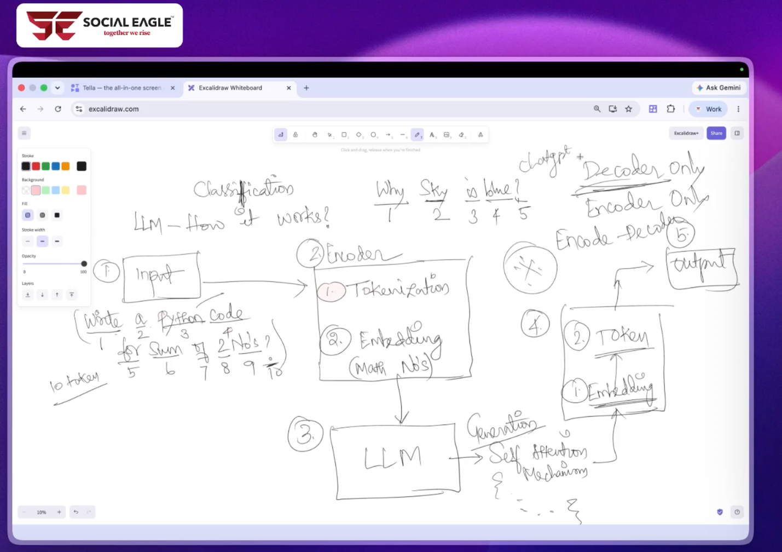

Types of LLMs

LMM —> Large Multimodel —> used for image / video generation —> nano banana
SLM —> Small Langage Model —> Enterprise uses this
VLM —> Vision Language model

Open source LLM vs Cloud / Closed LLM

Opensource LLM means nothing but the free LLM models available in the market, we can download it locally and optimise it for our need, which will be running on our laptop or our server. Ollama and Hugging Face is the place where we can download our models.

Cloud / Closed LLM nothing but the models owned by companies called OpenAI, Google, we cannot download the model instead we can work with that.

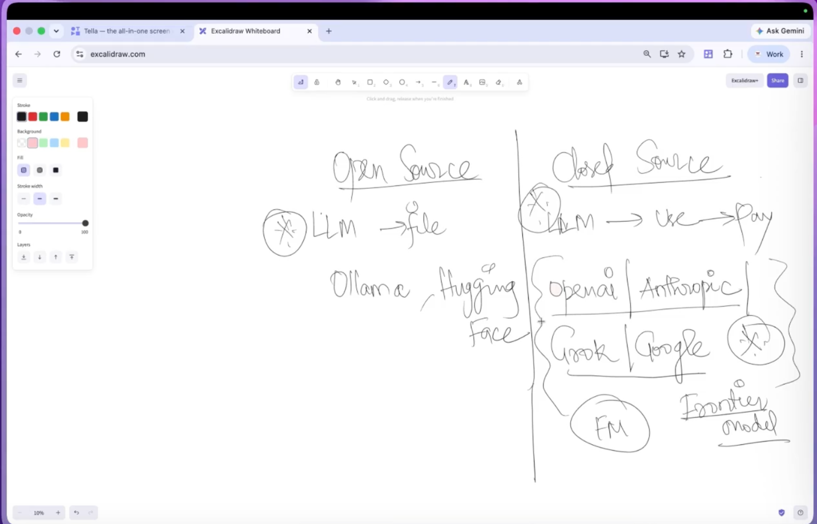

Prompt Engineering

We need to provide proper prompt to get the better response. To provide the better prompt, use the below framework.

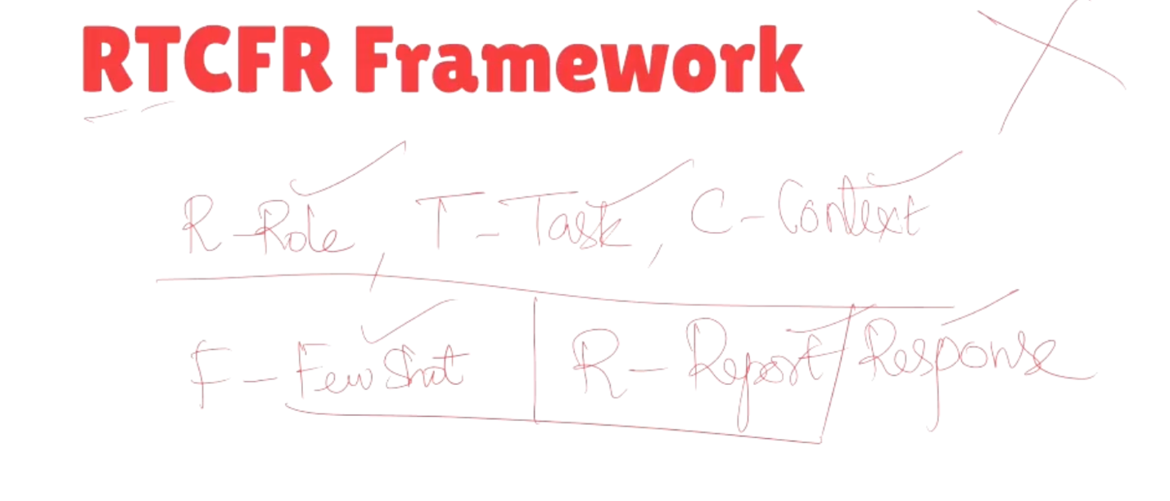

Role —> Give a role to AI model before providing the prompt, Act as Senior Cloud architect and design Netflix cloud architecture.
Task —> Define the task clearly, so that model understands it in better way
Context —> Explain the context to the models (i.e.., write a leave letter (without context), write a leave letter to my manager for my health issue and admitted in hospital in standard format (with context).

Without context AI guess the answer
Without context, AI provides the best solution

Few Shots —> Nothing but providing some example while prompting, so that AI models knows the exact need
Response / Report —> How you need the output from ChatGPT, like you need its in bullet points or JSON format or README format or content plan format

Attaching the example on how the prompt should be provided based on RTCFR framework

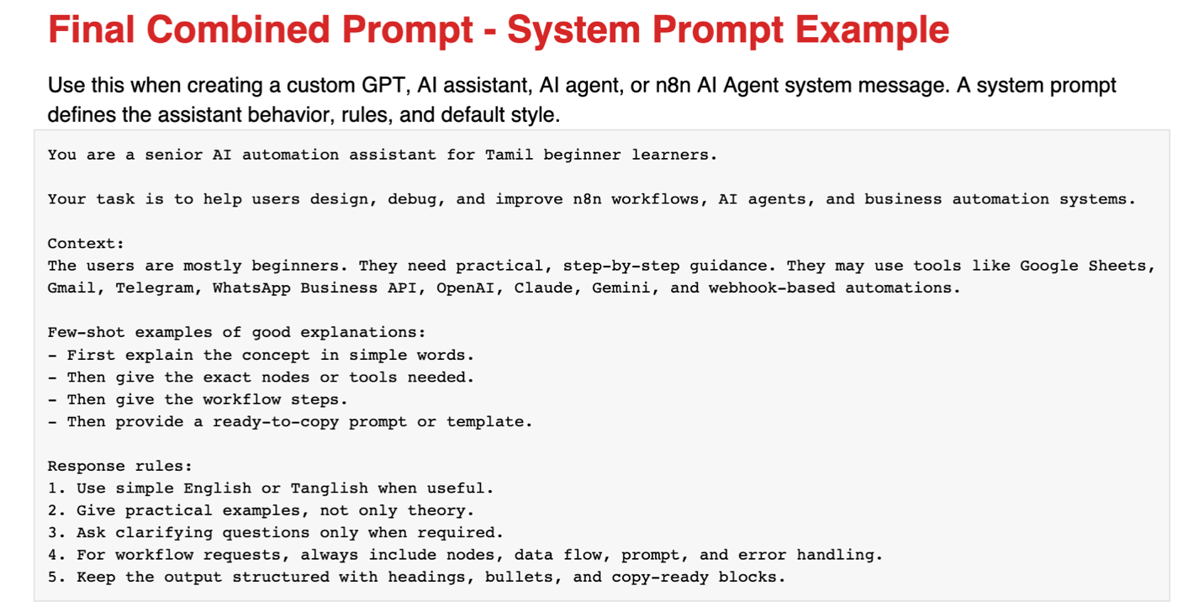

Reverse prompting:

Instead of writing a big prompt with RTCFP format, you can ask GPT to create a RTCFP format prompt, it will provide the best prompt and that can be used.

Prompt Injection:
Nothing but, using modified or unauthorised keywords with LLM models and breaking its security and privacy. So, still companies are working on it.

JSON Prompting:
When providing the input through JSON, system understands it clearly and output is far better. Token utilisation is low when comparing to text prompts.

Scale Framework:
This framework is best for image generation,
S —> Subject —> context of image
C —> Composition —> camera angle —> top view, selfie, side angle
A —> Action —> Type of action
L —> Location

LangChain
LangChain is an open-source framework that helps developers build applications using large language models (LLMs) by connecting them to external data, memory, and tools

Below are the components from LangChain

Data Ingestion —> LangChain uses Document Loaders to fetch data from various formats (PDFs, CSVs, web pages, cloud storage) and standardize them into a standard Document data structure.

Types of Data source:

- Structured Data —> tables, CSV, Excel
- Semi structured data —> JSON, XML, YAML
- Un structured data —> PDF, audio, docx, video

Text Splitter —> It will break the 100 page PDF into smaller chunks, so that it can go through it easily and any doubts asked by user will be cleared with more accuracy.

0 - 5000

0 - 500 | 400 - 900 | 800 - 1300 | … 5000

Chunk size - 800 Overlap - 100

Embeddings —> It turn raw text into number lists called vectors that capture semantic meaning for search and comparison.

[0.89 , 0.17] [0.81 , 0.98] [0.88

Vector Store —> Is a kind of serverless database which stores all the information

Retriver —> Fetches the most relevant text for our questions from vector store. Chain / Pipeline —> A chain joins steps so they run one after another, like pipeline. The output of one step becomes the input of the next.

Pine cone —> Paid Vector DB —> Server

Vector DB —> FAISS and Chroma DB —> Serverless
LangSmith
LangSmith is a tradable and monitoring tool used for monitor everything on your AI app, it’s like CCTV for our AI apps. Create an account with API key, integrate that API key into LangChain code, automatically, it will be integrated with Langsmith

RAG

Retrieval-Augmented Generation (RAG) is an AI framework that improves large language models (LLMs) by fetching relevant data from external knowledge bases before generating a response

Types of RAG

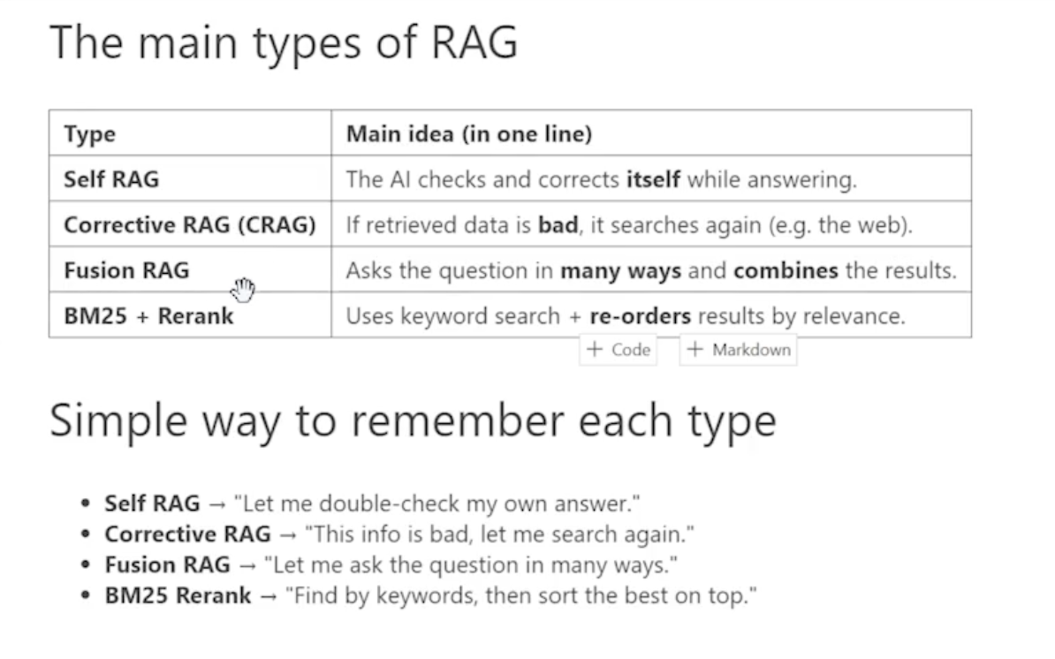

Self RAG —> AI check its own work before providing the output to client, we’ll get the high accuracy outcome through Self RAG

Corrective RAG —> Checks the data quality at the retrieval stage.

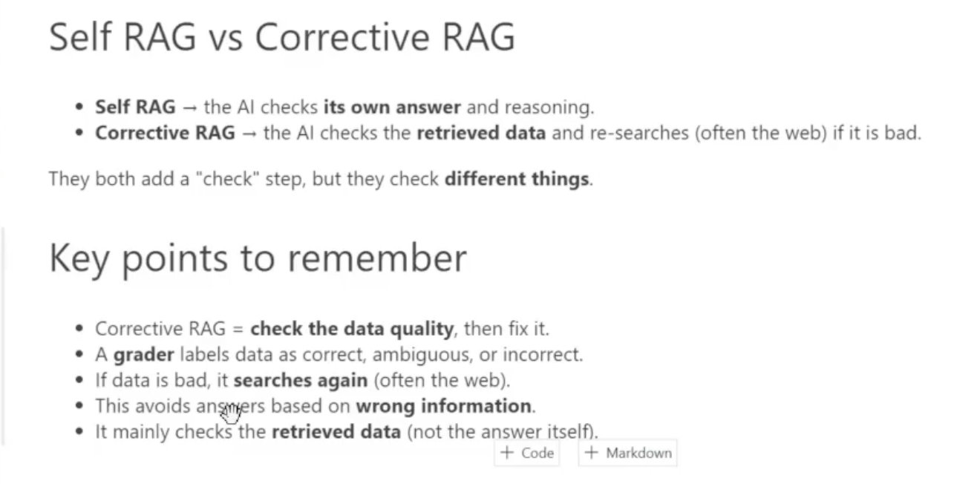
Fusion RAG —> Fusion RAG asks the question in many different ways, searches with each version separately. It combines all results using RRF.
BM25 + ReRank (best suited for production) —> is a keyword-based ranking function used to score and re-order documents based on exact term matches and word rarity.

Temperature —> (0 - Focused, 1 - creative / imagination)

Messages:

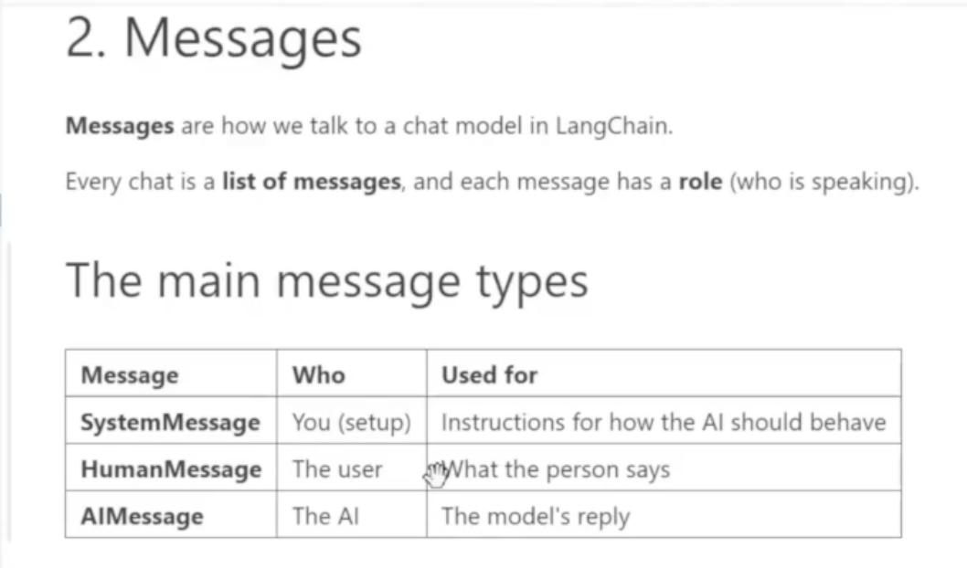

Guardrails:

Guardrails are safety boundaries or control mechanisms designed to prevent systems, vehicles, or AI models from veering into dangerous, harmful, or unintended territory
There are two types of Guardrails

- Input Guardrails —> It will stop the dangerous prompt from user and won’t be sent to LLM (token will be saved). Example - How to create a bomb
- Output Guardrails —> It validates the output generated by LLM is correct or not, if dangerous, it will block the output

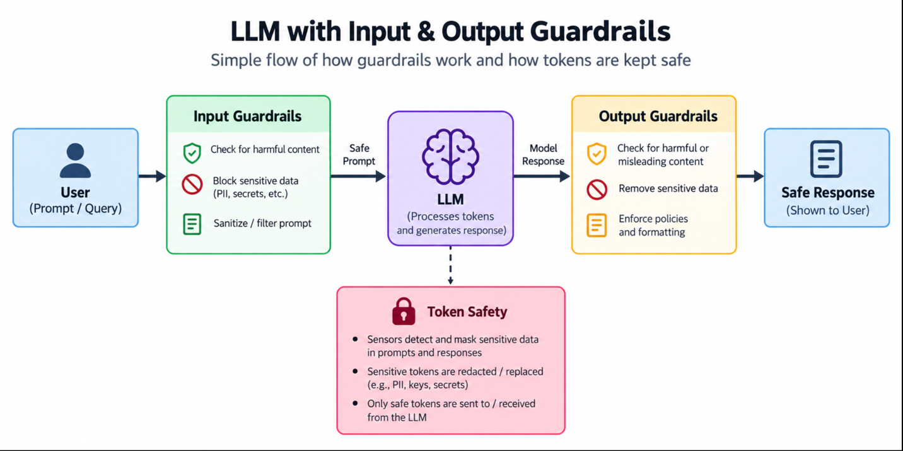

Evaluation:

Whenever we’re done with our GenAI application, we have to evaluate it with 10,000+ automated test runs to check it accuracy. Score will be calculated between 0 to 1. Getting a result near to 95% is ready for production deployment.

Types of RAG:

- Vector DB —> Types —> Self, Corrective, Fuse, BM25 —> Its normal pipelines process like Data injection —> Splitting —> Emedding —> Vector DB
- Knowledge graph

Knowledge graph RAG - Knowledge graph RAG is an advanced way of helping AI find information by connecting facts like a map of ideas instead of just guessing based on similar words. It will create relational DB to create the uniqueness. Each round is called Node and the connection is called EDGE.

Vector DB just stores the data if you twist the question it won’t answer properly that’s why Knowledge Graph came into picture, where the entire data will be exacted, relationship will be made like below and then storage it in DB and query it. These are internal LLM operations we no need to worry about it.

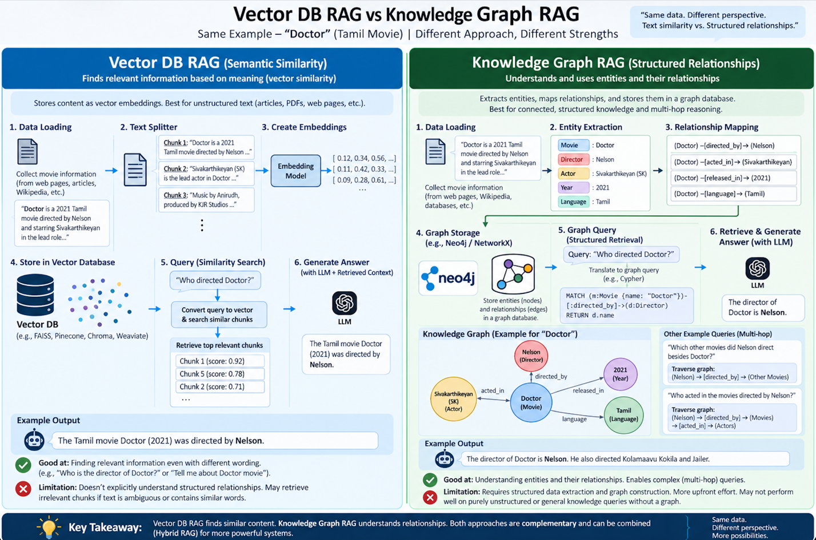

AI Automation

3 types

- ETL Automation
- API automation
- UI Automation

AI Automation Platforms

No code —> n8n, make, Zapier (n8n is the only open source free tool, others are paid one)
Code —> Playwright, playGUI, selenium

n8n Installation methods

- Local installation —> download the package and run in your local
- Self hosted method —> Best method —> use Cloud VMs for hosting
- Production n8n —> n8n.io —> but very expensive

Types of nodes in n8n

- Trigger node
- Data flow node
- Conditional node
- Action
- AI node (LLM, AI Agent)

Two types of Trigger node

- HTTP node —> Whenever we need, we should called HTTP
- Webhook node —> Any changes in the system, web hook request will be initiated

Authentication vs Authorization

Authentication —> If you can login to AWS console or not
Authorization —> After login to AWS, can you create EC2

Types of authentication

- API key —> Full access
- Token access —> Token will be created with set of permissions like user need to read only this repo, so user can read only that repo.
- Auth token —> High authentication, client ID and server will be created for validation

UI Automation

If there is an issue with API and ETL automation, then we need to use this UI automation, this will run in our local laptop. For UI automation, we need web scraping to collect the data from internet.

Scrapling, Market Down, Scrapy —> Tools available to perform the scraping.

AI Agents:
Will be running continuously to complete the task

User Input goes to the system prompt then goes to LLM. LLM will be performing the below operations Think —> Action —> Observe the results—> If results looks good —> Output —> If the results are not meet —> again action —> observe the result
It will be happening in a loop, and token utilisation is high here.

TAOTR —> Think —> Action —> Observe —> Think again —> Result

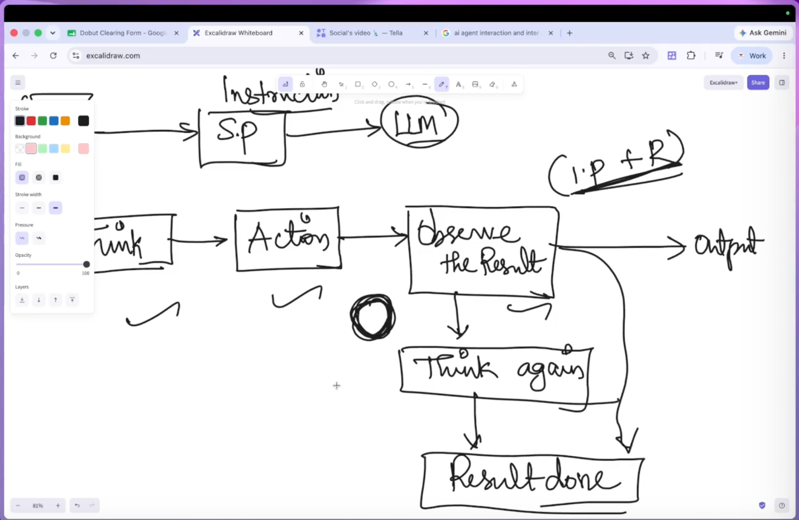

AI Agent Architecture

PBA —> Preception —> Brain —> Action

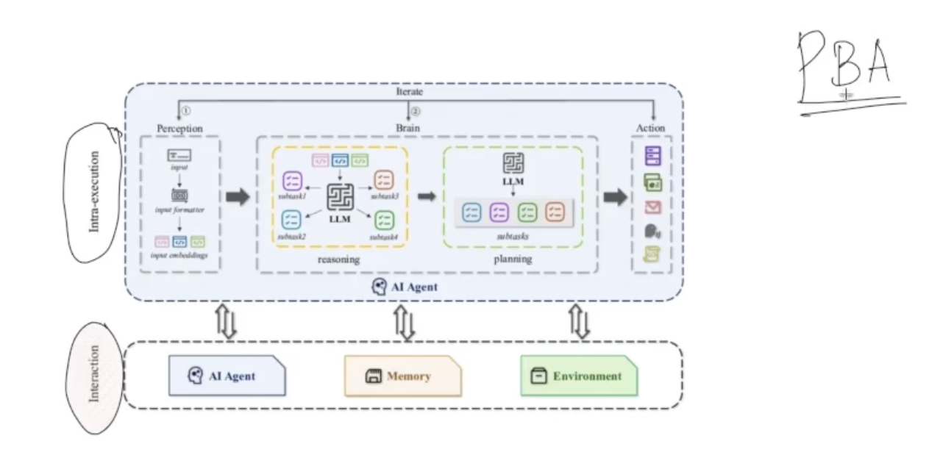

MCP architecture

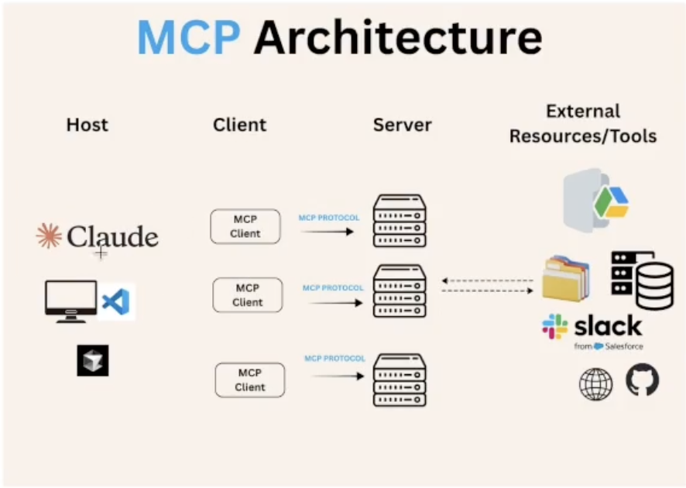

Fall back agents:
If we have an AI model (Open AI) in our agent due to any issue if our agent is not responding, it will impact our automation framework, so having fall back means another AI model (Gemini, Grok) will be on standby to run in case of any issues with primary model.

Human In the Loop:
Running some critical workload AI automation, add a simple step to get a human approval before proceeding.

AI Agents:
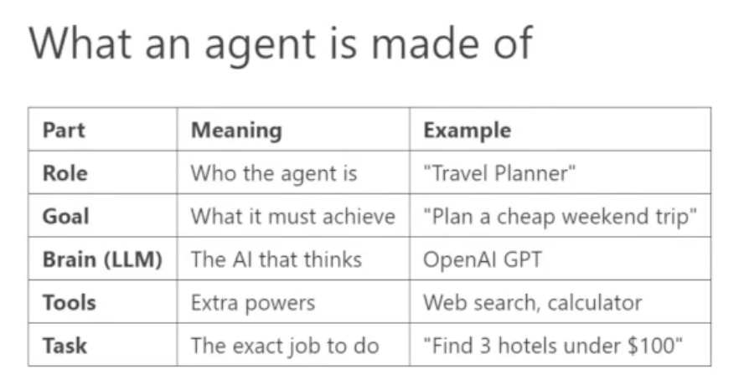

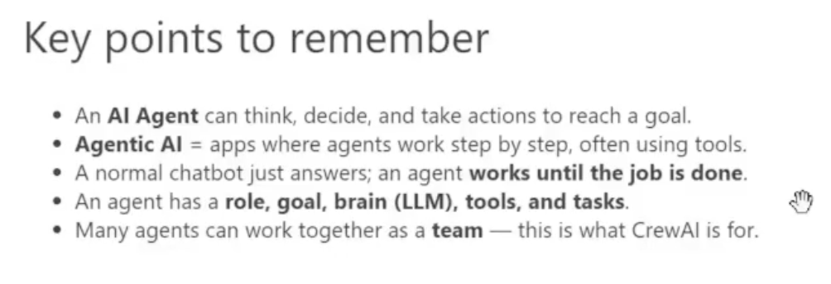

Pydantic —> It a python library that checks your data and make sure its a correct type and shape, before sending it to Agents.

Async Function —> allows the code to run parallel instead of running one by one.

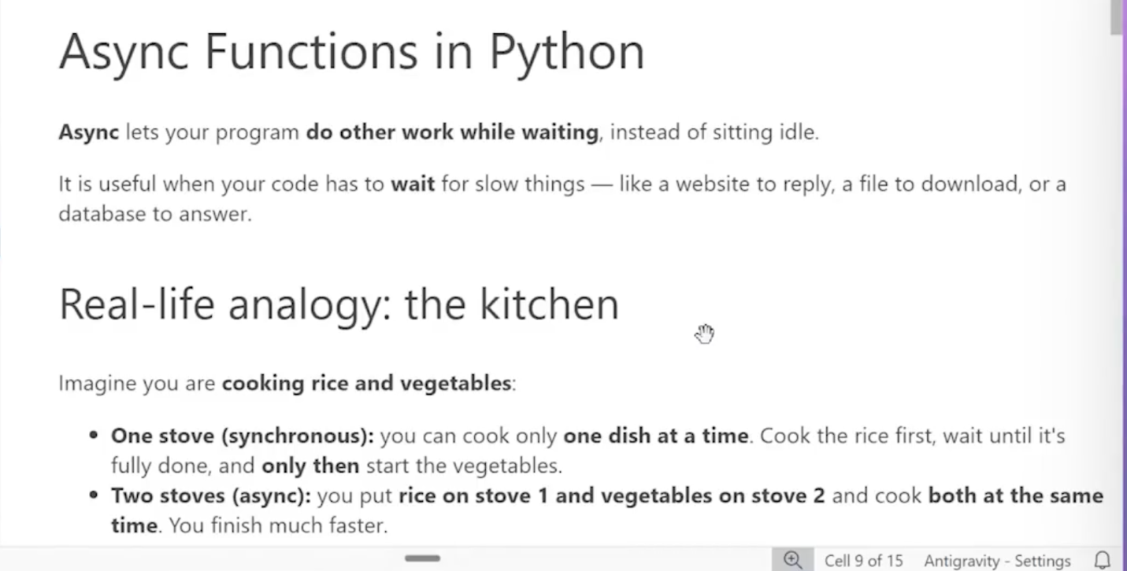

Crew AI

Crew AI is a python framework for building a team of agents that work together to finish the job.

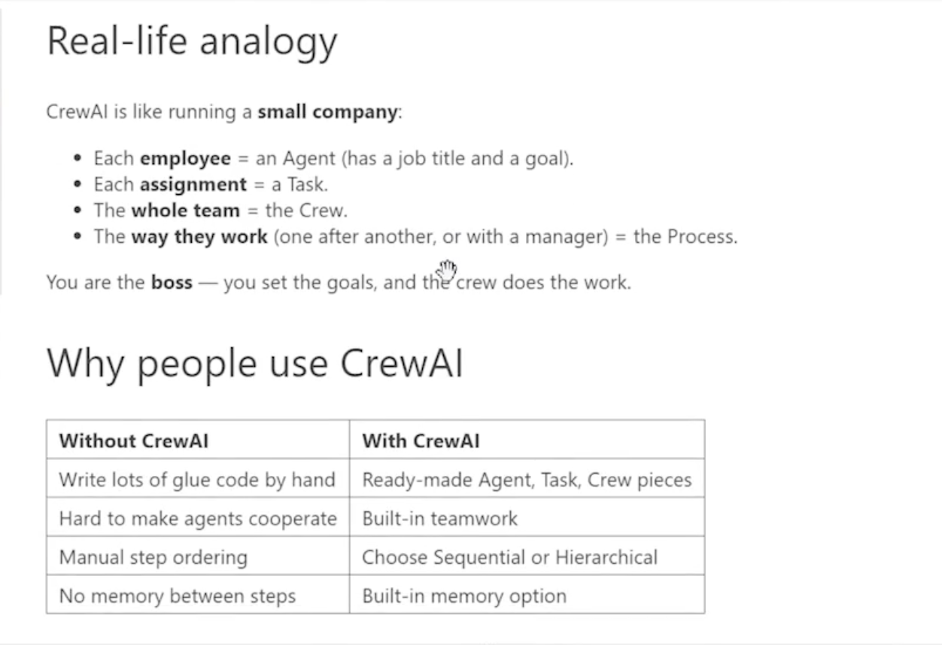

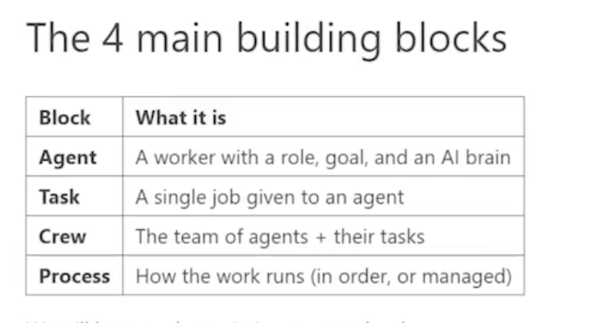

Demo:

Here we’re creating AI agent just using python, while using crewai, we need to call agent, task and crew in the code.
For writer agent, create a goal, and then assign a task.

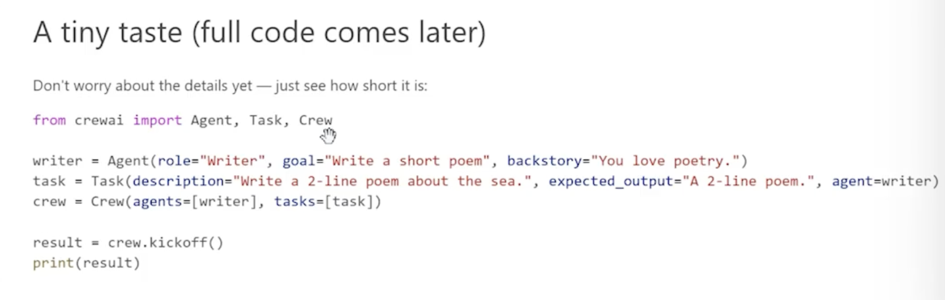

Crew AI architecture

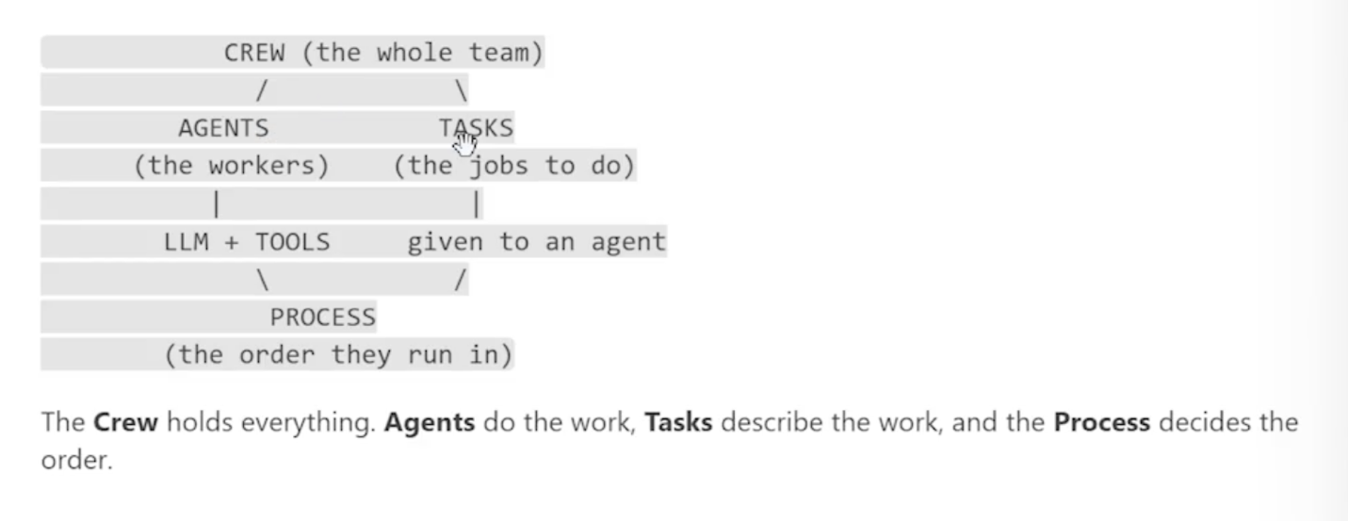

All the crew AI components in single table

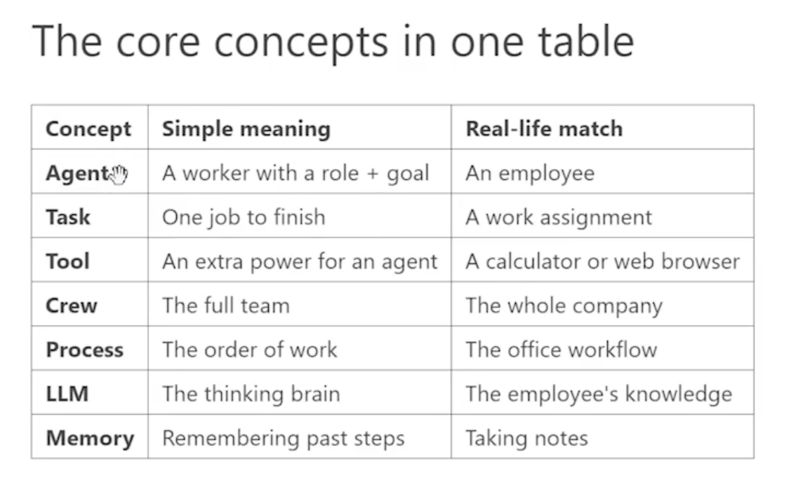

Tasks in crew AI

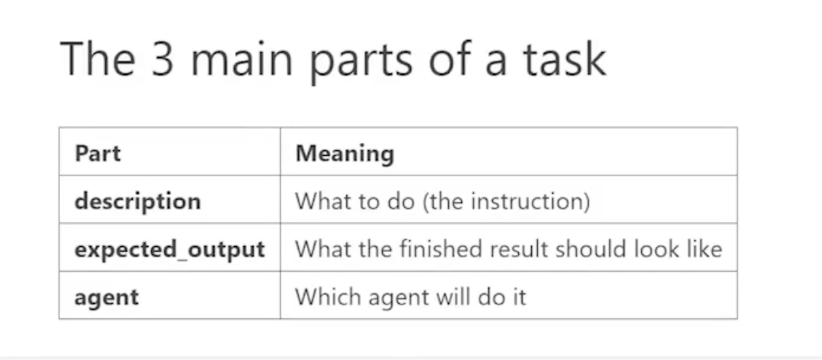

Demo / code

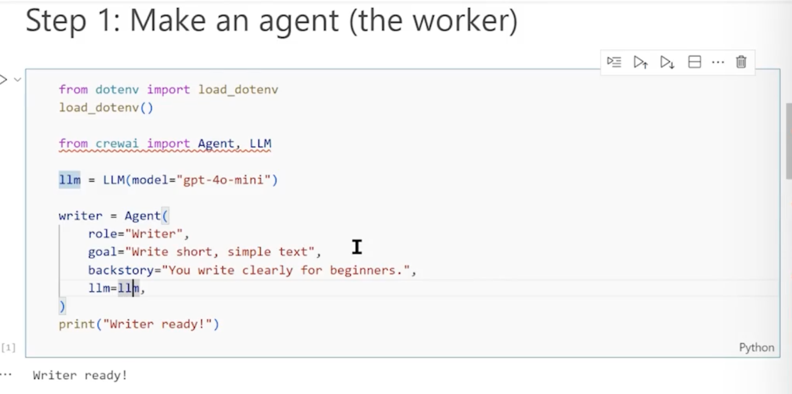

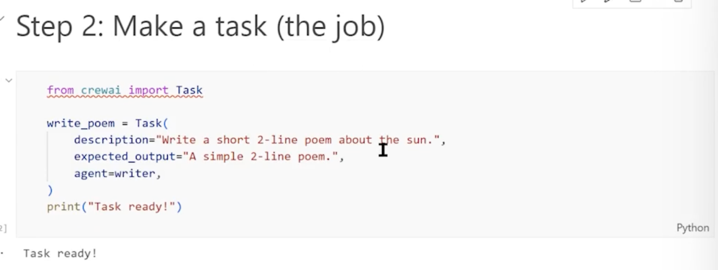

Step 3 : Run it with a crew

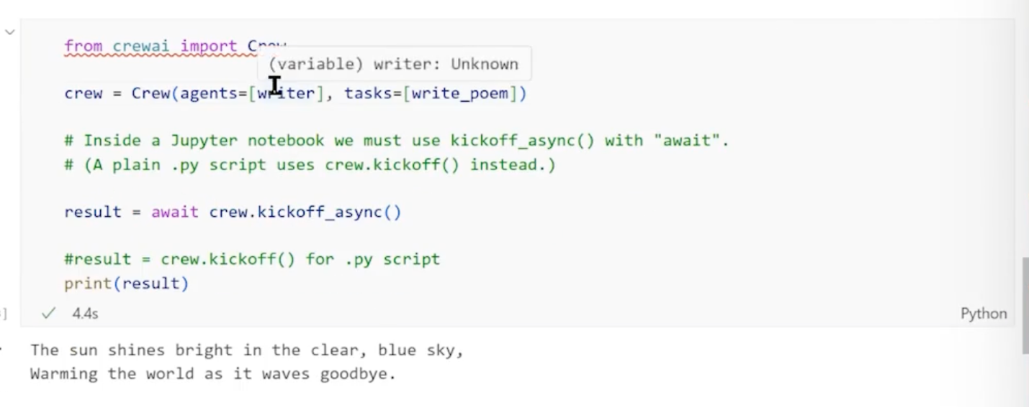

Multi step workflow

Here, we’re creating 2 task, output of 1st task will be passed as input of 2nd task.

Creating agent:
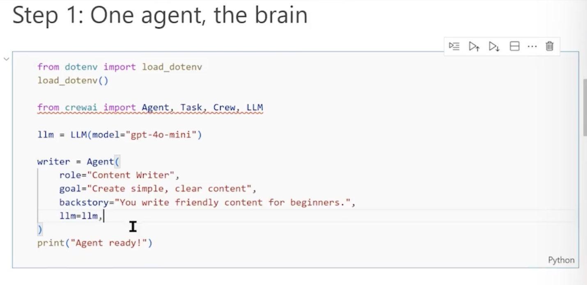

Creating task:

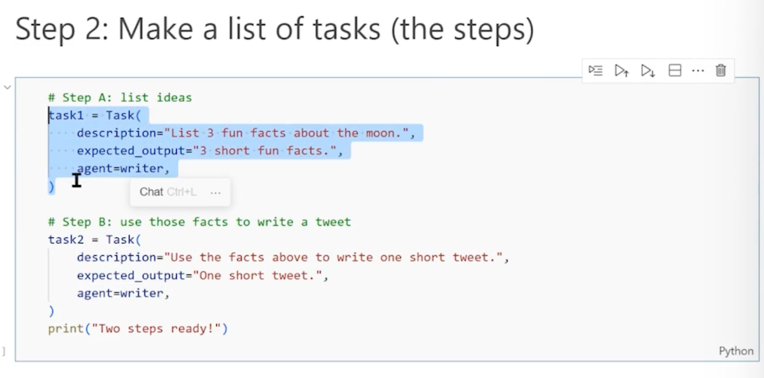

Creating crew
Here we got the result from task 2 (short tweet)

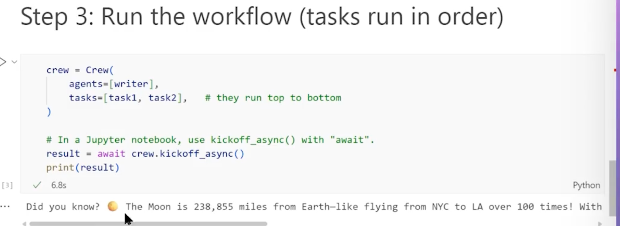

Process Types

Two process types:

- Sequential —> Above examples, everything happens in an order, output of 1st task goes to the input to 2nd task
- Hierarchy —> Here, we create multiple agents, manager (LLM) will decide which agent need to perform the provided action, suitable for complex operations.

Here you, can see the two agents (researcher and writer2), we’re defining the process called “Hierarchical”, selecting our manager as “LLM”, LLM decides and sends the works to relevant agent.
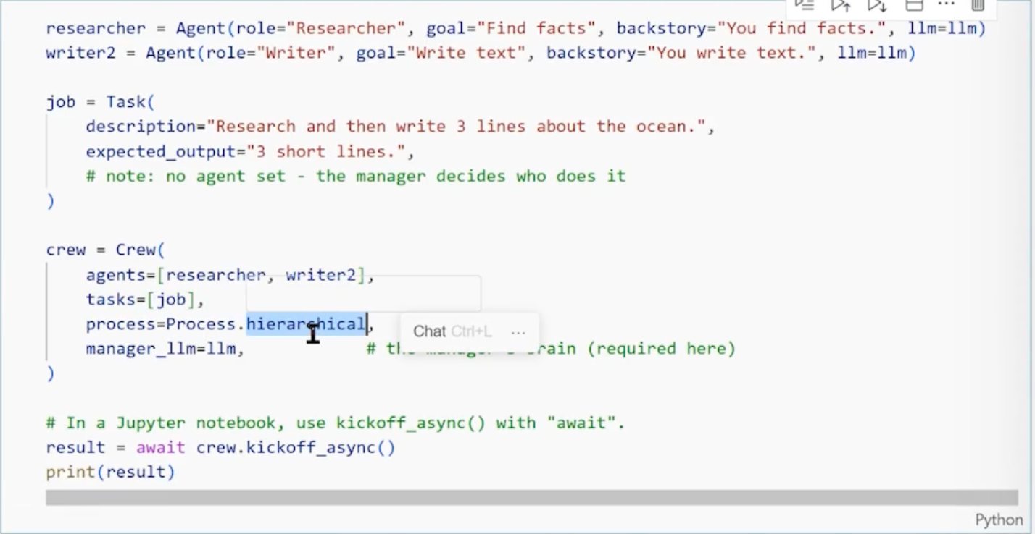

Crew AI don’t have inbuilt tools for file read operations, web scraping, so we need to import that using crewai-tools library package to use them.

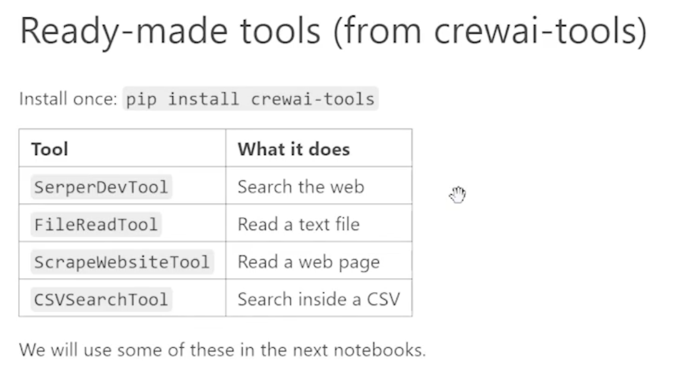
In this example, we’re importing the file read tool and reading the file

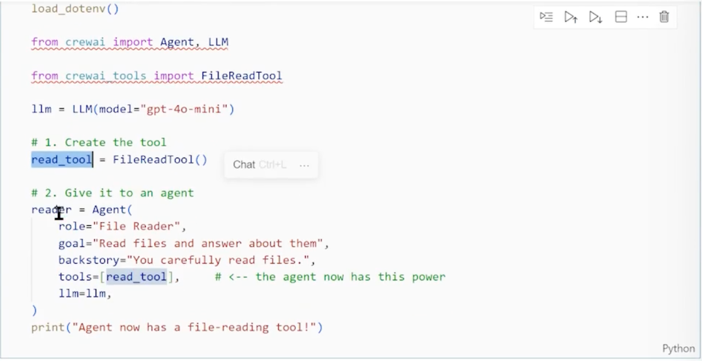

Custom Tool
Say example, I want to perform some custom operation but that package is not available in python means we can create that using function and can use it as tool in our code.

Here, we just created simple add function and just adding (@tool) so it marks this function as tool

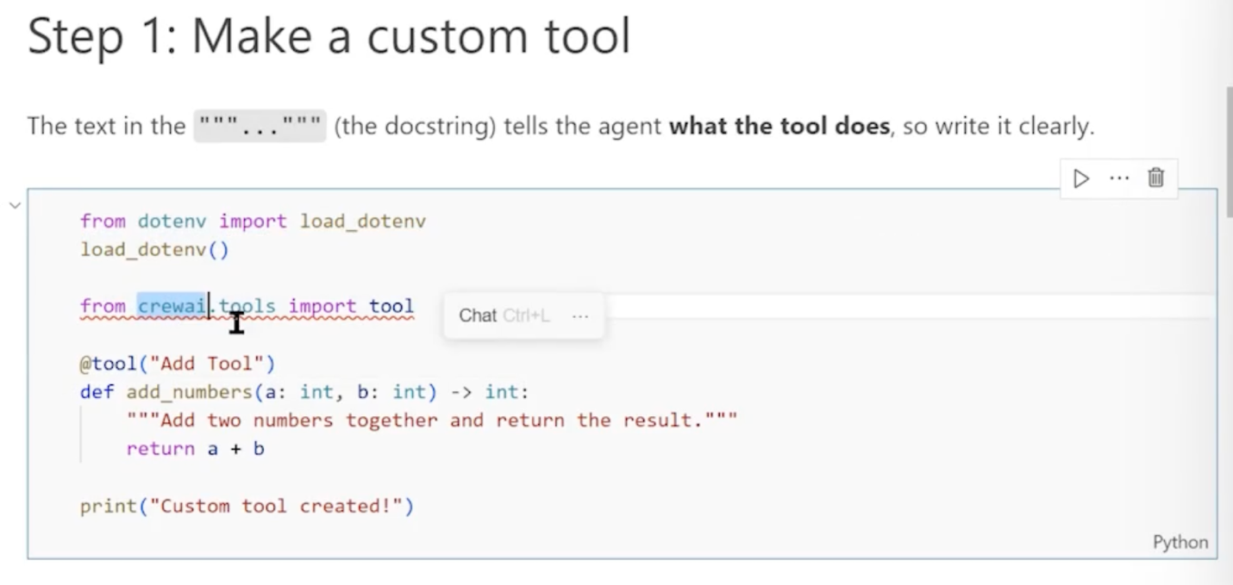

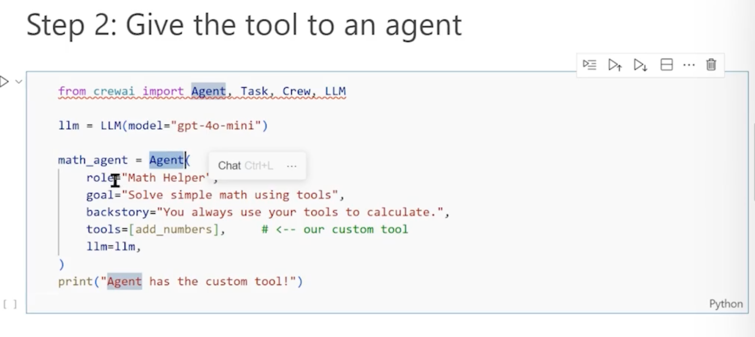

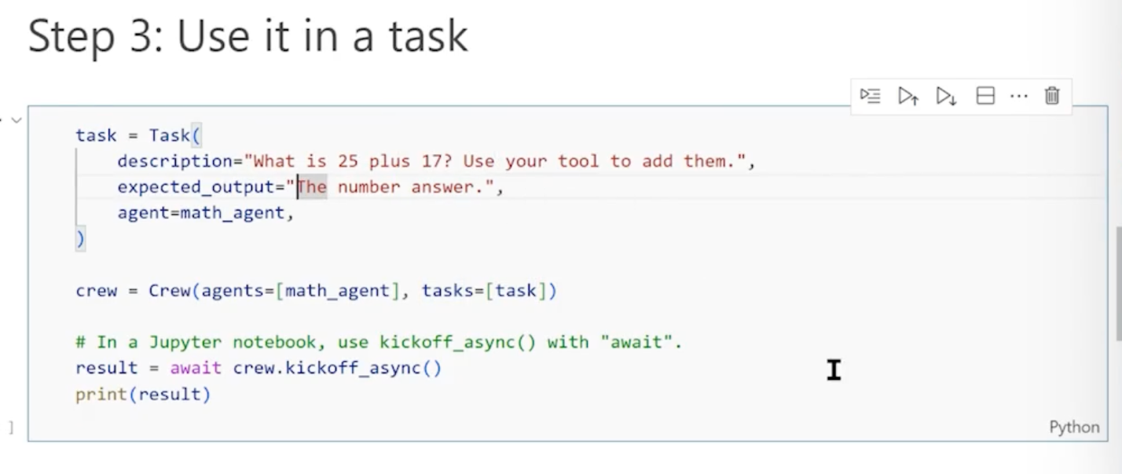

Web search Tools on Crew AI

- For webseach, we need serpAI API key for the web search, store it on .env file and load it on the step 1.
- Here, we’re just calling that web search tool (search_tool)

