There are different editions of MYSQL:

Free Version : Community edition
Free Version : Percona edition

Paid Version : Enterprise edition, it has more features like

Good monitoring tools
Enterprise backup
Audit facility

To find the edition of Software installed in your system:

Mysql –u root

-This will display the edition of the software

Another method to see mysql version:

Go to the path of mysql process :

Ps –ef | grep –i mysqld

It will show the mysql process running and the path from where it isrunning:

Mostly it will be /usr/sbin/mysqld

/usr/sbin/mysqld – version

Tis will display the mysql edition.

How to get the Version of MYSQL:

Mysql> select version();

Mysql –u root –e “select version()”

How to see all Users in MYSQL:

Mysql > select distinct user from mysql.user;

This will list down all users existing in MYSQL database.

how to run a sql file,application fsql file

- mysql -u root < queries.sql
- mysql -u root –vv < queries.sql

c) login to mysql

source queires.sql

tee queries.log

What is slow log ?

It will record all the long running and slow running sqls in the database

By default mysql logs all the queries which runs more than 10 seconds in the slow log

mysql> show global variables like '%LONG%';
mysql> show global variables like '%SLOW%';

mysql> set global slow_query_log = 1; -- This is to to turn on the slow query log file.

3) There are 2 sample databases in mysql

Employees
Sakila

4) How to change the Config variables?

Best practice for changing config:
- Set global variablename = values;
- Edit my.cnf

Do you restart MYSQL immediately? No for PROD and yes for SIT/UAT/DEV set the global settings will be gone once you restart MYSQL

NOTe: It is mandatory that you change the variables in my.cnf el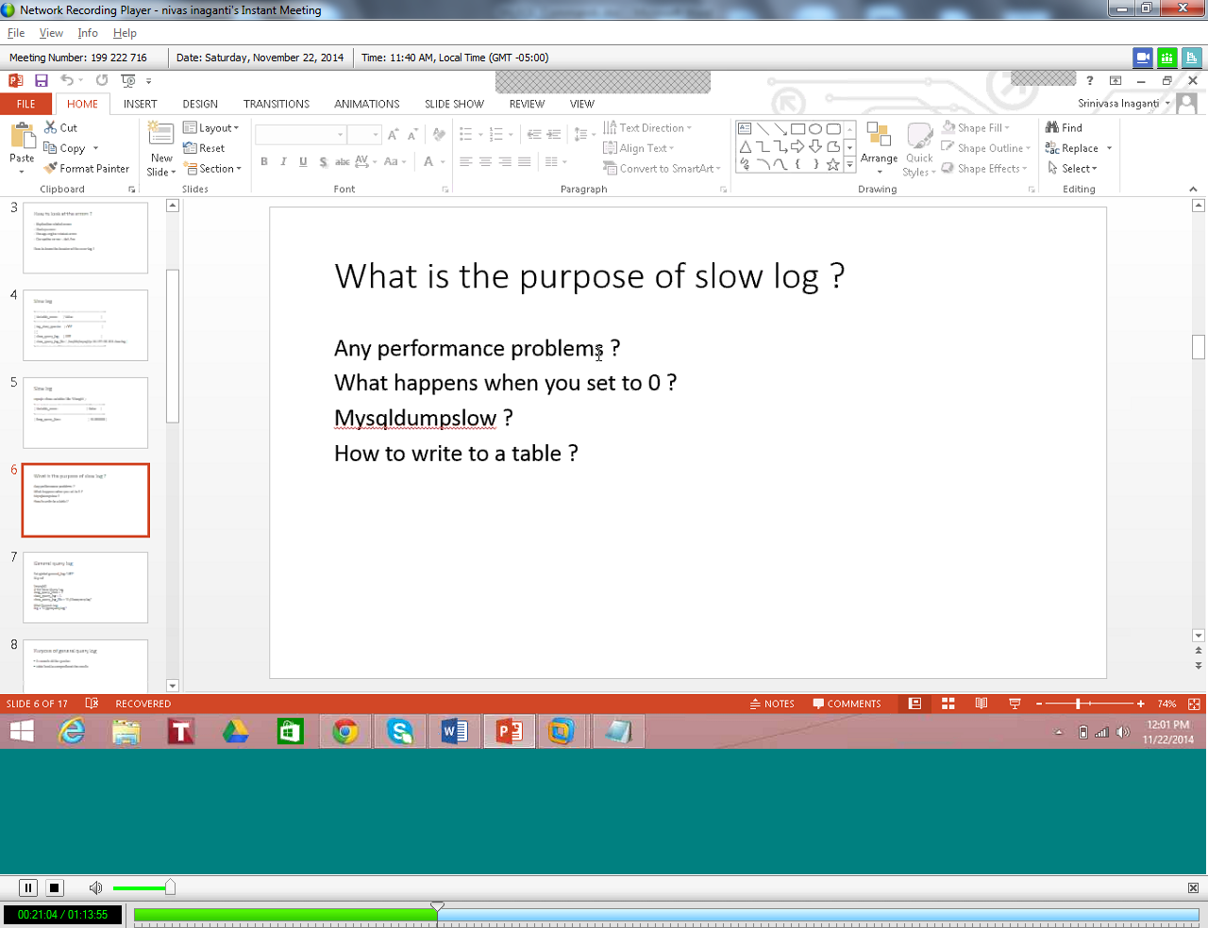

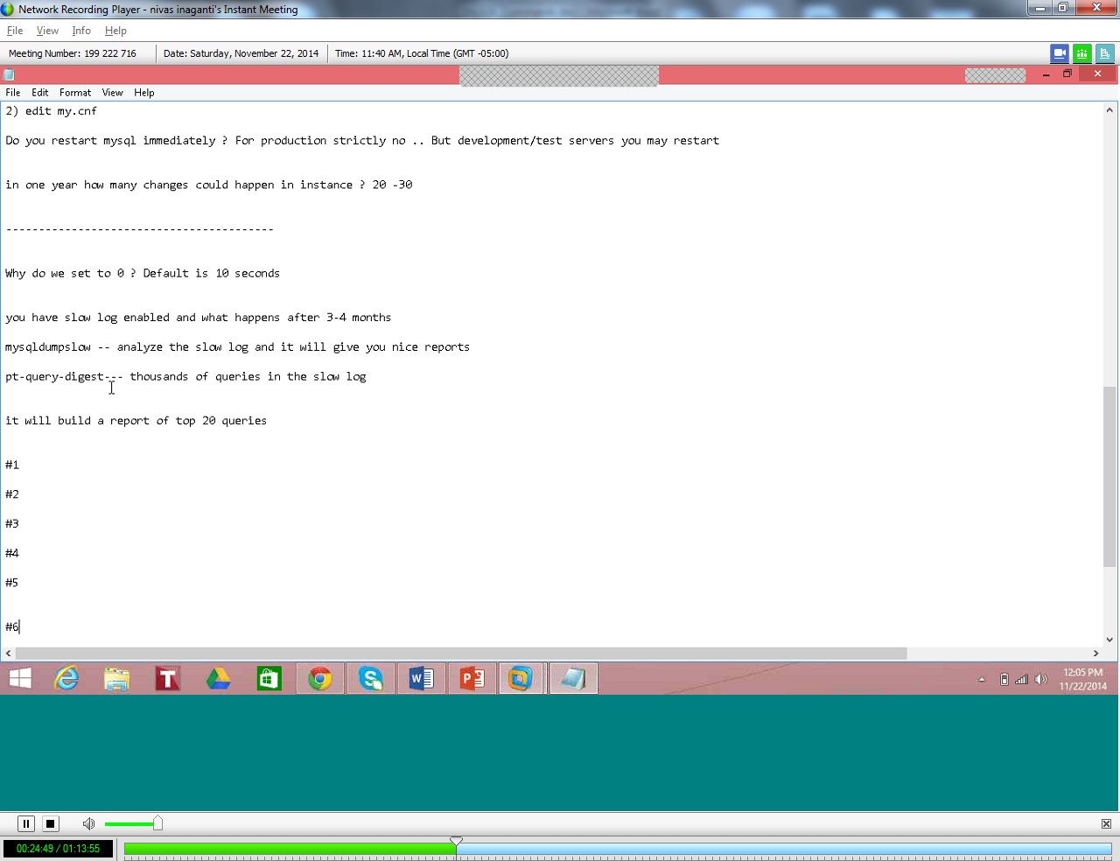

Purpose of General Query Log:

It records all the queries for that time
Little hard to comprehend the results as it does not have timestamps for query execution.

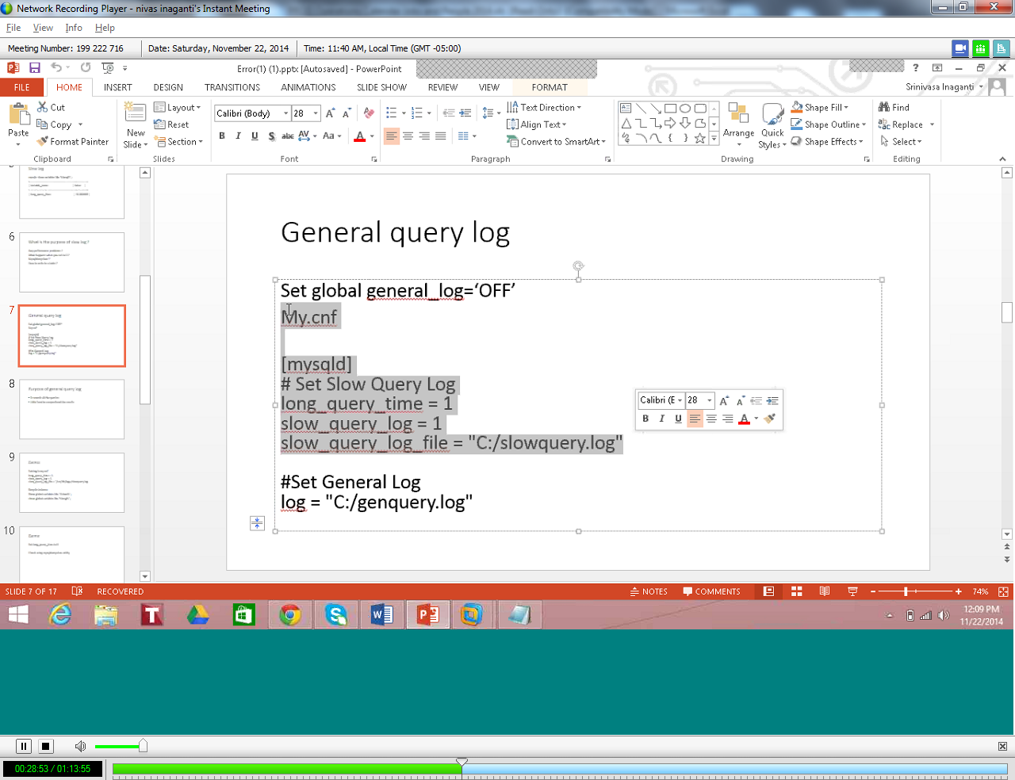

To Edit my.cnf file:
Vi /etc/my.cnf
After editing my.cnf we need to restart mysql
/etc/init.d/mysql stop

After stopping we need to start MYSQL again.

/usr/bin/mysqld_safe &

Show tables;
Show databases;
This will change the database.
Use DB_name;

To analyze the sow log file and to get the report, run the below command, it will generate a nice report:
Mysqldumpslow localhost-slow.log
This will set the elogs to be inserted into a ‘TABLE’ instead of the default ‘FILE’
Set global log-output = ‘TABLE’ ;
To fetch first 50 rows from the table then pelas euse below:
Select * from employees limit 1,50;
When we install MYSQL four databases are created by MYSQL:
1) Information_schema – Data dictionary
2) Mysql -- system tables
3) Performace_schema – Related to performance tuning.
4) Test – This is just a test database.

Mysql> show create table slow_log \G
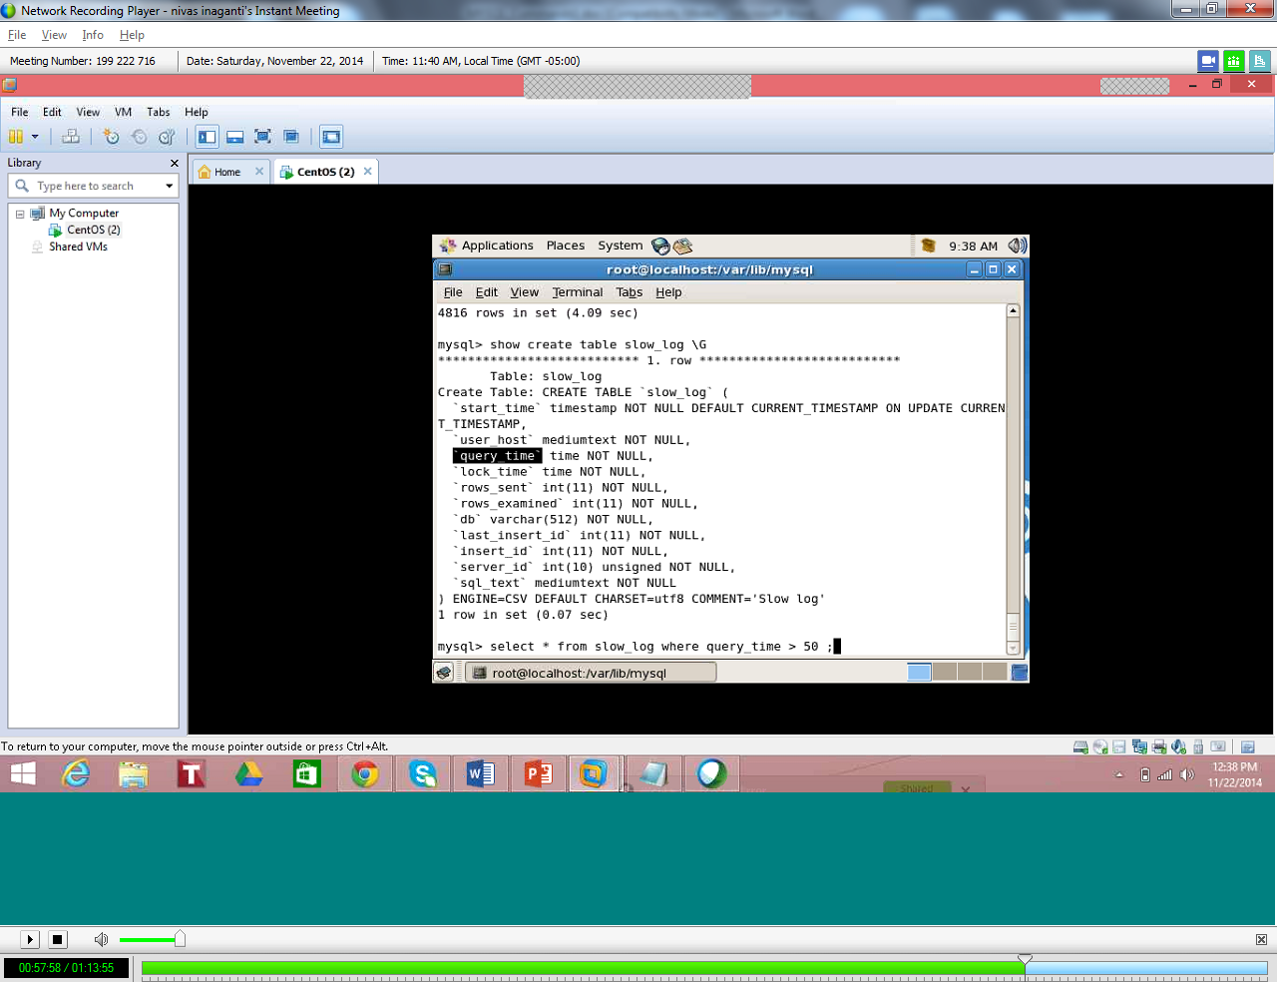
REDOLOG files:
- Used for Crash Recovery
- Two logs created by default
There are 2 default REDOLOG files created by default and they are:
/var/lib/mysql
- Ib_logfile0 –File1
- Ib_logfile1 – File2

BINARY LOG

It will record only DDL and DML statements ( All DB changes are recorded in Binary logs – mainly used in point in time recovery)
DML—Delete,insert,update
DDL
Create table
Drop table
Alter table
Create procedure
Triggers
Why do we need Binary log?
It is used for point in time recovery

By default it is stored in /var/lib/mysql
Enable Binary Log by setting below:

Log_Bin = 1
To see the contents of a particular Binary log, use below:
Mysqlbinlog filename

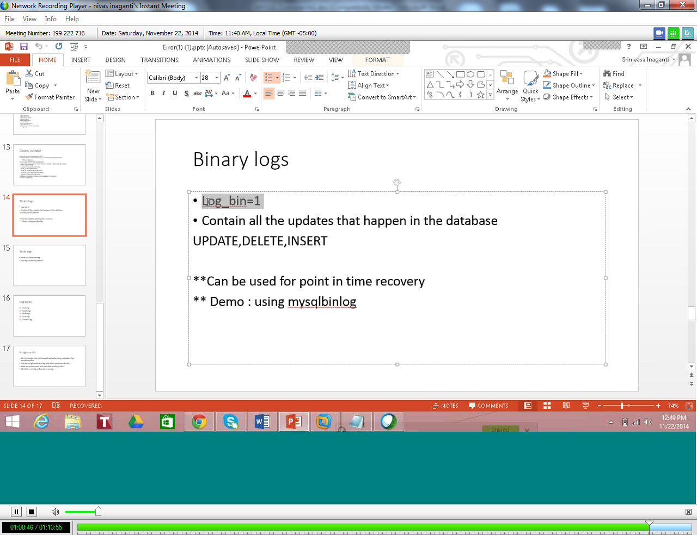

DIFFERENT TYPES OF LOGS:

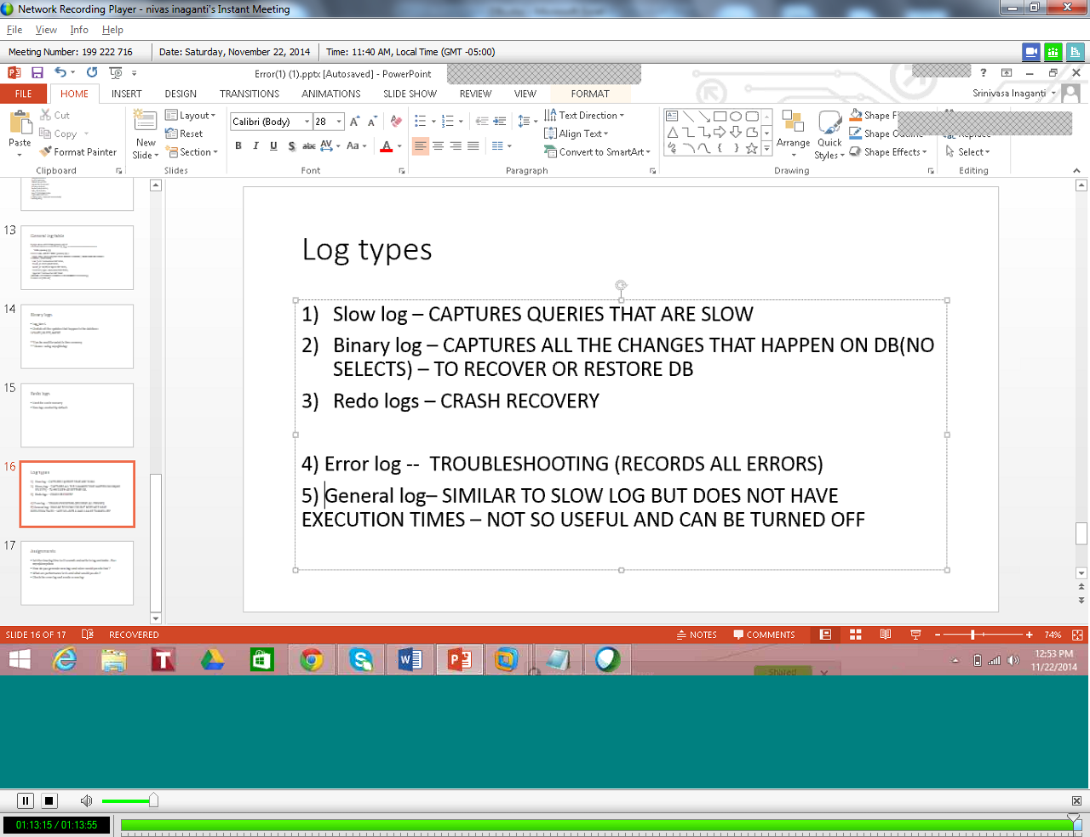

SHELL SCRIPTING:
IF LOOP
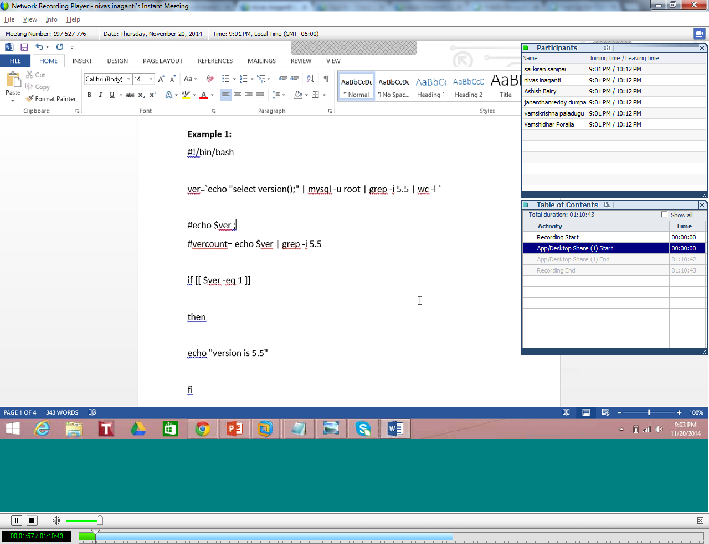

If you want to count the number of lines in output:
Less filename|wc –l
FOR LOOP:
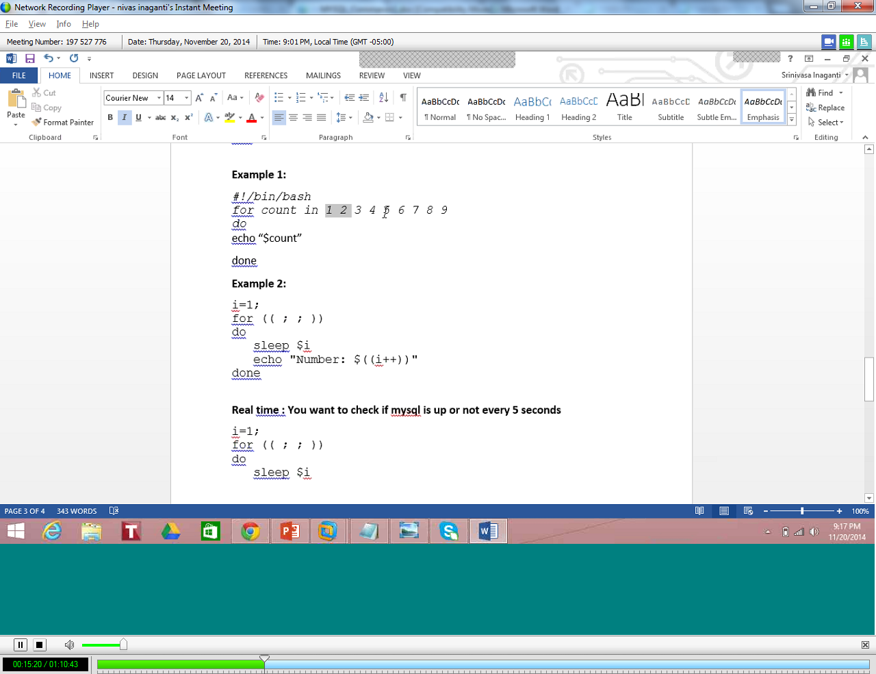
WHILE LOOP:
To get the Tables in all databases:
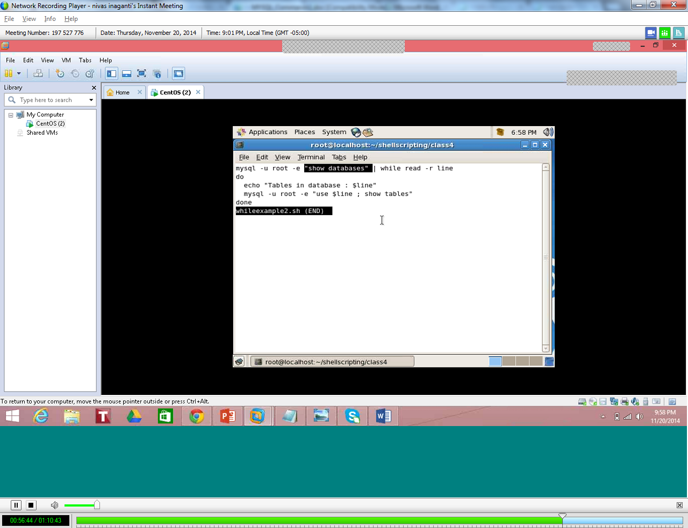
AWK Command:

Df –h awk ‘{print $5}’ | cut –d% -fl | grep –v ‘use’

BACKUPS AND RESTORE :
We can do a file backup of the entire Instance Data directory and can restore it in different Server.
Mysql –u root –e “show global variables like ‘%datadir%’”

Below will Zip the entire folder
ZIP Backup.zip /var/lib/sql

Below will copy the Zip file to the Backup Folder every night.
Cp Backup.zip /target/Backups
How to delete files older then 2 days
Find /root/backups/ -name *.zip –mtime 2 –exec rm
ROOT DIRECOTRY OF MYSQL:
Mysql –u root –e “show global variables like ‘%datadir%’”
Usually it will be /var/lib/sql

Script To Automate a Cold Backup:
- Mysql –u root –e “show global variables like ‘%datadir%’”
- /etc/init.d/mysql stop – This will stop MYSQL
Ps –ef | grep –I mysqld | wc –l
Zip the folder
- Zip backup.zip $datadir
- Pruning the old backups older than 2 days
- /etc/init.d/mysql stop – This will start MYSQL

CREATE DATABASE:
Create database emptest;
Use emptest;
Ensure all the tables are of type INNODB
Create table emp (id int) engine = INNODB;
Create table emp (id int) engine = myisam; -- This will have lot of locks , No Crash recovery.
Drop database emptest;

To create Primary Key :
Crate table (rollno,fname,lname,primary key (rollno));

To run UNIX commands inside MYSQL:
Mysql >\! Ls -ltr
To see warning messages in Logs:
Mysql> show warnings;
Mysql> show errors;
Mysql> show global variables like ‘%err%’ – To see the location of Error logs

What to see in Error Logs:
- Replication related errors
- Startup errors
- Storage engine related errors
- Corruption errors
REASON FOR SLOWNESS:
- HEAVY LOAD
- BAD APPLICATION CODE - BAD SQL QUERIES AT DATABASE LEVEL
- INADEQUATE RESOURCES—MEMORY,CPU,PROPER I/o
- NETWORK
- STORAGE ISSUES
- IMPROPER CONFIGURATION – BUFFERPOOL SHOULD BE MORE THAN 90% -- MORE% OF RAM

WHAT IS METADATA?
Metadata is data about data.
Information_Schema:
Information_schema is a default database which gets created in MYSQL
List all the tables that have a columnname called ID
Mysql> select table_schema from information_schema.columns where column_name = ‘ID’;

How to identify all tables of type ‘myisam’ ?
Mysql> select table_name from information_schema.tables where engine = ‘myisam’;

To see all connections in the MYSQL database:
Mysql> select * from information_schema.processlist;

To see all tables created before 4 days in the MYSQL database:
Mysql> select table_name from information_schema.tables where create_time < NOW() – INTERVAL 4 DAY;
To know the database size:
Df – sh – UNIX method
Mysql> select table_schema “Data Base Name”,SUM(Data_length + Index_Length) /1024/1024 “Databse Base Size in MB” from information_schema.tables group by table_schema;
SHOW statements are equivalent to Information_schema
Mysql> show processlist;
Or
Mysql> select * from information_schema.processlist;

To list the databases in the Instance
Show database;
Or
Mysql> select distinct table_schema from information_schema.schemata;

SHOW STATEMENTS:
- SHOW ENGINE
- SHOW databases
- SHOW create table
- SHOW create database
To see the parent child relationship – referential integrity:
Mysql> select distinct table_schema from information_schema.referential_constraints;

To see the VIEWS:
Mysql> select * from information_schema.VIEWS;
BACKUP AND RECOVERY :
If Data Is lost, Then Business is lost.
Therea re several types of failure:
- Server issues ( Hardware issues)
- SAN issues
- Software corruption
- Disaster – Hurricane,flood,datacenter is gone.

Types of Backups:

CATEGORY A:
Binary Backup
- To Zip all the files ( .ibd files,.frm files)—It’s a file level backup
Text Backup
It is nothing to do with Physical files
The databases are backed up by MYSQL utility mysqldump

Mysqldump –u root –p --all-databases > alldatabasebackup.sql
Mysqldump –u root –p --databases dbname > dbname_backup.sql
Mysqldump –u root –p --databases dbname1 dbname2 > dbname_backup.sql
Drop database dbname;
How to Restore?
Mysql –u root < dbname_backup.sql

How to backup a table alone?
Mysqldump –user=root –password=mypassword –h localhost databasename table1 table2 > table1_table2_backup.sql
How to backup a DDL alone with no data?
Mysqldump –u root –p --all-databases --no-data > alldatabasebackup.sql
How to backup a remote database in another host?

Mysqldump –u root –h 102.102.95.95 --databases dbname > dbname_backup.sql

To recreate Stored procedures and functions use –routines option
Mysqldump –user=root –password=mypassword –h localhost databasename - routines > table1_table2_backup.sql
Most common other options:
--Routines
--Databases
--Single-transacvtion( It will not lock tables) -- Always use for Innodb databases
--Master-data – Replication
--No-data
Functions and procedures are not backed up by default.
TRIGGERS will be backup by default.

Most common Backup command using mysqldump:
Nohup mysqldump –socket=mysql.sock –user=user1 –password=passord1 –single-transaction –flush-logs –master-data=2 --all-databases –extended-insert –quick –routines > orders_Dump.sql 2> orders_dump.err &
Use TIME Unix function to record time taken to backup
TIME Mysqldump –u root –p --databases dbname > dbname_backup.sql
Can we restore between Windows and UNIX? -- Yes

How do I transfer files between Servers?
- Use scp
- Use sftp
- Use winscp
CATEGORY B:
Full Backup
Incremental Backup
- MYSQLDUMP backup

Point in time recovery:
Backups + Binary Logs = Point in time recovery
First we need to make sure the Binary Logs are enabled.
Log_Bin = 1
Mysql> select now(); -- TO get current time

First backup the database using mysqldump
Mysqldump –u root –p --databases dbname > dbname_backup.sql
Restore the backup by executing the mysqldump backup file
Mysql –u root < dbname_backup.sql
Then restore data from Binary logs to do Point in time recovery:
Before that try to prune the old Binary logs by setting the parameter
%expire%
Mysql> show global variable like ‘%expire%’
Output will be:
Variable_name value
Expire_log_days 0
Default value will be Zero and we can set it to 7 so that we can keep 7 days worth of transactions in the binary logs
To Resore Point in time, Execute below:
Mysqlbinlog /var/lib/mysql/1.000027 –start-datetime=”2014-12-03 18:56:32” –stop-datetime=”2014-12-03 18:57:32” | mysql –u root
NOTE : Choose the Binary log with the latest timestamp to resore latest updates.
Mysql> show global variable like ‘%bin%’
Max_binlog_size – This will show the maz size of the binarylog
To read a Binarylog file , we need to use mysqlbinlog utility by outputting it to a file so that it can be human readable.
Mysqlbinlog /var/lib/mysql/1.000027> process.out

To recover data from multiple binary logs then use below:

Mysqlbinlog 1.000027 1.000028 1.000029 –start-datetime=”2014-12-03 18:56:32” –stop-datetime=”2014-12-03 18:57:32” > output.log
Use tee command to output to a file.
Mysql< tee gopi.log
Mysql> source output.log; -- This will execute the Binary log
Mysql>note – This will disable the output file

- percona Xtrabackup – Copy the data files
Xtrabackup Vs Enterprise backup

Both are functionally similar

Xtrabackup is free of cost

How to install ?

rpm -Uhv http://www.percona.com/downloads/percona-release/percona-release-0.0-1.i386.rpm -- percona repository

yum install percona-xtrabackup-20-2.0.8-587.rhel5

innobackupex -- will work for innodb and myisam
innobackupex –help will give all options for command inclusions
xtrabackup -- will work only for innodb
----------------------------------------------------------------------------------------------

Full backup :

innobackupex /mysqlbackups/backupdir

/etc/my.cnf should contain datadir

Apply log :

innobackupex /mysqlbackups/backupdir --apply-log

If you dont apply log you get wierd errors about logs which does not actually mean anything(demo)

Restore :

Drop database

innobackupex /mysqlbackups/backupdir/2014-12-09_18-17-33 --copy-back

--------------------------------------------------------------------------------------------

Create first database

Full backup :

innobackupex /mysqlbackups/backupdir

Create second database

Incremental backup:

innobackupex --incremental /mysqlbackups/backupdir/inc --incremental-basedir=/mysqlbackups/backupdir/2014-08-13_19-41-12

Apply log on full :

innobackupex --apply-log --redo-only /mysqlbackups/backupdir/2014-08-13_19-41-12

Apply incremental to base(full) :

innobackupex --apply-log --redo-only /mysqlbackups/backupdir/2014-08-13_19-41-12 --incremental-dir=/mysqlbackups/backupdir/inc/2014-08-13_19-43-30 --use-memory=1G

Drop the two databases

Stop MySQL

Restore from full :

innobackupex /mysqlbackups/backupdir/2014-08-13_19-41-12 --copy-back

Validate if mysql is started

Two databases are restored or not

After restore use mysqldsafe is db does not come up
>Which mysqld_safe
>/usr/bin/mysqld_safe &

3) Mysql enterprise backup

Is this free? No, It has to be bought ,ex: 5000$ /server.
Download Enterprise edition from below link:
Download link: edelivery.oracle.com
MEB – ibbackup(old name for MYSQWL Enterprise Backup)
--After going to te the Download website , sign in with your oracle id and the choose the version of MYSQL hat you want to download.
For enterprise backup, for Linux x86 version , download below:
MYSQL Enterprise Backup 3.11.1TAR for SuSE Enterprise Linux 11x86(32 bit)
For Centos,Redhat linux use below:
MYSQL Enterprise Backup 3.11.1RPM for Oracle Linux /RHEL 5 x86 (32 bit).

1) Full backup

./mysqlbackup --user=root --socket=/var/lib/mysql/mysql.sock --backup-dir=/mysql-backups backup-and-apply-log --with-timestamp

2) Full restore

Bring down mysql

/etc/init.d.mysql stop

./mysqlbackup --defaults-file=/mysql-backups/2014-12-08_17-45-56/server-my.cnf --user=root --socket=/var/lib/mysql/mysql.sock --backup-dir=/mysql-backups/2014-12-08_17-45-56 copy-back

After restore , you need to change the permission to mysql user else the tables won’t work

Chown mysql:mysql dbname

3) Full backup with compression

./mysqlbackup --user=root --socket=/var/lib/mysql/mysql.sock --no-locking --backup-dir=/mysql-backups/08-10-2014_repl_backup_compression --compress backup --with-timestamp

4) Restore compressed backup

./mysqlbackup --user=root --socket=/var/lib/mysql/mysql.sock --uncompress --backup-dir=/mysql-backups/08-10-2014_repl_backup_compression/2014-08-10_19-19-13 apply-log

./mysqlbackup --defaults-file=/mysql-backups/08-10-2014_repl_backup_compression/2014-08-10_19-19-13/server-my.cnf --user=root --socket=/var/lib/mysql/mysql.sock --backup-dir=/mysql-backups/08-10-2014_repl_backup_compression/2014-08-10_19-19-13 copy-back

---------------------
Incremental
----------------------

5)

Create a database before full

Full Backup(Sunday) :

./mysqlbackup --user=root --socket=/var/lib/mysql/mysql.sock --no-locking --backup-dir=/mysql-backup/12-07-2014_incremental_base backup

Create another database before full

take incremental(tuesday): -- It has all the changes between Sunday and Tuesday

./mysqlbackup --incremental --user=root --socket=/var/lib/mysql/mysql.sock --no-locking --incremental-backup-dir=/mysql-backup/12-07-2014_incremental_after_changes_one --incremental-base=dir:/mysql-backup/12-07-2014_incremental_base backup

Drop two databases

STEPS IN INCREMENTAL RESTORE:

1) You have to --apply-log to apply all the changes that happened during the backup

2) You have to merge the full and incremental

3) Restore using the merged backup (full+incremental)

./mysqlbackup --user=root --socket=/var/lib/mysql/mysql.sock --backup-dir=/mysql-backup/12-07-2014_incremental_base apply-log

./mysqlbackup --defaults-file=/mysql-backup/12-07-2014_incremental_base/server-my.cnf --user=root --socket=/var/lib/mysql/mysql.sock --backup-dir=/mysql-backup/12-07-2014_incremental_base --incremental-backup-dir=/mysql-backup/12-07-2014_incremental_after_changes_one apply-incremental-backup

Restore :

bring down mysql

./mysqlbackup --defaults-file=/mysql-backup/12-07-2014_incremental_base/server-my.cnf --user=root --socket=/var/lib/mysql/mysql.sock --backup-dir=/mysql-backup/12-07-2014_incremental_base copy-back

validate if the two dbs were recreated
Go to Data Directory and change permission.

BACKUP_HISTORY TABLE:
To see all backups history there is a table in MYSQL schema to look at it for any errors or successful backups.

CATEGORY C:
This is depending upon Storage Engine
INNODB Backup: Does not lock tables during Backup
MYISAM Backup: Locks tables during Backup

To get MYSQL HELP for Options:
Mysqldump –help
Above will list all mysql options

To take test
www.classmarker.com/online-test/#q

INNODB—has automatic crash recovery
MYISAM -- No Crash arecovery so no REDO logs
For a database which has both INNODB tables and MYISAM tables and If a crash happens only INNODB tables are fully recovered and MYISAM tables will be in corrupted state, so use below to bring it back to correct state:

Repair table tablename – Only for MYISAM tables

How to find if a particular table is corrupted after Restore?

Use ERROR LOG to see for errors.
Use below command to check if the table is in Corrupted state:
Mysql> check table tablename;

Use FLUSH LOGS command to create slow_log after it is deleted.
Mysql> flush logs;

MYSQLBINLOG is the utility to see and view the contents of Binary Logs

Pt-query-digest is the utility to see report from Slow_Logs
./ Pt-query-digest /var/lib/mysql > output.txt – Ths is is to see the slow log report

To see report for a particular time:
./Pt-query-digest /var/lib/mysql –since starttime –until stoptime> output.txt – Ths is is to see the slow log report

25 tips on MYSQLDUMPS:
1) Is mysqldump text backup or binary backup
It is a text backup . If you open the backup file you will see all the statements that can be used to recreate databases and objects . It also has the insert statements to populate the tables with data
2) What is the syntax for mysqldump ?
mysqldump -u [uname] -p[pass] –databases [dbname][dbname2] > [backupfile.sql]
3) How to backup all databases using mysqldump ?
mysqldump -u root -p –all-databases > backupfile.sql
4) How to backup specific databases using mysqldump ?
mysqldump -u root -p –databases school hospital > backupfile.sql
5) How to backup specific tables using mysqldump ?
mysqldump –user=root –password=mypassword -h localhost databasename table_name_to_dump table_name_to_dump_2 > dump_only_two_tables_file.sql
6) I do not want the data .How to get DDL only ?
mysqldump -u root -p –all-databases –no-data > backupfile.sql
7) How much time does a mysqldump backup take ?
It actually depends on the size of the database. A database of 100 GB size might take 2 hours or more
8) How to backup remote database that resides on other server ?
mysqldump -h 172.16.25.126 -u root -ppass dbname > dbname.sql
9) What is the significane of –routines option ?
The output generated by using –routines containsCREATE PROCEDURE and CREATE FUNCTION statements to re-create the routines. If you have procedures or functions you need to use this option
10) How to list all the available options in mysqldump
mysqldump –help
11) What are the most common options used in mysqldump ?
All-databases
Databases
Routines
Single-transaction (It will not lock tables) – Always use for innodb databases
Master-data – replication (Ignore for now)
No-data – It will dump a blank database without data
12) Are triggers backed up by default ?
Yes
13) What is the significance of single transaction option ?
–singletransaction option avoids any locks during backup for innodb databases. No locking during backup if we use this option
14) What is the most common command used to backup using mysqldump ?
nohup mysqldump –socket=mysql.sock –user=user1 –password=pass –single-transaction –flush-logs –master-data=2 –all-databases –extended-insert –quick –routines > market_dump.sql 2> market_dump.err &
15) How to compress a backup taken by mysqldump ?
Note: Compression might slow down the backup
Mysqldump [options] | gzip > backup.sql.gz
16) Is mysqldump ideal for large databases ?
Depending on your hardware, including available RAM and hard drive speed, an appropriate database size is between 5GB and 20GB. While it is possible to use mysqldump to back up a 200GB database, this single thread approach takes time to execute
17) How to restore the backup taken by mysqldump ?
a) Use source method
b) Mysql –u root –p < backup.sql
18) I want to record the errors in a log during recovery .. I also want to see the execution time of recovery ?
Time Mysql –u root –p < backup.sql > backup.out 2>&1
19) How to know if the restore is running ?
Show full processlist
20) What is something you have to do if the database is huge ?
Run it in the background using nohup
21) Can I take mysqldump backup on windows and restore to linux server ?
Yes
22) How do I transfer files onto the target server ?
a) Use scp
b) Use sftp
c) Use winscp
23) What happens if I use source on a big backup file to restore ?
If you source a big backup file , it might take forever to run . Better way of handling this situation is using nohup to run in the background
Alternate solution is to use screen in unix
24) Does mysqldump contain drop database by default ?
You may need to add the option –add-drop-database
25) How to extract one database backup out of a multiple database backup. (Assume the database name is test)
sed -n '/^-- Current Database: `test`/,/^-- Current Database: `/p' full

MYSQL EXPORT AND LOAD

Export a table:
Select * into outfile ‘c:\path\filename’ from sakila.payment;

To Change Ownership of a Folder in UNIX
Chown mysql:mysql util – where Util is the foldername
To Change Ownership of all Folder in UNIX

Chown –R mysql:mysql /var/lib/mysql
– where Util is the foldername

To delete from a table:
Delete from sakila.payment;
Load data from file to a table:
Mysql> load data infile ‘c:\path\filename’ into table sakila.payment;

Access control:
Grant select on emp to user username;

MYSQL_SECURE_INSTALLATION:

This will come with the default installation, Its good to run this after mysql installation as it will remove default password for users like ‘root’.
Type which MYSQL_SECURE_INSTALLATION
This will show you the path where the software is , just run the fiel and it will reset the password for root and other users.

REPLICATION:
--24/7 avalilability
--High Availability
Important job of a DBA

Prereqs for replication

Master server and slave server'

How does slave server track the changes that happen on master ?

1) Slave server will be continuosly checking the binary logs of master server to track the changes

2) Upon detection of a change slave server will pull the changes from master and replay them on the slave

Replication uses two threads

1) I/O thread -- Contiuously connecting to master and reading events from binary logs

2) SQL thread -- Apply any changes detected onto slave

Where should we create the replication user ? MASTER

create user 'slaveuser'@'%' identified by 'slavepass' ;

password for root is sairam

grant replication slave on *.* to 'slaveuser'@'%' ;

Take a backup of MASTER server database and restore in SLAVE Server

Mysqldump –u root –p –alldatabases –master-data=2 >backup_dump_12152014

–master-data=2 , Option will backup Binary logs also.

After backup is done, Open the backup file, it will show you the Binary file position that
You will need to restore in SLAVE for point in time Restore.

Now, we need to transfer the backup filename from MASTER to SLAVE server.

We can use scp, sftp for this.

Go to /etc/hosts in the destination server

Set the server-id = 1 for master and server-id = 2 (can by any number other than master)for slave.

It will give you the IP address of the destination server

To transfer file through SCO,use below:

Scp backup_dump_12152014 root@104.130.3.194:/backup

--where /backup is the backup folder in destination server.

--Now Restore the database in SLAVE Box.

Mysql> source backup_dump_12152014;

less /mysql/etc/my.cnf

Now after restore is completed, we need to notice the position of Binary log and SLAVE should continue from this position

Postion will be found in Backup file.

Implement below in SLAVE Box:

Mysql> CHANGE MASTER TO MASTER_HOST='104.130.2.234', MASTER_USER='slaveuser' , MASTER_PASSWORD='slavepass', MASTER_LOG_FILE='1.000016', MASTER_LOG_POS=3115;

Mysql> Start slave;

Above will start the SLAVE and begin Replication from MASTER.

Once we start the SLAVE, we need to see if SLAVE( Replication) is running or not.

Mysql> show slave status \G;
You need to check for the two threads which should always be running in order to work this as SLAVE and they are below:

Slave_IO_Running : Yes
Slave_SQL_Running: Yes

To see and change firewall rules settings , use below:

# history | grep –I iptables

Port 3306 is the default port for MYSQL

To stop the replication SLAVE:

Mysql> stop slave;

Mysql> show slave status;

Above might show you that Slave_IO_Running not running as we cnaged the firewall rule

Use telnet to troubleshoot.

# telnet mastneripaddress

Above will tell you if the firewall rules are established.

Once the firewall rules are setup right like ( ACDEPT or REJECT) , we need to stop and start the slave again.

Mysql> stop slave;

Mysql> start slave;

- end of REPLICATION.

mysqlfailover – Installation and Operations tutorial
by NIVAS on MARCH 6, 2015

Configuration

1) Download the utilities. Python connector is a prerequisite and this needs to be installed along with mysql utilities rpm
wget http://dev.mysql.com/get/Downloads/Connector-Python/mysql-connector-python-2.0.2-1.el6.noarch.rpm
wget http://dev.mysql.com/get/Downloads/MySQLGUITools/mysql-utilities-1.5.3-1.el6.noarch.rpm

2) Install the RPMs. “Mysqlfailover –help” will confirm the install of the utilities
rpm –ivh mysql-connector-python-2.0.2-1.el6.noarch.rpm
rpm -ivh mysql-utilities-1.5.3-1.el6.noarch.rpm

3) Set the GTID MODE to ON. GTID mode is a prerequisite for mysqlfailover. GTID tracks the transaction IDs for replication instead of tracking log file and position
log-bin=1
gtid_mode=ON
enforce_gtid_consistency=true
log-slave-updates=1
4) Setup replication using change master to command like below. Notice the difference in the change master to statement. We are not giving the binary log file and position
CHANGE MASTER TO
MASTER_HOST = ’104.xxx.xx.xx’,
MASTER_PORT = 3306,
MASTER_USER = ‘slaveuser’,
MASTER_PASSWORD = ‘slavepass’,
MASTER_AUTO_POSITION = 1;

5) Setup report host. Report host has to be updated on the slave. You can validate this configuration by issuing “show slave hosts” on the master server
report-host is the variables that needs to be updated in my.cnf on slave
e.g report-host=100.xx.xx.x

6) Master-info-repository has to be set to TABLE on slave. Implement the below changes in slave configuration
master-info-repository=TABLE
log-slave-updates=1

Operations

1) Checking health: Below command can be issued to check the status of the replication servers. This will connect to all slaves and list the health of each server. If you do not see any of the slave servers please go and fix it
mysqlfailover –master=root:sairam@localhost:3306 –discover-slaves- login=root:sairam health

2) Testing failover : Run the below command and kill mysql on the master server. Status should automatically get updated and the failover should start . Once failover is successful , old master can be configured to slave manually

mysqlfailover –master=root:sairam@localhost:3306 –discover-slaves-login=root:sairam –failover-mode=auto –force

3) Running as daemon : Below command can be used to run in the background. Process will run in the background and initiate the transfer when needed

mysqlfailover –master=root:sairam@localhost:3306 –discover-slaves-login=root:sairam –failover-mode=auto –force –deamon start

4) Post failover operations : You can use execute after option to execute post failover actions . For e.g if heartbeat is installed you can initiate failover of virtual IP as a post failover action

