/api/token/ Authenticate API calls

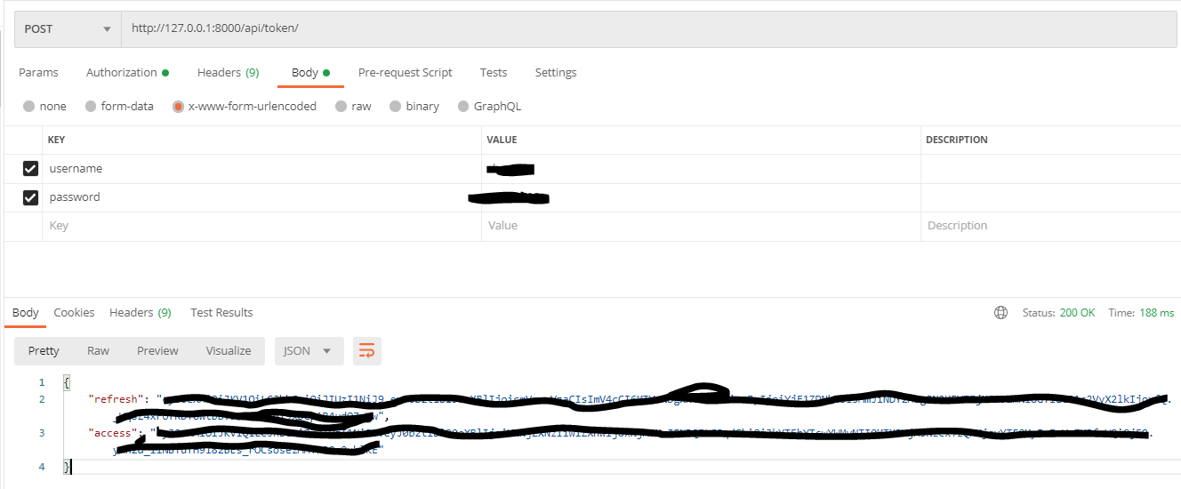

/register

/register no access token

/register invalid access token

/register successful registration (Note: all passwords are saved as encrypted format in database)

/register same emaild

/register missing info

/register same emaild – case senstive

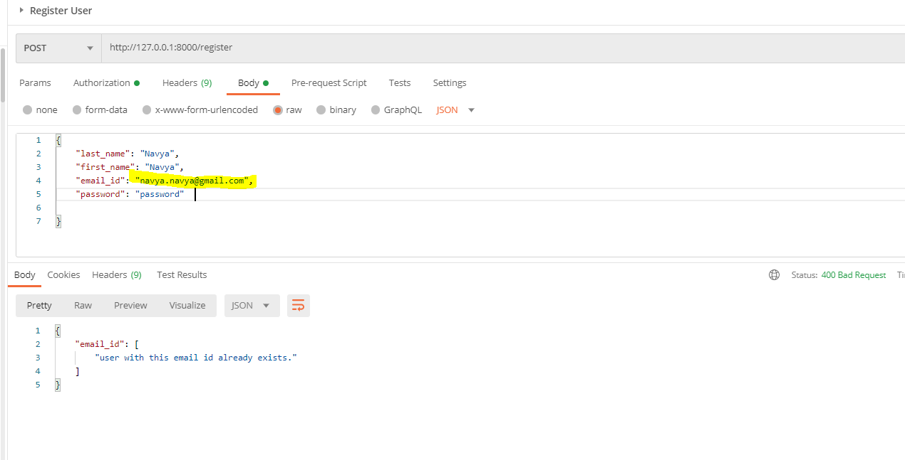

/login

/login without passing password

/login missing email_id or username

/login invalid email_id

/login wrong password

/login without access token

/login invalid access token

