Scenario 1 : positive test case with new card number(4324) and all the 3 different categories

Input:

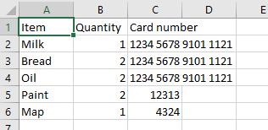

Output :

amount sheet: total amount paid is displayed

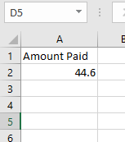

Card sheet: new card added to the sheet

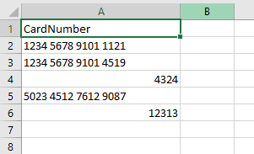

Scenario 2: Negative test case with essentials item limit exceeding!

Input:

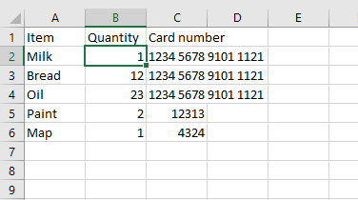

Error :

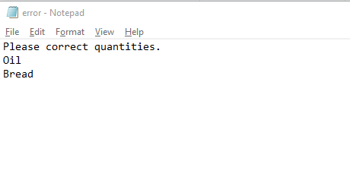

Scenario 3: Negative test case with luxury items exceeding limits!

Input:

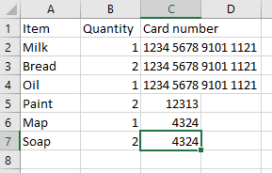

Output:

Cards:

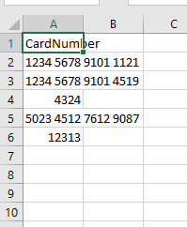

Error: as the luxury items has a limit of 3 we have to change the quantity for luxury items!

