**Flight Booking Application - Individual Project**

1. **Below is the Folder Structure of the application as expected**

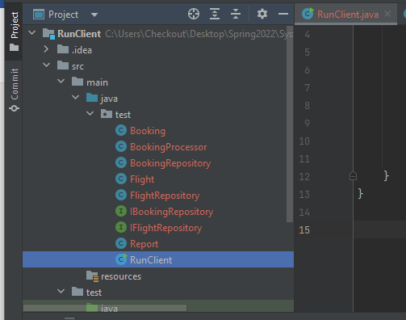

1. **Steps to Execute**
2. **Mvn compile**

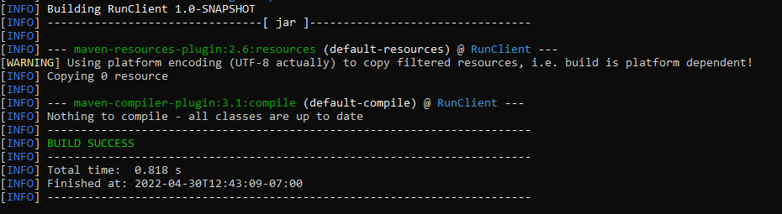

1. **Mvn clean install**

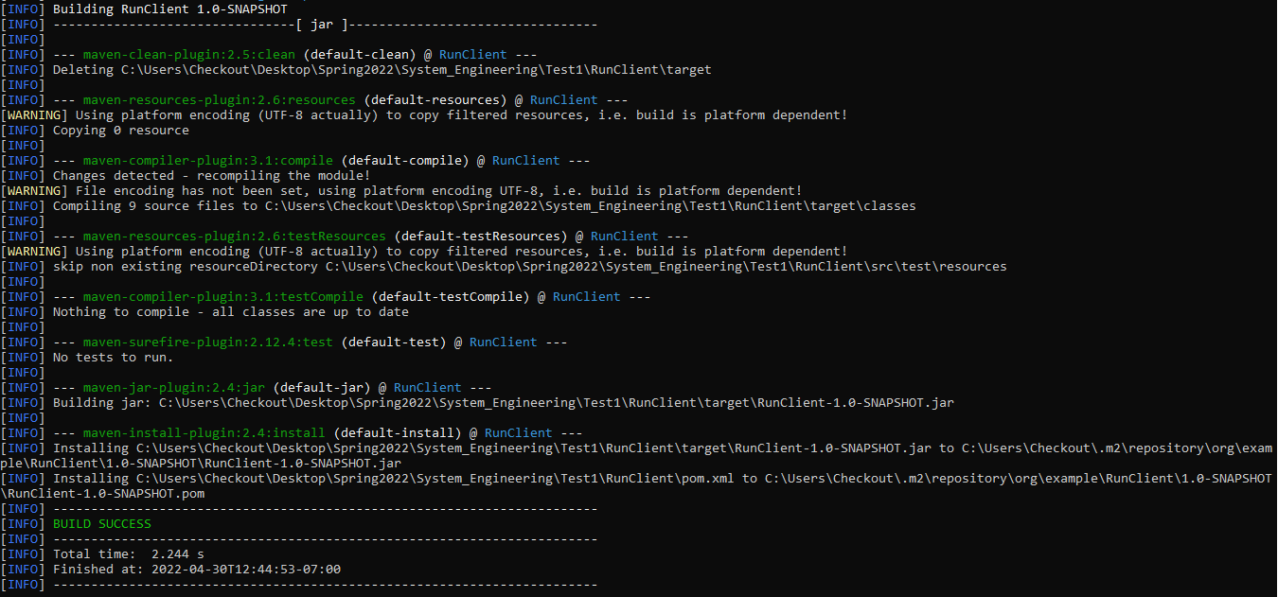

1. **Before Running the below command only Sample.csv and flights.csv is present in the Test1 Directory**

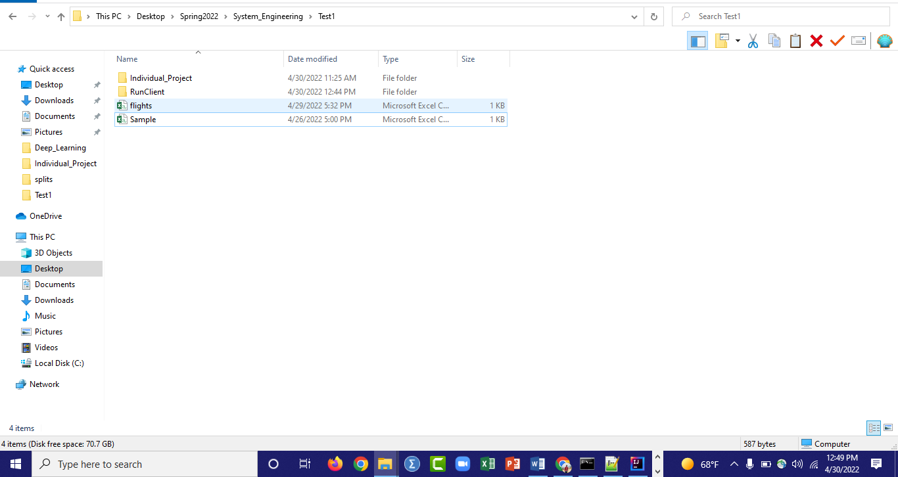

1. **Command to generate output.csv and output.txt based on the inputs of Sample.csv and flights.csv**

**mvn exec:java -Dexec.mainClass=test.RunClient -Dexec.args="C:\Users\Checkout\Desktop\Spring2022\System_Engineering\Test1\Sample.csv C:\Users\Checkout\Desktop\Spring2022\System_Engineering\Test1\flights.csv C:\Users\Checkout\Desktop\Spring2022\System_Engineering\Test1\output.csv C:\Users\Checkout\Desktop\Spring2022\System_Engineering\Test1\output.txt"**

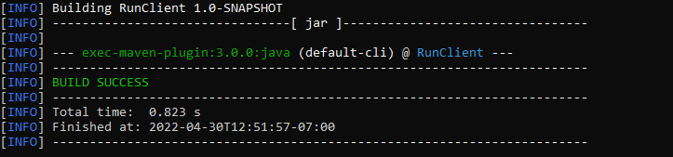

**Output.csv and output.txt file is generated by executing the above command in Test1 Folder**

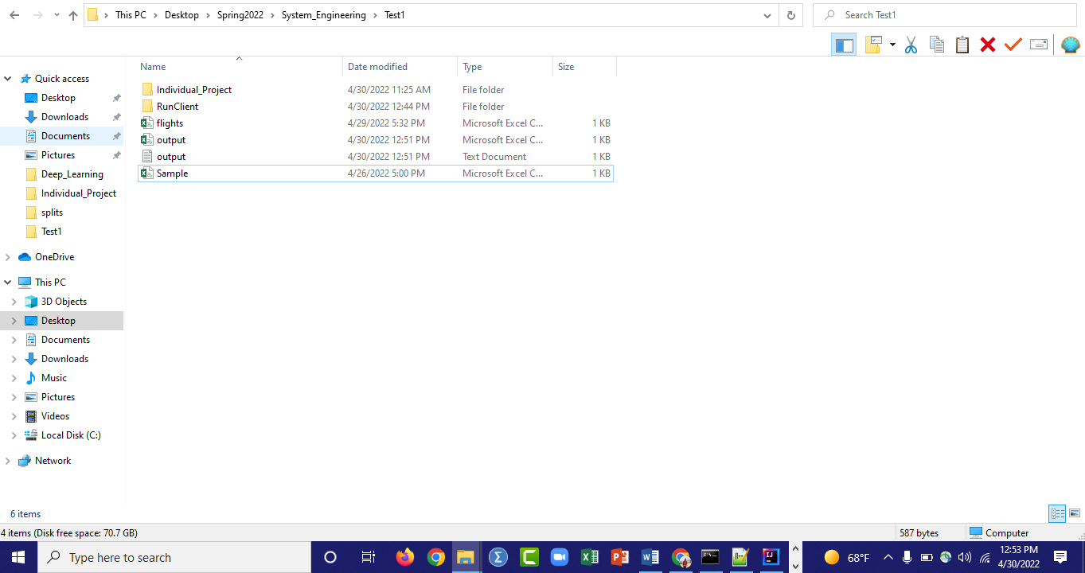

1. **Below are the contents of output.csv and output.txt file**

**Output.csv**

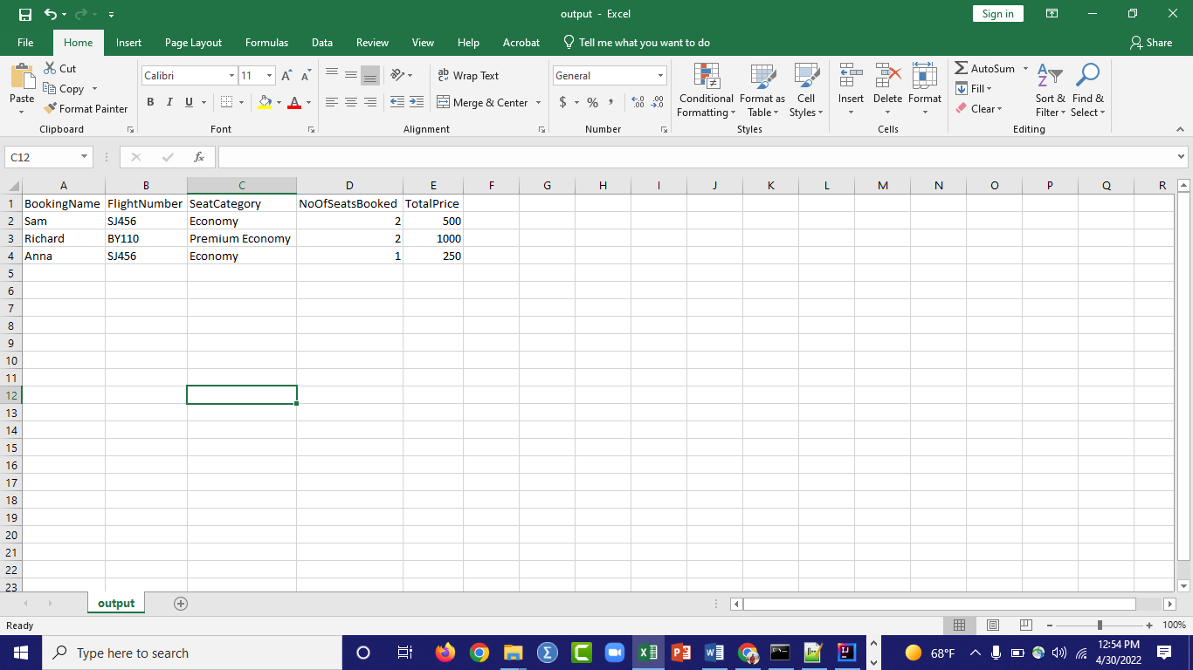

**Output.txt**

