Setup EC2 :

Login to your account :

Go to your services:

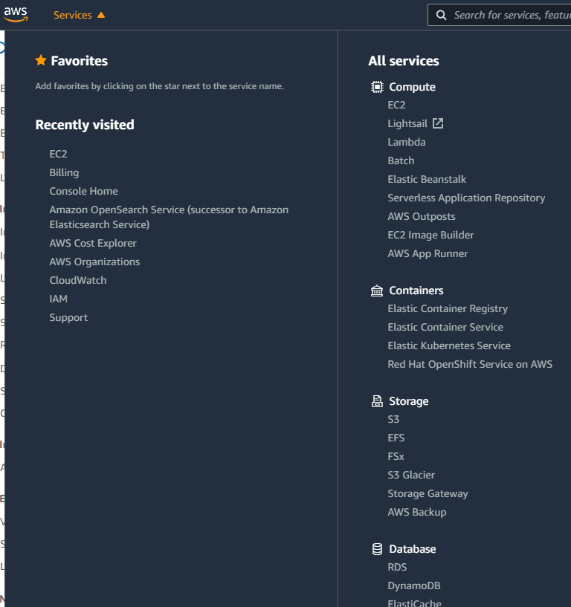

Click on EC2 :

Ec2 dashboard

Launch instance:

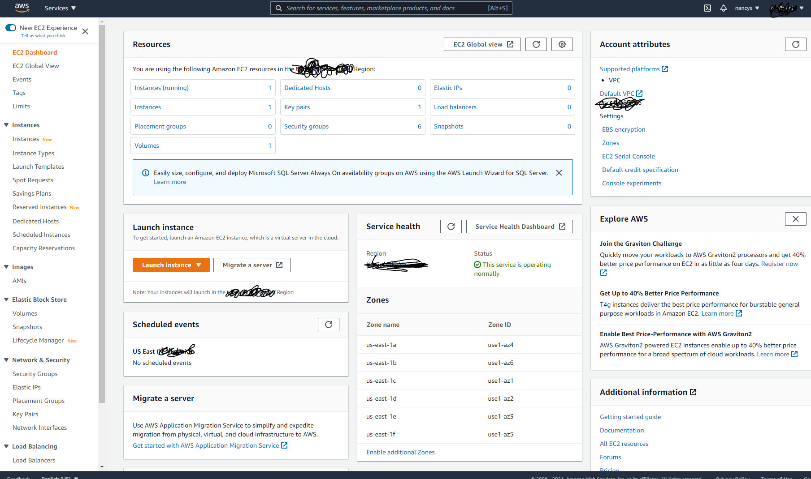

Choose any free tier available :

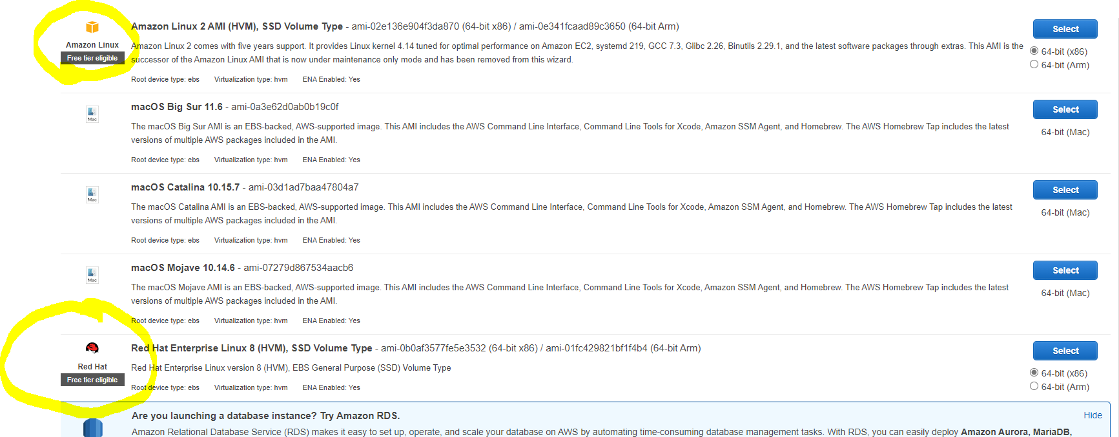

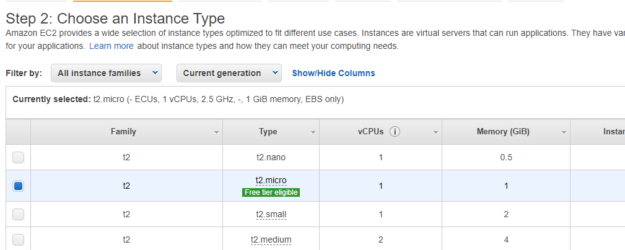

Click next on step 3 , step 4, step 5

For step 6 :

Add :

Http and https add ip and mask , click on next .

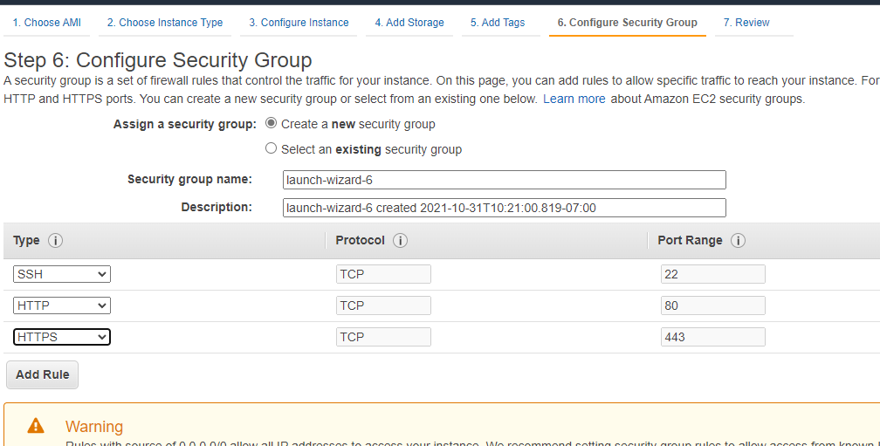

Click on review and launch, and launch.

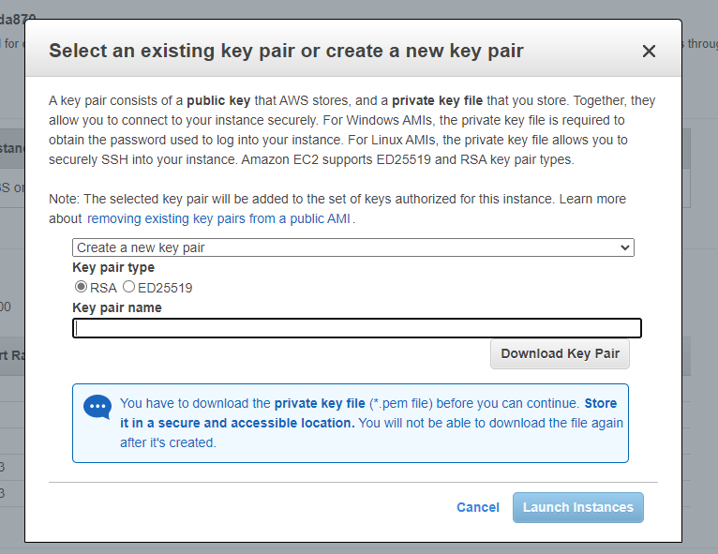

Create a new pair and download the keypair.

This key pair will be used to access the instance via putty.

Go to EC2 dashboard from the left hand side pane, you will see one instance running.

Click on the instances



You will instance below the heading in the next screenshot.

