**Wire Frames for Hotel Booking Application**

1. **Sign Up Page**

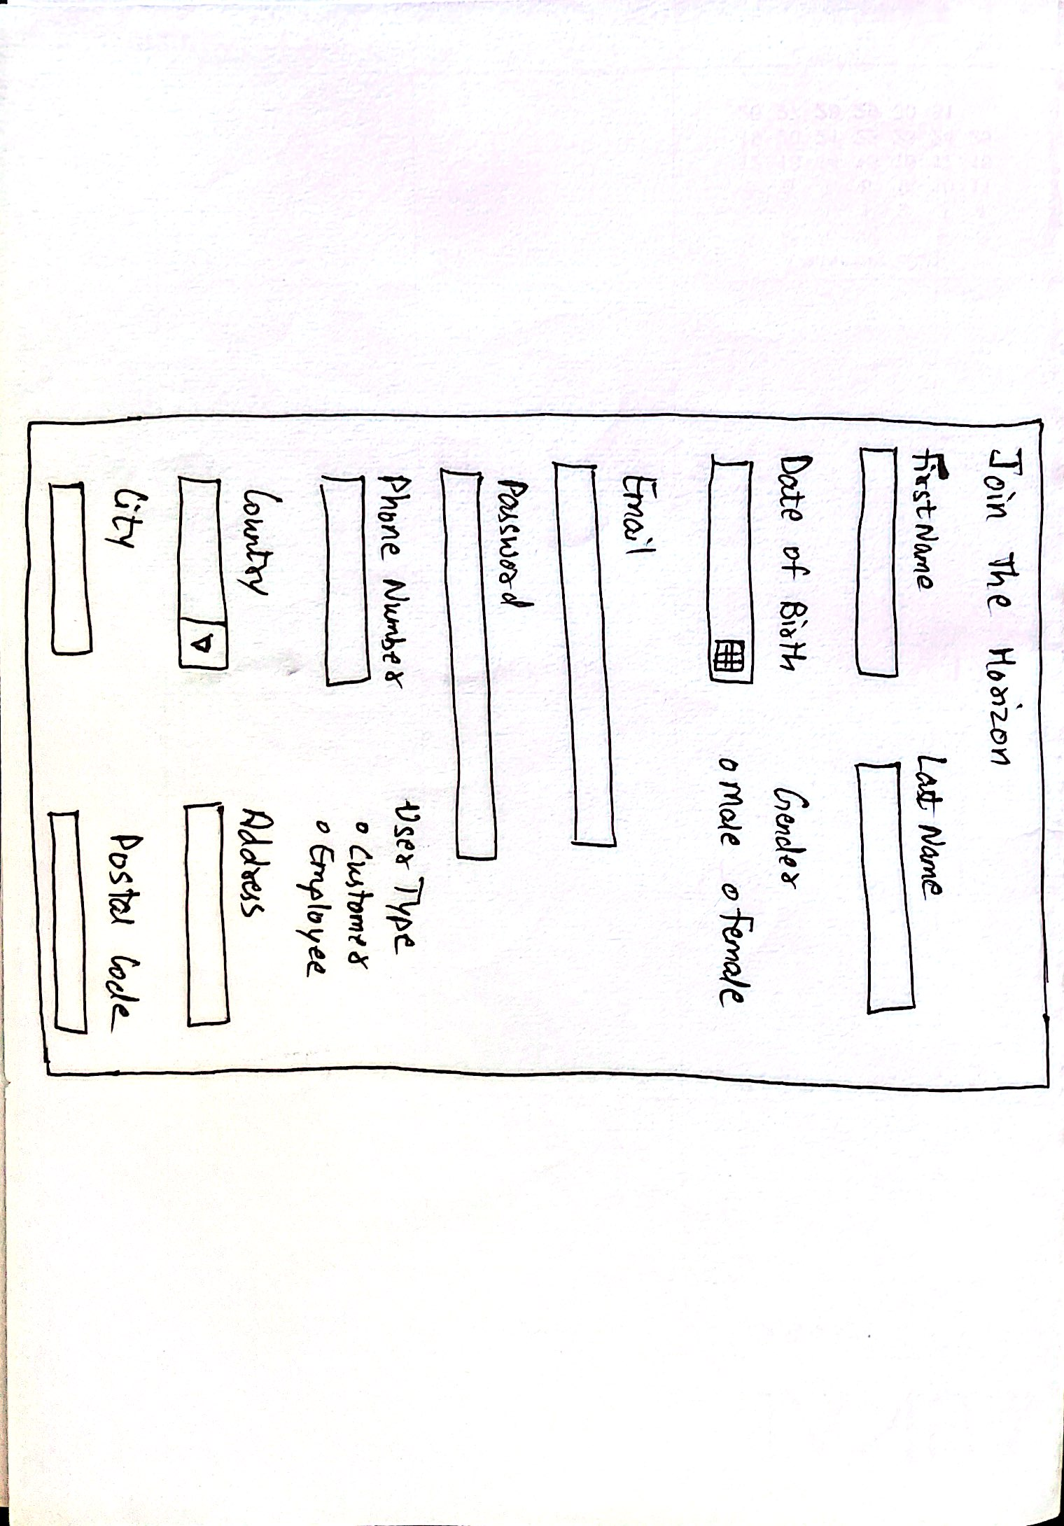

1. **Sign In Page**

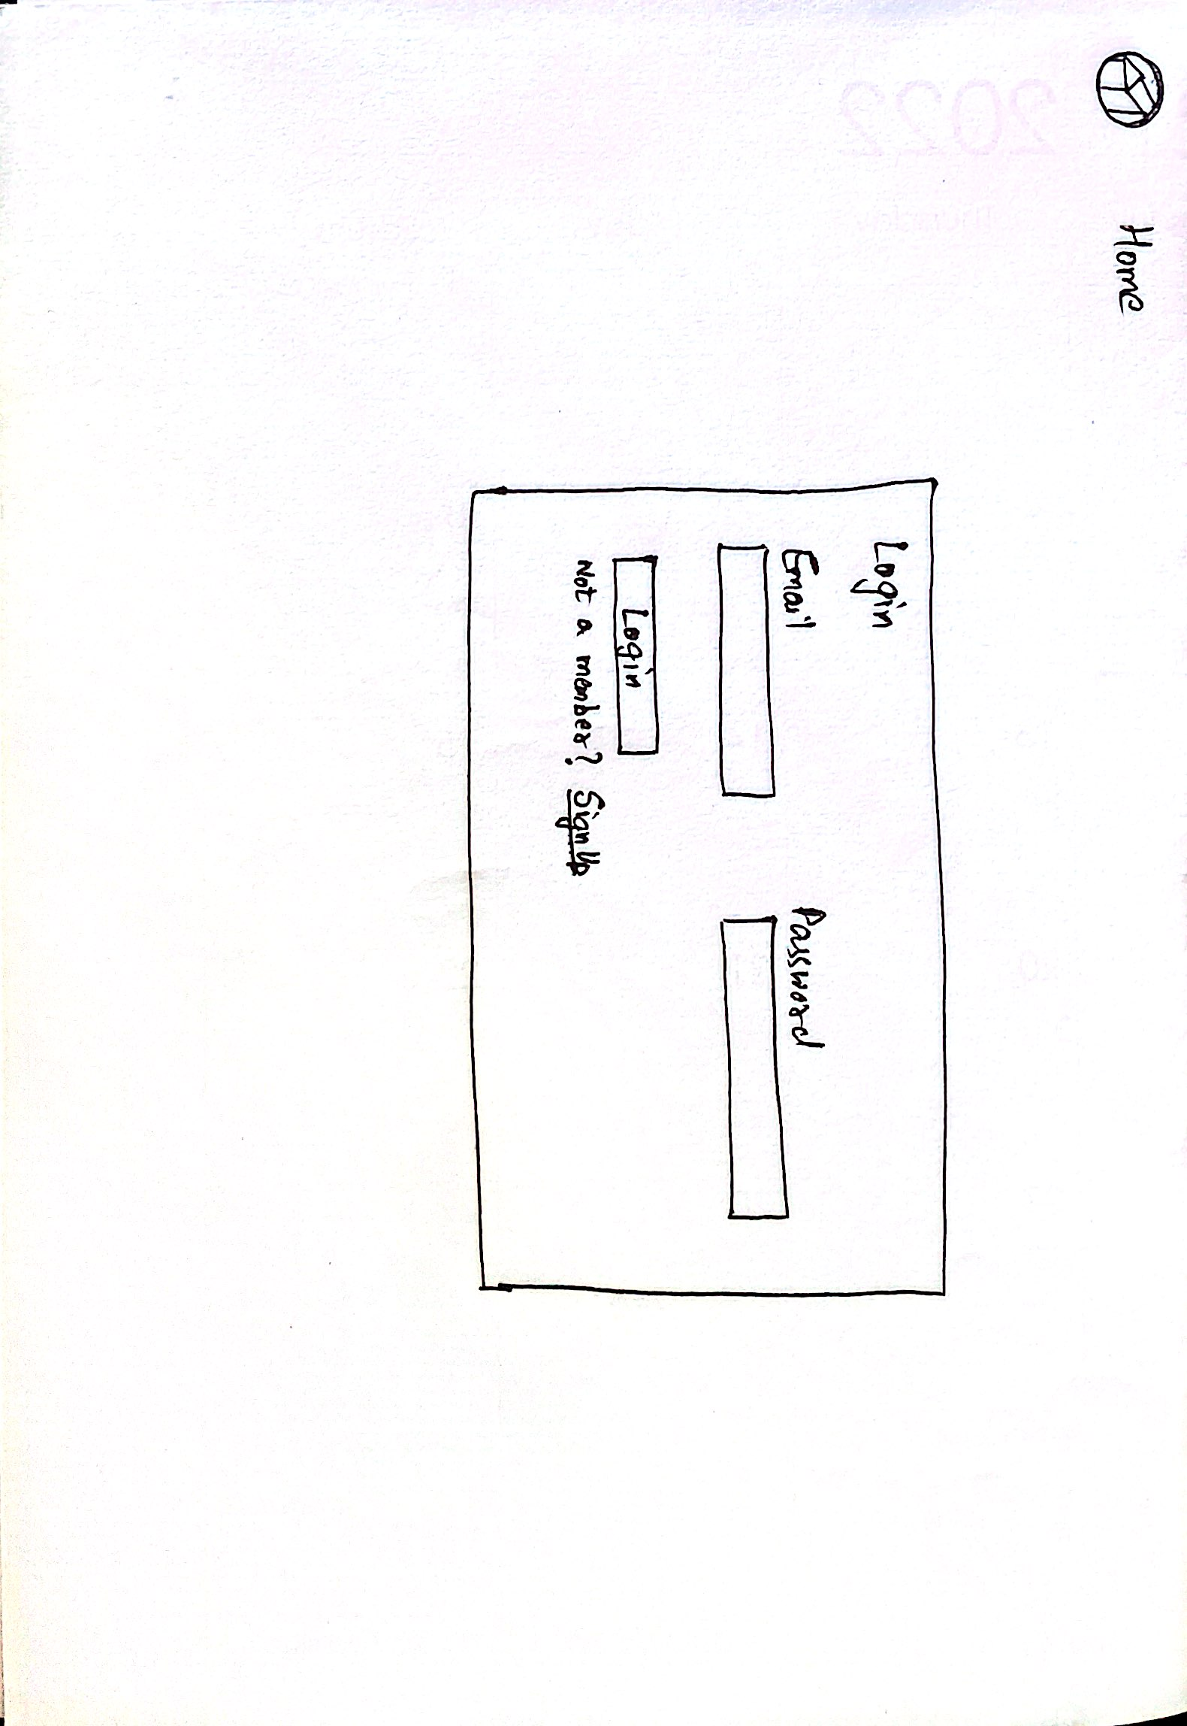

1. **Search Hotels Page**

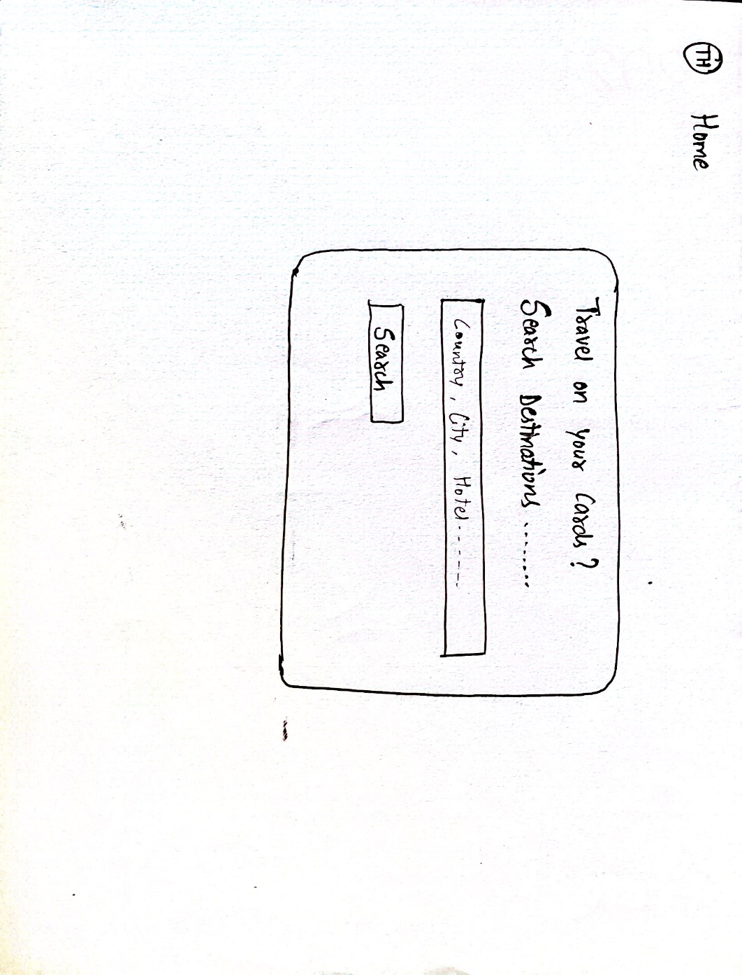

1. **Search Results Page**

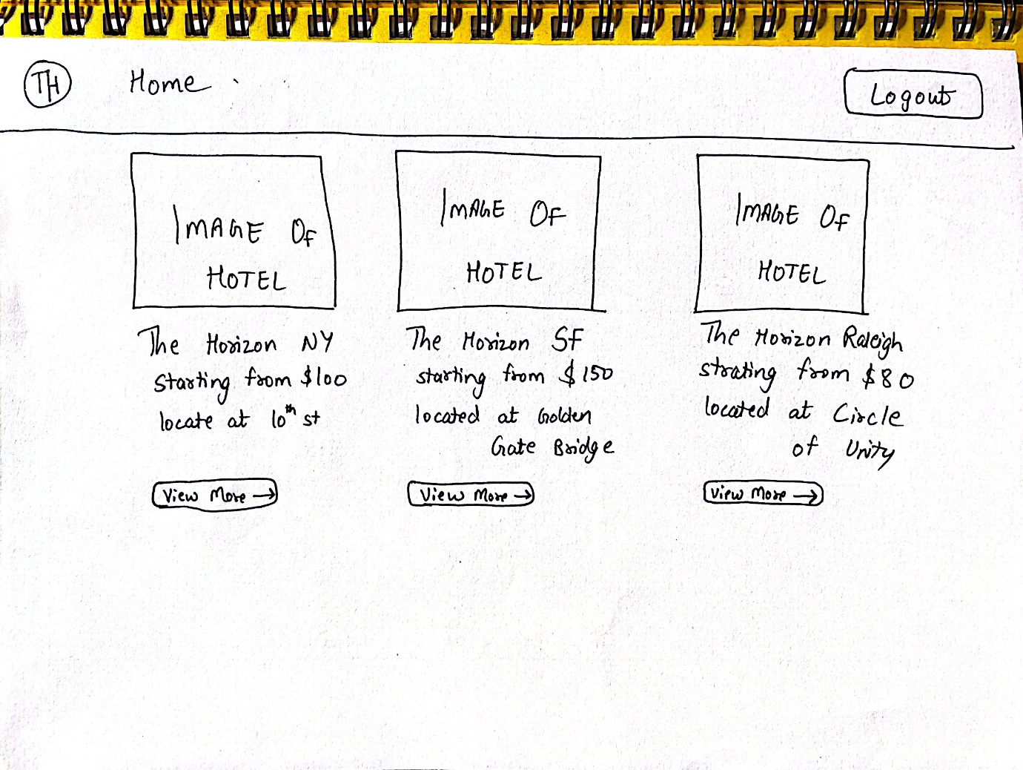

1. **Enter Booking Details Page**

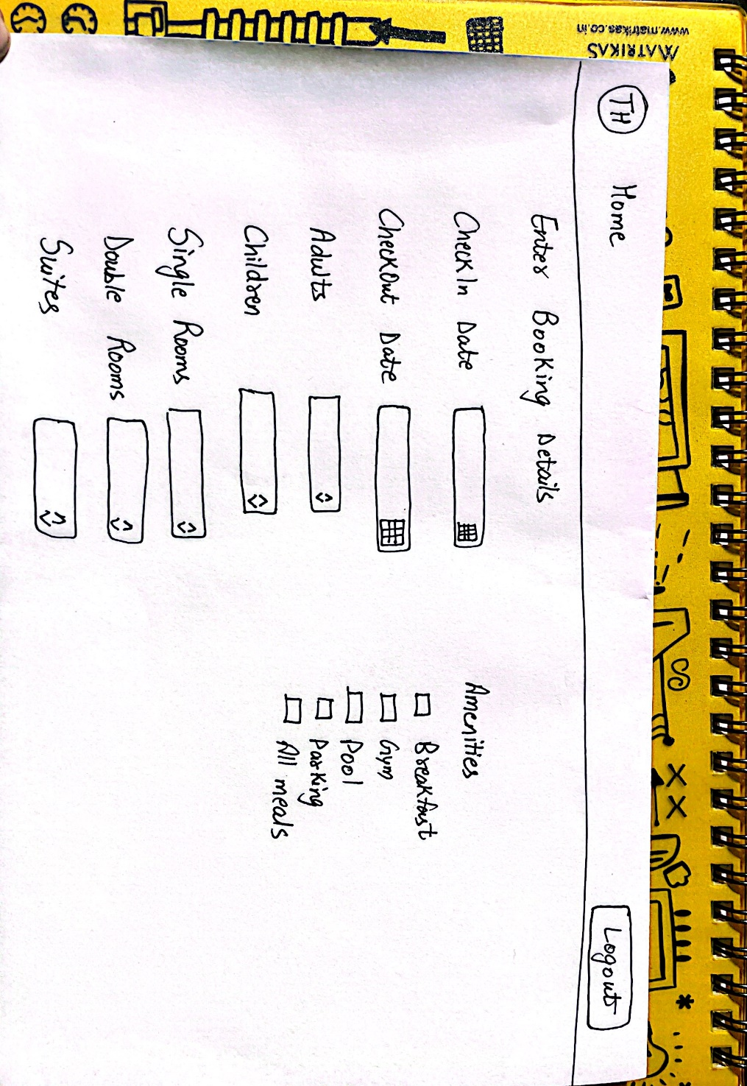

1. **Booking Summary Page**

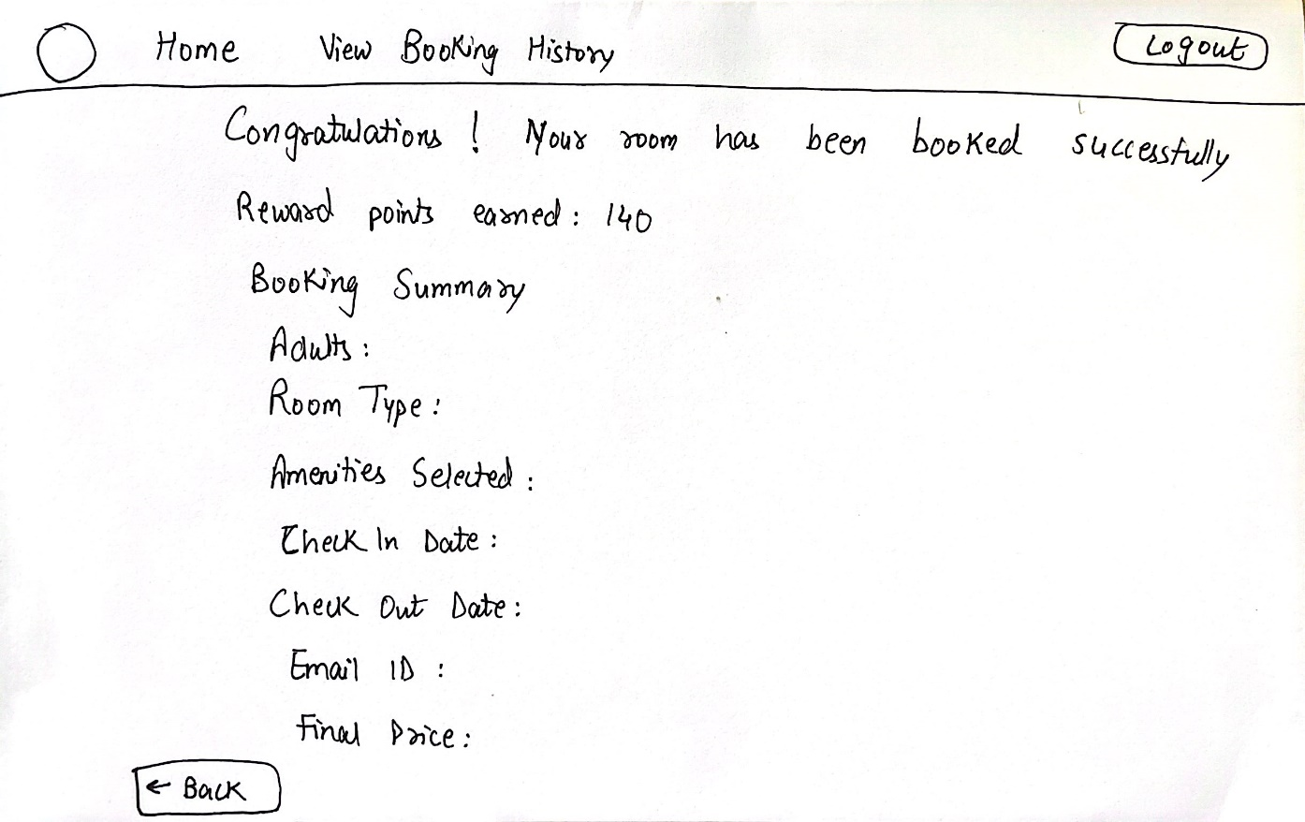

1. **Booking History Page**

