# Introduction:

This Report contains analysis on the retail prices of different commodities iin ndia from 1997-2015.

## Dataset:

The dataset used was taken by website

https://data.world/rajanm/india-retail-prices-of-key-commodities-from-1997-to-2015

The dataset contains below attributes

**date**

Date the retail price was recorded

**centre**

One of the 75 regional centres where the prices are recorded

**commodity**

Name of the commodity

**price_per_kg**

Price per Kilogram

**region**

The region of the country, the centre belongs to

**country**

Name of the country

The dataset can benefit greatly from additional content. Economics, additional demographics, administrative costs and more.

## Research Questions:

The research question for this study is “Is there a difference in the mean prices of Onion and Rice Commodities in India From 1997 to 2015?”

## Formulation of Null and Alternative Hypotheses

Mean Onion Price= µ1

Mean Rice Price = µ2

**Null hypothesis**

H0: µ1= µ2

Mean Prices of Onion and Rice are same

**Alternative Hypothesis:**

H1: µ1≠ µ2

Mean Prices of Onion and Rice are not same

# Visualization:

Different visualization was used in this study to assess the true picture of data.

**Box 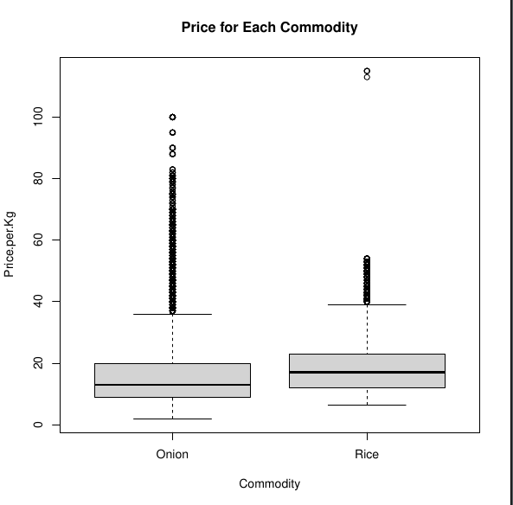Plot between Commodities and Price:**

From the above box plot between commodity and Price Per Kg the mean price of onion is little less than that of rice. The Box Plot shows the each price in different quartiles and there are some outliers in data for both onion and rice prices.

**Frequency Plot:**

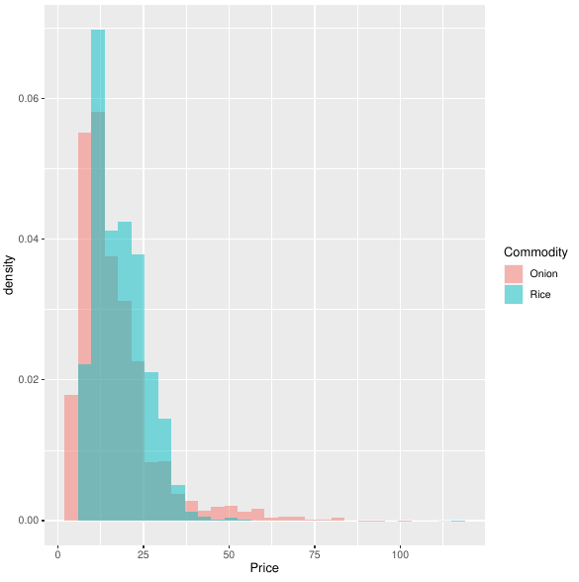This Plot is to test the normalcy of the data. As we can see both the distributions overlapped and looks like a twisted bell shaped curve.

# Analysis:

As the data points >30 and there is no need of checking normalcy of the data

## Significance level

**ɑ=0.05**

**F test to compare two variances:**

data: Price by Commodity

F = 2.2967, num df = 115990, denom df = 115369, p-value < 2.2e-16

alternative hypothesis: true ratio of variances is not equal to 1

95 percent confidence interval:

2.270334 2.323275

sample estimates:

ratio of variances

2.296652

As the p-value is way less than significance level 0.05 we can not use classical t-test.

## Calculations:

We calculated T-statistic and p-value using R.

$Z=1.64$

And p-value=0.1010

# Conclusion:

As, the p-value is greater than alpha, so we fail to reject H0 and conclude that average benefit per person is not significantly different from 60$. So, we can conclude that on average a person received 60$ benefit.