**Table of Contents**

Introduction: 1

Dataset: 1

Research Questions: 2

Formulation of Null and Alternative Hypotheses 2

Visualization: 2

Analysis: 5

Significance level 6

Calculations: 6

Conclusion: 6

# Introduction:

This Report contains analysis on the retail prices of different commodities iin ndia from 1997-2015.

## Dataset:

The dataset used was taken by website

<https://data.world/rajanm/india-retail-prices-of-key-commodities-from-1997-to-2015>

The dataset contains below attributes

**date**

Date the retail price was recorded

**centre**

One of the 75 regional centres where the prices are recorded

**commodity**

Name of the commodity

**price_per_kg**

Price per Kilogram

**region**

The region of the country, the centre belongs to

**country**

Name of the country

The dataset can benefit greatly from additional content. Economics, additional demographics, administrative costs and more.

## Research Questions:

The research question for this study is “Is there a difference in the mean prices of Onion and Rice Commodities in India From 1997 to 2015?”

## Formulation of Null and Alternative Hypotheses

Mean Onion Price= µ1

Mean Rice Price = µ2

**Null hypothesis**

H0: µ1= µ2

Mean Prices of Onion and Rice are same

**Alternative Hypothesis:**

H1: µ1≠ µ2

Mean Prices of Onion and Rice are not same

# Visualization:

Different visualization was used in this study to assess the true picture of data.

**Box Plot between Commodities and Price:**

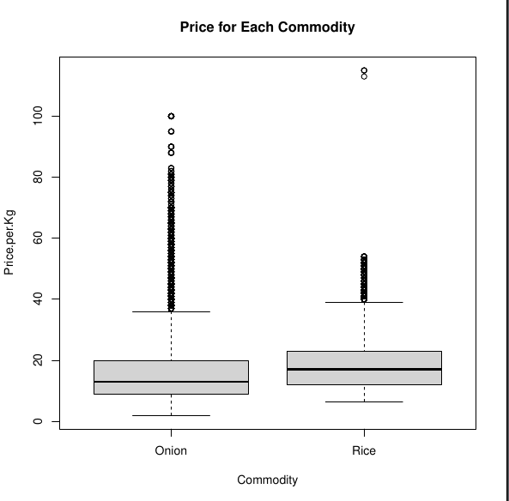

From the above box plot between commodity and Price Per Kg the mean price of onion is little less than that of rice. The Box Plot shows the each price in different quartiles and there are some outliers in data for both onion and rice prices.

**Frequency Plot:**

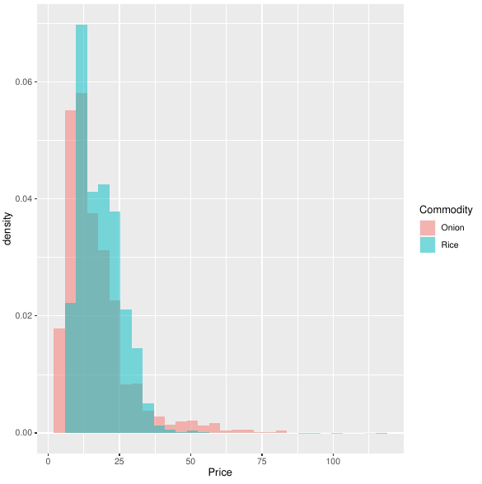This Plot is to test the normalcy of the data. As we can see both the distributions overlapped and looks like a twisted bell shaped curve.

# Analysis:

|  |  |  |
| --- | --- | --- |
| Commodity | Mean | Standard deviation |
| Onion | 16.22444 | 11.27685 |
| Rice | 18.08867 | 7.441153 |

The above table of values are calculated on the entire population and we can observe there is no significant difference between means and standard deviations of both the groups.

To get better understanding of the data need to apply sample tests rather than calculating values on entire data.

As the data points >30 and there is no need of checking normalcy of the data

**F test to compare two variances:**

data: Price by Commodity

F = 2.2967, num df = 115990, denom df = 115369, p-value < 2.2e-16

alternative hypothesis: true ratio of variances is not equal to 1

95 percent confidence interval:

2.270334 2.323275

sample estimates:

ratio of variances

2.296652

As the p-value is way less than significance level 0.05 we can conclude that the variances of onion and rice prices are different so we can not use classical t-test.

There by we are using Wech T-test

## Significance level

ɑ=0.05

## Calculations:

**Unpaired Two Sample Welch T-test:**

We calculated T-statistic and p-value using R.

data: Onion_Prices and Rice_Prices

t = -46.955, df = 201036, p-value < 2.2e-16

95 percent confidence interval:

-1.942047 -1.786415

sample estimates:

mean of x mean of y

16.22444 18.08867

# Conclusion:

As, the p-value is way less than significance level 0.05, we can reject the null hypothesis and accept the alternate hypothesis. In other words, we can conclude that the mean price of Onion and Rice are significantly different.