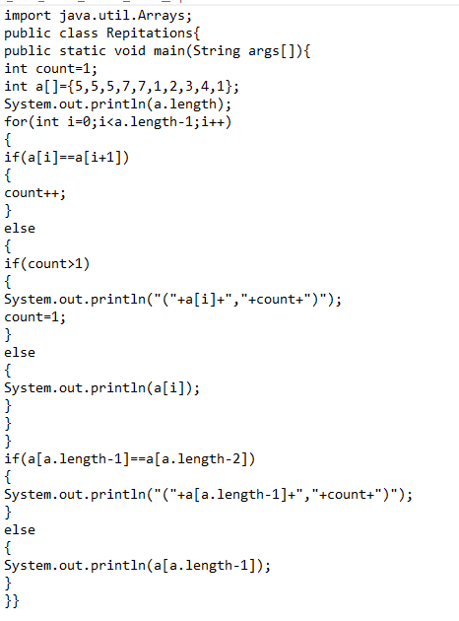

Input:

int a[]={5,5,5,7,7,1,2,3,4,1};

OutPut:

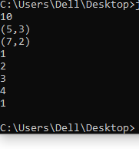

Input:

int a[]={5,5,5,7,7,1,2,3,4,4};

OutPut:

