CS1580 Assignment-4
Gopisainath Mamindlapalli
1) a) V(s) <- V(s) + ((Gt – V(s)) / N(s)
b) Q(St, At) <- Q(St, At) + ((G – Q(St, At)) / N(St, At)

2) a) Because the average is calculated over a wider range of rewards and discounts, the Every-Visit Monte Carlo method's training cycles grow faster. However, there won't be a difference between the First-Visit Monte Carlo and Every-Visit Monte Carlo methods in this game because the discount factor γ is set to 1.
b) After examining the first-visit algorithm, we find that the first visit has a value of 1. On the other hand, if we use a short script for the every-visit approach, we get 5.5.
c) As long as the expected return for each visit to the state remained at 1, the estimator's variance would be infinite. The main difference between the first visit and every-visit Monte Carlo methods in this situation is that the sum's term count grows in direct proportion to the number of state visits; this growth, represented by α, never ends.

4) c) Setting ε to 0 in Monte-Carlo Exploring Starts (MCES) eliminates exploration, demonstrating the vital role exploration plays in reinforcement learning. Without exploration, the agent remains stuck in deterministic, suboptimal policies, and fails to adapt to changing environments, risking learning stagnation and missing better solutions.

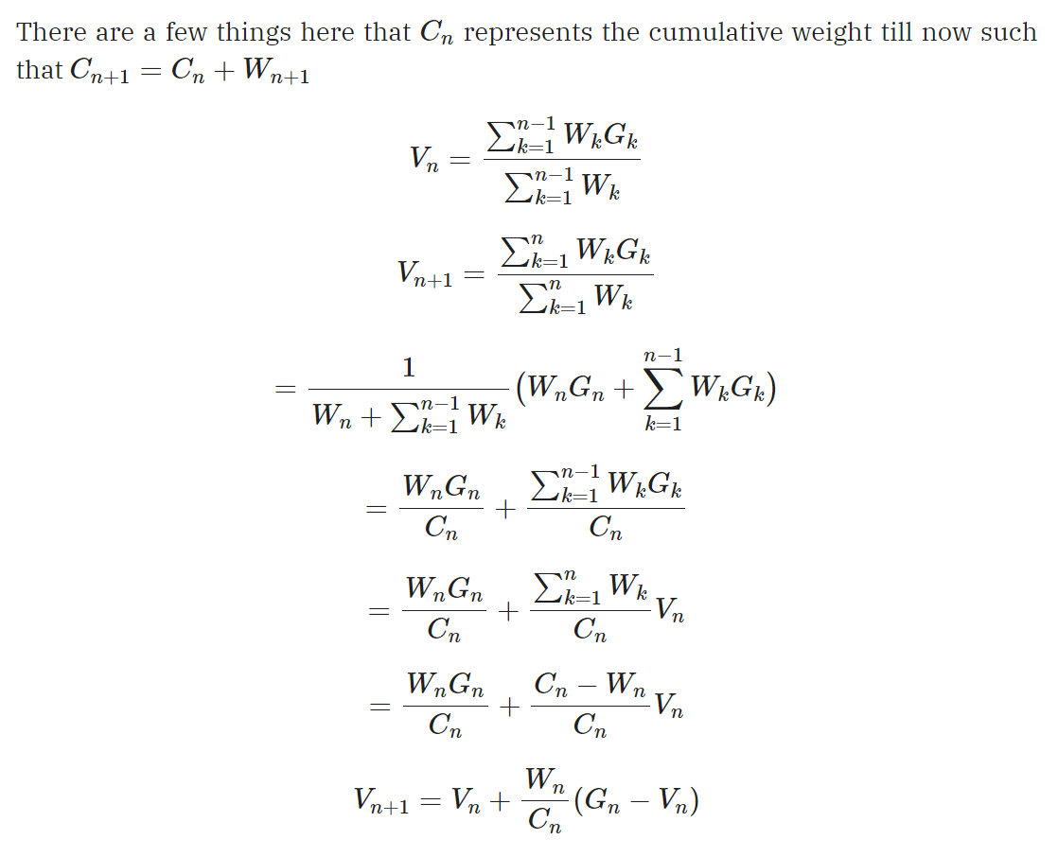
5) a)

b) Because our policy π(St) is greedy and predictable, we only find trajectories where π(At|St) = 1. As a result, the numerator of the equation is always set to 1.

6) c) In the context of reinforcement learning applied to racetrack problems, on-policy methods strictly adhere to the current policy during exploration and learning, which can make them more cautious but potentially slower in learning optimal strategies. In contrast, off-policy methods decouple exploration and learning policies, allowing for more efficient exploration by collecting data from various policies. The choice of the racetrack's complexity and obstacles can significantly impact the effectiveness of these approaches, with off-policy methods generally offering more sample-efficient exploration, while on-policy methods prioritize stability over speed.

