Project 1: Real-time filtering

The project is to apply filters to an image and video frames. By pressing specific keys, the user can use the application to add filters at runtime, such as the Greyscale, Blur, Sobel X, Sobel Y, Cartoon, etc., filters.
Task 1: Read an image from a file and display it
The image supplied in the path is opened by the program. The image window is closed when the user clicks the key "q," and an image in new window in greyscale is displayed when the user presses “g”.

Original image Greyscale image

Task 2: Display live video
This program displays live video using the camera in a new window. The video is displayed until the next key to be pressed by the user to perform the next action. If the user presses ‘q’ then the program breaks the loop and end the execution. When user presses “s”, it saves an image from the live frame.
Task 3: Display greyscale live video
When the user presses ‘g’ then the live video is converted into greyscale live video, this uses the cvtCOLOR() method.
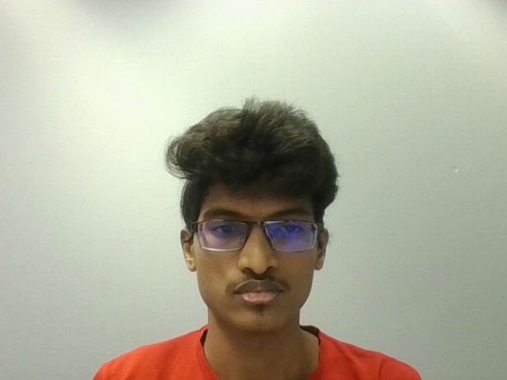
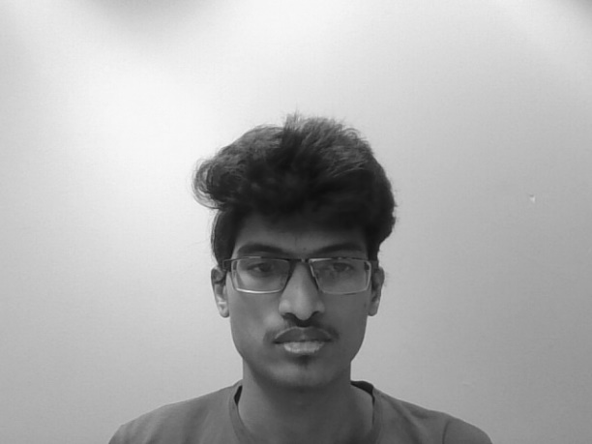

Original image Greyscale image
Task 4: Display alternative greyscale live video
When the user presses ‘h’ key then the live video is converted into alternate greyscale video.
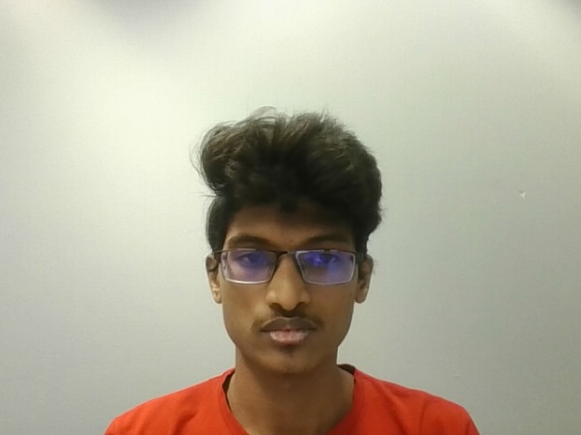
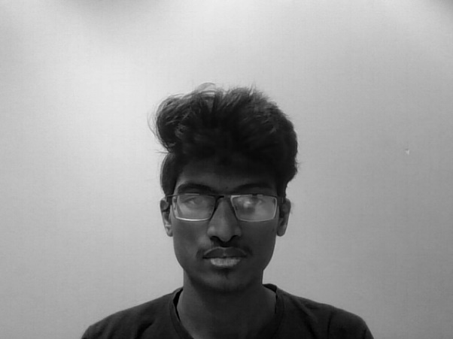

Original image Alternate greyscale image

Task 5: Implement a 5x5 Gaussian filter as separable 1x5 filters
This program blurs the image by using the gaussian filter of size 1X5. The filter is applied horizontally and then the vertical filter is applied to the output. The gaussian filter used in this program is [1, 2, 4, 2, 1].
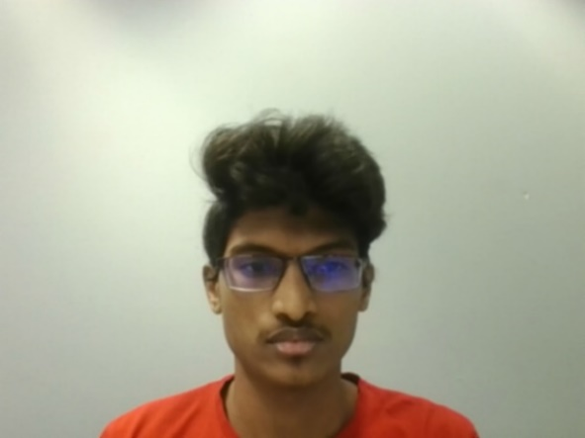
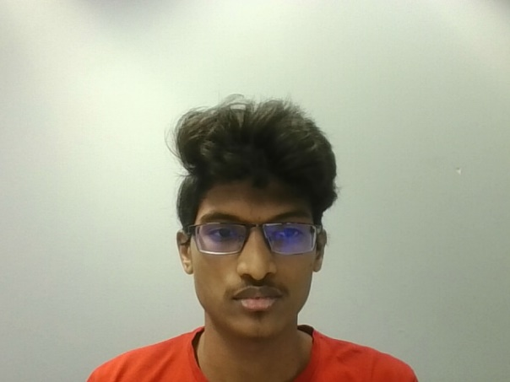

Original image Blurred image
Task 6: Implement a 3x3 Sobel X and 3x3 Sobel Y filter as separable 1x3 filters
This program applies the sobel-x filter which detects the change in the pixels in x-direction as a result this will identify the vertical edges. The sobel-y filter which detects the change in the pixels in y-direction as a result this will identify the horizontal edges. The sobel-x filter uses [1, 2, 1] and [-1, 0, 1] whereas the sobel-y filter uses[1, 0, -1] and [1, 2, 1] for applying filters.
Task 7: Implement a function that generates a gradient magnitude image from the X and Y Sobel images
This program applies the gradient magnitude filter using Euclidean distance for magnitude. This will take the outputs of sobel-x and sobel-y filters and finds the gradient magnitude by finding square root of summation of squares of x and y.
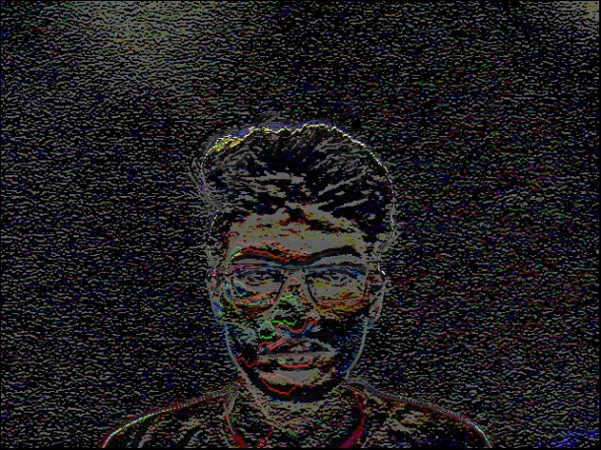
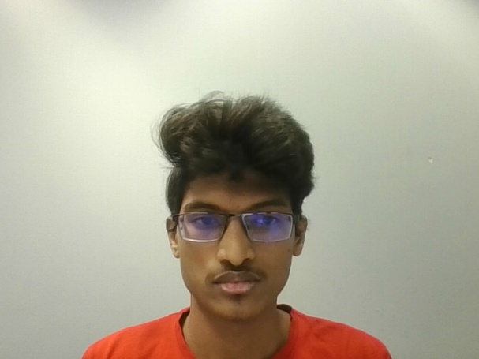

Original image Gradient magnitude image
Task 8: Implement a function that blurs and quantizes a color image
This program quantizes the image by using the levels parameter. First it blurs the image by applying blur filter and then quantizes the image into given number of levels.
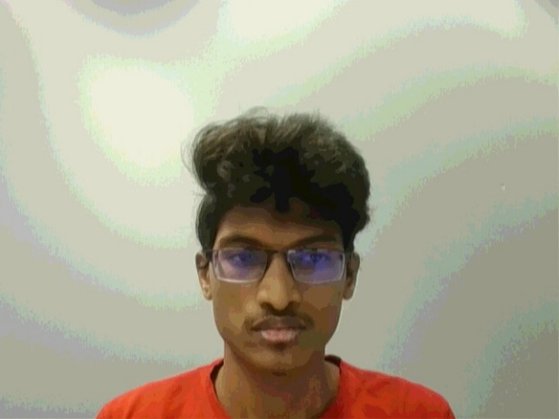
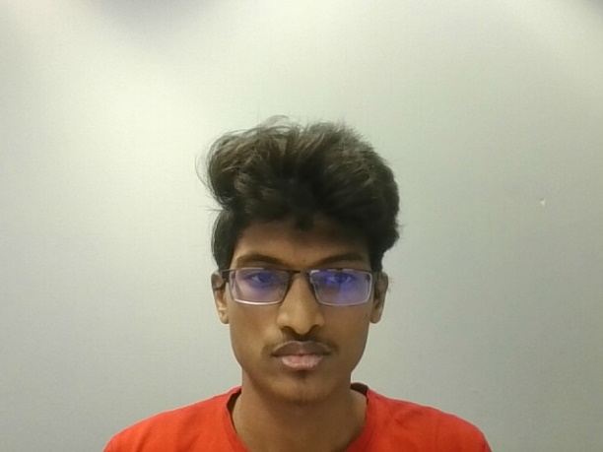

Original image Blurred and quantized image
Task 9: Implement a live video cartoonization function using the gradient magnitude and blur/quantize filters
This program converts the video into cartoon video, this quantizes the frame by using quantization method and then it applies the gradient magnitude filter to detect edges of the frame and converts the edges which are greater than the threshold value, with black pixels resulting the cartoon affect.
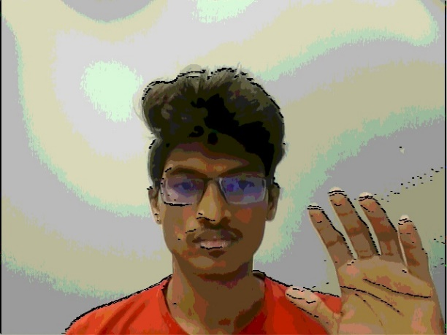
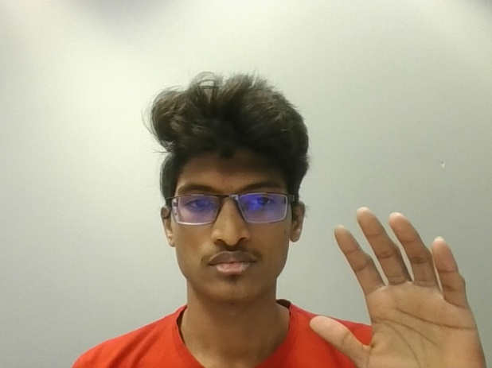

Original image Cartoon image
Task 10: Alternate blur filter
This program converts a live video into blurred image by accessing each pixel and multiplying it with each corresponding values in 3X3 matrix with values 0.3.
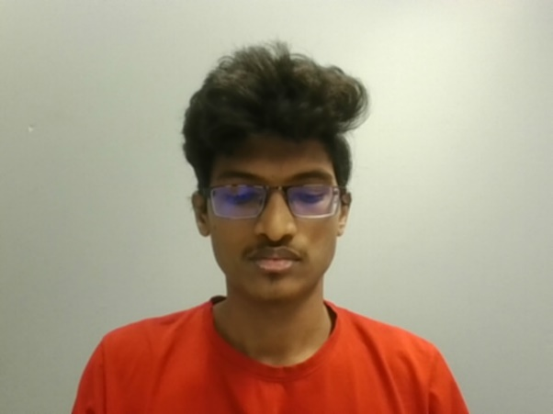
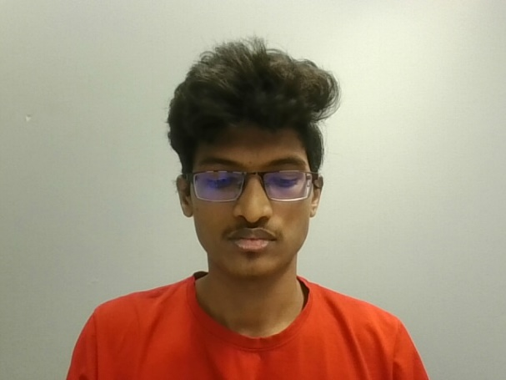

Original image alternate blur image

Acknowledgement:
Got familiar with the C++ language and OpenCV package with Visual Studio interface. It was a bit difficult in the start as it was a new language and interface to work with. But it was good learning to apply filter to images and video.

