Department of Computer Science and Engineering
2025-2026
Odd Semester


DATA STRUCTURES AND ALGORITHMS-3
(25CS2103E)

HIGH-PERFORMANCE TEXT SEARCH USING THE KMP ALGORITHM

M Jashwanth Reddy 2520030236
G Akshay 2520030363
M Ritvik Chowdhary 2500030133

COURSE INSTRUCTOR

DR. D SWATHI
Professor
Department of Computer Science and Engineering
HIGH-PERFORMANCE TEXT SEARCH USING THE KMP ALGORITHM
1.1 Abstract
This project implements a high-performance exact text-search application based on the Knuth–Morris–Pratt (KMP) string-matching algorithm. The application finds every occurrence of a pattern in manually typed text or in several uploaded text files. KMP first preprocesses the pattern into a Longest Proper Prefix which is also a Suffix (LPS) table and then uses that table to reuse already-matched characters after a mismatch, so the text pointer never moves backwards.
The matching core runs in O(N + M) time and O(M) auxiliary space, where N is the total length of the text and M is the length of the pattern (stored input and results are not counted). A Java back end, built on the JDK's built-in HTTP server, performs the search and returns match positions, line and column numbers and performance metrics as JSON to a browser dashboard. If a source contains no match, the dashboard lets the user edit that source and download a corrected copy.
1.2 Introduction
Exact pattern matching is one of the most common operations in computing. It underlies document search, log analysis, text-editor “find” features, plagiarism checks and the inspection of large text datasets. The task is simple to state: given a text of length N and a pattern of length M, report every position at which the pattern occurs in the text.
The straightforward (naive) approach tries the pattern at every possible starting position and compares character by character. When a mismatch occurs it discards everything it has learned, moves the starting position forward by one and begins comparing again. In the worst case, for example with highly repetitive text, the same text characters are compared many times and the running time becomes O(N·M).
KMP removes this redundancy. When a mismatch occurs after j characters have matched, the algorithm already knows the last j characters of the text, because they equal the first j characters of the pattern. The LPS table tells it the longest prefix of the pattern that is also a suffix of those j characters, so matching can resume from that prefix instead of starting over. The text index only moves forward, which gives the linear time bound.
Example. Searching for ABA in ABABA: the LPS table of ABA is [0, 0, 1], which says the last character A is also a one-character prefix. After matching ABA at index 0, the algorithm does not restart at index 1; it sets j = lps[2] = 1 and continues, immediately finding the overlapping match at index 2. With overlapping matches enabled the result is indices 0 and 2; with overlapping disabled it is index 0 only. Indices start at 0.
1.3 Problem Statement
Implement a high-performance text-searching application using the KMP algorithm. The system must construct a prefix (LPS) table for the search pattern and locate all occurrences of the pattern in large text files while avoiding unnecessary character comparisons. Results must be presented in a form that a user can inspect easily.
1.4 Objectives
- Achieve O(N + M) time for the matching core by building the LPS table once and reusing it for every source.
- Search multiple text files (and typed text) independently in a single request.
- Visualise every match with its zero-based index, line number and column number, together with the LPS table and metrics (match count, character comparisons, characters analysed and execution time).
- Demonstrate exact matching and prefix-table reuse, including optional overlapping matches and optional case-insensitive search.
- Make the tool useful beyond a demonstration: when a source has no match, allow it to be edited and downloaded as a new UTF-8 copy while the original file stays unchanged.
1.5 Literature Survey
Naive search checks the pattern at each possible position. It needs no preprocessing and is easy to implement, but it can repeat O(N·M) comparisons. Knuth, Morris and Pratt (1977) introduced a linear-time string-matching method that reuses previous comparisons through a failure (prefix) function, guaranteeing that the text is scanned only once. Boyer–Moore compares the pattern from right to left and uses mismatch-based shifts, which often skips large parts of the text in practice. Rabin–Karp compares rolling hash values of text windows with the hash of the pattern and verifies candidate matches character by character.
KMP suits this project because its prefix table explains the search process step by step and because it guarantees linear matching time irrespective of the input, which makes the LPS table a natural thing to display on the dashboard.
Algorithm | Core idea | Preprocessing | Matching time
Naive | Try every start position; restart after a mismatch | None | O(N·M) worst case
KMP | Reuse matched prefix via the LPS table; text index never moves back | O(M) | O(N) worst case
Boyer–Moore (basic) | Right-to-left comparison with mismatch-based shifts | O(M + alphabet size) | Often sublinear in practice; O(N·M) worst case
Rabin–Karp | Rolling hash of each text window; verify on hash match | O(M) | O(N + M) expected; O(N·M) worst case

Table 1: Comparison of exact string-matching algorithms
1.6 Case Study with Examples
The behaviour of the application was verified by running the submitted Java program and sending search requests to its /api/search endpoint. Four representative cases are described below; the figures quoted are the values returned by the program.
Example 1 – Overlapping matches
Text ABABA, pattern ABA. LPS = [0, 0, 1]. With overlapping enabled the matches are at indices 0 and 2 (line 1, columns 1 and 3); with overlapping disabled only index 0 is reported because j is reset to 0 after a match instead of lps[M − 1]. Both runs use 5 character comparisons for 5 characters.
Example 2 – Single match in an uploaded file
A 191-character file named “The quick brown fox jumps over the.txt” is searched for fox (case-sensitive). LPS = [0, 0, 0]. One match is found at index 16, which is line 1, column 17, using 195 character comparisons. This is the example shown in the screenshots of Section 4.
Example 3 – Pattern not found
Text HELLO, pattern XYZ. The result is zero matches and the dashboard reports that the pattern was not found. The “Pattern not found? Edit and download” panel opens so the user can change the text and either download an edited copy or apply the edit and search again.
Example 4 – Repetitive pattern, where KMP reuses the prefix table
Text ABABDABACDABABCABAB (19 characters) and pattern ABABCABAB. The pattern has the LPS table [0, 0, 1, 2, 0, 1, 2, 3, 4]. The single match is at index 10 (line 1, column 11). KMP needs 23 character comparisons, whereas a naive scan of the same input needs 29, because after each partial match KMP continues from the matched prefix rather than re-comparing text characters. A complete step-by-step trace of this example is given in Section 2.
Case | Pattern | Text / source | LPS | Matches (index) | Comparisons
1a (overlap on) | ABA | ABABA | [0, 0, 1] | 2 (0, 2) | 5
1b (overlap off) | ABA | ABABA | [0, 0, 1] | 1 (0) | 5
2 | fox | 191-char file | [0, 0, 0] | 1 (16) | 195
3 | XYZ | HELLO | [0, 0, 0] | 0 | 5
4 | ABABCABAB | ABABDABACDABABCABAB | [0,0,1,2,0,1,2,3,4] | 1 (10) | 23

Table 2: Outputs returned by the program for the case-study examples
Example 2 also shows an honest limit of the technique: for a pattern with no repeated prefix (fox), KMP and the naive method perform the same 195 comparisons on this text. KMP's advantage appears on repetitive patterns, and its real value is the guarantee that the work can never exceed about 2N comparisons.
1.7 System Overview and Features
The application has three cooperating parts: a browser front end (index.html), a Java back end (main.java) and a small JSON interface between them.
- Front end. A single HTML/CSS/JavaScript page. The user enters a pattern, types text or uploads one or more TXT, MD, CSV or LOG files, and chooses the case-sensitive and overlapping-match options. Results are drawn as a metrics panel, a highlighted view of the source, the LPS table and a clickable list of match locations.
- Back end. The JDK's com.sun.net.httpserver.HttpServer listens on localhost:8080. GET / serves the page and POST /api/search runs the search. No external libraries are used; a small hand-written JSON parser reads the request and a small serializer writes the response.
- Request. { pattern, caseSensitive, overlap, sources: [ { name, text }, ... ] }.
- Response. { lps, matches, comparisons, characters, elapsedMs, results: [ { name, text, matches: [ { index, line, column } ] } ] }.
- Console report. Every search is also printed in the IDE's Run console, which helps with testing and demonstration.
- Edit and download. For sources with zero matches the page offers an editor; a UTF-8 copy can be downloaded with “-edited” added to its name, or the edit can be applied and the search re-run.
1.8 Complexity Analysis
Part | Time | Space
Build LPS table | O(M) | O(M)
KMP scan of one source of length n | O(n) | O(1) extra (plus the list of matches)
Whole request (all sources, total length N) | O(M + N) for the matching core | O(M) auxiliary, excluding stored input and results
Line / column of each match | O(index) per match, as implemented | O(1)

Table 3: Complexity of the main operations
The O(N + M) guarantee applies to the KMP core. File loading, converting indices to line and column numbers and rendering the results add application overhead. In the present implementation each match recomputes its line and column by scanning the text from the start, so a source with very many matches costs more than the core; a single-pass computation is listed under Future Scope.
1.9 Hardware and Software Requirements
Item | Requirement
Hardware | A computer that can run a JDK and a modern web browser. Memory use grows with the size of the uploaded text and the number of results.
Development | IntelliJ IDEA (or any editor) and Java 17 or newer. The back end uses the JDK's built-in HTTP server, so no extra libraries are needed.
Front end | HTML, CSS and JavaScript in a modern browser. JSON requests connect the dashboard to POST /api/search.
Execution | Run main.java and open http://localhost:8080. Supported uploads: TXT, MD, CSV and LOG files.

Table 4: Hardware and software requirements
ALGORITHM / PSEUDO CODE
2.1 Overall Workflow
Figure 1 shows how a search request travels through the system. The numbered steps below describe the same flow in words.
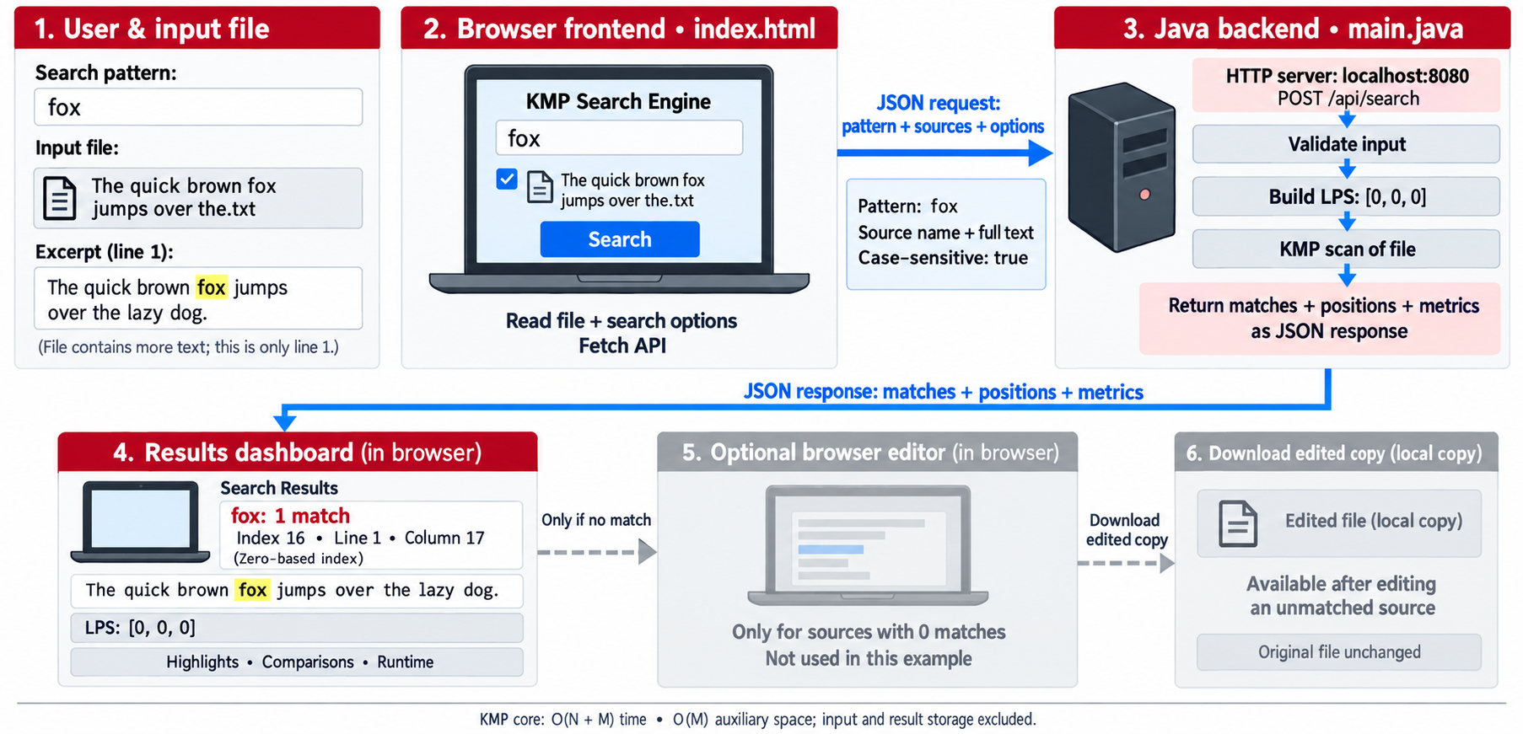
Figure 1: Workflow and system architecture of the KMP Search Engine
- The user enters the search pattern and supplies text, typed or uploaded, and selects the options.
- The browser reads each file as text and sends one JSON request to POST /api/search.
- The server validates the request. If the pattern is empty or no source is given, it answers with HTTP 400.
- If the search is not case-sensitive, the pattern is converted to lower case.
- The LPS table of the pattern is built once.
- For each source, the text (lower-cased when case-insensitive) is scanned with KMP, collecting the index of every match and counting character comparisons.
- Each match index is converted into a line and column number using the original text.
- The server totals the matches, comparisons and characters, measures the elapsed time, prints a console report and returns everything as JSON.
- The browser shows the metrics, highlights matches in the source, draws the LPS table and lists match locations.
- If a source has no match, the optional editor lets the user change the text and download an edited copy or search again. The original file is never modified.
2.2 Algorithm 1 – Build the LPS (Longest Prefix Suffix) Table
For a pattern P of length M, lps[i] is the length of the longest proper prefix of P[0..i] that is also a suffix of P[0..i]. “Proper” means the prefix is shorter than the whole substring. The table is computed in a single left-to-right pass using the table's own earlier values.
BUILD-LPS(P): // P has length M
lps[0..M-1] <- 0
i <- 1 // position being filled
length <- 0 // length of the current matching prefix
while i < M:
if P[i] = P[length]:
length <- length + 1
lps[i] <- length
i <- i + 1
else if length > 0:
length <- lps[length - 1] // fall back to a shorter prefix; i unchanged
else:
lps[i] <- 0
i <- i + 1
return lps

Step-by-step explanation
- lps[0] is always 0 because a single character has no proper prefix. Start with i = 1 and length = 0.
- If P[i] equals P[length], the current prefix can be extended by one character: increase length, store it in lps[i] and move to the next position.
- If they differ and length > 0, a shorter prefix may still match. Set length = lps[length − 1] and compare again at the same i. No character of P is re-read from the start.
- If they differ and length = 0, no prefix matches here: lps[i] stays 0 and i advances.
- Each iteration either increases i or decreases length, and length can only decrease as many times as it was increased, so the loop runs in O(M).
Dry run for P = ABABCABAB (result: lps = [0, 0, 1, 2, 0, 1, 2, 3, 4]):
i | length | Comparison | Action | length after
1 | 0 | P[1]='B' != P[0]='A' | lps[1] = 0 | 0
2 | 0 | P[2]='A' = P[0]='A' | lps[2] = 1 | 1
3 | 1 | P[3]='B' = P[1]='B' | lps[3] = 2 | 2
4 | 2 | P[4]='C' != P[2]='A' | length = lps[1] = 0 | 0
4 | 0 | P[4]='C' != P[0]='A' | lps[4] = 0 | 0
5 | 0 | P[5]='A' = P[0]='A' | lps[5] = 1 | 1
6 | 1 | P[6]='B' = P[1]='B' | lps[6] = 2 | 2
7 | 2 | P[7]='A' = P[2]='A' | lps[7] = 3 | 3
8 | 3 | P[8]='B' = P[3]='B' | lps[8] = 4 | 4

Table 5: Construction of the LPS table for ABABCABAB
Index | 0 | 1 | 2 | 3 | 4 | 5 | 6 | 7 | 8
Pattern | A | B | A | B | C | A | B | A | B
lps | 0 | 0 | 1 | 2 | 0 | 1 | 2 | 3 | 4

Table 6: Final LPS table
2.3 Algorithm 2 – KMP Matching
KMP-SEARCH(T, P, lps, overlap): // T has length N, P has length M
matches <- empty list
comparisons <- 0
i <- 0 // index in text (never decreases)
j <- 0 // number of pattern characters matched
while i < N:
comparisons <- comparisons + 1
if T[i] = P[j]:
i <- i + 1
j <- j + 1
if j = M: // complete match
append (i - j) to matches
if overlap: j <- lps[j - 1]
else: j <- 0
else if j > 0:
j <- lps[j - 1] // reuse matched prefix; i unchanged
else:
i <- i + 1
return matches, comparisons

Step-by-step explanation
- Keep two indices: i walks through the text and j counts how many pattern characters are currently matched.
- If T[i] = P[j], both advance. When j reaches M, a full match has ended at i − 1, so its start index is i − j.
- After a match, if overlapping matches are allowed the algorithm sets j = lps[M − 1], keeping the longest prefix that is also a suffix of the match so an overlapping occurrence is found without re-reading text. If overlapping is disabled, j is reset to 0 so the next search starts after the match.
- On a mismatch with j > 0, set j = lps[j − 1] and compare T[i] again. The text index does not move.
- On a mismatch with j = 0, nothing is matched, so i advances by one.
- Every loop iteration either increases i or decreases j. Since j is increased at most N times in total, the number of iterations is at most 2N, which gives O(N) matching time.
Dry run for T = ABABDABACDABABCABAB and P = ABABCABAB with overlapping enabled. The algorithm performs 23 comparisons and reports one match at index 10.
# | i | j | T[i] | P[j] | Action | j after
1 | 0 | 0 | A | A | match; advance i and j | 1
2 | 1 | 1 | B | B | match; advance i and j | 2
3 | 2 | 2 | A | A | match; advance i and j | 3
4 | 3 | 3 | B | B | match; advance i and j | 4
5 | 4 | 4 | D | C | mismatch; j = lps[3] = 2 | 2
6 | 4 | 2 | D | A | mismatch; j = lps[1] = 0 | 0
7 | 4 | 0 | D | A | mismatch at j=0; advance i | 0
8 | 5 | 0 | A | A | match; advance i and j | 1
9 | 6 | 1 | B | B | match; advance i and j | 2
10 | 7 | 2 | A | A | match; advance i and j | 3
11 | 8 | 3 | C | B | mismatch; j = lps[2] = 1 | 1
12 | 8 | 1 | C | B | mismatch; j = lps[0] = 0 | 0
13 | 8 | 0 | C | A | mismatch at j=0; advance i | 0
14 | 9 | 0 | D | A | mismatch at j=0; advance i | 0
15 | 10 | 0 | A | A | match; advance i and j | 1
16 | 11 | 1 | B | B | match; advance i and j | 2
17 | 12 | 2 | A | A | match; advance i and j | 3
18 | 13 | 3 | B | B | match; advance i and j | 4
19 | 14 | 4 | C | C | match; advance i and j | 5
20 | 15 | 5 | A | A | match; advance i and j | 6
21 | 16 | 6 | B | B | match; advance i and j | 7
22 | 17 | 7 | A | A | match; advance i and j | 8
23 | 18 | 8 | B | B | full match at index 10 | 4

Table 7: Step-by-step trace of KMP matching (23 comparisons)
2.4 Algorithm 3 – Line and Column of a Match
LINE-AND-COLUMN(text, index):
line <- 1
column <- 1
for k <- 0 to index - 1:
if text[k] = newline:
line <- line + 1
column <- 1
else:
column <- column + 1
return (line, column) // lines and columns start at 1

The index returned by KMP is zero-based. The function counts the line breaks before that index to get the line number, and the characters since the last line break to get the column. For Example 2, index 16 on line 1 gives column 17.
2.5 Algorithm 4 – Handling a Search Request (Server)
HANDLE-SEARCH(request):
if method is not POST: return HTTP 405
(pattern, caseSensitive, overlap, sources) <- parse JSON body
if pattern is empty or sources is empty: return HTTP 400
start <- current time
query <- pattern // lower-cased if not caseSensitive
lps <- BUILD-LPS(query)
totals <- (matches = 0, comparisons = 0, characters = 0)
for each source in sources:
text <- source.text // lower-cased copy if not caseSensitive
(indices, cmp) <- KMP-SEARCH(text, query, lps, overlap)
for each index in indices:
(line, column) <- LINE-AND-COLUMN(source.text, index)
record (index, line, column)
update totals with indices.size, cmp, source.text.length
print console report
return HTTP 200 with JSON { lps, totals, elapsed time, results }
on any parsing error: return HTTP 400

2.6 Algorithm 5 – Edit and Download an Unmatched Source (Browser)
- After the response arrives, collect every source whose match list is empty and show the editor panel; hide the panel if all sources matched.
- Fill a drop-down with the names of those sources. Keep a draft of each source's text so switching between sources does not lose edits.
- On “Download edited copy”, create a UTF-8 text Blob from the draft and download it under the original name with “-edited” inserted before the extension (typed text is saved as manual-input-edited.txt).
- On “Apply edits and search again”, write the drafts back into the page's sources and run the search again.
2.7 Correctness and Complexity Summary
- Correctness of LPS. At every step, length equals the length of the longest proper prefix of P that is a suffix of P[0..i − 1]. Falling back through lps[length − 1] enumerates the shorter border candidates in decreasing order, so none is skipped.
- Correctness of the search. After each step, j is the length of the longest prefix of P that is a suffix of T[0..i − 1]. A full match is reported exactly when j = M, and the fall-back through the LPS table only skips alignments that cannot lead to a match.
- Time. LPS construction is O(M); matching is O(N) with at most 2N loop iterations. Total O(N + M).
- Space. The LPS table needs O(M) integers; matching needs only the two indices i and j.
CODE
The project consists of two files. main.java contains the HTTP server, the KMP implementation (buildLps, kmp, lineAndColumn) and a small JSON reader and writer. index.html contains the dashboard. To run: compile and start main.java (for example javac main.java && java main), keep index.html in the working directory, and open http://localhost:8080 in a browser.
3.1 main.java
import com.sun.net.httpserver.HttpExchange;
import com.sun.net.httpserver.HttpServer;

import java.io.IOException;
import java.io.InputStream;
import java.net.InetSocketAddress;
import java.nio.charset.StandardCharsets;
import java.nio.file.Files;
import java.nio.file.Path;
import java.util.ArrayList;
import java.util.LinkedHashMap;
import java.util.List;
import java.util.Locale;
import java.util.Map;

/**
* KMP Search Engine server. Run with: javac main.java && java main
* Then open http://localhost:8080 in a browser.
*/
public class main {
private static final int PORT = 8080;

public static void main(String[] args) throws IOException {
HttpServer server = HttpServer.create(new InetSocketAddress("localhost", PORT), 0);
server.createContext("/", main::servePage);
server.createContext("/api/search", main::searchApi);
server.setExecutor(null);
server.start();
System.out.println("KMP Search Engine is running at http://localhost:" + PORT);
System.out.println("Press Ctrl+C to stop the server.");
}

private static void servePage(HttpExchange exchange) throws IOException {
if (!"GET".equals(exchange.getRequestMethod())) { send(exchange, 405, "text/plain", "Method not allowed"); return; }
Path workingDirectory = Path.of("").toAbsolutePath().normalize();
for (String location : List.of("index.html", "src/index.html", "src/main/resources/index.html")) {
Path page = workingDirectory.resolve(location);
if (Files.isRegularFile(page)) {
send(exchange, 200, "text/html; charset=utf-8", Files.readString(page));
return;
}
}
send(exchange, 404, "text/plain; charset=utf-8",
"Cannot find index.html.\n\nWorking directory: " + workingDirectory
+ "\n\nPlace index.html here or in its src folder."
+ "\nIn IntelliJ: Run > Edit Configurations > Working directory > select your project folder.");
}

@SuppressWarnings("unchecked")
private static void searchApi(HttpExchange exchange) throws IOException {
if (!"POST".equals(exchange.getRequestMethod())) { send(exchange, 405, "application/json", "{\"error\":\"POST required\"}"); return; }
try (InputStream body = exchange.getRequestBody()) {
Map<String, Object> request = (Map<String, Object>) new JsonParser(new String(body.readAllBytes(), StandardCharsets.UTF_8)).parse();
String pattern = (String) request.getOrDefault("pattern", "");
boolean caseSensitive = Boolean.TRUE.equals(request.get("caseSensitive"));
boolean overlap = !Boolean.FALSE.equals(request.get("overlap"));
List<Object> inputSources = (List<Object>) request.getOrDefault("sources", List.of());
if (pattern.isEmpty() || inputSources.isEmpty()) { send(exchange, 400, "application/json", "{\"error\":\"A pattern and at least one source are required.\"}"); return; }

long started = System.nanoTime();
String query = caseSensitive ? pattern : pattern.toLowerCase(Locale.ROOT);
int[] lps = buildLps(query);
long comparisons = 0, characters = 0, totalMatches = 0;
List<Object> results = new ArrayList<>();

for (Object item : inputSources) {
Map<String, Object> source = (Map<String, Object>) item;
String name = (String) source.getOrDefault("name", "Untitled source");
String text = (String) source.getOrDefault("text", "");
MatchRun run = kmp(caseSensitive ? text : text.toLowerCase(Locale.ROOT), query, lps, overlap);
comparisons += run.comparisons;
characters += text.length();
totalMatches += run.indices.size();
List<Object> matches = new ArrayList<>();
for (int index : run.indices) {
int[] location = lineAndColumn(text, index);
Map<String, Object> match = new LinkedHashMap<>();
match.put("index", index); match.put("line", location[0]); match.put("column", location[1]);
matches.add(match);
}
Map<String, Object> result = new LinkedHashMap<>();
result.put("name", name); result.put("text", text); result.put("matches", matches);
results.add(result);
}
Map<String, Object> response = new LinkedHashMap<>();
response.put("lps", toList(lps)); response.put("matches", totalMatches);
response.put("comparisons", comparisons); response.put("characters", characters);
response.put("elapsedMs", (System.nanoTime() - started) / 1_000_000.0); response.put("results", results);
printSearchResults(pattern, caseSensitive, overlap, response);
send(exchange, 200, "application/json; charset=utf-8", json(response));
} catch (Exception error) {
send(exchange, 400, "application/json; charset=utf-8", "{\"error\":\"Invalid search request.\"}");
}
}

/** Print browser searches in IntelliJ's Run console as well as on the dashboard. */
@SuppressWarnings("unchecked")
private static void printSearchResults(String pattern, boolean caseSensitive,
boolean overlap, Map<String, Object> response) {
StringBuilder out = new StringBuilder("\n========== KMP SEARCH RESULTS ==========\n");
out.append("Pattern: ").append(json(pattern)).append('\n');
out.append("Case sensitive: ").append(caseSensitive).append('\n');
out.append("Overlapping matches: ").append(overlap).append('\n');
out.append("LPS table: ").append(response.get("lps")).append('\n');
List<Object> results = (List<Object>) response.get("results");
for (Object item : results) {
Map<String, Object> result = (Map<String, Object>) item;
List<Object> matches = (List<Object>) result.get("matches");
out.append("\nSource: ").append(json(result.get("name"))).append('\n');
out.append("Matches: ").append(matches.size()).append('\n');
if (matches.isEmpty()) out.append("Pattern not found. You can edit and download this source in the browser.\n");
for (Object hit : matches) {
Map<String, Object> match = (Map<String, Object>) hit;
out.append(" Index: ").append(match.get("index"))
.append(" | Line: ").append(match.get("line"))
.append(" | Column: ").append(match.get("column")).append('\n');
}
}
out.append("\nSources searched: ").append(results.size()).append('\n');
out.append("Total matches: ").append(response.get("matches")).append('\n');
out.append("Character comparisons: ").append(response.get("comparisons")).append('\n');
out.append("Characters analyzed: ").append(response.get("characters")).append('\n');
out.append(String.format(Locale.ROOT, "Execution time: %.3f ms%n", response.get("elapsedMs")));
out.append("Indices are zero-based; lines and columns start at 1.\n");
out.append("========================================\n");
System.out.print(out);
}

private static MatchRun kmp(String text, String pattern, int[] lps, boolean overlap) {
List<Integer> indices = new ArrayList<>(); long comparisons = 0; int i = 0, j = 0;
while (i < text.length()) { comparisons++;
if (text.charAt(i) == pattern.charAt(j)) { i++; j++; if (j == pattern.length()) { indices.add(i - j); j = overlap ? lps[j - 1] : 0; } }
else if (j > 0) j = lps[j - 1]; else i++;
}
return new MatchRun(indices, comparisons);
}

private static int[] buildLps(String pattern) {
int[] lps = new int[pattern.length()];
for (int i = 1, length = 0; i < pattern.length();) {
if (pattern.charAt(i) == pattern.charAt(length)) lps[i++] = ++length;
else if (length > 0) length = lps[length - 1]; else i++;
}
return lps;
}

private static int[] lineAndColumn(String text, int index) {
int line = 1, column = 1;
for (int i = 0; i < index; i++) { if (text.charAt(i) == '\n') { line++; column = 1; } else column++; }
return new int[] { line, column };
}

private static List<Object> toList(int[] values) { List<Object> list = new ArrayList<>(); for (int value : values) list.add(value); return list; }
private static void send(HttpExchange exchange, int status, String type, String text) throws IOException { byte[] bytes = text.getBytes(StandardCharsets.UTF_8); exchange.getResponseHeaders().set("Content-Type", type); exchange.sendResponseHeaders(status, bytes.length); exchange.getResponseBody().write(bytes); exchange.close(); }

private record MatchRun(List<Integer> indices, long comparisons) { }

private static String json(Object value) {
if (value == null) return "null";
if (value instanceof String string) return "\"" + string.replace("\\", "\\\\").replace("\"", "\\\"").replace("\n", "\\n").replace("\r", "\\r").replace("\t", "\\t") + "\"";
if (value instanceof Number || value instanceof Boolean) return value.toString();
if (value instanceof Map<?, ?> map) { List<String> fields = new ArrayList<>(); for (Map.Entry<?, ?> entry : map.entrySet()) fields.add(json(entry.getKey().toString()) + ":" + json(entry.getValue())); return "{" + String.join(",", fields) + "}"; }
List<String> values = new ArrayList<>(); for (Object item : (List<?>) value) values.add(json(item)); return "[" + String.join(",", values) + "]";
}

/** Small JSON reader for the request format used by index.html; no external libraries needed. */
private static final class JsonParser {
private final String input; private int cursor;
JsonParser(String input) { this.input = input; }
Object parse() { Object value = value(); space(); if (cursor != input.length()) throw new IllegalArgumentException(); return value; }
private Object value() { space(); char c = input.charAt(cursor); if (c == '{') return object(); if (c == '[') return array(); if (c == '\"') return string(); if (c == 't') { cursor += 4; return true; } if (c == 'f') { cursor += 5; return false; } if (c == 'n') { cursor += 4; return null; } return number(); }
private Map<String, Object> object() { Map<String, Object> map = new LinkedHashMap<>(); cursor++; space(); if (take('}')) return map; do { space(); String key = string(); space(); need(':'); map.put(key, value()); space(); } while (take(',')); need('}'); return map; }
private List<Object> array() { List<Object> list = new ArrayList<>(); cursor++; space(); if (take(']')) return list; do { list.add(value()); space(); } while (take(',')); need(']'); return list; }
private String string() { need('\"'); StringBuilder out = new StringBuilder(); while (cursor < input.length()) { char c = input.charAt(cursor++); if (c == '\"') return out.toString(); if (c != '\\') { out.append(c); continue; } char e = input.charAt(cursor++); if (e == 'u') { out.append((char) Integer.parseInt(input.substring(cursor, cursor + 4), 16)); cursor += 4; } else out.append(switch (e) { case 'n' -> '\n'; case 'r' -> '\r'; case 't' -> '\t'; case 'b' -> '\b'; case 'f' -> '\f'; default -> e; }); } throw new IllegalArgumentException(); }
private Number number() { int start = cursor; while (cursor < input.length() && "-+0123456789.eE".indexOf(input.charAt(cursor)) >= 0) cursor++; return Double.parseDouble(input.substring(start, cursor)); }
private void space() { while (cursor < input.length() && Character.isWhitespace(input.charAt(cursor))) cursor++; }
private boolean take(char expected) { if (cursor < input.length() && input.charAt(cursor) == expected) { cursor++; return true; } return false; }
private void need(char expected) { if (!take(expected)) throw new IllegalArgumentException(); }
}
}

3.2 index.html
<!doctype html>
<html lang="en">
<head>
<meta charset="utf-8">
<meta name="viewport" content="width=device-width, initial-scale=1">
<title>KMP Search Engine</title>
<style>
:root{--ink:#182238;--muted:#697386;--line:#dce2ea;--blue:#2563eb;--bg:#f4f7fb;--card:#fff;--yellow:#ffe39a}*{box-sizing:border-box}body{margin:0;background:var(--bg);color:var(--ink);font:15px Inter,Segoe UI,Arial,sans-serif}.top{background:#101828;color:#fff;padding:17px max(22px,calc((100vw - 1240px)/2));display:flex;justify-content:space-between;align-items:center}.brand{font-weight:800;font-size:17px}.brand small{color:#aab5c8;font-weight:400;margin-left:10px}.shell{max-width:1240px;margin:24px auto;padding:0 20px;display:grid;grid-template-columns:340px 1fr;gap:20px}.card{background:var(--card);border:1px solid var(--line);border-radius:12px;box-shadow:0 5px 18px #22304b0a}.sidebar{padding:20px;height:max-content;position:sticky;top:16px}.eyebrow{color:var(--blue);text-transform:uppercase;font-size:11px;letter-spacing:.11em;font-weight:800}h1{font-size:23px;line-height:1.15;margin:8px 0}h2{font-size:20px;margin:0}h3{font-size:14px;margin:0}.muted{color:var(--muted);font-size:13px;line-height:1.45}.label{display:flex;justify-content:space-between;margin:16px 0 6px;font-size:12px;font-weight:700}.label span{color:var(--muted);font-weight:400}input[type=text],textarea{width:100%;padding:11px;border:1px solid #c9d2df;border-radius:8px;font:inherit}textarea{height:148px;resize:vertical}.drop{display:block;border:1px dashed #9ba8bb;border-radius:8px;padding:13px;text-align:center;font-size:12px;background:#fbfcfe}.drop input{display:none}.file-list{display:grid;gap:6px;margin-top:8px}.file{background:#f2f5fa;padding:7px 9px;border-radius:6px;font-size:11px;display:flex;justify-content:space-between}.file button{color:#be2733;border:0;background:none;cursor:pointer}.checks{margin-top:14px;display:grid;gap:10px;font-size:12px}.checks label{display:flex;justify-content:space-between}.primary,.secondary{border:0;border-radius:8px;padding:11px 14px;cursor:pointer;font-weight:700}.primary{background:var(--blue);color:#fff;width:100%;margin-top:16px}.secondary{border:1px solid #c9d2df;background:#fff;font-size:12px;padding:7px 10px}.main{display:grid;gap:16px}.hero{padding:22px;display:flex;justify-content:space-between;gap:16px;align-items:center}.badges{display:flex;gap:8px}.badge{background:#e9f7ef;color:#157347;border:1px solid #cbeed9;border-radius:7px;padding:7px 9px;font-size:12px;font-weight:700}.metrics{display:grid;grid-template-columns:repeat(4,1fr);gap:11px}.metric{padding:15px}.metric small{color:var(--muted)}.metric b{font-size:25px;display:block;margin-top:4px}.grid{display:grid;grid-template-columns:1.5fr .9fr;gap:16px}.head{padding:14px 16px;border-bottom:1px solid var(--line);display:flex;justify-content:space-between;align-items:center}.doc{white-space:pre-wrap;word-break:break-word;min-height:350px;max-height:530px;overflow:auto;padding:17px;font:13px/1.75 Consolas,monospace}.empty{display:grid;place-items:center;text-align:center;color:var(--muted);font:13px Inter,Arial}.mark{background:var(--yellow);border-radius:2px}.right{display:grid;align-content:start;gap:16px}.lps{padding:16px;display:flex;gap:5px;overflow:auto;min-height:100px}.cell{text-align:center}.char,.num{width:32px;height:30px;display:grid;place-items:center}.char{background:#eaf1ff;border:1px solid #cadbff;border-radius:5px 5px 0 0;font-weight:700}.num{border:1px solid var(--line);border-top:0;border-radius:0 0 5px 5px;color:var(--muted);font-size:12px}.matches{max-height:300px;overflow:auto}.match-row{padding:11px 14px;border-bottom:1px solid #edf0f4;display:grid;grid-template-columns:28px 1fr auto;gap:9px;align-items:center;cursor:pointer;font-size:12px}.match-row:hover{background:#f7f9fc}.n{background:#eaf1ff;color:var(--blue);width:25px;height:25px;border-radius:6px;display:grid;place-items:center;font-weight:700}.match-row small{color:var(--muted)}.toast{position:fixed;right:22px;bottom:22px;background:#101828;color:#fff;border-radius:7px;padding:10px 13px;font-size:12px;opacity:0;transition:.2s}.toast.show{opacity:1}@media(max-width:900px){.shell{grid-template-columns:1fr}.sidebar{position:static}.grid{grid-template-columns:1fr}}@media(max-width:600px){.metrics{grid-template-columns:1fr 1fr}.badges{display:none}.brand small{display:none}}
</style>
</head>
<body>
<header class="top"><div class="brand">KMP Search Engine <small>High-performance pattern intelligence</small></div><span>● Engine ready</span></header>
<div class="shell">
<aside class="card sidebar">
<div class="eyebrow">Search configuration</div><h1>Find exact patterns at linear speed.</h1><p class="muted">Use the Java implementation of the Knuth–Morris–Pratt algorithm on typed text or uploaded files.</p>
<label class="label">Search pattern <span id="patternLength">0 characters</span></label><input id="pattern" type="text" placeholder="Enter an exact pattern" autocomplete="off">
<label class="label">Text source <span>Manual input</span></label><textarea id="sourceText" placeholder="Paste or type text to analyze"></textarea>
<div class="label">Or upload text files <span>.txt, .md, .csv, .log</span></div><label class="drop">Choose one or more text files<input id="files" type="file" multiple accept=".txt,.md,.csv,.log,text/plain"></label><div id="fileList" class="file-list"></div>
<div class="checks"><label>Case-sensitive search <input id="caseSensitive" type="checkbox" checked></label><label>Include overlapping matches <input id="overlap" type="checkbox" checked></label></div><button id="run" class="primary">Run KMP analysis →</button>
</aside>
<main class="main">
<section class="card hero"><div><div class="eyebrow">Analysis dashboard</div><h2>Pattern search overview</h2><p id="summary" class="muted">Configure a pattern and text source to begin.</p></div><div class="badges"><span class="badge">Time O(N + M)</span><span class="badge">Space O(M)</span></div></section>
<section class="metrics"><div class="card metric"><small>Total matches</small><b id="matchCount">0</b></div><div class="card metric"><small>Comparisons</small><b id="comparisons">0</b></div><div class="card metric"><small>Characters</small><b id="characters">0</b></div><div class="card metric"><small>Execution</small><b id="runtime">0.00 ms</b></div></section>
<section class="grid"><section class="card"><div class="head"><div><h3>Highlighted result</h3><small id="sourceName" class="muted">No source selected</small></div><button id="copy" class="secondary">Copy text</button></div><div id="document" class="doc empty">Your analyzed text will appear here.</div></section><div class="right"><section class="card"><div class="head"><h3>LPS preprocessing table</h3></div><div id="lps" class="lps empty">Enter a pattern to generate the table.</div></section><section class="card"><div class="head"><h3>Match locations</h3><small id="locationCount" class="muted">0 results</small></div><div id="matchList" class="matches empty" style="min-height:160px">No match locations yet.</div></section></div></section>
<section id="editPanel" class="card" hidden style="padding:20px">
<h3>Pattern not found? Edit and download</h3>
<p class="muted">Choose a source with no matches, edit its text, and download a UTF-8 copy. Your original file stays unchanged. Apply your edits to search the updated text again.</p>
<label class="label" for="editSource">Source with no matches</label>
<select id="editSource" style="width:100%;padding:10px;border:1px solid #c9d2df;border-radius:8px"></select>
<label class="label" for="editText">File contents <span>Drafts are kept when switching sources</span></label>
<textarea id="editText" style="min-height:230px;font-family:Consolas,monospace" spellcheck="false"></textarea>
<div style="display:flex;gap:10px;flex-wrap:wrap;margin-top:12px">
<button id="downloadEdited" class="secondary">Download edited copy</button>
<button id="applyEdited" class="secondary">Apply edits and search again</button>
</div>
<p id="editStatus" class="muted" role="status" aria-live="polite"></p>
</section>
</main>
</div><div id="toast" class="toast"></div>
<script>
const $=id=>document.getElementById(id); let uploads=[], results=[], all=[], active=0;
const escape=s=>s.replace(/[&<>"']/g,c=>({'&':'&amp;','<':'&lt;','>':'&gt;','"':'&quot;',"'":'&#39;'}[c]));
const say=s=>{$('toast').textContent=s;$('toast').classList.add('show');setTimeout(()=>$('toast').classList.remove('show'),1800)};
function files(){ $('fileList').innerHTML=uploads.map((f,i)=>`<div class="file"><span>${escape(f.name)} · ${f.text.length.toLocaleString()} chars</span><button data-remove="${i}">Remove</button></div>`).join(''); document.querySelectorAll('[data-remove]').forEach(b=>b.onclick=()=>{uploads.splice(+b.dataset.remove,1);files()}) }
$('files').onchange=async e=>{for(const f of e.target.files)uploads.push({name:f.name,text:await f.text()});files()};
$('pattern').oninput=e=>$('patternLength').textContent=`${[...e.target.value].length} characters`;
function drawLps(pattern,lps){$('lps').classList.remove('empty');$('lps').innerHTML=pattern?[...pattern].map((c,i)=>`<div class="cell"><div class="char">${escape(c===' '?'␠':c)}</div><div class="num">${lps[i]}</div></div>`).join(''):'Enter a pattern to generate the table.'}
function showSource(i){active=i;let src=results[i];if(!src)return;let output='', cursor=0;src.matches.forEach(m=>{output+=escape(src.text.slice(cursor,m.index));output+=`<mark class="mark">${escape(src.text.slice(m.index,m.index+$('pattern').value.length))}</mark>`;cursor=m.index+$('pattern').value.length});output+=escape(src.text.slice(cursor));$('document').classList.remove('empty');$('document').innerHTML=output||'The selected source is empty.';$('sourceName').textContent=src.name}
function drawMatches(){let box=$('matchList');if(!all.length){box.classList.add('empty');box.style.minHeight='160px';box.textContent='No matches found.';return}box.classList.remove('empty');box.style.minHeight='';box.innerHTML=all.map((x,i)=>`<div class="match-row" data-i="${i}"><span class="n">${i+1}</span><div><b>${escape(results[x.source].name)}</b><br><small>Line ${x.line}, column ${x.column}</small></div><small>index ${x.index}</small></div>`).join('');box.querySelectorAll('.match-row').forEach(row=>row.onclick=()=>showSource(all[+row.dataset.i].source))}
async function run(){const pattern=$('pattern').value;const sources=[];if($('sourceText').value)sources.push({name:'Manual input',text:$('sourceText').value});sources.push(...uploads);const sourceTargets=sources.map(s=>s.name==='Manual input' && s===sources[0] && $('sourceText').value ? null : s);if(!pattern)return say('Enter a search pattern first');if(!sources.length)return say('Add text or upload a file');$('run').disabled=true;$('run').textContent='Analyzing…';try{const response=await fetch('/api/search',{method:'POST',headers:{'Content-Type':'application/json'},body:JSON.stringify({pattern,caseSensitive:$('caseSensitive').checked,overlap:$('overlap').checked,sources})});const data=await response.json();if(!response.ok)throw Error(data.error);results=data.results;setupEditor(sourceTargets);all=[];results.forEach((r,source)=>r.matches.forEach(m=>all.push({...m,source})));$('matchCount').textContent=data.matches.toLocaleString();$('comparisons').textContent=data.comparisons.toLocaleString();$('characters').textContent=data.characters.toLocaleString();$('runtime').textContent=data.elapsedMs.toFixed(2)+' ms';$('locationCount').textContent=`${all.length} result${all.length===1?'':'s'}`;$('summary').textContent=`Analyzed ${results.length} source${results.length===1?'':'s'} for “${pattern}” using Java KMP matching.`;drawLps(pattern,data.lps);drawMatches();showSource(0);say(`Analysis complete · ${all.length} matches`)}catch(error){say(error.message||'Could not contact the Java server.')}finally{$('run').disabled=false;$('run').textContent='Run KMP analysis →'}}
let editEntries=[];
function setupEditor(targets){
editEntries=results.map((result,index)=>({result,target:targets[index],draft:result.text}))
.filter(entry=>entry.result.matches.length===0);
$('editPanel').hidden=editEntries.length===0;
$('editSource').replaceChildren();
editEntries.forEach((entry,index)=>{
const option=document.createElement('option');
option.value=String(index);option.textContent=entry.result.name;
$('editSource').append(option);
});
$('editStatus').textContent='';
if(editEntries.length){$('editSource').value='0';$('editText').value=editEntries[0].draft;}
}
$('editText').oninput=()=>{
const entry=editEntries[Number($('editSource').value)];
if(entry)entry.draft=$('editText').value;
$('editStatus').textContent='Draft updated. Download or apply your changes.';
};
$('editSource').onchange=()=>{
$('editText').value=editEntries[Number($('editSource').value)].draft;
$('editStatus').textContent='';
};
$('downloadEdited').onclick=()=>{
const entry=editEntries[Number($('editSource').value)];if(!entry)return;
entry.draft=$('editText').value;
const original=entry.target ? entry.result.name : 'manual-input.txt';
const dot=original.lastIndexOf('.');
const name=dot>0 ? original.slice(0,dot)+'-edited'+original.slice(dot) : original+'-edited.txt';
const url=URL.createObjectURL(new Blob([entry.draft],{type:'text/plain;charset=utf-8'}));
const link=document.createElement('a');link.href=url;link.download=name;
document.body.append(link);link.click();link.remove();
setTimeout(()=>URL.revokeObjectURL(url),1000);
$('editStatus').textContent='Download requested: '+name;
};
$('applyEdited').onclick=()=>{
// Apply every draft so switching files never loses an edit during a new search.
if(editEntries.some(entry=>entry.target && !uploads.includes(entry.target))){
$('editStatus').textContent='A source was removed. Download any drafts you need, then run a new search.';
return;
}
editEntries.forEach(entry=>{
if(entry.target)entry.target.text=entry.draft;
else $('sourceText').value=entry.draft;
});
files();run();
};
$('run').onclick=run;$('pattern').onkeydown=e=>{if(e.key==='Enter')run()};$('copy').onclick=async()=>{if(results[active]){await navigator.clipboard.writeText(results[active].text);say('Source text copied')}};
</script>
</body>
</html>

RESULTS
4.1 Screenshots
Figure 2 shows the dashboard after searching the pattern fox in the uploaded file. The page reports 1 match, 195 character comparisons and 191 characters analysed, highlights the match in the source, draws the LPS table [0, 0, 0] and lists the location as line 1, column 17 (index 16). The execution time shown depends on the computer used.
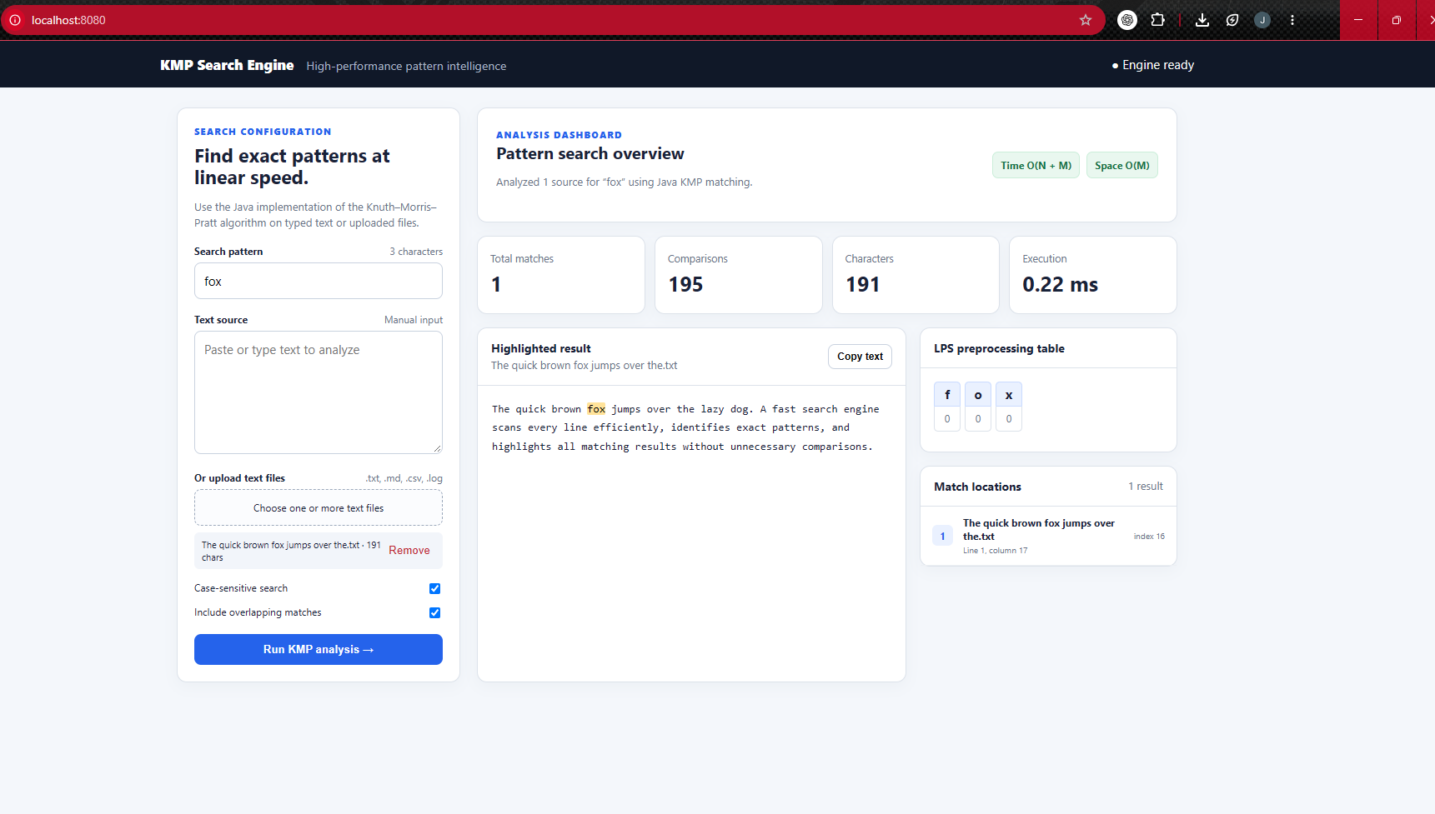
Figure 2: KMP Search Engine dashboard at localhost:8080 (pattern “fox”)
Figure 3 shows the IntelliJ IDEA project and the Run console for the same search, with the pattern, LPS table, match location, comparison count and number of characters analysed.
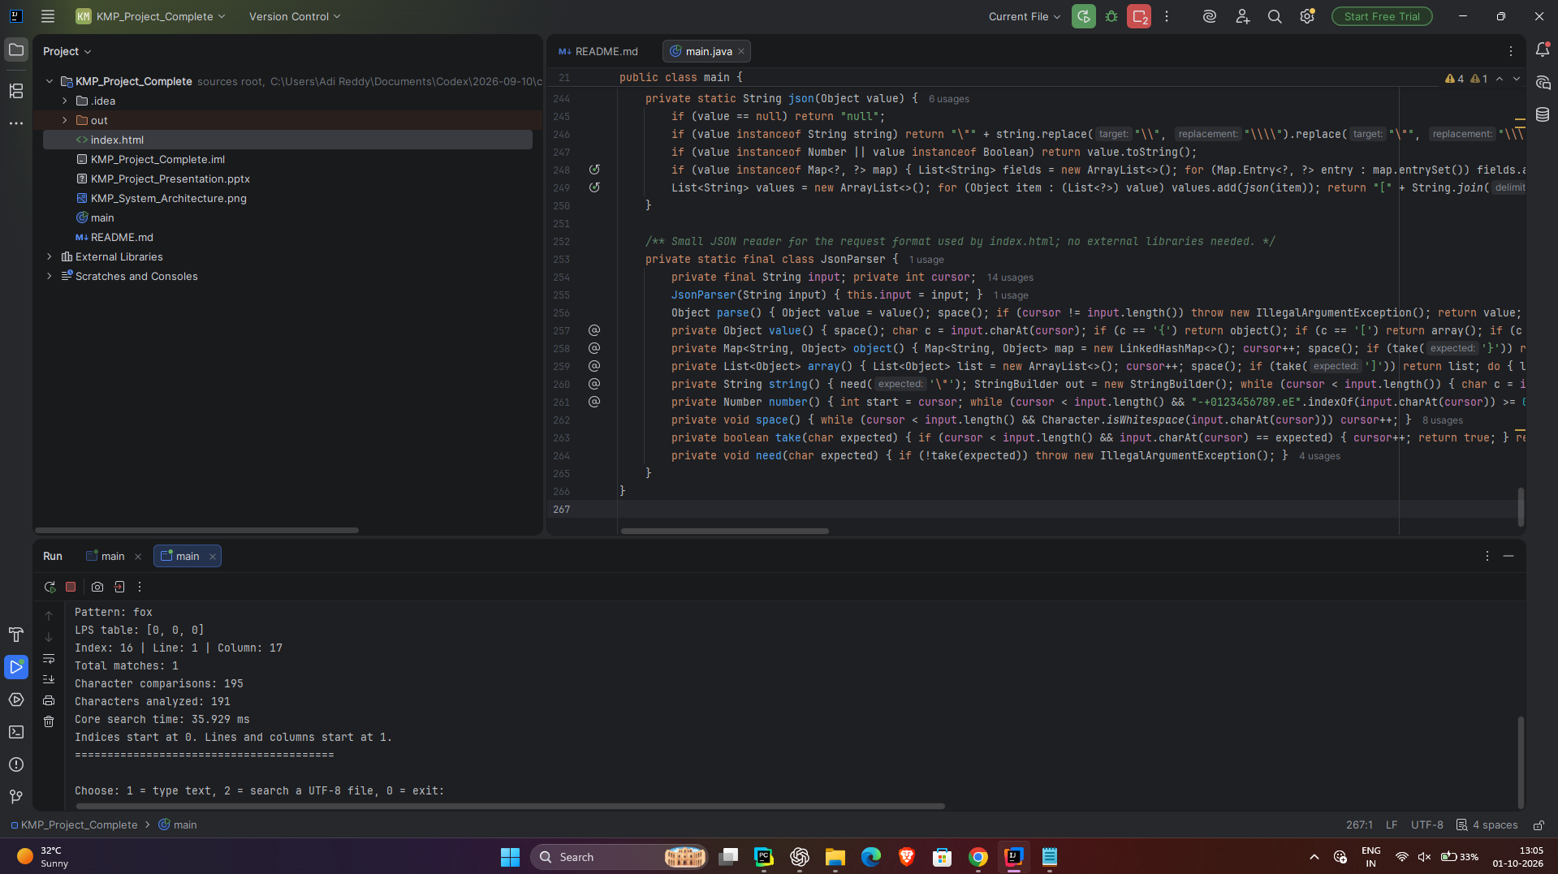
Figure 3: IntelliJ IDEA project and Run console output for the pattern “fox”
4.2 Console Output of the Submitted Program
Running the submitted main.java and sending the same request produces the following console report; the numbers match the screenshots above. (Execution time varies from machine to machine and is therefore not listed.)
========== KMP SEARCH RESULTS ==========
Pattern: "fox"
Case sensitive: true
Overlapping matches: true
LPS table: [0, 0, 0]

Source: "The quick brown fox jumps over the.txt"
Matches: 1
Index: 16 | Line: 1 | Column: 17

Sources searched: 1
Total matches: 1
Character comparisons: 195
Characters analyzed: 191
Indices are zero-based; lines and columns start at 1.
========================================

4.3 Observations
- All matches in Table 2 were reported with correct zero-based indices, and overlapping matches were found or suppressed according to the option.
- The number of comparisons stays close to the text length (195 for 191 characters; 23 for 19 characters in Example 4) and never exceeds 2N, in line with the O(N + M) analysis.
- For a repetitive pattern KMP used fewer comparisons than a naive scan (23 against 29 in Example 4). For fox the two are equal because the pattern has no repeated prefix. The examples explain behaviour; they are not large-file benchmarks.
- When no match exists, the dashboard shows the editor panel so the source can be corrected, downloaded or searched again.
CONCLUSION
The project shows how KMP performs exact matching by reusing prefix information instead of restarting after every mismatch. The application combines multiple-file search with an LPS display and detailed match positions (index, line and column). Editing and downloading a source after an unsuccessful search makes the tool useful beyond a pure search demonstration. The O(N + M) guarantee covers the KMP core; file loading, position reporting and rendering add application overhead.
FUTURE SCOPE
- Stream large files in chunks while preserving the KMP state (j) across chunk boundaries.
- Compute line and column positions in a single pass and paginate large result lists.
- Improve Unicode case handling and keep normalised matches aligned with the original text.
- Benchmark against naive search with varied file sizes and repeated patterns; add cancellation and progress updates.
REFERENCES
- D. E. Knuth, J. H. Morris Jr. and V. R. Pratt, “Fast Pattern Matching in Strings,” SIAM Journal on Computing, vol. 6, no. 2, pp. 323–350, 1977.
- R. Sedgewick and K. Wayne, Algorithms, 4th ed., Addison-Wesley, Section 5.3 (Substring Search).
- R. S. Boyer and J. S. Moore, “A Fast String Searching Algorithm,” Communications of the ACM, vol. 20, no. 10, pp. 762–772, 1977.
- R. M. Karp and M. O. Rabin, “Efficient Randomized Pattern-Matching Algorithms,” IBM Journal of Research and Development, vol. 31, no. 2, pp. 249–260, 1987.

