

Dynapac Course Library Web Application

*Technical Specifications*

Table of Contents

Application Purpose 4

Application Users 4

Site Map 5

Web Pages Features Proposal 5

Development Technologies 11

Reference Guide 12

Minimum User System Requirement 12

Deployment Environment 12

Test Environment 12

Additional specifications points… 12

*Version Control*

|  |  |  |  |
| --- | --- | --- | --- |
| Version | Date of Change | Author | Remarks |
| V1.0 | 15 Jun | CHRP-INDIA | Created the document |
| V2.0 | 22 Jun | CHRP-INDIA | Edits based on discussion with Petr |
| V3.0 | 27 Jun | CHRP-INDIA | Edits based on discussion with Ellen |

# Application Purpose

The Dynapac Course Library application will serve as a repository of courses. This knowledge repository will be accessible by the employees of Dynapac for viewing the courses.

# Application Users

There are two categories of users:

1. **Administrator**: Is the super user who would be managing the entire library. The administrator would manage the users and the courses that are uploaded on the library. We would be designing a backend that the administrator can access to perform their functions.
2. **Course Users**: These are the employees who would need to access the library to view the courses. They will have limited privileges as compared to the administrator. All users will have access to all the courses.

The following are the rights given to each user type:

1. **Administrator**:
   1. Manage the front end and back end panel
   2. Approve or Reject the registered users.
   3. Deactivate or Re-activate users
   4. Delete users permanently
   5. Upload the course package
   6. Delete an existing course package
   7. Search course based on course name
   8. Download the existing course
   9. Edit the Course Description
   10. View Admin upload and download activity
   11. Edit user types
2. **Course User**:
   1. User can use the front end
   2. Search course based on course name
   3. View course
   4. Download a course

# Site Map

Shown below is the site map for the web pages that we would develop for the course library.

# Web Pages Features Proposal

Shown below are some representative images of how the pages listed in the sitemap will look like.

*Note: these are not the final designs. The UI/UX team will be working on the final design once you approve the features of these pages.*

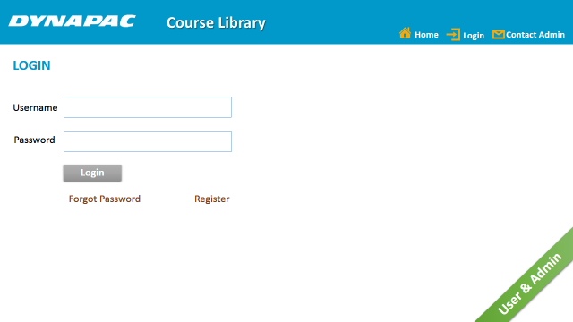

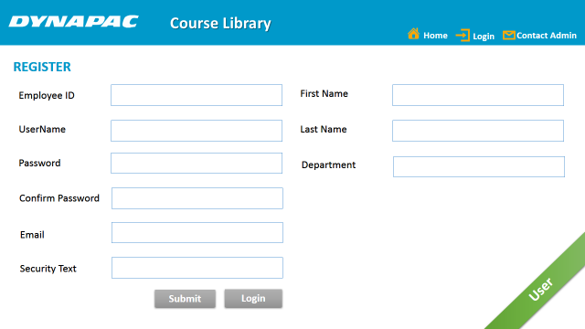

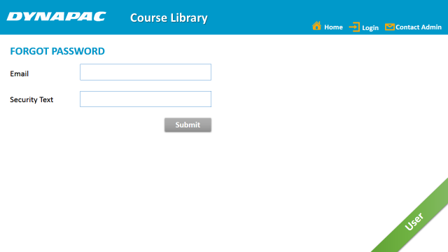

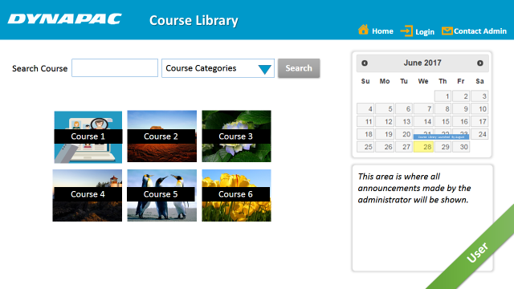

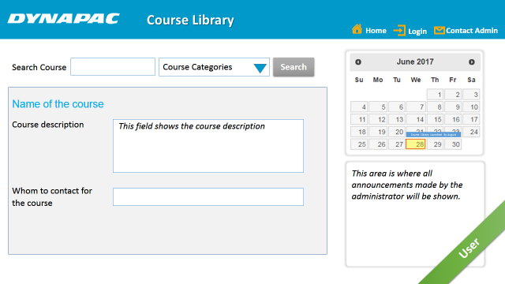

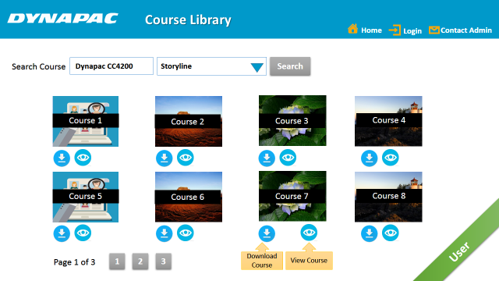

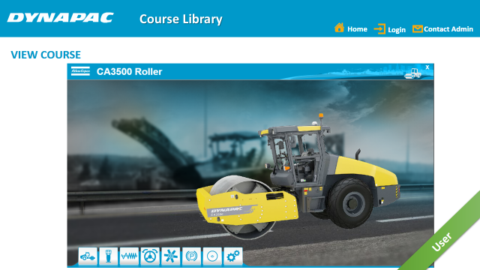

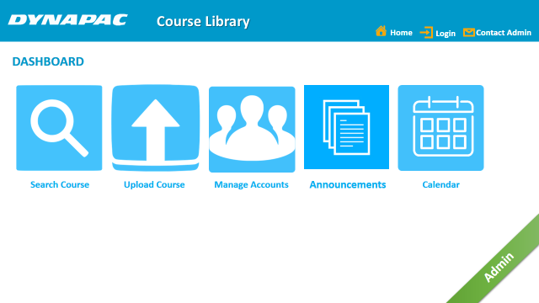

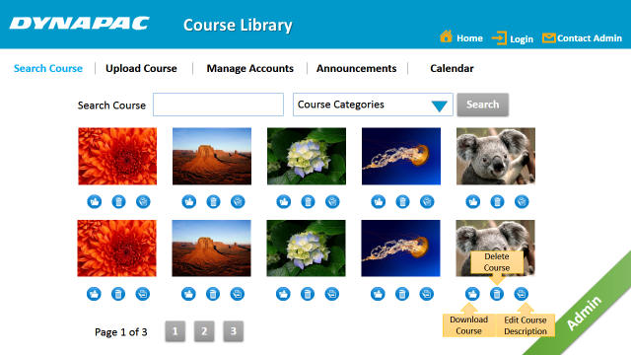

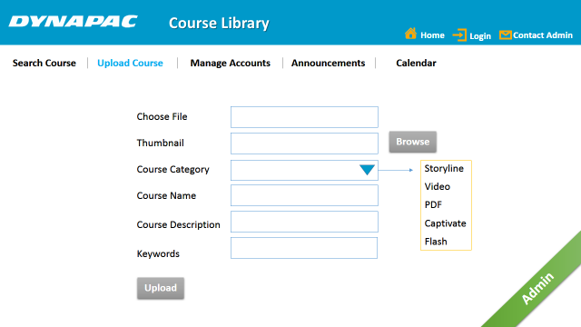

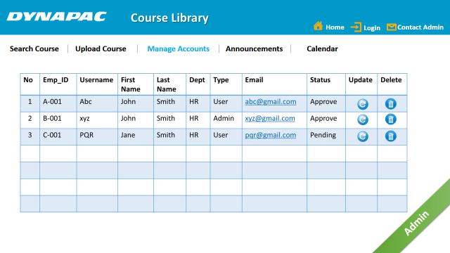

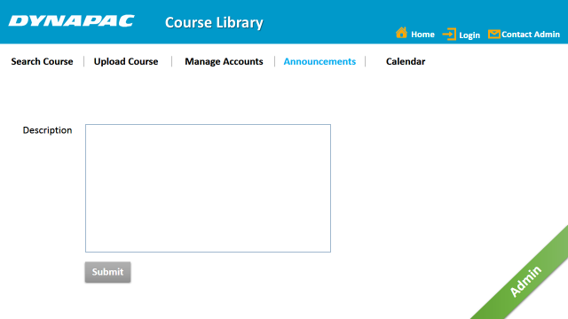

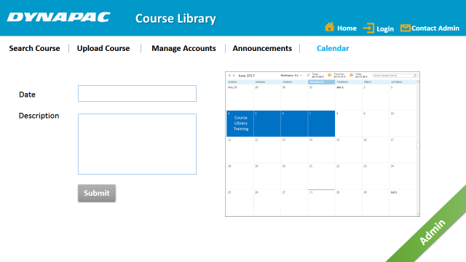

# Development Technologies

A combination of the following technologies will be used to develop the web application:

* HTML
* CSS
* Java Script
* PHP
* MySql
* JQuery

Version control will be done through BitBucket. All developments will be through BitBucket only. Resulting source code and all assets will be the property of Dynapac.

The project will be called as

# Reference Guide

A reference or a help guide will be created which will explain the procedures for using the course library.

# Minimum User System Requirement

|  |  |
| --- | --- |
| PROCESSOR | Intel i3 Core Processor or better performance processor |
| OPERATING SYSTEM | Windows 7 and above |
| MEMORY | 1 GB RAM or more |
| BROWSERS | Internet Explorer, Google Chrome, Firefox |
| ANDROID | Lollipop 5.0 and above |
| IOS | iOS 9.0 and above |

# Deployment Environment

|  |  |
| --- | --- |
| DATABASE | Intel Core Processor or better performance processor |
| SERVER | Windows 7 and above |
| MEMORY | 1 GB RAM or more |
| HARD DISK SPACE | Minimum 5 GB (depends on the total space required for the courses) |

# Test Environment

We would locally test the package using XAMPP server. For the purpose of reviews, we would share the library with a couple of sample courses.

# Additional specifications points…

Here are the key points we discussed with Petr in the meeting on 22 June. These have been updated after our discussion with Ellen.

* Start with internal users – employees of Dynapac
* Keep the registration page for the internal users
* Registration will be for external users – would be done later
* AD authorization should be available
* For backend search customized search program will be written instead of using a search engine.
* The package should be able to integrate into the Azure Web Apps
* We would test within XAMPP package and send the same to Petr for testing
* Anand to check if the package can be shared through One Drive
* Petr to give access to Big Bucket environment based on the details shared by Anand
* There will not be any Flash courses. So we do not need a category for Flash course.

Here are the key points we discussed with Ellen in the meeting 26 June.

* On the home page of the user, add a textbox which will be filled by the Administrator.
* On the home page of the user, on the right side of the page, show a calendar that can be managed by the administrator. The Admin can add the courses info on the calendar directly. On click of the course name, a screen with the information should appear. The course name is not for viewing the course, but to know the details related to it. No documents need to be linked or attached to this page.
  + Name of the course
  + Course description
  + Who to contact for the course
* The course user should be able to download a course.
* Use the same branding as the Dynapac website. Ellen to check with Anna and share the draft of the branding guidelines.
* All videos will be .mp4 format only
* For now keep a provision for Flash and Captivate courses as course categories.
* The reporting structure need not be created for this application.