NAME:T.Gopi

REGISTERED NUMBER:-192110316

SUBJECT:-SOFTWARE ENGINEERING WITH AI TECHNIQUES

SUBJECTCODE:-CSA1OO1

FACULTY:-DR.G.MARY VALANTINA

EXPERIMENT:-01

DATE:-26-09-2022

AIM:-To draw USE-CASE diagram for ONLINE VOTING SYSTEM using umbrella

DIAGRAM:-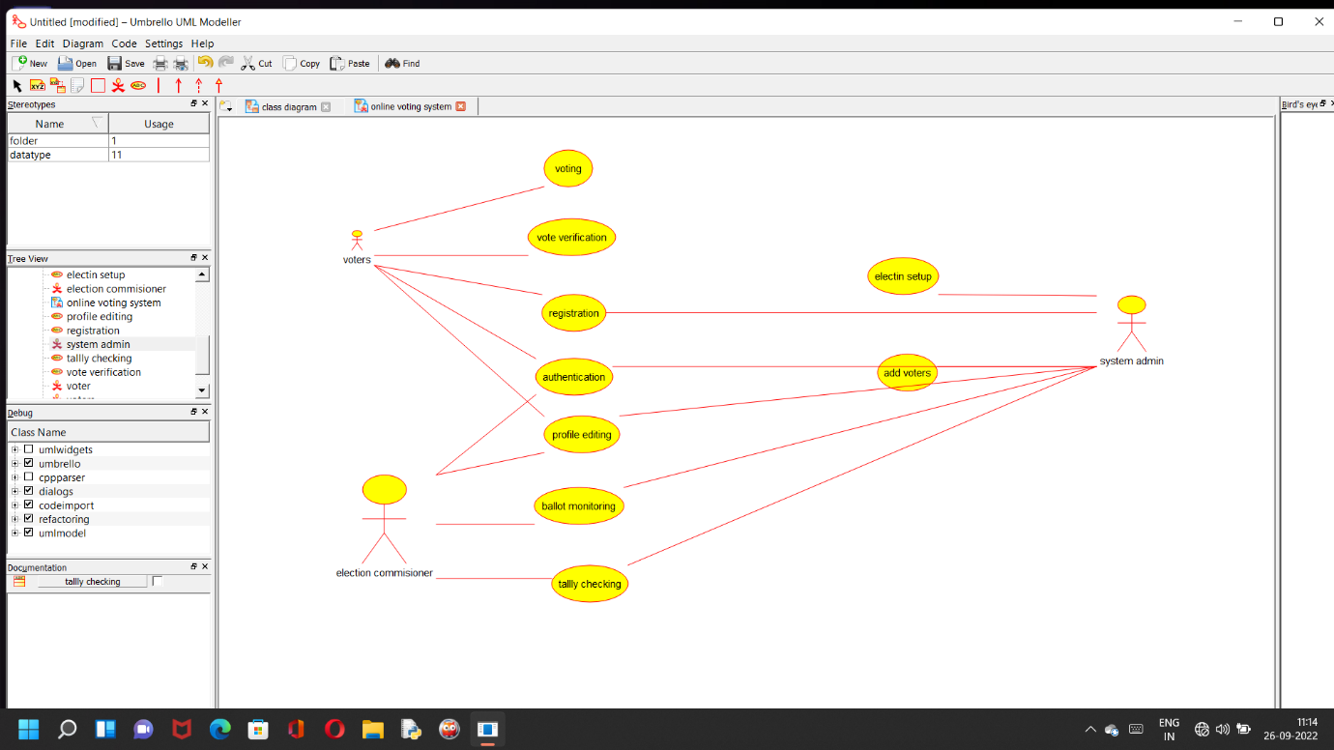

RESULT:-

SSuccessfully done the use case diagram of online voting system in umbrella software

EXPERIMENT-02

DATE:-26-09-2022

AIM:-To draw USE-CASE diagram for LIBRARY MANAGEMENT SYSTEM using umbrella

DIAGRAM:-

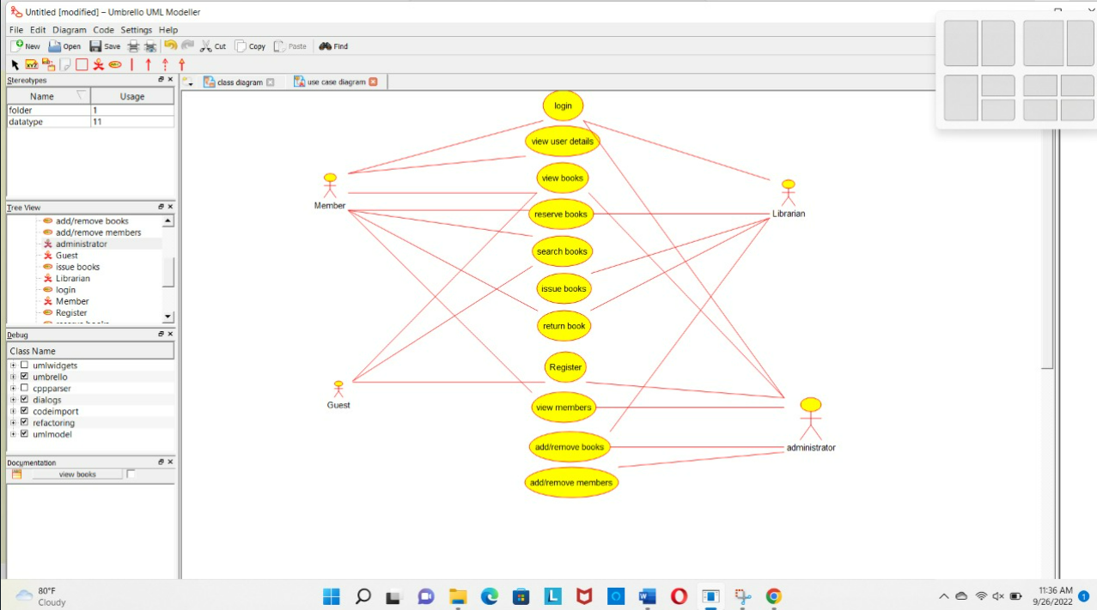

RESULT:-

SSuccessfully done the use case diagram of library management system in umbrella software.

EXPERIMENT-03

DATE:-26-09-2022

AIM:- To draw FLOWCHART diagram for compute the quotient and remainder using RAPTOR.

DIAGRAM:-

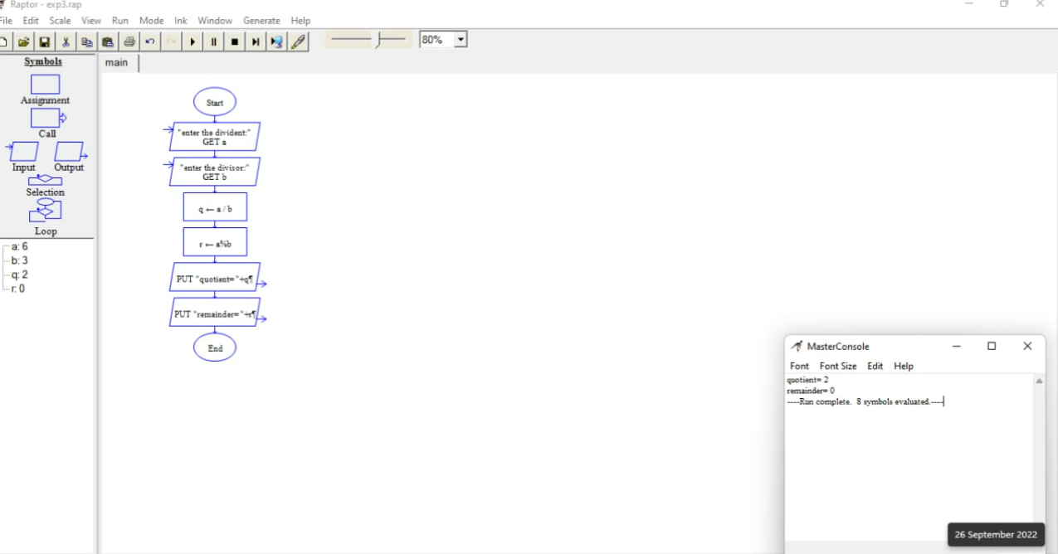

RESULT:-

SSuccessfully done the FLOWCHART diagram of COMPUTE THE QUOTIENT AND REMAINDER in RAPTOR.

EXPERIMENT-04

DATE:-26-09-2022

AIM:- To draw USE-CASE diagram for ONLINE SHOPPING SYSTEM using umbrella

DIAGRAM:-

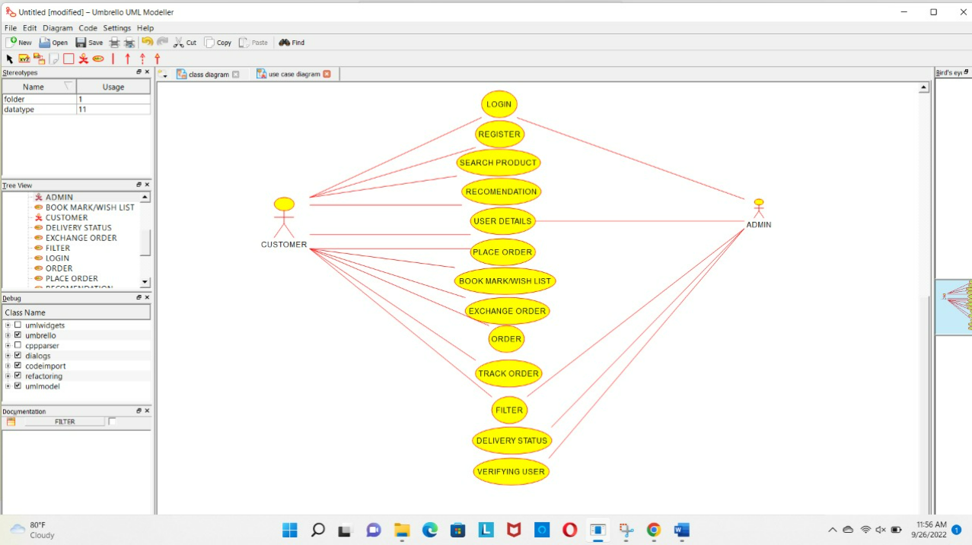

RESULT:-

SSuccessfully done the use case diagram of online shopping system in umbrella software.