Blue Sky Hotel (http://www.bluehotel.com/BLUE_SKY_HOTEL/HOME.html)

It is a good example of a nice layout. The webpage is clean and has a good style and not confusing to use. However, every button (e.g. HOME, HOTEL ROOMS) send user to a different .html document. Therefore, we tried to prevent that by using JavaScript in our website.

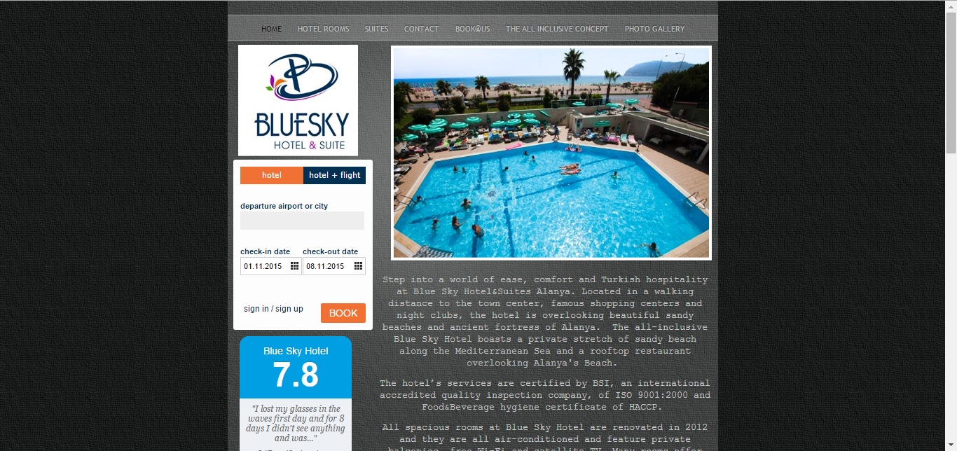

Fancybox (http://fancybox.net/)

We wanted our gallery to look stylish and with lots of research on the web how to make it possible, we decided to use an external plugin’s JavaScript, called “Fancybox”.

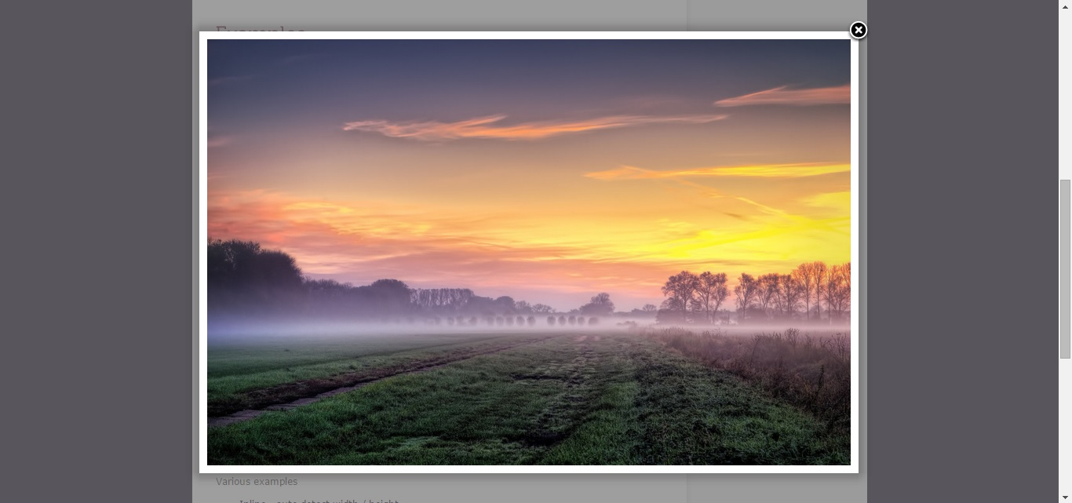

Lab Example website

A great example of a proper functional website without additional styles added. Raw source code helped to lay the foundation of our website.



Exmouth View page (http://www.exmouth-view.co.uk/)

A great example of how not to make a website. There is no layout and everything is cluttered. The pictures are very small and do not become enlarged on click. No descriptions about the rooms, services and local area. Contacts are very hard.

