Data Science in Finance (DSF182)
SS2 Part A Report

A Computer Vision Crop-Health Signal for Khula!’s Funder Dashboard

Student Name | Gopolang Mmutlwane
Module | Data Science in Finance (DSF182)
Assessment | SS2, Part A
Startup | Khula! (South African agritech and agri-finance platform)
AI Link | https://claude.ai/share/c0090d3c-4360-4ed8-a74d-4c75bc9b59da

1. Justification for choosing computer vision
Khula! provides small-scale and commercial farmers with software and a marketplace to grow their business (Food Business Africa, n.d.), including an app through which farmers can apply for production finance for their growing contracts and “access multiple funders with a single application” (Khula!, n.d.). Its Funder Dashboard “connects institutional investors with farmers who meet their funding mandates” (Food Business Africa, 2021), and the company collaborates with financial institutions to de-risk lending to small and semi-commercial farmers; its investors include Absa, which describes itself as South Africa’s largest agricultural financier (WeeTracker, 2025). This matters because many smallholders cannot offer the collateral that banks normally require: in a study of 223 South African smallholders, 95.1% farmed communal land without a title deed, and not owning a farm reduced the odds of accessing credit by 41% (Jonas et al., 2025). Khula! has not published how the dashboard assesses farmers, and the public descriptions reviewed for this report do not mention information about the condition of a farmer’s crop during the season. Because production finance is advanced before a crop is harvested, much of the credit risk builds up while the crop is growing: a crop lost to disease only becomes visible to a lender once the harvest fails and a repayment is missed, which is too late to act.

Computer vision suits this gap because the evidence of crop disease is visual and farmers already carry the sensor: a smartphone camera. Khula! already uses a trained image model in its farmer-facing crop-diagnosis feature, which recommends a treatment from a photo (African Farming, 2025; Tech In Africa, n.d.). This prototype applies the same technique in a different way: a healthy-versus-diseased classifier for maize leaf photographs whose output, aggregated per farmer, could give the Funder Dashboard an early and independent crop-health signal alongside transaction data. A binary output was chosen over disease-specific labels because a funder needs to know whether a crop is at risk, not which pathogen is responsible.

Two limits apply. First, using the prototype this way would require Khula! to extend its existing app so that farmers’ crop photos can feed the dashboard; this is not a capability Khula! currently documents. Second, the notebook tests only the classification step, not whether crop health predicts repayment, which would require Khula!’s own loan outcome data. Because the signal would feed into an assessment of creditworthiness, production use would also need to comply with section 71 of POPIA, which requires that people affected by automated decisions of this kind can make representations about the decision and receive sufficient information about its underlying logic (South Africa, 2013).

2. Links to the sources
Source | Link
Tutorial: Transfer Learning for Computer Vision Tutorial, PyTorch (Chilamkurthy, n.d.) | https://docs.pytorch.org/tutorials/beginner/transfer_learning_tutorial.html
Dataset: Maize_in_Field_Dataset, Kaggle (Craze, n.d.) | https://www.kaggle.com/datasets/hamishcrazeai/maize-in-field-dataset

The tutorial’s “Finetuning the ConvNet” approach was used: a ResNet18 pretrained on ImageNet, with the tutorial’s final layer, optimiser (SGD, learning rate 0.001, momentum 0.9), learning-rate schedule and training loop kept and adapted to the new data. The dataset contains 2355 photographs of maize leaves taken under field conditions in Mpumalanga, KwaZulu-Natal and the Eastern Cape, using devices ranging from smartphones to an SLR camera, for a peer-reviewed study of maize disease diagnosis (Craze et al., 2022). The study reports 2332 images; after the notebook removed 27 exact duplicate pairs, 2328 remained, close to that figure. The Kaggle dataset is released under a CC BY-NC-SA 4.0 licence (Craze, n.d.), which permits academic reuse with attribution but not commercial use, so Khula! would need the authors’ permission, or its own photographs, before any production use. Its mixed lighting, backgrounds and cameras are closer to what Khula!’s farmers would photograph than laboratory images, and after duplicate removal it holds 2102 diseased and 226 healthy images, a 9.3:1 imbalance.

3. Overall effectiveness
The prototype should not be taken into production yet. On 609 unseen images it reached 93.6% accuracy, below the 94.1% achieved by always predicting “diseased”; its balanced accuracy of 58.8% (95% CI 52.7–65.6%) shows a real but weak signal, and it flagged 29 of 36 healthy leaves as diseased (Figure 2), including every healthy leaf from two of the unseen photo groups. On the Funder Dashboard these false alarms would mark creditworthy farmers as risky, which works against the dashboard’s purpose of connecting farmers with funders, so more healthy-crop images from varied field conditions and validation against real repayment outcomes are needed before it is reconsidered.

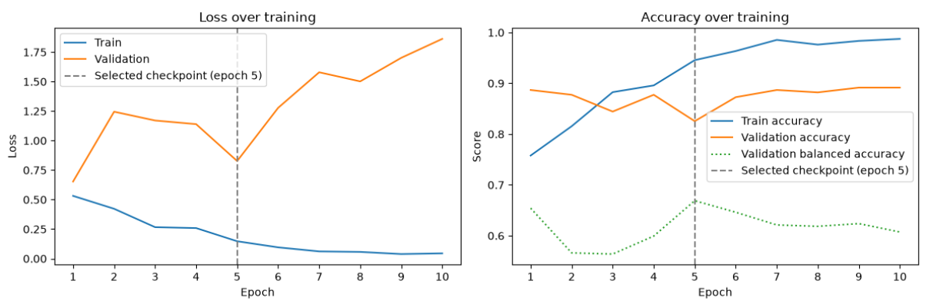
Figure 1: Training and validation curves over 10 epochs. Training loss falls while validation loss rises, showing overfitting; the checkpoint with the highest validation balanced accuracy (epoch 5) was used for testing. Source: notebook output.

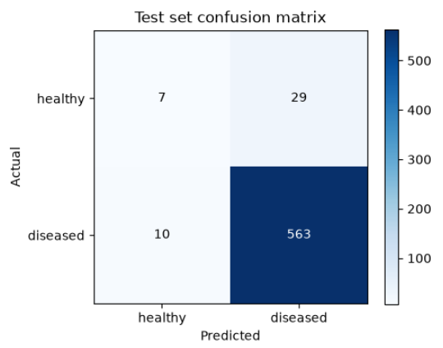
Figure 2: Confusion matrix on the 609-image test set. The model predicts “diseased” for 592 of 609 images and recognises only 7 of 36 healthy leaves. Source: notebook output.

References
African Farming (2025) Khula CEO Karidas Tshintsholo delivers game-changing vision at Citrus Indaba. Available at: https://www.africanfarming.com/2025/09/16/khula-ceo-karidas-tshintsholo-delivers-game-changing-vision-at-citrus-indaba/ (Accessed: 18 September 2026).
Chilamkurthy, S. (n.d.) Transfer learning for computer vision tutorial. PyTorch Tutorials. Available at: https://docs.pytorch.org/tutorials/beginner/transfer_learning_tutorial.html (Accessed: 13 September 2026).
Craze, H. (n.d.) Maize_in_Field_Dataset [Dataset]. Kaggle. Available at: https://www.kaggle.com/datasets/hamishcrazeai/maize-in-field-dataset (Accessed: 13 September 2026).
Craze, H.A., Pillay, N., Joubert, F. and Berger, D.K. (2022) ‘Deep learning diagnostics of gray leaf spot in maize under mixed disease field conditions’, Plants, 11(15), Art. 1942. Available at: https://doi.org/10.3390/plants11151942 (Accessed: 13 September 2026).
Food Business Africa (2021) South Africa’s agritech startup Khula! expands offering with launch of new app after closing US$1.3m funding. Available at: https://www.foodbusinessafrica.com/south-africas-agritech-startup-khula-expands-offering-with-launch-of-new-app-after-closing-us1-3m-funding/ (Accessed: 14 September 2026).
Jonas, N., Christian, M., Ntombela, S. and Letsoalo, S. (2025) ‘Empowering South African smallholder farmers: integrating climate resilience into credit assessment’, Sustainability, 17(1), Art. 261. Available at: https://doi.org/10.3390/su17010261 (Accessed: 31 August 2026).
Khula! (n.d.) Khula! [Company website]. Available at: https://www.khula.co.za/ (Accessed: 14 September 2026).
South Africa (2013) Protection of Personal Information Act 4 of 2013. Pretoria: Government Printer. Available at: https://www.justice.gov.za/legislation/acts/2013-004.pdf (Accessed: 14 September 2026).
Tech In Africa (n.d.) Agritech startup Khula backed by PepsiCo’s Kgodiso Fund. Available at: https://www.techinafrica.com/agritech-startup-khula-backed-pepsicos-kgodiso-fund/ (Accessed: 18 September 2026).
WeeTracker (2025) Khula raises USD 6.7 M Series A to expand agritech solutions in South Africa. Available at: https://weetracker.com/2025/03/04/sa-agritech-khula-raises-series-a/ (Accessed: 18 September 2026).

AI Conversation Link: https://claude.ai/share/c0090d3c-4360-4ed8-a74d-4c75bc9b59da

