Programming Assignment #6 Graphs - 50pts

Implement code in C to determine PERT TE, TL, and Critical Path(s) using graphs represented as double adjacency lists.

You will be provided with C code and a .h file to create the graph and print the graph. You must provide code to

* determine TE for each vertex
* determine TL for each vertex
* determine and print the critical path(s)
* free the graph

Input (until EOF):

Data will contain multiple sets of edges (one set for each graph)

From To PathWeight

%c %c %d

Each set of edges is terminated by a record having 0 0 0.

Turn in (please include in a folder named by your LastNmFirstNm)

* All .c files
* .h file
* output

Example Graphs and Output:

#1:

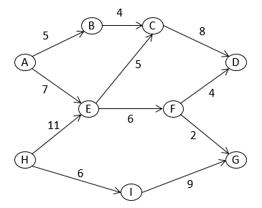

Graph # 1: Initial

Vtx TE TL SUCCESSORS PREDECESSORS

A 0 0 B 5 E 7 -

B 0 0 C 4 A 5

E 0 0 C 5 F 6 A 7 H 11

C 0 0 D 8 B 4 E 5

D 0 0 - C 8 F 4

F 0 0 D 4 G 2 E 6

G 0 0 - F 2 I 9

H 0 0 E 11 I 6 -

I 0 0 G 9 H 6

Graph # 1: PERT TE and TL

Vtx TE TL SUCCESSORS PREDECESSORS

A 0 4 B 5 E 7 -

B 5 12 C 4 A 5

E 11 11 C 5 F 6 A 7 H 11

C 16 16 D 8 B 4 E 5

D 24 24 - C 8 F 4

F 17 20 D 4 G 2 E 6

G 19 24 - F 2 I 9

H 0 0 E 11 I 6 -

I 6 15 G 9 H 6

Critcal Path(s)

H E C D

#2

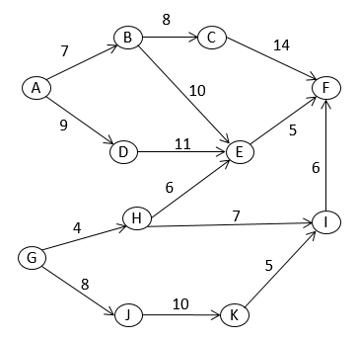

Graph # 2: Initial

Vtx TE TL SUCCESSORS PREDECESSORS

A 0 0 B 7 D 9 -

B 0 0 C 8 E 10 A 7

D 0 0 E 11 A 9

C 0 0 F 14 B 8

E 0 0 F 5 B 10 D 11 H 6

F 0 0 - C 14 E 5 I 6

G 0 0 H 4 J 8 -

H 0 0 E 6 I 7 G 4

J 0 0 K 10 G 8

I 0 0 F 6 H 7 K 5

K 0 0 I 5 J 10

Graph # 2: PERT TE and TL

Vtx TE TL SUCCESSORS PREDECESSORS

A 0 0 B 7 D 9 -

B 7 7 C 8 E 10 A 7

D 9 13 E 11 A 9

C 15 15 F 14 B 8

E 20 24 F 5 B 10 D 11 H 6

F 29 29 - C 14 E 5 I 6

G 0 0 H 4 J 8 -

H 4 16 E 6 I 7 G 4

J 8 8 K 10 G 8

I 23 23 F 6 H 7 K 5

K 18 18 I 5 J 10

Critcal Path(s)

A B C F

G J K I F