prassanna gokulachandran

Prassannavenkatesh.gokulachandran@cognizant.com

Final assement

Project Manager

Contents

Source Code 1

Unit Test 1

Performance Test 3

Jenkins Configuration 4

IIS Hosting 6

Screenshots 6

# 

# Source Code

<https://github.com/gopraIIHT/ProjectManagerSBA>

# Unit Test

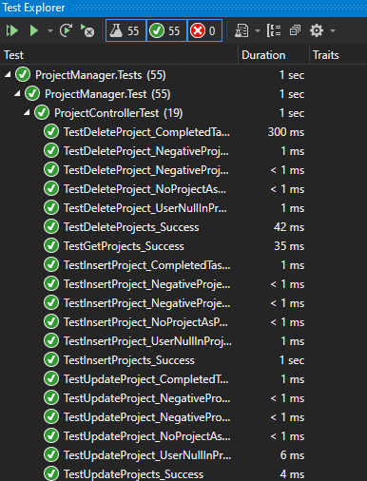

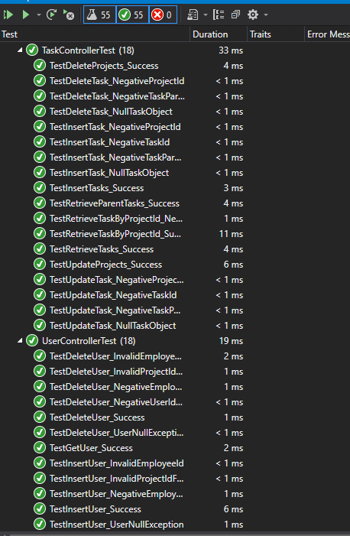

# Performance Test

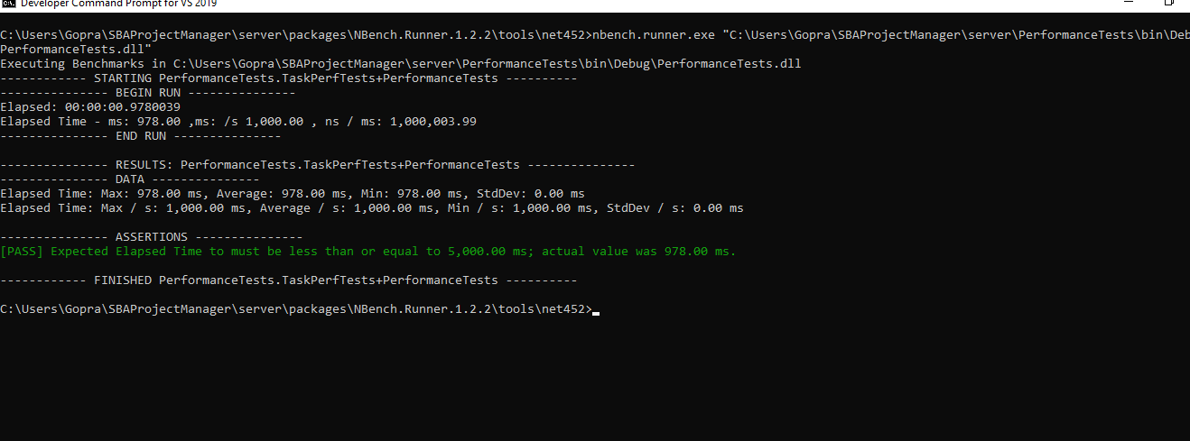

# Jenkins Configuration

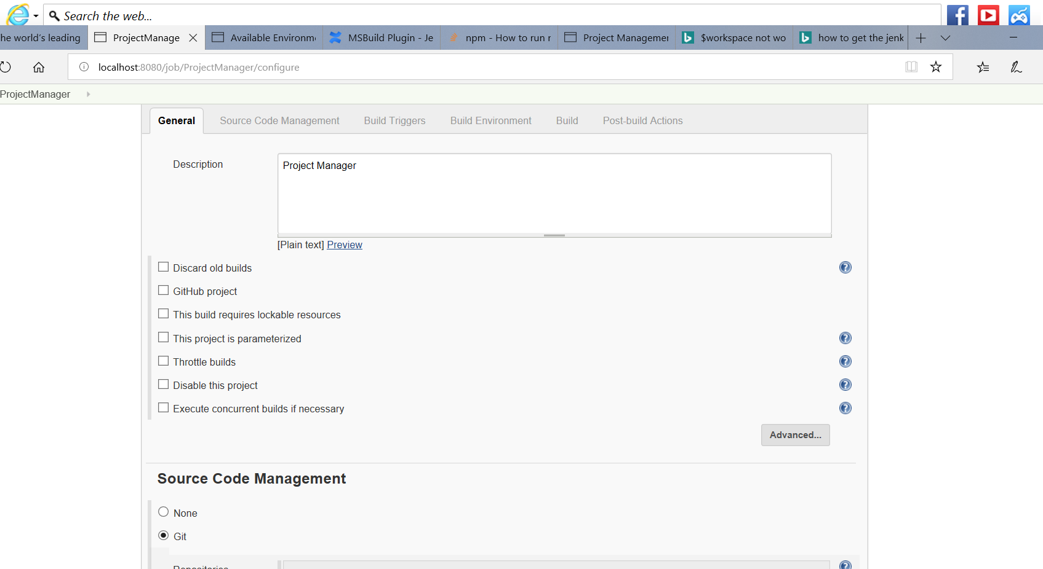

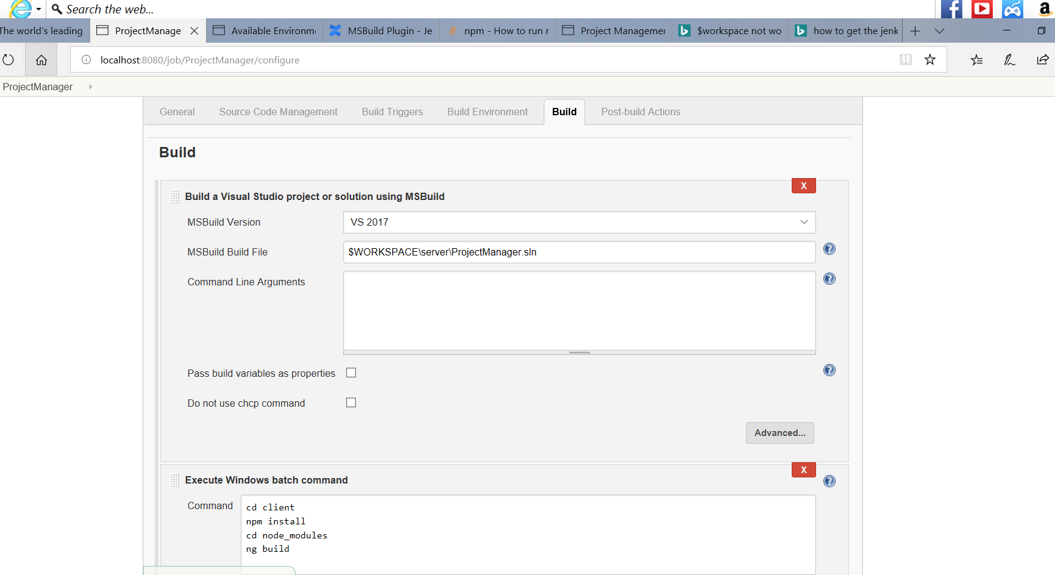

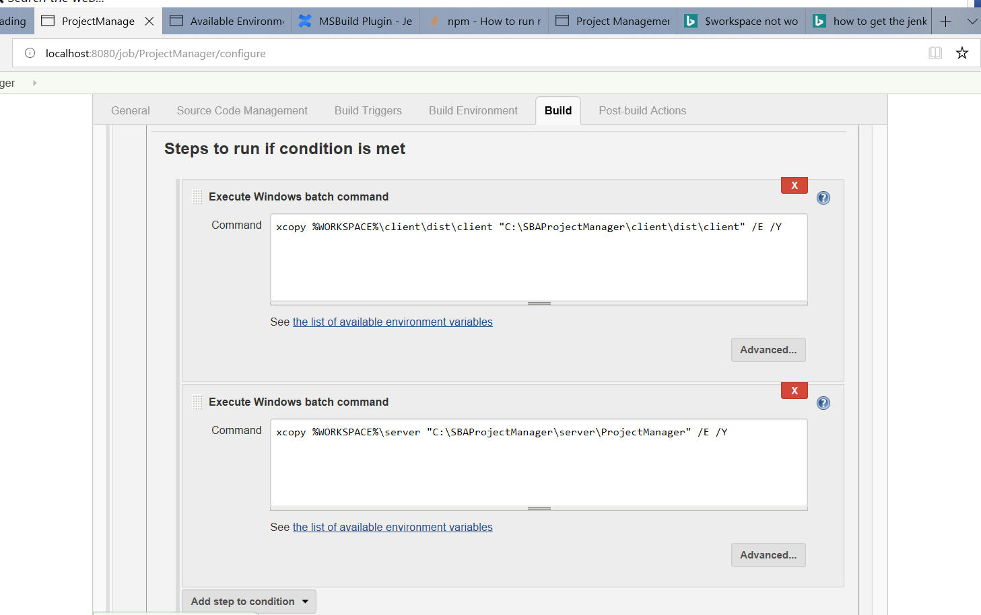

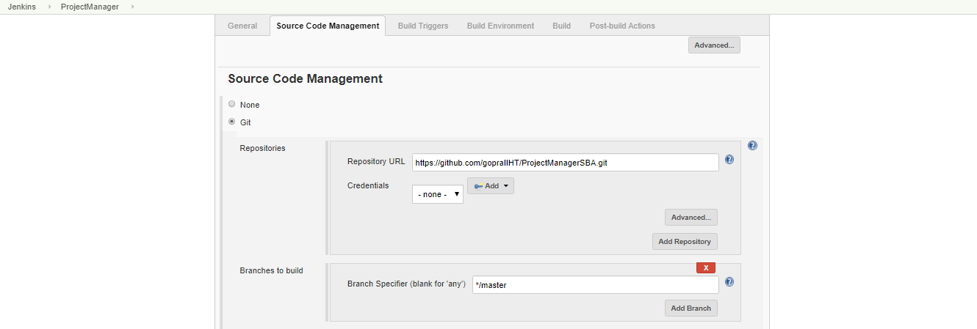

# IIS Hosting

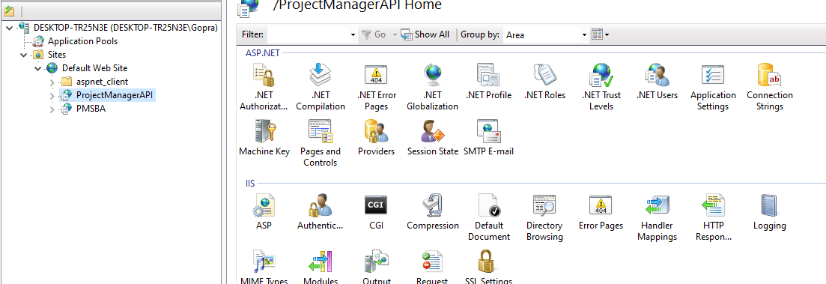

# Screenshots

