Email Swipes

Email Swipe 01
Subject: 90% of mass shootings victims could survive if they knew this...
Body:
This short video will show you the difference between being a victim mourned by your family and friends, and being a hero honored by the president of the country!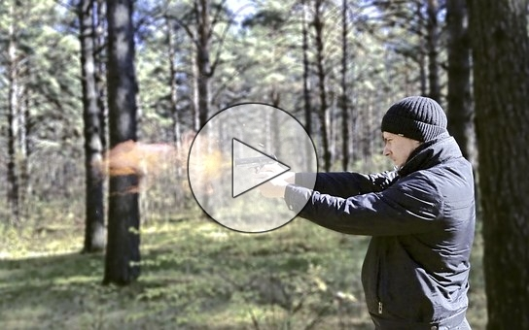
Experts are saying you have a huge chance to survive a mass shooting or a plane crash, and save other lives if you know the following... Click here to find out the shocking secrets...
<YOUR LINK HERE>

Email Swipe 02
Subject: You SHOULD teach this to your family...
Body:
This video will show you the ultimate secret to survive any threat you may face in your life!
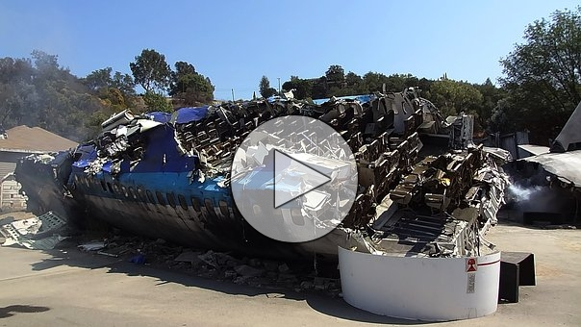
Whether you get caught in a mass shooting, facing a plane crash, or a mountain lion is chasing you, you can save your life if you master this...
Click here to find out the shocking secret...
<YOUR LINK HERE>

Email Swipe 03
Subject: What do you think are your chances to survive a bear attack or a plane crash?
Body:
This might surprise you but you can survive any kind of threat you may face!
This video explains it all: It's a basic rule that you can apply to any situation.

Click here to find out...
<YOUR LINK HERE>

Email Swipe 04
Subject: What's in common between the Orlando shooting and the Paris attack victims?
Body:
Well in addition to being all victims, also they all made the same fatal mistake that you can make too! Unless you watched this video:

It's very unfortunate that all those victims had missed this secret! But fortunately it is not too late for you!
Click here to find out...
<YOUR LINK HERE>

Email Swipe 05
Subject: Finally revealed! The secret of the 3 American heroes who saved hundreds of people in Paris
Body:
Probably you have heard about the 3 Americans heroes who aborted a terror attack on a train in France!
But do you know who they have managed to do it? Watch this short video to find out:

You might be surprised, but the secret these heroes used can save your life in any threatening situation!
More details can be found clicking here.
<YOUR LINK HERE>

Email Swipe 06
Subject: Your worst case scenario?
Body:
We all have this fear of facing scenarios that could threaten our lives, such as getting lost in the wild, getting trapped in a sinking car, getting stuck in a mass shooting, etc...
This short video explains it all about how to survive such threats: 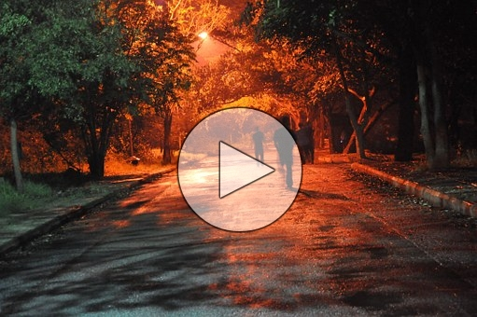
Experts are saying you have a huge chance to survive a mass shooting or a plane crash, and save other lives if you know the following...
More details can be found clicking here.
<YOUR LINK HERE>

