DECODER

AIM:
To construct and verify 3x8 decoder using the IC 74136.

APPARATUS REQUIRED:

(i) 3x8 decoder - IC 74138
(ii) Connecting wires

THEORY:
Discrete quantities of information are represented in digital systems by binary codes. A binary code of n bit can represent n th power of 2 information. A decoder is a combinational circuit that converts binary information from n input lines. These decoders are called n to m line decoders. Where m may be lesser than or equal to nth power of 2. Their purpose is to generate n th power of 2 minterms of n input variables. The name decoder is also used in conjunction with other code convertors; an eg. is BCD to seventh segment decoder. The 3 inputs are decoded into 8 outputs, each representing one of the minterms of the 3 input variables. A particular application of this decoder is octal to binary conversion. The input variables represent a binary number and the outputs represent 8 digit number in octal number system.

PROCEDURE:
The 3x8 decoder is mainly used for binary to octal conversion. The circuit connections are given as shown in circuit diagram. Inputs are given to the 3 invertors. Then each of the AND gates generates one of the minterms for the inputs. Then the decimal decoded output is verified.

PIN DIAGRAM:(IC 74138)
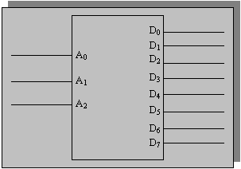

CIRCUIT DIAGRAM:
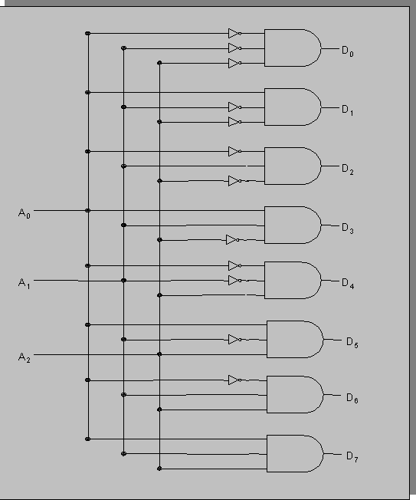

FUNCTION TABLE:
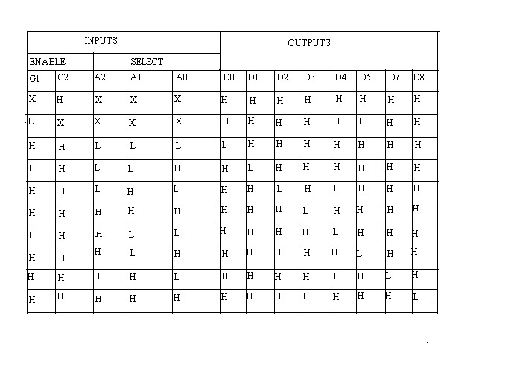

Result:
Thus the 3x8 decoder is constructed and verified using the digital IC 74138.

