**CRYSTAL REPORT INSTALLATIONS**

1. Oracle Server 11g Database

[32/64bit on Windows 7]

1. Oracle Client 10g

[version 10.2.0 client & it must be 32 bit on Windows 7]

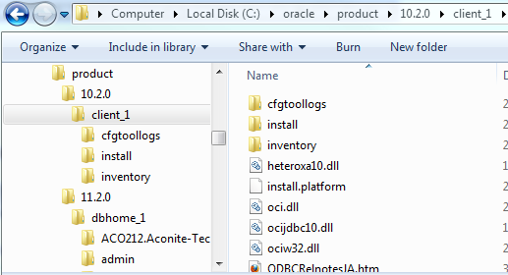

1. Remove PATH variable related to other Oracle Clients except 10g 32bit client.

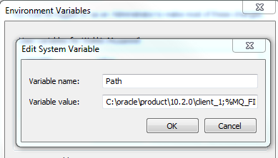

1. **Create a new system variable called TNS_ADMIN & In the Value field, put the path where your “tnsnames.ora” and “sqlnet.ora” will be located**

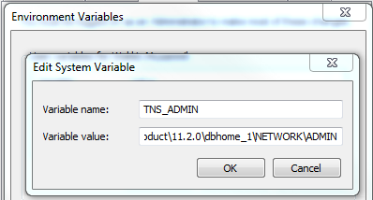



# tnsnames.ora Network Configuration File: C:\oracle\product\11.2.0\dbhome_1\NETWORK\ADMIN\tnsnames.ora

# Generated by Oracle configuration tools.

ORACLR_CONNECTION_DATA =

(DESCRIPTION =

(ADDRESS_LIST =

(ADDRESS = (PROTOCOL = IPC)(KEY = EXTPROC1521))

)

(CONNECT_DATA =

(SID = CLRExtProc)

(PRESENTATION = RO)

)

)

AFFINADB =

(DESCRIPTION =

(ADDRESS_LIST =

(ADDRESS = (PROTOCOL = TCP)(HOST = localhost)(PORT = 1521))

)

(CONNECT_DATA =

(SERVICE_NAME = AffinaDB)

)

)

AFFINADATASOURCE_PMA =

(DESCRIPTION =

(ADDRESS_LIST =

(ADDRESS = (PROTOCOL = TCP)(HOST = localhost)(PORT = 1521))

)

(CONNECT_DATA =

(SERVICE_NAME = AffinaDB)

)

)

1. Crystal Reports 2008 SP3 (32 bit) [Do not install CR2008 into Program Files(x86) select something else]

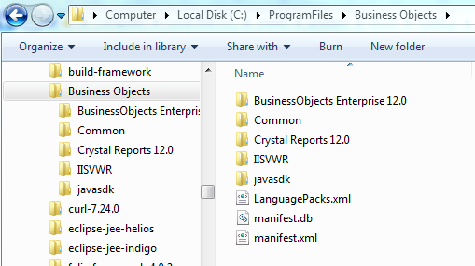

1. **Using ODBC**   
   a) create a 32 bit system DSN on the client machine (or the server).   
       On a 64bit operating system, you will find 32 bit ODBC setup file in the following path **[drive:/]Windows/sysWOW64/odbcad32.exe**

b) Open Crystal reports designer tool, and try connecting to the System DSN created in step 1.  Check the following screenshot, Crystal Reports 2008 SP3, Connection tested with ODBC and it is successful on my machine.  Oh what a relief !!

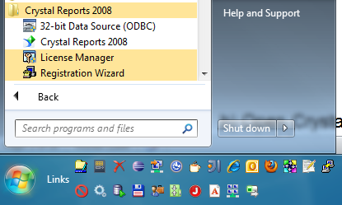

1. Restart the machine

1. Set these parameters to create a new connection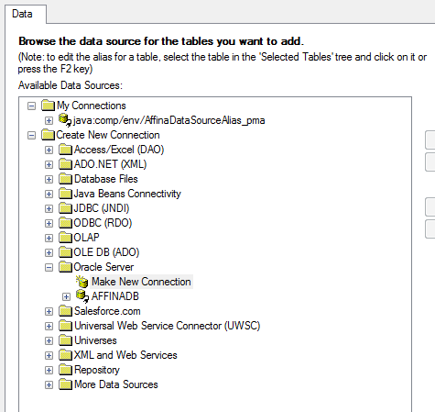
   1. Service Name : java:comp/env/AffinaDataSourceAlias_pma
   2. Username : pma
   3. TNS : AFFINADATASOURCE_PMA (WS7 must have datasource JNDI ‘AFFINADATASOURCE_PMA)

(if everything is alright, the TNS should be listed on the drop down list as ‘AFFINADATASOURCE_PMA)

* 1. Password : affina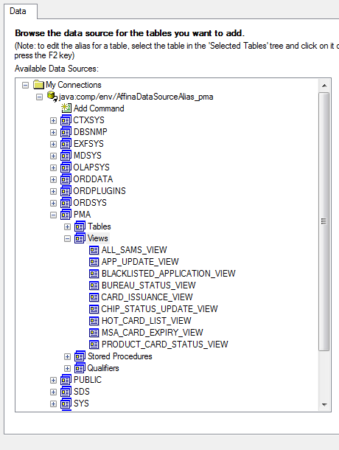

**JNDI Data sources :**

**Try to configure thin oracle client >>> jdbc:oracle:thin:@localhost:1521:AffinaDB**

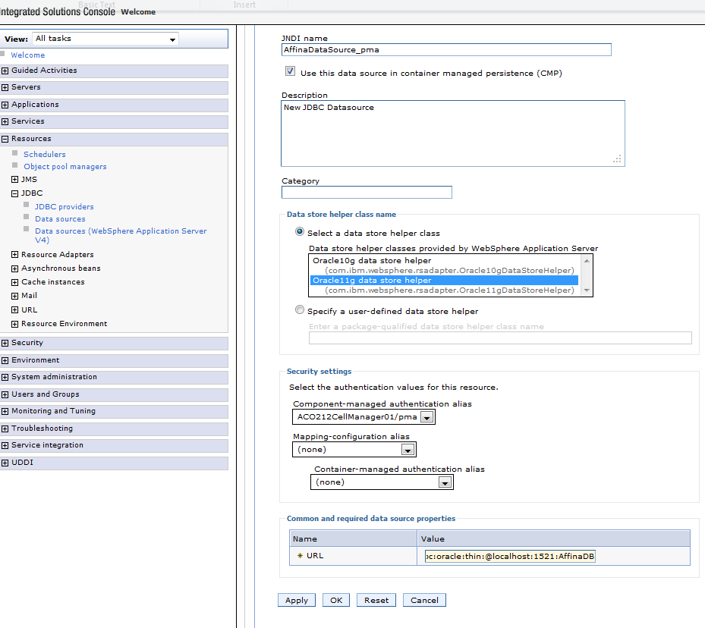

**INTERGRATING CR with JAVA WebApp**

|  |  |  |  |
| --- | --- | --- | --- |
| Web.xml entries |  |  |  |

Machine generated alternative text: : <context—param>
<paraxc—raame>crystal mage uri</param—narne>
<paraxn—value>crystalreportviewersl2</parazn—value>
<I context-param>
<context—parain>
<param—nare>crystal image use relative</param—narne>
<paran—value >webapp</param—value>
<I context—param>

Machine generated alternative text: <security—constraint>
<web—resource—collection>
<web—rescurce—narne>Controller Main Senrlet</web—resource—nan’.e>
<url-pattern>/home. jsp</url—pattern>
<url-pattern>/controllerMain</url—pattern>
<url-pattern>/CrystalReportVi ewerflandler</url-pattern>
<url-pattern>/parseConfig</url-pattern>
<url-pattern>/exportConfi gcontroller</url—pattern>
<url-pattern>/saveQueryReponse</url-pattern>
<url-pattern>/reportController</url-pattern>
<url-pattern>/savefxportConfigcontroller</url-pattern>
<http-rnethod>GET</http-method>
<http—rnethod>POST</http—rnethod>
</web—resource—collection>
<auth—constraint>
<role—name>Operator</role—naxne>
<role—nane>Audi tor</role—name>
<role—narne>Reporter</role—nasce>
<role—naxr.e>Configurationlnstaller</role—nanie>
<role-narr.e>Contigurationvalidator</role-nazce>
</auth—constraint>
</security—constraint>

Machine generated alternative text: <servlet>
<servlet—name)crystalReportVi ewerServlet</ servlet—name>
<servlet—class>oom. orystaldecisions . report.web.viewer. CrystalReportViewerServ].et</servlet—class>
<load—on—s tartup>1</ load—on—startup>
<f se rvle t>
<servlet-rnapping>
<servlet—name>-CrystalReportVi ewerServlet</ servlet—naxne>
<url-pattern>/CrystalReportVi ewerflandler<furl-pattern>
<fservlet-mapping>

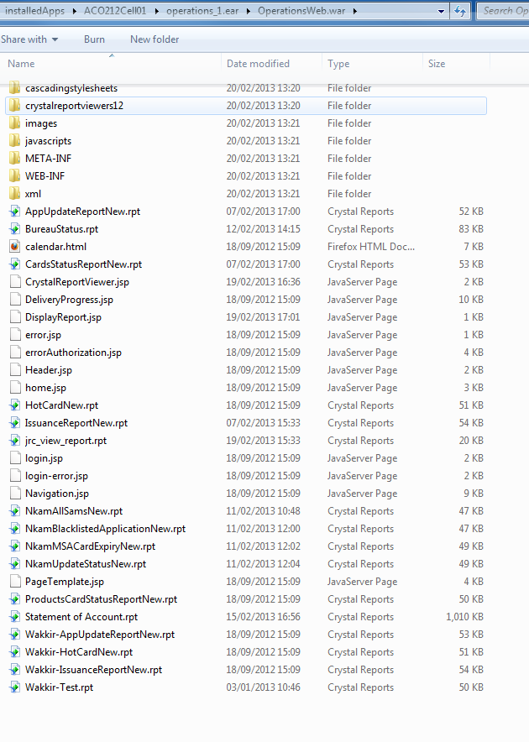

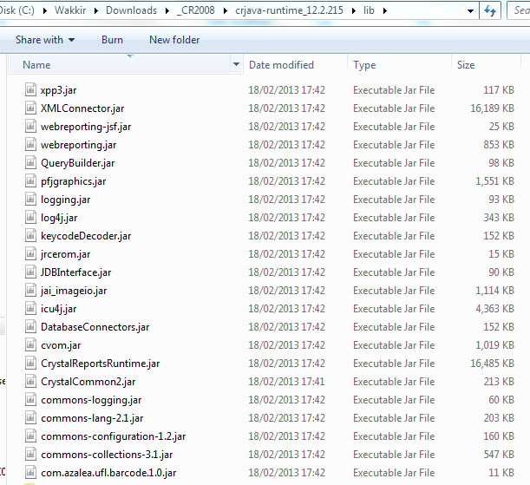

**References:**

<http://irfansworld.wordpress.com/2011/04/23/crystal-reports-2008-failed-to-open-the-connection-test_oracle-details-database-vendor-code-12154-resolved/>

<http://blog.able-ventures.com/using-oracle-11g-client-with-crystal-reports-xi-r2/>

<http://thetendjee.wordpress.com/2006/08/11/oracle-10g-instant-client-hard-to-make-it-work/>

<http://edn.embarcadero.com/article/33621>

<http://www.sdn.sap.com/irj/boc/index?rid=/webcontent/uuid/e00492ef-5c84-2b10-fe82-ce9db9d09baf>

<http://www.sdn.sap.com/irj/boc/index?rid=/webcontent/uuid/d0d7fd6f-5d84-2b10-5dad-a3d432285bff>

### Crystal Reports 2008: Failed to open the connection. test_oracle Details: [Database Vendor Code: 12154 ] – Resolved

Filed under: [SAP Crystal Reports](http://irfansworld.wordpress.com/category/olap-reporting-tools/sap-crystal-reports/) — Irfan @ 12:13 am

After spending lot of time on Google to fix the connectivity issue on Windows 7 64bit between Oracle 10g and Crystal Reports 2008 SP3, I thought I should write this post that may assist some of my readers including me for future reference down the road.  There is not much information available on the web and not any documentation about this issue.  The above error appears sometimes in Business Objects 3.1 SP3 Infoview or when you connect Crystal Reports 2008 Designer Tool to Oracle 10g database.

**Remember the following steps:**   
a) Crystal Reports 2008 SP3 is a 32 bit application.   
b) Business Objects 3.1 SP3 is a 32 bit application.   
c) So, install  Oracle 10g 32 bit or 64 bit, But install Oracle 10g client connectivity software of 32 bit only to interact with Crystal Reports 2008.   
d) If you want to use ODBC, you can connect using Microsoft ODBC drivers that are installed by default or you can also download [Data Direct 5.3 drivers](https://websmp230.sap-ag.de/sap%28bD1lbiZjPTAwMQ==%29/bc/bsp/spn/bobj_download/main.htm). or try this link <https://websmp230.sap-ag.de/sap%28bD1lbiZjPTAwMQ==%29/bc/bsp/spn/bobj_download/main.htm>

**Following is my environment on which connection is successful:**   
Operating System:   Windows 7 Ultimate (64 bit)   
Database:                Oracle 10g 10.2.0.3 (32 bit)   
Reporting Tool:       Crystal Reports 2008 SP3 (32 bit)   
Enterprise:               Business Objects 3.1 SP3 (32 bit)

**Using ODBC**   
1) create a 32 bit system DSN on the client machine (or the server).   
    On a 64bit operating system, you will find 32 bit ODBC setup file in the following path **[drive:/]Windows/sysWOW64/odbcad32.exe**

2) Open Crystal reports designer tool, and try connecting to the System DSN created in step 1.  Check the following screenshot, Crystal Reports 2008 SP3, Connection tested with ODBC and it is successful on my machine.  Oh what a relief !!

[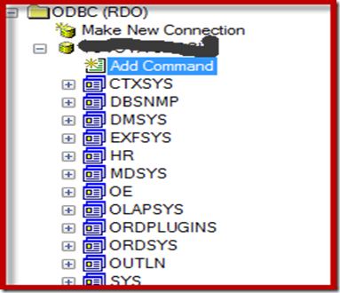](http://irfansworld.files.wordpress.com/2011/04/snaghtml7fcf80.png)

**Using TNSNAMES.ORA**   
2) Check the following screenshot, Crystal Reports 2008 SP3, Connection tested with TNSNAMES.ORA (i.e. Oracle Server)

[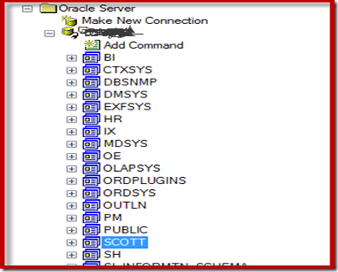](http://irfansworld.files.wordpress.com/2011/04/snaghtml772f8a.png)

Make sure that you install all the correct 32 bit versions of Crystal Reports 2008, Business Objects 3.1 and Oracle 10g to be compatible with each other. The report should work fine in Infoview and local PC.

Share your thoughts or any alternative solutions to resolve this error. Have a Good day.!!  Smile

**Using Oracle 11g Client with Crystal Reports XI R2**

http://i0.wp.com/blog.able-ventures.com/wp-content/uploads/2012/11/case2.png?resize=40%2C40The Case

For our first post I thought Id share a rather elemental issue that many of our clients and even myself have run into time and time again. It seems this issue isnt documented enough, or at least not indexed properly by Google or any of the associated vendor knowledge bases (SAP/Business Objects, Oracle, Infor/Lawson, etc). The issue is installing and using the native Oracle (11gR2) client with Crystal Reports.

First up…  
  
**Client Environment……….**

|  |  |  |
| --- | --- | --- |
| Crystal Reports | : | 2008 XI R3 SP3 (12.3.0.601) |
| Host OS | : | WINDOWS 7 ULTIMATE |
| Oracle Client | : | 11gR2 x64 |

## http://i2.wp.com/blog.able-ventures.com/wp-content/uploads/2012/11/breakdown.png?resize=40%2C40The Break Down

This was done on a fresh install of Windows. Oracle was installed first and then Crystal. Upon opening Crystal and creating a new report, I wanted to add a Native Oracle connection but *Oracle Server* was not listed under *New Connection*. Upon doing some research the most common reasons for this behavior were:

1. Crystal installed before the Oracle client  
2. Oracle home not being included in the Windows Environment Variable *PATH*  
3. Multiple installations of the Oracle client

None of these were case in my situation. My instance of SQL Developer could connect to the service IDs and I was able to TNSPING the Oracle server, so I was sure the client was installed and configured correctly.

## http://i0.wp.com/blog.able-ventures.com/wp-content/uploads/2012/11/magic1.png?resize=40%2C40The Magic

After much searching and forum trolling I finally determined the issue. Crystal Reports is a 32bit application and thus you must use 32bit Oracle drivers. I had installed the 64bit client, thus uninstalling the 64bit Oracle client and reinstalling the 32bit client resolved my issue of not seeing *Oracle Server* in the new connections list in Crystal Reports.

One final note, I also had been receiving the following error after resolving the 64bit problem:

Failed to open connection

[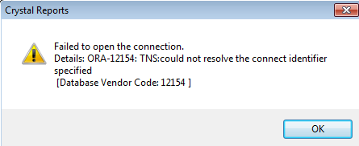](http://blog.able-ventures.com/wp-content/uploads/2012/11/oracle1.png)  
ORA-12154: TNS:could not resolve conflict with identifier specified

This issue was a result of Crystal Reports being installed into the Program Files (x86) directory. Reinstalling into Program Files corrected the error and I was able to finally connect to the Oracle server.

This entry was written by [matt](http://blog.able-ventures.com/author/matt/), posted on November 5, 2012 at 10:17 am, filed under [Business Intelligence](http://blog.able-ventures.com/category/business-intelligence/), [Troubleshooting](http://blog.able-ventures.com/category/troubleshooting/) and tagged [Crystal Reports](http://blog.able-ventures.com/tag/crystal-reports/), [Oracle](http://blog.able-ventures.com/tag/oracle/). Bookmark the [permalink](http://blog.able-ventures.com/using-oracle-11g-client-with-crystal-reports-xi-r2/). Follow any comments here with the [RSS feed for this post](http://blog.able-ventures.com/using-oracle-11g-client-with-crystal-reports-xi-r2/feed/). [Post a comment](http://blog.able-ventures.com/using-oracle-11g-client-with-crystal-reports-xi-r2/#respond) or leave a trackback: [Trackback URL](http://blog.able-ventures.com/using-oracle-11g-client-with-crystal-reports-xi-r2/trackback/).

[Lawson/Infor Smart Office Scripting for S3: Modifying a Subordinate Form »](http://blog.able-ventures.com/lawson-infor-smart-office-scripting-for-s3-modifying-a-subordinate-form/)

### Oracle 10g instant client – Hard to make it work

By [Nicolas de Fontenay](http://thetendjee.wordpress.com/author/blog2beton/) [47 Comments](http://thetendjee.wordpress.com/2006/08/11/oracle-10g-instant-client-hard-to-make-it-work/#comments)

Categories: [Maintenance](http://thetendjee.wordpress.com/category/maintenance/)

Oracle 10g works fine with oracle 8i clients. SQL plus, toad, they connect fine using the oracle 8i client.

But there are some reasons why it’s a good idea to move to Oracle 10g client.

1) Oracle 10g has an instant client which is very light 254 KB compared to 259MB for the runtime client.  
2) Oracle 8i is getting a bit old and won’t be supported anymore.

3) It’s good to have some homogeneity in the IT parc. (at least for Oracle,not for printers but that’s another history)

So, I’ve been testing the instant client a bit because I found it cool.

It install just the basic to connect using TNS or ODBC. It doesn’t install any tools of its own. It means that when you install that client you might have some tools or application of your own to work with.

**Things to know when Installing 10g instant client**

1) After installing the Oracle 10g instant client, a new environment variable must be created.

**Go to control panel> system> advanced tab> Environment variable.**

**Create a new system variable called TNS_ADMIN.**

**In the Value field, put the path where your tnsnames.ora and sqlnet.ora will be located.**

Note: If you already have a folder called like that from Oracle forms for example, just point to that folder. It makes less work for future maintenance.

2) Very often, if not all the time, after installing the client, I tried to create my first Oracle 10g ODBC.But I got the following error message:

“The setup routines for the Oracle in instantclient10_2 ODBC Driver could not be loaded due to system error code 126″

followed by:

“Could not load the setup or translator library”

Well it’s an error, let’s check Metalink to see what they say about it.

Brilliant! They describe the error exactly as I have it.

Here is the [article](https://metalink.oracle.com/metalink/plsql/f?p=130:14:11269305487432975530::::p14_database_id,p14_docid,p14_show_header,p14_show_help,p14_black_frame,p14_font:NOT,336693.1,1,1,1,helvetica). You will need a metalink login to get it.

**What Oracle say**

## Cause

This error may occur for the following two reasons.

1. There is not a mfc71.dll and msvcrt.dll located on the pc that the Instant Client is installed on.

2. The directory that mfc71.dll and msvcrt.dll is in is not included in the path environment variable.

and

## Solution

To implement the solution, please execute the following steps:

1. Find the mfc71.dll and msvcrt.dll if it on your pc and include the directory in which it is in in the path variable. It is normally found in the C:\WINDOWS\system32 directory. Or copy mfc71.dll and msvcrt.dll to the directory where the instant client is installed.

2. If you have installed the full Oracle Client and ODBC Drivers for version 10.2.0.1 both mfc71.dll and msvcrt.dll are located in the ORACLE_HOME\bin directory

**It couldn’t be that easy**

Ok. First of all I check if the two dlls are on my test computer. I check ORACLE_HOME\bin

None of them are in it. So it seems the instant client doesn’t install a couple of required dlls. But apparently windows should have it.

If it is, there are 2 solutions:

a) Modify the “path” variable in Control Panel>System>advance tab> environment variable> system variable and add the path where the dll should be. Logically it’s C:\windows\system32.

b) Copy the dlls from C:\windows\system32 to the location specify in the “path” environment described at point a)

OK let’s copy them: I found msvcrt.dll but there was no mfc71.dll in system32. I’m using Windows XP. I’ve tried with Windows 2000 too.

I had a runtime client installed on my computer to manage oracle. I decide to copy them from the bin folder on my computer and into the location specified in “path” on the test computer.

I have to admit at that point that I thought it would work. Well it didn’t.

I finally cleaned up the instant client installation 254KB and installed the runtime client 259MB.

Then I wanted to create my finally working ODBC connection.

Oupsy: ***There’s no ODBC driver installed with the runtime client***.

But this time it’s easy.

On top of that runtime client, make a new installation but this time customized, make sure to use the same home. Locate Oracle 10g ODBC and install it.

Finally, it’s possible to enjoy the new ODBC driver.

**Summary**

To get Oracle 10g ODBC driver installed and working on your computer:

1) Install Oracle runtime client

2) Install Oracle 10g ODBC driver on top of that using a customized installation.

## Crystal Reports – tables not found during Verify Database

June 18, 2011 [Jeff Trotman](http://wisdomofsolomon.wordpress.com/author/jefftrotman/) [Leave a comment](http://wisdomofsolomon.wordpress.com/2011/06/18/crystal-reports-tables-not-found-during-verify-database/#respond) [Go to comments](http://wisdomofsolomon.wordpress.com/2011/06/18/crystal-reports-tables-not-found-during-verify-database/#comments)

<http://wisdomofsolomon.wordpress.com/2011/06/18/crystal-reports-tables-not-found-during-verify-database/>

If you try to do a Verify Database on a Crystal report used by Dynamics SL, you may get an error message like this:

“The database table “GLTran” cannot be found. Proceed to remove this table from the report?”

even though GLTran (or whatever table name is in the error message) is in the database.

I have found this to be usually caused by Crystal  using Fully Qualified table names.  If you click “Show SQL Query” (or run a SQL Profiler trace while the report is running), you may see entries like “select * from databasename.dbo.GLTran”, instead of “select * from GLTran”.  The databasename may be the name of the SQL Server used when the report was originally written, which is usually not a server on your network.

In older versions of Crystal Reports, you could edit the SQL query in this dialog box to get rid of the database name, but in Crystal Reports 10, the SQL query dialog is read-only.

The way to do this in Crystal 10 was not intuitive to me, but here’s what you can do.  From the Database menu, choose Set Datasource Location.

[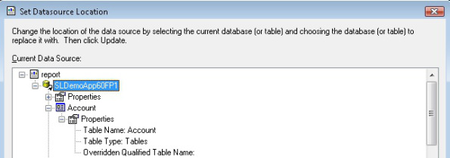](http://wisdomofsolomon.files.wordpress.com/2011/06/setdatasource.jpg)

Click the Overridden Qualified Table Name line and a textbox will appear to the right.  In that textbox, type the table name, just as it shows in the Table Name line.  (Account in this example.)  Do this for each table in the report and click Close.

Putting a value in the Overridden Qualified Table Name textbox seems to tell Crystal to use what you typed there for the table name instead of the Fully Qualified table name.

Save your changes and you should be able to Verify Database without getting the errors any more.

June 18, 2011 at 1:36 am

[Reply](http://wisdomofsolomon.wordpress.com/2011/06/18/crystal-reports-tables-not-found-during-verify-database/?replytocom=46#respond)

While your prescribed method will work, a better way to do this that is GUI driven is to use the Set Location menu item as you started with but then use the replace with window (bottom frame), create a new connection using ODBC (which is what Crystal Reports utilizes) and open an ODBC connection to your actual database. Drill down to the table view. Once you have the tables exposed in the bottom frame, click on a table or view in the top frame to highlight it and then click on the same table name in the bottom frrame in your desired database and click the Update button. Repeat this for each table used in the top frame. If your report includes subreports, you will need to drill down to those tables (or views) and perform the same steps. This will change the dbo association with each table or view in your report to be with your database.

June 18, 2011 at 5:25 pm

[Reply](http://wisdomofsolomon.wordpress.com/2011/06/18/crystal-reports-tables-not-found-during-verify-database/?replytocom=47#respond)

Good point Rick. Thanks for chiming in.

I will confess that some of my habits related to SL practices were set years (and versions ago) so there are probably some things I do to avoid bugs/problems that existed a long time ago and may have been fixed by now.

I believe the method you describe will change the SQL statement from “select * from database1.dbo.tablename” to “select * from database2.dbo.tablename”, where database1 exists only on an SL dev server somewhere and database2 is your database.

I actually prefer the SQL statement to be “select * from tablename” and to only get the database name from the connection. If you’re running an installation where there’s only 1 application database, it probably doesn’t matter much. Expand the scenario to include a database3, where database2 and database3 both exist on your server.

In this scenario, I have seen SL choke when needing to change the statement at runtime from database2 and database3. Again, this was probably a long time ago, but old habits (and suspicions) die hard.

My recollection is that SL changing from database1 to database2 at runtime was not a problem (since database1 wasn’t available at my site), but that sometimes since database2 was available, the redirect to database3 didn’t happen correctly. It was almost like it tried the linkage that was there, and only if that wasn’t available, did it explicitly redirect to the currently logged in application database.

That’s probably a lot more than you wanted to hear on that, but I thought I’d explain why I use the method I describe.

Thanks for reading and I appreciate the comments and feedback.

JT