**TO DO WORK LIST**

Description:

A **to-do list project** is an application that helps users keep track of their tasks and works. It allows users to enter the tasks they need to do and remove them from the list once they are done. The project can be built using different programming languages such as**JavaScript**, **Python**, or **Java.**

Now in this app designing project ,I had used a java and xml for implementation purpose .This app main purpose is to make a note of the works through the app application that makes use of completion of the tasks that are created by the user.

The application can have a simple user interface that displays the list of tasks and allows users to add, edit, and delete tasks. It can also have features such as setting reminders, prioritizing tasks, and categorizing tasks based on their type.

**App is made-up of:**

* Java
* Xml

**Features:**

* Due Date: Each task should have a due date to help you prioritize your work and manage your time effectively.
* Priority Levels: Assign priority to tasks as Low, Medium, or High to help you focus on the most important tasks first.
* Category: Ability to categorize tasks based on their type or project to help you stay organized.
* Task Status: Mark tasks as New, In Progress, or Completed to help you track your progress and stay motivated.
* Title and Description: Each task should have a title and a detailed description to help you remember what needs to be done and why.
* Local Storage: The app should use local storage to save tasks so that you can access them even when you’re offline.

**About:**

A small to-do app with the features that above mentioned can be very useful for managing your tasks and keeping track of your progress. By assigning a due date to each task, you can prioritize your work and manage your time effectively. This feature can help to stay on top of your tasks and ensure that you meet your deadlines.

Assigning priority levels to tasks as Low, Medium, or High can help you focus on the most important tasks first. This feature can help you manage your workload and ensure that you complete your most important tasks on time. Categorizing tasks based on project can help you stay organized. This feature can help you group similar tasks together and ensure that you don’t forget anything important.

Marking tasks as New, In Progress, or Completed can help you track your progress and stay motivated. This feature can help you see how much progress you’ve made and how much work you have left to do. Each task should have a title and a detailed description to help you remember what needs to be done and why. This feature can help you stay focused on your tasks and ensure that you don’t forget any important details. There is a another important feature this app contains that is a time duration this makes the user to understand how duration of time is there to complete the task. There is also a remainder that comes alarm in between the time duration.so that we can get the remainder to do the tasks whenever the task time is near to the completion.

**Instructions on how to set up and run the application:**

* Firstly download the zip file that is uploaded in the link
* Downloaded file should be stored in the operating system of any folder
* Now open the file from the android studio

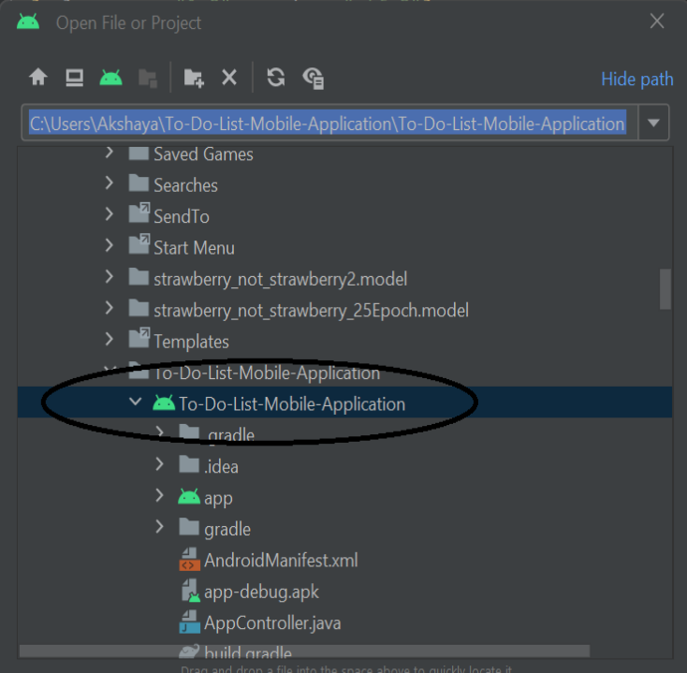

* After selecting the file click on ok
* The wait for few min till the whole file gets opened in your android studio
* Now choose a device and run the

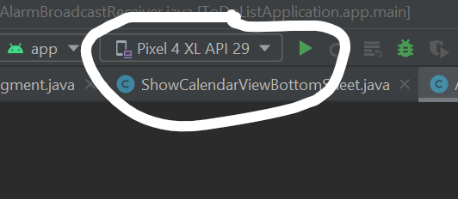

* Now click on the device manger

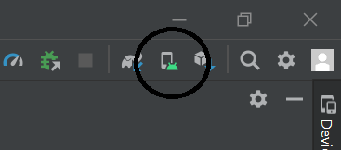

* Choose the device from available

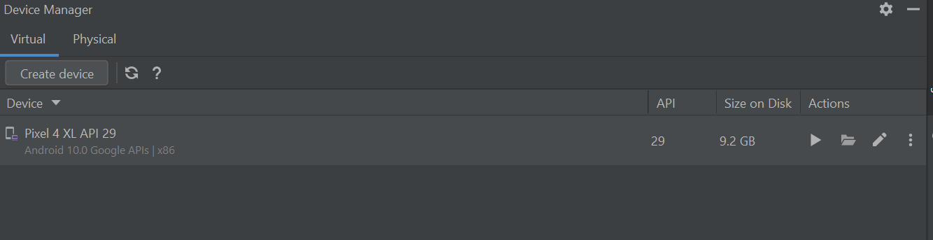

* click on the pause symbol to enumerate/execution.

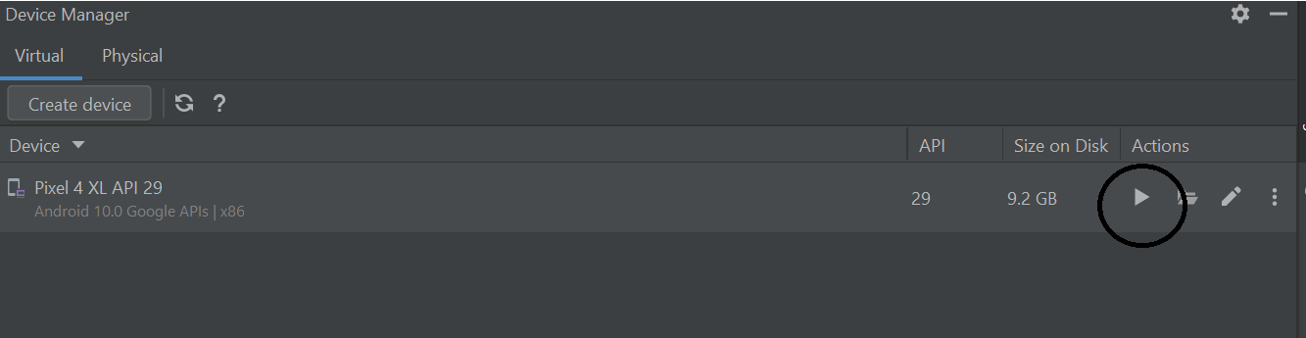

Output:

* A screen opens in the emulator(phone screen) ,you have to scroll up and search for the app name of to do list mobile application.

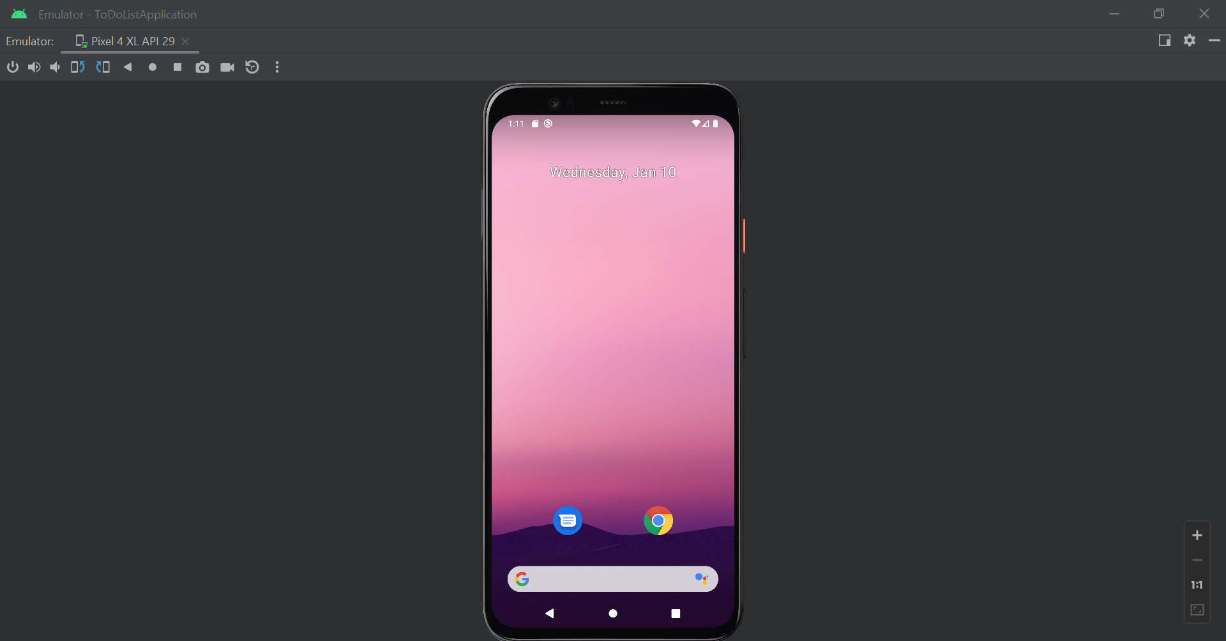

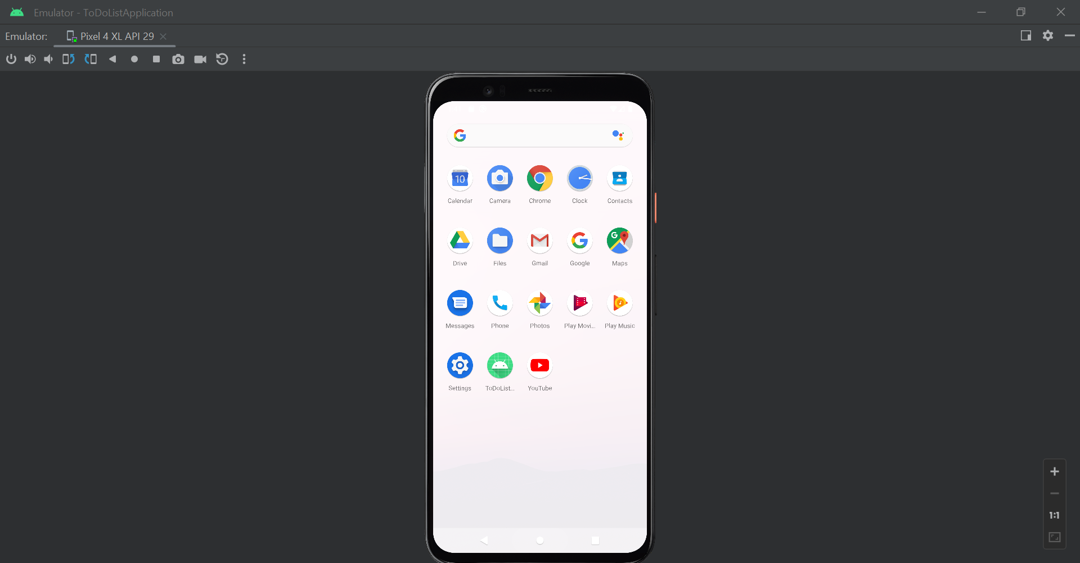

* Then open the app

Output: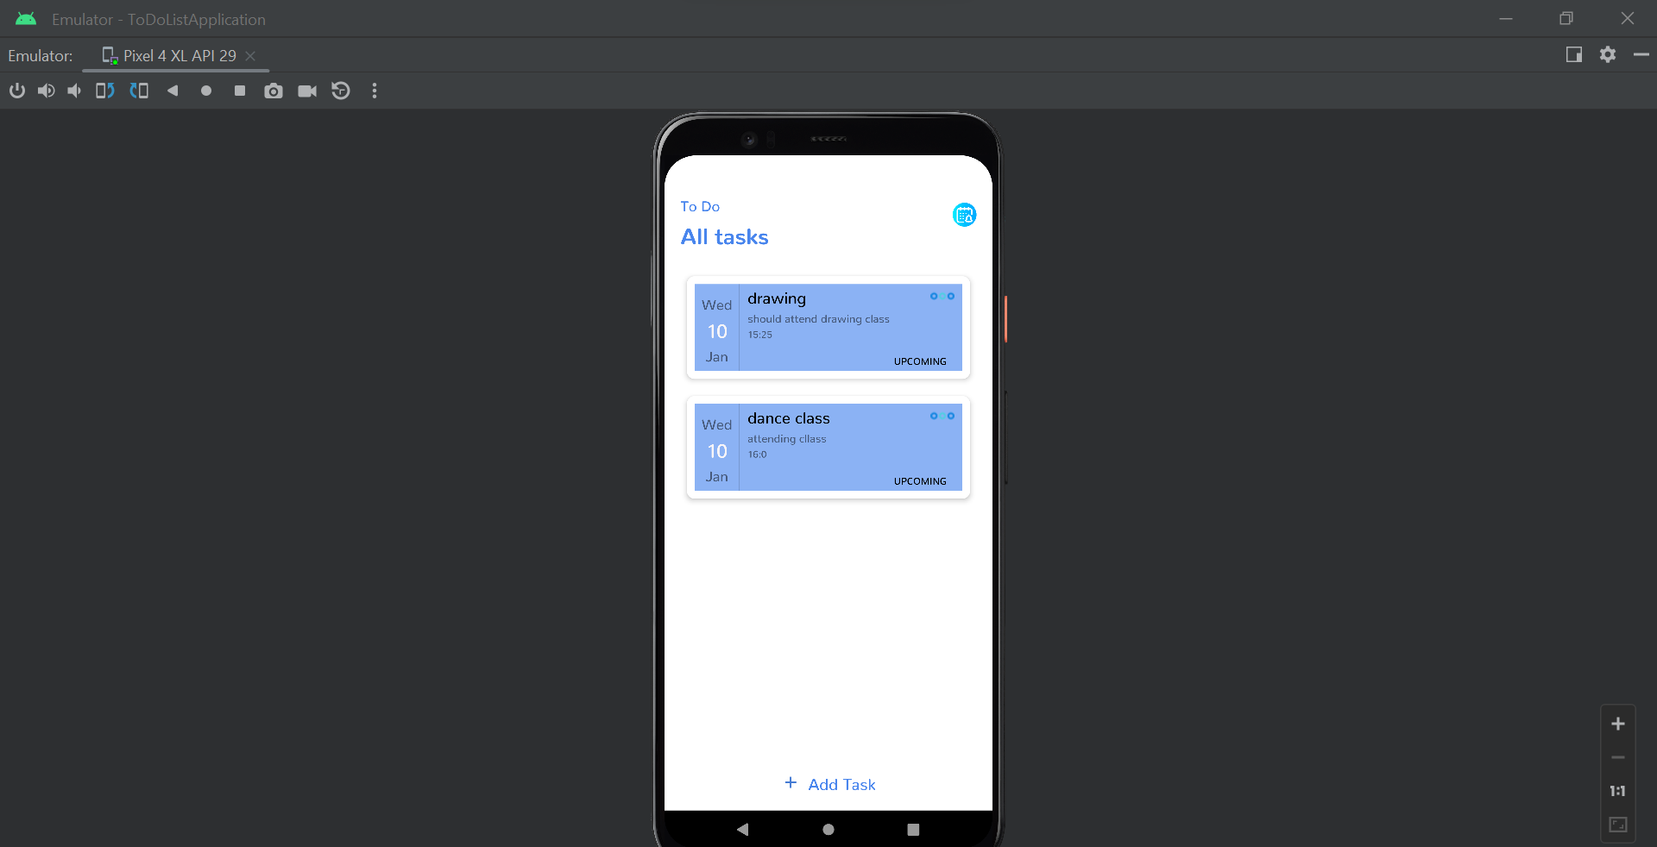

**Acknowledgement**:

I would like to express our sincere gratitude to everyone who has contributed to the development of this to-do list project in Java.

First and foremost, i would like to thank our professor for providing me with the opportunity to work on this project and for guiding me throughout the development process. And also thank you for much for providing a opportunity to do the project.

I would also like to thank the open-source community for providing us with valuable resources and sample code that helped me to build this project.

Finally, i would like to thank our friends,for their support and encouragement throughout this project.

Thank you for your support!