МИНИСТЕРСТВО ОБРАЗОВАНИЯ РЕСПУБЛИКИ БЕЛАРУСЬ

Учреждение образования «БЕЛОРУССКИЙ ГОСУДАРСТВЕННЫЙ

ТЕХНОЛОГИЧЕСКИЙ УНИВЕРСИТЕТ»

Факультет: Информационных технологий

Кафедра: Программной инженерии

Выполнила: студентка 2 курса 5 группы

специальности ПОИТ Городилина А. С.

**Отчёт**

По дисциплине “Математическое программирование”

На тему “Алгоритмы на графах”

Минск

2024

**Лабораторная работа 6. Алгоритмы на графах.**

**Цель работы:** Освоить сущность и программную реализацию: а) способов представления графов; б) алгоритмов поиска в ширину и глубину; в) алгоритма топологической сортировки графов. Разобрать алгоритм Прима и алгоритм Крускала

**Ход Работы**

1. **Представление графа в виде матрицы смежности, матрицы**

**инцидентности, списка смежных вершин.**

Вариант 6

e1

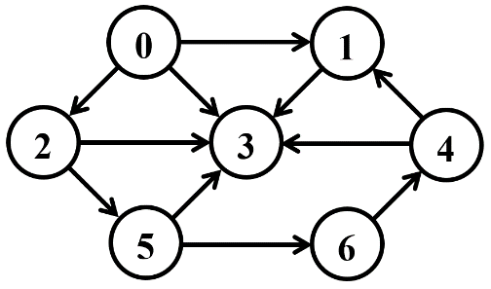

e11

e10

e7

e5

e3

e2

e8

e9

e6

e4

Матрица смежности:

|  |  |  |  |  |  |  |  |
| --- | --- | --- | --- | --- | --- | --- | --- |
|  | v0 | v1 | v2 | v3 | v4 | v5 | v6 |
| v0 | 0 | 1 | 1 | 1 | 0 | 0 | 0 |
| v1 | 0 | 0 | 0 | 1 | 0 | 0 | 0 |
| v2 | 0 | 0 | 0 | 1 | 0 | 1 | 0 |
| v3 | 0 | 0 | 0 | 0 | 0 | 0 | 0 |
| v4 | 0 | 1 | 0 | 1 | 0 | 0 | 0 |
| v5 | 0 | 0 | 0 | 1 | 0 | 0 | 1 |
| v6 | 0 | 0 | 0 | 0 | 1 | 0 | 0 |

Матрица инцидентности:

|  |  |  |  |  |  |  |  |  |  |  |  |
| --- | --- | --- | --- | --- | --- | --- | --- | --- | --- | --- | --- |
|  | e1 | e2 | e3 | e4 | e5 | e6 | e7 | e8 | e9 | e10 | e11 |
| v0 | 1 | 0 | 1 | 0 | 0 | 0 | 0 | 0 | 0 | 1 | 0 |
| v1 | -1 | -1 | 0 | 0 | 0 | 0 | 1 | 0 | 0 | 0 | 0 |
| v2 | 0 | 0 | -1 | 1 | 0 | 0 | 0 | 0 | 0 | 0 | 1 |
| v3 | 0 | 0 | 0 | 0 | -1 | 0 | -1 | 0 | -1 | -1 | -1 |
| v4 | 0 | 1 | 0 | 0 | 0 | 0 | 0 | -1 | 1 | 0 | 0 |
| v5 | 0 | 0 | 0 | -1 | 1 | -1 | 0 | 0 | 0 | 0 | 0 |
| v6 | 0 | 0 | 0 | 0 | 0 | 1 | 0 | 1 | 0 | 0 | 0 |

Список смешных вершин:

V0: V1, V2, V3

V1: V3

V2: V3, V5

V3: –

V4: V1, V3

V5: V3, V6

V6: V4

1. **Алгоритмы поиска в ширину и глубину, топологическая сортировка**

**Поиск в ширину (BFS)**

|  |  |  |  |  |  |  |  |
| --- | --- | --- | --- | --- | --- | --- | --- |
| **Q** | **0** |  |  |  |  |  |  |
|  |  |  |  |  |  |  |  |
| **C** | **G** | **W** | **W** | **W** | **W** | **W** | **W** |
|  |  |  |  |  |  |  |  |
| **D** | **0** | **I** | **I** | **I** | **I** | **I** | **I** |
|  |  |  |  |  |  |  |  |
| **P** | **N** | **N** | **N** | **N** | **N** | **N** | **N** |

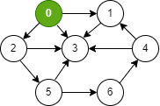

|  |  |  |  |  |  |  |  |
| --- | --- | --- | --- | --- | --- | --- | --- |
| **Q** | **1** | **2** | **3** |  |  |  |  |
|  |  |  |  |  |  |  |  |
| **C** | **B** | **G** | **G** | **G** | **W** | **W** | **W** |
|  |  |  |  |  |  |  |  |
| **D** | **0** | **1** | **1** | **1** | **I** | **I** | **I** |
|  |  |  |  |  |  |  |  |
| **P** | **N** | **0** | **0** | **0** | **N** | **N** | **N** |

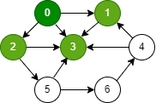

|  |  |  |  |  |  |  |  |
| --- | --- | --- | --- | --- | --- | --- | --- |
| **Q** | **3** | **5** |  |  |  |  |  |
|  |  |  |  |  |  |  |  |
| **C** | **B** | **B** | **B** | **G** | **W** | **G** | **W** |
|  |  |  |  |  |  |  |  |
| **D** | **0** | **1** | **1** | **1** | **I** | **2** | **I** |
|  |  |  |  |  |  |  |  |
| **P** | **N** | **0** | **0** | **0** | **N** | **2** | **N** |

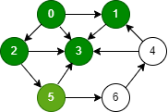

|  |  |  |  |  |  |  |  |
| --- | --- | --- | --- | --- | --- | --- | --- |
| **Q** | **6** |  |  |  |  |  |  |
|  |  |  |  |  |  |  |  |
| **C** | **B** | **B** | **B** | **B** | **W** | **B** | **G** |
|  |  |  |  |  |  |  |  |
| **D** | **0** | **1** | **1** | **1** | **I** | **2** | **3** |
|  |  |  |  |  |  |  |  |
| **P** | **N** | **0** | **0** | **0** | **N** | **2** | **5** |

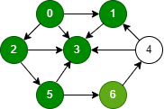

|  |  |  |  |  |  |  |  |
| --- | --- | --- | --- | --- | --- | --- | --- |
| **Q** | **4** |  |  |  |  |  |  |
|  |  |  |  |  |  |  |  |
| **C** | **B** | **B** | **B** | **B** | **G** | **B** | **B** |
|  |  |  |  |  |  |  |  |
| **D** | **0** | **1** | **1** | **1** | **4** | **2** | **3** |
|  |  |  |  |  |  |  |  |
| **P** | **N** | **0** | **0** | **0** | **6** | **2** | **5** |

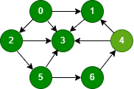

|  |  |  |  |  |  |  |  |
| --- | --- | --- | --- | --- | --- | --- | --- |
| **A** | **0** | **1** | **2** | **3** | **5** | **6** | **4** |
|  |  |  |  |  |  |  |  |
| **C** | **B** | **B** | **B** | **B** | **B** | **B** | **B** |
|  |  |  |  |  |  |  |  |
| **D** | **0** | **1** | **1** | **1** | **4** | **2** | **3** |
|  |  |  |  |  |  |  |  |
| **P** | **N** | **0** | **0** | **0** | **6** | **2** | **5** |

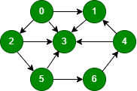

3

1

0

5

2

6

4

**Поиск в глубину (DFS)**

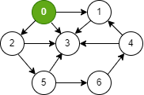

|  |  |  |  |  |  |  |  |
| --- | --- | --- | --- | --- | --- | --- | --- |
| **С** | **G** | **W** | **W** | **W** | **W** | **W** | **W** |
|  |  |  |  |  |  |  |  |
| **D** | **1** | **I** | **I** | **I** | **I** | **I** | **I** |
|  |  |  |  |  |  |  |  |
| **P** | **N** | **N** | **N** | **N** | **N** | **N** | **N** |
|  |  |  |  |  |  |  |  |
| **F** | **0** | **0** | **0** | **0** | **0** | **0** | **0** |

t = 1

|  |  |  |  |  |  |  |  |
| --- | --- | --- | --- | --- | --- | --- | --- |
| **С** | **G** | **G** | **W** | **W** | **W** | **W** | **W** |
|  |  |  |  |  |  |  |  |
| **D** | **1** | **2** | **I** | **I** | **I** | **I** | **I** |
|  |  |  |  |  |  |  |  |
| **P** | **N** | **0** | **N** | **N** | **N** | **N** | **N** |
|  |  |  |  |  |  |  |  |
| **F** | **0** | **0** | **0** | **0** | **0** | **0** | **0** |

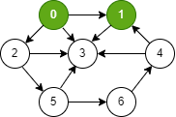

t = 2

|  |  |  |  |  |  |  |  |
| --- | --- | --- | --- | --- | --- | --- | --- |
| **С** | **G** | **G** | **W** | **G** | **W** | **W** | **W** |
|  |  |  |  |  |  |  |  |
| **D** | **1** | **2** | **I** | **3** | **I** | **I** | **I** |
|  |  |  |  |  |  |  |  |
| **P** | **N** | **0** | **N** | **1** | **N** | **N** | **N** |
|  |  |  |  |  |  |  |  |
| **F** | **0** | **0** | **0** | **0** | **0** | **0** | **0** |

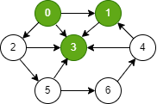

t = 3

|  |  |  |  |  |  |  |  |
| --- | --- | --- | --- | --- | --- | --- | --- |
| **С** | **G** | **G** | **W** | **B** | **W** | **W** | **W** |
|  |  |  |  |  |  |  |  |
| **D** | **1** | **2** | **I** | **3** | **I** | **I** | **I** |
|  |  |  |  |  |  |  |  |
| **P** | **N** | **0** | **N** | **1** | **N** | **N** | **N** |
|  |  |  |  |  |  |  |  |
| **F** | **0** | **0** | **0** | **4** | **0** | **0** | **0** |

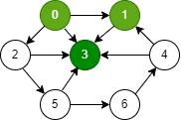

t = 4

|  |  |  |  |  |  |  |  |
| --- | --- | --- | --- | --- | --- | --- | --- |
| **С** | **G** | **B** | **W** | **B** | **W** | **W** | **W** |
|  |  |  |  |  |  |  |  |
| **D** | **1** | **2** | **I** | **3** | **I** | **I** | **I** |
|  |  |  |  |  |  |  |  |
| **P** | **N** | **0** | **N** | **1** | **N** | **N** | **N** |
|  |  |  |  |  |  |  |  |
| **F** | **0** | **5** | **0** | **4** | **0** | **0** | **0** |

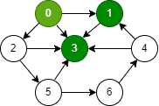

t = 5

|  |  |  |  |  |  |  |  |
| --- | --- | --- | --- | --- | --- | --- | --- |
| **С** | **G** | **B** | **G** | **B** | **W** | **W** | **W** |
|  |  |  |  |  |  |  |  |
| **D** | **1** | **2** | **6** | **3** | **I** | **I** | **I** |
|  |  |  |  |  |  |  |  |
| **P** | **N** | **0** | **0** | **1** | **N** | **N** | **N** |
|  |  |  |  |  |  |  |  |
| **F** | **0** | **5** | **0** | **4** | **0** | **0** | **0** |

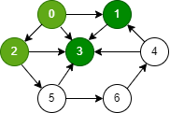

t = 6

|  |  |  |  |  |  |  |  |
| --- | --- | --- | --- | --- | --- | --- | --- |
| **С** | **G** | **B** | **G** | **B** | **W** | **G** | **W** |
|  |  |  |  |  |  |  |  |
| **D** | **1** | **2** | **6** | **3** | **I** | **7** | **I** |
|  |  |  |  |  |  |  |  |
| **P** | **N** | **0** | **0** | **1** | **N** | **2** | **N** |
|  |  |  |  |  |  |  |  |
| **F** | **0** | **5** | **0** | **4** | **0** | **0** | **0** |

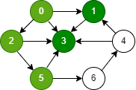

t = 7

|  |  |  |  |  |  |  |  |
| --- | --- | --- | --- | --- | --- | --- | --- |
| **С** | **G** | **B** | **G** | **B** | **W** | **G** | **G** |
|  |  |  |  |  |  |  |  |
| **D** | **1** | **2** | **6** | **3** | **I** | **7** | **8** |
|  |  |  |  |  |  |  |  |
| **P** | **N** | **0** | **0** | **1** | **N** | **2** | **5** |
|  |  |  |  |  |  |  |  |
| **F** | **0** | **5** | **0** | **4** | **0** | **0** | **0** |

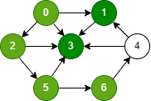

t = 8

|  |  |  |  |  |  |  |  |
| --- | --- | --- | --- | --- | --- | --- | --- |
| **С** | **G** | **B** | **G** | **B** | **G** | **G** | **G** |
|  |  |  |  |  |  |  |  |
| **D** | **1** | **2** | **6** | **3** | **9** | **7** | **8** |
|  |  |  |  |  |  |  |  |
| **P** | **N** | **0** | **0** | **1** | **6** | **2** | **5** |
|  |  |  |  |  |  |  |  |
| **F** | **0** | **5** | **0** | **4** | **0** | **0** | **0** |

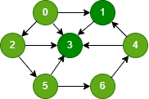

t = 9

|  |  |  |  |  |  |  |  |
| --- | --- | --- | --- | --- | --- | --- | --- |
| **С** | **G** | **B** | **G** | **B** | **B** | **G** | **G** |
|  |  |  |  |  |  |  |  |
| **D** | **1** | **2** | **6** | **3** | **9** | **7** | **8** |
|  |  |  |  |  |  |  |  |
| **P** | **N** | **0** | **0** | **1** | **6** | **2** | **5** |
|  |  |  |  |  |  |  |  |
| **F** | **0** | **5** | **0** | **4** | **10** | **0** | **0** |

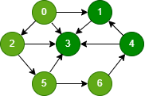

t = 10

|  |  |  |  |  |  |  |  |
| --- | --- | --- | --- | --- | --- | --- | --- |
| **С** | **G** | **B** | **G** | **B** | **B** | **G** | **B** |
|  |  |  |  |  |  |  |  |
| **D** | **1** | **2** | **6** | **3** | **9** | **7** | **8** |
|  |  |  |  |  |  |  |  |
| **P** | **N** | **0** | **0** | **1** | **6** | **2** | **5** |
|  |  |  |  |  |  |  |  |
| **F** | **0** | **5** | **0** | **4** | **10** | **0** | **11** |

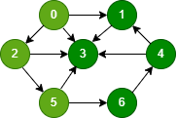

t = 11

|  |  |  |  |  |  |  |  |
| --- | --- | --- | --- | --- | --- | --- | --- |
| **С** | **G** | **B** | **G** | **B** | **B** | **B** | **B** |
|  |  |  |  |  |  |  |  |
| **D** | **1** | **2** | **6** | **3** | **9** | **7** | **8** |
|  |  |  |  |  |  |  |  |
| **P** | **N** | **0** | **0** | **1** | **6** | **2** | **5** |
|  |  |  |  |  |  |  |  |
| **F** | **0** | **5** | **0** | **4** | **10** | **12** | **11** |

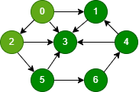

t = 12

|  |  |  |  |  |  |  |  |
| --- | --- | --- | --- | --- | --- | --- | --- |
| **С** | **G** | **B** | **B** | **B** | **B** | **B** | **B** |
|  |  |  |  |  |  |  |  |
| **D** | **1** | **2** | **6** | **3** | **9** | **7** | **8** |
|  |  |  |  |  |  |  |  |
| **P** | **N** | **0** | **0** | **1** | **6** | **2** | **5** |
|  |  |  |  |  |  |  |  |
| **F** | **0** | **5** | **13** | **4** | **10** | **12** | **11** |

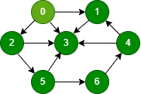

t = 13

|  |  |  |  |  |  |  |  |
| --- | --- | --- | --- | --- | --- | --- | --- |
| **С** | **B** | **B** | **B** | **B** | **B** | **B** | **B** |
|  |  |  |  |  |  |  |  |
| **D** | **1** | **2** | **6** | **3** | **9** | **7** | **8** |
|  |  |  |  |  |  |  |  |
| **P** | **N** | **0** | **0** | **1** | **6** | **2** | **5** |
|  |  |  |  |  |  |  |  |
| **F** | **14** | **5** | **13** | **4** | **10** | **12** | **11** |

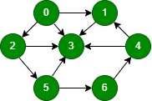

t = 14

0

A: 3-> 1 -> 4 -> 6 -> 5 -> 2 -> 0

15

35

5

4

65

2