Functional Specification Rimi Pluss

Android Version

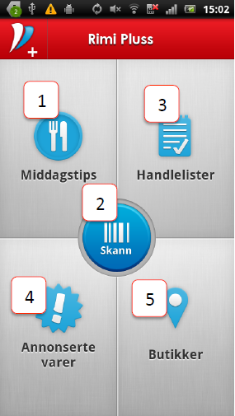1 Front page

Dashboard for Rimi Pluss

1.  Tap to go to dinnertips

2.  Tap to go to scanning

3.  Tap to go to shoppinglists

4.  Tap to go to campaign products

5.  Tap to go top find Rimi Stores

General

•  Navigation back uses back-button on phone, therefore there is no back-buttons on screen as on iOS

•  To get menus press menu-button on phone

1 Frontpage dinnertips

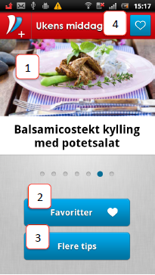1. Show todays dinnertips – tap takes you to dinnertips frontpage – swipe left/right to see dinnertips for from Monday thru Sunday

2. Takes you to your list your favorite dinnertips

3. Takes you to list of all dinnertips

4. Tap to ad dinnertips to your favorite, tap once more to remove from favorites

2a Dinnertips

(front-page-ingredients)

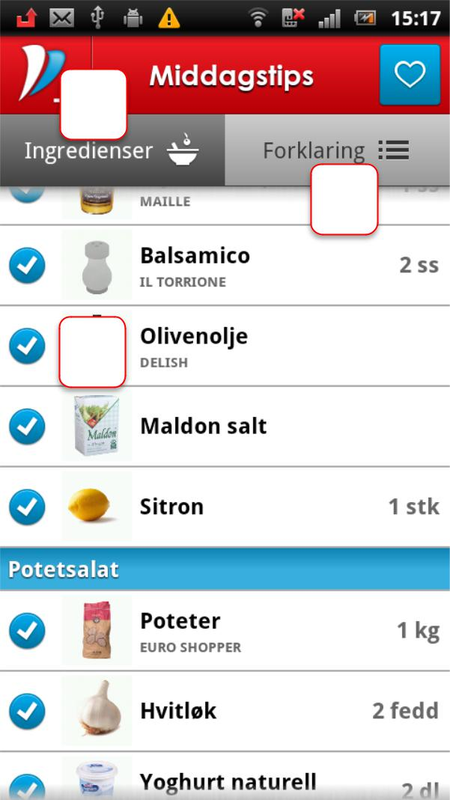

|  |  |  |  |
| --- | --- | --- | --- |
|  |  |  | Shows ingredients in dinnertips, lets you put |
|  |  |  | products into a shoppinglist |
| 1 |  |  |
|  |  |  |
|  |  |  | 1.  Takes you to ingredients view of |
|  |  | |
|  |  | 2 |
|  |  |  | dinnertips |
|  |  |  |
|  |  |  | 2.  Takes you to description view of |
|  |  |  | dinnertips |
| **3** |  |  |
|  |  | 3.  When you tap blue button the product |
|  |  |  |

will not be included in shopping list (for products you already have at home)

4.  Products becomes red (not shown on screenshot) when you have them in a shoppinglist

5.  Slider on top (not shown on screenshot) that lets you select number of portions

2a Dinnertips cont.

(front-page-ingredients)

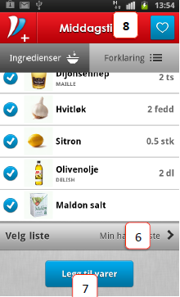

6. 6.Takes you to view to choose which shoppinglist products shall be added to

7.  7.Adds selected products to the selected shoppinglist

8.  8.One tap adds dinnertips to favorites – another tap removes dinnertips as favorite

2b Dinner tips

(description)

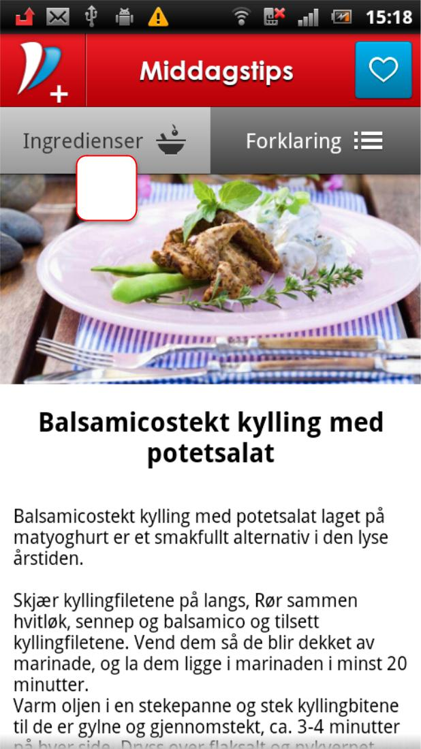

Shows description of how to make dinnertips

|  |  |
| --- | --- |
| **1** | 1.  Tap to back to |
|  |

ingredients view

2 c Choose shoppinglist

1.  Default list is marked with blue

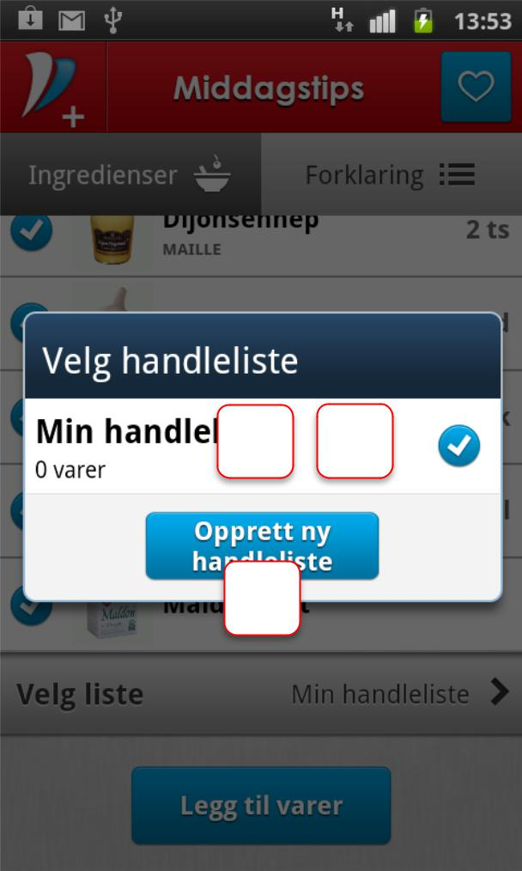

|  |  |  |  |  |
| --- | --- | --- | --- | --- |
|  |  |  | ribbon – all list will be shown (on | |
|  |  |  | screenshot only one is available) | |
|  |  |  | 2.  Tap any list to choose the list | |
|  |  |  | you want to add products to | |
|  |  |  | 3.  Add new list if you want by | |
|  |  | | tapping “opprett..” - when | |
| **2** |  | **1** |
|  |  |  | tapping “add new list” box is | |
|  |  |  |
|  | opened, default name is name | | |
| **3** |
| of dinnertips you come from, | | |
|  |
|  |
|  | this can be changed by user see | | |
|  | next slide | | |

2 c Choose shoppinglist cont.

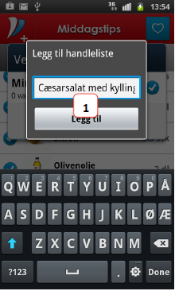

1.  Add new list if you want by tapping “+” -when tapping “add new list”

box is opened, default

name is name of

dinnertips you come

from, this can be

changed by user

3 Favoritelist

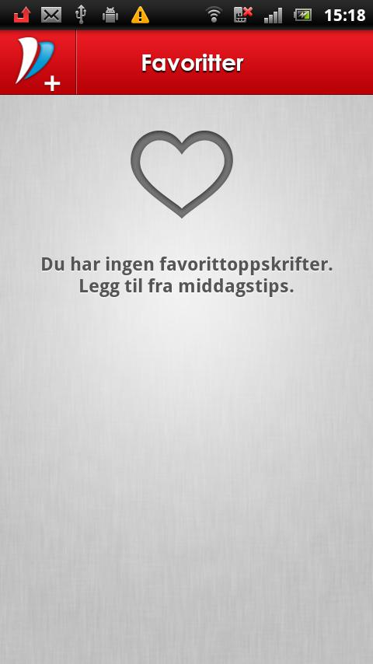

This list shows list of favorites in you have any, if not this message is shown

4 List of all dinnertips categories

**3**

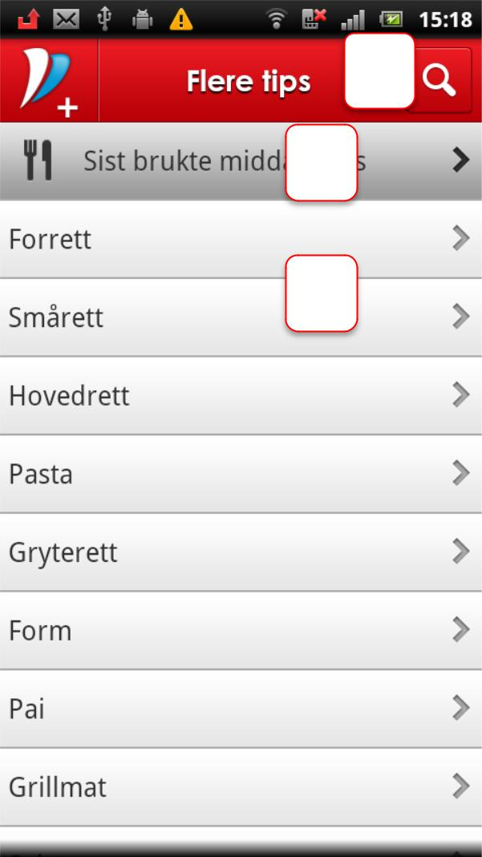

**1**

**2**

Shows list of all categories of dinnertips

1.  Tap this and you see all “last used dinnertips” – dinnertips appears in this list if user has added the

dinnertips to a shoppinglist – newest added is on top

2.  Tap this and you see all dinnertips in this category

3.  Search within dinnertips

5 List of dinnertips within a category

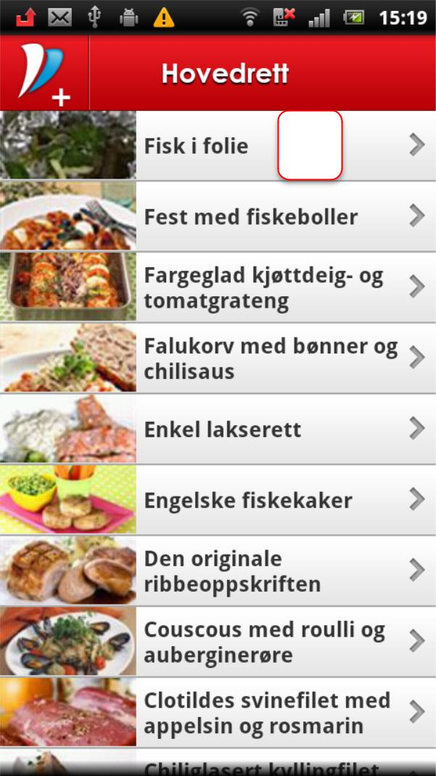

|  |  |
| --- | --- |
|  | Shows list of all dinnertips in |
| **1** | the selected category |

1.  Tap the to see the dinnertips – landingpage for dinnertips (2a)

6a List of shoppinglists

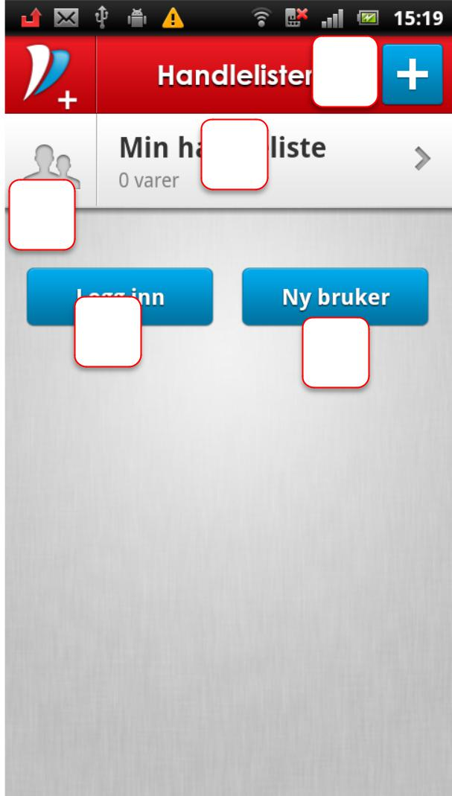

**3**

**1**

**2**

**4** **5**

This user is not logged in Shows list of all shoppinglists

1.  Tap to see the selected list – text says “0 product” as there is no

products added to list

2.  Icon indicates if this list is shared with others, if blue it´s shared and the number indicates with the number of contacts that share list

3.  Tap the “+” to add new shoppinglist

4.  Tap here to log in – only when logged in you can share list with other devices and other contacts

5.  Tap here if you are new user to register

6a List of shoppinglists cont.

**1**

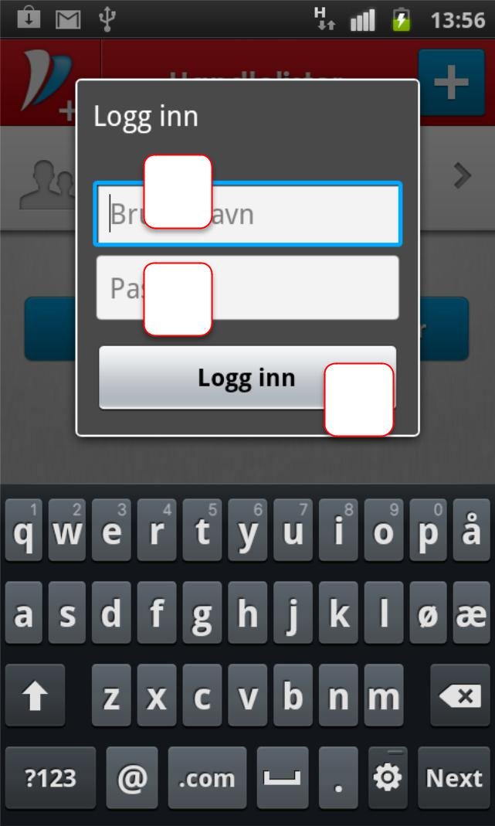

**2**

**3**

1.  Type username

2.  Type password

3.  Tap to log in

6a List of shoppinglists cont.

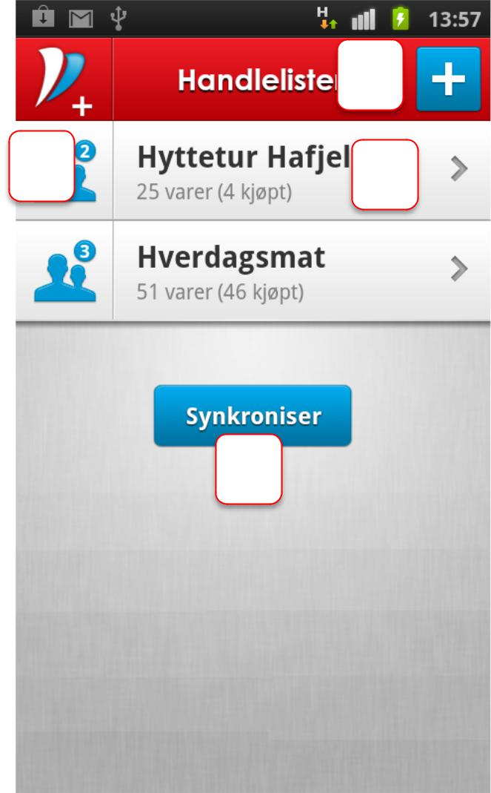

**3**

**2** **1**

**4**

This user is logged in as user -­‐ shows list of all shoppinglists

1.  Tap to see the selected list – text says “25 products (4 purchased)” as there is no products added to list

2.  Icon indicates if this list is shared

with others, if blue it´s shared and the number indicates with the number of contacts that share list, tap on icon to add contacts – landing page is 10

3.  Tap the “+” to add new shoppinglist

4.  Tap here to manually synchronize your device with other devices/ contacts

7 shoppinglist

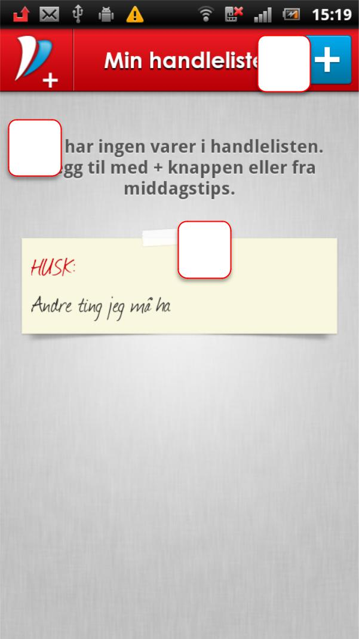

**2** 1.  Products in list will be

|  |  |  |  |
| --- | --- | --- | --- |
|  |  |  | listed here, if no products |
| **1** |  |  |
|  |  | this message is shown, |
|  |  |  |
|  |  |  |
|  |  |  | for list with products see |
|  |  | **3** |
|  |  |  |
|  |  |  | next slide |
|  |  |  |
|  |  |  | 2.  Tap add products to list |
|  |  |  | 3.  Tap to edit post-­‐it note |
|  |  |  | with text |

7 shoppinglist cont

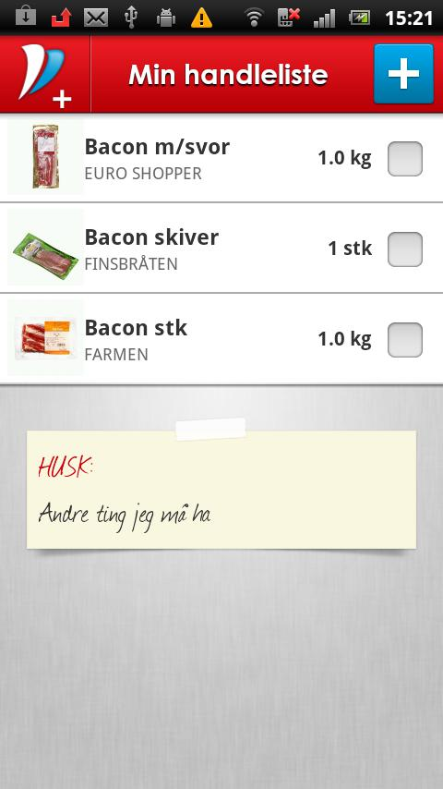

Presentation with products

7 shoppinglist cont

1.  Presentation when product is checked out, checkbox turns red and

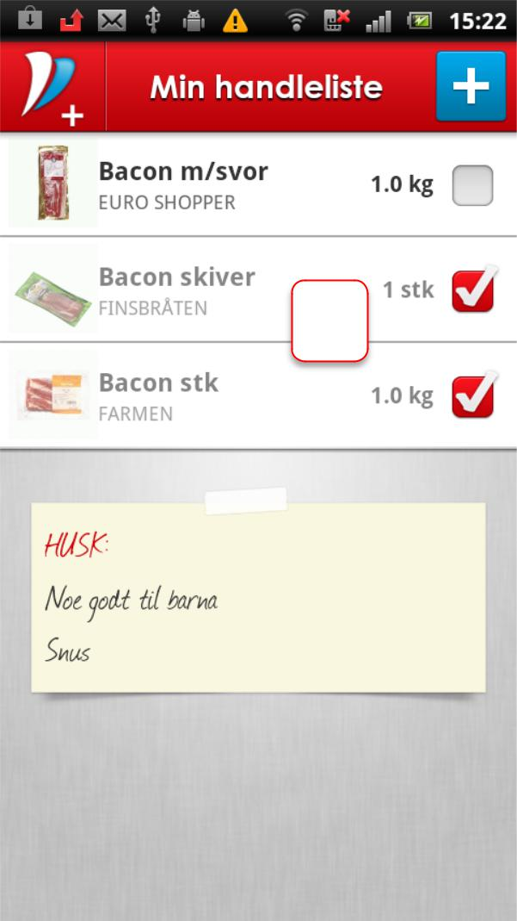

**1** products is moved to bottom of list

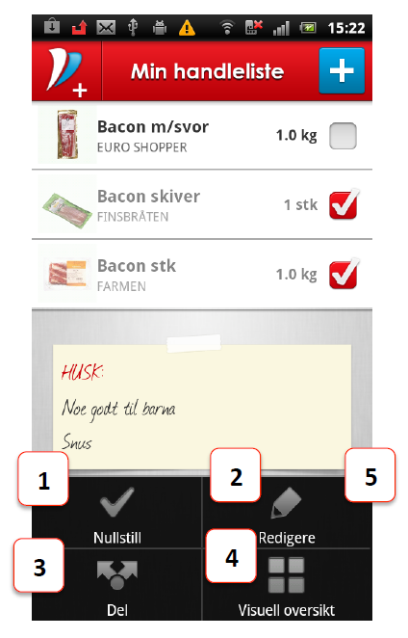7 shoppinglist cont

1. Removes all checkouts on list, all red checkboxes is cleared at the sorting of list turns back to normal

2. Tap to edit list, remove one or more lists

3. Tap to share list on email/sms

4. Tap to show gridview

5. Use menu button on phone to see menu

7 shoppinglist cont

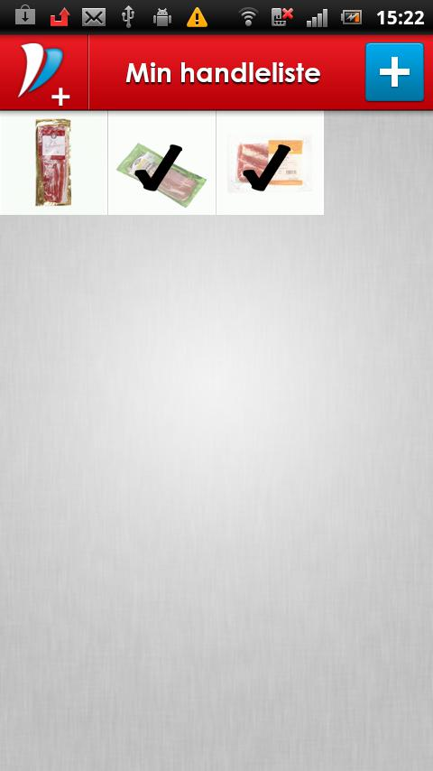

1.  To turn back to list view use back button