(Q1) # total and average marks take as input english,maths ,computer
english=int(input("enter english marks:"))
maths=int(input("enter maths marks:"))
computer=int(input("enter computer marks:"))
total=english+maths+computer
average=total/3
print("total marks=",total)
print("average=",average)
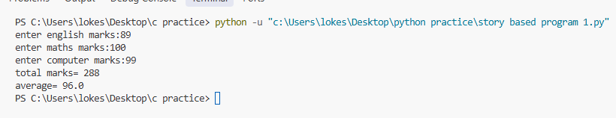
(Q2) #notebook for 80,pen for 30,bag for 750 calculate total bill and give discount if total is more than 500and also display the final amount
notebook=80
pen=30
bag=750
total=notebook+pen+bag
if total>500:
discount=total*10/100
final_amount=total-discount
else:
final_amount=total
print("total bill=",total)
print("final_amount=",final_amount)
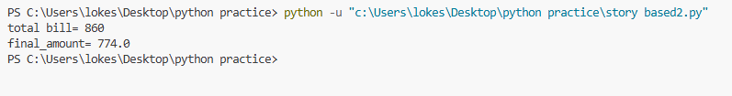
(Q3) #A game asks a player to enter a number. Write a Python program that determines whether the number is even or odd.
number=int(input("enter a number:"))
if number%2==0:
print("even")
else:
print("odd")
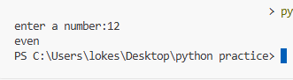
(Q4) #Calculate electricity bill using these rules:
#First 100 units → ₹5 per unit
#Next 100 units → ₹7 per unit
#Above 200 units → ₹10 per unit
units=int(input("enter electricity units:"))
if units<=100:
bill = units*5
elif units<=200:
bill=(100*5) +((units-100)*7)
else:
bill=(100*5)+(100*7)+((units-200)*10)
print("electricity bill=",bill)
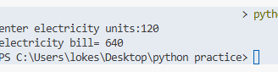

(Q5) #A cinema charges ₹200 per ticket. Ask for the number of tickets and calculate the total cost. If more than 5 tickets are booked, give a 15% discount
tickets=int(input("enter a number of ticket:"))
total=tickets*200
if tickets>5:
discount=total*15/100
final_amount=total-discount
else:
final_amount=total
print("total amount =",total)
print("final_amount =",final_amount)
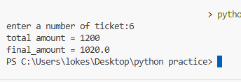

(Q6) #An ATM has a customer's current balance. Write a Python program that takes the account balance and withdrawal amount as input.
#If withdrawal amount is less than or equal to balance, display the remaining balance.
#Otherwise, display "Insufficient Balance".
balance=float(input("enter account balance:"))
withdrawal=float(input("enter withdrawal amount:"))
if withdrawal<=balance:
remaining=withdrawal-balance
print("remaining balance=",remaining)
else:
print("insufficient balance")
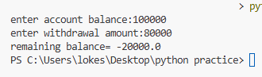
(Q7) #A weather application stores temperature in Celsius but needs to display it in Fahrenheit. Convert Celsius to Fahrenheit using:
celsius=float(input("enter temperature in celsius:"))
fahrenheit=(celsius*9/5)+32
print("temperature in fahrenheit=",fahrenheit)
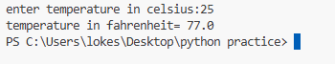
(Q8) #A student returns a library book late. The library charges:
#1–5 late days → ₹2 per day
#6–10 late days → ₹3 per day
#More than 10 days → ₹5 per day
#Write a Python program to calculate the total fine
days=int(input("enter late days:"))
if days<=5:
fine=days*2
elif days<=10:
fine=days*3
else:
fine=days*5
print("total fine =",fine)

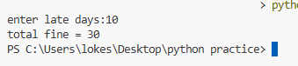
(Q9) #A website requires a password to contain at least 8 characters.
#If password has 8 or more characters → "Strong enough"
#Otherwise → "Password too short"
password=(input("enter password:"))
if len(password)>=8:
print("password is strong")
else:
print("password is too short")

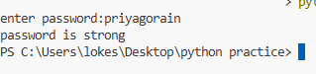
(Q10) 'A bus service charges different fares based on age:
Age below 5 → Free
Age 5–17 → ₹20
Age 18–59 → ₹40
Age 60 or above → ₹25
Write a Python program that takes the passenger's age and displays the ticket fare'''
age=int(input("enter your age:"))
if age<5:
fare=5
elif age<17:
fare=20
elif age<59:
fare=40
else:
fare=25
print("ticket fare=",fare)



